COMP4522 - Advanced Databases
Project: ETL, Data Quality, and Predictive Analytics
Student name / ID: ______________________ Date: ______________

1. Summary
A retail dataset of four CSV files (11 stores, 100 employees, 42 products, 20,000 sales records) was loaded into pandas, inspected for data quality problems, cleaned, and transformed into a mining dataset of 19,604 valid sales. Descriptive analytics show that effort hours is by far the strongest driver of revenue (correlation 0.89). A linear regression of Revenue on Effort_Hours (R² = 0.80) predicts that a sale made with 10 hours of effort will generate about $324.59 in revenue (95% prediction interval $239 to $410).

2. Data loading and design
The project uses the pandas route allowed by the assignment (software requirement 1: pandas or MariaDB). No relational database server is used, so no SQL scripts are submitted; the data loading script is loadData.py. The logical schema from the assignment is still the model that the code follows: Store (Store_ID PK), Employee (Employee_ID PK, Store_ID FK), Product (Product_ID PK) and Sales_Performance (Employee_ID FK, Product_ID FK). Because pandas does not enforce constraints, the primary and foreign key rules are checked explicitly in the ETL script (section 3).
Design decisions:
- Load everything as text. loadData.py reads the four CSVs with dtype=str so that malformed values ('a', 'A69', 'C3PO', 'bc31') are kept exactly as supplied and can be reported, instead of being silently coerced or raising an error. Conversion to numbers and dates happens only after inspection, during cleaning.
- Constraints replaced by explicit checks. Key uniqueness, foreign key validity and the value rules (Units_Sold ≥ 1, Revenue ≥ 0, Effort_Hours ≥ 0) are implemented as checks, and a row that fails is removed and logged rather than rejected by a database.
- Independent cross-check. loadData.py also contains a compact version of the cleaning (load_and_clean_data) written separately by the group. Running it gives exactly the same 19,604 valid sales as the full pipeline in etl/etl_pipeline.py, which confirms the cleaning rules; the full pipeline is the one that produces the discard log and the mining dataset.
- Discard log. Every discarded or repaired record is written to output/discard_log.csv with the table, record and reason; the results of every check are in output/quality_checks.csv.
- Employee.DOB and DOJ are kept as text because the source values are not dates (section 3).
- No database-side aggregation is used anywhere. All joins and aggregation for the mining dataset are done in pandas, as required.

3. Data quality inspection and handling
All required checks were run before any analytics (etl/etl_pipeline.py). Results on the raw files:
Table | Check | Records | Action
store | Missing / non-numeric Store_ID | 0 | none found
store | Duplicate Store_ID (primary key) | 0 | none found
store | Implausible Opening_Year (<1800 or >current year) | 1 | Opening_Year set to NULL, store kept
product | Non-numeric Product_ID, unknown Category (e.g. 'Other') or invalid Base_Price | 2 | discarded (no sale references them)
product | Duplicate Product_ID (primary key) | 0 | none found
product | Base_Price <= 0 | 0 | none found
employee | DOB / DOJ are not valid YYYY-MM-DD dates (corrupted 'mm:ss.f' fragments) | 100 | kept as text, excluded from analysis
employee | Missing / non-numeric Employee_ID | 1 | discarded
employee | Duplicate Employee_ID (primary key) | 0 | none found
employee | Store_ID not found in Store (FK) | 1 | discarded
sales_performance | Missing / blank values | 0 | none found
sales_performance | Unparseable Sale_Date | 0 | none found
sales_performance | Non-numeric Revenue/Effort_Hours or non-integer Units_Sold | 0 | none found
sales_performance | Revenue < 0 | 2 | discarded
sales_performance | Units_Sold < 1 | 0 | none found
sales_performance | Effort_Hours < 0 | 1 | discarded
sales_performance | Revenue = 0 (allowed by rule Revenue >= 0) | 1 | kept, flagged
sales_performance | Employee_ID not in the Employee table (FK) | 194 | discarded: 1048 x192, C3PO x1, R2D2 x1
sales_performance | Employee exists but was removed in cleaning (invalid Store_ID) | 199 | discarded: 1023 x199
sales_performance | Product_ID not in Product (FK) | 0 | none found
sales_performance | Exact duplicate rows | 0 | none found

Discarded and repaired records (complete list in output/discard_log.csv):
Table | Records | Reason | Handling
Sales_Performance | 194 rows | Employee_ID does not exist in the Employee table: 1048 (192 rows), C3PO (1), R2D2 (1) | Discarded (FK)
Sales_Performance | 199 rows | Employee 1023 exists, but was removed because its Store_ID is 'a', so its sales have no valid employee | Discarded (FK)
Sales_Performance | 2 rows | Revenue < 0 (-284.12 and -259.00) | Discarded
Sales_Performance | 1 row | Effort_Hours < 0 (-1.77) | Discarded
Employee | 1 row | ID 'A69' is not numeric; it never appears in the sales data | Discarded
Employee | 1 row | ID 1023: Store_ID 'a' is not a valid store | Discarded
Product | 2 rows | IDs 'bc31' and 999, categories 'Other' / 'Other 2', not one of the four real categories; no sale references them | Discarded
Store | 1 row | Store_11 Opening_Year = 1492 (implausible) | Value set to NULL, row kept

In total 396 of 20,000 sales rows (2.0%) were removed, leaving 19,604. No row was missing a value, had an unparseable date, a non-numeric measure, Units_Sold below 1, or was an exact duplicate. One sale has Revenue = 0; this is allowed by the rule Revenue ≥ 0, so it was kept and flagged.
Reasoning behind the choices:
- Foreign keys that cannot be resolved cannot be repaired from the data, so these rows are discarded instead of guessed. Employee 1048 is a special case: the employee table has the odd ID 'A69' exactly where 1048 would fall in the numbering and 192 sales belong to 1048, so 'A69' is probably a corrupted 1048. This is only an inference, not evidence, so the strict rule (discard) was applied. Because the removed rows look like ordinary sales, the effect on the model is expected to be small.
- The invalid Opening_Year is set to NULL rather than discarding Store_11, since the store is otherwise a legitimate row; it has no employees or sales, so it does not affect the analysis.
- DOB and DOJ in all 100 employee rows are fragments such as '58:57.4' (minutes:seconds), apparently the remains of a spreadsheet date-time export. They cannot be turned into ages or tenure, so they were kept verbatim and excluded from the analysis. This is a data limitation, not an error that could be fixed.

4. ETL and transformation
Extract: the four tables are read into pandas with loadData.load_tables(). Inspect/clean: the rules above are applied in a fixed order so each rejected sale gets one logged reason. Transform (pandas only): Sales is joined to Employee (to get Store_ID), to Store (name and city) and to Product (category, base price); all joins are validated as many-to-one so no rows are duplicated. Computed attributes were added: Revenue_per_Hour, Revenue_per_Unit, Price_Realisation (revenue / (units × base price)), Sale_Month and Sale_Weekday. Aggregated tables were then built with groupby: per employee, per store and per category (sales count, units, total revenue, total effort, averages, revenue per effort hour).
Mining dataset: one row per valid sale, enriched with the joined and computed attributes (output/mining_dataset.csv, 19,604 rows). The sale is kept as the unit because the prediction question is about a single sale; the aggregated tables are used for the descriptive analysis and to justify the modelling level (section 6).

5. Descriptive analytics
Revenue per sale averages $229 (median $224, maximum $528) with a mild right tail; effort is spread almost evenly between 1 and 12 hours with a hard cap at 12.
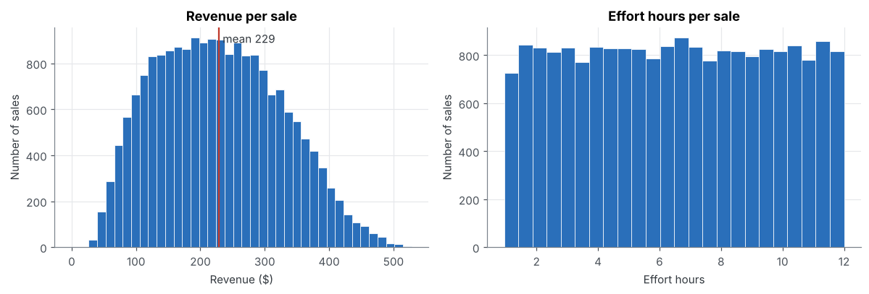
Figure 1. Distribution of revenue and effort hours per sale.
Effort and revenue are strongly and linearly related (r = 0.89); units sold has little relation to revenue (r = 0.25) and none to effort.
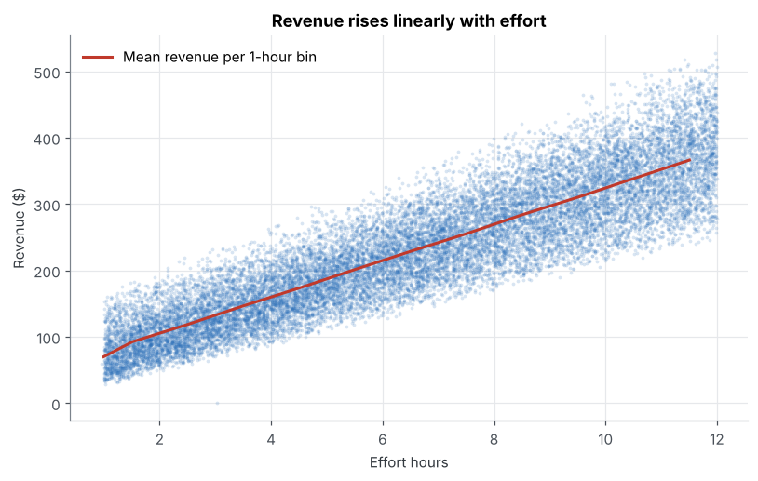
Figure 2. Revenue versus effort hours, with mean revenue in 1-hour bins.
Store totals range from $232,399 to $653,085 (Store_10 is highest) and follow head-count closely, while revenue per effort hour is almost identical across stores (about $35.00 to $35.50). Product categories and cities also have very similar revenue per sale, so effort rather than store, category or location drives revenue.
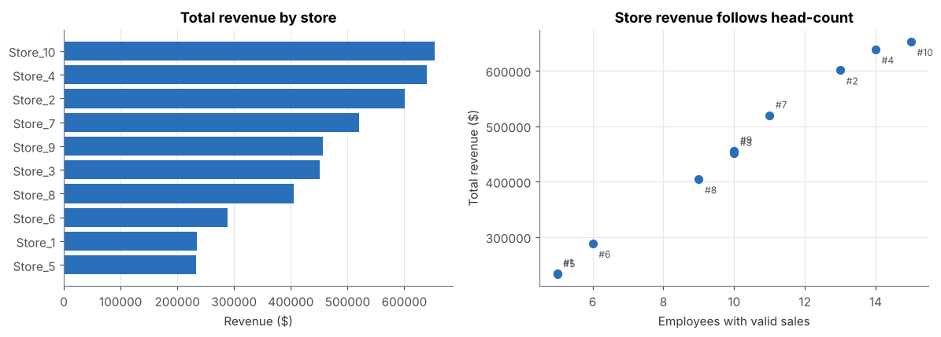
Figure 3. Total revenue by store and its relation to the number of employees.

6. Predictive analytics
Model: Revenue = b0 + b1 × Effort_Hours, fitted with scikit-learn LinearRegression on the transformed dataset. The model is fitted on individual sales rather than on employee averages because the question concerns the next single sale; the employee-level averages span only about 5.8 to 7.0 hours of effort, so a model built on them could not support a 10-hour prediction without extrapolating.
Quantity | Value
Intercept b0 | 50.48
Slope b1 (revenue per extra effort hour) | 27.41
R², all data | 0.799
R², 20% hold-out (random_state = 42) | 0.794
RMSE / MAE, hold-out | $44.12 / $35.49

Prediction: for an employee's next sale with 10 hours of effort, the model predicts revenue of $324.59. The approximate 95% prediction interval for a single sale is $239 to $410.
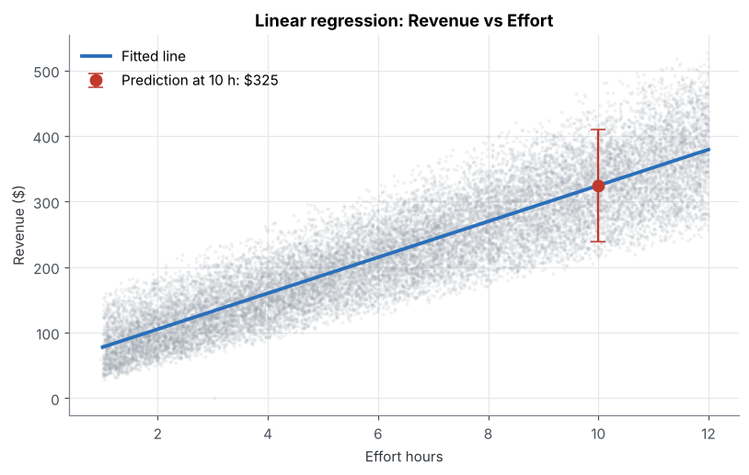
Figure 4. Fitted line and the prediction at 10 hours (red, with 95% prediction interval).
Model checks and limitations:
- The hold-out R² (0.79) is practically the same as the full-data R² (0.80), so there is no sign of overfitting. About 20% of the variance in revenue is not explained by effort.
- The residuals are centred on zero but their spread grows with effort (standard deviation about $32 for 0-3 hours and $55 for 9-12 hours). The point prediction is therefore reliable, but a single pooled interval is too narrow at high effort and too wide at low effort. Weighted least squares or a log model could address this.
- 10 hours lies inside the observed range (0.95 to 12), so the prediction is an interpolation.
- The model uses one variable. Employee age and tenure could not be used because the DOB/DOJ values are corrupted, and product category and store showed no relevant effect.
- The 396 discarded sales (2%), including all sales of employees 1023 and 1048, are not represented; if 'A69' really is employee 1048, the other 192 sales could be restored.
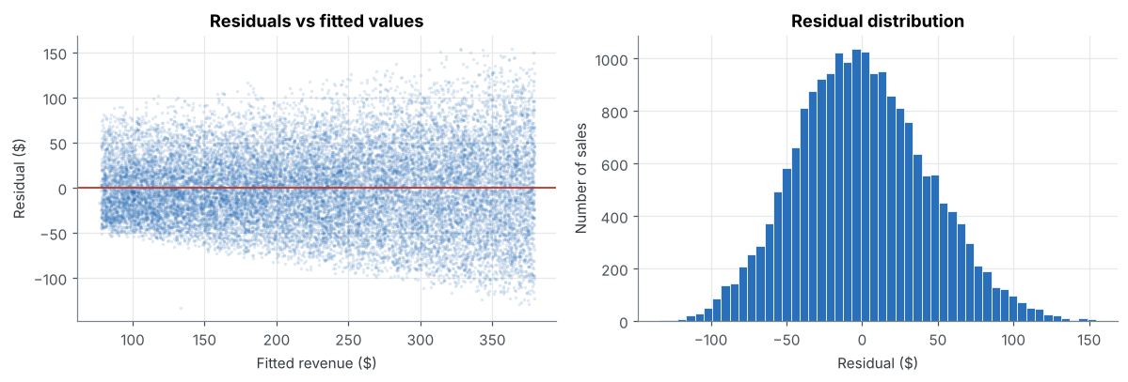
Figure 5. Residuals versus fitted values and residual distribution.

7. Files submitted and how to run
File | Purpose
loadData.py | Data loading script: reads the four CSVs as text
etl/etl_pipeline.py | Quality checks, cleaning, pandas joins and aggregation; writes output/
notebook/analytics.ipynb | Descriptive and predictive analytics (uses output/ only)
output/mining_dataset.csv | Transformed dataset used for mining
output/*_summary.csv | Aggregated tables per employee, store and category
output/quality_checks.csv, discard_log.csv | Results of all checks and every discarded or repaired record

Order: run python etl/etl_pipeline.py from the project root (it uses loadData.py and writes the output/ folder), then open and run all cells of notebook/analytics.ipynb.

