CREWAI MULTI-AGENT PROJECT

Smart Shopping &
Price-Comparison AI Agent
A practical system for product research, price comparison, and purchase guidance

SEARCH  Find suitable products | COMPARE  Evaluate price and value | RECOMMEND  Support the final decision

Project Type | Autonomous multi-agent shopping assistant
Framework | CrewAI
Language | Python
Main Output | Evidence-based Markdown and PDF purchasing reports
Student Name | Reaksmey Rin
Course | CS 342 AI
Instructor | Rathanak Sreang

Prepared as a technical project report

PROJECT SUMMARY

Executive Summary
Online shopping offers more choice than ever, but it also creates a practical problem: buyers must move between websites, compare incomplete information, judge seller reliability, and decide whether a low price is actually a good deal. The Smart Shopping & Price-Comparison AI Agent was designed to handle that research process in a structured way.
The system is built with CrewAI and uses three specialized agents. The first agent searches for products that match the user’s request and verifies selected pages. The second agent compares the available prices, specifications, sellers, warranties, delivery details, and overall value. The final agent selects the best-supported option. The tasks exchange validated Pydantic objects, and a deterministic Python callback renders the final result as matching Markdown and PDF reports with alternatives and source URLs.
Project idea in one sentence
A user describes what they want to buy, and the system researches the market, compares realistic options, and explains which product offers the strongest value for that user.

Report at a Glance
Section | Focus
1–3 | Background, problem, and objectives
4–6 | Technology stack, agent design, and workflow
7–10 | Input, reliability, efficiency, and output
11–15 | Evaluation, safe buying, limitations, improvements, and conclusion
BACKGROUND

1. Introduction
Finding a suitable product online is rarely a single-step task. A buyer may begin with a budget, a preferred brand, or a specific use case, but still needs to compare many details before deciding. The same product can appear under different names, at different prices, and with different warranty or shipping conditions.
This project addresses that gap by turning the shopping process into a small research workflow. Instead of generating an immediate answer from memory, the system searches current web sources, organizes the findings, and produces a recommendation that can be checked by the user.

2. Problem Statement
Consumers often spend a significant amount of time comparing products across online stores. Important details are frequently scattered between product pages, marketplace listings, seller policies, and delivery information. A low listed price may also be misleading when shipping, warranty, or seller reliability are considered.
Core problem
The buyer does not only need the cheapest listing. The buyer needs the option that best balances price, quality, suitability, seller reliability, and purchasing conditions.

3. Project Objectives
The project was designed around one main goal: make product research easier without hiding uncertainty.
- Understand the user’s product type, budget, intended use, preferred features, and location.
- Find several realistic products from accessible online sources.
- Compare price, specifications, availability, seller information, warranty, and delivery details.
- Identify the normal price range and the strongest value option.
- Recommend alternatives instead of forcing a single choice.
- Provide direct source URLs and label missing evidence clearly.
SYSTEM DESIGN

4. Technology Stack
Technology | Role in the Project | Why It Was Chosen
CrewAI | Coordinates agents, tasks, context, and execution order. | Provides a clear structure for multi-step work.
DeepSeek V4 Flash | Performs reasoning, comparison, and recommendation. | Suitable for language-based analysis within the crew.
ExaSearchTool | Searches the web and returns product-related sources. | Provides current information and source URLs.
ScrapeWebsiteTool | Reads selected product pages for verification. | Helps confirm details beyond a search-result snippet.
Pydantic | Defines and validates the structured data exchanged between tasks. | Provides consistent fields, types, and predictable task handoffs.
Python + uv | Runs the project and manages dependencies. | Keeps the environment reproducible and easy to maintain.
PyMuPDF | Renders the validated recommendation as a printable PDF. | Creates a shareable report without another model call.
API keys are stored in a local `.env` file and are not hardcoded into the source code. This keeps credentials separate from the project logic and reduces the risk of accidentally publishing secrets.

5. Agent Roles
Agent | Main Responsibility | Search Access
Product Search Specialist | Finds suitable products and verifies selected pages. | Exa search and page scraping
Price Comparison Analyst | Compares price, value, seller conditions, and missing information. | One targeted verification search when necessary
Product Recommendation Advisor | Selects the best-supported option and explains alternatives. | No new search; uses previous task results

6. Sequential Workflow
01 | The user submits a shopping request through {product_query}.
02 | The search agent returns a validated ProductSearchResult.
03 | The comparison agent returns a validated PriceComparisonResult.
04 | The advisor returns a validated FinalRecommendationResult.
05 | A Python callback renders the structured result to outputs/report.md and outputs/report.pdf.

6.1 Architecture Overview
The diagram below shows both the flow of information and the separation of responsibilities. Search tools are available only where new evidence is needed, while each completed stage passes a typed result to the next agent.
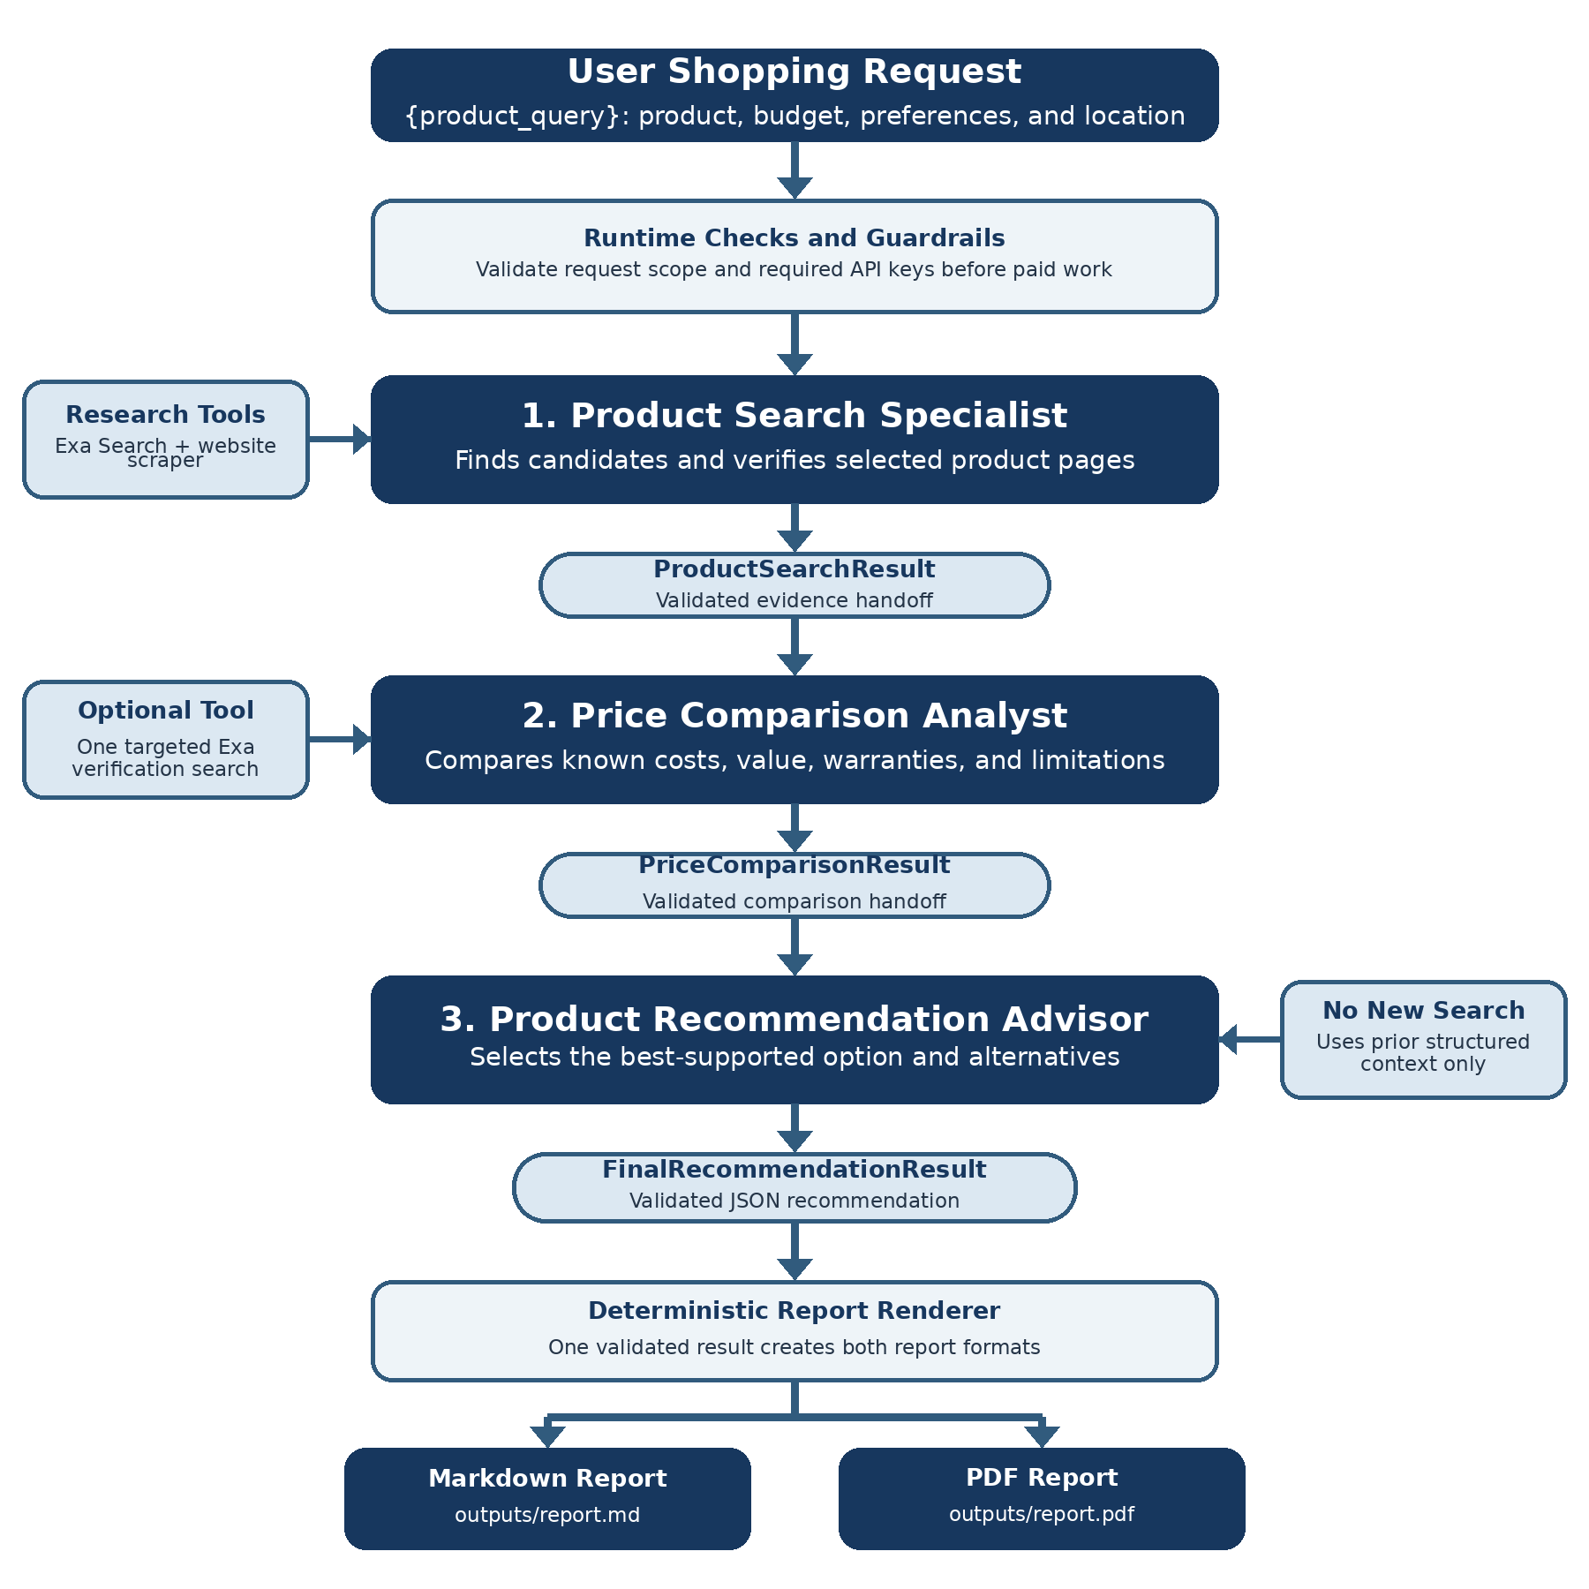
Figure 1. System architecture and structured data flow.

6.2 Key Design Decisions
- Specialized roles: each agent has one clear responsibility, making the workflow easier to understand, test, and explain.
- Sequential execution: comparison depends on research evidence, and recommendation depends on both earlier results.
- Structured handoffs: Pydantic contracts reduce missing fields and prevent free-form reports from becoming the next agent’s only input.
- Restricted tool access: the advisor cannot start a conflicting search, and the analyst uses search only for targeted verification.
- Deterministic reporting: Python creates Markdown and PDF from one validated result, avoiding an additional model call.

6.3 Structured Agent Handoffs
The contracts make the educational purpose of each stage visible. They validate field names and data types while keeping uncertain facts explicit.
Stage | Structured Contract | Information Passed Forward
Research | ProductSearchResult | Requirements, product evidence, source URLs, research issues, and shortfall
Comparison | PriceComparisonResult | Per-product costs, value analysis, price ranges, best-value deal, and limitations
Recommendation | FinalRecommendationResult | Selected option, alternatives, confidence, checklist, and numbered sources
Simplified handoff example
ProductSearchResult(products=[…]) → PriceComparisonResult(comparisons=[…]) → FinalRecommendationResult(recommendation=…, confidence=…)
OPERATION

7. User Input
The main input is passed through the `{product_query}` placeholder. A short request can work, but the recommendation becomes more useful when the user includes a budget, intended use, important features, and location.
Example input
Find the best gaming laptop under $1,000 for university work and gaming. It should have at least 16 GB of RAM and be available to a buyer in Cambodia.

8. Reliability Rules
Shopping information changes quickly, so the project treats verification as part of the workflow. The agents are instructed not to present unsupported details as confirmed facts, and every task must return data that matches its assigned Pydantic schema.
- Every recommendation should include direct source URLs.
- Prices, sellers, availability, warranty, delivery, and purchase links must come from accessible evidence.
- When a fact cannot be confirmed, the report uses the label “Could not verify.”
- The final advisor should not perform a second independent search that conflicts with earlier task context.
- The buyer is reminded to recheck price and stock before payment.
- Structured outputs reject unexpected fields, require HTTP(S) product URLs, use exact decimal values for money, and limit ProductSearchResult to five product records.
- The three task contracts are ProductSearchResult, PriceComparisonResult, and FinalRecommendationResult.
- Structural validation improves consistency but does not independently prove that every shopping claim is true; the buyer must still recheck time-sensitive facts.

9. Efficiency and Cost Control
Control | Configured instruction or limit
Focused product searches | At most two Exa searches (task instruction)
Verified product pages | At most five pages plus one replacement (task instruction)
Additional analyst search | At most one targeted search (task instruction)
Recommendation research | No search tools; uses prior structured results
Retries and iterations | Bounded in agent settings

10. Final Output
The final advisor produces a validated FinalRecommendationResult. A deterministic Python callback then renders the same structured data into `outputs/report.md` and `outputs/report.pdf`. Both formats contain the same recommendation and sources, and PDF generation does not require another agent or model call.
- Summary of the user’s requirements
- Recommended product and reason
- Verified price, seller, and product URL
- Top alternatives
- Advantages, limitations, and recommendation confidence
- Unverified information
- Safe-buying checklist
- Numbered source list
EVALUATION

11. Educational Evaluation
The offline test suite was run on 25 July 2026 using `python -m unittest discover -s tests -v`. All 27 tests passed without using Exa Search or DeepSeek credits. The tests demonstrate that the project is configured correctly and handles its structured outputs consistently.
Evaluation Area | Evidence Checked | Result
Crew configuration | Three agents, tools, models, task order, and context references | Passed
Runtime guardrails | Missing keys, prohibited requests, vague requests, and valid scoped requests | Passed
Structured data | Exact decimals, HTTP(S) URLs, extra-field rejection, and five-product limit | Passed
Crew loading | Schemas and final report callback resolve from the JSONC configuration | Passed
Report generation | Readable Markdown and PDF, source links, and invalid JSON rejection | Passed
Live factual accuracy | Prices, stock, seller claims, and delivery information can change online | Manual verification required
Evaluation interpretation
Passing tests shows that the software structure, validation, and report generation work as intended. It does not prove that every live shopping claim is permanently correct, so source links and the final buying checklist remain important.

12. Safe-Buying Guidance
The project supports the decision, but it does not complete a purchase automatically. Before paying, the user should complete the following checks:
- Open the original product page and confirm the current price.
- Check whether the exact model and configuration are still in stock.
- Review warranty, return, and refund conditions.
- Confirm the final shipping cost and delivery estimate.
- Check seller reputation and avoid untrusted payment channels.
- Use a secure payment method and keep the order confirmation.

13. Current Limitations
The system can reduce research time, but it cannot remove every uncertainty. Some websites block automated access, some sellers publish incomplete specifications, and shipping costs may only appear during checkout. Prices and stock can also change after the report is generated. Pydantic validates the structure of task outputs, not the truth of every claim.
How the project should be understood
This is a decision-support system, not an automatic purchasing system. It organizes evidence and explains trade-offs, while the final decision and payment remain with the user.

14. Future Improvements
Improvement | Purpose
Price history | Track price changes and identify whether a current discount is genuine.
Cambodian store coverage | Add more local sellers and delivery information.
Currency handling | Convert prices and show the exchange-rate date.
User interface | Provide a Streamlit dashboard with filters and comparison cards.
Saved preferences | Remember preferred brands, budgets, and previous searches.
Notifications | Alert users when a product reaches a chosen price.

15. Conclusion
The Smart Shopping & Price-Comparison AI Agent demonstrates how a multi-agent workflow can support a practical consumer task. The project separates product discovery, price analysis, and recommendation into three clear roles, which makes the process easier to understand and easier to improve.
With one user request, the system can research products, compare available evidence, identify value, and produce a purchasing recommendation with sources. Its most important design choice is how it handles uncertainty: the agents exchange structured results, unexpected data shapes are rejected, and missing details are marked instead of guessed. The user still performs the final verification before payment.

APPENDIX

Project Configuration Summary
Item | Configuration
Project name | Smart Shopping & Price-Comparison AI Agent
Execution model | Sequential multi-agent workflow
Agents | Product Search Specialist; Price Comparison Analyst; Product Recommendation Advisor
Primary input | {product_query}
Search tool | ExaSearchTool
Verification tool | ScrapeWebsiteTool
Language model | DeepSeek V4 Flash
Output files | outputs/report.md; outputs/report.pdf
Credential storage | .env
Structured outputs | ProductSearchResult; PriceComparisonResult; FinalRecommendationResult
Report renderer | tools.reporting.save_recommendation_report

Sample Request
Find the best smartphone under $500 available in Cambodia. Compare at least five options, show verified prices and sources, and explain which model offers the best overall value.

Suggested Run Command
cd ~/smart_shopping_price_comparison_agent
uv run crewai run

