Aleksandar Ivanov

EDUCATIONAL AR/VR SYSTEMS FOR MILITARY PROJECTS

Thesis plan

Information Technology



CONTENTS

1 Introduction 3

2 AUGMENTED REALITY AND VIRTUAL REALITY 3

2.1 Augmented reality 4

2.2 Virtual reality 4

Application in education 4

3 STRUCTURE and sources 5

Bibliography 6

# Introduction

Developments and improvements in computing technology have allowed for vastly improved immersion when consuming digital media. The most notable examples of such technologies are Augmented reality and Virtual reality. The immersion these technologies offer can be used to create educational systems that have more benefits than traditional digital educational systems.

In this thesis project I will be comparing the difference between AR(Augmented reality) and VR(Virtual reality) in the context of educational software. Different implementations and physical devices will be compared and analyzed. A device and a technology will be chosen to prototype an educational application for Observis Oy related to the company’s Situational Awareness System(SAS).

The SAS product has a steep learning curve which raises the need for a more efficient educational tool. The goal of the project is to pick the most suitable technologies and implement such a tool. Advantages and disadvantages of AR/VR need to be considered over more traditional digital educational tools.

# AUGMENTED REALITY AND VIRTUAL REALITY

Augmented reality and Virtual reality are technologies that offer a different view and experience to the physical world. They leverage similar kinds of technology and both aim to provide an enhanced and enriched experience to the user. However they have different goals and are essentially different in terms of user experience.

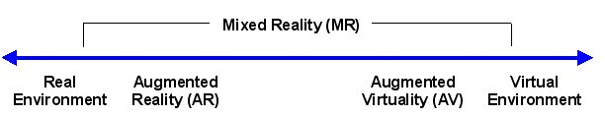

Figure 1. Milgram’s reality-virtuality continuum

## Augmented reality

Augmented reality

## Virtual reality

Virtual reality

## Application in education

Application

# STRUCTURE and sources

The thesis will be structured in four main parts. First is a comparison between the different virtuality-reality technologies available and deciding which is the most suitable one for this case. Second is examining the prerequisites for the implementation stage. Third stage is the actual implementation of the project. Last stage is the evaluation of the outcome, documentation and analyzing further possibilities.

# Bibliography