DS 0311-01 / Instructor: Norman Lo ( [lokman@mail.sfsu.edu](mailto:lokman@mail.sfsu.edu) ) / 07 October 2022

**DS 311 Group Assignment 1**

Tasks: Write a page of summary of the dataset includes 5 fun facts that your team found.  
The 1-page write up is not including your code or coding file.  
Push the coding file and summary report to the group project repository.

Fun facts about the dataset, option 2: “salary_data_states.xlsx”

After reading through the entire dataset once we realised that there were a lot of missing datapoints (“NaN”). We replaced those missing datapoints with “0”, “Unknown”, “Nothing” or “n” (Figure 1 replacing missing data).

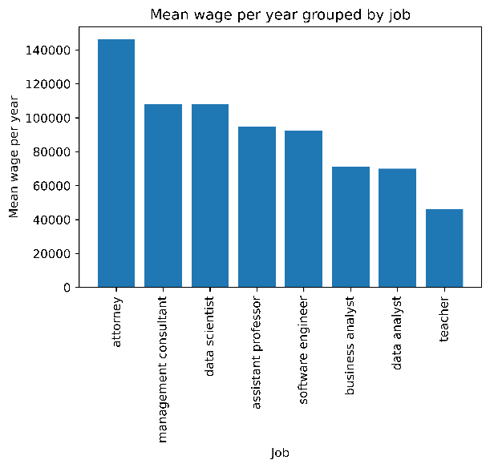Fact number 1:

Figure 1 Mean wage per year, grouped by job category

Sorting the mean wage per year by job subgroups, we can conclude that “attorney” related jobs make the most money, they make 140,000$ on average per year. The subgroup “teacher” is in last place and makes less than half of an attorney.

Fact number 2:

Ein Bild, das Text enthält.
Sorting the mean wage per year by states, we can conclude that employees in “West Virginia” make the most money, they make around 109,000$ per year. We displayed the top 5 states in (Fig2)

Figure 2 Mean wage per year, grouped by state.

Fact number 3:

The mean salary per year in San Francisco is around 123,850$

Ein Bild, das Text enthält.
Fact number 4:

Looking at who makes the most money per year as a single person, we can see that there are a few attorneys that make substantially more than the rest in the dataset. Number 1 to 5 are attorneys that each make over a million more than number 6.

Figure 3 Best paid people with job and city.

Fact number 5:

@Alleyda @Audrey you can put fun fact no. 5 here ✌️😋

Summary:

To summarize our initial look at the dataset, we can say that…(not finished yet)

**Code screenshots attachment:**

Ein Bild, das Text enthält.

Figure 4 replacing missing data

Ein Bild, das Text enthält.

Figure 5 Code for fact 1



Figure 6 Code for fact 2



Figure 7 Code for fact 3



Figure 8 Code for fact 4