Team tidy

DS 0311-01

Instructor: Norman Lo ( [lokman@mail.sfsu.edu](mailto:lokman@mail.sfsu.edu) )

13 November 2022

**DS 311 Group Assignment 2**

Question 1 (answered by Alleyda Barraza)

1. Do specific sub-types of data-related jobs have higher or lower salaries than others?
   * 1. Specific sub-types of data-related jobs do differ in salaries than others. When comparing a business analyst, data analyst, and software engineer, we can see that a Software engineer makes the most money of all 3. The average paid wage per year was referenced.
        1. software engineer 92505.30
        2. business analyst 71300.08
        3. data analyst 70030.08

* -  Which companies have the highest salaries for those sub-types?
  + The companies that have the highest salaries for software engineer are
    - KPI PARTNERS, INC. 1400000.00
    - ABACUS TECHNICAL SERVICES, LLC 1224800.60
    - INSIDE, INC. 1222788.00
    - ROVI CORPORATION 1176000.00
    - GOOGLE INC. 1139001.00
* -  Changes with location of the job?
  + Yes, annual salary is affected by the location of the job. When analyzing the location, we can see that the top 5 highest paying states for the respective job titles are
    - Software engineer
      * California
      * Washington
      * Virgin Islands
      * New York
      * Massachusetts
    - Business Analyst
      * Washington
      * New York
      * Wyoming
      * California
      * Puerto Rico
    - Data analyst
      * Connecticut
      * California
      * Delaware
      * New Hampshire
      * Maine
* -  Will the answer change if I take standard of living into account?
  + Yes, the Standard of living affects the amount of take home annual salary. I compared 10 states and cross all job titles, the standard of living significantly affected annual salary. In Hawaii’s case the cost of living per year was $146,437, but the wages for the three data subgroup jobs were significantly lower averaging at about $80,000 per year. Employees should consider location and annual living wage when interviewing or applying to a job within their respective fields.

Question 2 (answered by Pyimoe Than)

**Average Data Scientist salary in America**

Ein Bild, das Karte enthält.

**Average Data Analyst salary in America**

Ein Bild, das Karte enthält.

**Average Business Analyst salary in America**

Ein Bild, das Karte enthält.

**Out of all US states, I choose California, Washington, Hawaii, Wisconsin and New Mexico as my preferred state.**

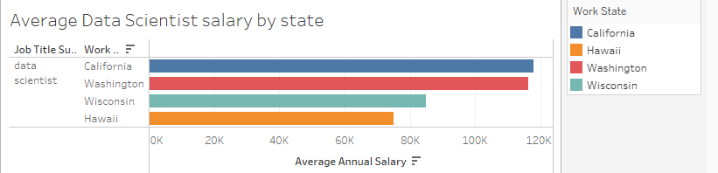

Note: Don’t have data for New Mexico for data scientists.

When we compare the salary of data scientists, California and Washington have the highest average salary. In contrast, Wisconsin and Hawaii have the lowest average salary when we compare them with California and Washington. Because of the six figure data scientist salary, many people want to move to live in California and Washington state. They want to become rich. However, we should not only look at the salary. We also need to determine the cost of living and taxes. According to *businessinsider.com*, the living wage in California is $99,971 and the living wage in Wisconsin is $67,667. According to *gobankingrates.com*, the real value of $100 in Wisconsin is $108.10 and the real value of $100 in California is $83.60. Therefore, the dollar value changes depending on where you live. When we add a cost of living in our calculation, average data scientists in Wisconsin get paid more than the average data scientists in California.

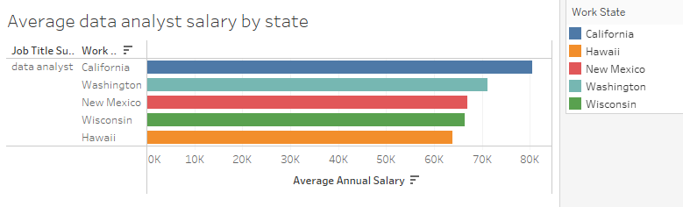

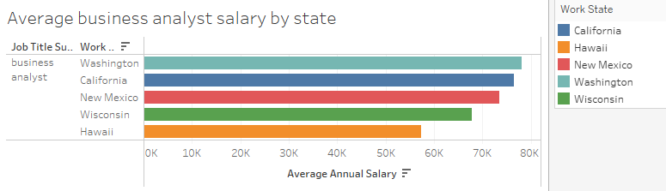

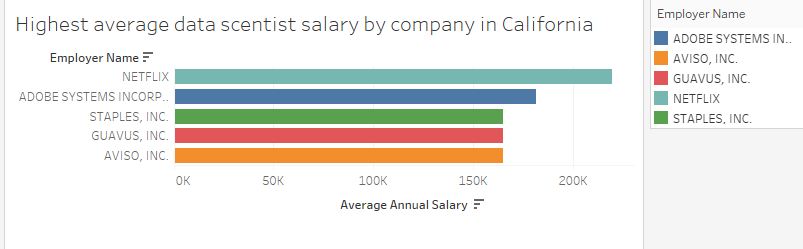

NETFLIX has the highest average data scientist salary in California.

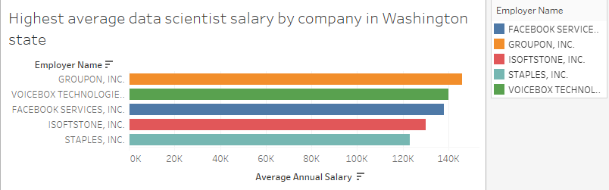

GROUPON, INC has the highest average data scientist salary in Washington state.

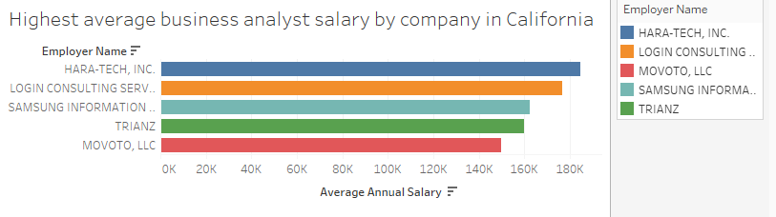

Hara-tech, inc has the highest average business analyst salary in California.

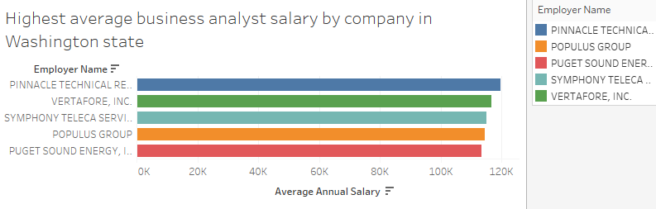

Pinnacle Technical has the highest average business analyst salary in Washington state.

Question 3 (answered by Paul Hartung)

Question 4&5 (answered by Maximilian Leitschuh)

Question 6 (answered by Audrey De Leon)