# Results additional questions – Maximilian Leitschuh

1. Does more required work experience increase the likelihood of a higher salary?
   1. What are the differences between the length of required work experience in relation to average salary?

The figure shows that the higher the prior work experience in months, the higher the average annual salary. This trend breaks down at an assumed work experience of 140 months, but this is probably due to too few values within the data set.

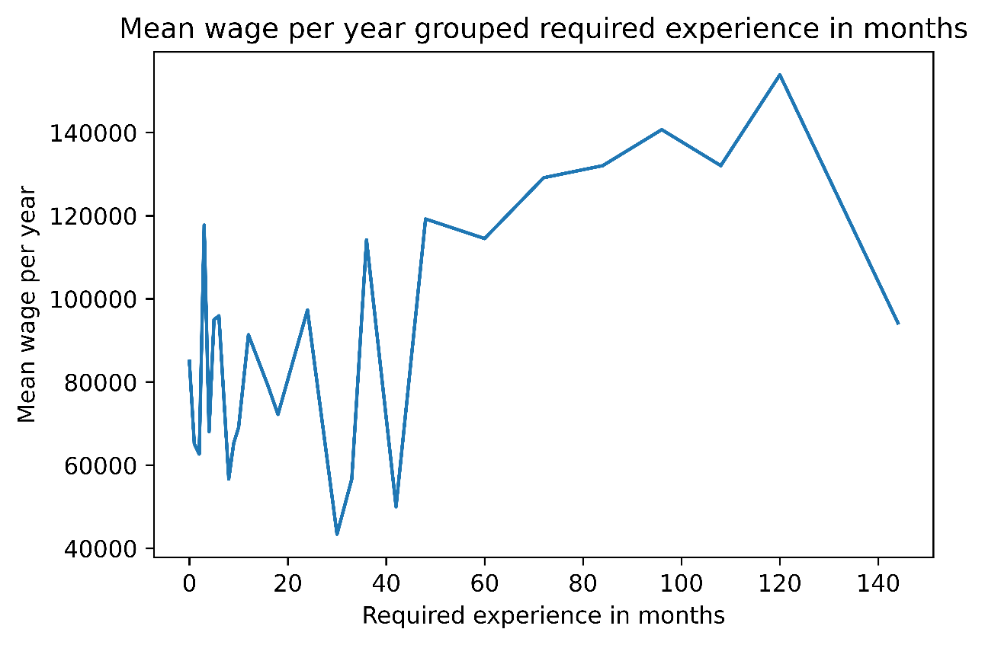

* 1. Do you earn more at a company that requires work experience?

As shown in the figure, the average salary at companies that require work experience is just over $100 thousand. Thus, at companies that require work experience, one earns on average about 20 thousand dollars more per year.

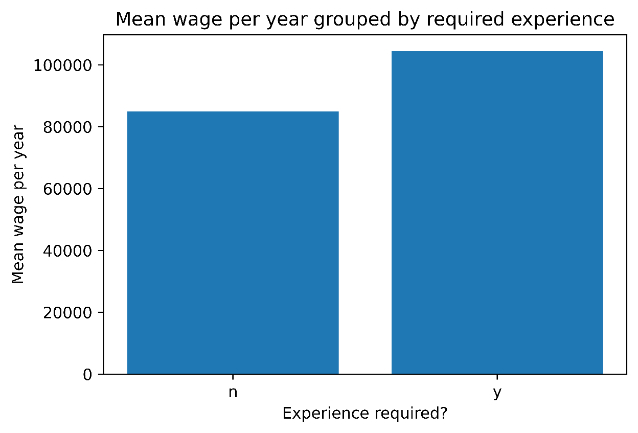

* 1. What is the rate of companies in the tech industry that require work experience and what is the mean salary?
     1. 3.95% in the tech industry require work experience

3.95 percent of tech companies within this data set require work experience. This is not a lot and shows that without work experience, finding a job is not a problem. However, it can be seen the figure that tech companies that require work experience pay significantly better. For example, the difference for a data analyst is about $30 thousand per year on average.

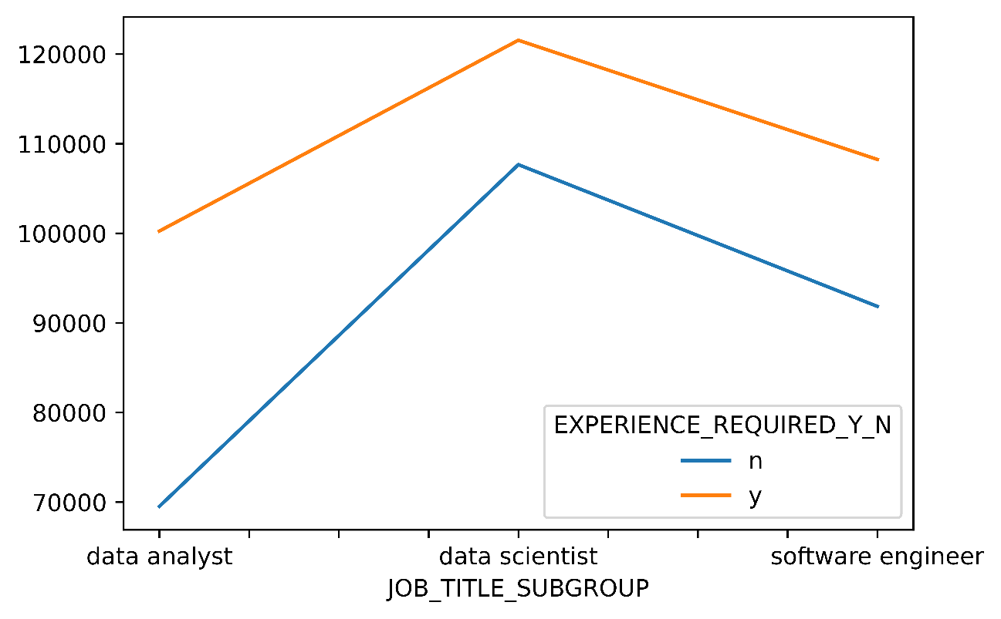

**Conclusion:**

All in all, required work experience increases the likelihood of a higher salary but it is not often necessary, so that, for example, during the study is not mandatory to gain work experience.

1. Does better required education increase the likelihood of a higher salary?
   1. What are the differences between different levels of education in terms of average salary?

The highest average salary within this dataset is achieved by individuals with the educational level "Other". This is just under 140 thousand dollars and is not specified in more detail. Furthermore, it can be deduced from the figure that people with a bachelor's and master's degree earn the most with an average of just under 100 thousand dollars. High school graduates are somewhat behind at just under 60 thousand dollars.

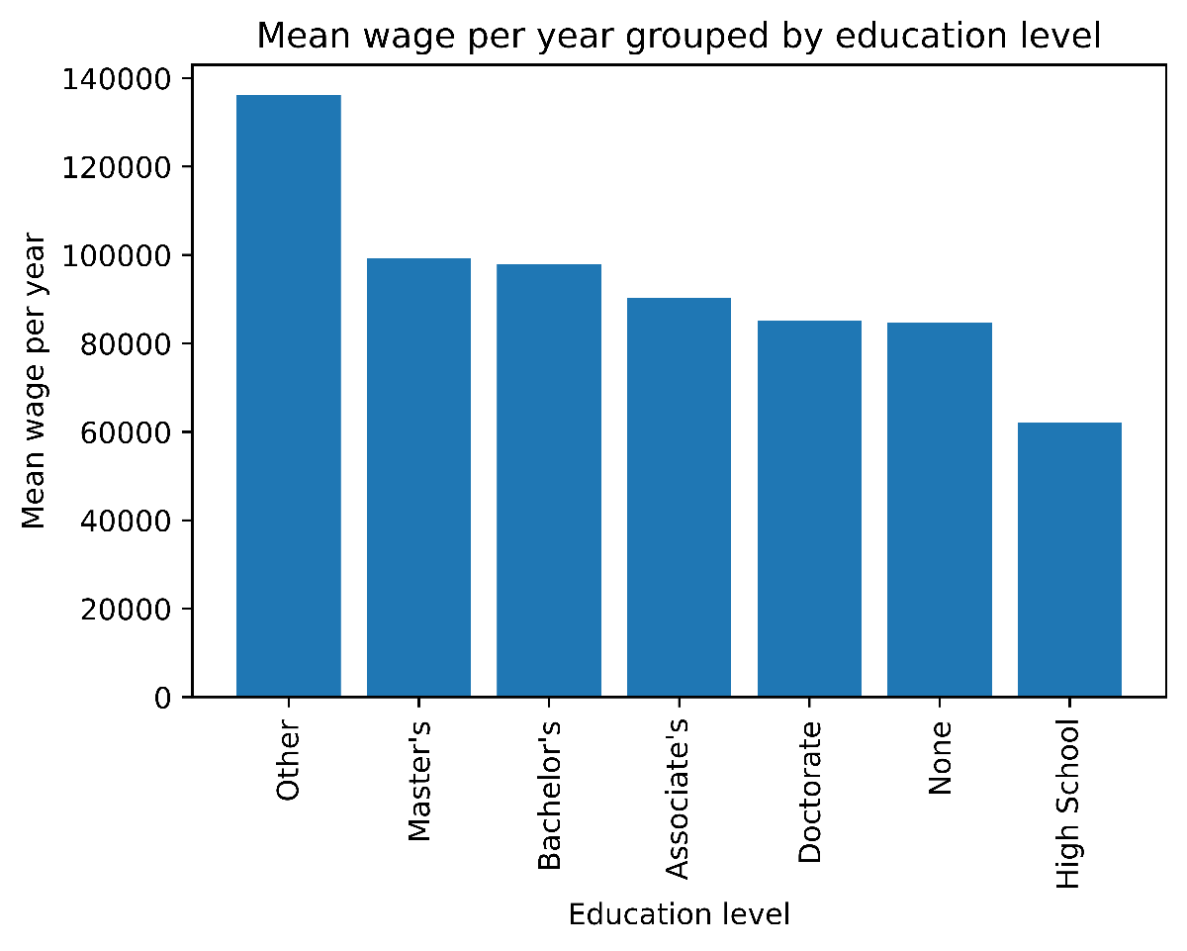

* 1. Do you earn more at a company that requires a college degree?
     1. 6.61% require a college degree

Only 6.61 percent of the companies in this data set require a college major. This is not much. In fact, the average salary with and without a college major differs by only about $15 thousand a year.

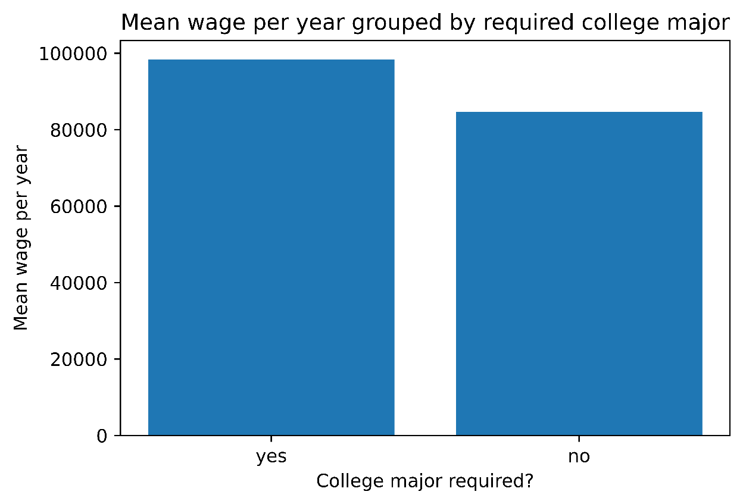

* 1. What is the rate of companies in the tech industry that require a college major and what is the average wage?
     1. 7.70% of the companies in the tech industry require a college major

Even in tech companies, only 7.7 percent require a college major. Again, the range in annual salary between one and no college is around $15 thousand.

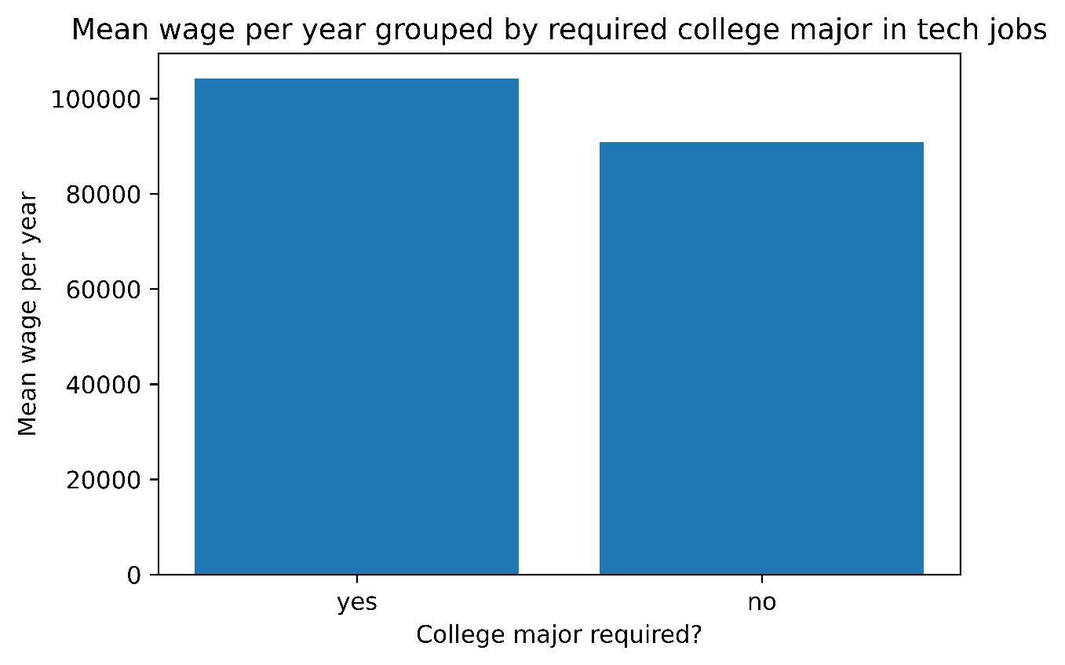

**Conclusion:** With a college major or a good education, one earns more on average than with a poor or no education. However, the margins are not as high as for work experience. This suggests that work experience is more important to companies today than the highest possible degree. Of course, this is not always the case, and education is and always will be an important factor for a successful professional life.

**Code:**

**Question 4.1:**

df1 = pd.DataFrame(df.groupby(['EXPERIENCE_REQUIRED_NUM_MONTHS'])['PAID_WAGE_PER_YEAR'].mean()).reset_index()  
plt.plot('EXPERIENCE_REQUIRED_NUM_MONTHS', 'PAID_WAGE_PER_YEAR', data=df1)  
plt.title('Mean wage per year grouped required experience in months')  
plt.xlabel('Required experience in months')  
plt.ylabel('Mean wage per year')  
  
plt.savefig('1_wage_experience.png', bbox_inches='tight', dpi=1200)

**Question 4.2:**

df2 = pd.DataFrame(df.groupby(['EXPERIENCE_REQUIRED_Y_N'])['PAID_WAGE_PER_YEAR'].mean()).reset_index()  
plt.bar(x='EXPERIENCE_REQUIRED_Y_N', height='PAID_WAGE_PER_YEAR', data=df2)  
plt.title('Mean wage per year grouped by required experience')  
plt.xlabel('Experience required?')  
plt.ylabel('Mean wage per year')  
  
plt.savefig('2_wage_experience_required.png', bbox_inches='tight', dpi=1200)

**Question 4.3:**

# create dataframe with only jobs from the tech industry  
only_tech= df.drop(df[(df.JOB_TITLE_SUBGROUP == 'attorney') | (df.JOB_TITLE_SUBGROUP == 'management consultant') | (df.JOB_TITLE_SUBGROUP == 'assistant professor') | (df.JOB_TITLE_SUBGROUP == 'business analyst') | (df.JOB_TITLE_SUBGROUP == 'teacher')].index)  
# rate of the companies in the tech industry that require work experience  
only_tech.pivot_table(values="PAID_WAGE_PER_YEAR",index="JOB_TITLE_SUBGROUP",columns="EXPERIENCE_REQUIRED_Y_N").plot()  
print(len(only_tech[only_tech['EXPERIENCE_REQUIRED_Y_N']=='y'])/len(only_tech['EXPERIENCE_REQUIRED_Y_N'])*100)  
  
plt.savefig('3_wage_experience_tech.png', bbox_inches='tight', dpi=1200)

**Question 5.1:**

df4 = pd.DataFrame(df.groupby(['EDUCATION_LEVEL_REQUIRED'])['PAID_WAGE_PER_YEAR'].mean()).reset_index()  
df4 = df4.sort_values('PAID_WAGE_PER_YEAR',ascending=False)  
plt.bar(x='EDUCATION_LEVEL_REQUIRED', height='PAID_WAGE_PER_YEAR', data=df4)  
plt.xticks(rotation=90)  
plt.title('Mean wage per year grouped by education level')  
plt.xlabel('Education level')  
plt.ylabel('Mean wage per year')  
  
plt.savefig('4_wage_education.png', bbox_inches='tight', dpi=1200)

**Question 5.2:**

print((len(df[df['COLLEGE_MAJOR_REQUIRED']!='Nothing'])/len(df['COLLEGE_MAJOR_REQUIRED'])*100))  
required=df[df['COLLEGE_MAJOR_REQUIRED']!='Nothing']  
not_required=df[df['COLLEGE_MAJOR_REQUIRED']=='Nothing']  
  
data = {  
 "COLLEGE_MAJOR_REQUIRED": ["yes", "no"],  
 "PAID_WAGE_PER_YEAR": [round(required.PAID_WAGE_PER_YEAR.mean(),2), round(not_required.PAID_WAGE_PER_YEAR.mean(),2)]  
}  
  
df5 = pd.DataFrame(data)  
  
plt.bar(x='COLLEGE_MAJOR_REQUIRED', height='PAID_WAGE_PER_YEAR', data=df5)  
plt.title('Mean wage per year grouped by required college major')  
plt.xlabel('College major required?')  
plt.ylabel('Mean wage per year')  
  
plt.savefig('5_wage_college.png', bbox_inches='tight', dpi=1200)

**Question 5.3:**

print((len(only_tech[only_tech['COLLEGE_MAJOR_REQUIRED']!='Nothing'])/len(only_tech['COLLEGE_MAJOR_REQUIRED'])*100))  
required=only_tech[only_tech['COLLEGE_MAJOR_REQUIRED']!='Nothing']  
not_required=only_tech[only_tech['COLLEGE_MAJOR_REQUIRED']=='Nothing']  
  
data2 = {  
 "COLLEGE_MAJOR_REQUIRED": ["yes", "no"],  
 "PAID_WAGE_PER_YEAR": [round(required.PAID_WAGE_PER_YEAR.mean(),2), round(not_required.PAID_WAGE_PER_YEAR.mean(),2)]  
}  
  
df6 = pd.DataFrame(data2)  
  
plt.bar(x='COLLEGE_MAJOR_REQUIRED', height='PAID_WAGE_PER_YEAR', data=df6)  
plt.title('Mean wage per year grouped by required college major in tech jobs')  
plt.xlabel('College major required?')  
plt.ylabel('Mean wage per year')  
  
plt.savefig('6_wage_college_tech.png', bbox_inches='tight', dpi=1200)