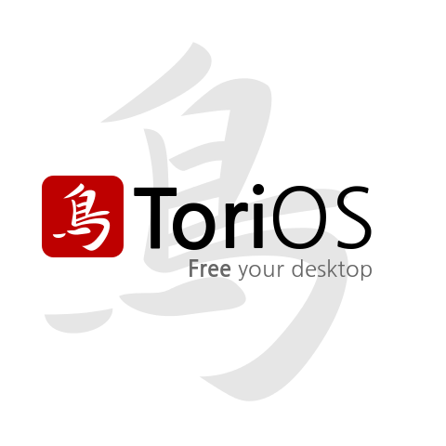

Tori Operating System Overview
- Low memory and resource requirements
- Low disk space
- Low package overheads (you get to build your own system from a very minimal install base)
- Built with Ubuntu 12.04LTS as a base , and completely compatible with many thousands of free and paid apps.
- A modern OS with up-to-date security built-in, as well as compatible with older processors and video graphics cards.
- Free and open source
- A secure replacement for older unsupported versions of Microsoft Windows Operating System


/ToriOS.Linux


/Tori_OS

http://torios.org/

