Team 5

* Member #1: Muthanuni ME 218002694
* Member #2: T Qondelani 220149140
* Member #3:
* Member #4:

**Input and Output**

**Inputs**

numCountries

For subject

SubjectName

For Person

PersonName, PersonGender, PersonAge, CountryOfResidence, and subject

For Educator

Remunaration, Duration, Staffid and WorkHoursDay

For Subject

IsAttending, HasPassed, StudentID, TransportNeeded, and distance from School

For School:

SchoolName, NumberOfChildren, WeecklyFoods, People

For Country:

numberOfSchools, CountryName, Schools.

**Output**

* Remuneration
* Trip fare
* Pass rate
* Fail rate
* Male dropout rate
* Female dropout rate
* Literacy rate
* Display of input data

**Interface**

**Events and Action**

**Variables**

**Pseudocode**

**UML**

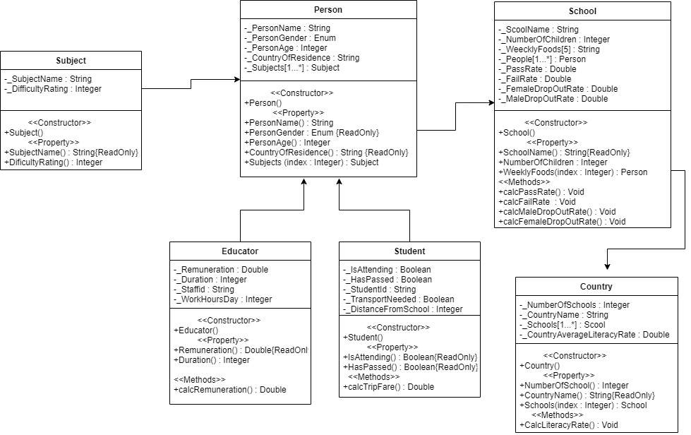

**Test data**

|  |  |
| --- | --- |
| Educator class | |
| Persons Name | Jackie |
| Persons Gender | Female |
| Persons Age | 30 |
| Country of Residence | South Africa |
| Remuneration | 20.4 |
| Duration | 6 |
| Staff ID | 175 678 456 |
| Work Hours Day | 7 |
| Calc Remuneration |  |

|  |  |
| --- | --- |
| Student class | |
| Persons Name | Roman |
| Persons Gender | male |
| Persons Age | 20 |
| Country of Residence | South Africa |
| Is attending | yes |
| Has Passed | yes |
| Student ID | 21 111 7467 |
| Transport Needed | No |
| Distance from school | 4 |
| Amount for transport | R9 |
| Trip Fare | R36 |

|  |  |
| --- | --- |
| Subject Class | |
| Subject Name | Mathematics |
| Difficulty Rating | 95 |

|  |  |
| --- | --- |
| School Class | |
| School Name | Auckland Park Secondary School |
| Number of Children | 1040 |
| Weekly food | 6050 |
| Pass Rate | 50% |
| Fail Rate | 40% |
| Female Dropout rate | 12.9% |
| Male dropout rate | 20.8% |

|  |  |
| --- | --- |
| Country | |
| Number Of schools | 23 000 |
| Country Name | South Africa |
| Country Average Literacy Rate | 87% |
| Literacy rate |  |