Records

Series. 1.

BERT-LINEAR-SOFTMAX

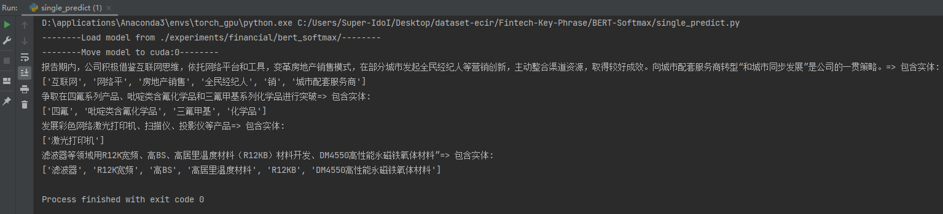

RoBERTa-LINEAR-SOFTMAX

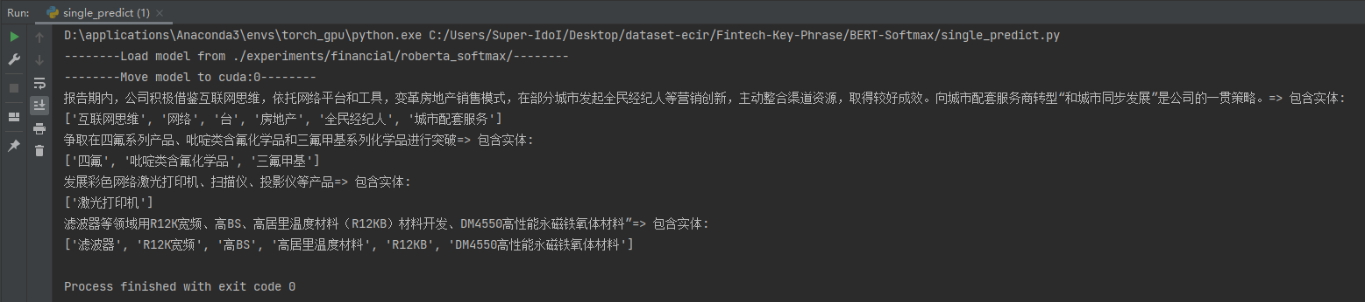

Series. 2.

BERT_CRF

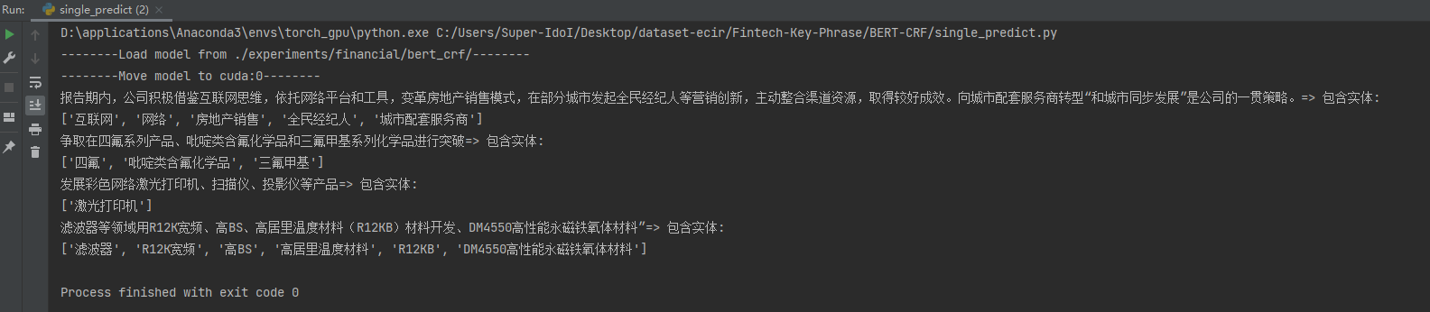

RoBERTa_CRF

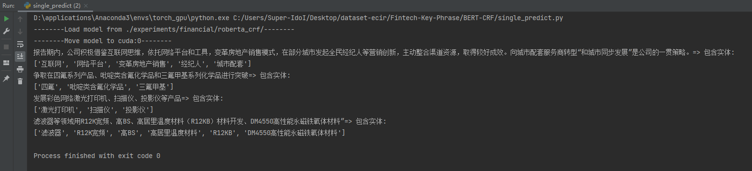

Series. 3.

BERT_LSTM_CRF

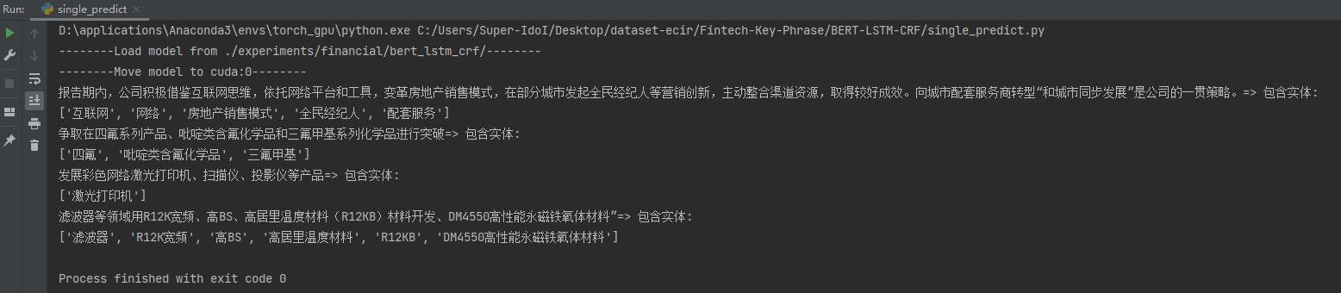

RoBERTa_LSTM_CRF

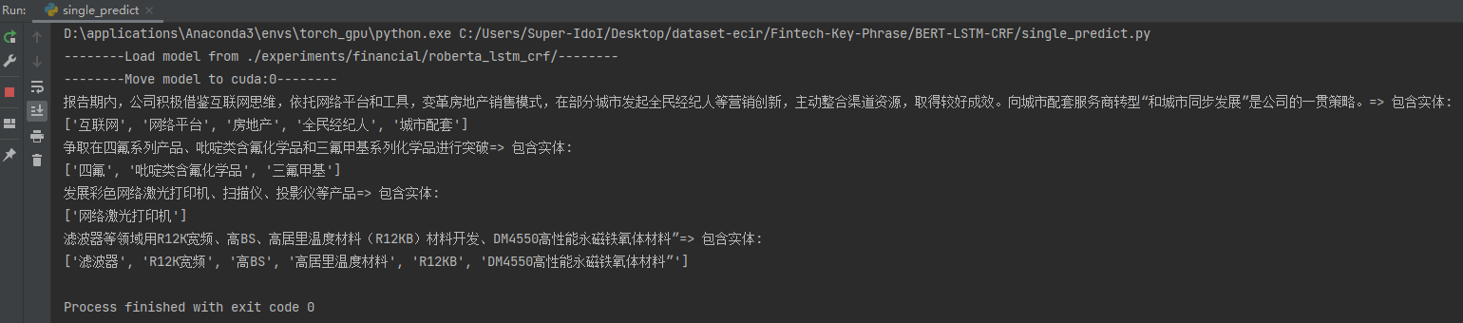

URL: <https://31863ew564.zicp.fun/information_retrieval>

Request Method: POST

BODY: (includes two parameters)

Sent:

the sentence from which you need to extract information.

model_type:

select from [bert_linear, roberta_linear, bert_crf,roberta_crf, bert_lstm_crf, roberta_lstm_crf]

Return Format:

