**Contents**

MOTIVATION 2

DESCRIPTION 2

EXISTING SOLUTION 2

PLANNING 3

Figure-1: Table of planning. 4

FUNCTIONAL AND NON_FUNCTIONAL REQUIREMENTS 5

STAKEHOLDER 6

USER STORY 6

DIAGRAMS 7

USE CASE DIAGRAM 7

Figure2:Use case diagram of House rent service 8

Figure2.1:Registration 8

Figure2.2:Post Advertisement 9

Figure2.3:Search Ads 10

ACTIVITY DIAGRAM 11

Figure-3: Activity diagram

CLASS DIAGRAM 11

Figure.4: Class Diagram 12

LIMITATION……………………………………………………………………………………………………………………………………………………….12

FUTURE SCOPE 13

REFERENCE 13

# **MOTIVATION**

“Home sweet home” is a proverb going on. But in today’s life finding a comfort home is a big challenge for us. We, the people of Dhaka city are facing a lot of problem with it. Sometimes we find a home but location is not appropriate. Sometimes house rent goes beyond our range. Moreover, the bachelor people are hardly to find a home for them, the owner of the home can be rude sometimes. Apart from this the utility services can be found very poor in some case. We think about to solve all of these problems through our project. Our project is about the solution of house rent problem. There is already some website to help to find a home in Bangladesh. The Bproperty, Rental Home Bd, Thetolet.com are some of them. But they are not as much as user friendly. The Mayfair is a website where only a holiday home offered by owner. All these websites do not help all the people who want to rent a home. So, we will try to create a user-friendly website or application which can solve the problem of all categories people and also save the time.

# **DESCRIPTION**

In our project we will try to keep some features that can help the user to find a perfect and comfortable home for them. We will keep a form that should be fill up by the owner of the house. The owners should give a detail information of his/her house.

The user can search according to location or area through the google map and can get the result how many homes are in one location. He or she can also find out the house if he/she is bachelor. We keep different categories such as family, female bachelor or male bachelor.

The user can acknowledge the rent information, facility bill information along with utility bills. Flat details can be provided with pictures or video. The user can get information about the owner through comments or review systems. The owner can also have the information about the tenant.

# 

# **EXISTING SOLUTION**

With the current system recording the details of various activities of user is completely manual and entails a lot of paper work. Each house has a file that contains the house number, size, rent per month, expected deposit, occupant and status. The transactions are not secure as papers may get lost or damaged. Hence, there is need of reformation of the system with more advantages and flexibility. The system eliminates most of the limitations of the existing system.

There are so many systems which provide software based on rental system. Rent payment system contains tenants first name, last name, phone number, date of payment, amount, balance and location. But in most of the system there is no comment section or review section from where tenant can get information about that particular house such as water service, security service, behavior of the owner and so on.**[4]**So, we will include that review section in our project as a special feature of existing solution.

Moreover, the existing system only provides text-based interface which is not as user friendly as Graphical user interface. So, we will also add google map and YouTube facilities which will be more beneficial for the user.

Example of some existing solution:

Bproperty- This website has many advertisements of houses for rent with pictures. They have implemented that website with some limited pictures and information.**[1]** Moreover, they do not provide any special feature such as comment or review section. **[2]**

Rental Home Bd- This is another website for rental system. They also have implemented common features of rent system such as number of rooms, amount, location, facilities etc. But there is no assurance of there facilities or service. That is our target point to update the system. **[3]**

Thetolet.com- This website also does not provide adequate information. All the features are almost same in every website. Further sometimes the picture quality of the given system may be bad or confusing. To provide a better solution of this problem we will add YouTube feature. There will be a video clip from where people will get a clear concept of that area, flat view. There is no chance of confusion. So, it will be a different approach of this existing solution. **[5]**

# **PLANNING**

As we want to develop the system with Microsoft’s ASP.NET Core 2.0 (MVC), here is the development plan for our project. Where we will try to work with goggle’s different APIs as well.

|  |  |  |
| --- | --- | --- |
| Weeks | Working Flow | Show Time (Lab Date) |
| 1st | Feature Designs | 10th June |
| 2nd | Database Design | 17th June |
| 3rd | Starting Works With ASP.NET Framework | 24th June |
| 4th | Login System | 1st July |
| 5th | Feature Implementation - I | 15th July |
| 6th | Feature Implementation - II | 22th July |
| 7th | Working with API | 29th July |
|  |  |  |

### Figure-1: Table of planning.

# **FUNCTIONAL AND NON-FUNCTIONAL REQUIREMENTS**

**FUNCTIONAL REQUIREMENTS**

* A user shall be able to post one or more than one advertisements of his or her house for rent.
* A user can search the advertisements according to the given categories such as date, area, rent range, flat size etc.
* Each user using the system shall be uniquely identified by his or her user name.
* User can access to the system by user name and password.
* User can delete or make any change to its own advertises and comments or reviews.
* Admin has the right to delete or change of all advertises.

**NON-FUNCTIONAL REQUIREMENTS**

* Huge number of advertisements can be stored into the system.
* The system can be used by many users simultaneously.
* The house rent service system is quite easy to use.
* This system is reliable and rate of failure occurrence is less.
* The system is secured to use and the information is only saved for user.

# 

# **STAKEHOLDER**

Stakeholder is any person or organization who is affected by the system in some way and so who has legitimate interest.

Stakeholder types:

* End user
* System manager
* System owner
* External stakeholder

In this project stakeholders are house owners, tenant, users, admin, system developer. They are directly or indirectly related to this project.

Stakeholders in the House Rent Service

* House owners post the advertisements and can delete his post when they want .
* Tenants can search the advertisements according to the given catagories.
* Users can be both house owners or tenants and also comment on the post.
* Admin can maintain the system service and he can see and delete the post what he wants.
* System developer develops and maintains and adds features as per needed.

# **IMPLEMENTATION DETAILS**

# **IMPLEMENTATION TOOL**

For implementing our project, we use some different programming languages and technology, such as:

1. html
2. CSS
3. Bootstrap
4. C#
5. Javascript
6. .Net
7. MVc

We developed our project in Visual Studio 2017.

# **IMPLEMENTATION**

Our software has two interfaces, one is for the users, users are also two types house owner and tenants and another is for the admins. Admin panel have the following options-

* Admin is the owner of the website and has the right to control of all software.
* Admin is able to add and delete advertises.
* Admin can view the list of advertisements and edit details. But he has no right to change the house rent and other fees.
* Admin can authenticate new user subscription.
* Admin can check the comments and review.

The User panel have the following options-.

* They can search for their desired home on the search panel.
* They can search through different categories and can find the exact location of the house in google map.
* They can create one or more advertisements and can also edit their posts.
* They can contact officials of the website for any problem they are facing, through the complaint section.
* Users are also able to give their opinion through comments and reviews.

# **USER STORY**

First of all, to record the information of users create user account and input the necessaries such as name, email, address, contact number, user name, password, image(avatar) . Then you can log into your account by giving input email id and password. In case of wrong id or password you will get a warning to give the correct id and password.

Select either ‘Advertises’, ‘Post Advertise’ or ‘My Posts’.

If you select ‘Advertises’, then you can see given advertisements of different people. If you wish to hire a house then you can watch the advertisement in detail by log in your email id and password. You can search house according to different categories, rent fare range, locations.

If you select ‘Post Advertise’, you can see a form page. In this form page, you can add new advertisement. Here you need to input flat description such as house location, flat size, bill, utilities bill, flat image, YouTube video links etc. are included in this place. These advertisement pages can be created or edited or deleted by you.

If you select ‘My post’, then you can see all the post and advertises that are created by you. You can create or edit or delete any of your post. Your posts are added to advertises and all the users can watch your post.

There is another feature named comment. In this section anyone who has an account can comment on any post or advertisement. Below every advertisement there is comment section. You can comment on it. After writing a comment select ‘Submit’ button.

Here, if you want to make a video of the rooms and create a youtube link, then you can post it to your advertisement. When the other user visited to your advertisement, they can watch this video.

Apart from, google map is used for identifying house location perfectly so that the tenants can easily reach house and find their dreamed house.

You can give feedback or review through the ‘Rating’ system on any particular post.

# **DIAGRAMS**

# **USE CASE DIAGRAM:**

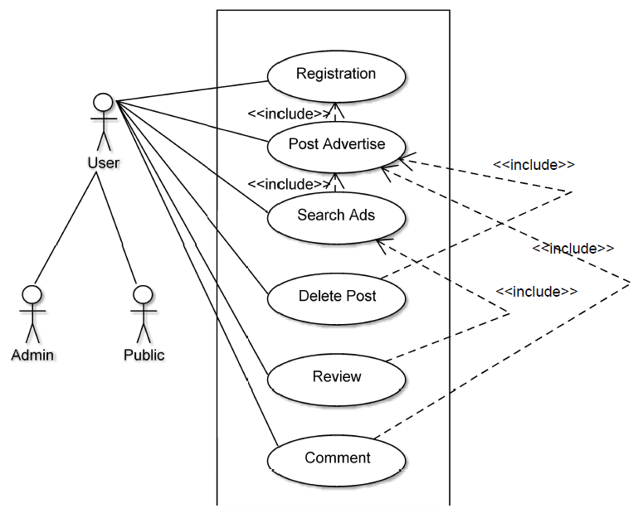

Figure.2: Use case diagram for House rent service.

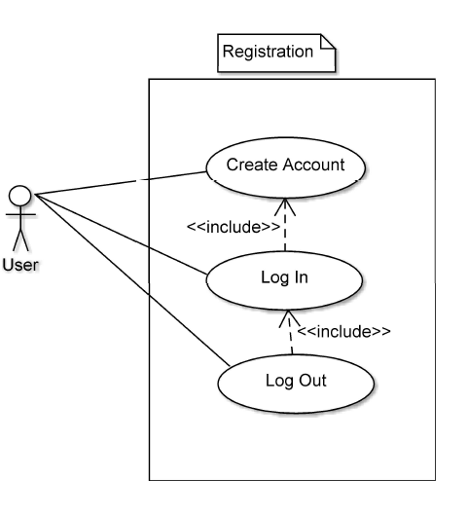

Figure.2.1: Registration

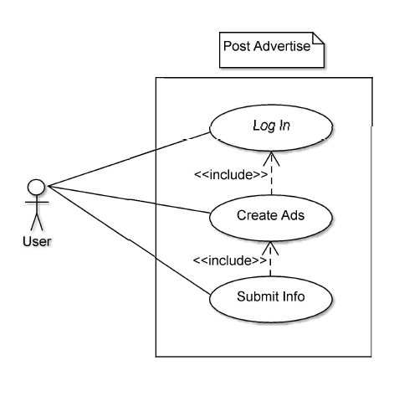

Figure.2.2: Post Advertise

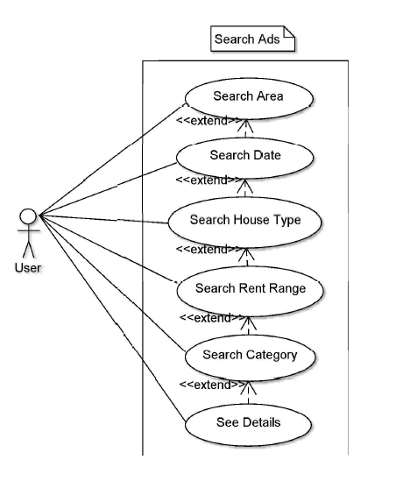

Figure.2.3: Search Area

**ACTIVITY DIAGRAM**

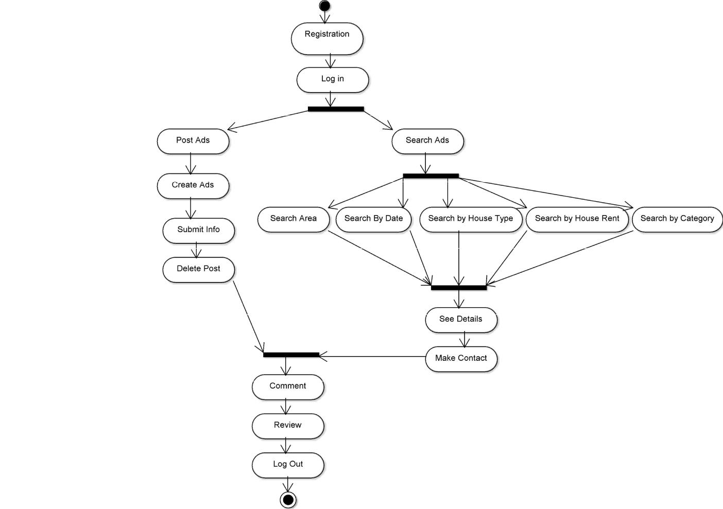

## 

Figure.3: Activity Diagram

# **Class Diagram**

# 

# **Figure.4: Class Diagram**

# **LIMITATION**

There are some limitations of our project:

* **Ui design is not that much attractive.**
* **Admin has not much functionality except some basic activities like admin can observe all the advertisements and he can also delete the posts as he wants.**
* **Comments can be deleted once these are written but cannot be edited.**

# 

# **FUTURE SCOPE**

Future scope of our project is given below:

* **We want to turn this project into Android application format.**
* **For betterment of this project we use machine learning algorithms and techniques.**
* **We also want to create a business plan by this project.**

# **REFERENCE**

**1. https://www.bproperty.com/**

**2.** [**https://www.bproperty.com/en/dhaka/apartments-for-rent/**](https://www.bproperty.com/en/dhaka/apartments-for-rent/)

**3.** [**https://www.rentalhomebd.com/**](https://www.rentalhomebd.com/)

**4.** [**http://to-let.com.bd/advertisement_details.php?to-let_for=149**](http://to-let.com.bd/advertisement_details.php?to-let_for=149)

**5.** [**https://www.thetolet.com/dhaka/mohammadpur/1085/lalmatia-block--d**](https://www.thetolet.com/dhaka/mohammadpur/1085/lalmatia-block--d)