实验项目编号 | 1505B000107 | 实验项目名称 |  | 链式存储结构
实验学时 | 4 | 实验日期 | 12.10/12.14 |  | 成绩
实验地点 | 计算机应用技术实验室 |  |  | 指导老师 |  | 厉丹
一、实验内容提要:
1. 掌握链表结点定义的存储结构；
2. 掌握使用指针访问数组元素。
二、实验要求:
1．建立链表，并在链表上实现插入、删除和查找操作；
2．查找并计算已知一个链表中数据域值为一个指定值范围（如成绩是良好等）的结点个数。
3．建立另外一个同结构的链表，将2个链表分别排序，并合并2个同结构链表为一个有序链表并显示数据。
三、实验步骤：
/*****************
*班级：16计转本
*姓名：陈贺
*学号：20160566140
*C语言实验七1
*****************/
#include <stdio.h>
#include <stdlib.h>
#define LEN sizeof(struct Student)
struct Student
{
long num;
char name[20];
char sex;
int age;
long score;
struct Student *next;
};
struct Student *find( struct Student *head, long num )
{
struct Student *p1;
p1 = head;
if ( head == NULL )
{
printf( "\n list null\n" );
return(head);
}
while ( num != p1->num && p1->next != NULL )

p1 = p1->next;
if ( num == p1->num )
return(p1);
}

struct Student *creat( struct Student *p, int x )
{
int n = 0;
struct Student *p1, *p2, *head;
p1 = p2 = (struct Student *) malloc( LEN );
head = NULL;
p1 = p;
while ( n < x )
{
n = n + 1;
if ( n == 1 )
head = p1;
else
p2->next = p1;
p2 = p1;
p1 = (struct Student *) malloc( LEN );
p1 = p + n;
}
p2->next = NULL;
return(head);
}

void print( struct Student *head )
{
struct Student *p;
printf( "\nNow,These records are:\n" );
p = head;
if ( head != NULL )
do
{
printf( "%ld %s %c %d %ld\n", p->num, p->name, p->sex, p->age, p->score );
p = p->next;
}
while ( p != NULL );
}

struct Student *insert( struct Student *head, struct Student *stud )
{
struct Student *p0, *p1, *p2;
p1 = head;
p0 = stud;
if ( head == NULL )
{
head = p0;
p0->next = NULL;
}else { while ( (p0->num > p1->num) && (p1->next != NULL) )
{
p2 = p1;
p1 = p1->next;
}
if ( p0->num <= p1->num )
{
if ( head = p1 )
head = p0;
else
p2->next = p0;
p0->next = p1;
}else { p1->next = p0;
p0->next = NULL; } }
return(head);
}

struct Student *del( struct Student *head, long num )
{
struct Student *p1, *p2;
p1 = head;
if ( head == NULL )
{
printf( "\n list null\n" );
return(head);
}
while ( num != p1->num && p1->next != NULL )
{
p2 = p1;
p1 = p1->next;
}
if ( num == p1->num )
{
if ( head == p1 )
head = p1->next;
else
p2->next = p1->next;
printf( "delete:%d\n", num );
}else
printf( "%ld not been found", num );
return(head);
}

int main( void )
{
struct Student stu[3];
int i;
printf( "enter the data:\n" );
for ( i = 0; i < 3; i++ )
scanf( "%ld %s %c %d %ld", &stu[i].num, &stu[i].name, &stu[i].sex, &stu[i].age, &stu[i].score );
struct Student *head;
head = creat( stu, 3 );
print( head );
printf( "输入要查找的学号:\n" );
long x;
scanf( "%ld", &x );
while ( x != 0 )
{
head = find( head, x );
printf( "%ld %s %c %d %ld\n", head->num, head->name, head->sex, head->age, head->score );
printf( "输入要查找的学号:\n" );
scanf( "%ld", &x );
}
head = creat( stu, 3 );
printf( "输入要删除的学号:\n" );
long nu;
scanf( "%ld", &nu );
while ( nu != 0 )
{
head = del( head, nu );
print( head );
printf( "输入要删除的学号:\n" );
scanf( "%ld", &nu );
}
printf( "输入插入的数据:\n" );
struct Student *stude;
stude = (struct Student *) malloc( LEN );
scanf( "%ld %s %c %d %ld", &stude->num, &stude->name, &stude->sex, &stude->age, &stude->score );
while ( stude->num != 0 )
{
head = insert( head, stude );
print( head );
printf( "输入插入的数据:\n" );
stude = (struct Student *) malloc( LEN );
scanf( "%ld %s %c %d %ld", &stude->num, &stude->name, &stude->sex, &stude->age, &stude->score );
}
return(0);
}

/*****************
*班级：16计转本
*姓名：陈贺
*学号：20160566140
*C语言实验七2
*****************/
#include <stdio.h>
#include <stdlib.h>
#define LEN sizeof(struct Student)
struct Student
{
long num;
char name[20];
char sex;
int age;
long score;
struct Student *next;
};

struct Student *creat( struct Student *p, int x )
{
int n = 0;
struct Student *p1, *p2, *head;
p1 = p2 = (struct Student *) malloc( LEN );
head = NULL;
p1 = p;
while ( n < x )
{
n = n + 1;
if ( n == 1 )
head = p1;
else
p2->next = p1;
p2 = p1;
p1 = (struct Student *) malloc( LEN );
p1 = p + n;
}
p2->next = NULL;
return(head);
}

void print( struct Student *head )
{
struct Student *p;
printf( "\nNow,These records are:\n" );
p = head;
if ( head != NULL )
do
{
printf( "%ld %s %c %d %ld\n", p->num, p->name, p->sex, p->age, p->score );
p = p->next;
}
while ( p != NULL );
}

int search( struct Student*head )
{
struct Student *p1;
p1 = head;
if ( head == NULL )
{
printf( "\n list null\n" );
return(0);
}
int n = 0;
while ( p1 != NULL )
{
if ( p1->score > 60 )
n = n + 1;
p1 = p1->next;
}
printf( "优秀学生%d", n );

return(0);
}

int main( void )
{
struct Student stu[3];
int i;
printf( "enter the data:\n" );
for ( i = 0; i < 3; i++ )
scanf( "%ld %s %c %d %ld", &stu[i].num, &stu[i].name, &stu[i].sex, &stu[i].age, &stu[i].score );
struct Student *head;
head = creat( stu, 3 );
print( head );
int search( struct Student *head );
search( head );

return(0);
}

四、实验结果及分析：
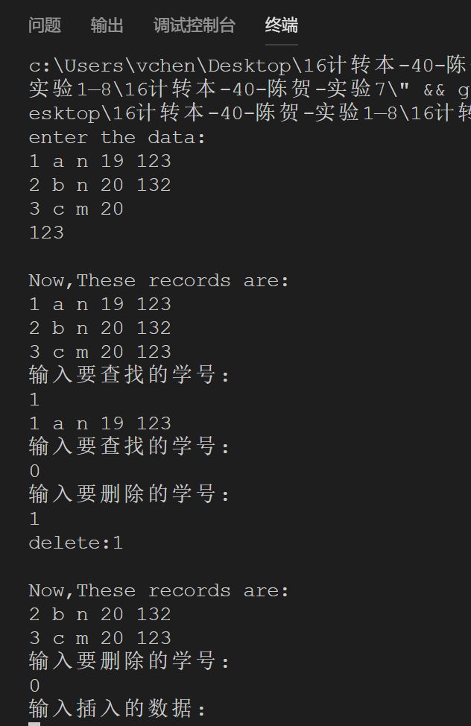

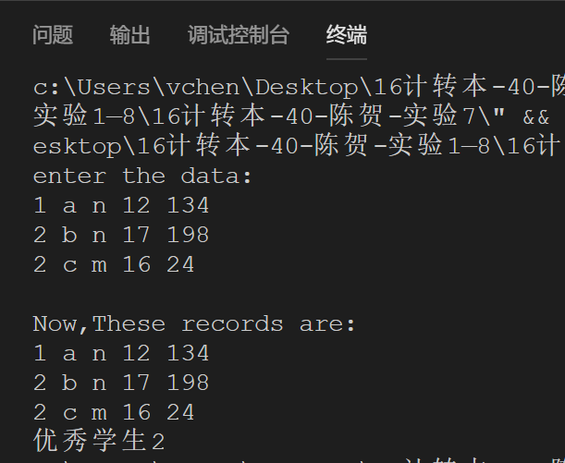

五、实验总结：
Malloc返回的指针必须转换为 struct student 类型数据的指针

