**Cp Calculation**

**The NASA7-Coefficient Polynomial Parameterization**

* The NASA 7-coefficient polynomial parameterization is used to compute the species reference-state thermodynamic properties cp0(T)
* The NASA parameterization represents cp0(T) with a fourth-order polynomial: cp0(T)/R = a0 + a1T + a2T^2 + a3T^3 + a4T^4

This is the "old" NASA polynomial form, used in the original NASA equilibrium program and in Chemkin, which uses 7 coefficients in each of two temperature regions.

### NASA7-coefficient polynomials

The polynomial form above, given for one or two temperature regions. Additional fields of a NASA7 thermo entry are:

**Temperature-ranges**

A list giving the temperature intervals on which the polynomials are valid. For one temperature region, this list contains the minimum and maximum temperatures for the polynomial. For two temperature regions, this list contains the minimum, intermediate, and maximum temperatures.

**Data**

A list with one item per temperature region, where that item is a 7-item list of polynomial coefficients. The temperature regions are arranged in ascending order. Note that this is different from the standard CHEMKIN formulation that uses two temperature regions listed in descending order.

**Example:**

**thermo:**

model: NASA7

temperature-ranges: [200.0, 1000.0, 6000.0]

data:

- [2.85948209, 2.35106377e-03, 2.51225636e-04, -3.40666545e-07, 1.38333372e-10,

-1.17815129e+04, 17.6905061]

- [18.1657042, 0.051774734, -1.86809409e-05, 3.02499547e-09, -1.81483745e-13,

-2.00506251e+04, -82.4466452]

**State of equation**

A key assumption made in CHEMKIN is that the gas behaves as a perfect gas, a restriction that results in non-interference of the individual species in a gas mixture (i.e., partial molal properties equal specific properties of pure component)

CHEMKIN makes use of a thermodynamic data base structure similar to the one used in the NASA chemical equilibrium codes. Standard-state, constant-pressure specific heat data for each of the species are written in the form of a polynomial expansion in temperature,

Cpk(T)/R = a1k + a2k *T + a3k *T^2 + . . . + ank *T^(n-1)

Here, R is the universal gas constant, subscript ' k' refers to the k-th species, and superscript 'o' is in reference to the standard-state pressure of 0.1 MPa (1 atmosphere). In CHEMKIN, the polynomial coefficients ank and O , applicable temperature ranges of the C (T) curve fits are stored in the thermodynamic data base where they are accessed through a special interpreter program

**Cv calculation**

R = 287 J/kg·K for air

Cp – R = Cv

**Cp calculation**

C​pmixture​​ = (M1 / M​mixture​​​​​​​​)C​p1 + (M2 / M​mixture ​​​​)C​p2​​

**Where:**  
C​p​​ = Heat Capacity  
m = Mass  
Mmixture is M1+M2

* phases:
* name: air
* thermo: ideal-gas
* elements: [O, N, Ar]
* species: [O, O2, N, NO, NO2, N2O, N2, AR]
* kinetics: gas
* transport: mixture-averaged
* state: {T: 300.0, P: 1 atm, X: {O2: 0.21, N2: 0.78, AR: 0.01}}

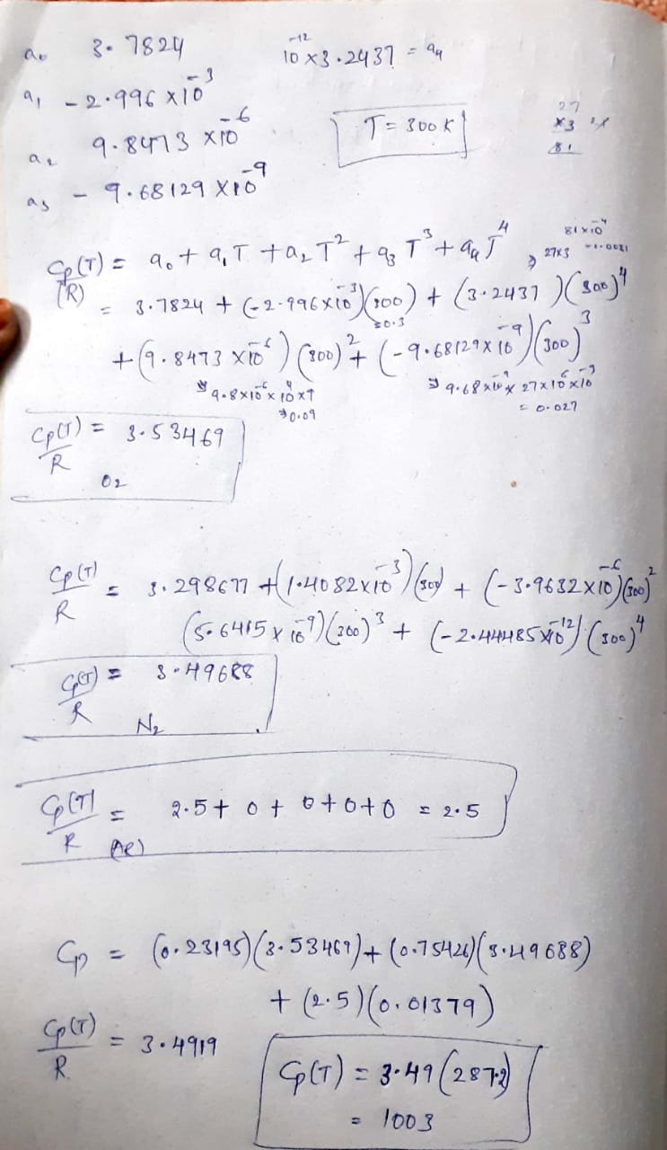

**References**

<https://cantera.org/science/science-species.html>

<https://cantera.org/documentation/docs-2.5/sphinx/html/yaml/species.html#sec-yaml-nasa7>

<https://www.google.com/url?sa=t&rct=j&q=&esrc=s&source=web&cd=&ved=2ahUKEwiOoZrtqpzxAhVk7XMBHZKPDVAQFjANegQIERAE&url=https%3A%2F%2Fwww.osti.gov%2Fservlets%2Fpurl%2F6224858&usg=AOvVaw3wopOypXjv98Jp6XQb5y0w>