ADAPTIVE PATHFINDING IN A DYNAMICALLY WEIGHTED ENVIRONMENT
In the case of a dynamically weighted network, as the rate of change of the network weights fluctuates, will an ant colony approach to pathfinding become more efficient than a deterministic approach to pathfinding such as A*?
CITS4403 Computational Modelling - Project Report
Team members: James Caporn (24011123), Logan Frost (22478026)
Simulation / final build: Project GitHub repository
Reference implementation: Sebastian Lague, Ant-Simulation
Prepared: 7 October 2026

Abstract
This project investigates whether a pheromone based ant navigation system becomes more efficient than deterministic A* when the cost of traversal in the network becomes dynamic. The model is run on a Unity two-dimensional ant-foraging simulation with a moving Perlin-noise storm that changes traversal cost and physical movement speed based on where the agents are situated. We’ve used a Python notebook to run the simulation on certain configurations and produce graphs. Ants use local sensing, exploration and pheromone trails as a decentralised collective memory, not knowing where the food source is, only what’s directly in front of them, whereas A* agents search a weighted grid and replan every second, knowing exactly where the end goal is. Three conditions were tested: a no-storm control, a slow-moving severe storm, and a fast-moving severe storm. Each condition used six independent replicates, a 1,800 s simulation horizon (equivalent to 30 minutes), 500 ants and 20 A* agents. Throughput was measured as food returned per agent per simulation minute. A* was more efficient in the control condition (no storm, i.e., static environment), but its advantage fell sharply under the slow storm and reversed under the fast storm. In the fastest storm, ants achieved 0.382 food per agent per minute, compared with 0.289 for A*, a 32.5% advantage. These results support the hypothesis. That is: as environmental costs change more rapidly, decentralised pheromone memory becomes comparatively more effective than periodic global replanning.
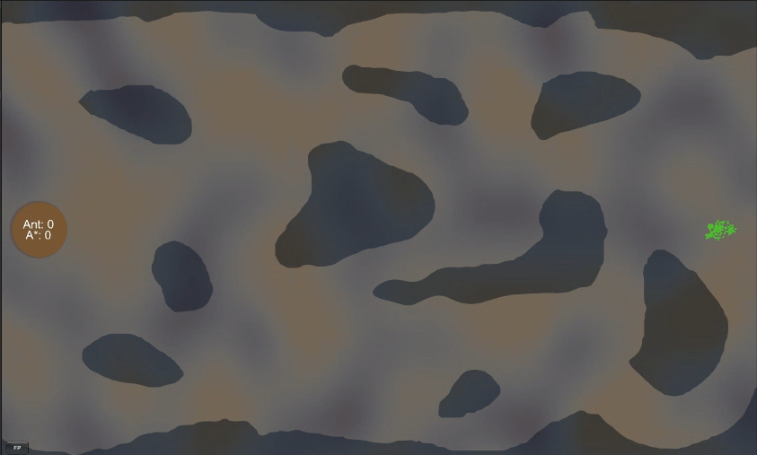
Figure 1: A screenshot of the simulation environment

1. Background and Research Aim
Pathfinding seeks a minimum-cost route through a graph. A* broadly evaluates paths using accumulated path cost and a heuristic estimate of remaining cost, making it a strong deterministic baseline for static shortest path problems [1]. Its limitation in a dynamic environment is temporal. That is, a route that is optimal when searched may become suboptimal before it is completed, hence introducing a slowdown effect. Dynamic replanning methods such as D* address changing costs explicitly [5]. In this project, periodic full A* replanning is retained because it is transparent and it helps expose a meaningful control parameter: how frequently the planner can react to environmental change.
Ant colony optimisation provides a contrasting information structure to plan paths. Ants reinforce successful routes through the use of pheromones, while evaporation reduces the influence of old information [2,3]. Dynamic shortest path studies have similarly explored ant based adaptation when network weights change over time [4]. This model is inspired by these ideas rather than implementing more canonical graph level ant colony optimisation: each ant uses local steering and pheromone sensing, and useful routes emerge collectively from repeated trips.
The research question is whether this decentralised pheromone based navigation becomes more efficient than deterministic A* as the rate of environmental change increases. The environmental change is measured with a storm system that fluctuates the cost of traversal. The hypothesis is conditional rather than universal. That is, when storm-induced costs change slowly, periodic A* replanning should remain competitive with high output. But when costs change rapidly enough for a one second replanning interval to become less responsive, the collective pheromone memory from the ant implementation may provide a relative advantage and provide more throughput.

2. Originality and Contribution
The contribution is the integration of four components into a single quantitative test: a deterministic A* comparison population, a continuously moving Perlin-noise storm (this movement is changing based on certain configurations for data collection), dynamic traversal costs with speed slowdown effects via the storm system, and automated performance logging for both the ants and the A* agents.. The storm changes spatial weights without changing the set of walkable cells, allowing the experiment to focus on adaptation to changing costs rather than obstacle discovery. The data was procured using a customised experiment runner that reset the scene, applied controlled storm conditions and random seeds, recorded replicate results, and exported condition summaries.
The two methods receive different information. A* can inspect the current weighted grid globally whenever it replans, knowing the start and end goal at all times. Ants do not calculate a global shortest path; they respond to local cues and pheromone trails produced by the population, and don’t necessarily have an inbuilt memory of the goal location like A*. Both methods use the same baseline movement speed and acceleration and the same storm-dependent physical slowdown at a given location as controlled variables. Therefore, this comparison concerns how the methods acquire, retain and update routing information rather than simply giving one method a faster movement model.

3. Model Specification and Justification
The environment is a 60 x 30 unit two dimensional (2D) static world containing fixed obstacles, paths, a colony (where the ants and A* agents begin), and a food source. The final experiments for data collection used 500 ants and 20 A* agents. Ant and A* agents shared AntSettings movement parameters of maximum speed v0 = 2 and acceleration a = 3 to ensure the same base constant movement speed. The A* population was deliberately limited to 20 to keep repeated path searches computationally tractable as noticeable lag was introduced as the A* agent count rose, as it required the simultaneous calculation of many shortest paths. Throughput was therefore normalised per agent, while the population size difference being treated as a limitation rather than being hidden.
The storm is a scalar field sampled in world coordinates to try and obtain as much of a “random” storm as possible via Perlin Noise. For position x and time t, the noise field is represented as:
N(x,t) = PerlinNoise(sx + ox(t), sy + oy(t))
Storm intensity is then mapped from the noise value using threshold T and transition width W, giving I(x,t) in [0,1]. The traversal cost is calculated with the following equation:
C(x,t) = 1 + (Cmax - 1) I(x,t)
For the storm conditions, Cmax was fixed at 30. The noise scale was fixed at 0.15, threshold at 0.60 and transition width at 0.46. The movement direction of the storm field was fixed at (1, 0.7) to not overextend the scope. Lower noise scales produce larger, more spatially coherent regions. Also, changing storm movement speed changes how quickly those storm regions (or “clouds”) move across the map. In the control condition, storm movement was disabled and Cmax was set to 1.
A* adds the storm derived traversal penalty to its weighted grid and uses the standard orthogonal/diagonal 10/14 movement approximation with obstacle proximity penalties. And to best try and account for hardware limitations, it recalculates its route every 1s, not in real time. Both methods use the same physical speed rule, so at a given position the storm modifies the maximum movement speed as v_max(x,t) = v0 M(I). The A* implementation has been done so that the multiplier is applied once and A* starts from zero velocity, matching the ant acceleration process. Both the ants and the A* agents are designed to have the exact same movement speed, acceleration, slowdown, etc… The only difference is the pathfinding mechanisms they employ.
Ant navigation is decentralised. Agents use obstacle avoidance, random exploration, food sensing and three direction pheromone sensing (forward, forward right, and forward left). Pheromone markers form a collective memory and their influence decays over time. The base settings are an evaporation time of 60 seconds, and a run out time of 30 seconds. Evaporation time is how long the pheromones last, and the run out time is how long until the ant stops laying pheromones without reaching the end goal. For the final runs, pheromone lifetime was left at its project baseline while the run-out and weight multipliers were held fixed at 2.0x as these seemed to procure ideal baseline results. These parameters were not changed between experimental conditions.
Table 1. Fixed model settings used in the final experiments.
Variable | Final setting | Role
Map | 60 x 30 | Spatial domain
Agents | 500 ants; 20 A* | Computationally tractable comparison
Base speed / acceleration | 2 / 3 | Shared movement parameters
Noise scale | 0.15 | Fixed storm spatial scale
Threshold / transition width | 0.60 / 0.46 | Fixed storm coverage/boundary
Cmax | 1 control; 30 storm | Traversal-cost severity
A* replanning interval | 1 s | Planner response rate
Pheromone run-out / weight | 2.0 / 2.0 | Fixed ant-colony behaviour
Simulation horizon | 1,800 s | Fixed duration per replicate

4. Experimental Design
The final experiment was deliberately reduced to three conditions so that the independent variable matched the research hypothesis. C0 is no storm control (i.e., no storm slowdown effect. A static weighted map). C1 used a severe but slowly moving storm, and C2 used the same severe storm with a higher movement speed. Thus, storm movement speed was the principal independent variable after the baseline was established, while storm severity and spatial structure were held fixed between C1 and C2. Six replicates were collected for each condition using seeds 4403-4408, giving 18 runs in total.
Table 2. Final experimental conditions.
Condition | Storm speed | Cmax | Replicates | Purpose
C0: No-storm control | 0.0 | 1 | 6 | Baseline
C1: Slow dynamic storm | 0.1 | 30 | 6 | Slow environmental change
C2: Fast dynamic storm | 0.6 | 30 | 6 | Rapid environmental change
Each replicate reset the scene, food counters, agent populations and storm state. Running multiple replicates helps to assess outlier data. The experiment runner applied the condition parameters and recorded the startup seed. Each run simulated 1,800 s (30 min); Unity time acceleration was used to reduce physical waiting time and did not alter the simulated horizon. The primary response variable was throughput, which is defined from cumulative food F(t), agent count (N) and elapsed time (t) as F(t)/(Nt). For readability, the throughput that was recorded is expressed in food/agent/min. The relative difference in Table 3 is (Ant - A*)/A* x 100.
The main analysis compares mean throughput across the six replicates for better accuracy, with 95% confidence intervals calculated using the t distribution with five degrees of freedom. The same random seeds were used for Ant and A* within each replicate as well. This is designed to help the runs form matched method comparisons. The experimental runner for the data analysis exported an individual CSV for every run and a combined summary CSV, making the analysis reproducible without relying on visual judgement of the simulation.

5. Results
The final results show a clear change in the relative ranking of the two methods as storm movement speed increased. In the no storm control where there was no changing environment and the paths all had a static weight, A* achieved a mean throughput of 0.630 food/agent/min compared with 0.409 for the ants, corresponding to an ant disadvantage of 35.0%. Under the slow dynamic storm, the gap narrowed to 7.9% in favour of A*. Under the fast dynamic storm, the ranking reversed. Ants achieved 0.382 food/agent/min while A* achieved 0.289 food/agent/min, giving a 32.5% ant advantage.
The confidence intervals were also quite narrow relative to the differences between methods. The fast storm result is particularly notable because the ant throughput changed little from the control (a 6.6% decrease), while A* throughput fell by 54.2%. This is a very interesting result which indicates that the reversal was driven primarily by a much larger performance degradation for A* rather than by a large increase in absolute ant throughput. It suggests that the ants are less affected by the dynamic environment compared to the A* agents. Final cumulative food per agent showed the same pattern: 18.89 for A* versus 12.28 for ants in C0, but 8.66 for A* versus 11.47 for ants in C2.
Figure 2 summarises the mean throughput and 95% confidence intervals across conditions. Figure 3 shows the mean cumulative food trajectory in the fast-storm condition, where the ant curve becomes increasingly steeper and finishes above A*. As a supporting statistical check, paired t-tests across the six matched seeds found method differences within each condition (C0 p < 0.001; C1 p = 0.010; C2 p < 0.001). These p-values are descriptive rather than a replacement for replication and uncertainty analysis, given the modest number of replicates.
Table 3. Measured throughput results (mean +/- 95% CI).
Condition | Ant throughput  (food/agent/min) | A* throughput  (food/agent/min) | Relative difference
C0: No storm | 0.409 +/- 0.015 | 0.630 +/- 0.003 | -35.0%
C1: Slow storm | 0.390 +/- 0.016 | 0.423 +/- 0.009 | -7.9%
C2: Fast storm | 0.382 +/- 0.020 | 0.289 +/- 0.009 | +32.5%

6. Discussion and Conclusions
The results support the hypothesis within the tested parameters. A* was clearly superior over the ants when the environment was static, which is consistent with its ability to compute a near optimal route from a known weighted map. With a slow moving storm, A* remained slightly better compared to the ants, suggesting that a one second replanning interval was still sufficiently responsive for much of the environmental change. When storm movement increased from 0.1 to 0.6, however, A* throughput dropped much more sharply, causing the ant throughput to became superior. This pattern is consistent with the proposed mechanism: repeated global replanning becomes less effective as the cost field changes more rapidly, while pheromone trails provide a distributed memory that is updated continuously through many agents, and provides a more steady path that is less susceptible to a dynamically weighted environment with changing paths.
The fast storm result is especially informative because the experiment does not show ants becoming intrinsically faster. Their throughput remained close to the control value, whereas A* lost more than half of its control throughput. The interpretation is there is relative robustness to environmental volatility. The ant colony does not commit to one global route that becomes invalid as the path cost changes from the storm. Instead, information about useful directions is continuously accumulated and decayed in the pheromone field over a long period of time. A* can react to the changed costs, but the route is only reconsidered at its 1s replanning interval, so route information can be stale between searches, and constantly replanning routes can cause a longer path in the long run depending on the storm strength. Increasing replanning frequency might improve A*, but would also increase computational cost dramatically.
The experiment also reveals an important trade-off in the model. The ant population contains 500 agents while the A* population contains 20 agents. This was necessary as previously mentioned to keep repeated A* searches computationally feasible, and throughput was normalised per agent, but the populations are not equivalent in collective information density or total computation. Consequently, the result should be interpreted as a comparison of the implemented navigation systems under practical simulation constraints, not as a hardware or resource equal benchmark. The final experiment also used six replicates per condition. To improve the accuracy in the results, more replicates would improve confidence in the effect estimates.
Other limitations that can be built on in future study include the synthetic Perlin noise storm, the simplified ant colony optimisation inspired ant rules, and the use of periodic full A* replanning rather than an incremental dynamic planner such as D*. The study also fixes pheromone parameters and storm spatial structure as constant values that are assumed, so the interaction between pheromone decay, storm correlation length and planner response rate remains unexplored, which could be an interesting avenue for further study. Future work should also vary the A* replanning interval directly, test different pheromone decay rates, and record route cost and physical search time alongside throughput.
In conclusion, the final experiments show a clear crossover: A* is more efficient in the static baseline with no dynamic environment compared to the ants, remains slightly more efficient under a slowly moving severe storm, but is overtaken by the ant colony under the fastest tested storm. This provides evidence for the hypothesis that decentralised collective memory becomes advantageous as the environment changes more rapidly, while avoiding the stronger and unsupported claim that ant-based pathfinding is universally better than A*.

Figures:
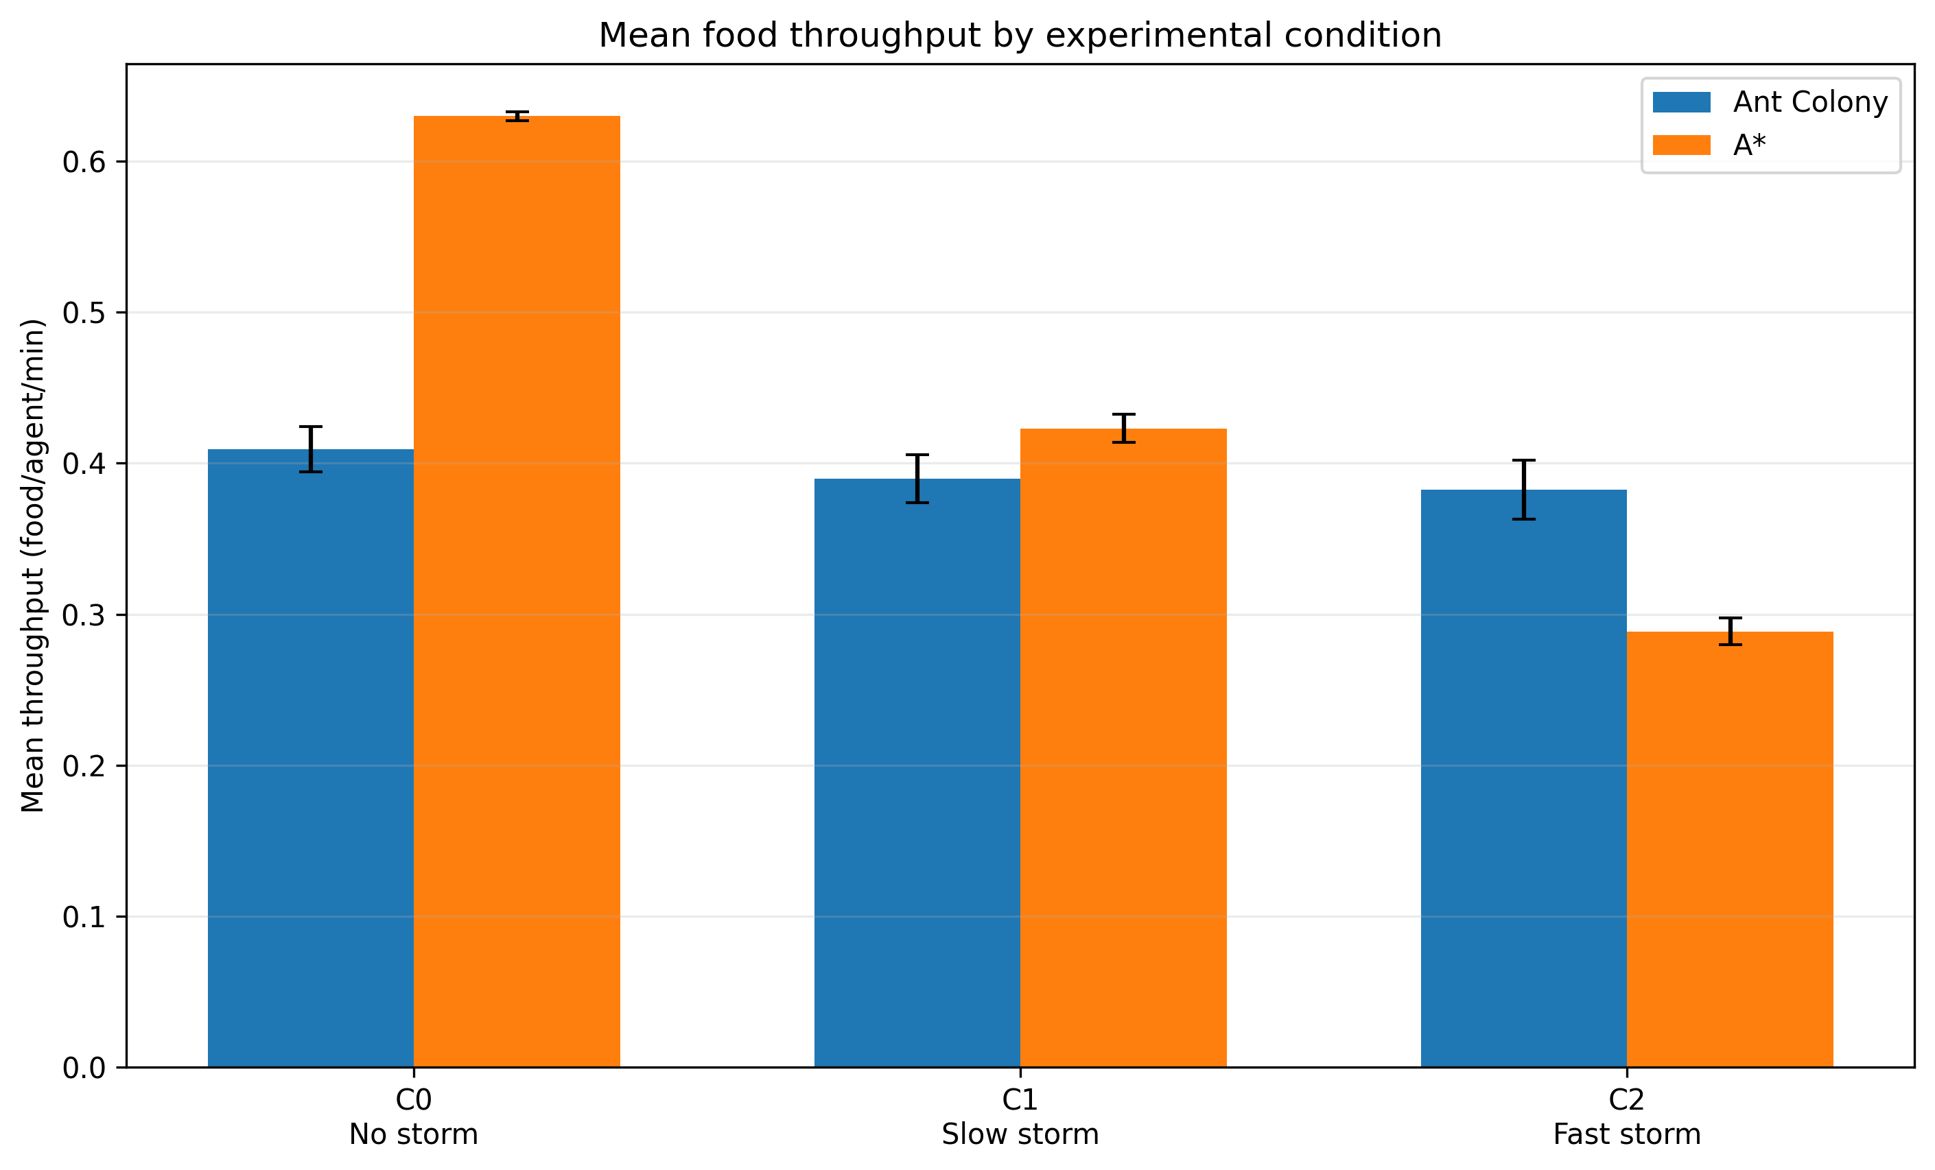
Figure 2. Mean food throughput by condition. Error bars show 95% confidence intervals across six replicates.
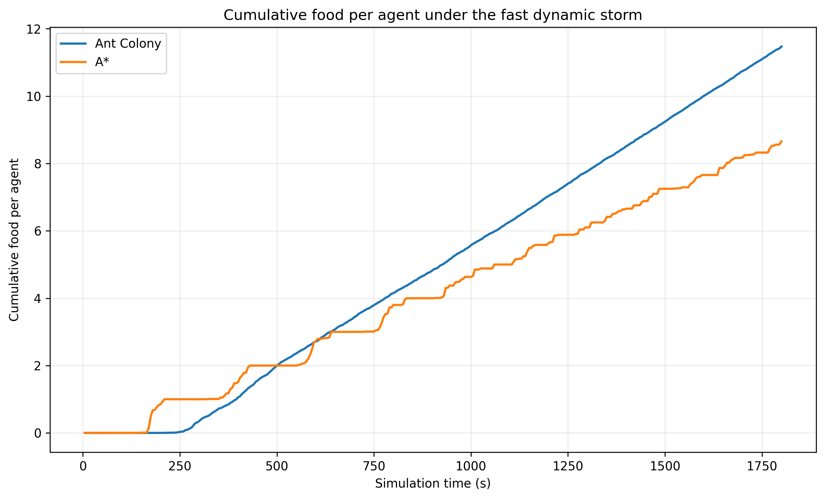
Figure 3. Mean cumulative food delivered per agent under the fast dynamic storm (C2), averaged across six replicates.
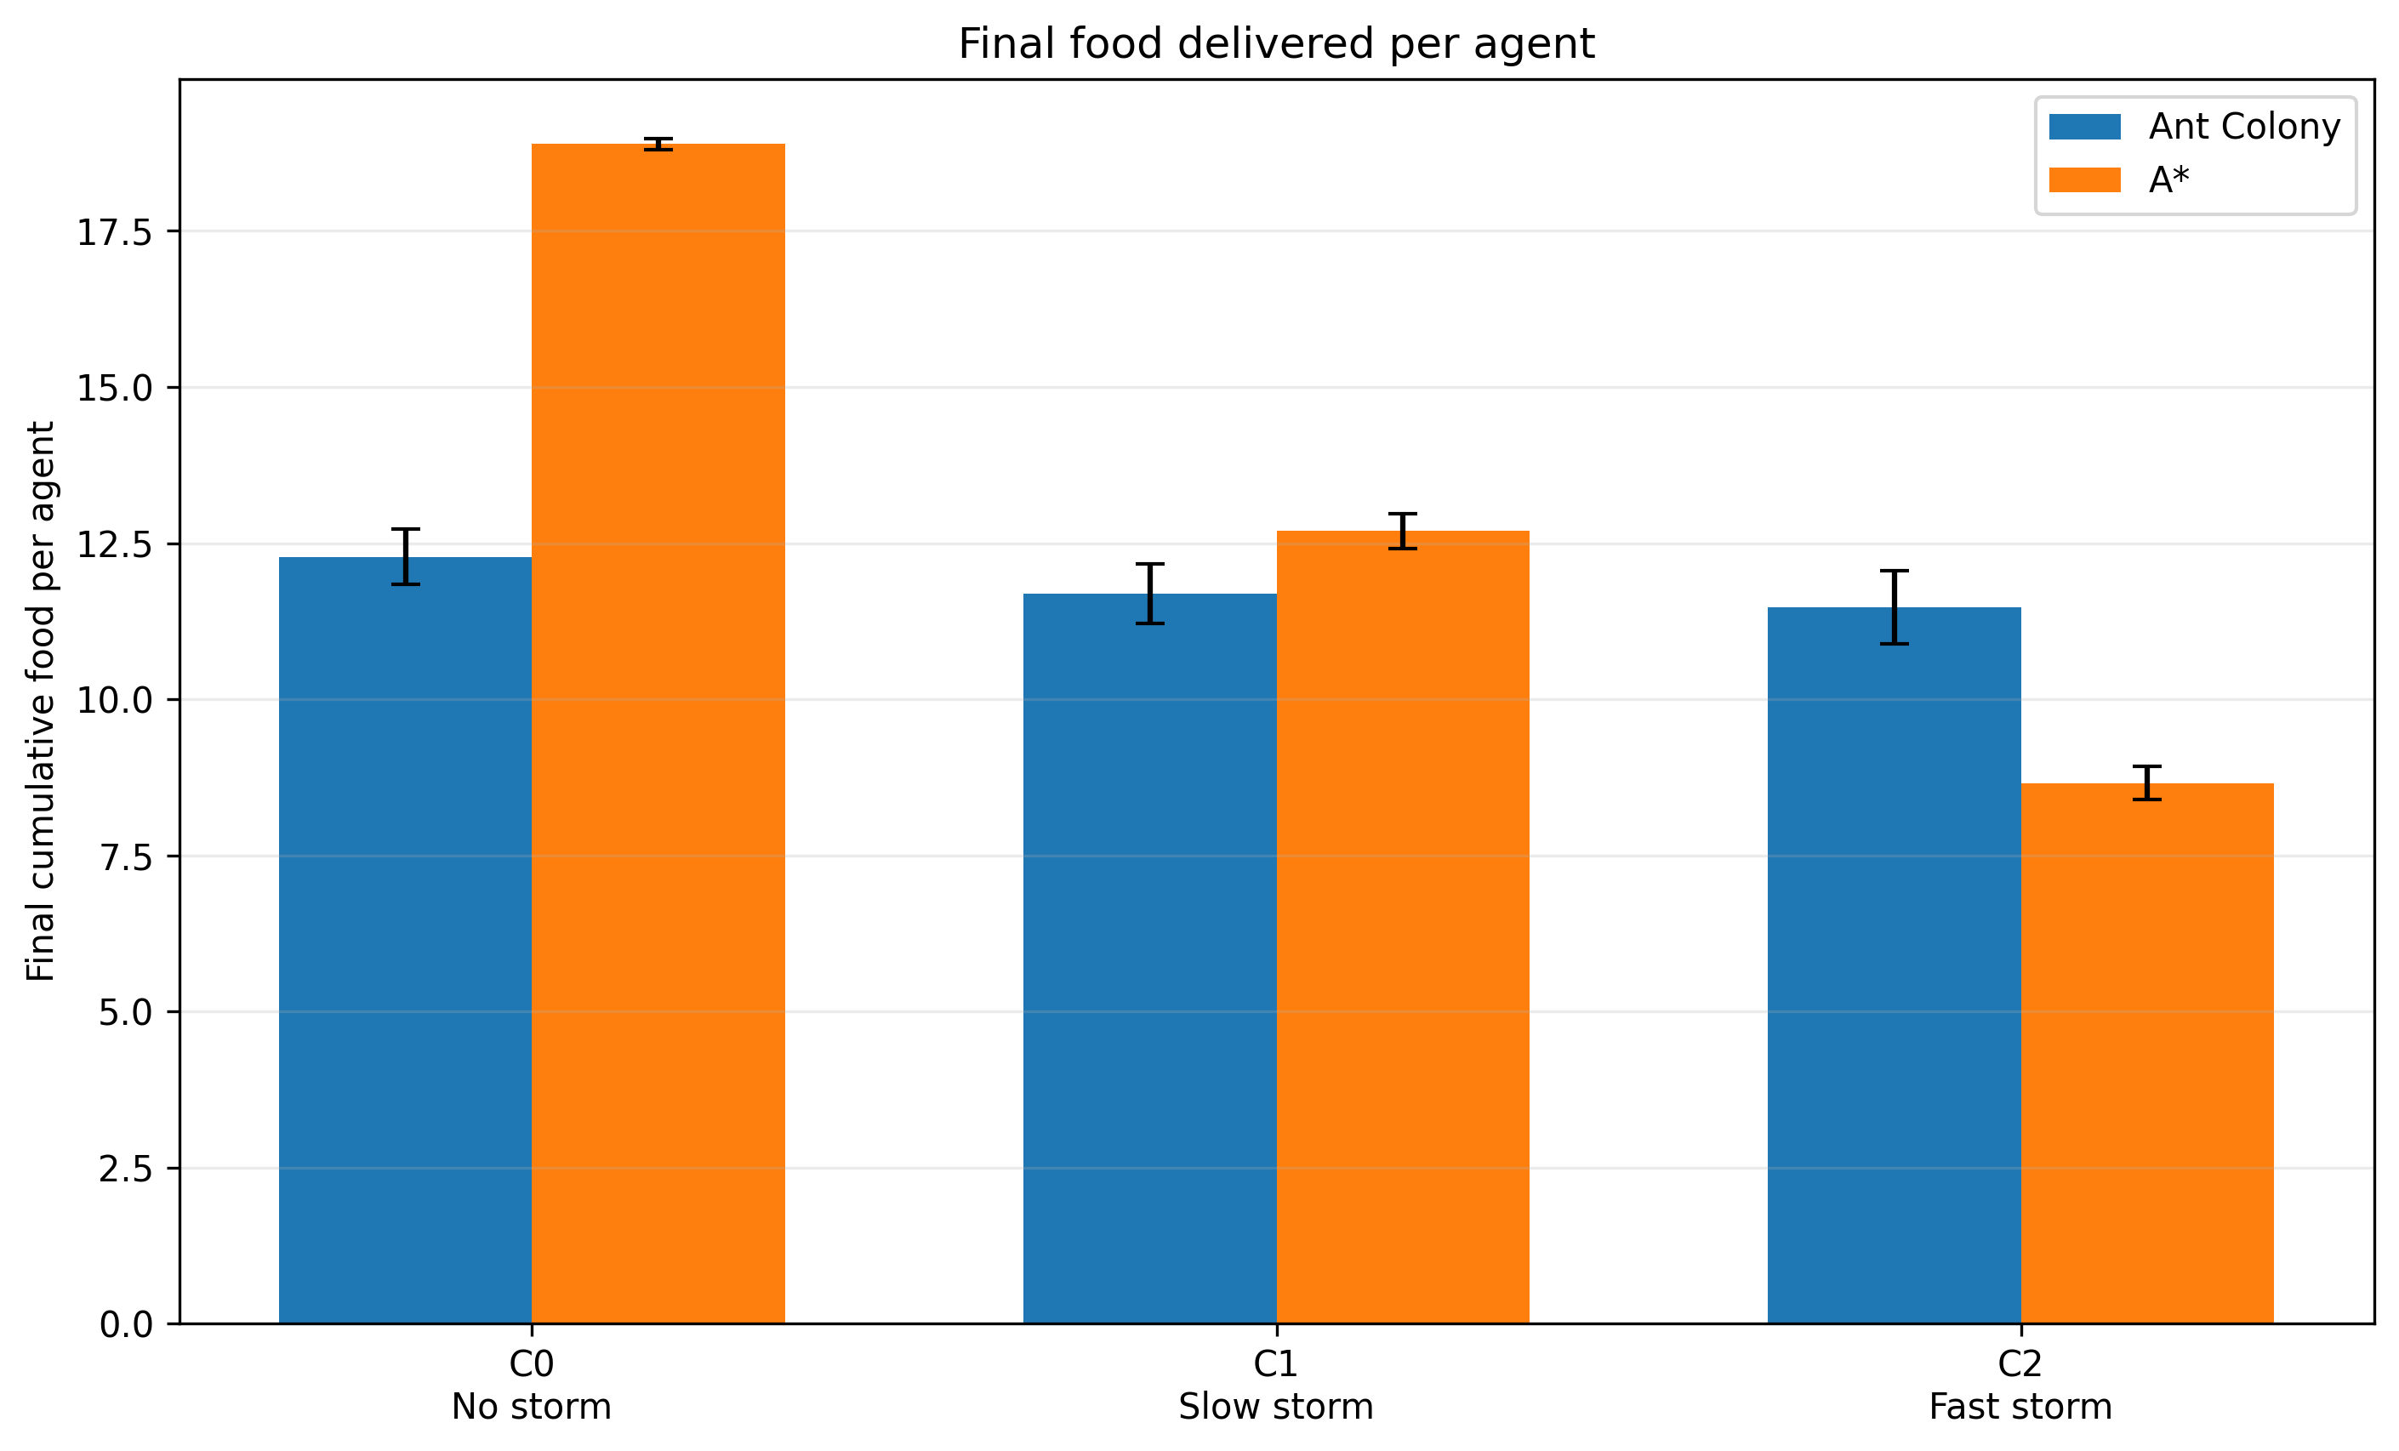
Figure 4. Final cumulative food delivered per agent at the end of each condition. Error bars show 95% confidence intervals.

References
[1] Hart, P. E., Nilsson, N. J., & Raphael, B. (1968). A formal basis for the heuristic determination of minimum cost paths. IEEE Transactions on Systems Science and Cybernetics, 4(2), 100-107. doi:10.1109/TSSC.1968.300136.
[2] Dorigo, M., & Gambardella, L. M. (1997). Ant colony system: A cooperative learning approach to the traveling salesman problem. IEEE Transactions on Evolutionary Computation, 1(1), 53-66. doi:10.1109/4235.585892.
[3] Dorigo, M., & Stutzle, T. (2004). Ant Colony Optimization. MIT Press. doi:10.7551/mitpress/1290.001.0001.
[4] Yu, F., Li, Y., & Wu, T.-J. (2010). A temporal ant colony optimization approach to the shortest path problem in dynamic scale-free networks. Physica A, 389(3), 629-636. doi:10.1016/j.physa.2009.10.005.
[5] Stentz, A. (1995). The focussed D* algorithm for real-time replanning. Proceedings of the Fourteenth International Joint Conference on Artificial Intelligence, 1652-1659.
[6] Lague, S. Ant-Simulation. GitHub repository. Accessed 7 October 2026.

Appendix A. Reproducibility and Implementation Notes
The final experiments used Unity 2021.3.17f1 along with Jupyter Notebook (using Python) to process the simulations, a 60 x 30 storm field, world space Perlin noise, randomised startup offsets using seeds 4403-4408, 500 ants and 20 A* agents. The storm used noiseScale = 0.15, threshold = 0.60, transitionWidth = 0.46 and movement direction (1, 0.7). The storm movement speeds were 0.0, 0.1 and 0.6 for C0, C1 and C2 respectively; Cmax was 1 for C0 and 30 for C1/C2. A* replanned every 1 s. The simulation horizon was fixed at 1,800 seconds per replicate (30 minutes).
Pheromone settings were held constant across all final runs as an assumed fixed variable. The project configuration used a pheromone lifetime multiplier of 1.0, run-out multiplier of 2.0, weight multiplier of 2.0, and spacing and sensor multipliers at their project baseline values. The experiment runner exported one CSV per replicate plus a combined experiment_summary.csv. The summary values used in Table 3 were calculated from the six replicate throughput measurements for each condition. Confidence intervals use t0.975,5 = 2.571.
The automated runner was configured to accelerate simulation time to avoid waiting for 9 hours in physical time to complete all the tests, suppress unnecessary live visualisation during batch runs such as visualizing the storm, keep the A* population at 20, and preserve fixed pheromone settings between scene resets to ensure particles are cleared inbetween automated runs. These implementation choices reduced wall clock execution time without changing the simulated duration or the independent variable. The final project build and source are available at the repository link given on the title page.

