Engineering Design and Graphics 1C03

McMaster Engineering 1 Cornerstone Project

Instructor: Dr. Doyle

Group 93

Yosef Kelly 1151293

Benjamin Pister 1132694

Tom Woudenberg 1140006

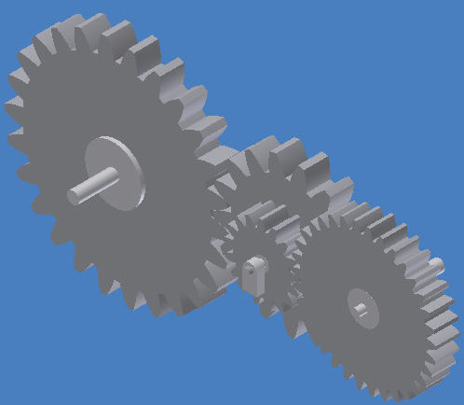

As a future member of the engineering profession, the student is responsible for performing the required work in an honest manner, without plagiarism and cheating. Submitting this work with my name and student number is a statement and understanding that this work is my own and adheres to the Academic Integrity Policy of McMaster University and the Code of Conduct of the Professional Engineers of Ontario Submitted by

Yosef Kelly, 1151293­­­­­­­­­­­­­­­­__________________________________________________________

As a future member of the engineering profession, the student is responsible for performing the required work in an honest manner, without plagiarism and cheating. Submitting this work with my name and student number is a statement and understanding that this work is my own and adheres to the Academic Integrity Policy of McMaster University and the Code of Conduct of the Professional Engineers of Ontario Submitted by

Benjamin Pister, 1132694______________________________________________________

As a future member of the engineering profession, the student is responsible for performing the required work in an honest manner, without plagiarism and cheating. Submitting this work with my name and student number is a statement and understanding that this work is my own and adheres to the Academic Integrity Policy of McMaster University and the Code of Conduct of the Professional Engineers of Ontario Submitted by

Thomas Woudenberg, 1140006__________________________________________________

Table of Contents

1.0 Introduction................................................................................Page 2

1.1 Mechanism Description..............................................................Page 2

1.2 Linear Responsibility Chart.........................................................Page 2

1.3 Schedule of Meetings.................................................................Page 3

1.4 Gantt Chart.................................................................................Page 3

2.0 Calculations................................................................................ Page 3-5

3.0 MapleSim 2D Schematic View.................................................... Page 6

3.1 MapleSim 3D View......................................................................Page 6

3.2 Probe Graphs.............................................................................. Page 7

4.0 Engineering Drawings

CD ROM Drive.......................................................................Page 8

Exploded Assembly.............................................................. Page 9

Spur Gears 1 & 3.................................................................. Page 10

Spur Gear 2.......................................................................... Page 11

Spur Gear 4.......................................................................... Page 12

Worm 1 & 2..........................................................................Page 13

Worm Gear 1........................................................................Page 14

Worm Gear 2........................................................................Page 15

Worm 3................................................................................Page 16

Rack..................................................................................... Page 17

Bearing................................................................................ Page 18

The purpose of this project was to design a gear train to operate the read head of a CD ROM drive. Through knowledge in Autodesk and MapleSim, we were able to design a model of a functional CD ROM drive read head. The gear train would run from the motor, through the chassis and connect to the read head to allow linear motion of the read head. Through proper methods of calculations and manipulation of the overall design, we were able to achieve exactly what our client has asked from us. The following report will describe and give a representation of the overall design process and final design.

For our gear train, we wanted to take the simplest approach so as not to cause complications, and so if corrections were needed to be made, they could be done without changing a huge gear train. Our gear train consists of 2 spur gear pairs 2 worm-gear pairs and 1 worm-rack pair. The reason for the 2 spur gear pairs is to increase the rotational speed. All of our worms have only 1 tooth and so every worm-gear pair has a great decrease in rotational speed due to the large gear ratio between the worm gear and the worm. To get to our final rotational speed of the read head, we needed to use the 2 spur gear pairs to increase the speed from our input rotational velocity. The purpose of the two worm-gear pairs is to turn the gear train 90 degrees due to the shape of the chassis. The two worm gears are connected by a rotating rod (more practical than having spur gear pairs all the way through the chassis). Finally the worm-rack pair was used to connect to the read head which gave linear motion to the read head thus allowing it to function. As one can see, a very simplistic approach to a gear train in a CD ROM drive, however quite practical.

Overall, each team member contributed to each part of the project. When our team had our meetings we worked on all aspects of the project at the same time, helping one another to better understand all aspects of the final design. Though each team member put effort into each part of the project, they also had leadership roles in certain aspects of the project. The following linear responsibility chart describes the above statement:

|  |  |  |  |  |
| --- | --- | --- | --- | --- |
| Section | Task | Yosef K. | Benjamin P. | Thomas W. |
| Conceptual Design | Schedule Meetings | 1 | 1 | 1 |
|  | Review Requirements | 1 | 1 | 1 |
| Preliminary Design | Calculations | 2 | 2 | 1 |
| Detailed Design | AutoCAD Models | 2 | 2 | 1 |
|  | MapleSim Modelling | 1 | 2 | 2 |
| Design Communication | Engineering Drawings | 2 | 2 | 1 |
|  | Visual Representations (i.e. graphs) | 2 | 1 | 2 |
|  | Technical Report | 2 | 1 | 2 |

Note: Should work not be completed in meetings, the person with a ‘1’ would be in charge of making sure it is fully finished, with the other members of the group, ‘2’, looking over the work to make sure it is complete and correct.

**Meeting Schedule**

|  |  |  |  |  |
| --- | --- | --- | --- | --- |
| Meeting Type | Date of Meeting | Yosef Kelly | Benjamin Pister | Thomas Woudenberg |
| # 1)First Meeting | Nov. 3, 2011 | P | P | P |
| #2)Calculations | Nov. 5, 2011 | P | P | P |
| #3)Create Gear Parts | Nov. 10, 2011 | P | P | P |
| #4)Assemble Model | Nov. 10, 2011 | P | P | P |
| #5)Technical Report | Nov. 17, 2011 | P | P | P |

Note: ‘P’ stands for present and means the group member attended the group meeting.

Note: Task #1, which was our first meeting, occurred on Nov. 3 and ended on Nov. 3, hence there was no real duration or deadline of the first meeting. Also, the graph goes by intervals of 5 days beginning from Nov.1,2011. The whole project, including the technical report was completed on Nov. 29, 2011

**Calculations:**

The following information will describe in detail all the calculations that were used in this project. Our purpose for showing these calculations is to demonstrate our knowledge in gear trains as well as allow the viewer to fully understand our gear train design. The calculations are written out below in the order that we did our calculations during the preliminary design.

1) Calculated the Input speed (in RPM) from project outline and converted it to revolutions per second:

2) Converted output from m/s to mm/s to correspond to input speed (RPS):

3) Wanted module of final worm to be approximately one, so calculated the Gear Ratio according to this requirement:

4) Set our designed gear train to equal approximately a 10.54 gear ratio

4i) The requirements for the gears were set to the following:

4ii) Diameter of first 3 gears has to be smaller than 15mm since they will be surrounded with walls from the case which are 15mm apart:

5) Need to maximize Gear 1 and 2, since they are the only gears decreasing our gear ratio:

6) Once simplifying the equation and putting in the previous constraint:

7) The smallest gears we could put with the worms was 10 teeth. Both were set to the same value to simplify manufacturing process:

8) Now we had to pick a value for Gear 2 and 4 which had to be large enough to not have a factor of 5 and equal a gear ratio of about 10.54. Also both gears should have the same number of teeth in order to simplify manufacturing.

We picked the lowest factor of 10 possible, so 20 teeth:

9) Now we determined the Gear ratio again according to these new gears:

10) We recalculated the output rev/s with the new gear ratio:

11) Then the required pitch of the final worm was calculated with the new output rotational speed:

12) We final set the pitch of every worm to the same size, so you could just make one worm during manufacturing and cut that to the desired lengths:

**Final results**

GR=11.111111

Gear 1 & 3 = 60 teeth Module = 0.25 Diameter = 15 mm

Gear 2 & 4 = 20 teeth Module = 0.25 Diameter = 5 mm

Worm Gear 1 & 2 = 10 Pitch =

**2D Schematic View**

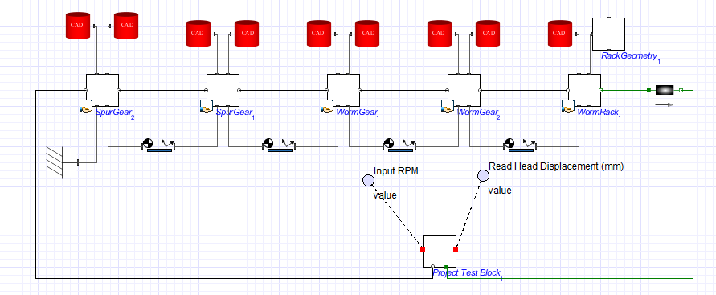

**3D View**

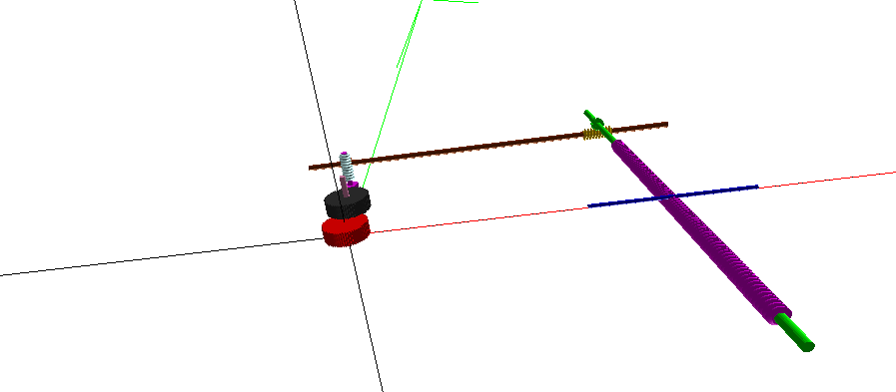

**Probe Graphs**

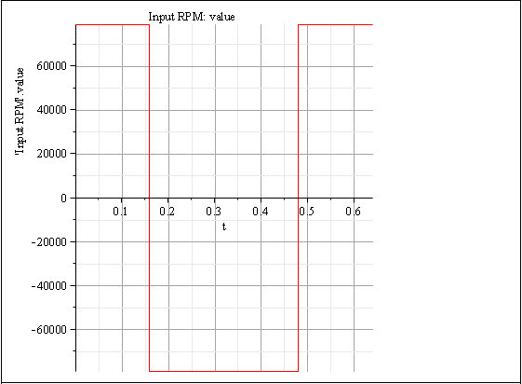

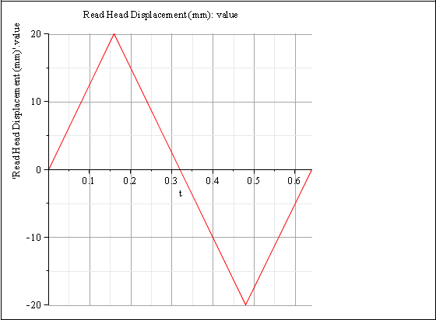

**Engineering Drawings**

