INTEGRATED DISASTER INCIDENT RECORD MANAGEMENT AND AUTOMATED SITUATION REPORT GENERATION SYSTEM

A Capstone Project Proposal
submitted to the Computer Science Department
as partial fulfillment of the requirements for the degree of
Bachelor of Science in Information Technology

by
Perez, Katrina Mae D.G.
Somosa, RJ P.

Precious T. Opinion
Adviser

September 9, 2026

TABLE OF CONTENTS
TABLE OF CONTENTS 2
List of Tables 4
List of Figures 4
INTRODUCTION 9
1.1 Project Context 9
1.2 Statement of the Problem and Purpose 23
1.3 Objectives 49
General Objective 49
Specific Objectives 50
1.4 Scope and Limitations 54
1.5 Significance of the Project 61
REVIEW OF RELATED LITERATURE 65
2.1 Disaster Management Frameworks and Mandates 65
2.2 The Need of Reporting and SitRep Generation 69
2.3 The Advantages of Switching Fragmented to Centralized Reporting 71
2.4 The Importance of Secure Information Management 73
2.5 Disaster Reporting and SitRep Generation Technology 75
2.6 Related Systems 76
2.6.1 Bandilyo App 76
2.6.2 Advanced Gathering for Assistance Preparedness for Protection (AGAPP) 78
2.6.3 IRespondPH 83
2.6.4 The Mamamayan Web App 84
2.7 Comparative Analysis of Existing Systems 88
2.8 Synthesis 93
METHODOLOGY 98
3.1 Architectural Design 98
3.2 Requirement Specification 102
3.2.1 Users and Characteristics 102
3.2.2 Software Functionalities 103
3.2.3 Security Requirements 107
3.2.4 Technical Requirements 107
Hardware Requirements 108
Software Requirements 109
3.3 Analysis 110
3.3.1 Process Models 110
A. Context Flow Diagram 110
B. Level 0 Data Flow Diagram 113
Process 1: Manage Purok Users 117
Process 2: Manage Barangay Users 119
Process 3: Purok Profiling 120
Process 4: Log In Validation 123
Process 5: Hazard Creation 126
Process 6: Purok Profile Verification 127
Process 7: Barangay Profile Verification 129
Process 8: Purok Incident Reporting 130
Process 9: Verify Purok Incident Report 131
Process 10: Consolidate and Submit Barangay Incident Report 133
Process 11: Verify Barangay Incident Report 137
Process 12: Generate Situation Report 139
3.3.2 Data Models 145
3.3.3 Logic Models 153
3.3.3.1 Purok Profile Verification 153
3.3.3.2 Barangay Profile Verification 154
3.3.3.3 Purok Incident Verification 156
3.3.3.4 Barangay Incident Verification 157
3.3.3.5 Situation Report Generation 159
3.3.3.6 Purok Historical Catalog 165
3.3.3.7 Barangay Historical Catalog 166
3.3.3.8 Situation Report Historical Catalog 168
3.3.3.9 Log In 169
3.3.3.10 System User Management 171
3.4 Design 174
3.4.1 Database Design 174
3.4.2 User Interface Design 190
3.4.4 Integrity Controls 219
3.4.5 Security Controls 221
3.5 Development 224
3.6 Testing 225
3.6.1 Alpha Testing 225
3.6.2 Beta Testing 231
3.7 Calendar of Activities 234
REFERENCES 236

List of Tables
Table 1. Comparison Table of the Related Systems and SitRepO Integrated Disaster Incident Record Management and Automated Situation Report Generation System
Table 2. Users and Characteristics
Table 3. Functional Requirements
Table 4. Automated Unit Testing Sample Criteria
Table 5. Automated Integration Testing Sample Criteria

List of Figures
Figure 1. Current Process of Barangay Reporting and ZCDRRMO Situation Report Generation
Figure 2 Proposed Online Integrated Disaster Incident Record Management and Automated Situation Report Generation System Flowchart
Figure 3. Purok User Management Flowchart
Figure 4. Purok Profile Creation Flowchart
Figure 5. Purok Profile Verification Flowchart
Figure 6. Purok Incident Reporting Flowchart
Figure 7. Purok Incident Report Verification Flowchart
Figure 8. Purok Incident Report History Flowchart
Figure 9. Barangay User Management Flowchart
Figure 10. Barangay Profile Creation Flowchart
Figure 11. Barangay Profile Verification Flowchart
Figure 12. Barangay Incident Reporting Flowchart
Figure 13. Barangay Incident Report Verification Flowchart
Figure 14. Barangay Incident Report History Flowchart
Figure 15. System User Management Flowchart
Figure 16. Hazard Creation Flowchart
Figure 17. Situation Report Generation Flowchart
Figure 18. Situation Report Historical Catalog Flowchart
Figure 19. System Dashboard Flowchart
Figure 20. Advanced Gathering for Assistance Preparedness for Protection (AGAPP) Landing Page
Figure 21. Advanced Gathering for Assistance Preparedness for Protection (AGAPP) Report Page
Figure 22. Advanced Gathering for Assistance Preparedness for Protection (AGAPP) Map Page
Figure 23. Advanced Gathering for Assistance Preparedness for Protection (AGAPP) FAQ Page
Figure 24. Mamamayan Web App Pages
Figure 25. Integrated Disaster Incident Record Management and Automated Situation Report Generation System N-tier Architecture Diagram
Figure 26. Integrated Disaster Incident Record Management and Automated Situation Report Generation System Context Data Flow Diagram
Figure 27. Integrated Disaster Incident Record Management and Automated Situation Report Generation System Context Level 0 Data Flow Diagram
Figure 28. Integrated Disaster Incident Record Management and Automated Situation Report Generation System Level 1 DFD Manage Purok Users
Figure 29. Integrated Disaster Incident Record Management and Automated Situation Report Generation System Level 1 DFD Manage Barangay Users
Figure 30. Integrated Disaster Incident Record Management and Automated Situation Report Generation System Level 1 DFD Purok Profiling
Figure 31. Integrated Disaster Incident Record Management and Automated Situation Report Generation System Level 1.1 Barangay Profiling
Figure 32. Integrated Disaster Incident Record Management and Automated Situation Report Generation System Level 1 Hazard Creation
Figure 33. Integrated Disaster Incident Record Management and Automated Situation Report Generation System Level 1 DFD Purok Profile Verification
Figure 34. Integrated Disaster Incident Record Management and Automated Situation Report Generation System Level 1 Barangay Profile Verification
Figure 35. Integrated Disaster Incident Record Management and Automated Situation Report Generation System Level 1 Purok Incident Reporting
Figure 36. Integrated Disaster Incident Record Management and Automated Situation Report Generation System Level 1 Verify Purok Incident Report
Figure 37. Integrated Disaster Incident Record Management and Automated Situation Report Generation System Level 1.5 DFD
Figure 38. Integrated Disaster Incident Record Management and Automated Situation Report Generation System Level 1.5 DFD
Figure 39. Integrated Disaster Incident Record Management and Automated Situation Report Generation System Level 1.5 DFD
Figure 40. Integrated Disaster Incident Record Management and Automated Situation Report Generation System Entity Relationship Diagram
Figure 41. Integrated Disaster Incident Record Management and Automated Situation Report Generation System Relational Data Model
Figure 42. Log In Page
Figure 43 . Purok Dashboard
Figure 44. Purok Profile
Figure 45. Purok Incident Reporting
Figure 46. Purok Incident Workspace
Figure 47. Web Application Admin System Report Page
Figure 48. Barangay User Dashboard
Figure 49. Purok User Management
Figure 50. Purok Profile Verification
Figure 51. Purok Profile Verification
Figure 52. Barangay Profile
Figure 53. Purok Incident Verification
Figure 54. Purok Incident Verification Details
Figure 55. Barangay Incident Reporting
Figure 56. Barangay Incident Reporting
Figure 57. Notifications and Account
Figure 58. DRRM User Dashboard
Figure 59. Barangay User Management
Figure 60. Barangay User Management
Figure 61. Barangay Profile Verification
Figure 62. Barangay Profile Detail
Figure 63. Barangay Profile Detail
Figure 64. Barangay Incident Verification
Figure 65. Barangay Incident Verification Detail
Figure 66. SitRep Generation and Structured Editor
Figure 67. SitRep Generation and Structured Editor
Figure 68. Barangay and SitRep Historical Catalogs
Figure 69. System Audit Log
Figure 70. Hazard Creation
Figure 71. Gantt Chart for the Activities and Phases

CHAPTER 1

INTRODUCTION

Project Context
The efficacy of disaster response in the Philippines is fundamentally anchored on the velocity, integrity, precision, and accuracy of disaster incident data. The Philippine disaster management framework operates under the primary legislative mandate of Republic Act No. 10121, otherwise known as “The Philippine Disaster Risk Reduction and Management Act of 2010.” This landmark legislation precipitated a paradigm shift from a purely reactive emergency response model to a proactive, risk-reduction, and resilience-building approach. At the local governance level, this mandate is explicitly operationalized through the Department of the Interior and Local Government’s (DILG) Operation L!STO (Operation LISTO) manual.
The information-management responsibilities of local DRRM institutions are further established in Section 12 of RA 10121. The law requires an LDDRM Office in every province, city, and municipality and a Barangay Disaster Risk Reduction Management Committee in every barangay. Within their respective jurisdiction, these bodies are tasked to consolidate local disaster-risk information, maintain risk maps and databases of resources and critical infrastructure, conduct continuous monitoring, disseminate information, coordinate local DRRM activities, establish linkages with other LGUs, and operate local DRRM operations centers. These provisions establish the institutional need for consistent information collection and coordination, although they do not prescribe a particular web platform or transfer public decision-making authority to a private system provider (Republic Act No. 10121, 2010). Operation L!STO complements this statutory framework by providing minimum preparedness protocols, manuals, and capacity-development activities for LGUs (DILG Region IX, 2023)
Under RA 10121 and the National Disaster Risk Reduction and Management Council (NDRRMC) standard operating procedures, the SitRep is the authoritative, single-source-of-truth document for disaster impact assessment in the Philippines. It is not merely an informational update; it is an official operational trigger. The SitRep aggregates empirical data on hazard impacts, casualties, displaced populations, and damaged public infrastructure from the barangay level up to the national NDRRMC Operations Center.
The timely escalation of standardized SitRep data from LGUs holds immense national and legal significance. Firstly, it forms the empirical basis for the President or the local Sanggunian to legally declare a "State of Calamity," which subsequently enforces price freezes on basic commodities and authorizes emergency spending. Secondly, the quantitative metrics within the SitRep dictate the deployment of national Quick Response Funds (QRF) and trigger resource augmentation from national agencies (such as the DSWD and AFP) when local capacities are overwhelmed. The DILG strictly monitors SitRep compliance; LGUs are even mandated to submit "Nil Reports" (zero damage) to prevent information vacuums. Failure to submit SitReps promptly subjects local officials to administrative sanctions and paralyzes post-disaster rehabilitation planning.
The 2024 NDRRM Operations Center Standard Operating Procedures and Guidelines clarify that disaster reporting is a progressive information lifecycle rather than a single act of documentation. An Initial Report communicates early observations, circumstances, and impacts and may be issued before complete supporting information becomes available. Progress Reports document changes in incident status and response actions, while Terminal and Final Reports close the response phase and preserve final impact figures, outcomes, shortcomings, and recommendations. A SitRep is a cumulative and contains the prevailing situation, preparedness measures, response actions, consolidated effects, issues, and concerns, and recommendations where application (NDRRMC, 2024). This progression is important to the proposed system because an early report may be incomplete but still operationally useful when its source, time, validation status, subsequent corrections, and relationship to later versions remain visible. The platform therefore supports local SitRep preparation and consolidation; it does not independently confer official NDRRMC status on every report generated by a participating DRRM organization.
The same guidelines show that disaster impacts must be geographically disaggregated and attributable to recognized sources. For example, affected families and displaced populations are organized by barangay, city or municipality, and province, with consolidated LDRRMC reports among the identified official sources (NDRRMC, 2024). This requirement supports the use of stable organization and jurisdiction identifiers, structured affected-population fields, source attribution, and version histories. These controls allow a consolidated value to be traced back to the local record from which it originated, especially when reports are updated as field conditions change.
However, despite these clear, standardized national mandates, a significant operational gap exists at the grassroots level. Extensive institutional evaluations and academic research demonstrate that disaster response communication remains highly fragmented between the grassroots tier (puroks/sitios and barangays) and municipal or city command centers. While LGUs formally adopt the Operation LISTO manuals, compliance with exact monitoring timelines and real-time SitRep generation is severely hindered by disorganized, legacy infrastructure. Recent studies indicate that barangay officials frequently lack standardized digital reporting protocols and instead rely heavily on unstructured, informal communication channels such as SMS, two-way radios, and personal social media applications like Facebook Messenger (De Gracia, 2025; Benigno et al., 2026). This reliance creates single points of failure when telecommunication networks drop, resulting in fragmented data reporting and critical data loss.
Furthermore, performance audits by the Commission on Audit (COA) reveal that many LGUs struggle to fully execute their mandated CPAs due to an over-reliance on manual, paper-based workflows (such as physical "Listo si Kap" checklists) and incomplete local records. Managing DRRM compliance across over 42,000 barangays using physical documentation creates an immense administrative burden (Domingo & Manejar, 2021). The lack of a centralized data structure forces municipal Operations Departments to engage in continuous back-and-forth communication to extract, translate, and verify specific demographic and damage data points from fragmented text messages. This manual consolidation causes critical delays in generating the formal NDRRMC-compliant SitReps during the crucial hours of a disaster, stalling the release of life-saving national funds.
The operational difficulties identified in the local workflow are consistent with broader Philippine institutional evidence, although they should not be assumed to occur uniformly in every DRRM office. Domingo and Manejar (2023) found that Philippine loss-and-damage accounting remains narrow and inconsistent, with weaknesses in institutional capacity, methodological application, process efficiency, monitoring, and knowledge management. Their assessment also notes that localized, small-scale, and slow-onset impacts may remain undocumented when recording systems emphasize only major, direct, or immediately visible losses. Earlier PIDS reviews likewise identified continuing gaps in the institutional translation of DRRM policy and in structured monitoring across national and subnational levels (Domingo, 2016; Domingo and Manejar, 2021). These findings strengthen the case for a system that preserves local observations, verification decisions, and historical records, but they do not establish that technology alone can resolve staffing, coordination, or resource limitations.
Disaster information quality is also contextual. A report can be complete in form while remaining unreliable, outdated, difficult to to interpret, or unsupported by a traceable source. Jayawardene et al. (2021) identify completeness, validity, reliability or credibility, accuracy, currency, accessibility, interpretability, and consistency as relevant dimensions of disaster information quality. Seppannen and Virrantaus (2015) similarly explain that shared situational awareness depends on whether information quality matches the needs of users and their operational context. For the proposed system, this means that standard fields should be accompanied by timestamps, source attribution, preliminary and verified states, corrections histories, explicit unknown values, and role-based access.
The value of structured records also extends beyond the immediate emergency. UNDRR emphasizes that accurate, comparable, disaggregated, and systematically documented disaster-loss data supports risk analysis, planning, and Sendai framework monitoring. Its DesInventar methodology emerged partly from the problem of incompatible records and the tendency to overlook small and medium disasters when documentation focuses only on major events (UNDRR, n.d.). A chronological catalog of localized incident records and SitRep versions can therefore support later assessment and institutional learning, provided that the organization maintains clear provenance, consistent categories, and lawful records governance.
To address these systemic vulnerabilities, the development of a centralized, role-based Online Integrated Disaster Incident Record Management and Automated Situation Report Generation System is proposed as a highly scalable technological intervention. Empirical research confirms that replacing fragmented, informal communication with centralized web and mobile platforms equipped with Role-Based Access Control (RBAC) significantly mitigates information latency, prevents unauthorized data tampering, and reduces reporting errors by up to 32% (Mustafa et al., 2025; Goh et al., 2023).
By establishing a structured, digital pipeline from the purok leader up to the LGU's command center, the proposed solution acts as the critical bridge between national policy and local execution. It aims to eliminate data silos, automate the validation of incident reports, and seamlessly translate raw grassroots data into the official SitRep format required by the NDRRMC. This ensures that localized threats are elevated to city and national awareness in real-time, ultimately professionalizing the flow of disaster data, minimizing information latency, and empowering LGUs to fully comply with the stringent preparedness and reporting mandates set forth by RA 10121 and the DILG.
The system is intended to operate beyond a single local government client. Under the current product direction, it is conceived as a startup-operated, responsive web platform for barangay, or other authorized DRRM organizations. Each organization retains authority over its jurisdiction, users, validation workflow, approved reports, and official submissions, while the service provider manages hosting, maintenance, security updates, and technical support. This separation reflects RA 10121, which assigns DRRM functions within territorial jurisdiction, and avoids treating ZCDRRMO as the platform’s only possible administrator or owner.
This multi-organization direction is consistent with the policy environment introduced by the E-Governance Act. Republic Act 12254 covers LGUs and their internal and government-to-government operations, promotes interoperable processes, secure information assets, continuity planning, accessible and mobile-friendly services, and the use of electronic transactions during disruptions. It also recognizes collaboration with startups and other private entities, subject to public accountability, transparency, procurement, and good-governance requirements. Its record and knowledge-management provisions cover the creation, processing, tracking, verification, storage, archiving, and disposal of government records (Republic Act No. 12254, 2025). These provisions support a reusable platform model, but they do not establish that the prototype is already integrated with national systems or compliant merely by being web-based.
A shared service also introduces governance and security requirements that were less visible in the earlier single-office framing. Under an outsourcing arrangement in which a participating DRRM organization determines the purpose and scope of personal-data processing, the organization ordinarily retains controller responsibilities while the startup processes information under documented instructions. The Data Privacy Act and its Implementing Rules and Regulations require purpose limitation, proportionality, safeguards, accountability for outsourced processing, and contractual provisions concerning processing scope, security, audit assistance, subprocessors, and the return or lawful retention of data when the service ends (Republic Act No. 10173, 2012; National Privacy Commission, 2016). At the application level, the authenticated user’s organization and jurisdiction must constrain every record query, approval, dashboard calculation, file operation, and export. OWASP guidance recommends deriving tenant context from authenticated identity, validating ownership at the data-access layer, and testing specifically for cross-organization leakage (OWASP foundation, n.d.).
Government records under the custody and records remain under the custody and records-management authority of the responsible public office even when a private provider hosts the system. Republic Act No. 9470 requires government offices to inventory public records, maintain approved records-disposition schedules, preserve restricted records appropriately, and obtain National Archives authorization before disposal. The platform must therefore support organization-controlled export, retention classification, version preservation, and authorized disposition rather than treating offboarding as automatic deletion of all customer records (Republic Act No. 9470, 2007).
Finally, responsive browser access improves the reach of the platform without creating a native mobile application. The current implementation does not include offline synchronization or SMS fallback and cannot guarantee submission during internet, power, or telecommunications failures. RA 12254 itself requires consideration of alternate delivery modes for users without internet access. Existing radio, telephone, paper, and other contingency procedures must therefore remain available during outages. The proposed platform should be understood as the structured system of record for connected operations, not as a replacement for every emergency communication channel for the trained personnel and institutional arrangements on which disaster response depends.
In Zamboanga City, the City Disaster Risk Reduction and Management Office (ZCDRRMO) performs these responsibilities through its Administration and Training, Research and Planning, and Operations and Warning functions. Its official responsibilities include consolidating disaster-risk information, maintaining risk and resource records, supporting preparedness planning, monitoring hazards, issuing warnings, coordinating responders and partner organization, and supporting the City Disaster Risk Reduction and Management Council. The office also uses several communication channels, including radio, landline, and other communication technologies, to reach communities and coordinate operations (City Government of Zamboanga, n.d.).
This local structure operates in a multi-hazard environment. Recent government reports document recurring flooding in vulnerable Zamboanga City communities. The city’s adoption of the Rapid Earthquake Damage Assessment System also supports local planning for hazards such as earthquakes, tsunamis, floods, storm surges, and rain induced landslides (Department of Science and Technology, 2025). The progressive DSWD reporting for the June 2025 flooding in Zamboanga City further demonstrates that disaster information changes as new observations and assessments become available (Department of Social Welfare and Development, 2025).
Consequently, local disaster reporting is not a single act of preparing a document. Information begins with field or community observations, passes through barangay and city personnel, undergoes clarification and verification, and is consolidated into successive reports for authorized recipients. The 2024 NDRRM Operations Center guidelines distinguish initial, progress, terminal, cumulative situation, and final reports and require later updates to remain supported by identifiable sources (National Disaster Risk Reduction Management Council, 2024). A local information system must therefore preserve the source, place, observation and submission times, verification status, corrections, and relationship between early records and later consolidated outputs.
Interviews conducted for this study indicate that both Zamboanga City and Isabela City workflow depends on follow-up calls, information received through different channels, manual consolidation, and personnel-intensive verification. Records also originate from several office functions, while access to operational and personal information must remain controlled. These conditions create a need for a role-based system that provides a shared traceable incident record without replacing authorized assessment, approval, emergency communication, or official government reporting procedures.
The proposed system will support structured incident submission, controlled information sharing, human-led verification, version preservation, searchable records, and the preparation of reviewable Situation Report drafts. It will serve as a connected system of record for authorized barangay and ZCDRRMO users. Existing radio, telephone, and other contingency procedures must remain available during power, internet, telecommunications, or hosting disruptions.
Figure 1 shows the current process of reporting disaster incident information from the Purok and Barangay levels to the ZCDRRMO Operations Department and the subsequent preparation of the City Situation Report. The process begins at the Purok level when an incident is observed. The Purok gathers the location, time, and hazard involved, then checks whether there are affected populations or other exposure units. If none exist, the process ends. If affected populations or exposure units are present, the Purok notifies the Barangay through existing communication channels such as SMS, online messages, or phone calls.
Upon receiving the Purok notification, the Barangay checks the area of the incident and prepares the initial information. This information is sent to the ZCDRRMO through SMS, phone calls, or online messaging. The ZCDRRMO Operations Department receives the information and first checks whether the Barangay is asking for a response. If a response is requested, the ZCDRRMO sends a response team to the Barangay. The ZCDRRMO then checks whether the Barangay's information is complete and consistent. If it is not, the ZCDRRMO requests clarification through the existing channel or sends personnel to gather data. The Barangay reviews the request, creates modified initial information, and sends it back to the ZCDRRMO. This exchange repeats until the information is considered complete and consistent.
Once the information is complete and consistent, the ZCDRRMO manually consolidates the messages, documents, drives, and spreadsheets gathered from the Barangays. This consolidated information becomes the basis for preparing the City Situation Report, which is then submitted to the respective government offices. The figure therefore presents the current process as a largely manual and communication-dependent workflow, where verification, clarification, response dispatch, and report consolidation all pass through several organizational handoffs.

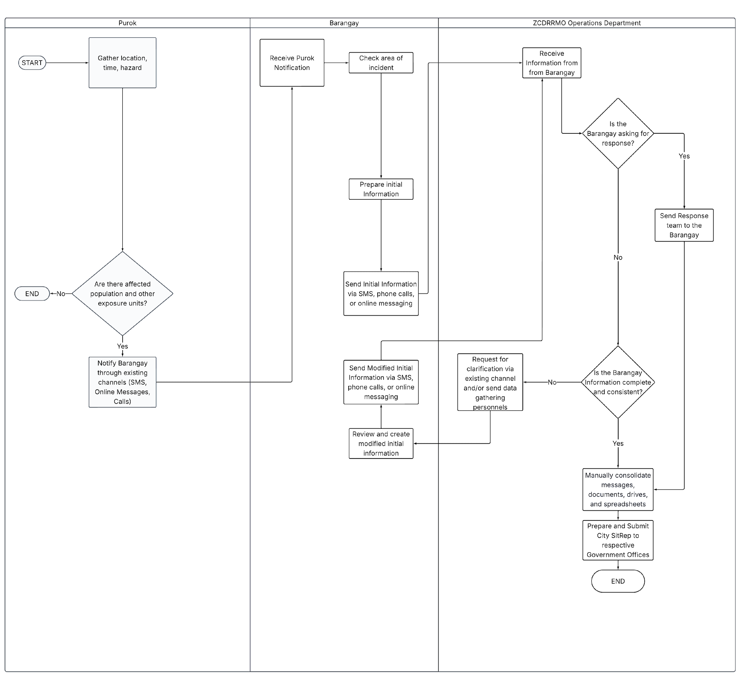
Figure 1. Current Process of Barangay Reporting and ZCDRRMO Situation Report Generation

Statement of the Problem and Purpose
The current disaster-reporting workflow described by the interviewed ZCDRRMO Operations practitioner, Sir Abdel Kanti, contains four related problems: communication delay, manual record management delay, limited data sharing, and inefficient verification. These problems occur at different handoffs between barangay personnel, operational units, assessors, documentation personnel, and approving authorities. These issues, arising as they do at separate points in the reporting process, are best understood as distinct problems rather than a single general one.
    - Communication Delay
Incident information does not always move directly from the barangay to the city disaster office. A. Kanti (ZCDRRMO second interview, March 26, 2026) explained: “Halimbawa yung barangay nilagay mo diyan gagawa sila ng report, kami pa yan tatawag minsan…nagpapadala pa yan kami ng tao to verify. Ang nangyayari, kahit sa submission ng report, we had to call them”. “For example, when a barangay is expected to prepare a report, we still have to call them and may send personnel to verify. Even for report submission, we have to call them” (A. Kanti, ZCDRRMO second interview, March 26, 2026). As mentioned, this creates an additional handoff between local observation, barangay reporting, city follow-up, and consolidation. Until the source responds or supporting information is obtained, the city office may lack a sufficiently documented record for its evolving situational picture. National guidance similarly requires information gathered from originating councils and agencies to undergo verification and validation before official dissemination (NDRRMC, 2024). The problem is therefore not the use of communication channels themselves but the absence of a shared and a visible submission, acknowledgement, and follow-up status.
    - Time Consuming Record-Management
The reporting burden continues after information is received. When asked whether reports still require manual editing, the interviewee answered: “Yes, kaya siya ganon kasimple lang. Pero kay may way na automatic yung generation, maganda sana. … Sinubmit ko yung full, hiningi niya ito, pagkatapos nito, pinasummarize niya pa sa akin”. “Yes, that is why it is kept simple. If there were a way to automate the preparation, that would be useful. I submitted the full version, and afterward I was asked to summarize it again.” (A. Kanti, ZCDRRMO second interview, March 26, 2026). The workflow moves from collected incident information to manual consolidation, recipient-specific editing, review, and sometimes further condensation. Repeated handling consumes staff time and can produce omissions or inconsistent copies whose relationship is difficult to trace. Because disaster information changes across initial, progress, terminal, cumulative situation, and final reports, the required response is not merely one-click document generation. The system must preserve reusable incident data, provenance, status, corrections, and version history while allowing authorized personnel to prepare and review outputs for different recipients (NDRRMC, 2024).
    - Limited Data Sharing
The interview also revealed a knowledge- and record-sharing gap among office functions. A. Kanti (ZCDRRMO second interview, March 26, 2026) stated: “Ibig sabihin, lahat ng alam ko should be shared ... Unfortunately dito sa office natin... ang research and planning division, they don't know ... what we do dito sa training ... operation ... [and] EMS. That's why they cannot effectively come up with situational report.”. “Knowledge should be shared. However, research and planning does not always know what training, operations, and EMS do, which affects its ability to prepare the report effectively”. Information from operational divisions may therefore pass to documentation personnel and return for clarification for correction. This circular handoff can delay consolidation and introduce inconsistent terminology or role descriptions. The remedy, however, is not unrestricted access. The same participant explained that access remains limited even within the office, and disaster records may contain names, health information, casualty details, and other protected data. The proposed system should consequently provide a shared but role-governed incident management function established by RA 10121 while respecting the proportionality, confidentiality, integrity and accountability requirements of the Data Privacy Act and government data-security rules (Republic Act No. 10173, 2012; National Privacy Commission, 2016).
    - Inefficient Verification
Verification remains necessary, but the current routing described in the interview can be human-resource intensive. A. Kanti (ZCDRRMO second interview, March 26, 2026) explained: “Most often than not, we even have to send people to verify which is not effective. ... Pero dahil sa kulang ang tao, iilan lang din ang capable ... apart from ako yung team lead, ako yung lead sa extrication, sa medical services, ako din naglead ng assessment.”. “More often than not, we send people to verify. Because personnel are insufficient and only a few are capable, the same person may lead the team, extrication, medical services, and assessment” (A. Kanti, ZCDRRMO second interview, March 26, 2026). When information is incomplete, indirect, or unsupported, city personnel may call its source or dispatch qualified staff for field assessment. The sequence of receipt, follow-up, dispatch, assessment, documentation, and approval can compete with operational duties. Field verification cannot simply be removed because official reporting requires validation and source documentation (NDRRMC, 2024, pp. 45, 52–55). The bounded problem is the inefficient routing and documentation of verification work. The proposed system should make the source, evidence, assigned reviewer, status, requests for correction, decision, rationale, and timestamps visible while retaining qualified human judgment.

Figure 2 presents the general cross-functional flow of the proposed Integrated Disaster Incident Record Management and Automated Situation Report Generation System. The figure covers account log-in, role identification, incident reporting, profile verification, user management, hazard creation, dashboard access, and report history across four lanes: System User, Purok, Barangay, and DRRM Administrator. The process begins when the user opens the application log-in page and enters log-in credentials. The system checks whether the entered credentials are valid. Invalid credentials end the session, while valid credentials proceed to account-type identification. This step routes the user to one of three lanes based on account type: Purok, Barangay, or DRRM Administrator.
The Purok lane allows the user to create a hazard, report a Purok disaster incident, create a Purok profile, view the system dashboard, or view the Purok incident report history. Incident reports and profile submissions from this lane are sent to the Barangay lane for verification. The Barangay lane allows the user to verify Purok profiles, verify and consolidate Purok incident reports into a Barangay incident report, manage Purok user accounts, create a hazard, view the Barangay incident report history, view the system dashboard, or create a Barangay profile. Barangay incident reports and Barangay profiles are then forwarded to the DRRM Administrator lane for review.
The DRRM Administrator lane allows the user to verify Barangay profiles, verify Barangay incident reports, manage Barangay user accounts, create a hazard, generate a Situation Report, view the Situation Report historical catalog, or manage system user accounts, before reaching the system dashboard. The figure therefore shows the proposed system as a role-based workflow, where each account type performs its own set of functions, and incident and profile data move upward from the Purok level, through the Barangay level, to the DRRM Administrator level for verification, consolidation, and system-wide user management.

Figure 2 Proposed Online Integrated Disaster Incident Record Management and Automated Situation Report Generation System Flowchart
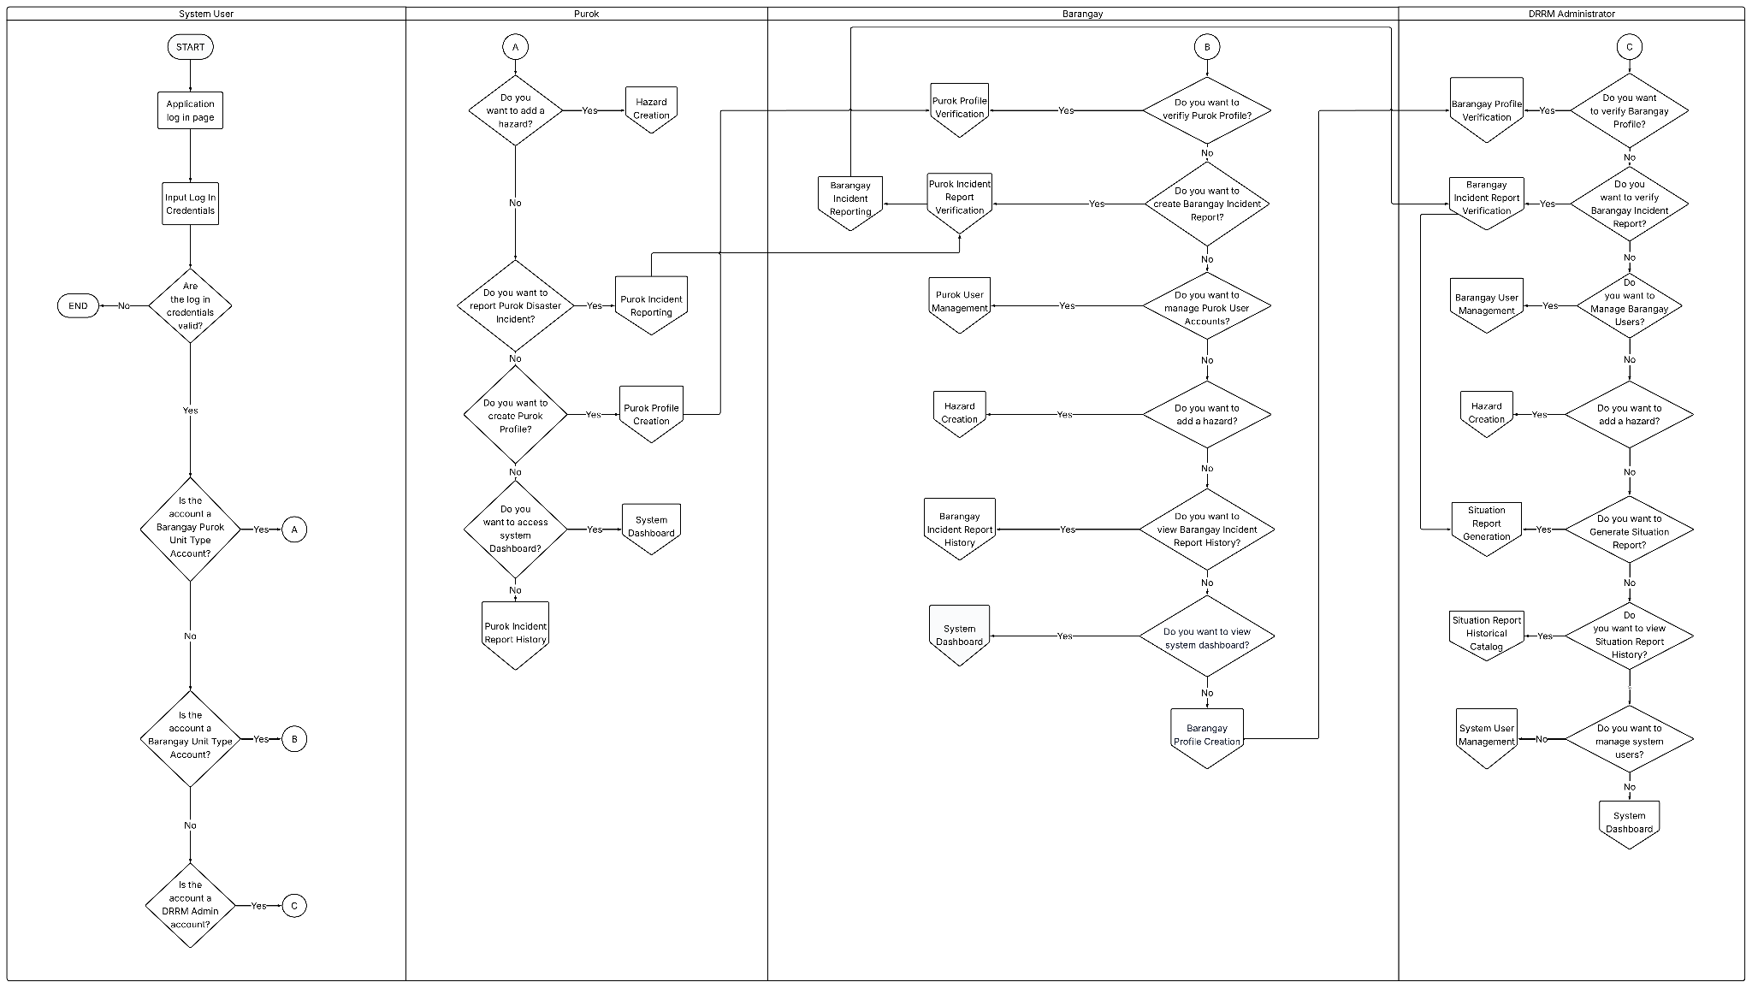
Figure 3 shows how the Purok User Management module handles account creation. The process begins through the Purok User Management connector, where an authorized user inputs the Purok account details. These details, along with the account credentials and the assigned barangay, are then prepared for account creation.
The system proceeds to confirm the Purok account creation, and the finalized account information is stored in the Accounts Database. Once the account is created, the system sends a Purok account creation notification to inform the user. The process then returns to the Purok User Management connector, completing the cycle. The figure therefore represents the Purok User Management module as the entry point for registering new Purok-level accounts, covering the input, confirmation, storage, and notification stages of the account creation process.

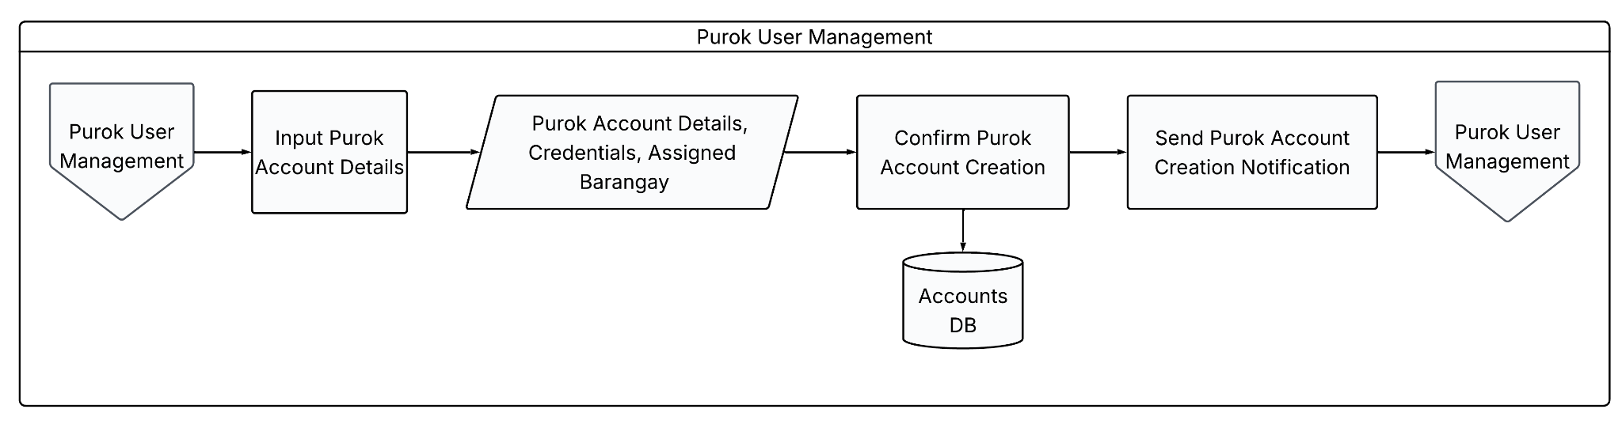
Figure 3. Purok User Management Flowchart

Figure 4 shows how the Purok Profile Creation module is facilitated within the system. The process begins with the Purok Profile Creation function, where an authorized user initiates the creation of a new purok profile record. The user then enters the purok profile details, which include the purok identification, population, housing and vulnerability information, and hazard exposure data. These details capture the essential characteristics of the purok needed for community profiling and disaster-related assessment.
Once the profile details are entered, the information is stored in the Purok Profile Database, which serves as the central repository for all recorded purok profiles. The completed and stored record is then made available through the Purok Profile Creation output, confirming that the profile has been successfully generated and saved. The figure therefore represents the process of establishing a purok's baseline profile, from data entry to storage, forming the foundational record used for monitoring population, housing, and hazard-related conditions at the community level.

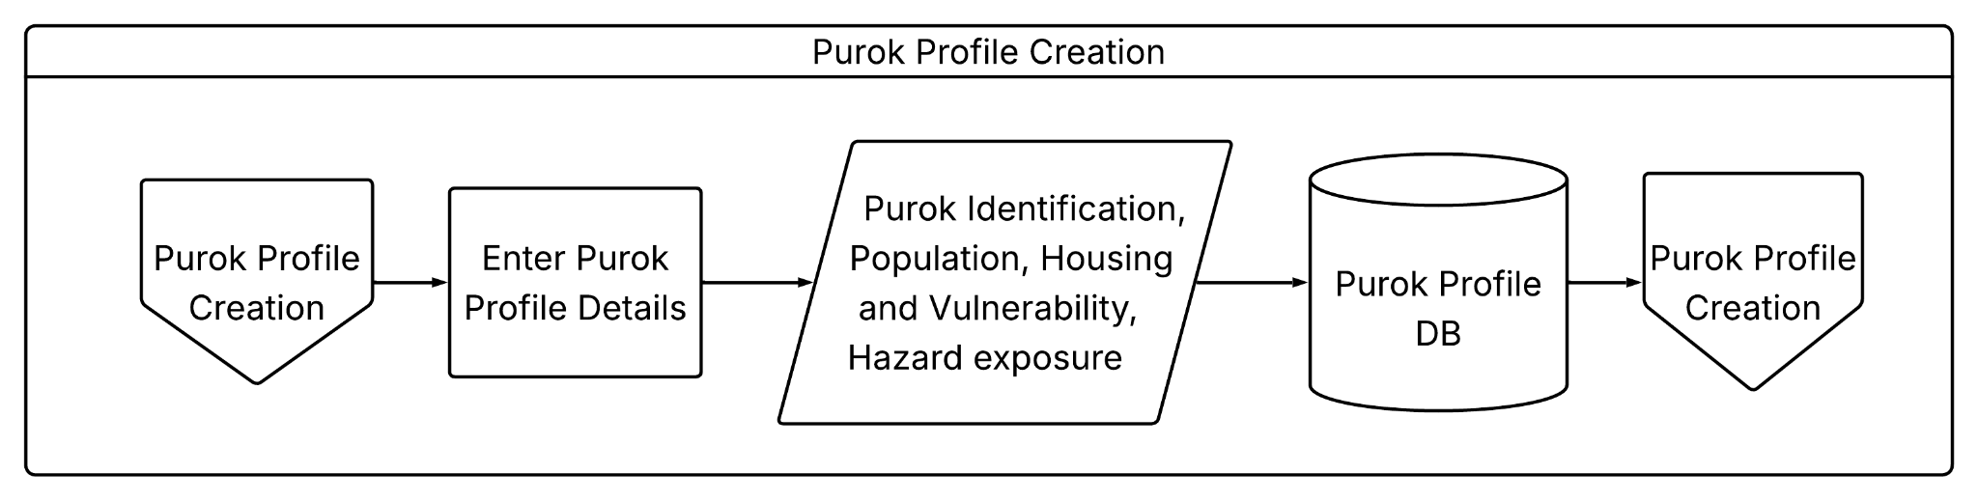
Figure 4. Purok Profile Creation Flowchart

Figure 5 illustrates the Purok Profile Verification process of the proposed system. The process begins with the Purok Profile Verification start point and proceeds to display the Purok Profile Entry for review. The submitted profile is then cross-checked against available references to confirm the accuracy of its details.
The system determines whether the information in the Purok Profile is accurate and verified. When the details do not meet the verification requirements, the system generates a request and notifies the relevant Purok user for Purok Profile modification. When the details are confirmed to be accurate, the system sends a verification notification and finalizes the Purok Profile Details.
The Purok Profile Database supplies the source information used in this process, covering Purok identification, population, housing and vulnerability, and hazard exposure data. The figure therefore represents profile verification as a validation step that relies on reference-based cross-checking, ensuring that only accurate and confirmed Purok Profile information is retained for use by the system.

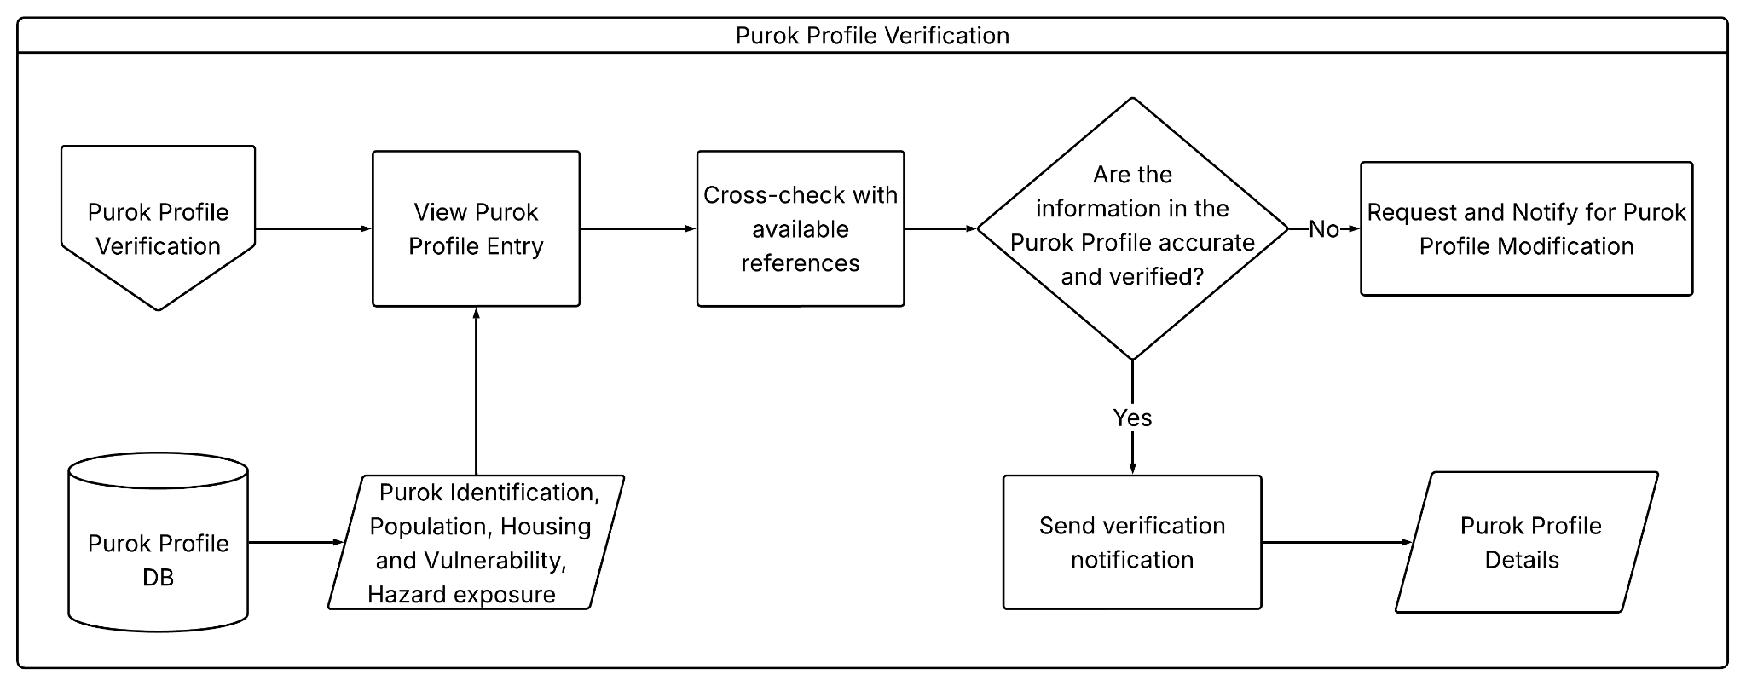
Figure 5. Purok Profile Verification Flowchart

Figure 6 shows how the Incident Reporting Module is facilitated at the Purok level. The process begins with the Purok Incident Reporting function and determines whether there is a request to update an existing Purok Incident Report. If an update request exists, the authorized user modifies the incident report information through version control. The modified report details and their corresponding exposure units version are then stored in the Purok Incident Report Database.
When there is no update request, the process determines whether the user intends to create a new incident report instance. If a new report is required, the user creates the Purok Incident Report and supplies its report details, exposure units, and hazard information. The submitted information is saved in the Purok Incident Report Database. If the user does not create a new report, the module proceeds directly to the Purok Incident Report History view. Both newly created and modified records are made available through this view, which then returns the process to Purok Incident Report History. The figure therefore represents the Purok module as the initial reporting and record-maintenance point of the system, supporting the creation, versioned modification, storage, and historical viewing of incident reports originating from the community level.

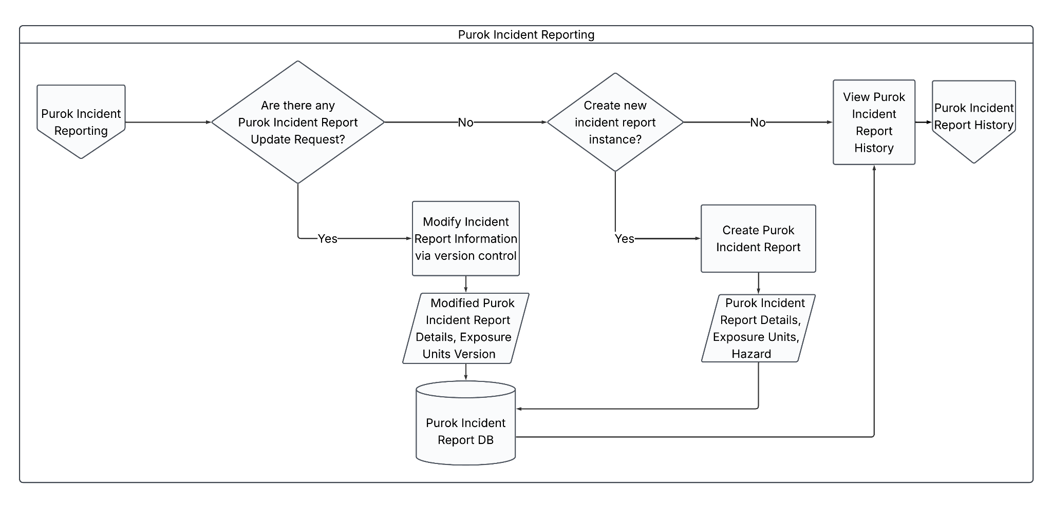
Figure 6. Purok Incident Reporting Flowchart

Figure 7 shows how the Purok Incident Report Verification module confirms the accuracy of a submitted incident report before it is finalized. The process begins when the authorized user opens the Purok Incident Report Verification function, which retrieves the corresponding report from the Purok Incident Report Database for review.
The system then checks whether the report details are accurate and consistent with existing records. If the details do not match, the process sends a request for modification, prompting the user to correct the report before it can be verified again. If the details are accurate and verified to be correct, the system sends a verification notification and stores the verified report back in the Purok Incident Report Database. The verified record is then made available through the Purok Incident Report Verification output, completing the process.

Overall, the figure illustrates how the module safeguards data quality by ensuring that only accurate and cross-checked incident reports are confirmed and stored, supporting the reliability of records maintained at the community level.

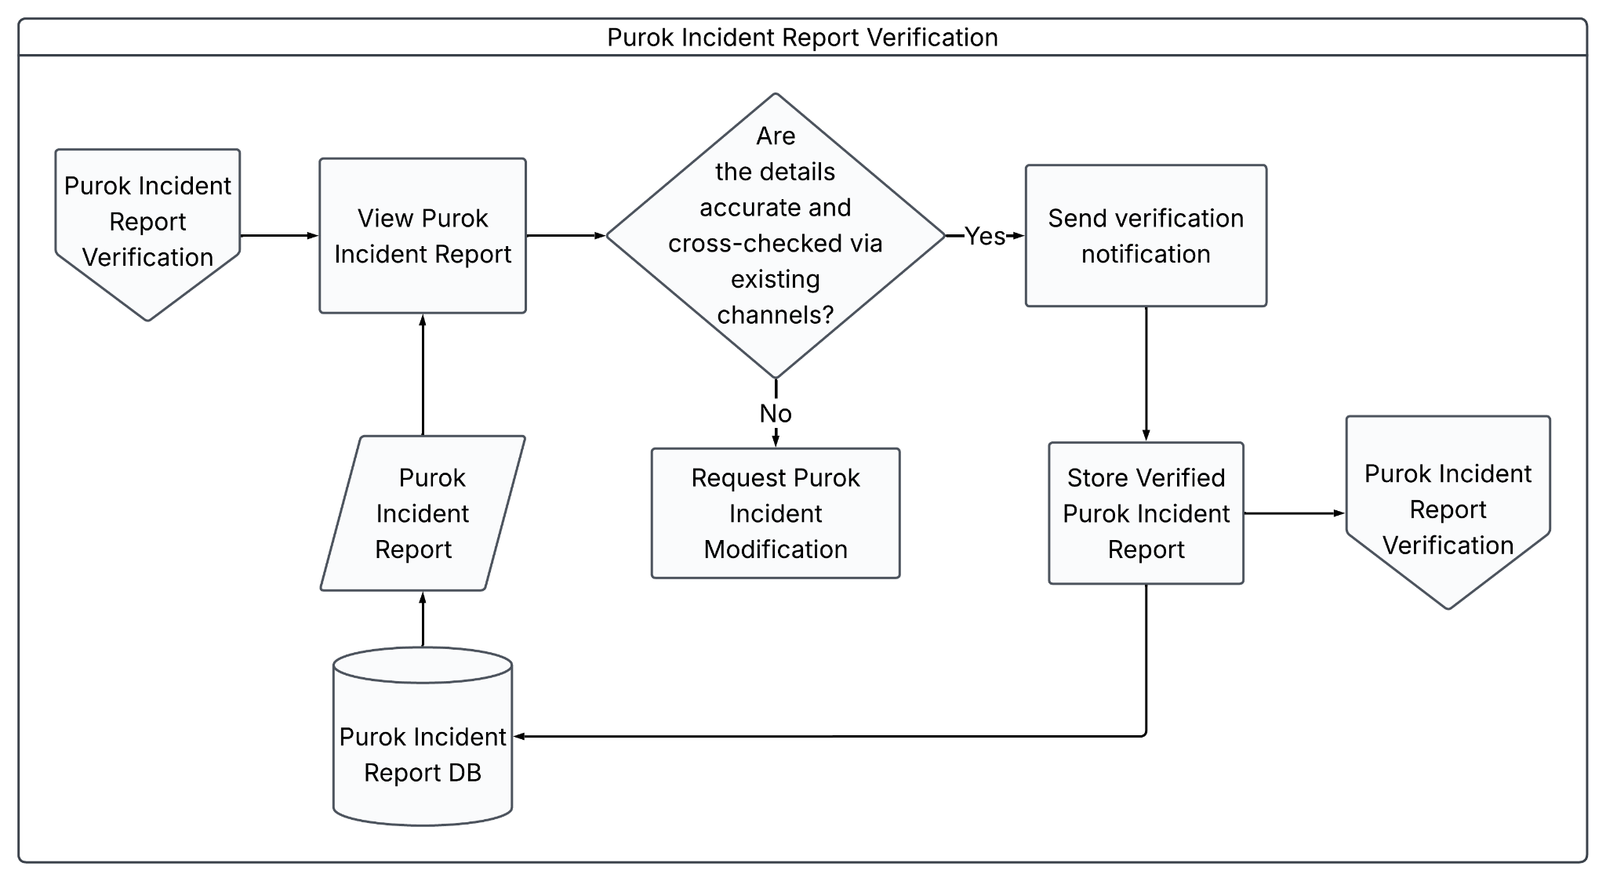
Figure 7. Purok Incident Report Verification Flowchart

Figure 8 illustrates how the Purok Incident Report History process retrieves and displays incident report records at the Purok level. The process begins with the Purok Incident Report History function, which initiates the request to view existing incident reports. This request is passed to the View Purok Incident Reports process, which retrieves the corresponding data from the Purok Incident Reports data store. The data store, in turn, draws its records from the Purok Incident Report Database, ensuring that only the most current and accurate report information is displayed to the user.
Once the incident reports are retrieved, the View Purok Incident Reports process forwards the data to the View Purok Incident Report History process, which compiles and presents the historical records to the user. This process also pulls Purok Incident Report Versions Data, sourced from the Purok Incident Report Database, to display the different versions of each report over time. The figure therefore represents the Purok module's retrieval and presentation of incident report records, allowing users to view both current reports and their version history for reference and monitoring purposes.

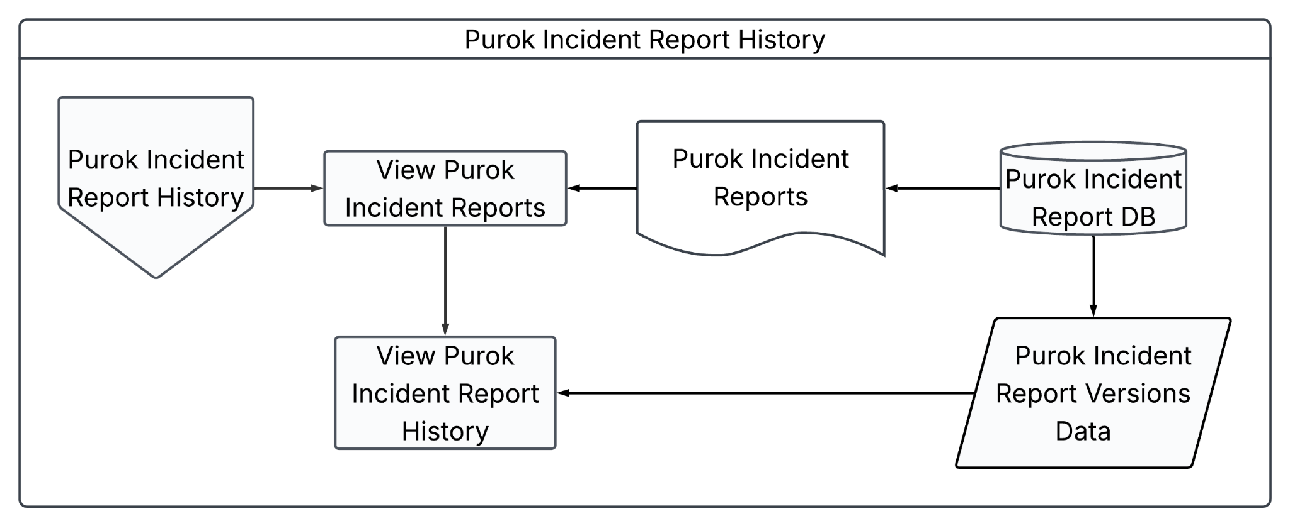
Figure 8. Purok Incident Report History Flowchart

Figure 9 illustrates the account creation process within the Barangay User Management module. The process begins at the Barangay User Management connector, which leads into the account creation workflow. An authorized user inputs the barangay account details required to set up a new account. These details, along with the generated credentials, are then passed forward for confirmation.
The system confirms the barangay account creation, and once verified, the account details are stored in the Accounts Database. After the account is successfully created and saved, the system sends a barangay account creation notification to inform the user that the account has been set up. The process then returns to the Barangay User Management connector, completing the cycle. This figure illustrates how the module handles the creation, validation, storage, and notification of new barangay user accounts within the system.

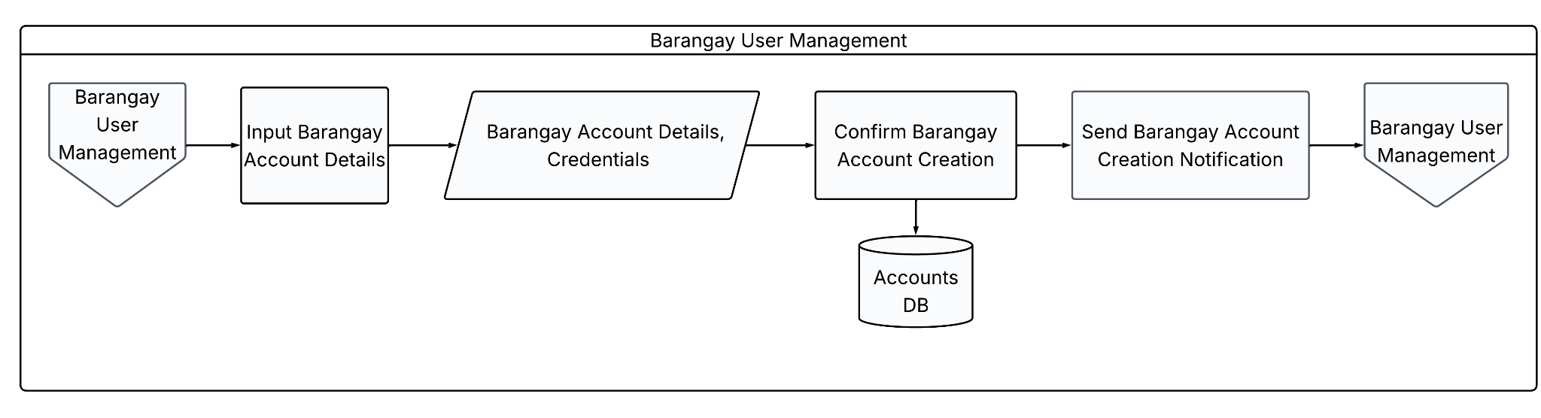
Figure 9. Barangay User Management Flowchart

Figure 10 illustrates how the Barangay Profile Creation process is carried out at the barangay level. The process begins with the Barangay Profile Creation step, which checks whether the Purok Profile has been verified. If the Purok Profile is not yet verified, the system requests and notifies the relevant Purok user to modify the Purok Profile before proceeding. This ensures that only verified data moves forward in the process.
Once the Purok Profile is verified, its details are retrieved from the Purok Profile Database and consolidated to form a complete set of Purok Profile Data. This consolidated data is then used to create the Barangay Profile. The resulting Barangay Profile Details are saved in the Barangay Profile Database, completing the Barangay Profile Creation process. The figure therefore illustrates how verified Purok-level data serves as the foundation for generating an accurate and consolidated Barangay Profile.

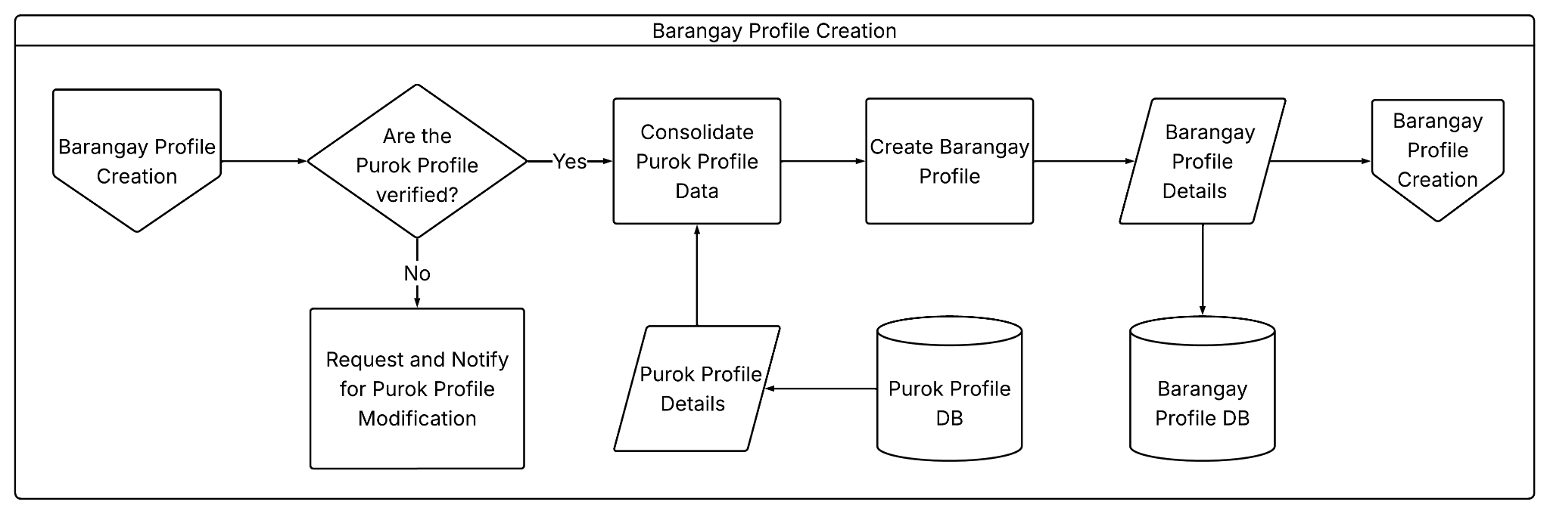
Figure 10. Barangay Profile Creation Flowchart

On the other hand, Figure 11 presents the Barangay Profile Verification process of the proposed system. The process begins with the Barangay Profile Verification step, which retrieves the Barangay Profile Entry for review. The entry consists of consolidated Purok data covering identification, population, housing and vulnerability, and hazard exposure, all retrieved from the Barangay Profile Database.
Once the profile entry is displayed, it is cross-checked against available references to validate its content. The system then determines whether the information in the Barangay Profile is accurate and verified. If the information is found to be inaccurate or unverified, the system requests and notifies the responsible Barangay user to modify the Barangay Profile accordingly. If the information is confirmed accurate and verified, a verification notification is sent, and the corresponding Barangay Profile Details are finalized. The figure therefore illustrates how the system ensures the reliability of barangay-level data through reference-based validation before the profile is confirmed as verified.

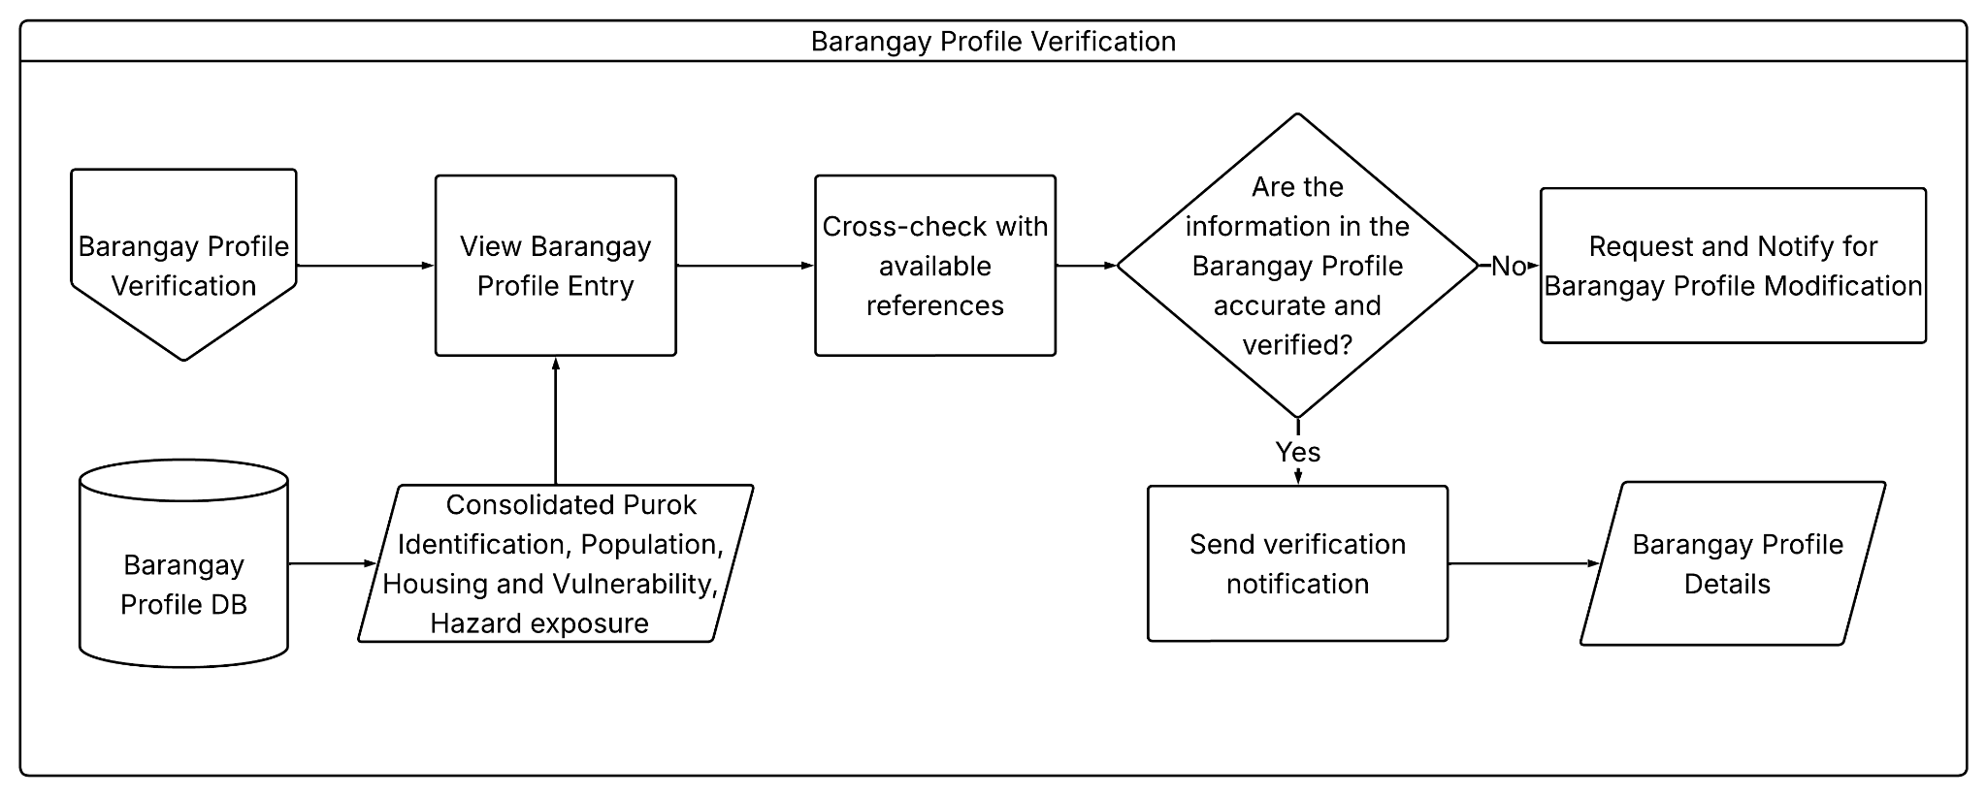
Figure 11. Barangay Profile Verification Flowchart

Figure 12 shows how the Barangay Incident Reporting process is carried out at the barangay level. The process begins with the Barangay Incident Reporting step, which checks whether there is a Barangay Incident Report Update Request. If an update request exists, the report information is modified via version control, and the modified report is submitted. The resulting Modified Barangay Incident Report Details, along with hazard, exposure units, and version information, are then stored in the Barangay Incident Database.
If there is no update request, the process checks whether there are any Purok Incident Reports. When Purok Incident Reports exist, the system further checks whether they are verified and correct. If they are not verified and correct, the concerned Purok is notified to make the necessary corrections. If the reports are verified and correct, they are consolidated into a Barangay Incident Report, which is then submitted. The submitted report, together with its hazard, exposure units, and version details, is likewise stored in the Barangay Incident Database.
When there are no Purok Incident Reports to process, the module proceeds directly to the Barangay Incident Report History view, which retrieves the stored records from the Barangay Incident Database. The figure therefore represents the Barangay module as the consolidation and record-maintenance point of the system, supporting the modification, verification, storage, and historical viewing of incident reports at the barangay level.

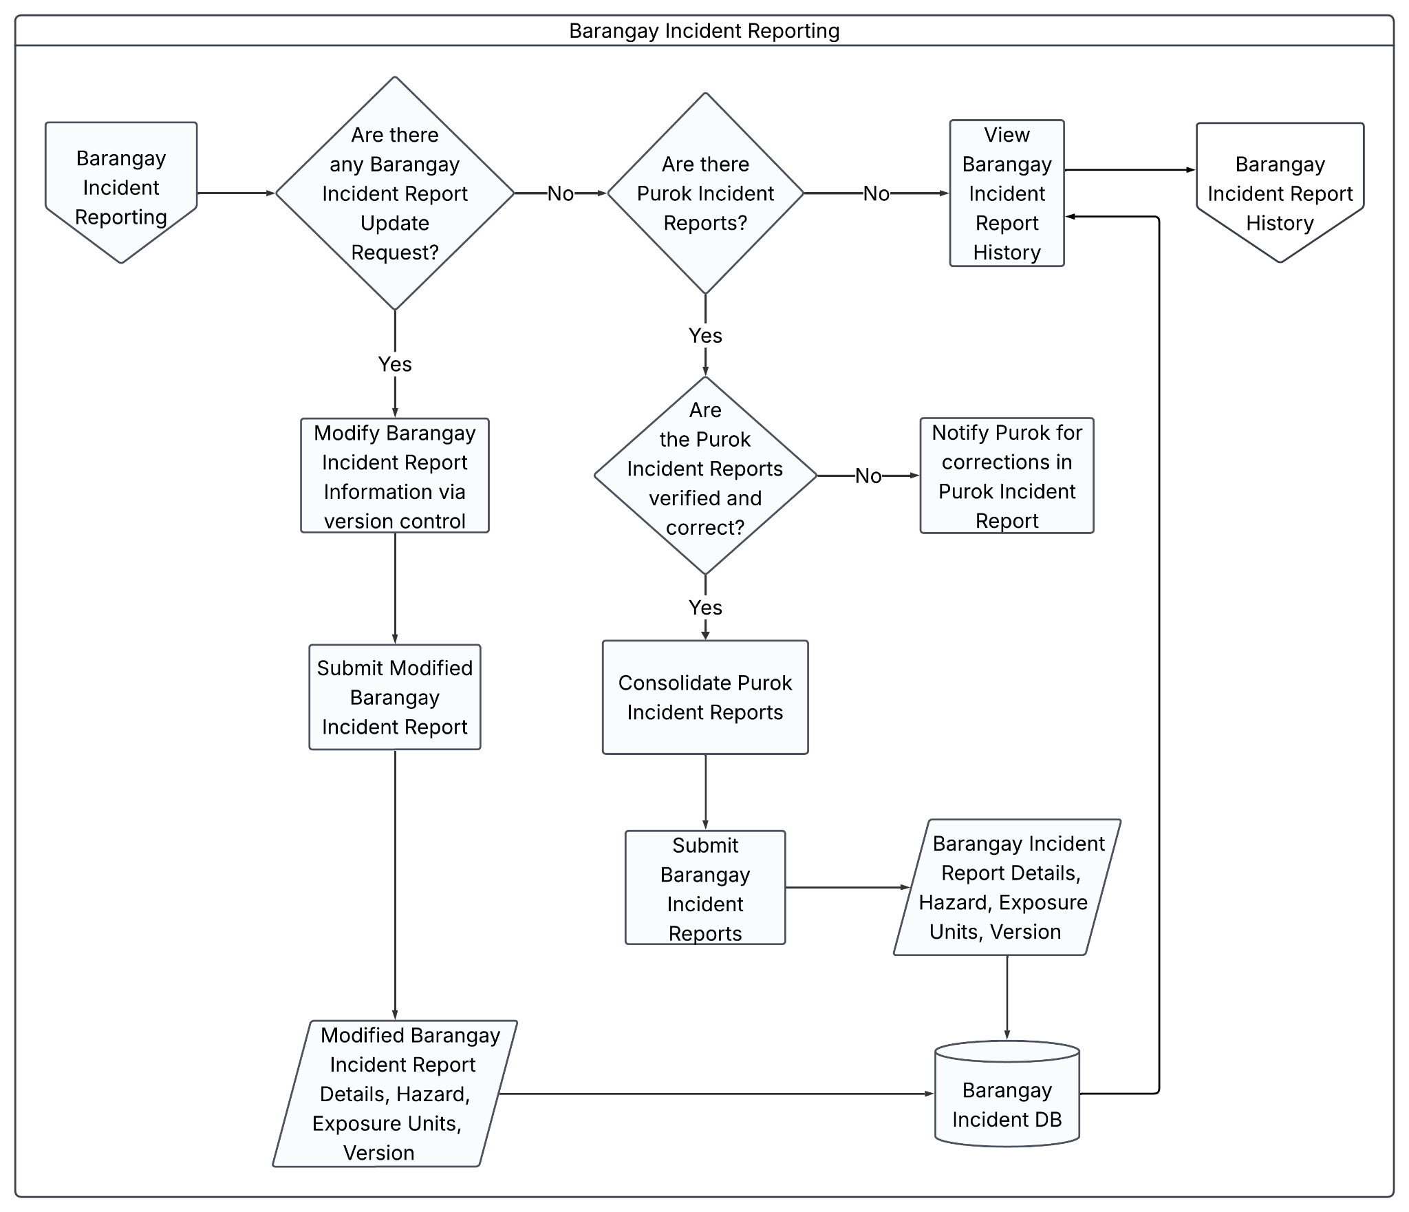
Figure 12. Barangay Incident Reporting Flowchart

Figure 13 shows how the Barangay Incident Report Verification process is carried out. The process begins with the Barangay Incident Report Verification step, which checks whether there are new Barangay Incident Reports. If none exist, the system checks whether there is a new Barangay Incident report modification notification. When neither condition is present, the process proceeds directly to view existing Barangay Incident Reports, which are retrieved from the Barangay Incident Report Database, leading to the Barangay Incident Report History.
If new Barangay Incident Reports exist, or if a modification notification is present, the system checks whether the Barangay Incident reports are verified. If they are not yet verified, a Barangay Incident Report modification request is sent so the necessary corrections can be made. If the reports are verified, they are consolidated into Barangay Incident Report Data along with their version information, which is then stored in the Barangay Incident Report Database. The figure therefore illustrates how the system validates barangay-level incident reports, whether newly submitted or modified, before making them available for viewing and historical reference.

Figure 13. Barangay Incident Report Verification Flowchart
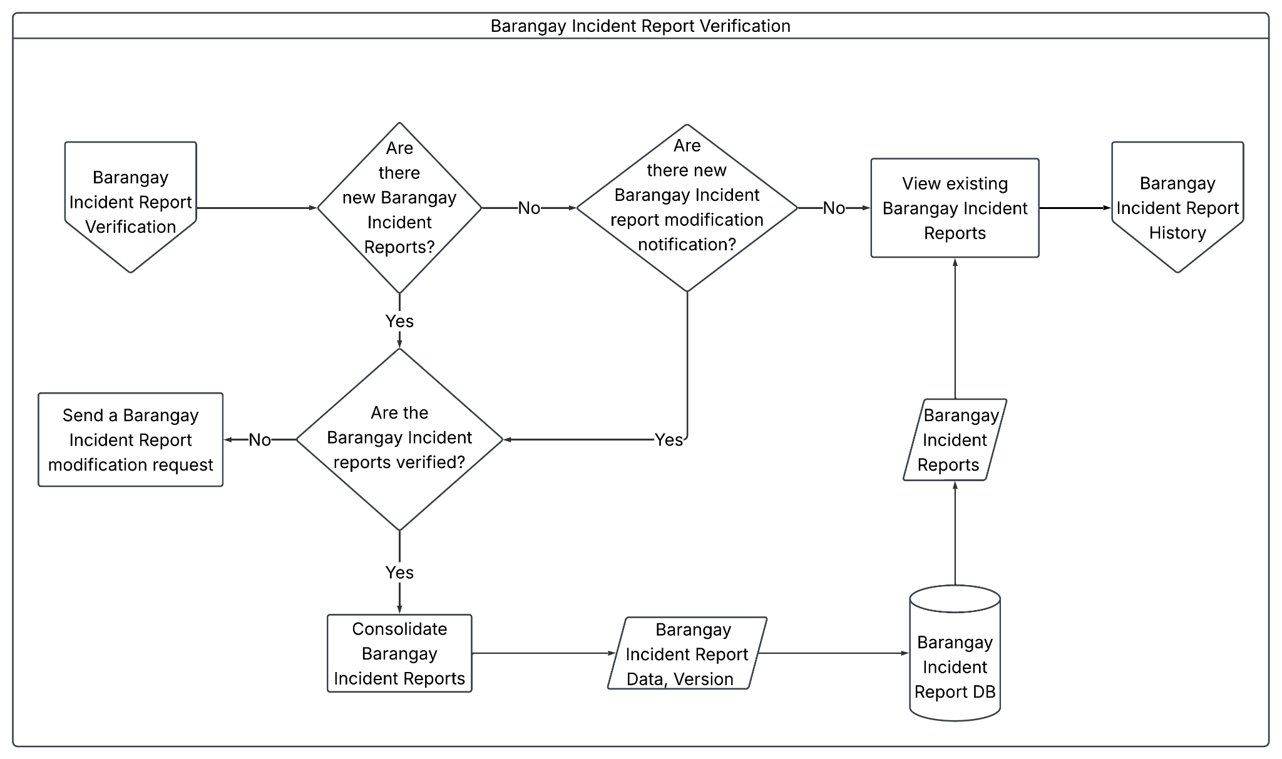

Figure 14 shows how the Barangay Incident Report History process is carried out. The process begins with the Barangay Incident Report History step, which leads to viewing the Barangay Incident Reports. These reports are retrieved from the Barangay Incident Report Database and displayed as a Barangay Incident Reports document for reference.
The Barangay Incident Reports view then leads to the View Barangay Incident Report History step, which displays the Barangay Incident Report Versions Data retrieved from the database. This allows users to trace the different versions of a report over time. The figure therefore illustrates how the system retrieves, displays, and maintains a historical record of barangay-level incident reports, enabling users to review both current reports and their prior versions.

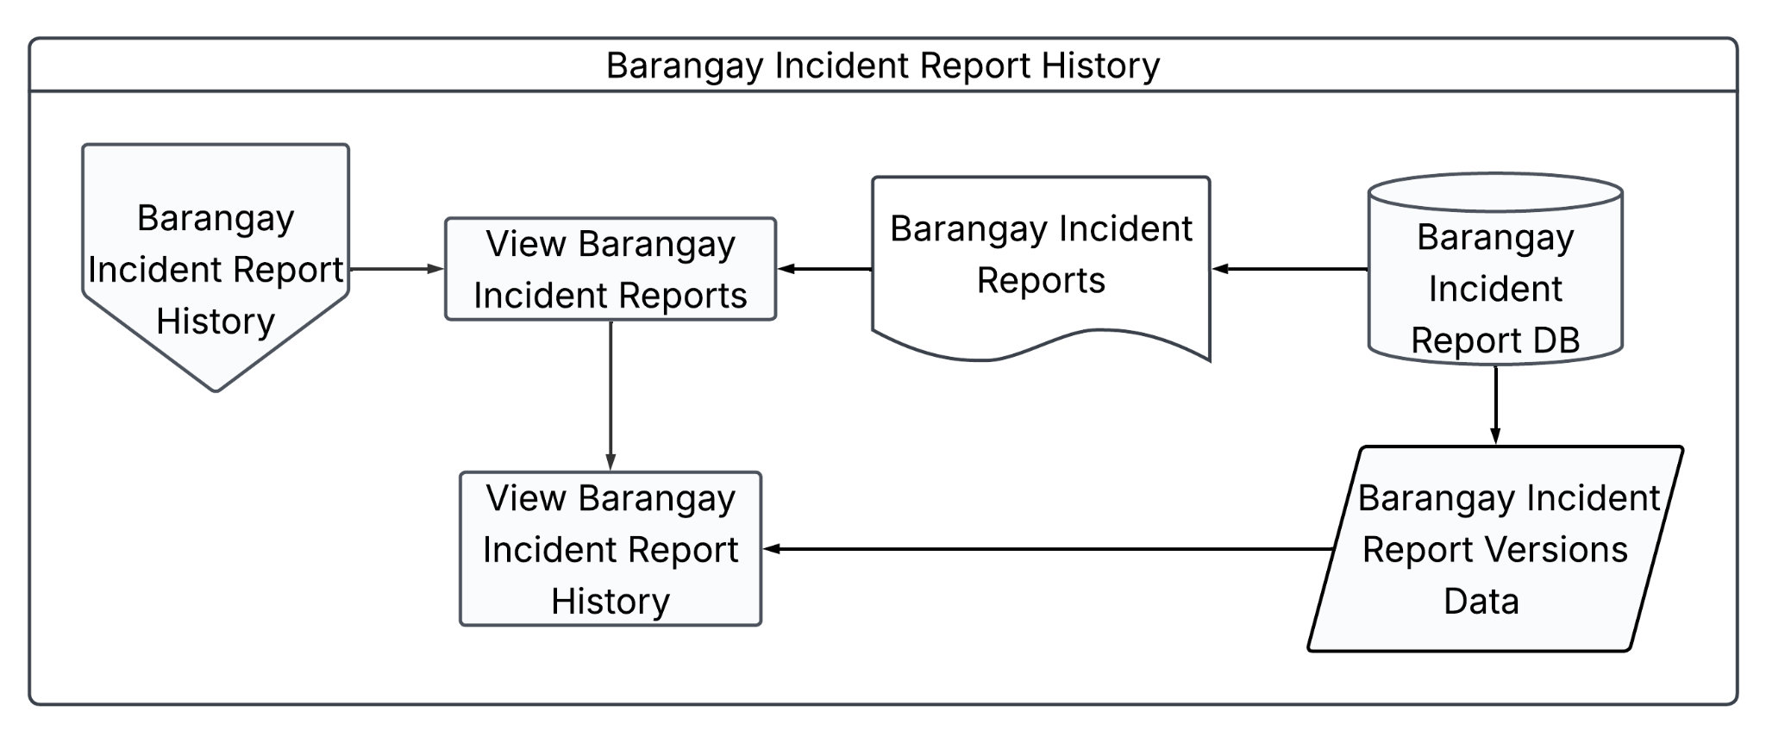
Figure 14. Barangay Incident Report History Flowchart

Figure 15 presents the System User Management process, which handles the creation and modification of system user accounts. The process begins at the System User Management connector and proceeds to Input Account Details, where the authorized user enters the necessary account information. This includes the account details, credentials, assigned role, and reason for the account action, which are passed forward for processing.
The system then proceeds to Confirm Account Creation/Modification, where the entered information is validated and saved to the Accounts Database. Once the account record is stored, the process moves to Send and Audit Account Creation/Modification, where the system logs the transaction for audit purposes and notifies the relevant user of the completed action. The process concludes by returning to the System User Management connector, completing the cycle. The figure therefore illustrates System User Management as a controlled process for creating and modifying user accounts, supported by validation, database storage, and audit logging to maintain accountability and data integrity.

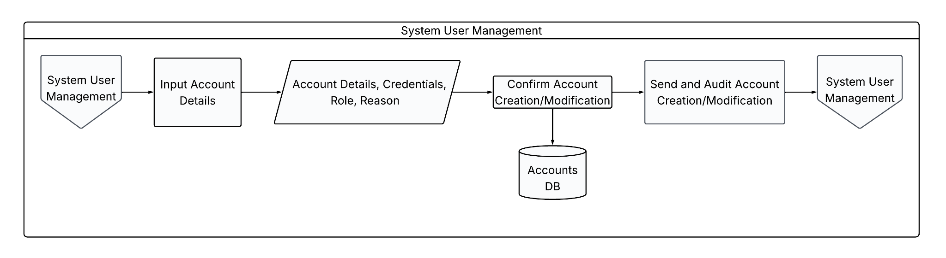
Figure 15. System User Management Flowchart

Figure 16 illustrates how the Hazard Creation process is carried out. The process begins with the Hazard Creation step, where the user inputs the Hazard Details, including the hazard date and time, hazard code or name, description, and location. The user then inputs the Hazard Type.
The system checks whether the entered Hazard Type is one of the hazard types determined in the CDRA Hazard Type. If it is not, the user is prompted to create a new specific hazard type before proceeding. If the Hazard Type matches an existing CDRA Hazard Type, the system proceeds to create the Hazard, completing the Hazard Creation process. The figure therefore illustrates how the system ensures that every recorded hazard is properly classified, either by matching it to an existing CDRA hazard type or by defining a new specific type when needed.

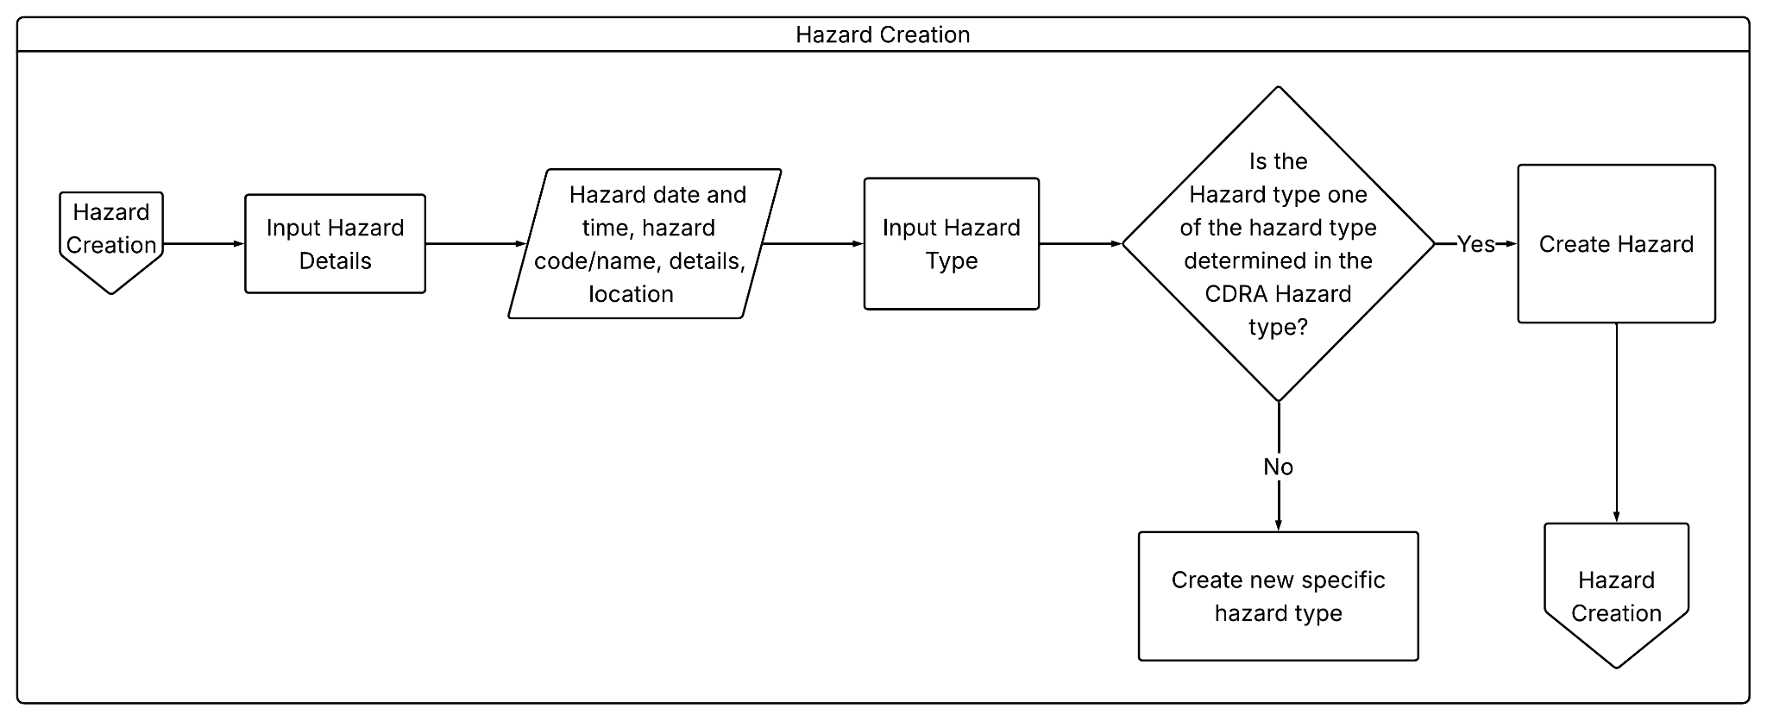
Figure 16. Hazard Creation Flowchart

Figure 17 shows how the Situation Report Generation module produces and maintains situation reports. The process begins by checking whether a current situation report update exists. If no update exists, the system consolidates the related barangay incident reports and produces the consolidated barangay incident information along with its version. This consolidated information is then used to create a new situation report, which is saved in the Situation Report Database.
If an update exists, the system retrieves the related barangay incident reports and produces the updated barangay incident report data. This updated data is used to modify the current situation report, along with its corresponding version. The modified report and version are then saved in the Situation Report Database. The figure therefore represents the Situation Report Generation module as responsible for both creating new situation reports and updating existing ones, ensuring that barangay incident reports are properly consolidated, version-controlled, and stored for reference.

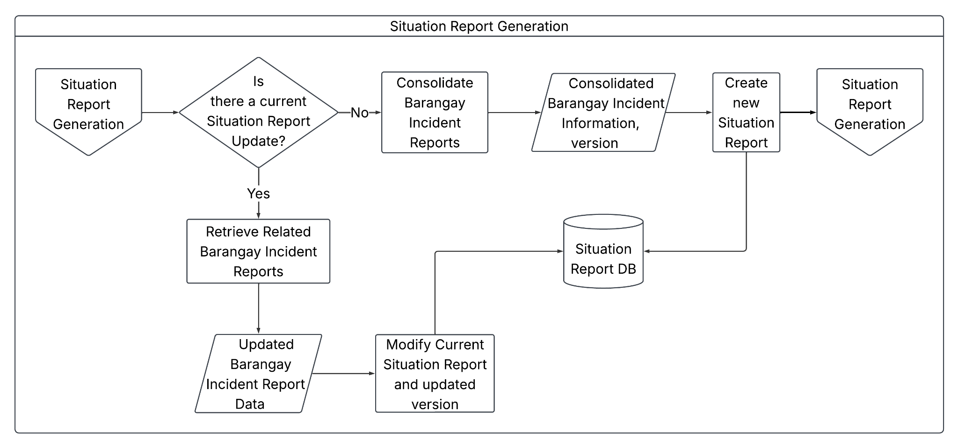
Figure 17. Situation Report Generation Flowchart

Figure 18 illustrates how the Situation Report Historical Catalog module allows users to view situation reports and their version history. The process begins through the Situation Report Historical Catalog connector, which leads to the View Situation Reports process. This process retrieves the situation reports document from the Situation Report Database and displays it to the user.
The retrieved situation reports are then passed to the View Situation Report History process, which also retrieves the situation report versions data from the Situation Report Database. This step allows the user to view the different versions of a situation report over time. The process then leads back to the Situation Report Historical Catalog, completing the cycle. The figure therefore represents the module as the viewing and reference point of the system, allowing users to access both current situation reports and their historical versions stored in the database.

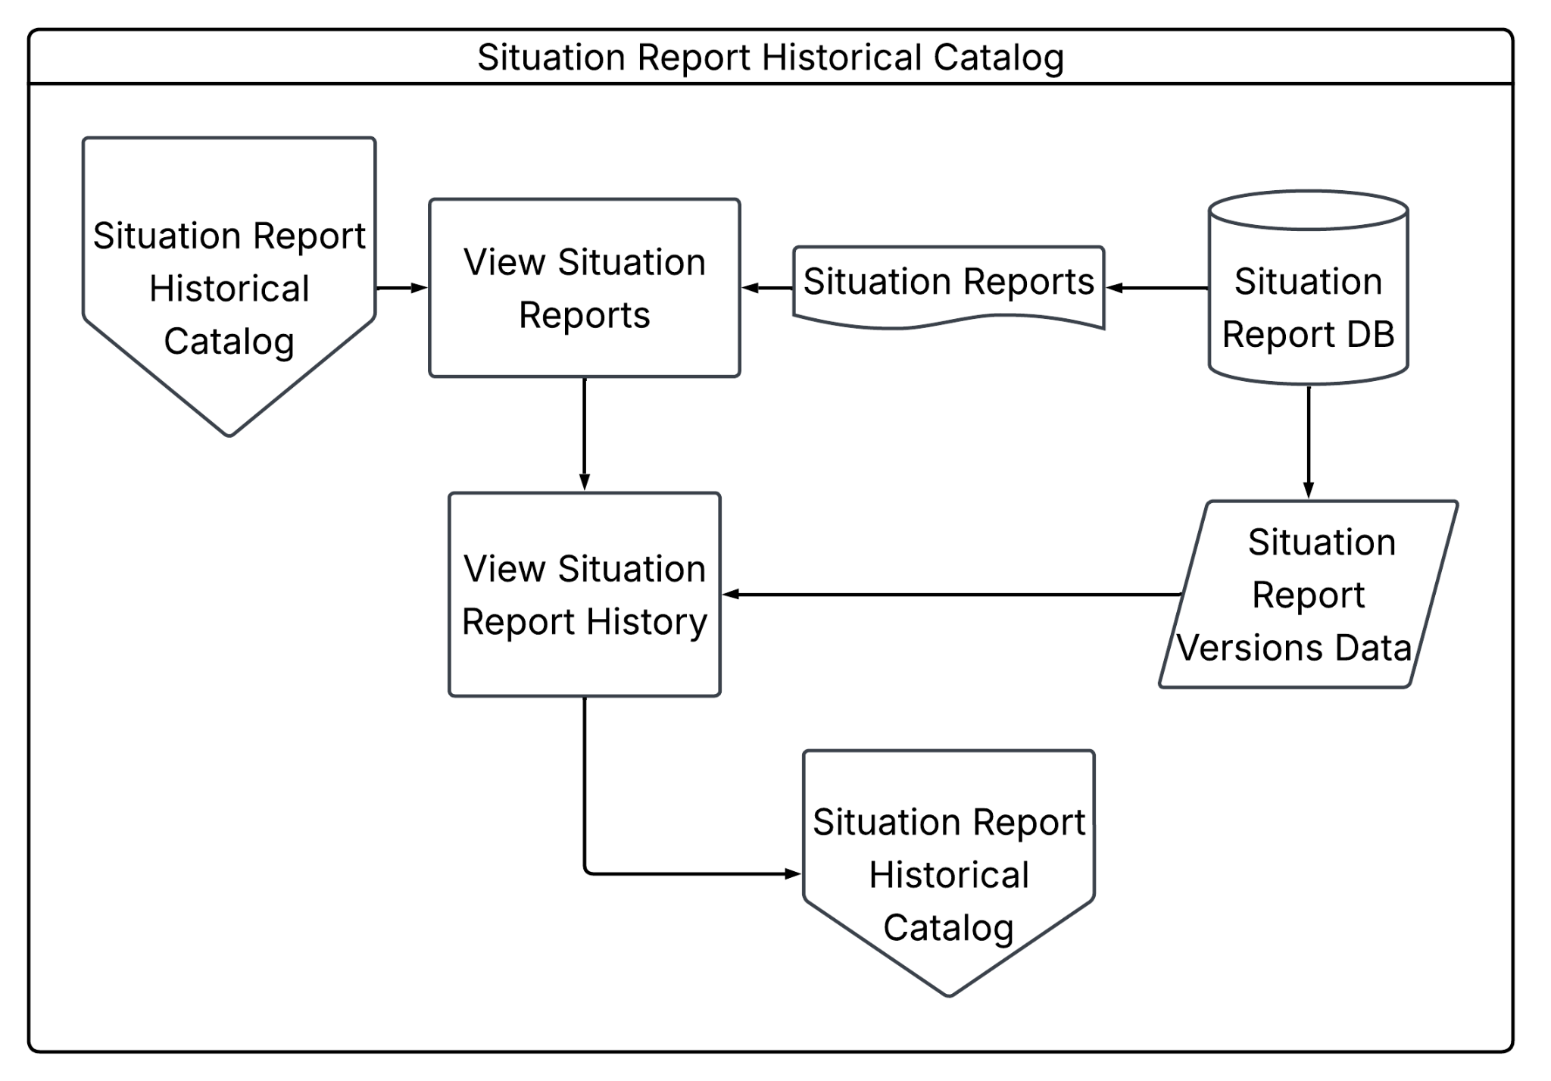
Figure 18. Situation Report Historical Catalog Flowchart

Finally, Figure 19 shows how the System Dashboard module determines and displays content based on the account's unit type. The process begins by checking whether the account is of the Purok unit type. If it is, the system retrieves the Purok incident reports data from the Purok Incident Report Database and uses it to display the Purok dashboard page.
If the account is not a Purok unit, the system checks whether it is of the Barangay unit type. If it is, the system retrieves the barangay incident reports data from the Barangay Incident Report Database and uses it to display the Barangay dashboard page.
If the account is not a Barangay unit, the system checks whether it is a DRRM Administrator type. If it is, the system retrieves the incident data, affected population data, and situation report data from their respective databases, and uses this information to display the DRRM Administrator dashboard page. If the account does not match any of these unit types, the system denies access to the pages. The figure therefore represents the System Dashboard module as the access-control and entry point of the system, ensuring that each account type is directed to the appropriate dashboard view based on its assigned role.

Figure 19. System Dashboard Flowchart
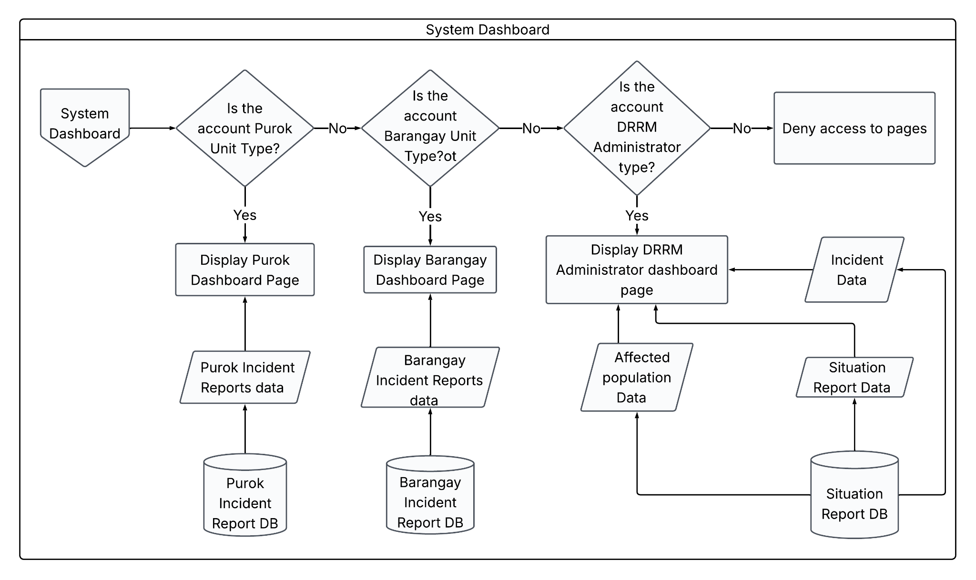

Objectives

General Objective
The general objective of this research is to design, develop, and evaluate a centralized, role-based Online Integrated Disaster Incident Record Management and Automated Situation Report Generation System that streamlines grassroots disaster reporting and automates National Disaster Risk Reduction and Management Council (NDRRMC) SitRep consolidation for Local Government Units (LGUs)

Specific Objectives
- To develop a Purok User Management Module that registers Purok-level accounts and links each one to its assigned barangay for jurisdictional routing, achieving 100% successful account creation, barangay assignment, and notification delivery with no duplicate or unsaved records during testing.
- To develop a Purok Profile Creation Module that captures purok identification, population, housing, vulnerability, and hazard exposure data as the community's baseline profile, correctly storing 100% of required fields with no data loss upon submission.
- To develop a Purok Profile Verification Module that allows authorized reviewers to cross-check each individually submitted purok profile against reference data before it is confirmed, achieving a 100% correct verification decision rate during user acceptance testing.
- To develop a Purok Incident Reporting Module that allows authorized users to create and modify initial community-level incident reports with exposure units, hazard information, version history, and visible submission status, enforcing 100% required-field validation and accurate version tracking across at least three consecutive report revisions.
- To develop a Purok Incident Report Verification Module that allows Barangay personnel to compare submitted report sources and versions, flag duplicate or conflicting entries, and validate, partially validate, return, or reject a Purok report with a recorded reason, preserving the original submission, responsible actor, timestamps, evidence references, decision, and subsequent corrections in an append-only history, and achieving a 100% correct verification decision rate during user acceptance testing.
- To develop a Purok Incident Report History Module that retrieves and displays current and past versions of individual purok-level incident reports, correctly returning 100% of stored report versions.
- To develop a Barangay User Management Module that allows authorized DRRM Administrators to input barangay account details and register new barangay-level accounts with system-generated credentials, achieving 100% successful account creation, credential generation, and notification delivery with no duplicate or unsaved records during testing.
- To develop a Barangay Profile Creation Module that consolidates verified Purok profile data into a complete barangay-level profile record, requiring Purok Profile verification as a prerequisite and correctly consolidating data from 100% of verified Purok profiles with no missing or mismatched fields.
- To develop a Barangay Profile Verification Module that allows authorized reviewers to cross-check the consolidated multi-purok barangay profile against reference data before it is confirmed, achieving a 100% correct verification decision rate during user acceptance testing.
- To develop a Barangay Incident Reporting Module that consolidates verified Purok reports into a detailed Barangay Incident Report with visible submission status, supporting update requests and returning unverified Purok reports for correction, correctly consolidating 100% of verified reports with accurate version tracking.
- To develop a Barangay Incident Report Verification Module that allows DRRM Administrators to detect newly submitted or modified barangay reports awaiting review, verify their accuracy against existing records, and consolidate verified reports into the Barangay Incident Report Database with version tracking, comparing sources and flagging duplicate or conflicting entries and validating, partially validating, returning, or rejecting a report with a recorded reason, preserving the original submission, jurisdiction, responsible actor, timestamps, evidence references, decision, and subsequent corrections in an append-only history, and achieving a 100% correct verification decision rate during user acceptance testing.
- To develop a Barangay Incident Report History Module that retrieves and displays current and past versions of consolidated, multi-purok barangay-level incident reports, correctly returning 100% of stored report versions.
- To develop a Barangay Incident Report History Module that retrieves and displays current and past versions of consolidated, multi-purok barangay-level incident reports, correctly returning 100% of stored report versions.
- To develop a System User Management Module that allows DRRM Administrators to view, edit, activate, and suspend accounts across the Purok, Barangay, and Administrator levels, achieving 100% accurate reflection of account status changes with zero unauthorized modifications during security testing.
- To develop a Hazard Creation Module that allows authorized users to record hazard details and classify each entry against an existing CDRA hazard type or define a new one, correctly classifying 100% of hazard entries with no unclassified records during testing.
- To develop a Situation Report Generation Module that consolidates verified barangay incident reports into a new or updated Situation Report using the official NDRRMC SitRep template, tagging report type, number, and reporting period, and routing each output through authorized human review and approval before release, accurately reflecting 100% of verified barangay reports in the generated output.
- To develop a Situation Report Historical Catalog Module that allows authorized users to view, search, filter, compare, export, correct, and supersede SitReps while preserving prior approved versions, classification, retention information, legal or archival holds, and audit history, correctly returning 100% of stored report versions.
- To develop a System Dashboard Module that presents role-specific summaries of disaster incidents, affected populations, report status, verification activity, SitRep coverage, and processing time, distinguishing provisional from verified values and disclosing applied filters and last update, achieving 100% correct role-based content routing with zero unauthorized dashboard access during security testing.

Scope and Limitations
This study covers the design, development, and prototype evaluation of a centralized, role-based, responsive web system, the Online Integrated Disaster Incident Record Management and Automated Situation Report Generation System. The platform is conceived as a configurable service for participating disaster risk reduction and management (DRRM) organizations rather than as a system permanently owned and administered by only one DRRMO. ZCDRRMO serves as the original study setting and may serve as the pilot organization, but each participating organization retains authority over its jurisdiction, users, reporting route, verification and approval decisions, records, disclosures, and official submission. The technical operator maintains the service but does not acquire the statutory authority of an LDRRMO, local government, incident command system authority, or national agency.
The system follows a three-level role structure: Purok, Barangay, and DRRM Administrator. Each level has its own set of modules for account management, profiling, incident reporting, and verification, while report consolidation, hazard classification, situation report generation, and system-wide oversight remain with the DRRM Administrator. For instance, a Purok user may create and submit an incident report to the Barangay for verification, but cannot generate or approve the consolidated Situation Report because that function is reserved for authorized DRRM Administrators.
At the Purok level, the system includes the Purok User Management, Purok Profile Creation, Purok Profile Verification, Purok Incident Reporting, Purok Incident Report Verification, and Purok Incident Report History modules. These modules cover the registration of Purok-level accounts and their assignment to a barangay, the capture of baseline community data such as population, housing, vulnerability, and hazard exposure, and the reference-based cross-checking of that profile before it is confirmed. They also cover the creation and version-controlled modification of initial incident reports with hazard and exposure information, the verification of those reports against existing records, including requests for correction where needed, and the retrieval and display of current and past report versions for reference. Automated validation at this level is limited to syntactic, domain, range, consistency, and possible-duplicate checks. It does not determine the factual accuracy of a report, which remains the responsibility of the human reviewer or verifier. Duplicate and conflict flags likewise assist reviewers but do not automatically merge records or decide which source is authoritative, and material changes to a verified report create a new version rather than replacing the prior submitted or approved record without history.
At the Barangay level, the system includes the Barangay User Management, Barangay Profile Creation, Barangay Profile Verification, Barangay Incident Reporting, Barangay Incident Report Verification, and Barangay Incident Report History modules. These modules mirror the Purok-level structure but operate on consolidated, multi-purok data. Barangay accounts are registered by authorized DRRM Administrators, and barangay profiles are built only from already-verified Purok profiles. Barangay incident reports consolidate verified Purok incident reports, with unverified submissions returned to the originating Purok for correction, and verified barangay-level reports, along with their version history, are stored for later reference and use in situation report preparation. The same validation limits apply at this level: automated checks confirm structure and consistency, not the correctness of the underlying facts, and corrections remain linked to the affected record and reporting period rather than overwriting it.
The system also includes the System User Management, Hazard Creation, Situation Report Generation, Situation Report Historical Catalog, and System Dashboard modules. The System User Management module allows DRRM Administrators to view, edit, activate, and suspend accounts across the Purok, Barangay, and Administrator levels. Removing an account does not erase the authorship or approval history attached to the records that account created or verified. The Hazard Creation module allows authorized users to record hazard details and classify each entry against an existing Climate and Disaster Risk Assessment (CDRA) hazard type, or define a new specific type when the entry does not yet match one on record. Hazard coverage therefore follows the CDRA hazard types adopted by each participating organization rather than a fixed list built into the prototype, allowing the system to accommodate any hazard the organization's CDRA recognizes (e.g., flood, typhoon, fire, landslide, earthquake, storm surge) provided it is classified through the Hazard Creation module. The system does not independently determine or validate hazard classifications; it records and organizes them as defined by the organization's own CDRA and the users authorized to configure it.
Moreover, the Situation Report Generation module consolidates verified barangay incident reports into a new or updated Situation Report using the official NDRRMC SitRep template, tagging report type, number, and reporting period, and routing each output through authorized human review and approval before release. The prototype covers SitRep generation for the during-disaster (response) and post-disaster (recovery) phases only, corresponding to Initial, Progress, Terminal, and Final Reports as defined under the 2024 NDRRM Operations Center guidelines. Pre-disaster preparedness reporting, risk assessment documentation, and continuous hazard-monitoring activities mandated under RA 10121 are outside the scope of this system, reflecting the operational gap this study addresses: data fragmentation and reporting delay occur most critically during active response and its aftermath, when barangay-to-DRRMO communication relies on unstructured channels such as SMS and Messenger.
The Situation Report Historical Catalog module, on the other hand, allows authorized users to view, search, filter, compare, export, correct, and supersede SitReps while preserving prior approved versions, classification, retention information, legal or archival holds, and audit history. The module organizes stored reports chronologically and by hazard category as defined through the Hazard Creation module, with filters and search bars for easier access. Generated SitReps may also be downloaded to the authorized user's or office's local device.
Meanwhile, the System Dashboard module presents role-specific summaries based on the account's unit type. Purok accounts view a dashboard built from Purok incident report data. Barangay accounts view one built from Barangay incident report data, and DRRM Administrator accounts view incident, affected population, and situation report data across the system. The dashboard distinguishes provisional from verified values and discloses applied filters and the last update time, serving as an analytical tool for monitoring relevant trends.
On the technical side, the system is built and deployed as a responsive web application, accessed through a browser rather than installed as a native app. The frontend is developed using React.js and Next.js, with HTML templates for page structure and Tailwind CSS for styling. The backend runs on Node.js together with PostgREST, which exposes the underlying PostgreSQL database as a RESTful API supporting real-time creation, retrieval, and updating of incident and situation report data. User authentication is handled through OpenAuth. The system is planned for deployment on a Virtual Private Server (VPS) paired with a Content Delivery Network (CDN) to serve static assets and improve load times for users across different locations. Because it runs in the browser, the system can be accessed from desktop, laptop, or mobile devices without a separate installation, provided the device runs a supported operating system: Windows 10/11 or macOS 13 (Ventura) or later for administrative and development terminals, and Android 10 or later or iOS 15 or later for browser-based end-user access on mobile. Administrative terminals used for report generation and day-to-day system management are recommended to run at least an Intel Core i5 or AMD Ryzen 5 processor, 16 GB of RAM, 512 GB of SSD storage, and a Full HD display. The minimum supported configuration is an Intel Core i3 or AMD Ryzen 3 processor, 8 GB of RAM, and a 1366×768 display.
This also defines the technical limits of the prototype. The system depends on a stable internet connection and the continued availability of its VPS host. Because all records are consolidated in a single centralized database rather than distributed across barangay-level servers, system-wide access depends on that database remaining reachable. It also does not use device-level features such as push notifications that a native mobile app would normally provide.
As for the other limitations of this project, the system also covers SitRep generation for the during- and post-disaster phases only. Pre-disaster preparedness reporting and risk-monitoring functions mandated under RA 10121 are excluded from this prototype. Additionally, the system is developed as a responsive web platform and will not be built as a native mobile application. While responsive design ensures accessibility across devices through a browser, the prototype does not include offline synchronization or SMS fallback and cannot guarantee submission during internet, power, or telecommunications failures. Existing radio, telephone, and other contingency procedures must therefore remain available during such disruptions. Real-time operations in the system, such as disaster reporting, will mainly take place online. Factors such as network signal and internet connectivity are beyond the control of this project. Also, authorized DRRM Administrators will be responsible for checking and validating whether a newly registered account is legitimate and permitted to access the system, as well as for overseeing transactions across the Purok, Barangay, and Administrator levels (e.g., initial reporting, report verification, etc.). Ultimately, the system will be designed exclusively for the ZCDRRMO Situation Report Generation and Record Management process and will not handle announcements to the general public.

Significance of the Project
The development of the Online Integrated Disaster Incident Record Management and Automated Situation Report Generation System serves as a critical technological intervention in the localized disaster response framework. By directly addressing the communication fragmentation and compliance bottlenecks experienced under the Department of the Interior and Local Government's (DILG) Operation LISTO mandate, the significance of the study manifests across multiple stakeholders and dimensions. While ZCDRRMO serves as the original study setting and pilot organization, the platform is designed as a configurable service that any participating DRRM organization can adopt for its own jurisdiction, so its benefits are not limited to Zamboanga City alone.
At the grassroots level, the system empowers Purok leaders by providing a structured, web-based reporting tool, accessible from a phone or computer browser, that bypasses the traditional delays of physical transit and unverified social media chats. During fast-moving hazards, Purok leaders are the first line of incident detection. By using a standardized web interface, they can transmit exact incident coordinates, household demographic impacts, and immediate resource needs as conditions unfold. This ensures that their specific communities are not overlooked during city-wide relief distributions and reduces the burden of manual, error-prone tallies that often lead to double-counting or lost data.
Under the DILG's Operation LISTO, specifically the "Listo si Kap" checklist, the Barangay Captain and the Barangay Disaster Risk Reduction and Management Committee (BDRRMC) Chair carry the mandate of executing pre-emptive evacuations, monitoring casualties, and consolidating grassroots data. The system provides these officials with an automated dashboard that aggregates Purok-level data as it comes in, reducing the operational latency commonly associated with consolidating physical logbooks and paper tally sheets (Goh et al., 2019). Consequently, barangay leadership can make faster, evidence-based decisions, maintain a more accurate inventory of affected families, and submit mandatory Operation LISTO compliance reports to their DRRMO with less administrative friction.
For the participating DRRM organization, whether ZCDRRMO or another adopting LGU, the system acts as an operational force multiplier. By enforcing a standardized digital reporting pipeline, the organization's operations office gains clearer, more consistent visibility into the disaster landscape as barangay and Purok reports come in. Automated validation of report structure and completeness helps prevent the central command center from being overwhelmed by unstructured SMS or Facebook messages, while human reviewers retain responsibility for verifying the accuracy of what is reported. This supports more informed tracking of alert-level protocols and the dispatch of search-and-rescue assets or relief goods to specific, reported locations. Ultimately, it professionalizes the flow of data, supporting the timely and accurate generation of formal Situation Reports (SitReps) required by the National Disaster Risk Reduction and Management Council (NDRRMC) and reviewed by oversight bodies such as the Commission on Audit (COA).
This project also provides value to the academic fields of disaster informatics, public policy, and resilient governance. Future researchers can use this system as a foundational case study for evaluating how national mandates, specifically RA 10121 and Operation LISTO, are integrated into local government IT infrastructure, and how a configurable, multi-organization platform can be adapted across different LGUs facing similar reporting challenges.
By transitioning grassroots disaster governance from analog to digital, the system generates empirical, structured data (e.g., incident and exposure records, verification timelines, and SitRep version history). According to the Philippine Institute for Development Studies (PIDS), local disaster information systems represent indispensable inputs for policy research, enabling scholars to evaluate institutional capacity and risk governance effectiveness at the grassroots level (Domingo & Manejar, 2018; 2021).
Furthermore, subsequent researchers can build on this localized historical disaster data to explore predictive analytics, hazard mapping, and models for identifying future vulnerability zones. It also opens avenues for academic inquiry into behavioral studies, such as integrating the Protection Motivation Theory (PMT) with real-world preparedness data (Kurata et al., 2023), and into the sociology of digital technology adoption among local government officials in developing nations.

CHAPTER II

REVIEW OF RELATED LITERATURE

2.1 Disaster Management Frameworks and Mandates
Globally, the United Nations Office for Disaster Risk Reduction (UNDRR) is the lead United Nations entity for the coordination of disaster risk reduction. UNDRR supports the implementation and review of the Disaster Risk Reduction Frameworks formed through inter-governmental negotiations and stakeholder consultations involving United Nations Member States. Currently, the Sendai Framework for Disaster Risk Reduction 2015-2030 is the landmark global agreement adopted by United Nations member states, with the goal of minimizing the catastrophic impacts of natural and human-induced hazards, where it focuses on proactive approach to disaster risk management for the prevention of new risks and the reduction of existing vulnerabilities (United Nations Office for Disaster Risk Reduction, 2015).
Priority 1 of the Sendai Framework establishes that effective disaster risk management must be fundamentally rooted in a comprehensive understanding of risk, encompassing vulnerability, capacity, exposure, and hazard characteristics, at both local and global scales. To achieve this, the framework mandates a systematic approach to the collection, analysis, and dissemination of detailed and categorized data, by also utilizing advanced technological innovations like geospatial tools and real-time monitoring to inform decision-making. Moving beyond technical data, this priority focuses on integrating scientific research with traditional and indigenous knowledge to ensure disaster impacts are recorded transparently across all sectors. Ultimately, by aligning science with policy, promoting public education, and fostering global cooperation, this priority aims to create a collection of evidence that empowers governments, communities, and the private sector to move beyond mere reactive emergency response toward proactive prevention and sustainable risk reduction (United Nations Office for Disaster Risk Reduction, 2015).
While the Sendai Framework provides a comprehensive and solid global framework for disaster management, its implementation under Priority 1 is hindered by several structural gaps. First, there is a persistent data fragmentation issue, where many member states lack standardized reporting mechanisms and centralized focal points, which leads to inconsistent disaster loss data and a heavy reliance on the private sector for economic loss information (Dix et al., 2021). Furthermore, a technocratic bias often prioritizes high-level geospatial tools over the integration of traditional and indigenous knowledge, which remains underutilized in formal policy. These technical challenges are compounded by a significant financing gap and growing technological inequalities, where developing nations and local governments struggle to access the advanced monitoring systems and high-resolution data required to model increasingly complex, climate-driven systemic risks (Fang & Rahman, 2019).
Similarly, the United Nations Disaster Assessment and Coordination (UNDAC) 8th Edition Handbook of the United Nations Office for the Coordination of Humanitarian Affairs (UNOCHA), a reference guide for the UNDAC team members before and during a disaster or emergency mission, shares the same sentiments with regards to establishing an understanding of a disaster and its impacts, highlighting good situational awareness as a key to an effective and accountable humanitarian response. Part of developing their Information Management (IM) strategy is determining the required information for decision-making and its dissemination schedule. Subsequently, part of the execution of the IM plan is regularly updating and sharing information products like situation reports (United Nations Office for the Coordination of Humanitarian Affairs, 2024).
However, the operational environment, as described by Staufaccher (2011), the co-founder of the ICT4Peace Foundation, highlights a persistent methodological fragmentation that is mirrored in the UNDAC Handbook (8th Edition). By relying on what the author calls 'haphazard' tech adoption and standalone tools, the Handbook's processes inadvertently create the data silos and interoperability gaps the UN Crisis Information Management Strategy (CiMS) was designed to solve. As a result, these processes struggle to translate raw data into actionable intelligence, leading to the information overload and reactive reporting cycles that the ICT4Peace Foundation co-founder identifies as a primary barrier to effective humanitarian response.
Nationally, the mandate for the Philippines’ Disaster Risk Reduction and Management System, which is the Republic Act No. 10121 or the Philippine Disaster Risk Reduction and Management Act of 2010, emphasizes the functions of the NDRRMC as the primary policy-making and coordinating body. Crucial to this mandate is the Council’s responsibility for information management and situation report generation. These reports serve as the definitive baseline for the President to declare a State of Calamity and are significant because they transform raw, multi-agency data into actionable intelligence. By providing a unified 'situation map,' the NDRRMC ensures that resource mobilization is targeted, that the National DRRM Fund is utilized appropriately and efficiently, and that all stakeholders, from local volunteers to international partners, operate under a single, synchronized response strategy (Congress of the Philippines, 2010).
At the local level, the mandate shifts to ground-level implementation and rapid response through the Local Disaster Risk Reduction and Management (LDRRM) Offices and the Barangay Disaster Risk Reduction and Management (BDRRM) Committees, where as the primary executors of disaster programs within their territorial jurisdictions, these offices are mandated to maintain 24/7 monitoring and operation centers. The significance of local situation report generation cannot be overstated because it serves as the immediate trigger for the mobilization of local resources and the deployment of emergency response teams. Furthermore, these reports provide the necessary legal and empirical basis for the utilization of the Local DRRM Fund, ensuring that aid, particularly for the most vulnerable sectors like women and children as well as persons with disability (PWDs), is delivered with equity and precision. By consolidating real-time disaster situation information, the LDRRMO acts as the vital information bridge that connects community-level realities to national-level decision-making (Congress of the Philippines, 2010).

2.2 The Need of Reporting and SitRep Generation
According to Abello (2017), disaster reporting through Situational Reports (SitReps) is a mandated activity used to support strategic, operational, and tactical situational awareness for national and international organizations. Within the Philippine National Disaster Response Plan (NDRP), SitReps from various clusters are integrated across all phases of operations: pre-disaster, during-disaster, and post-disaster, to guide coordinated response efforts. These reports serve as critical operational triggers. For instance, if no information or reporting is received from an affected area within 6 to 12 hours of a typhoon's landfall, the national government assumes response activities and prepositions Rapid Deployment Teams (RDT). These teams are tasked with conducting Rapid Disaster Needs Assessments and aerial surveys to assess the magnitude of damage when ground-level communication is lost.
Despite its importance, reporting often faces challenges related to data accuracy, consistency, and validation. Research indicates significant discrepancies between official NDRRMC SitReps, media reports, and local government data, particularly regarding casualty counts in specific locations (Agapito et al., 2025; Aminoltaheri et al., 2017). For example, mass casualty events recorded by local disaster officers or the press may sometimes be absent from final official tallies, necessitating the use of multiple data sources to account for reporting gaps (Agapito et al., 2025). Furthermore, according to Abello (2017), disaster-related data is frequently characterized by unverified rumors and "perishable" social media information, which amplifies the need for officers to perform rigorous triangulation between official national data and crowd-mapped platforms. Inaccurate barangay-level assessment reports and the difficulty of transmitting information from grassroots communities further complicate the generation of reliable SitReps.
According to Aminoltaheri et al. (2017), the evolution of reporting now encompasses a shift toward open data policies and the integration of multisectoral damage estimates. The Philippine government has increasingly utilized online platforms to promptly publish SitReps and updates, adhering to a commitment to transparency and information sharing. However, damage data collection is often described as a "socially constructed process" that remains fragmented and unsystematic due to the diverse priorities of different stakeholders. To address this, frameworks like the Post Disaster Needs Assessment (PDNA) provide a reporting system designed to identify long-term community needs and capture systemic interdependencies among affected sectors. By integrating "crisis data", where real-time, georeferenced reports from affected populations and digital volunteers are included, with traditional official SitReps, planners can create a more dynamic and comprehensive spatial representation of disaster impacts to support recovery.
2.3 The Advantages of Switching Fragmented to Centralized Reporting
The transition from fragmented to centralized reporting addresses a critical vulnerability in disaster management where data is often collected in an unsystematic manner. Currently, many agencies operate within information silos, viewing damage and data collection through diverging priorities and requirements. In regions like Catanduanes, this fragmentation is evident as various municipalities rely on a disparate mix of SMS, VHF radio, and even amateur radio, often without a unified protocol for total communication failure. This lack of coordination can lead to geographical isolation during catastrophes, where physical damage to ground-based infrastructure further severs the flow of information between grassroots communities and national responders (Aminoltaheri et al., 2017; Toyado, 2020).
Moreover, according to Aminoltaheri et al. (2017) and Agapito et al. (2025), the shift toward a centralized system, such as a unique workflow for data management, ensures that information produced in one phase of a disaster remains relevant and accessible for subsequent phases. Centralized platforms like Project NOAH demonstrate this advantage by transforming "siloed," university-based research into a unified national strategy for disaster preparedness. By moving away from fragmented, non-machine-readable formats like printed maps or scanned PDFs, centralized reporting allows for interoperable digital data that can be easily shared and analyzed across multiple Geographic Information System (GIS) platforms. This integration is vital for creating a "target data structure" that supports intelligent search and retrieval during the frantic timeline of a crisis.
Centralization significantly enhances strategic and operational situational awareness by providing a "single version of truth" for decision-makers. The implementation of the Pre-Disaster Risk Assessment (PDRA) system in the Philippines exemplifies how a centralized reporting mechanism can provide hazard-specific, area-focused, and time-bound warnings (Agapito et al., 2025; Aminoltaheri et al., 2017). This approach facilitates interagency collaboration, allowing the national government to assume response activities immediately if local reporting is lost for more than six hours. Also, according to Abello (2017) and Agapito et al. (2025), the availability of a centralized Web-GIS platform further empowers stakeholders to access real-time analytics and high-resolution hazard maps, which has been shown to reduce mass casualty events even when physical property damage remains high.
Ultimately, the advantages of centralized reporting extend into the post-disaster recovery and spatial planning phases. By integrating real-time crisis data from victims and digital volunteers into a centralized repository, urban planners can identify long-term community needs and capture systemic interdependencies. According to Aminoltaheri et al. (2017), this knowledge management approach allows for the comparison of post-event damage assessments against pre-disaster hazard maps to verify the accuracy of risk models. Centralization thus fosters resilient reconstruction by ensuring that lessons learned during the emergency are systematically embedded into land-use planning and community-based disaster risk reduction programs.
2.4 The Importance of Secure Information Management
According to Alvarez et al. (2016), secure information management is a critical "force-multiplier" during disasters, as the impairment of existing infrastructure often forces responders to rely on substitute solutions with unknown or reduced security properties. While analog radios and unsecured internet access provide necessary connectivity, they are vulnerable to eavesdropping and message tampering by adversaries like militias, terrorists, and looters who become more active during crises. Foundational security features, specifically confidentiality, integrity, and authenticity, are mandatory to prevent the distribution of false information, which can lead to widespread confusion or a total loss of trust among recipients. Without these protections, malicious actors can replay old messages or inject fabricated data regarding the location of safe zones or critical facilities to manipulate the movement of victims and agencies.
The complexity of disaster scenarios necessitates a balance between open data transparency and the protection of sensitive information. While organizations increasingly adopt open access policies for situational reports and hazard maps, disaster management systems must implement strict authorization protocols to keep personally identifiable information (PII) from leaking to the public domain. For instance, during the 2008 Sichuan Earthquake, the lack of secure, anonymous channels led to the imprisonment of a citizen for sharing disaster-related images that the government deemed sensitive. Effective information management thus requires a structured workflow that ensures data is not only accessible to authorized planners but also protected against unauthorized manipulation (Alvarez et al., 2016; Ha et al., 2017).
Technological integration, such as the use of biometrics and secure mobile platforms, offers defense against information subversion. The E-Ligtas application in the Philippines exemplifies this by integrating fingerprint biometrics with GPS tracking to provide a reliable and verifiable means of alerting authorities (Rey, 2024). Similarly, according to Ha et al. (2017), frameworks like Sahana and WebEOC provide security at both the modular and framework levels to ensure that synchronized tasks remain protected across jurisdictions. By transitioning from non-machine-readable formats, like scanned PDFs, to interoperable digital data, organizations can maintain a "single version of truth" that is less prone to the errors and discrepancies often found between official reports and unverified social media rumors .
Finally, the importance of secure information management extends beyond the immediate emergency into the post-disaster recovery and reconstruction phase. Secure, immense repositories like those provided by crisis mapping platforms generate a historical memory of the event that is vital for verifying the accuracy of pre-disaster risk models. Maintaining the validity and "freshness" of this information prevents the replaying of superseded data that could harm long-term spatial planning and relocation efforts. By embedding operations research (OR) and secure data management into national policy, such as the Philippine DRRM Act, governments can ensure that the scientific knowledge produced during a crisis remains a trusted foundation for building resilient and adaptive communities (Alvarez et al., 2016; Agapito et al., 2025; Aminoltaheri et al., 2017).

2.5 Disaster Reporting and SitRep Generation Technology
The digital transformation of disaster management has led to numerous web-based and mobile application Incident Reporting Systems that aids in Disaster Risk Reduction. These platforms aim to offer a more accessible avenue for reporting whilst decreasing the response and awareness latency. An implementation of such a system by de los Santos et al. leverages React Native and Laravel to facilitate geotagged reporting via SMS and mobile interfaces. This implementation is supported by a MySQL relational database. This architecture exemplifies how IT solutions can be utilized to build robust, scalable mediums for emergency response and communication (Eastern Visayas State University, 2025).
Standardized reporting under the NDRRMC framework states that various administrative levels from municipalities to regions produce Situation Reports according to rigorous templates. Currently, this process is characterized by manual entry via conventional productivity tools, leading to potential inefficiencies and discrepancies. Although the surge of automated reporting modules has graced other sectors, such innovations have yet to be applied to the generation of official disaster situation reports. This gap highlights a significant need for an integrated system capable of automating the synthesis of data into formal documentation.

2.6 Related Systems
There are several systems that use Information Technology tools with the goal of making disaster situation reporting organized, streamlined, and systematic. Reviewing these existing studies offers a basis for understanding how the proposed system improves upon the past systems.

2.6.1 Bandilyo App
The Bandilyo App serves as a specialized Disaster Risk Reduction (DRR) and Incident Reporting System (IRS) that demonstrates how integrated command and control communication can modernize emergency management. Prior to the development of the system, disaster coordination in Tanauan, Leyte faced challenges in information lag and manual reporting. With the introduction of the mentioned integrated platform, the municipality gained a system equipped with Geotagging and Short Messaging Services (SMS) technology, allowing for more precise tracking and faster humanitarian response. This digital approach not only streamlines the coordination of planning activities but also ensures that emergency data is captured and transmitted through an accessible mobile form factor (De Los Santos et al., 2020) .
The system provides a comprehensive suite of features that simplify the complexities of disaster response and administrative monitoring. It utilizes a combination of broadband connectivity, mobile applications, and a client-server network architecture to create a robust environment for incident reporting. Technical features vital for the system include real-time geolocation for incident mapping and a secure database powered by MySQL to ensure data reliability. By utilizing a technical stack of Laravel, React Native, and JavaScript, the Bandilyo App provides an intuitive interface for field responders while maintaining a secured backend for administrators to monitor and manage resources effectively. To ensure that the system met the rigorous requirements of emergency response, the researchers employed an Agile Software development methodology, allowing for iterative development improvements based on user requirement (De Los Santos et al., 2020) .
The Bandilyo App serves as a valuable technical reference for the proposed system, with its successful integration of multi-platform communication and its proven efficiency in high-stakes operational environments.

2.6.2 Advanced Gathering for Assistance Preparedness for Protection (AGAPP)
The Advanced Gathering for Assistance Preparedness for Protection (AGAPP) is a system developed by the Information and Communications Technology Management Service (ICTMS) in collaboration with the Disaster Response Management Bureau (DRMB) of the Department of Social Welfare and Development (DSWD) for disaster data and information reporting systems of the department. It is a mobile application tool that is designed to streamline the collection of data and information on disaster incidents (Philippine Disaster Response Management Bureau, 2024). The primary purpose of this tool is to provide near real-time situation reports, which are essential for informed decision-making by disaster managers and other stakeholders. By enabling the immediate transmission of information, the app ensures that interventions and services can be swiftly implemented in areas affected by disasters.
In addition to speeding up data transmission, AGAPP is vital for enhancing situational awareness through the meticulous compilation of essential incident details. The application features an intuitive interface and robust tools that empower responders to efficiently manage incidents and mitigate risks. These capabilities are designed to foster coordinated response efforts and facilitate prompt decision-making to safeguard the well-being of affected communities. Ultimately, the system serves as a critical component in the DSWD's efforts to modernize disaster response operations and provide comprehensive situational awareness during emergencies (Philippine Disaster Response Management Bureau, 2024).

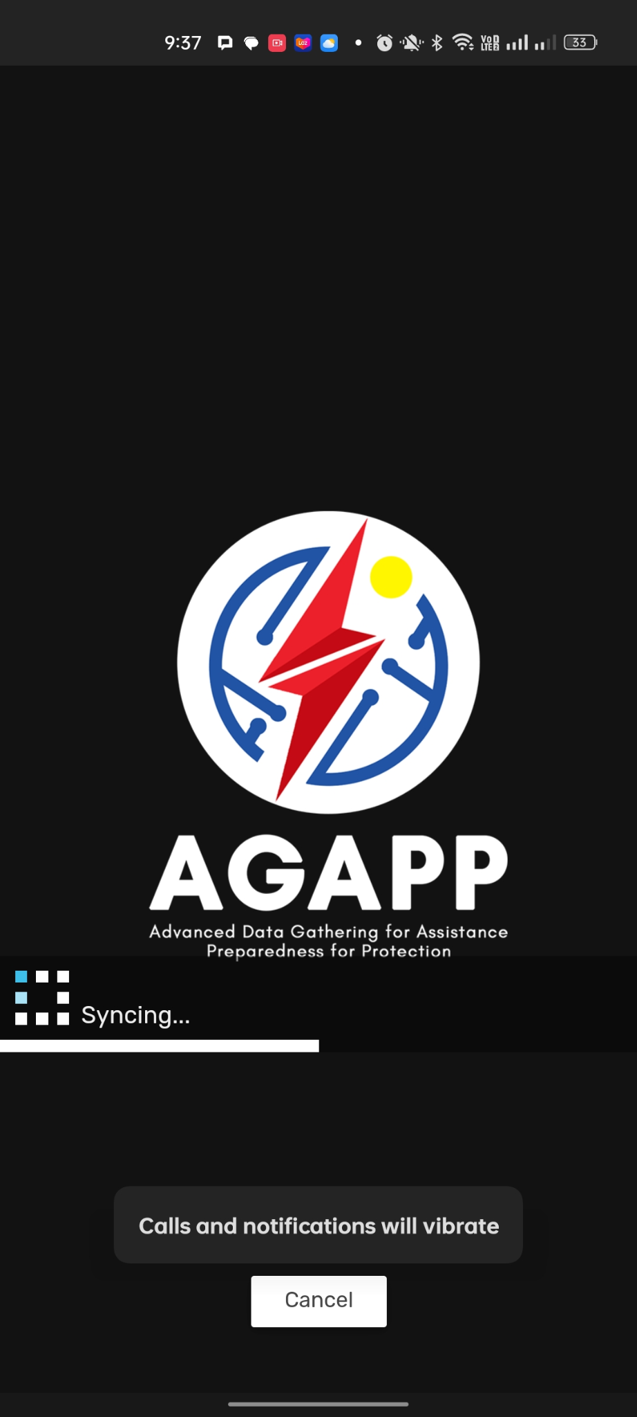
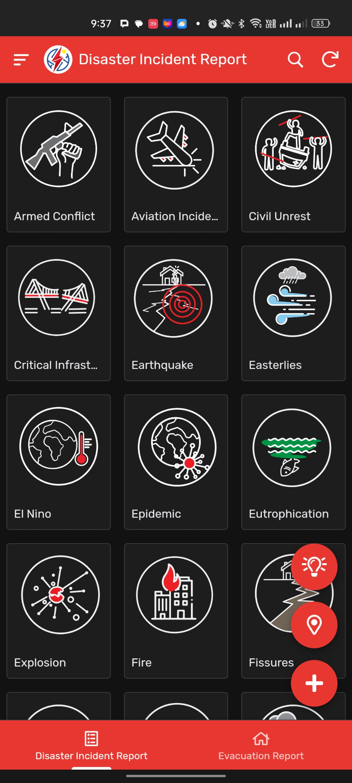
Figure 20. Advanced Gathering for Assistance Preparedness for Protection (AGAPP) Landing Page

Figure 21. Advanced Gathering for Assistance Preparedness for Protection (AGAPP) Report Page
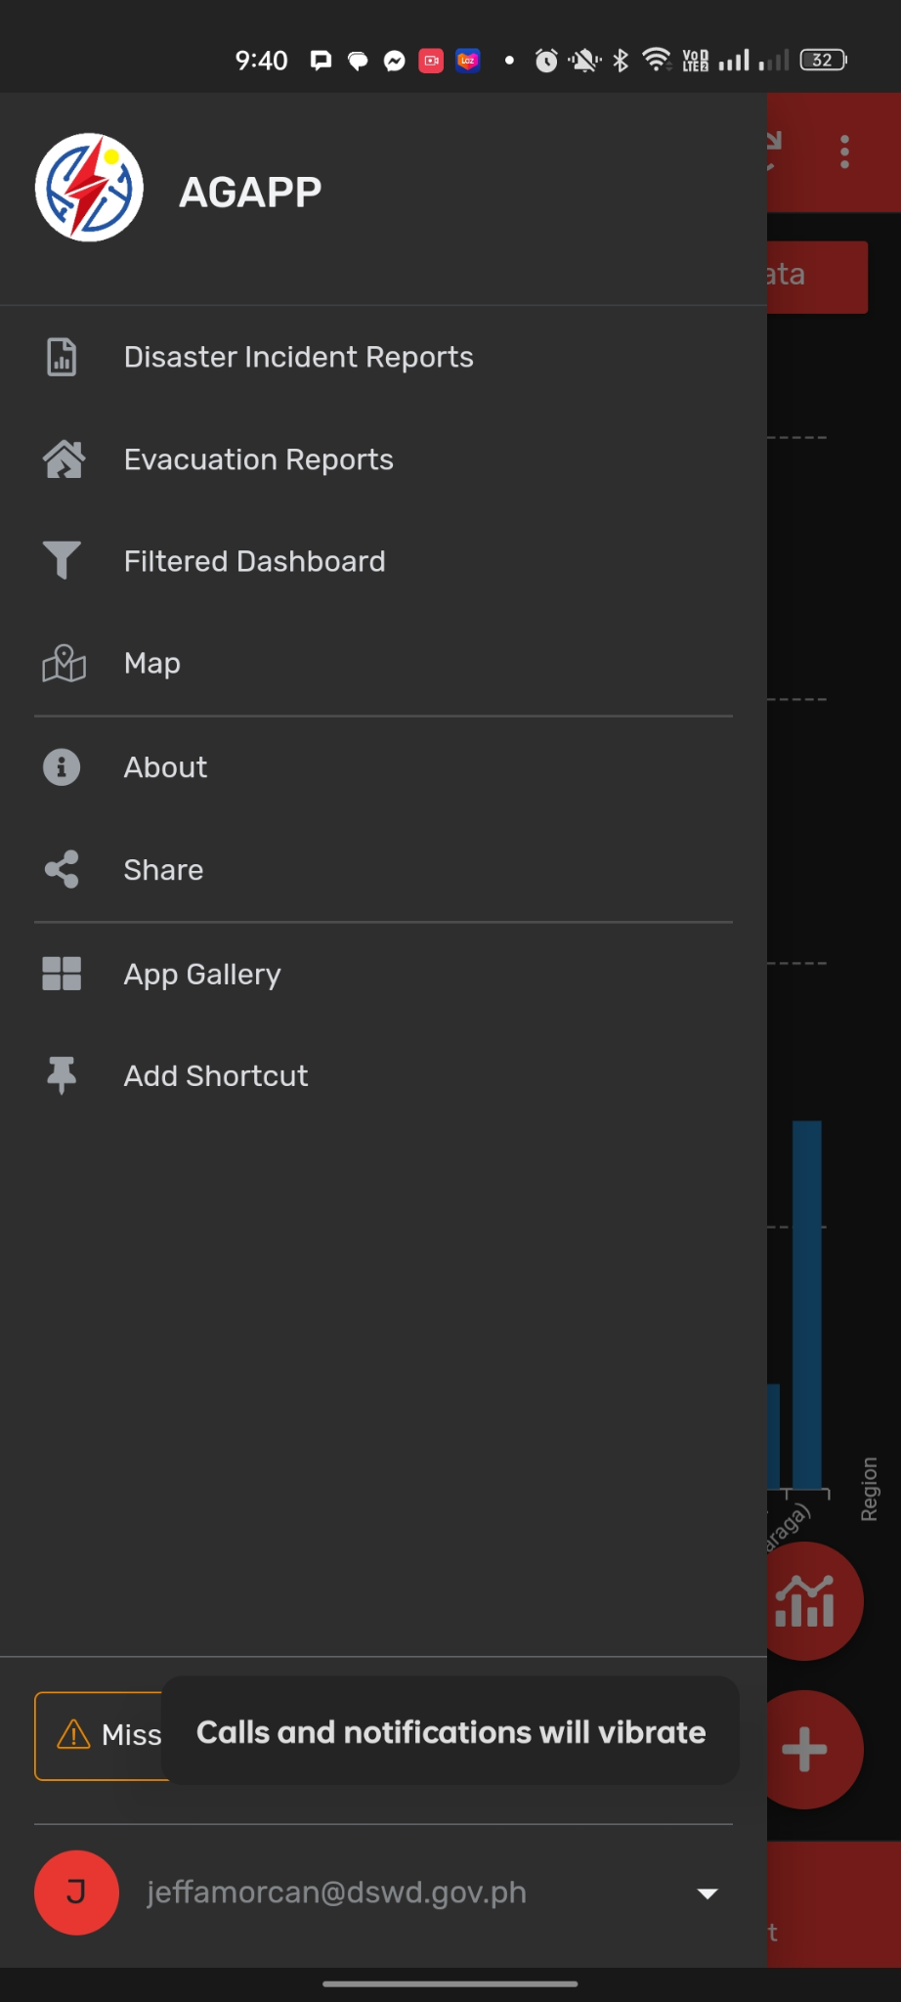
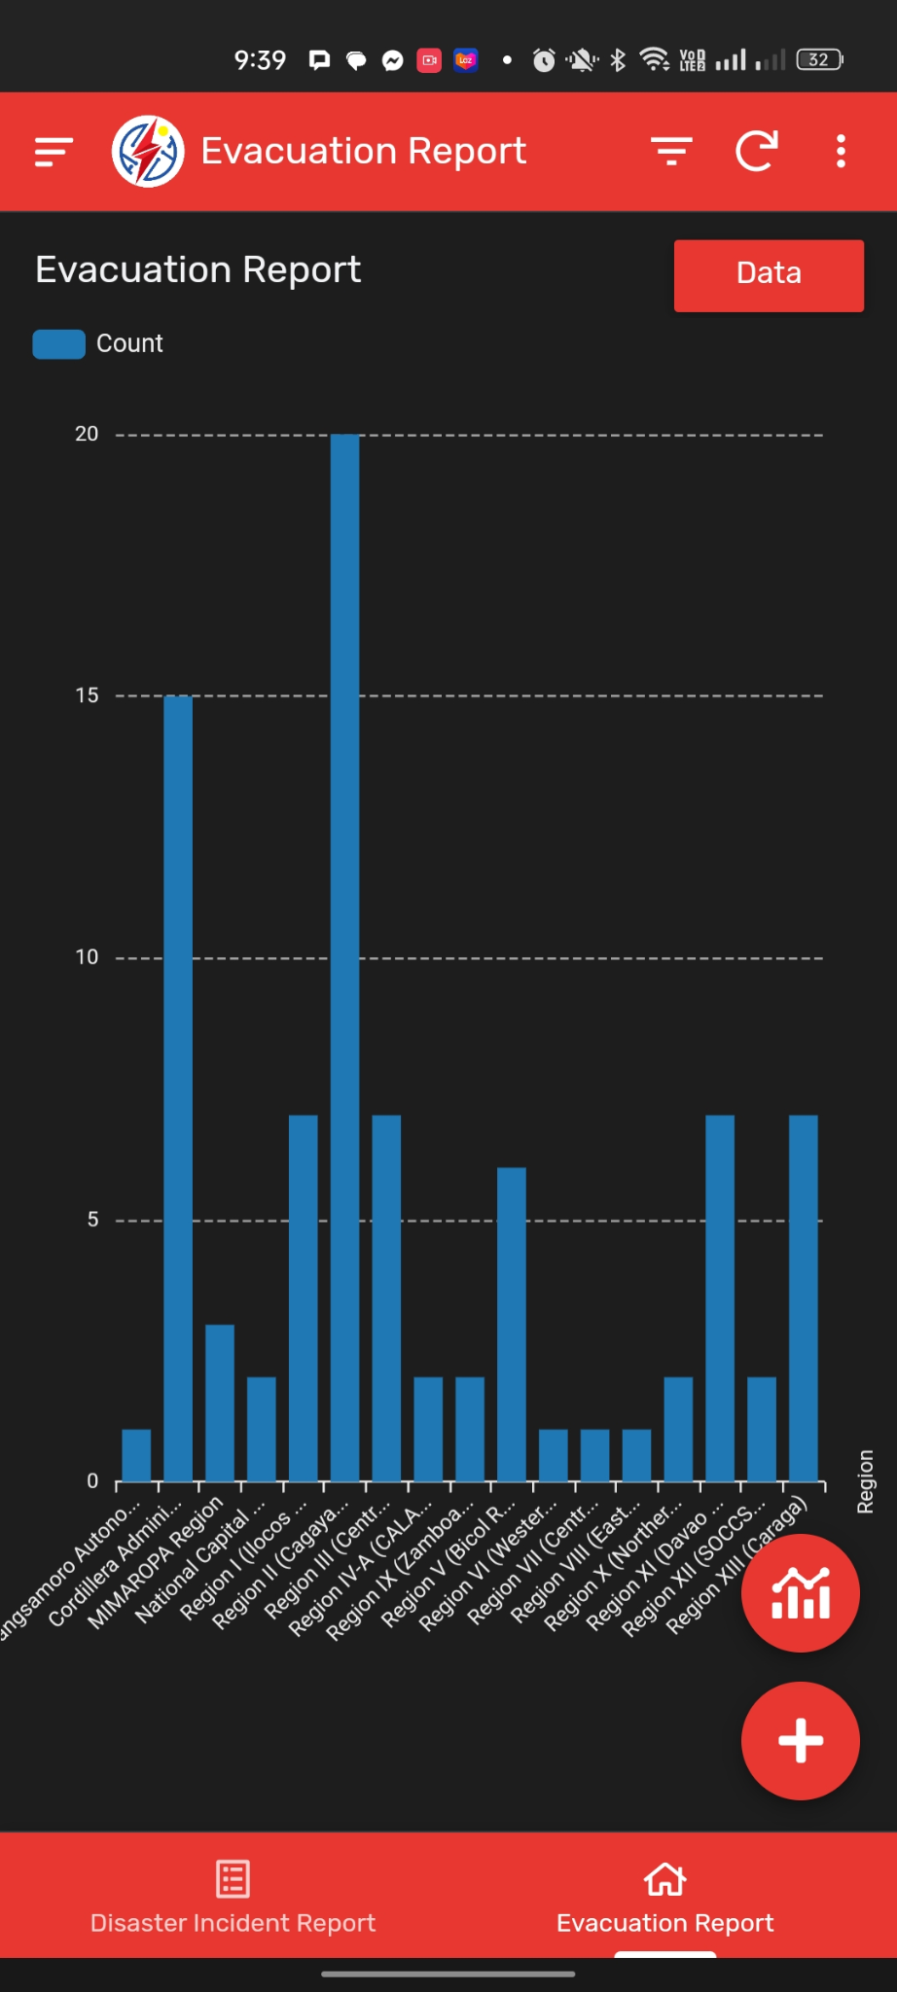

Figure 22. Advanced Gathering for Assistance Preparedness for Protection (AGAPP) Map Page
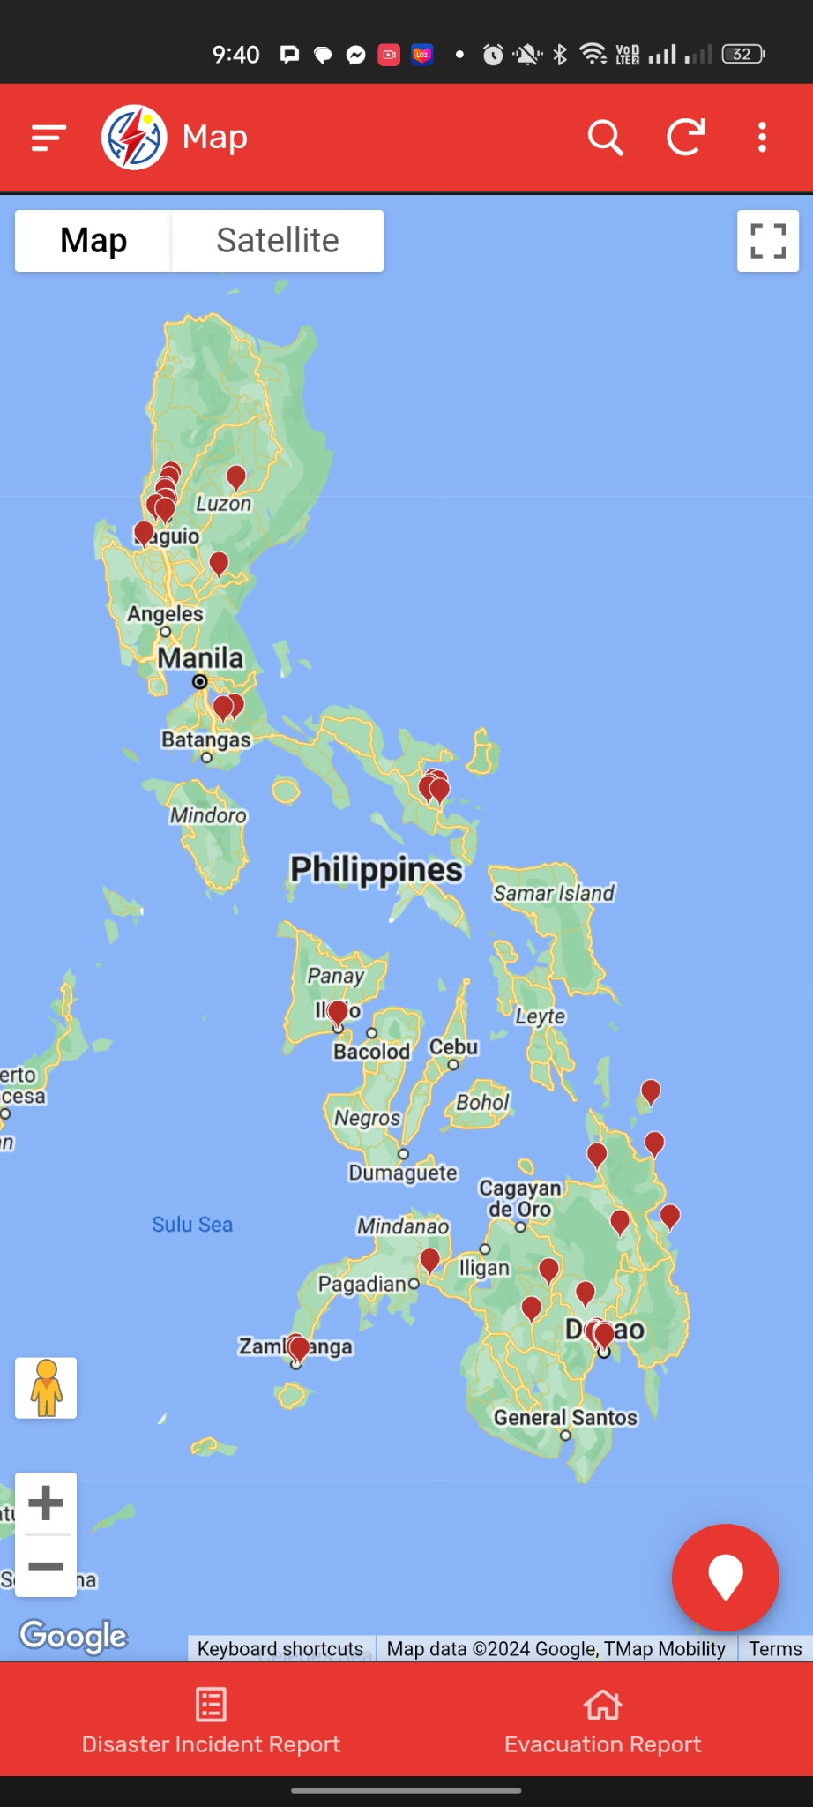
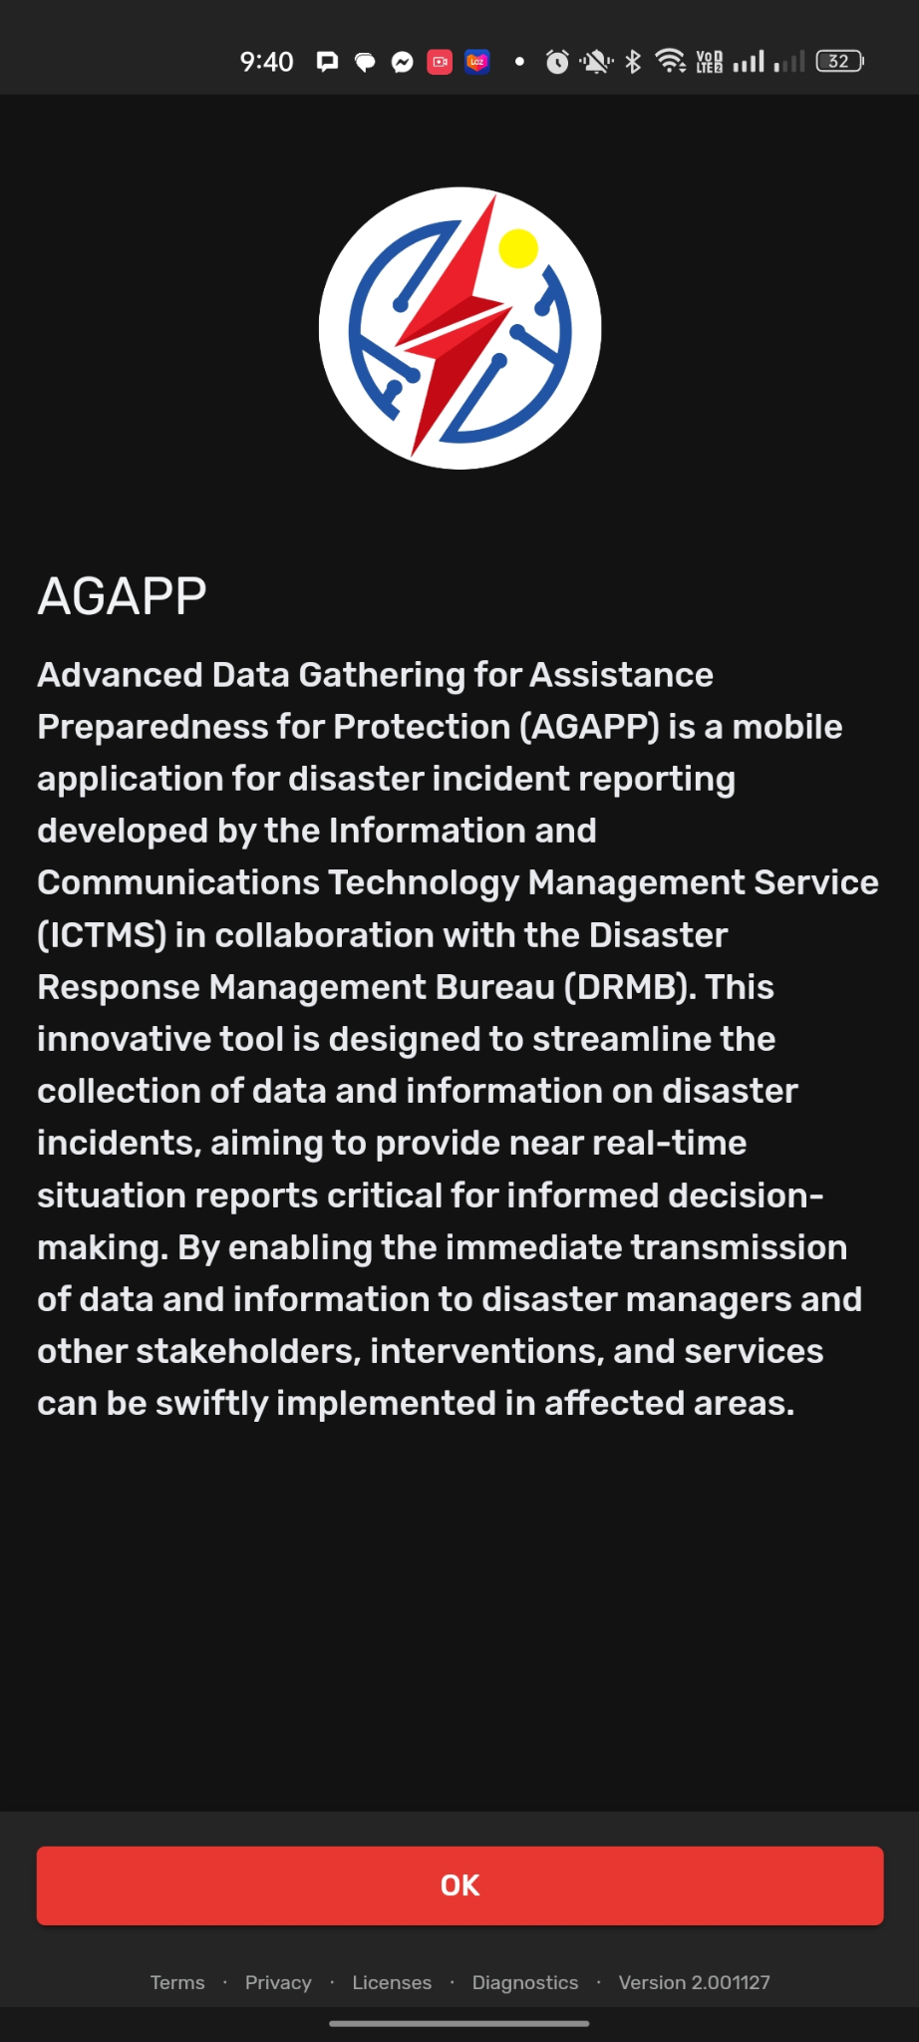

Figure 23. Advanced Gathering for Assistance Preparedness for Protection (AGAPP) FAQ Page
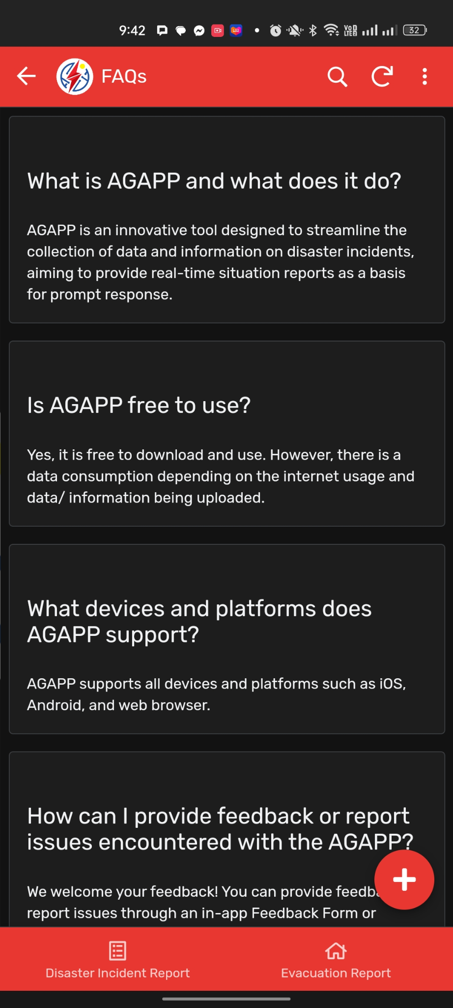

2.6.3 IRespondPH
According to Montefalcon et al. (2021), IRespondPH is a comprehensive mobile and web-based application specifically designed for Post Disaster Needs Assessment (PDNA) and disaster response in the Philippines. Developed by a team of researchers from National University-Manila and Mapua University-Manila, including Myron Darrel Montefalcon and others, the system addresses the critical need for efficient post-disaster response to minimize the adverse impacts of natural calamities such as typhoons, earthquakes, and volcanic eruptions. Its primary purpose is to provide citizens with real-time disaster information while enabling disaster managers to make data-driven decisions based on reports submitted by the public in the immediate aftermath of an event. By integrating technology into the assessment process, the system aims to improve the effectiveness of aid relief operations and contribute to building disaster resiliency across the country.
The system architecture facilitates interaction between three primary user groups: Citizens (Users), Local Government Units (Admins), and Disaster Management Coordinators (Master Admins). Citizens utilize the mobile application to report disaster occurrences, maintain a personal profile of their engagement, and access real-time news updates and safety tips for various types of natural hazards. They can also view a heatmap that displays the severity and details of disasters in their area. On the web-based side, LGU Admins are responsible for monitoring the disaster database, validating citizen reports, and scaling the severity of incidents for public display. Master Admins oversee the entire platform, managing the registry of new admins, coordinating with other government institutions for relief efforts, and utilizing a real-time dashboard of graphs and charts to guide strategic response decisions.
Moreover, IRespondPH was developed using the Agile Software Development Cycle, an iterative process consisting of four stages: Concept, Inception, Construction, and Release. The development team used WordPress and Flutter for the frontend interfaces, while the backend was built using MySQL and Firebase. The construction phase involved four specific iterations that moved from initial design and database creation to the integration of complex features like the heatmap and history logs. To ensure system reliability, it underwent Agile testing at four levels: unit/component testing, integration testing, system testing, and Usability Acceptance Testing (UAT). The UAT, which evaluated the system based on learnability, efficiency, errors, and satisfaction, resulted in high mean scores ranging from 3.8 to 4.6, indicating that the application is ready for deployment and implementation within local government units..

2.6.4 The Mamamayan Web App
According to Calanog et al. (2024), Mamamayan is a mobile community-based emergency reporting and notification system specifically designed for Makati City in the Philippines. Developed by William Penaflor Rey, Sydney Alison S. Adalin, Khristopher Ross L. Calanog, and Gian Windsor R. Jimenez from Mapua University, the system aims to prioritize disaster risk reduction and climate change adaptation. Its primary purpose is to serve as a resilient emergency alert system that informs the public and the local government about crises, accidents, or incidents requiring immediate attention, ultimately to save lives and protect property in a densely populated urban environment.
The system architecture facilitates interaction between two main user groups: the "Makatizens" (residents) and emergency dispatchers at the Makati Command Center. Residents use an Android-based mobile application to report a wide range of emergencies, including fires, typhoon-related incidents, vehicular accidents, and health-related concerns. The system utilizes the geolocation capabilities of smartphones, allowing dispatchers to pinpoint a caller's exact location for a more effective response. Beyond reporting, the app provides users with a "marked-as-safe" feature, evacuation-map assistance, local emergency contact lists, and safety tips.
Technically, Mamamayan was developed using a Feature-Driven Development (FDD) approach within the Agile methodology. The system was built using Java as the primary programming language and utilizes Firebase as its cloud-based database. The design follows an Input, Process, Output (IPO) model, where the mobile app communicates with web services that process data for a monitoring software tool used by city officials. This architecture ensures a continuous flow of data from the citizens to the authorities who can then coordinate resource deployment.
Furthermore, the system underwent rigorous evaluation using IBM’s Post-Study System Usability Questionnaire (PSSUQ) and ISO/IEC 9126 standards. It achieved high marks for usability, with a PSSUQ overall mean score of 1.50 (indicating high acceptance in usefulness and interface quality) and an ISO 9126 score of 4.71, reflecting strong performance in reliability, efficiency, and maintainability. Performance testing also confirmed that the web application operates at "Fast" speeds for parameters like First Contentful Paint and Fully Loaded Time, ensuring it can handle the
demands of real-time emergency management.

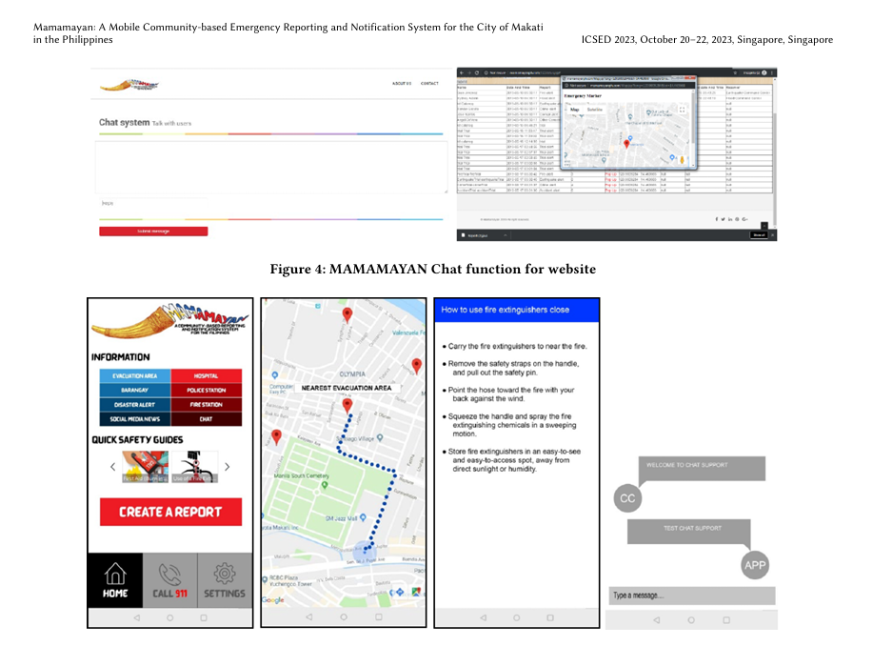
Figure 24. Mamamayan Web App Pages

2.7 Comparative Analysis of Existing Systems
This section presents the difference between each related system and the SitRepO website system based on the system feature:
Table 1. Comparison Table of the Related Systems and SitRepO Integrated Disaster Incident Record Management and Automated Situation Report Generation System
System Features | Bandilyo App | AGAPP | IRespondPH | Mamamayan | SitRepO
User Management | ✓ | ✓ | ✓ | ✓ | ✓
Real-Time Reporting | ✓ | ✓ | ✓ | ✓ | ✓
Geolocation, Geotagging | ✓ |  | ✓ | ✓ | ✓
Community/Jurisdiction Hazard-Exposure Profiling |  |  |  |  | ✓
Initial Disaster Reporting |  |  |  |  | ✓
Report Verification |  | ✓ | ✓ |  | ✓
Hazard/Disaster Event Creation |  |  |  |  | ✓
Disaster Situation Reporting | ✓ | ✓ | ✓ | ✓ | ✓
Update Situation Report |  |  | ✓ |  | ✓
Situational Report (SitRep) Generation |  | ✓ | ✓ |  | ✓
Situation Report Historical Catalog |  |  | ✓ |  | ✓
System Dashboard |  |  | ✓ |  | ✓
Search and Filter |  |  |  |  | ✓
Export Functionality |  |  |  |  | ✓

The core similarity among these systems: IRespondPH, Mamamayan, Bandilyo, AGAPP, and the proposed SitRepO, is their shared objective to modernize disaster management in the Philippines through mobile and web-based technologies, while SitRepO achieves the same objective through a dedicated web-based platform. All projects utilize geolocation and real-time data to bridge the "information lag" that often hampers humanitarian response in hazard-prone regions. They are designed to assist decision-makers by providing a centralized platform for reporting and monitoring, moving away from traditional manual processes to ensure that interventions are implemented swiftly in affected areas.
Relative to SitRepO, IRespondPH focuses heavily on Post Disaster Needs Assessment (PDNA) and citizen-centric features. While SitRepO is structured around a formal administrative reporting chain from puroks to the city office, IRespondPH includes modules for donations, news updates, and safety tips designed specifically for citizens. Furthermore, IRespondPH utilizes heatmaps to visualize disaster severity for the public, whereas SitRepO's primary innovation lies in its structured "Disaster Situation Reporting Module" designed for local government units to generate official, data-driven situation reports.
Systems like Mamamayan and Bandilyo emphasize real-time incident reporting of various emergencies, including fires, vehicular accidents, and crimes. Mamamayan operates through a community-based system that feeds directly into the Makati Emergency Operations Center for immediate dispatch. Bandilyo highlights technical innovation through its use of SMS technology and a modern tech stack (Laravel and React Native) to ensure connectivity in high-stakes environments. SitRepO distinguishes itself from these by focusing on the lifecycle of the SitRep itself, providing a dedicated Verification Module that allows for formal revisions and responses before a report is finalized.
Unlike Bandilyo and Mamamayan, both AGAPP and IRespondPH include a documented Report Verification step, AGAPP through its intuitive review tools for disaster managers, and IRespondPH through its two-tier LGU Admin and Master Admin validation process (Montefalcon et al., 2021). SitRepO extends this further with a three-tier verification chain that follows the actual administrative hierarchy: Purok, then Barangay, then System/DRRMO, with each tier independently reviewing and recording its own decision before a report moves upward, rather than a single or two-step check performed by one administrative side.
A further point of distinction is SitRepO's Hazard/Disaster Event Creation feature, which none of the four related systems provide. Bandilyo, AGAPP, IRespondPH, and Mamamayan all begin from an individual citizen or field report, with no upstream step to formally define the disaster event itself. SitRepO requires an authorized System-level user to open a hazard record, specifying type, location, and onset, before any incident report can be linked to it, giving each disaster a single point of reference from onset to closure.
SitRepO also maintains a standing Community/Jurisdiction Hazard-Exposure Profiling record for each purok and barangay, capturing population, housing, vulnerability, and hazard exposure data independent of any single incident. Barangay-level profiles are consolidated directly from verified Purok profiles. None of the four related systems maintain an equivalent standing record of a community's demographic or hazard-exposure characteristics; they are all structured around individual incident or emergency reports rather than a persistent community baseline.
A key innovation of SitRepO is its Situation Report Historical Catalog, where finalized situation reports are stored and made retrievable through search and filtering. IRespondPH offers a partial equivalent through its history logs, which track report versions during testing (Montefalcon et al., 2021), but these function as an internal testing record rather than a searchable, filterable catalog presented to end users the way SitRepO's does. AGAPP, by contrast, aims to streamline data collection for "near real-time" reports but includes no storage or retrieval mechanism for past situation reports at all (Philippine Disaster Response Management Bureau, 2024). This functionality is critical for long-term disaster risk reduction (DRR) planning, as it allows authorized personnel to analyze past data trends to improve future emergency protocols.
On analytics, only IRespondPH offers a comparable feature to SitRepO's System Dashboard, in the form of a real-time chart view for its Master Admins (Montefalcon et al., 2021). Mamamayan's web app, by contrast, functions as a live monitoring console for dispatchers rather than an analytics tool, and neither Bandilyo nor AGAPP describe a dashboard feature in their published materials (Calanog et al., 2024).
Beyond these major distinctions, several smaller features round out SitRepO's feature set relative to the four related systems. Its Initial Disaster Reporting function gives Purok-level users a distinct first-response entry point, separate from the consolidated Barangay and System-level reporting stages, a separation the four related systems do not describe, since their reporting structures are flat rather than tiered. IRespondPH is the only related system offering a comparable Update Situation Report capability, allowing prior reports to be revised as new information arrives; SitRepO extends this to every report in its catalog rather than treating updates as an isolated feature. Finally, SitRepO's Search and Filter and Export Functionality support its broader positioning as a documentation and record-keeping tool: none of the four related systems describe equivalent capabilities, since they are built around live reporting and dispatch rather than retrieving and exporting historical records for institutional use.
Finally, while these systems all implement user authentication and role-based access to protect data integrity, none explicitly mention the use of encryption for sensitive data at rest. Mamamayan uses Firebase for cloud-based data storage, and Bandilyo relies on a secured MySQL database, reflecting a common trend of prioritizing availability and reliability. The primary difference remains that SitRepO acts as a comprehensive management and generation tool for official documentation, whereas the other systems function more as immediate reporting and notification interfaces for field responders and the general public (Philippine Disaster Response Management Bureau, 2024; Montefalcon et al., 2021; Calanog et al., 2024; De Los Santos et al., 2020).

2.8 Synthesis
The reviewed literature and related systems point to a consistent set of findings that shape the direction of the proposed system. Global and national frameworks, including the Sendai Framework and RA 10121, establish that effective disaster response depends on accurate, timely, and centralized information (United Nations Office for Disaster Risk Reduction, 2015; Congress of the Philippines, 2010). In practice, however, Abello (2017) and Agapito et al. (2025) show this is undermined by fragmented reporting channels and manual, inconsistent data entry, particularly at the barangay level. Security literature further establishes that any system built to close this gap must also protect the integrity and confidentiality of the data it handles (Alvarez et al., 2016; Ha et al., 2017).
The four related systems reviewed all address parts of this reporting problem, but each stops short of a different piece of it, and each also demonstrates practices worth carrying into the design and evaluation of the proposed system. Bandilyo App strengthens the initial detection and transmission stage of reporting, using SMS and geolocation to maintain field connectivity (De Los Santos et al., 2020). However, it does not provide a structured process for what happens after a report is received; there is no formal verification stage, no historical catalog, and no mechanism for consolidating individual reports into an official situation report. SitRepO's Report Verification and SitRep Generation Modules directly address this gap.
On the other hand, AGAPP is built primarily for speed, aiming to transmit incident data to disaster managers on a near real-time basis (Philippine Disaster Response Management Bureau, 2024). While it includes basic review tools, it does not produce a standardized, retrievable situation report, moving data quickly without formalizing it into an official document. SitRepO's Situation Report Historical Catalog, with search, filtering, and version history, responds directly to this limitation. A practice worth adapting from AGAPP is its emphasis on an intuitive, low-friction reporting interface at the point of initial data entry, reinforcing that usability in the field is as important as the administrative workflow that follows. One practice worth noting from Bandilyo, though it falls outside the current scope of the proposed system, is its use of SMS as a fallback channel for connectivity-poor areas, which mirrors the offline and SMS limitation already identified in the Scope and Limitations of this study and may serve as a direction for future enhancement.
Meanwhile, IRespondPH is citizen-facing by design, allowing the public to report incidents and view heatmaps while LGU admins validate incoming reports (Montefalcon et al., 2021). It lacks a formal, template-based SitRep generation process, and its verification step is limited to a two-tier validate-and-scale action rather than a jurisdiction-based review chain. SitRepO's structured, three-tier Verification process, which records decisions and justifications at each level, extends beyond this. IRespondPH does maintain history logs that track report versions during testing, offering a partial equivalent to SitRepO's Situation Report Historical Catalog, but these logs function as an internal testing record rather than a catalog end users can search and filter. Notably, IRespondPH's own usability evaluation reported high acceptance scores across learnability, efficiency, errors, and satisfaction, reinforcing that structured usability testing is a standard and expected practice among comparable Philippine disaster reporting systems.
Mamamayan, on the other hand, is a community-based emergency alert system for Makati City, designed for fast citizen-to-dispatcher communication across a broad range of incidents such as fires, accidents, and health emergencies (Calanog et al., 2024). Like Bandilyo, it does not include formal report verification or historical document generation; its web application functions as a live monitoring dashboard for dispatchers rather than a report-authoring tool. SitRepO's administrative reporting chain and Situation Report Historical Catalog address this directly. Mamamayan reported strong usability and software quality results in its own evaluation, further supporting the precedent that formal, standardized usability testing is expected of systems in this domain.
Moreover, a further gap across all four systems is the absence of a formal step for defining the disaster event itself. Bandilyo, AGAPP, IRespondPH, and Mamamayan all begin from an individual incident report, with severity or scale assigned only after the fact. SitRepO's Hazard/Disaster Event Creation module closes this gap by requiring a System-level user to formally open a hazard record before incident reports can be linked to it, giving each disaster a single point of reference from onset to closure.
Beyond the incident lifecycle, none of the four systems maintain a standing profile of the communities they serve. SitRepO's Community/Jurisdiction Hazard-Exposure Profiling record, consolidated from Purok to Barangay level, gives the system a persistent baseline of population, housing, and vulnerability data that exists independently of any single reported incident, supporting longer-term disaster risk reduction planning in a way that incident-only systems cannot.
Across all four systems, the consistent pattern is that existing tools optimize for capturing a report quickly, through mobile channels, geolocation, or citizen alerts, but none formalize what happens afterward: a structured, jurisdiction-based chain of triage, verification, and consolidation into an official, NDRRMC-compliant Situation Report, supported by a searchable historical record and a standing community risk profile. SitRepO is designed specifically for this administrative lifecycle. Its intended users, namely purok leaders, barangay officials, and city-level DRRMO personnel, operate from fixed reporting posts rather than as field-based or general-public users, which is why a responsive web platform meets this need directly, without requiring a native mobile application. In this light, SitRepO extends the four related systems by addressing the administrative reporting stage that Bandilyo, AGAPP, IRespondPH, and Mamamayan do not cover.

CHAPTER III

METHODOLOGY

3.1 Architectural Design
Figure 25 illustrates the layered architectural design of the Integrated Disaster Incident Record Management and Automated Situation Report Generation System, displaying a decoupled, responsive web architecture engineered to accommodate centralized administration and decentralized field reporting through a single platform. The structural layout is divided into four distinct, specialized tiers comprising the User Interface Component Layer, the Business Logic Layer, the Network Layer, and the Data Layer, which collectively support the administrative web portal and its role-specific views. The presentation layer forms the operation frontier of the application, role-specific interfaces to stakeholders through the same responsive web application. The Administrator accesses a web console containing components for Log In Validation, Analytics Dashboard, Account Registration and Hierarchy Management, Disaster Incident Creation, Situation Report Generation and Export, and an Initial and Incident Report Viewing. Conversely, decentralized operations are what is present in the Barangay web workspace. This includes user interface components for Log In Validation, Localized Barangay Dashboard, a Purok Account Registration Approval View, an Initial Reporting dashboard, an Incident Report Entry Form, an Affected Population entry module, and a Local Situation Data View, while the ground-level Purok's web view is restricted to basic operation inputs consisting of a Log In Validation screen, an Account Registration Request Screen, and an Initial Incident Reporting Module.
Operating directly beneath the presentation layer, the business logic layer functions as the core computation engine of the platform, executing the internal processing rules, transactional validations, and data manipulation routines that govern the lifecycle of disaster records. To maintain a strict separation of concerns and ensure role-based security, these core logic handlers are segregated into independent processing blocks tailored to each entity’s specific functions. The Administrator business logic engine manages secure login/logout sequences with encrypted password validation, enforces system-wide role-based access control, regulates administrative profile configurations, initializes new hazard event parameters within the central repository, drives the report compiler to aggregate complex data into situation reports, and runs background audit tracking to generate event log records. The Barangay business logic engine focuses primarily on validation and data enrichment within localized domains, rendering localized monthly analytics dashboards, processing field incident entries, aggregating extensive quantitative affected population metrics across specific vulnerable demographics, and operating verification to audit incoming ground-level reports. The Purok business logic engine provides low-overhead operational processing routines restricted to managing entry-level mobile authentication, passing registration datasets to higher-tier verification queues to receive automated approval notifications and executing the executing workflows required to capture and send the initial ground-level emergency records.
The transport and persistence of data across these distributed runtime environments are regulated by the network and data layers, which maintain systemic stability and data consistency during high-concurrency event states or severe communication drops. The network layer establishes a communication architecture that handles real-time updates via HTTPS and WebSocket frameworks, ensuring that localized field records instantly reflect on the administrative console. This transport tier leverages a unified RESTful API Gateway Engine to parse incoming JSON payloads uniformly across all user roles accessing the web application. Finally, the data layer data layer implants a centralized, fault-tolerant persistence model engineered to provide maximum operational uptime during catastrophic events. This framework utilizes a cloud-hosted PostgreSQL database engine, exposed through PostgREST as the master ledger to service all web views, run heavy analytical aggregates, and maintain long-term archival storage, ensuring a single consistent source of truth for all system tables.

Figure 25. Integrated Disaster Incident Record Management and Automated Situation Report Generation System N-tier Architecture Diagram
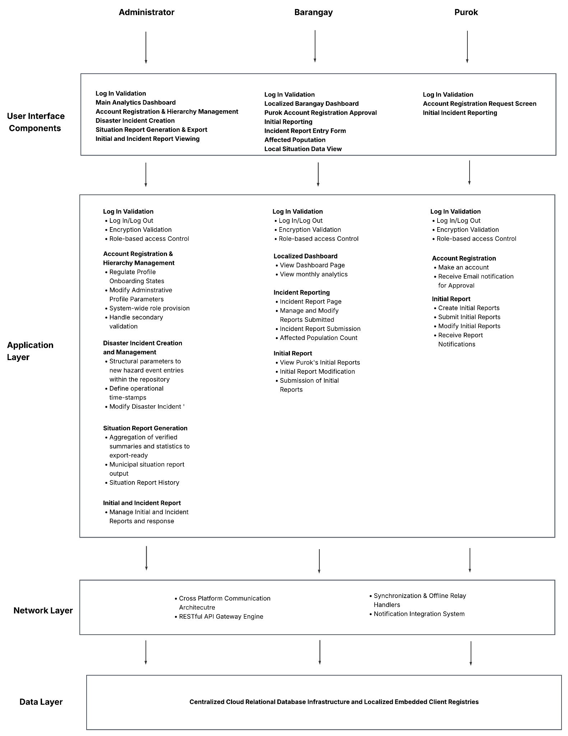

3.2 Requirement Specification
The section focuses on the functional and non-functional requirements of the proposed Integrated Disaster Incident Record Management and Automated Situation Report Generation System. The requirements were gathered from the interviews from the Barangay Officials that have dealt with the process of Disaster Situation Report and their BDRRMC chairperson as well as personnel from ZCDRRMO responsible for emergency response and Situation Report Generation. It is also rooted from the current workflow of the offices and the mandate by the NDRRMC. The system aims to streamline the process of Disaster Situation Reporting and Situation Report Generation by providing a platform for the different bodies involved in the entire process.

3.2.1 Users and Characteristics
Integrated Disaster Incident Record Management and Automated Situation Report Generation System categorizes users based on their roles, access privileges, and technical expertise. The following users are administrator, barangay personnel, and their respective purok/s personnel/s.
Table 2. Users and Characteristics
User Type | Access Privileges
Administrator | Full system access including user management, analytics, reports, logs, and administrative controls
Barangay personnel | Limited to their own barangay data, purok initial reports, purok user management, and barangay incident report
Purok Personnel | Limited to purok data and their barangay analytics

3.2.2 Software Functionalities
The proposed system provides a set of core functionalities designed to address the current challenges faced in recording, reporting, generating, and managing disaster situation reports. The functionalities are the following:
Table 3. Functional Requirements
Module | Function
Purok User Management Module | Registers Purok-level accounts and links each one to its assigned barangay for jurisdictional routing
Purok Profile Creation Module | Captures purok identification, population, housing, vulnerability, and hazard exposure data as the community's baseline profile
Purok Profile Verification Module | Cross-checks each submitted purok profile against reference data before it is confirmed
Purok Incident Reporting Module | Allows creation and modification of initial community-level incident reports with exposure units, hazard information, version history, and visible submission status
Purok Incident Report Verification Module | Allows Barangay personnel to compare report sources/versions, flag duplicate or conflicting entries, and validate, partially validate, return, or reject a report with a recorded reason
Purok Incident Report History Module | Retrieves and displays current and past versions of individual purok-level incident reports
Barangay User Management Module | Allows DRRM Administrators to register new barangay-level accounts with system-generated credentials
Barangay Profile Creation Module | Consolidates verified Purok profile data into a complete barangay-level profile record
Barangay Profile Verification Module | Cross-checks the consolidated barangay profile against reference data before it is confirmed
Barangay Incident Reporting Module | Consolidates verified Purok reports into a detailed Barangay Incident Report, supporting update requests and returning unverified Purok reports for correction
Barangay Incident Report Verification Module | Allows DRRM Administrators to verify newly submitted/modified barangay reports, flag duplicate or conflicting entries, and validate, partially validate, return, or reject a report with a recorded reason
Barangay Incident Report History Module | Retrieves and displays current and past versions of consolidated, multi-purok barangay-level incident reports
System User Management Module | Allows DRRM Administrators to view, edit, activate, and suspend accounts across Purok, Barangay, and Administrator levels
Hazard Creation Module | Allows authorized users to record hazard details and classify each entry against an existing CDRA hazard type or define a new one
Situation Report Generation Module | Consolidates verified barangay incident reports into a new or updated Situation Report using the NDRRMC SitRep template, routed through authorized human review and approval before release
Situation Report Historical Catalog Module | Allows authorized users to view, search, filter, compare, export, correct, and supersede SitReps while preserving prior approved versions, classification, retention information, and audit history
System Dashboard Module | Presents role-specific summaries of disaster incidents, affected populations, report status, verification activity, SitRep coverage, and processing time

3.2.3 Security Requirements
The proposed system will utilize a login module to restrict and control system access, ensuring only authorized users can access the system, and only the organization’s head can generate the situation report to avoid duplication. Furthermore, passwords must be encrypted using secure hashing algorithms. Access control should restrict users from accessing unauthorized modules. Also, the system should be able to maintain session management in order to prevent unauthorized logins. All data stored in the database should be secured and protected in a hashed format. Lastly, all forms must include security measures to avoid web and mobile vulnerabilities.

3.2.4 Technical Requirements
The proposed system will utilize a single, centralized database using PostgreSQL that supports real-time storage of data, creation, retrieval, and updating of disaster situation reports. The system will be implemented by the developer using modern web technologies such as the JavaScript library React, Next.js, and TailWindCSS for the css styling. The system will cater to three types of users: Reporters, Verifiers/Approvers, and Admins. For the reporters, they are the users who can send initial incident reports in the system using their mobile phones. For the verifiers/approvers, they are responsible for verifying that the report is legitimate and coordinate with each other, including organization head (e.g., barangay captain/BDRRMC chair in the barangay level, operations department head for the CDRRMO). Lastly, the admin will be responsible for monitoring site activity, ensuring incident reports are taken care of and disaster situation reports are monitored.

Hardware Requirements
Web Client Deployment
Minimum
  - Processor: Intel Core i3-10100 (4 Cores, 8 Threads, up to 4.30 GHz) or AMD Ryzen 3 3100 (4 Cores, 8 Threads, up to 3.90 GHz)
  - Memory: 8 GB DDR4 RAM
  - Storage: 256 GB SATA III Solid State Drive (SSD)
  - Display: 1366 x 768 minimum resolution console monitor
  - Device: Desktop, laptop, or workstation terminal computer
Recommended
  - Processor: Intel Core i5-12400 (6 Cores, 12 Threads, up to 4.40 GHz) or AMD Ryzen 5 5600X (6 Cores, 12 Threads, up to 4.60 GHz)
  - Memory: 16 GB DDR4/DDR5 RAM
  - Storage: 512 GB NVMe M.2 Solid State Drive (SSD)
  - Display: 1920 x 1080 Full HD widescreen display monitor
Software Requirements
  - Operating Systems: Windows 10 / 11 (64-bit) or macOS 13 (Ventura) or newer for development and administrative deployment terminals; any modern mobile OS (Android 10.0+ or iOS 15+) is sufficient for browser-based end-user access.
  - Development Frameworks: Web-tier backend services and administrative portals engineered via the Node.js + PostgREST for backend, React.js and Next.js for frontend, Tailwind CSS for styling, OpenAuth for authentication.
  - Database Management Systems (DBMS): Cloud-hosted PostgreSQL relational database server acting as the high-availability central repository for all system data, exposed as a RESTful API through PostgREST.
  - Web and Local Development Servers: A Virtual Private Server (VPS) paired with a Content Delivery Network (CDN) configured to host the live production database pools and serve static assets, improving load times for users across different locations, alongside Docker-based local development environments for isolated testing.
  - Containerization Tools: Docker Desktop environments implemented to containerize local development dependencies, ensuring absolute environment parity between local building nodes and operational production runtimes.
  - Integrated Development Environments (IDE): Visual Studio Code equipped with relevant JavaScript/TypeScript and Node.js extensions for backend and frontend development.
  - Version Control and Management: Git software packages linked with remote GitHub organizations to regulate source code version tracking, branch merges, and manuscript code backups.
  - Dependency and Package Managers: Node Package Manager (NPM) for managing both backend Node.js dependencies and frontend JavaScript compiling.

3.3 Analysis

3.3.1 Process Models

Context Flow Diagram
Figure 26 presents the Context-Level Data Flow Diagram of the Integrated Disaster Incident Record Management and Automated Situation Report Generation System. It defines the system boundary and illustrates the exchange of information between the system and its three principal external entities: the Purok User, Barangay User, and DRRM Administrator. At this level, the system is represented as a single process, while its internal processes and data stores are omitted to emphasize the information entering and leaving the system. The diagram therefore provides an overview of the system’s external interactions and the responsibilities associated with each administrative level.
The Purok User serves as the primary source of Purok-level profile and initial incident information. The entity provides Purok user credentials for system access and submits Purok identification, population, housing, vulnerability, and hazard-exposure information. In relation to incident reporting, the Purok User supplies the affected exposure units, incident time and date, location, and initial situation details, together with relevant hazard information such as hazard type, name, date, and time. In response, the system provides the Purok User Access Page and communicates profile and validation statuses. These exchanges represent the Purok User’s role in originating local disaster information and receiving feedback concerning the status of submitted records.
The Barangay User interacts with the system through account management, Barangay profiling, and incident-reporting activities. The entity provides Barangay user credentials, Purok user credentials and details for account-related transactions, and Barangay information for profile maintenance. It also supplies Barangay profile and incident-report information, including Purok profile and incident-report details used in Barangay-level activities. The system returns the Barangay User Access Page, profile status, and validation status, and provides access to Purok incident reports. These data exchanges reflect the Barangay User’s responsibility for maintaining Barangay-level information and handling Purok records within the Barangay reporting workflow.
The DRRM Administrator performs higher-level administrative and reporting interactions with the system. The entity provides administrative credentials and Barangay user credentials and details for account-management activities. The system supplies the DRRM Access Page and makes available Barangay profile information, Barangay incident reports, hazard information, and generated Situation Reports. These exchanges represent the DRRM Administrator’s role in accessing the information required for higher-level disaster monitoring, report preparation, and administrative oversight.

Figure 26. Integrated Disaster Incident Record Management and Automated Situation Report Generation System Context Data Flow Diagram
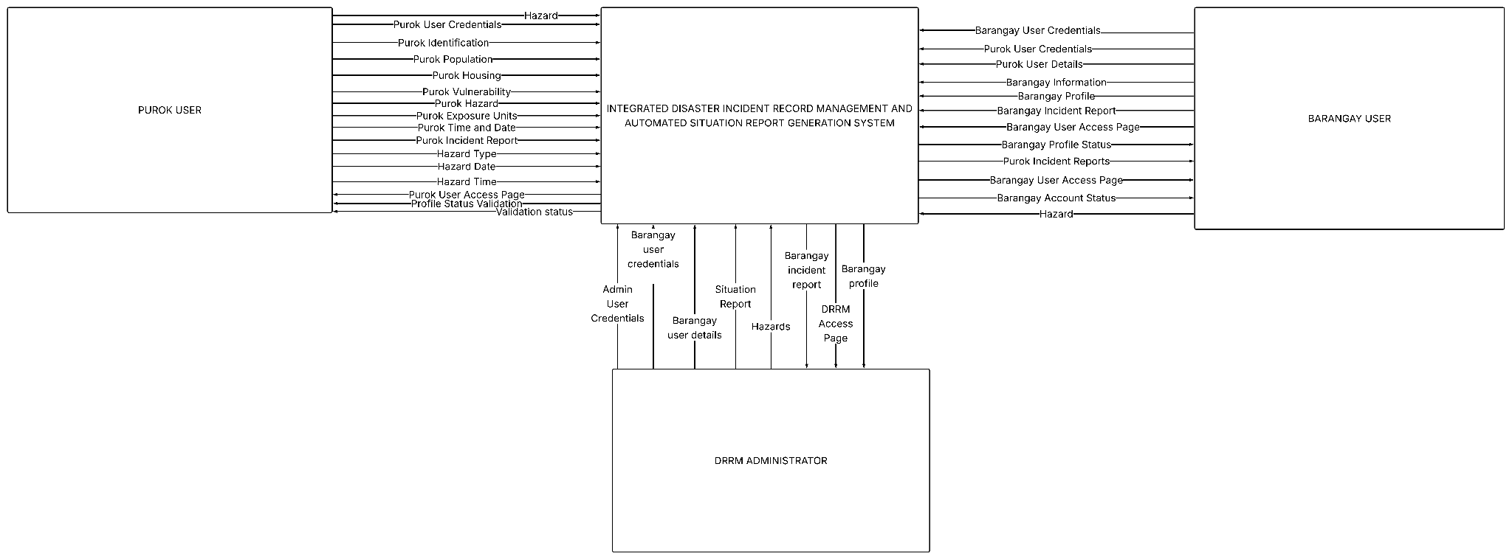

Level 0 Data Flow Diagram
Figure 27 presents the Level 0 Data Flow Diagram of the Disaster Situation Record Management and Situation Report Generation System. It defines the system boundary, identifies its principal external entities, and illustrates the movement of information among the system’s major processes and data stores. The external entities are the Purok User, Barangay User, and DRRM Administrator, whose responsibilities are separated according to their administrative level and authorized functions.
The Purok User is responsible for maintaining the Purok profile and submitting an initial incident report. Purok profiling involves the submission of Purok identification, population, housing and vulnerability information, hazard exposure, and other relevant profile data. The Purok User may also submit initial incident information, including the incident location, affected exposure units, date and time, and an initial situation description. These records are stored in the Purok Profile Database and Purok Incident Database, respectively, and are subject to Barangay-level verification.
The Barangay User manages Purok accounts, maintains the Barangay profile, consolidates verified Purok profile information, and prepares Barangay incident reports. Barangay profiling receives Barangay-level information together with consolidated Purok details. In incident reporting, the Barangay User uses verified Purok incident reports and hazard details as inputs for the preparation of a more comprehensive Barangay incident report. The Barangay User also verifies Purok profiles and Purok incident reports before these records become eligible for Barangay consolidation.
The DRRM Administrator performs higher-level administrative, verification, reporting, and governance functions. These include managing Barangay user accounts, verifying Barangay profiles and Barangay incident reports, maintaining hazard records, and generating Situation Reports from verified Barangay incident information and hazard details. The Situation Report Generation process stores the resulting report in the Situation Report Database. The DRRM Administrator may subsequently access historical Situation Reports, while authorized Purok and Barangay users may access their respective historical report catalogs.
The diagram also includes the Log In process, which authenticates users and directs them to the appropriate access page according to their account type and authorization. The System User Management process supports account queries, administrative credentials, and account maintenance. Overall, Figure 27 demonstrates a hierarchical and controlled information flow in which data originate at the Purok level, are reviewed and consolidated at the Barangay level, and are finally verified, interpreted, and transformed into formal Situation Reports by the DRRM Administrator. This structure supports data traceability, role-based access, progressive verification, and the separation of Purok, Barangay, and DRRM responsibilities.

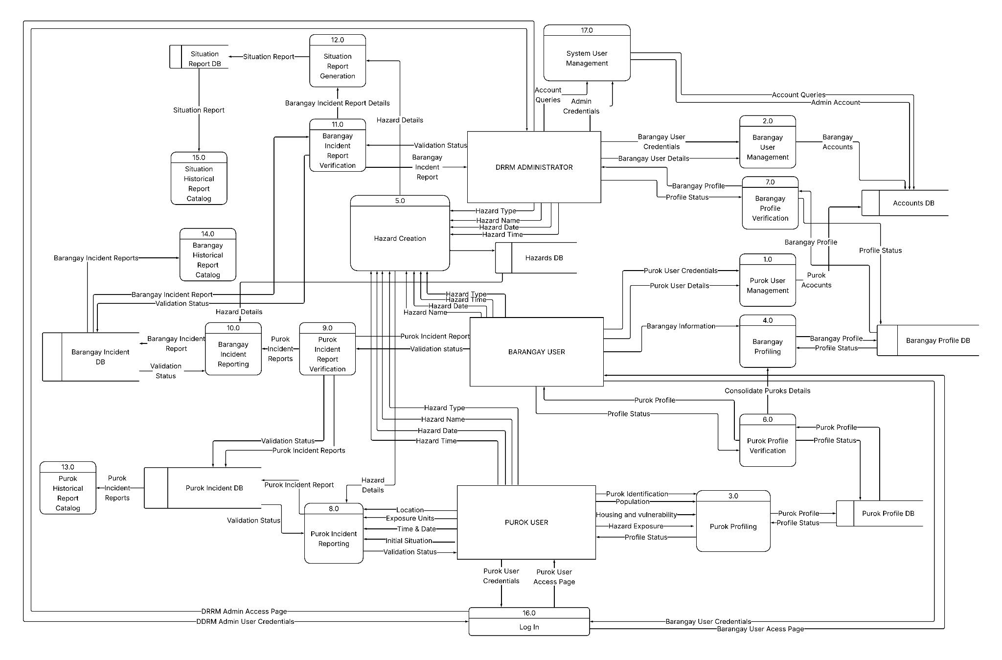
Figure 27. Integrated Disaster Incident Record Management and Automated Situation Report Generation System Context Level 0 Data Flow Diagram

Process 1: Manage Purok Users
Figure 28 presents the Level 1 decomposition of Process 1.0, Manage Purok Users. The process is performed by the authorized Barangay User, reflecting the system’s hierarchical account-management rule that Purok accounts are created and administered by the next higher administrative level. Consequently, Purok users do not independently register their accounts.
The process begins with 1.1 Input Purok User Details, where the Barangay User provides the required account information, including the Purok user’s full name, mobile number, email address, account status, and assigned Purok. These inputs are transferred to 1.2 Validate and Verify Purok User Details, which checks the completeness, validity, and administrative appropriateness of the submitted information. The process produces the validated Purok account details and a validation status. Invalid or incomplete information is returned for correction, while validated information proceeds to account creation.
The validated details are passed to 1.3 Create Purok User Account, which establishes the Purok account within the system and produces an account audit record. Authorized account maintenance is handled through 1.4 Update Purok User Account, where changes to account details or account status are recorded as updated Purok details and update-audit information. The audit information is returned to the validation and verification process to preserve traceability of administrative changes. Finally, 1.5 Issue Account Credentials generates or initiates the issuance of the Purok user’s access credentials. In accordance with secure authentication practice, credentials should be issued through the authentication service and should not be stored as readable passwords within the application database.
Overall, the decomposition demonstrates a controlled maker-and-auditor workflow in which Purok account information is collected, validated, created, maintained, and issued through distinct subprocesses. This separation supports role-based authorization, account accountability, auditability, and the prevention of unauthorized self-registration.

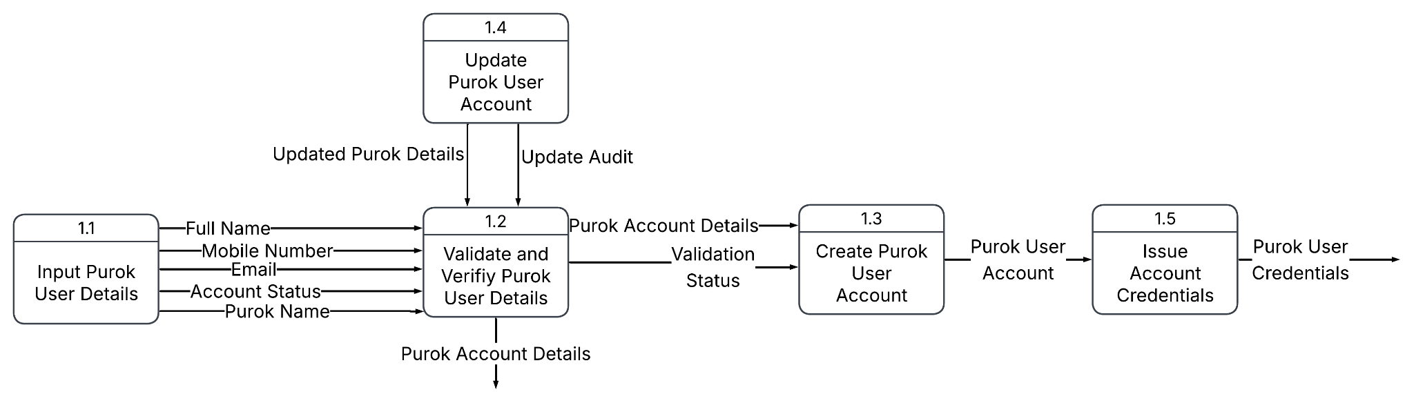
Figure 28. Integrated Disaster Incident Record Management and Automated Situation Report Generation System Level 1 DFD Manage Purok Users

Process 2: Manage Barangay Users
Figure 29 presents the Level 1 Decomposition of Process 2.0, Manage Barangay Users. This process is performed by the authorized DRRM Administrator, consistent with the system’s hierarchical account-management structure in which Barangay accounts are created and administered by the higher-level DRRM authority. Barangay users do not independently register their accounts, similarly to Purok users
The process begins with 2.1 Input Barangay User Details, where the DRRM Administrator enters the Barangay user’s full name, mobile phone number, email address, status, and assigned Barangay. These details are forwarded to 2.2 Validate and Verify Barangay User Details. This subprocess checks the completeness, validity, and appropriateness of the submitted account information and Barangay assignment. It produces valid Barangay account details and a validation status. Records that fail validation are returned for correction.
Validation information is then transferred to 2.3 Create Barangay User Account, which establishes the Barangay account and records the corresponding account details. Account maintenance is performed through 2.4 Update Barangay User Account. Changes to user information or account status produce updated Barangay details and an update-audit record, which is returned to the validation and verification subprocess to maintain traceability.
Finally, 2.5 Issue Account Credentials provides the Barangay user with the credentials required to access the system. Credentials issuance should be handled through the system’s authentication service, while readable passwords should not be stored in the application database.

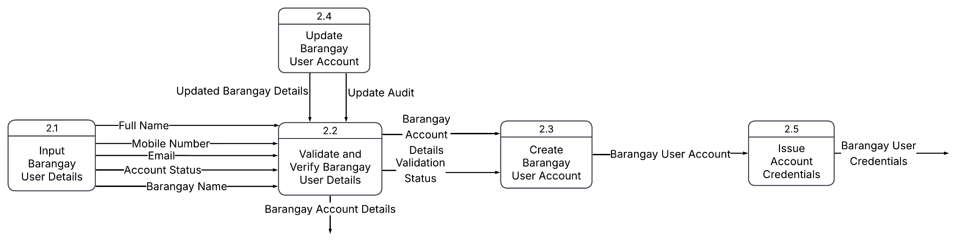
Figure 29. Integrated Disaster Incident Record Management and Automated Situation Report Generation System Level 1 DFD Manage Barangay Users

Process 3: Purok Profiling
Figure 30 illustrates the Level 1 Data Flow Diagram of Process 3.0 Purok Profiling. The process enables the Purok User to establish and maintain an aggregate baseline profile of the Purok. Consistent with the project’s approved data boundary and CDRA-oriented approach, the profile records summarized population, housing, and hazard-exposure information rather than named residents or individuals household records.
The process begins with 3.1 Record Purok Identification, where the Purok name, parent Barangay, and Purok location are recorded. These identifiers provide the administrative and geographic context for the succeeding profile information. The identification data are then passed to 3.2 Record Purok Population, which records aggregate population characteristics, including household, families, male and female population, infants, children, adults, senior citizens, persons with disabilities, pregnnant women, and lactating women.
The resulting population information is forwarded 3.3 Record Purok Housing Situation. This subprocess records the housing conditions of the Purok, including the total number of housing units and housing characteristics associated with construction materials, roofing, walls, and other relevant housing-situation indicators. These data support the assessment of vulnerability and exposure without storing individual household profiles.
The housing and population information are then used by 3.4 Record Purok Hazard Exposure. This subprocess associates the Purok with the applicable hazard type and records the exposed families, households, population, vulnerable groups, and related Purok population and housing exposure information. The resulting information is consolidated by 3.5 Submit Purok Profile, which produces the Purok Profile and its Profile Status for subsequent Barangay-level verification.

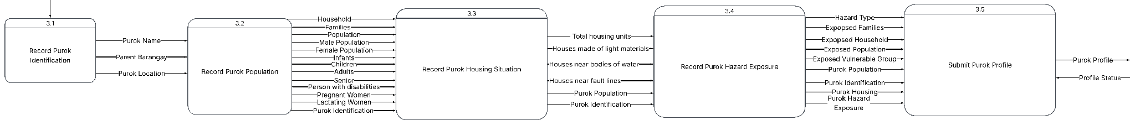
Figure 30. Integrated Disaster Incident Record Management and Automated Situation Report Generation System Level 1 DFD Purok Profiling

Process 4: Log In Validation
Figure 31 presents the Level 1 decomposition of Process 4.0, Barangay Profiling. The process enables the Barangay User to construct an aggregate Barangay profile by retrieving verified Purok profiles and combining them with Barangay-level information. This arrangement reflects the project’s hierarchical design, in which the Barangay profile is informed by verified Purok data while remaining a distinct administrative-level profile.
The process begins with the retrieval of verified Purok profiles. These profiles provide the source information required for Barangay-level consolidation. The Barangay User then records the Barangay identification information, including the Barangay name, city, province, and number of Puroks. This establishes the geographic and administrative scope of the profile.
The identification data are followed by the recording of aggregate Barangay population information. The population subprocess includes households, families, male and female population, infants, children, adults, senior citizens, persons with disabilities, pregnant women, and lactating women. Purok identification information is retained to maintain traceability between the Barangay totals and their contributing Purok profiles.
The consolidated population data are then used in recording the Barangay housing situation. This subprocess documents the total housing units and relevant housing characteristics, including construction materials, roofing, walls, and other housing-condition indicators. The resulting population and housing information are subsequently used to record Barangay hazard exposure.
The hazard-exposure subprocess identifies the applicable hazard type and documents the exposed families, households, population, vulnerable groups, affected Puroks, and hazard-map information. These data support the Barangay’s baseline exposure and vulnerability assessment in accordance with the information categories associated with Climate and Disaster Risk Assessment.
Finally, the Barangay User submits the completed Barangay Profile. The subprocess produces the Barangay Profile and its Profile Status, after which the profile becomes subject to DRRM-level verification

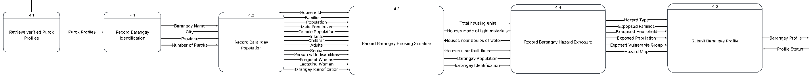
Figure 31. Integrated Disaster Incident Record Management and Automated Situation Report Generation System Level 1.1 Barangay Profiling

Process 5: Hazard Creation
Figure 32 presents the Level 1 decomposition of Process 5.0, Hazard Creation. This process enables authorized Purok, Barangay, and DRRM users to create a jurisdiction-specific hazard record using the system’s controlled hazard classification. The hazard categories should correspond to the all-hazards coverage adopted by the project and the hazard categories used in the CDRA baseline.
The process begins with 5.1 Select Hazard Type, where the user selects the applicable hazard from the approved hazard-type list. The selected Hazard Type is transferred to 5.2 Input Hazard Identification. In this subprocess, the user records the hazard name, hazard type, date, location, and severity. These fields identify the hazard occurrence or observation and establish its temporal, geographic, and intensity-related context.
The completed hazard information is then transferred to 5.3 Save Hazard Record. This subprocess creates a versioned hazard record and produces the hazard data for storage and subsequent processing. The saved record should retain the originating organization unit, preparer, reporting time, source information, and supporting evidence where applicable. These details are necessary for traceability and for distinguishing reported information from verified information.
The hazard output is subsequently routed to the appropriate verification process. Purok-originated hazard records are subject to Barangay-level verification, Barangay-originated records are subject to DRRM verification, and DRRM-originated records require review by another authorized DRRM account. Therefore, saving a hazard record does not constitute approval or verification; it only establishes the hazard record for controlled review and possible inclusion in profiling, incident reporting, and Situation Report generation.

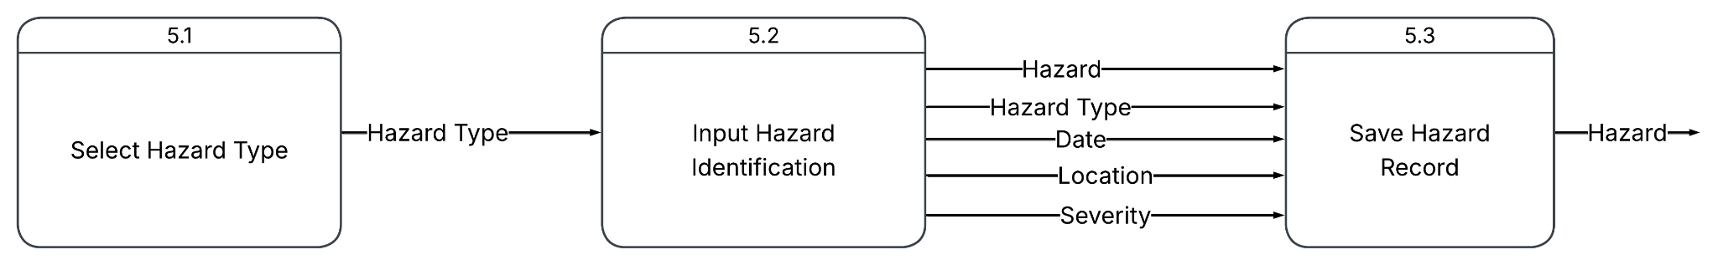
Figure 32. Integrated Disaster Incident Record Management and Automated Situation Report Generation System Level 1 Hazard Creation

Process 6: Purok Profile Verification
Figure 33 presents the Level 1 decomposition of Process 6.0, Verify Purok Profile. This process is performed by the authorized Barangay User and establishes whether a submitted Purok profile is sufficiently complete and appropriate for Barangay-level consolidation.
The process begins with 6.1 Retrieve Submitted Purok Profile, which obtains the submitted Purok profile for review. The profile is then forwarded to 6.2 Check Required Mandated Sections. This subprocess examines whether the submission contains the required profile information, including Purok identification, aggregate population data, housing information, hazard exposure, and relevant vulnerability or capacity information required by the project’s CDRA-oriented profile structure. It also checks whether the information is internally consistent, sufficiently supported, and assigned to the correct Purok jurisdiction.
The result of the review is passed to 6.3 Notify Purok on Profile Verification. The notification communicates the profile-verification result to the Purok User, including whether the profile was accepted, returned for correction, or rejected. A profile is considered eligible for Barangay consolidation only after the Barangay User records an affirmative verification decision. If required information is missing or inconsistent, the profile is returned with a correction request rather than being silently modified.

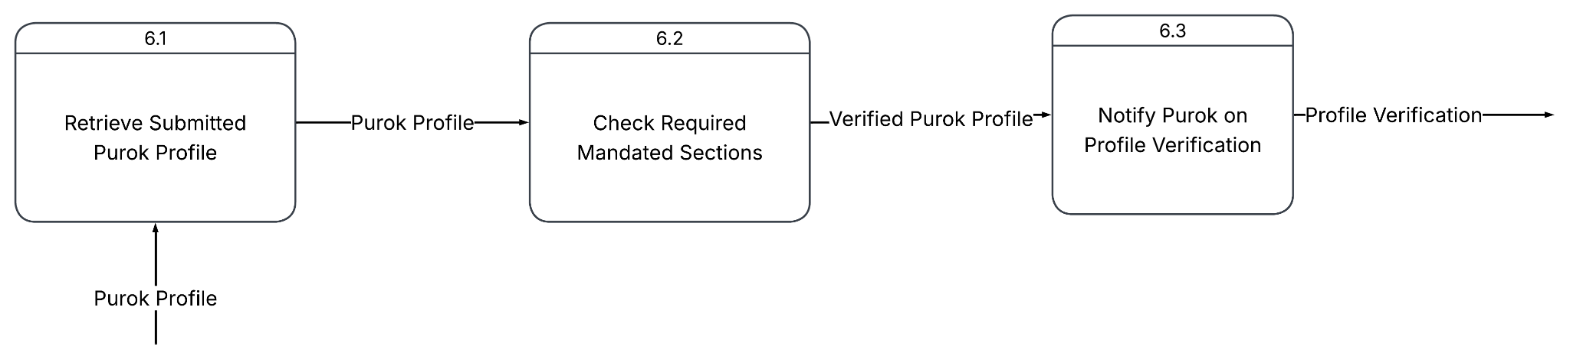
Figure 33. Integrated Disaster Incident Record Management and Automated Situation Report Generation System Level 1 DFD Purok Profile Verification

Process 7: Barangay Profile Verification
Figure 34 presents the Level 1 decomposition of Process 7.0, Verify Barangay CDRA Profile. This process is performed by the DRRM Administrator and provides the higher-level review required before a Barangay profile can be treated as an accepted baseline for city-level analysis and Situation Report preparation.
The process begins with 7.1 Retrieve Submitted Barangay Profile, which obtains the Barangay profile submitted for review. The profile is then transferred to 7.2 Check Required Mandated Sections. This subprocess examines the completeness and consistency of the Barangay identification, consolidated population, housing situation, hazard exposure, and related vulnerability, capacity, and risk information. It also verifies that the Barangay profile properly reflects its contributing verified Purok profiles and that exclusions, data gaps, limitations, and reconciliation matters are documented.
The review result is forwarded to 7.3 Notify Barangay on Profile Verification. The notification communicates the formal profile-verification outcome, such as acceptance, return for correction, or rejection. A Barangay profile becomes eligible for authorized city-level use only after the DRRM Administrator records an affirmative verification decision. Incomplete or inconsistent information is returned with a documented correction request rather than being silently changed.

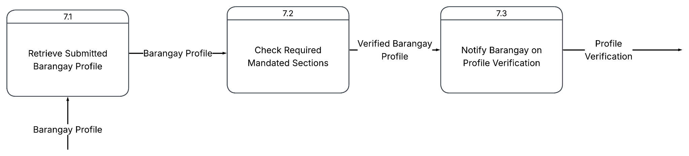
Figure 34. Integrated Disaster Incident Record Management and Automated Situation Report Generation System Level 1 Barangay Profile Verification

Process 8: Purok Incident Reporting
Figure 35 presents the Level 1 decomposition of Process 8.0, Submit Purok Incident Report. This process enables the Purok User to submit a concise initial incident report based on the hazard information available to the Purok. In accordance with the project’s reporting boundary, the Purok submission is limited to essential incident details and affected-population information; detailed casualty and damage assessment are completed at the Barangay and DRRM levels.
The process begins with 8.1 Identify Incident Details. Hazard Details are used to establish the hazard type and hazard name associated with the incident. The Purok User then records the incident location, affected exposure units, date, time, and initial situation. In this context, exposure units refer to aggregate affected population information, such as affected families and affected persons, rather than individually identified households or residents.
The identified information is transferred to 8.2 Submit Purok Report. This subprocess performs the initial completeness and format validation, records the report as a versioned Purok Incident Report, and produces a Validation Status. The validation status indicates whether the submission was accepted for review or requires correction. It does not represent final verification, since the submitted report must still be reviewed by the authorized Barangay User.

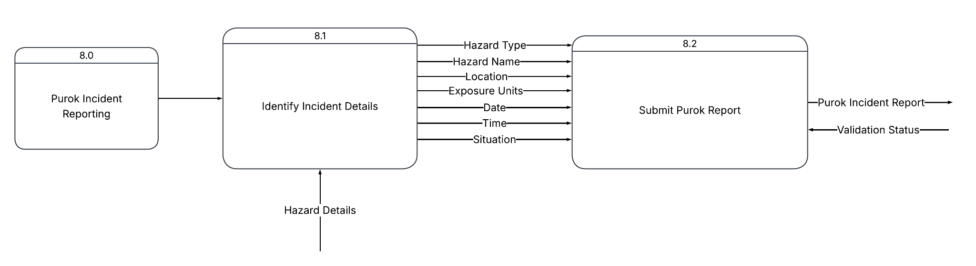
Figure 35. Integrated Disaster Incident Record Management and Automated Situation Report Generation System Level 1 Purok Incident Reporting

Process 9: Verify Purok Incident Report
Figure 36 presents the Level 1 decomposition of Process 9.0, Verify Purok Incident Report. This process is performed by the authorized Barangay User and determines whether a submitted Purok Incident Report is sufficiently complete, timely, consistent, and suitable for inclusion in Barangay-level consolidation.
The process begins with 9.1 Retrieve Submitted Purok Incident Report, which obtains the submitted report version for review. In 9.2 Check Timeliness and Required Information, the Barangay User examines the report’s as-of date and time, incident location, hazard reference, situation description, and affected-population information. This step also verifies that the submission contains the essential fields required for a Purok initial report.
The report is then processed by 9.3 Validate Incident Report via Existing Records. The submitted information is compared with the applicable hazard record, Purok profile, reporting jurisdiction, and other authorized system records. This validation helps identify inconsistent locations, mismatched hazard references, implausible values, or information that is not supported by the available records.
In 9.4 Resolve Duplicates and Discrepancies, the Barangay User investigates duplicate submissions and documents any discrepancy, limitation, or correction requirement. The original submitted version is not silently overwritten. If correction is necessary, the Purok User must submit a corrected successor version while the earlier submission and its review history are retained.
The reviewed result is recorded through 9.5 Record Purok Incident Report, which produces a report audit record and preserves the version-specific verification decision. Finally, 9.6 Release Validated State and Report communicates the validation status and releases the validated Purok Incident Report for authorized Barangay consolidation. The result may indicate acceptance, return for correction, or rejection.

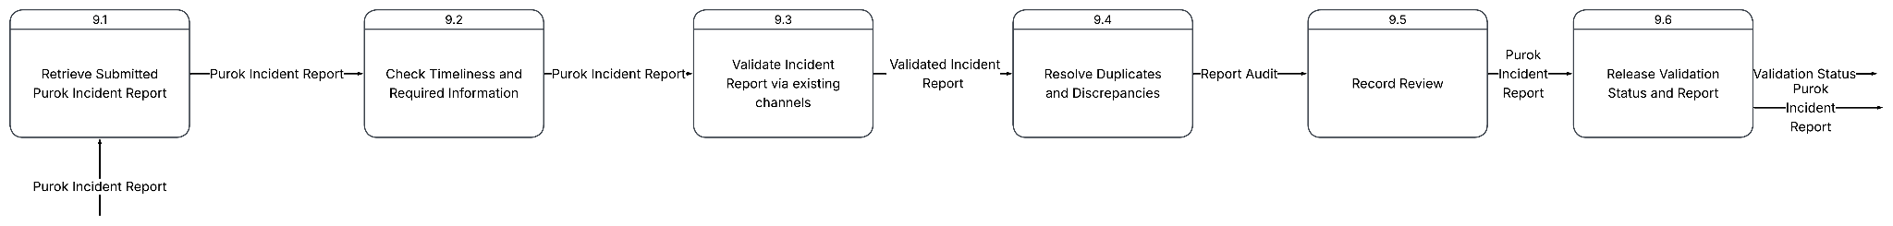
Figure 36. Integrated Disaster Incident Record Management and Automated Situation Report Generation System Level 1 Verify Purok Incident Report

Process 10: Consolidate and Submit Barangay Incident Report
Figure 37 presents the Level 1 decomposition of Process 10.0, Consolidate and Submit Barangay Incident Report. This process is performed by the Barangay User and transforms verified Purok Incident Reports into a consolidated Barangay-level report. The process follows the project’s hierarchical reporting structure, in which Purok submissions provide the initial data and the Barangay produces a broader, validated account of the incident.
The process begins with 10.1 Retrieve Purok Incident Reports, which obtains the Purok report versions that have passed Barangay verification. These reports are processed in 10.2 Consolidate Purok Reports, where the Barangay User combines the eligible Purok submissions and records the consolidated Purok data. The consolidation must retain the exact source versions used, identify excluded or pending reports, and document discrepancies or limitations.
In 10.3 Insert Barangay Information, the Barangay User adds Barangay-level information and uses the Barangay Profile to provide geographic, population, housing, and exposure context. The resulting information is transferred to 10.4 Record Barangay Incident Details from Consolidated Purok Data. This subprocess records the hazard type and name, location, exposure units, date, time, situation description, and consolidated affected-population information. For completeness, the Barangay report should also include aggregate casualty summaries and damage assessments, with their corresponding sources, data states, and as-of times.
The completed information is then submitted through 10.6 Submit Barangay Incident Report. Submission creates an immutable Barangay Incident Report version and produces the Barangay Incident Report and its Validation Status for subsequent DRRM-level verification.
The current diagram labels subprocess 10.5 as Record Actions, Assistance, and Needs. This is inconsistent with the approved responsibility boundary of the project. Detailed response actions, assistance, needs, and related operational content are assigned to the DRRM Administrator during Situation Report preparation. Therefore, 10.5 should either be removed from the Barangay process or replaced with a subprocess for recording the Barangay casualty summary and damage assessment. If retained, it should be moved to Process 12.0, Generate, Review, and Approve Situation Report.

Figure 37. Integrated Disaster Incident Record Management and Automated Situation Report Generation System Level 1.5 DFD

Process 11: Verify Barangay Incident Report
Figure 38 presents the Level 1 decomposition of Process 11.0, Verify Barangay Incident Report. This process is performed by the DRRM Administrator and provides the higher-level verification required before a Barangay Incident Report can be used as an authoritative source for Situation Report generation.
The process begins with 11.1 Retrieve Submitted Barangay Incident Report, which obtains the submitted Barangay report version for review. In 11.2 Check Timeliness and Required Information, the DRRM Administrator examines the report’s reporting period, as-of time, incident reference, location, situation description, consolidation cutoff, source coverage, affected-population totals, casualty summary, and damage assessment. The review also confirms that required limitations, exclusions, and reconciliation notes have been documented.
The report is then processed by 11.3 Validate Incident Report via Existing Records and Channels. The submitted information is compared with the relevant Barangay profile, verified Purok report versions, hazard records, supporting evidence, and other authorized information channels. This validation assesses whether the Barangay totals are traceable, internally consistent, geographically appropriate, and supported by the available sources.
In 11.4 Resolve Duplicates and Discrepancies, the DRRM Administrator investigates duplicate reports, conflicting figures, incomplete source coverage, and other inconsistencies. Any correction requirement or accepted limitation is documented. The submitted report is not silently overwritten; a correction must be represented by a successor version while the original report and its review history remain available.
The review outcome is recorded through 11.5 Record Review, which produces a report-audit record and preserves the version-specific verification decision. Finally, 11.6 Release Validation Status and Report communicates the validation status and releases the Barangay Incident Report for authorized Situation Report processing. The outcome may indicate verification, return for correction, or rejection.

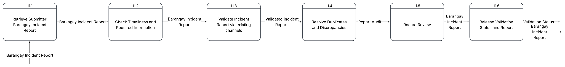
Figure 38. Integrated Disaster Incident Record Management and Automated Situation Report Generation System Level 1.5 DFD

Process 12: Generate Situation Report
Figure 39 presents the Level 1 decomposition of Process 12.0, Generate, Review, and Approve Situation Report. This process is performed by the DRRM Administrator and converts verified Barangay incident information into a structured Situation Report. The process applies a fixed disaster-incident scope and reporting cutoff so that all information included in the r eport corresponds to a defined operational period and an identifiable source set.
The process begins with 12.1 Select Disaster Incident and Cutoff. The DRRM Administrator selects the disaster incident to be covered and specifies the time cutoff for the report. These selections determine the reporting scope and prevent information received after the defined cutoff from being unintentionally included. The selected incident and cutoff are then used by 12.2 Retrieve Verified Barangay Incident Reports, which obtains the Barangay Incident Report versions that have completed DRRM verification and are eligible for Situation Report use.
The first output group is created through 12.3 Build Document Control and Identification Section. This subprocess establishes the report’s administrative identity, including the Situation Report number, title, primary incident, associated hazards, operational period, version number, preparer information, and document status. These fields provide document control and allow each report version to be distinguished, reviewed, approved, and retained in the historical catalog.
The Situation Overview is constructed through several specialized subprocesses. Process 12.4 Build Situation Overview (Incident Identification) records the incident name, primary hazard, onset date and time, current status, incident scale, and incident description. Process 12.5 Build Situation Overview (Location and Geographic Coverage) identifies affected Barangays and Puroks, landmarks, affected areas, geographic descriptions, and location remarks. Process 12.6 Build Situation Overview (Hazard Conditions) records the hazard severity, intensity, hazard level, alert level, advisory measures, and expected development based on available hazard information and authorized advisories. Process 12.7 Build Situation Overview (Situation Chronology) documents the sequence of significant developments, including the date and time, event or development type, location, description, reporting party, information source, verification status, and supporting evidence. Process 12.8 Build Situation Overview (Preparedness Measures) records preparedness activities, responsible agencies, areas covered, implementation times, standby response units, evacuation-centre status, and dissemination measures.
The Consolidated Effects section is developed from verified Barangay data through Processes 12.9 to 12.22. Process 12.9 records affected geographic and exposure units by identifying the affected Barangays and Puroks, exposure categories, baseline exposure quantities, affected quantities, impact severity, dates, and remarks. Process 12.10 records related incidents and their relationship to the primary incident or hazard. Process 12.11 consolidates the affected population, while Process 12.12 records the displaced population, including current and cumulative families or persons, affected areas, reporting times, source reports, and verification status.
Process 12.13 consolidates casualty information by category and location, distinguishing validated counts, counts requiring validation, and total reported counts. Process 12.14 records damaged houses according to location, damage severity, quantity, estimated cost, assessment date, source, and verification status. Process 12.15 records agricultural and fisheries effects, including affected commodities, farmers, fisherfolk, livestock owners, crop areas, livestock, fishery areas, and estimated production losses. Process 12.16 records infrastructure damage, including infrastructure category, facility identification, damage classification, operational status, severity, estimated repair cost, assessment date, validating agency, source, and remarks. Process 12.17 records other damaged assets using asset identification, affected and damaged quantities, operational condition, estimated cost, source, validating agency, and verification status. Process 12.18 records the status of lifelines, including the service provider, affected Barangay or Purok, operational status, interruption percentage, interruption and restoration times, cause, advisory reference, and remarks.
Processes 12.19 to 12.22 record additional DRRM-owned effects and operational conditions. Process 12.19 documents class or work suspensions, including the affected sector, education or work level, geographic coverage, suspension and resumption times, issuing authority, advisory reference, and status. Process 12.20 records declarations of a state of calamity, including the geographic area, declaration level, ordinance or resolution number, effective date, issuing authority, and declaration status. Process 12.21 documents pre-emptive evacuation, including the hazard basis, evacuated families, evacuation-centre information, start time, current status, and remarks. Process 12.22 records assistance provided, including recipients, assistance type, date and time, families or persons served, source, distribution status, evidence, and remarks.
The Response Actions section is produced through 12.23 Build Response Actions Section. This subprocess records the response cluster, action category, involved agencies, response time, action description, affected Barangays or Puroks, current status, population served, and operational result. Process 12.24 Build Issues and Concerns Section identifies unresolved gaps, remaining concerns, planned follow-up actions, supporting sources, and evidence. These issues provide the basis for Process 12.25 Build Recommendations Section, which records the related issue, recommendation category, proposed action, justification, responsible agencies, estimated time and budget, expected outcome, decision authority, approval status, implementation status, and results or remarks.
Finally, 12.26 Finalize Situation Report assembles the completed sections into the report document and produces the Situation Report output. Finalization should preserve the report version, source cutoff, verification results, approval status, and document hash or equivalent integrity reference. A clean report should only be released after the required DRRM review and approval controls have been completed, while draft versions remain identifiable as drafts.
Overall, Figure 39 demonstrates a source-controlled and progressive Situation Report generation process. Verified Barangay reports provide the principal source for affected population, casualties, damage, and other consolidated effects, while the DRRM Administrator authors or validates the chronology, preparedness measures, lifeline conditions, suspensions, declarations, evacuation, response actions, issues, and recommendations. The decomposition therefore preserves the Purok-to-Barangay-to-DRRM reporting hierarchy, separates derived information from DRRM-authored operational content, and supports traceable, cumulative, and formally controlled Situation Report production.

Figure 39. Integrated Disaster Incident Record Management and Automated Situation Report Generation System Level 1.5 DFD
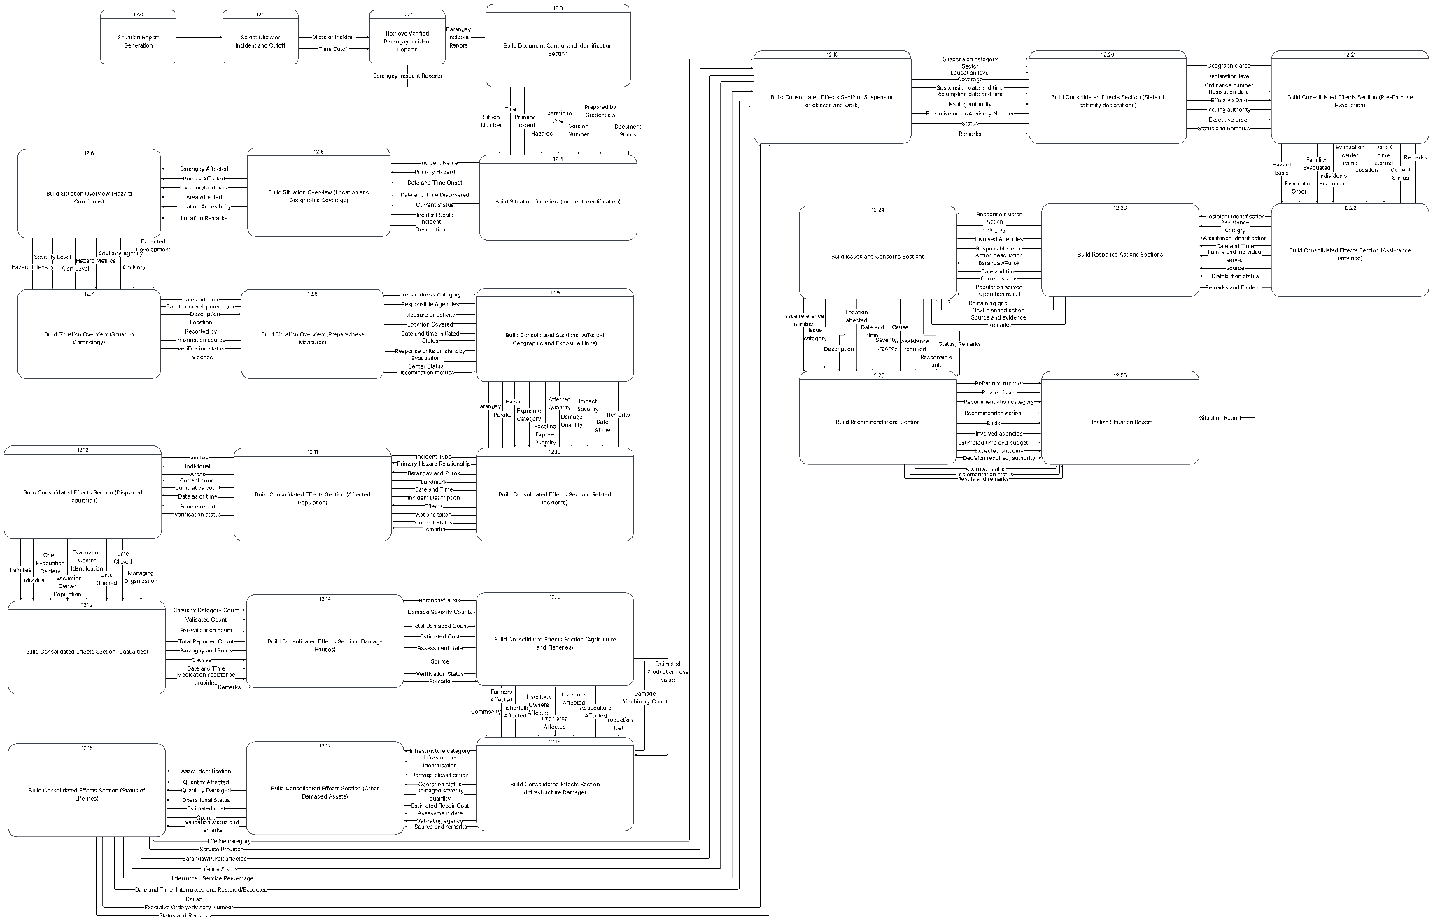

3.3.2 Data Models
Figure 40 presents the conceptual Entity–Relationship Diagram (ERD) of the Disaster Situation Record Management and Situation Report Generation System. It identifies the principal entities, their attributes, and the relationships required to support account administration, hazard documentation, community profiling, incident reporting, verification, consolidation, and formal situation report generation. The model represents the system’s hierarchical information structure, beginning with data collected at the Purok level, progressing through Barangay consolidation and verification, and ending with the preparation and release of a formal situation report by the DRRM Administrator.
The ERD is organized into five major data domains: account and access management, hazard documentation, community profiling, incident reporting, and situation report management. This organization separates operational data according to its purpose while maintaining the relationships necessary for traceability. The entities are presented as conceptual data objects rather than as interface screens or process steps. Consequently, the relationship labels describe data association and responsibility, not the chronological flow of activities shown in a Data Flow Diagram.
The Account entity serves as the general account or supertype for the system’s authorized users. It contains common account attributes, including the account identifier, username, password hash, name, contact information, address or location, account status, creation date, and the account responsible for creating the record. The account structure is specialized into DRRM_account, Barangay_account, and Purok_account. The disjoint specialization marker indicates that an account belongs to one authorized user category within the system. This reflects the system’s role-based administrative arrangement: the DRRM Administrator manages Barangay accounts, Barangay users manage Purok accounts, and Purok users perform data-entry activities for their assigned communities. Account creation is therefore controlled by the appropriate higher administrative level rather than by public self-registration.
The hazard domain is represented by the Hazard and Hazard_characteristic entities. The Hazard entity stores the basic identification of a hazard, including its type, date, time, location, and severity. The Hazard_characteristic entity stores the more detailed description of the hazard, such as its narrative description, landmark, intensity or magnitude, measurement unit, duration, severity, current status, record status, preparer, and submission date. Separating the basic hazard record from its descriptive characteristics allows a hazard to be documented consistently while preserving additional technical information required for assessment and reporting. Hazard records are associated with the account that creates or submits them, thereby establishing accountability for the source of the information.
The community-profiling domain is divided into Purok and Barangay entities. Purok_profile represents the profile of an individual Purok and includes its identification, location, population totals, household totals, sex-disaggregated counts, age-group counts, and other aggregate demographic indicators. It also includes separate entities for Purok_profile_housing and Purok_profile_hazard_exposure. These dependent entities store aggregate housing conditions and hazard-exposure counts, respectively. The model does not represent individual household records; instead, it records the aggregated information submitted by the Purok user, such as total population, housing conditions, and the number of households or persons exposed to particular hazards.
Barangay_profile represents the corresponding Barangay-level profile. Its attributes include the Barangay identity, location, total population, demographic totals, and other required aggregate indicators. The Barangay profile is supplemented by Barangay_profile_housing and Barangay_profile_hazard_exposure, which store the Barangay’s consolidated housing conditions and hazard-exposure information. The relationship between Purok and Barangay profiling reflects the system’s aggregation principle: verified Purok profiles serve as the source for Barangay consolidation. This prevents the Barangay profile from becoming an unrelated duplicate and establishes a clear connection between local source data and the higher-level administrative summary.
The verification entities, Purok_profile_verification and Barangay_profile_verification, document the review of submitted profiles. They record the profile being reviewed, the reviewing organization or user, the verification decision, the reason or remarks for the decision, the verification status, and the date of review. These entities support a controlled workflow in which submitted profiles are not immediately treated as official records. Instead, a profile proceeds from submission to review and is accepted, returned for correction, or otherwise assigned an appropriate status before it can be used for higher-level consolidation or situation reporting.
The incident-reporting domain is represented by the general Incident_report entity and its specialized report entities, Purok_incident_report and Barangay_incident_report. The disjoint specialization indicates that an incident report is classified according to the reporting level at which it is created. The Purok report represents the initial and intentionally simplified account of an incident. It primarily records the hazard involved, the affected population, the location, the date and time, and other essential initial observations. It is not intended to contain the full set of casualty, damage, response, or recommendation information required in a formal situation report.
The Barangay report represents the consolidated and verified account of the incident at Barangay level. It incorporates information from submitted Purok reports and provides a broader assessment of the incident’s effects. The Barangay-level record may consolidate affected population figures and document casualty summaries and damage assessments. This distinction reflects the approved reporting boundary of the system: Purok users provide timely initial information, Barangay users validate and aggregate that information, and DRRM Administrators use the verified Barangay record as the principal operational source for formal reporting.
The Incident_report_version entity preserves the version history of each incident report. Its attributes identify the report version, stage, start and end of the reporting period, record status, preparer, and preparation date. Versioning is important because incident information changes as additional verification and assessment are completed. Maintaining versions enables the system to distinguish an initial submission from a corrected, verified, or released version rather than silently overwriting earlier information.
The related entities Incident_report_affected_population, Incident_report_casualty_summary, and Incident_report_damage_assessment separate the major categories of incident effects. The affected-population entity records the affected area, Purok, family count, person count, current count, and cumulative count. The casualty-summary entity records casualty categories and the number of affected, injured, deceased, missing, or still-for-validation cases, subject to the categories adopted by the project. The damage-assessment entity records the affected area, damage category, owner or responsible party, damage classification, estimated damage, and estimated loss. Separating these effect categories avoids placing unrelated repeating values in a single incident table and supports more accurate aggregation for Barangay and DRRM reporting.
The situation-reporting domain is centered on the Situation_report entity. This entity identifies the formal report through attributes such as the report identifier, title, report type, creation date, and report version. The report is supported by several related entities, each representing a structured section of the formal situation report. These entities allow the report to be assembled from verified operational data while keeping each section independently maintainable and auditable.
The Situation_report_assistance-provided entity records assistance delivered during the response, including the assistance type, recipient group, item or service, provider, quantity or measurement unit, estimated cost per unit, resource source, and delivery date and time. The Situation_report_response-action entity records response activities, including the response phase, cluster, action category, description, responsible organization, start and completion times, action status, population coverage, and resources used. Together, these entities document what assistance was provided, which organizations participated, which communities were served, and whether the response action was completed or remains ongoing.
The Situation_report_issue and Situation_report_recommendation entities document unresolved concerns and proposed actions. The issue entity records the issue category, description, location or point of identification, severity, priority, and responsible organization. The recommendation entity records the target organization, priority, rationale, recommendation text, target date, status, and resulting action or decision. These entities ensure that the situation report is not limited to descriptive statistics but also communicates operational gaps, required interventions, and decisions that must be addressed by responsible authorities.
The Situation_report_calamity-declaration entity records formal declarations related to the incident, including the declaration body, reason, declaration date, effective date, and remarks. The Situation_report_classwork-suspension entity records the suspension of classes or work, including the suspension category, type, coverage, start and end dates, issuing authority, and status. The Situation_report_lifeline-status entity records the condition of essential services and lifelines, including the service type, operator, damage classification, affected area, estimated loss, and operating status. These entities provide structured records for administrative decisions and the continuity of essential services.
The Situation_report_preemptive-evacuation entity records evacuation undertaken before or during the escalation of a hazard. Its attributes include the reason, number of families and persons evacuated, evacuation center, start date and time, and current status. The Situation_report_signatory entity identifies the individuals responsible for reviewing, approving, or signing the report. It records the signatory’s role, name, designation, and identifying number. The signatory entity supports formal accountability and distinguishes a prepared draft from an officially approved or released situation report.

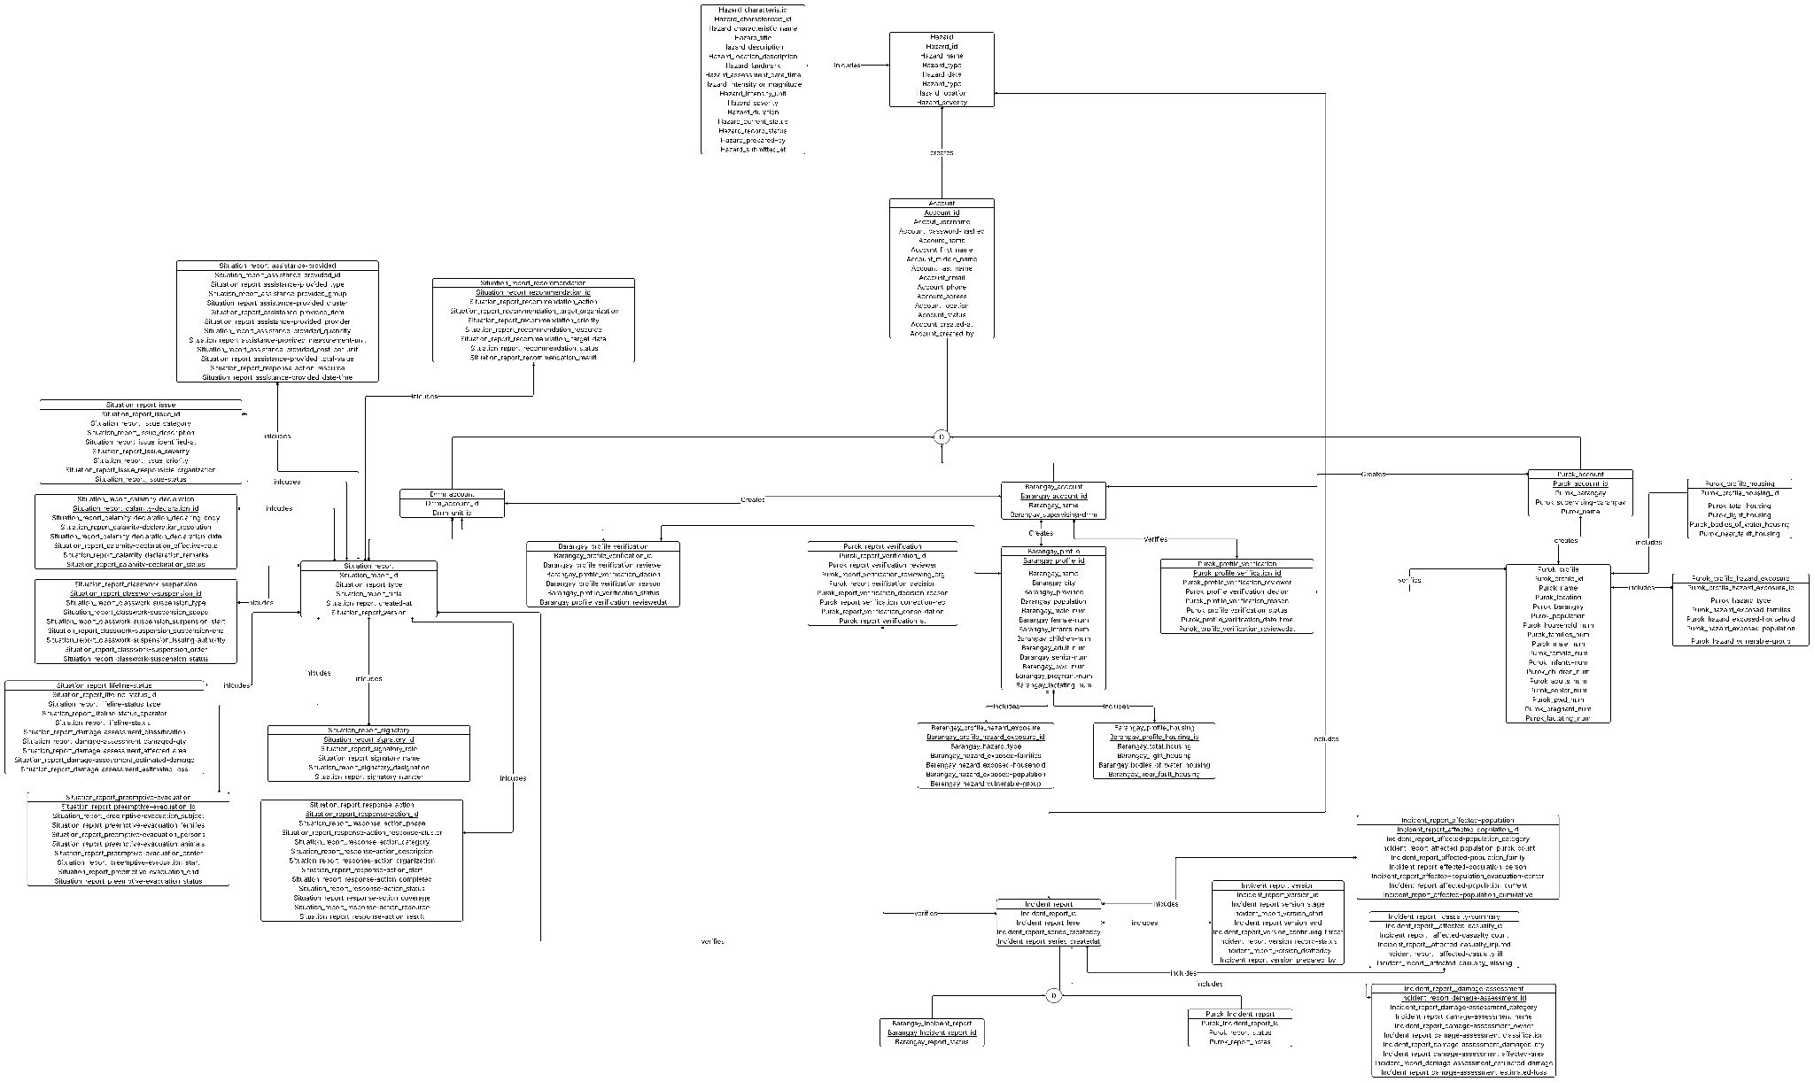
Figure 40. Integrated Disaster Incident Record Management and Automated Situation Report Generation System Entity Relationship Diagram

3.3.3 Logic Models

3.3.3.1 Purok Profile Verification
This process allows the authorized Barangay user to review and verify a submitted Purok profile.
RETRIEVE Submitted Purok Profile FROM Purok Profile DB
RETRIEVE Purok Housing Data FROM Purok Profile DB
RETRIEVE Purok Hazard Exposure Data FROM Purok Profile DB
RETRIEVE Purok Account Details FROM Accounts DB
IF Barangay Account is authorized for the Purok THEN
CHECK Required Profile Sections
CHECK Population and Housing Consistency
CHECK Hazard Exposure Completeness
CHECK Supporting Remarks or Evidence
IF Profile is complete AND internally consistent THEN
RECORD Verification Decision as "Verified"
RECORD Reviewer and Review Date
SAVE Purok Profile Verification
UPDATE Purok Profile Status to "Verified"
NOTIFY Purok User
MAKE Verified Purok Profile Available for Barangay Consolidation
ELSE
RECORD Verification Decision as "For Correction"
RECORD Verification Reason
SAVE Purok Profile Verification
UPDATE Purok Profile Status to "Returned"
NOTIFY Purok User of Required Corrections
ENDIF
ELSE
DISPLAY "Unauthorized Profile Verification Request"
ENDIF
EXIT

3.3.3.2 Barangay Profile Verification
This process allows the DRRM Administrator to verify a consolidated Barangay profile.
RETRIEVE Submitted Barangay Profile FROM Barangay Profile DB
RETRIEVE Barangay Housing Data FROM Barangay Profile DB
RETRIEVE Barangay Hazard Exposure Data FROM Barangay Profile DB
RETRIEVE Verified Purok Profiles FROM Purok Profile DB

IF DRRM Account is authorized THEN
CHECK Required Barangay Profile Sections
CHECK Whether Barangay Values Correspond to Verified Purok Data
CHECK Population, Housing, and Exposure Totals
CHECK Supporting Remarks or Evidence
IF Profile is complete AND consolidation is consistent THEN
RECORD Verification Decision as "Verified"
RECORD Reviewer and Review Date
SAVE Barangay Profile Verification
UPDATE Barangay Profile Status to "Verified"
NOTIFY Barangay User
MAKE Verified Barangay Profile Available for Incident Reporting
ELSE
RECORD Verification Decision as "For Correction"
RECORD Verification Reason
SAVE Barangay Profile Verification
UPDATE Barangay Profile Status to "Returned"
NOTIFY Barangay User of Required Corrections
ENDIF

ELSE
DISPLAY "Unauthorized Profile Verification Request"
ENDIF
EXIT

3.3.3.3 Purok Incident Verification
This process allows the Barangay user to review the initial Purok incident report.
RETRIEVE Submitted Purok Incident Report FROM Purok Incident DB
RETRIEVE Affected Population Data FROM Purok Incident DB
RETRIEVE Hazard Details FROM Hazards DB
RETRIEVE Existing Incident Reports FROM Purok Incident DB
IF Barangay Account is authorized THEN
CHECK Required Incident Details
CHECK Hazard, Location, Date, and Time
CHECK Affected Population Values
CHECK Duplicate or Existing Incident Records
IF Report is complete AND
Report is not a duplicate THEN

RECORD Verification Decision as "Verified"
RECORD Reviewer and Review Date
SAVE Verification Result
UPDATE Purok Incident Report Status to "Verified"
NOTIFY Purok User
MAKE Verified Purok Report Available for Barangay Consolidation
ELSE
RECORD Verification Decision as "For Correction"
RECORD Verification Reason
SAVE Verification Result
UPDATE Purok Incident Report Status to "Returned"
NOTIFY Purok User of Required Corrections
ENDIF
ELSE
DISPLAY "Unauthorized Incident Report Verification Request"
ENDIF
EXIT

3.3.3.4 Barangay Incident Verification
RETRIEVE Submitted Barangay Incident Report FROM Barangay Incident DB
RETRIEVE Incident Report Version FROM Barangay Incident DB
RETRIEVE Affected Population Data FROM Barangay Incident DB
RETRIEVE Casualty Summary FROM Barangay Incident DB
RETRIEVE Damage Assessment FROM Barangay Incident DB
RETRIEVE Verified Purok Incident Reports FROM Purok Incident DB
IF DRRM Account is authorized THEN
CHECK Incident Identification
CHECK Whether Barangay Totals Correspond to Verified Purok Reports
CHECK Affected Population Counts
CHECK Casualty Summary
CHECK Damage Assessment
CHECK Duplicate or Conflicting Reports
IF Report is complete AND
Consolidated Values are supported by verified sources THEN
RECORD Verification Decision as "Verified"
RECORD Reviewer and Review Date
SAVE Barangay Incident Report Verification
UPDATE Report Status to "Verified"
RELEASE Verified Report for Situation Report Generation
NOTIFY Barangay User
ELSE
RECORD Verification Decision as "For Correction"
RECORD Verification Reason
SAVE Verification Result
UPDATE Report Status to "Returned"
NOTIFY Barangay User of Required Corrections
ENDIF
ELSE
DISPLAY "Unauthorized Barangay Report Verification Request"
ENDIF
EXIT

3.3.3.5 Situation Report Generation
This process transforms verified Barangay incident information into a formal, editable, versioned, and exportable situation report.
RETRIEVE DRRM Account Details FROM Accounts DB
RETRIEVE Verified Barangay Incident Reports FROM Barangay Incident DB
RETRIEVE Verified Incident Report Versions FROM Barangay Incident DB
RETRIEVE Verified Profile Data FROM Barangay Profile DB
RETRIEVE Hazard Details FROM Hazards DB

INPUT Situation Report Parameters:
Selected Disaster Incident
Reporting Cutoff Date and Time
Report Title
Operational Period
Report Type
IF Verified Barangay Incident Reports exist for the selected incident THEN
CREATE Situation Report Draft
BUILD Document Control and Identification Section:
SitRep Number
Title
Primary Incident
Primary Hazards
Operational Period
Version Number
Prepared By
Document Status
BUILD Situation Overview:
Incident Identification
Incident Name
Primary Hazard
Date and Time of Onset
Incident Scale
Current Status
Incident Description
Affected Barangays and Puroks
Geographic Coverage
Hazard Intensity and Severity
Situation Chronology
Preparedness Measures
BUILD Consolidated Effects Section:
Affected Geographic and Exposure Units
Related Incidents
Affected Population
Displaced Population
Casualties
Damaged Houses
Agriculture and Fisheries Effects
Infrastructure Damage
Other Damaged Assets
Lifeline Status
Class or Work Suspensions
State of Calamity Declarations
Pre-emptive Evacuation
BUILD Response and Assistance Sections:
Response Cluster
Response Action Category
Responsible Agencies
Action Description
Date and Time
Current Status
Population Served
Assistance Type
Recipients
Quantity or Service Provided
Distribution Status
Source and Evidence
BUILD Issues and Concerns Section:
Issue Reference Number
Issue Category
Issue Description
Affected Location
Severity or Urgency
Assistance Required
Responsible Unit
Current Status
Remarks
BUILD Recommendations Section:
Reference Number
Related Issue
Recommendation Category
Recommended Action
Basis
Involved Agencies
Estimated Time and Budget
Expected Outcome
Decision Authority
Approval Status
Implementation Status

ATTACH Source Records and Evidence References
SAVE SitRep Draft TO Situation Report DB
DISPLAY Editable Situation Report Draft to DRRM Administrator
IF DRRM Administrator confirms that all mandatory sections are complete THEN
RECORD Signatory Details
RECORD Approval Status
CREATE Situation Report Version
SET Document Status to "Approved" or "Released"
SAVE Final Situation Report TO Situation Report DB
EXPORT Situation Report to Approved Document Format
DISPLAY "Situation Report Finalized and Exported"
ELSE
SET Document Status to "Draft"
DISPLAY "Complete or revise required sections before finalization"
ENDIF
ELSE
DISPLAY "No Verified Barangay Incident Data Found for Selected Period"
ENDIF

EXIT

3.3.3.6 Purok Historical Catalog
This process allows authorized users to retrieve historical Purok incident reports.
RETRIEVE Purok Account Details FROM Accounts DB
RETRIEVE Purok Incident Reports FROM Purok Incident DB
RETRIEVE Incident Report Versions FROM Purok Incident DB

IF Purok Account is active THEN
INPUT Search Parameters:
Purok
Hazard Type
Reporting Period
Report Status
FILTER Purok Incident Reports Using Search Parameters
IF Matching Reports exist THEN
DISPLAY Purok Historical Report Catalog:
Report Identifier
Hazard
Incident Date
Reporting Period
Affected Population
Report Status
Verification Status
Version Information
ELSE
DISPLAY "No Purok Historical Reports Found"
ENDIF
ELSE
DISPLAY "Unauthorized Historical Report Access"
ENDIF
EXIT

3.3.3.7 Barangay Historical Catalog
RETRIEVE User Account Details FROM Accounts DB
RETRIEVE Barangay Incident Reports FROM Barangay Incident DB
RETRIEVE Incident Report Versions FROM Barangay Incident DB
IF User is authorized for the selected Barangay or DRRM unit THEN
INPUT Search Parameters:
Barangay
Hazard Type
Incident Date
Reporting Period
Verification Status
FILTER Barangay Incident Reports Using Search Parameters
IF Matching Reports exist THEN
DISPLAY Barangay Historical Report Catalog:
Report Identifier
Affected Barangays and Puroks
Affected Population
Casualty Summary
Damage Summary
Report Status
Verification Status
Version Information
ELSE
DISPLAY "No Barangay Historical Reports Found"
ENDIF

ELSE
DISPLAY "Unauthorized Historical Report Access"
ENDIF
EXIT

3.3.3.8 Situation Report Historical Catalog
RETRIEVE User Account Details FROM Accounts DB
RETRIEVE Situation Reports FROM Situation Report DB
RETRIEVE Situation Report Versions FROM Situation Report DB
IF User is authorized to access Situation Reports THEN
INPUT Search Parameters:
Report Number
Incident
Report Type
Operational Period
Report Date
Document Status
FILTER Situation Reports Using Search Parameters
IF Matching Reports exist THEN
DISPLAY Situation Report Historical Catalog:
SitRep Number
Report Title
Primary Incident
Operational Period
Version Number
Prepared By
Approval Status
Release Date
Document Status
ALLOW User to View or Export Approved Report
ELSE
DISPLAY "No Historical Situation Reports Found"
ENDIF
ELSE
DISPLAY "Unauthorized Situation Report Access"
ENDIF
EXIT

3.3.3.9 Log In
INPUT Username
INPUT Password
RETRIEVE Account Details FROM Accounts DB
IF Username exists THEN
VERIFY Submitted Password Against Stored Password Hash
IF Password is valid AND Account Status is "Active" THEN
CREATE Authenticated Session
RETRIEVE Account Role
RETRIEVE Assigned Purok, Barangay, or DRRM Unit
IF Account Role is "Purok User" THEN
DISPLAY Purok Access Page
ELSE IF Account Role is "Barangay User" THEN
DISPLAY Barangay Access Page
ELSE IF Account Role is "DRRM Administrator" THEN
DISPLAY DRRM Administrator Access Page
ELSE
DISPLAY "Invalid Account Role"
ENDIF
ELSE
DISPLAY "Invalid Credentials or Inactive Account"
ENDIF
ELSE
DISPLAY "Account Not Found"
ENDIF
EXIT

3.3.3.10 System User Management
RETRIEVE DRRM Account Details FROM Accounts DB
RETRIEVE Account Records FROM Accounts DB
RETRIEVE Purok Account Records FROM Accounts DB
RETRIEVE Barangay Account Records FROM Accounts DB
IF DRRM Account is active THEN
INPUT Account Query:
Account Role
Name
Barangay
Purok
Account Status
Username
Date Created
FILTER Account Records Using Query Parameters
DISPLAY Matching Account Records
IF Account Maintenance is requested THEN
SELECT Account Record
IF Update Request is valid THEN
UPDATE Account Details
UPDATE Account Status or Assigned Unit
RECORD Updating DRRM Account
SAVE Updated Account TO Accounts DB
DISPLAY "Account Updated"

ELSE IF Deactivation Request is valid THEN
SET Account Status to "Inactive"
RECORD Deactivation Reason
RECORD Updating DRRM Account
SAVE Account Status TO Accounts DB
DISPLAY "Account Deactivated"
ELSE IF Credential Reset is requested THEN
GENERATE New Account Credentials
SAVE Credential Update TO Accounts DB
DISPLAY "Credentials Reset"
ELSE
DISPLAY "Invalid Account Maintenance Request"
ENDIF
ENDIF
ELSE
DISPLAY "Unauthorized System User Management Request"
ENDIF
EXIT

3.4 Design
The design phase is focused on the planning of the logistics of Disaster Incident Report and Situation Report Generation. The design planning phase ensures that the system is aligned with the specific needs and addresses the challenges of the current process. It also ensures that the system flow is intuitive and accessible for ease of use.

3.4.1 Database Design
Figure 41 is the actual snapshot of the database schema of the Disaster Situation Record Management and Situation Report Generation System. It illustrates the relational structure of the database, identifies its principal entities and attributes, and defines the relationships through which organizational, profiling, hazard, incident, and Situation Report information is maintained. The schema is implemented using PostgreSQL and employs primary keys, foreign keys, unique constraints, and validation rules to maintain the consistency of related records. Its design separates the identity of a record from its successive versions, allowing the system to preserve historical information, document corrections, and trace the information used in the preparation of formal Situation Reports.
The database is organized around the administrative hierarchy of the system. Organizational units and user accounts establish the context in which records are created and maintained. Profile and hazard records provide baseline and situational information, while incident reports document disaster effects and reporting activities. Verified Barangay reports and hazard information subsequently serve as inputs to Situation Report preparation. Supporting tables maintain information sources, evidence, review decisions, derived values, and generated outputs. Overall, the relational structure provides a controlled information pathway from the originating administrative unit to the final report, while retaining the identities and relationships of the records involved.
Each principal entity contains a primary key that uniquely identifies its records. Most principal tables use a UUID-based `id` column, while selected associative tables use composite primary keys composed of the identifiers of the records they connect. For example, `incident_hazard` uses the combination of `tenant_id`, `incident_id`, and `hazard_version_id` to identify the association between an incident and a specific hazard version. Similarly, `profile_version_evidence` uses `tenant_id`, `profile_version_id`, and `evidence_id` to identify the evidence associated with a particular profile version. These composite keys prevent duplicate associations involving the same combination of records.
Foreign keys establish the relationships among the tables and maintain referential integrity. The `tenant_id` column is included in many foreign-key relationships to ensure that dependent records reference entities within the same tenant. For instance, the composite foreign key `(tenant_id, account_id)` references `account(tenant_id, id)`, while `(tenant_id, unit_id)` references `organization_unit(tenant_id, id)`. Through these relationships, the database associates records not only with their corresponding entities but also with the organizational context in which they are maintained.
The schema further distinguishes between record identifiers and version identifiers. The `incident_report` table, for example, identifies a continuing report series through its `id` column, whereas `incident_report_version` identifies each individual version through a separate `id`. The `report_id` foreign key connects a version to its parent report, while `parent_version_id` establishes the relationship between successive versions. The same design is applied to `profile` and `profile_version`, `hazard_record` and `hazard_version`, and `situation_report` and `situation_report_version`. This separation allows the system to retain the identity of a report while maintaining a history of its revisions and submitted states.
The `tenant` table represents the organizational boundary of the system. Each tenant may contain multiple records in `organization_unit`, which stores the city, barangay, and purok units associated with that tenant. The `parent_id` foreign key establishes a self-referencing relationship that represents the hierarchy from city to barangay and from barangay to purok. The schema’s hierarchy rules require a barangay to belong to a city and a purok to belong to a barangay, while a city has no parent. This relationship provides the jurisdictional context for user assignments, profile ownership, hazard records, and incident reporting.
The `account` table stores the application-level information of system users and connects each account to its corresponding Supabase authentication identity through `auth_user_id`. The `created_by_account_id` foreign key establishes a self-referencing relationship that identifies the account responsible for creating another account. Administrative assignments are represented through the `purok_account`, `barangay_account`, and `drrm_account` tables. Each subtype uses `account_id` as both a primary key and a foreign key to `account`, while its respective unit identifier connects the account to the assigned purok, barangay, or city. The schema enforces the correspondence between an account’s administrative level and its subtype, ensuring that each account is associated with exactly one administrative-level assignment.
The `role_assignment` table defines the relationship between an account, an organizational unit, and an authorized role. Its `account_id` foreign key identifies the role holder, `unit_id` identifies the jurisdiction in which the role applies, and `assigned_by_account_id` identifies the account responsible for the assignment. The `valid_from` and `valid_until` attributes provide the temporal boundaries of the assignment. Together, these relationships support the separation of reporting, verification, preparation, approval, and administrative responsibilities according to the user’s assigned organizational unit and role.
The `information_source` and `evidence` tables provide the supporting structure for documenting the origin and evidentiary basis of recorded information. The `information_source` table stores source identification, reference information, observation and receipt dates, and reliability-related details. The `evidence` table stores information concerning supporting materials, including their storage location, capture details, privacy classification, and integrity checksum. Both tables contain foreign keys identifying the account responsible for creating or uploading the corresponding record.
Evidence is associated with specific record versions through the `profile_version_evidence`, `hazard_version_evidence`, and `report_version_evidence` tables. Each associative table connects an evidence record to the version it supports. The `sitrep_content_evidence` table performs a similar function for structured Situation Report content. These relationships allow supporting materials to be linked to the exact version or content item to which they pertain, rather than only to the general record series. The schema also maintains source relationships through tables such as `report_version_source`, which associates an incident report version with its information sources and stores citation-related information. This arrangement supports the documentation of provenance throughout the reporting process.
The profiling component is centered on the `profile` and `profile_version` tables. Each profile is associated with an organizational unit and a reporting month, while its versions contain the information prepared for that profile series. The `profile_id` foreign key connects each version to its parent profile, and `parent_version_id` identifies the preceding version when a correction is created. The `prepared_by_account_id` foreign key identifies the account responsible for preparing the version.

The `profile_population`, `profile_housing`, `profile_demographic`, and `profile_hazard_exposure` tables store the corresponding baseline information through foreign keys to `profile_version`. The population table contains aggregate population, household, family, and sex-related counts, while the housing table stores housing characteristics. The demographic table records population categories and their corresponding counts, and the hazard-exposure table associates a profile version with a configured hazard type through `hazard_type_id`. The `profile_exposed_group` table further describes population groups associated with a particular exposure record through `exposure_id`. These relationships allow baseline information to be maintained as structured records associated with a specific profile version.
The `profile_review_decision` table records the review outcome associated with a submitted profile version. Its `profile_version_id` foreign key identifies the version being reviewed, while `reviewer_account_id` identifies the reviewing account. The `barangay_profile_source` table establishes the relationship between a Barangay profile version and the Purok profile versions used in its consolidation. Its foreign keys identify both the Barangay version and the exact Purok version included in the source relationship. The schema also records the source disposition and reconciliation information, allowing the database to distinguish included records from those that remain pending, excluded, or superseded. This structure supports the preparation of Barangay baseline information from verified Purok profile records.
Hazard information is maintained through the `hazard_type`, `hazard_record`, and `hazard_version` tables. The `hazard_type` table defines the configured hazard classifications, while `hazard_record` identifies a hazard record associated with an organizational unit. The `hazard_type_id` foreign key classifies the hazard, and `unit_id` identifies the originating organizational unit. The `hazard_version` table stores the successive assessments or updates associated with the hazard record. Its `hazard_record_id` foreign key connects the version to the parent record, while `parent_version_id` establishes the relationship between successive versions.
Additional hazard information is stored in `hazard_characteristic`, which is associated with a specific hazard version through `hazard_version_id`. The `hazard_review_decision` table records the corresponding review outcome and identifies the reviewing account. Supporting evidence is connected through `hazard_version_evidence`. These relationships allow the database to preserve the distinction between a hazard’s continuing identity, its individual assessments, and the review and evidence associated with each assessment.
The `incident_type` table defines the configured incident classifications, while `incident` stores the principal information associated with a disaster incident. Its `incident_type_id` foreign key identifies the classification, and `created_by_account_id` identifies the account responsible for creating the incident record. The `incident_hazard` table connects incidents to specific hazard versions through `incident_id` and `hazard_version_id`. This associative relationship allows an incident to be associated with the hazard information relevant to its occurrence and provides the basis for connecting hazard observations to subsequent incident reports.
The incident-reporting component is organized around `incident_report` and `incident_report_version`. Each incident report is associated with an incident through `incident_id` and with a reporting organizational unit through `reporting_unit_id`. The `level` attribute distinguishes Purok and Barangay report series. The version table stores the report stage, occurrence or observation information, prevailing situation, reporting dates, and submission details. Its `report_id` foreign key connects the version to its report series, while `parent_version_id` identifies the preceding version.
The `report_effect_item` table connects a report version to its reported effects through `report_version_id`. The `kind` attribute identifies the type of effect, while the `affected_population`, `casualty_summary`, and `damage_assessment` tables contain the corresponding type-specific information. Each subtype uses `effect_item_id` as its primary key and as a foreign key to `report_effect_item`. The schema enforces the correspondence between an effect item and its subtype, ensuring that an effect is represented by the appropriate detail table. This structure separates the common identification and provenance of an effect from the attributes required for population, casualty, or damage reporting.
The `report_review_decision` table records the review outcome associated with a submitted incident report version. Its `report_version_id` foreign key identifies the version being reviewed, while `reviewer_account_id` identifies the reviewing account. The `barangay_report_source` table establishes the relationship between a Barangay report version and the Purok report versions used in its consolidation. It stores the exact Purok version, the corresponding report-series identifier, and the source disposition. The schema’s validation rules require included Purok sources to belong to the same incident, fall within the appropriate Barangay jurisdiction, and satisfy the applicable verification and consolidation-cutoff requirements. These relationships establish the progression from Purok-level reporting to Barangay-level consolidation.
The Situation Report component is centered on `situation_report` and `situation_report_version`. The `situation_report` table identifies the continuing report series and associates it with a city through `city_unit_id`. The `situation_report_version` table stores the individual report versions, including their operational period, information cutoff, preparation details, and workflow state. Its `situation_report_id` foreign key connects each version to the parent report, while `parent_version_id` establishes the relationship between successive versions.
The `situation_report_incident` table identifies the incidents covered by a particular Situation Report version. Its foreign keys connect the report version to the corresponding incident records. The `situation_report_section` table stores the formal sections of the report, including their section codes, headings, sequence numbers, content, and completion status. These relationships allow a Situation Report version to contain multiple covered incidents and multiple formal sections while retaining a single report-series identity.
The `sitrep_source_snapshot` table represents the source set associated with a Situation Report version. The `snapshot_barangay_report` and `snapshot_hazard_version` tables identify the specific Barangay report versions and hazard versions associated with that snapshot. Their foreign keys connect the snapshot to the exact source versions, while their disposition fields identify whether a source is included, pending, excluded, or superseded. The schema’s validation rules require included Barangay reports and hazard versions to satisfy the applicable verification, jurisdiction, incident-coverage, and cutoff requirements. Once frozen, the snapshot preserves the source membership used for the corresponding Situation Report version. This structure supports the reproducibility and traceability of the information selected for report preparation.
Derived Situation Report information is stored in `sitrep_data_point`. Each data point is associated with a Situation Report version through `situation_report_version_id` and contains a field code, value, measurement unit, value state, aggregation method, source-coverage information, and derivation hash. The `sitrep_data_point_source` table establishes the relationship between a derived data point and the report-effect records that contributed to it. Its foreign keys connect the data point to `sitrep_data_point` and the contributing effect to `report_effect_item`.
Through this relationship, a consolidated value can be traced from the Situation Report back to the specific report-effect records from which it was derived. The schema further requires source lineage to correspond to included Barangay report versions in the relevant source snapshot. This prevents a derived value from being associated with an unrelated report effect and supports the identification of the records used in the consolidation process.
The `sitrep_value_override` table records an authorized replacement of a derived value. Its `sitrep_data_point_id` foreign key identifies the affected data point, while `requested_by_account_id` and `approved_by_account_id` identify the accounts responsible for requesting and approving the override. The table also stores the original value, original derivation hash, replacement value, and justification. This relationship preserves the distinction between the originally derived information and an approved adjustment, thereby supporting accountability when a consolidated value requires correction.

The Situation Report component further separates the general identity of a content item from the attributes required by its particular content type. The `sitrep_content_item` table stores the common information associated with a report entry, including its Situation Report version, content kind, sequence number, information date, value state, source, and recording account. The corresponding subtype tables contain the attributes specific to each category of information. This arrangement allows the database to represent different Situation Report contents through a common relational structure while retaining the fields necessary for their individual reporting purposes.
The incident-related subtype tables include `sitrep_incident_overview`, `sitrep_geographic_coverage`, `sitrep_hazard_condition`, `sitrep_chronology`, `sitrep_exposure_summary`, and `sitrep_related_incident`. These tables respectively represent the incident description, geographic coverage, hazard conditions, chronological events, exposure information, and related incidents included in a Situation Report. Their foreign keys connect the content to the relevant incident, organizational unit, hazard version, hazard type, or baseline profile version where applicable. Through these relationships, the report can retain both descriptive information and references to the underlying records from which the information was obtained.
The operational subtype tables include `sitrep_preparedness_measure`, `sitrep_displaced_population`, `sitrep_lifeline_status`, `sitrep_class_work_suspension`, `sitrep_calamity_declaration`, `sitrep_preemptive_evacuation`, `sitrep_response_action`, and `sitrep_assistance_provided`. These tables represent preparedness activities, displacement, essential-service conditions, suspension information, calamity declarations, evacuation activities, response operations, and assistance delivered. The `evacuation_center` table serves as a supporting reference entity for displacement and evacuation information. Its `unit_id` foreign key identifies the associated organizational unit, while evacuation-related content may reference the center through `evacuation_center_id`.
The `sitrep_issue_concern` and `sitrep_recommendation` tables represent identified issues and proposed actions. The `related_issue_content_item_id` foreign key in `sitrep_recommendation` establishes a direct relationship between a recommendation and the issue to which it responds. Each structured content subtype is also connected to `sitrep_content_item` through its content-item identifier and corresponding content kind. This structure preserves the relationship between the common report entry and its type-specific details.
The schema incorporates a value-state mechanism to distinguish unavailable information from values that have been explicitly reported or verified. The `value_state` enumeration includes `unknown`, `reported_zero`, `not_applicable`, `provisional`, `for_validation`, `verified`, and `disputed`. These states are used alongside quantitative fields in the profiling, incident-effect, and Situation Report components. For example, `affected_population` stores `family_count` and `person_count` together with their corresponding state fields, while `sitrep_data_point` stores a value state and information concerning source coverage. This structure allows the database to distinguish an explicitly reported zero from an unknown value and to retain the qualification associated with provisional or disputed information.
The schema also applies validation rules to the relationship between a value and its state. The `valid_count_state` and `valid_numeric_state` functions require values marked as unknown or not applicable to be null, values marked as reported zero to equal zero, and other reported numerical values to be nonnegative. In addition, `sitrep_data_point` records whether source coverage is complete and restricts the use of verified or reported-zero states when coverage is incomplete. These constraints support the consistent interpretation of quantitative information during consolidation and reduce the possibility of treating missing information as a confirmed absence of impact.
The review and approval structure is represented through the `profile_review_decision`, `hazard_review_decision`, `report_review_decision`, and `sitrep_decision` tables. The first three tables connect review decisions to submitted profile, hazard, and incident report versions, respectively. The `sitrep_decision` table connects a decision to a Situation Report version and identifies the decision stage, decision value, reviewing or approving account, and decision date. These relationships maintain a distinction between the account that prepared a record and the account responsible for its review or approval.
The `sitrep_signatory` table stores the signatory information associated with a Situation Report version, while `sitrep_annex` stores the corresponding annex records. The `sitrep_export` table records generated report outputs, including their format, filename, storage path, content hash, and generating account. Each of these tables contains a foreign key to `situation_report_version`, ensuring that signatories, annexes, and exported files are associated with the particular report version to which they belong. This arrangement supports the preservation of report-specific output information across successive versions.
The `audit_event` table provides an additional mechanism for recording system actions. It stores the actor, action, affected entity, previous and new states, reason, and occurrence date. Its foreign keys connect the audit record to the corresponding tenant and, when applicable, the account responsible for the action. This relationship supports the documentation of changes and administrative activities associated with the system’s records.
Overall, the Entity-Relationship Diagram demonstrates a hierarchical and version-oriented database structure in which organizational units establish jurisdiction, accounts and role assignments establish responsibility, and foreign keys connect the records involved in profiling, hazard assessment, incident reporting, and Situation Report generation. Baseline profiles and hazard records are maintained as versioned information, incident reports document disaster effects, and Barangay consolidation tables identify the verified Purok records used in preparing higher-level reports. Situation Report source snapshots subsequently identify the exact Barangay report and hazard versions selected for report preparation.
The database further maintains the relationships between derived values and their contributing report effects, between structured report content and its supporting evidence, and between report versions and their review, approval, and output records. Through the combined use of primary keys, composite foreign keys, version identifiers, validation rules, and source-association tables, the schema supports referential integrity, administrative accountability, historical preservation, and data traceability. The resulting structure provides the relational foundation for transforming disaster information originating at the Purok and Barangay levels into formal Situation Reports prepared under the DRRM reporting workflow.

Figure 41. Integrated Disaster Incident Record Management and Automated Situation Report Generation System Relational Data Model
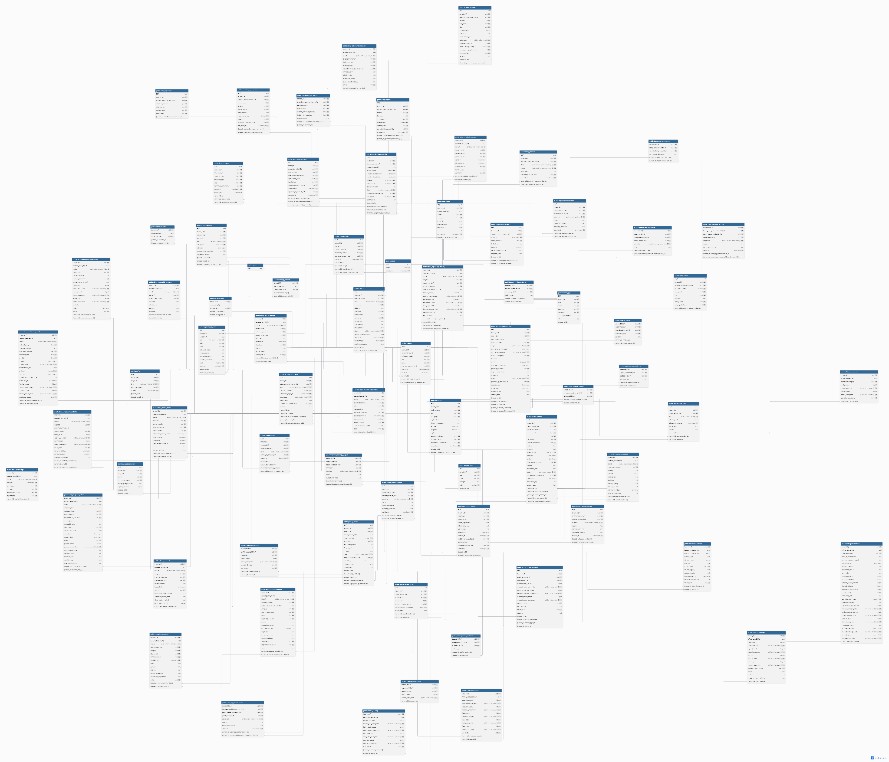

3.4.2 User Interface Design
Log In Screen
The single-point authenticated entry to the system. It presents the institutional identity of the system, an explicit access restriction notice (Authorized users only), and a sign-in workspace. Authentication is invite-only by design: there is no self-registration (Product Rule 1). It states that access is limited to an account assigned to a role and jurisdiction, and it offers prototype demonstration handles (purok.demo, barangay.demo, drrm.demo) to support the reviewer workflow. The screen exposes the system's stance that identity is issued, never requested.

Figure 42. Log In Page
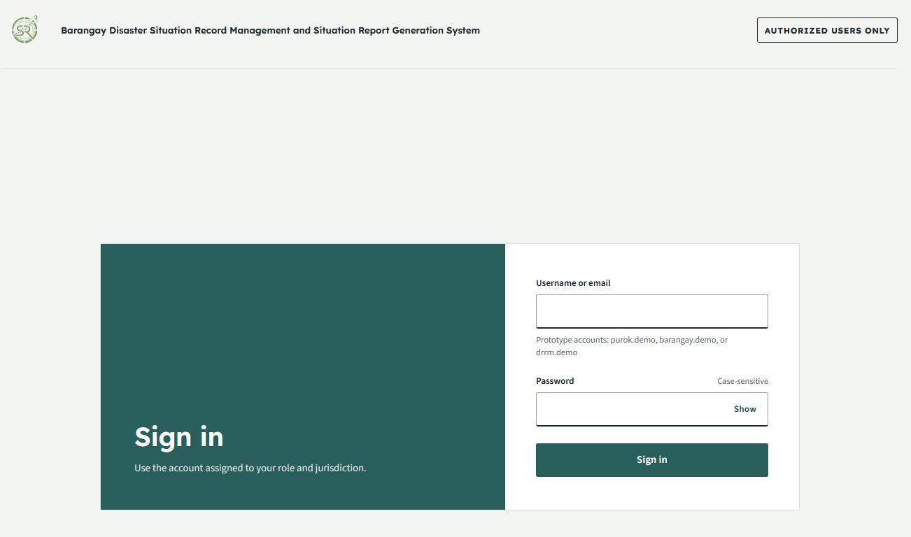

Purok User Screen
Purok User Dashboard
A mobile-first operational summary that prioritizes the status of the current monthly profile, active reporting tasks, offline drafts, correction requests, and recent history. It adheres to the Dashboard Rule that current operational work precedes historical trends, and that every aggregate discloses its reporting period, filters, denominator, and last-update metadata. Complete statuses (Verified, Provisional, Missing, Not Applicable) are distinguished rather than conflated (Rule 16).

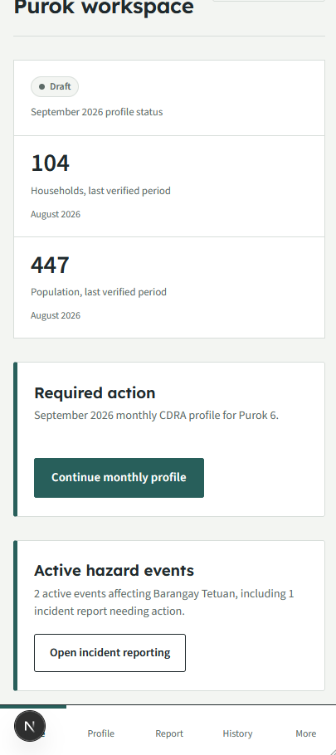
Figure 43 . Purok Dashboard

Purok Profile
The structured capturing of a Purok's monthly Community-Based Disaster Risk Assessment (CDRA) aggregate profile. It is organized as a resumable, sectioned form: Reporting Period and Purok Identification, Population and Households, Housing and Facilities, Vulnerability and Hazard Exposure, Local Capacities, followed by Review and Submit.
Two non-negotiable rules govern this surface: profiles contain aggregate totals only, never named resident or household records, and profiles are complete monthly snapshots prefilled from the previous verified month. The form tracks per-section completion and validation and presents the state lineage (draft, saved on device, queued offline, submitted, under review, correction requested, verified, rejected, superseded).

Figure 44. Purok Profile
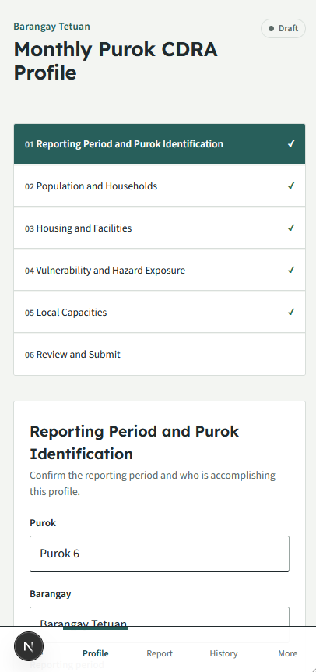
Purok Incident Reporting
Enables the filing of an incident report against an active hazard event. Incident reporting uses the mandated progressive version model: Initial, Progress, Terminal, and Final reports (Rule 8). Initial reports accept only operationally essential facts (administrative location, landmark, observation time, reporter/source, hazard event, prevailing situation, immediate needs) while Progress, Terminal, and Final reports apply increasing completeness requirements. GPS and maps are optional and never obligatory. The screen presents the source lineage and the report version state.

Figure 45. Purok Incident Reporting
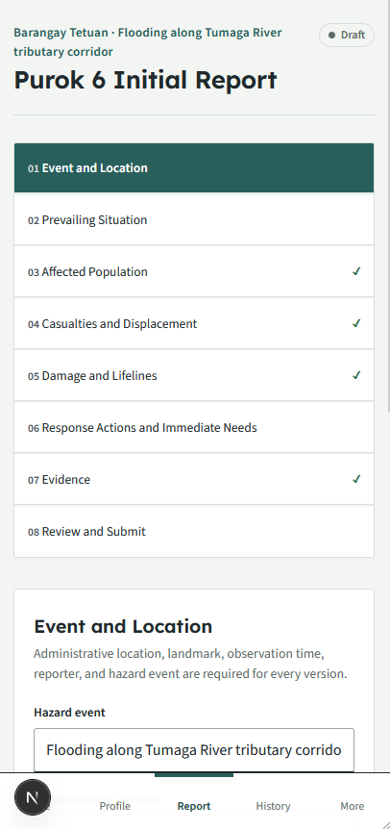

Purok Incident Workspace
The structured editor for a specific incident report version. It organizes the report into the mandated sections (Event and Location, Prevailing Situation, Affected Population, Casualties and Displacement, Damage and Lifelines, Response Actions and Immediate Needs, Evidence) and enforces the completeness rules per version. Modes of Verification remain visible as incomplete during review and never silently default to a value.

Figure 46. Purok Incident Workspace
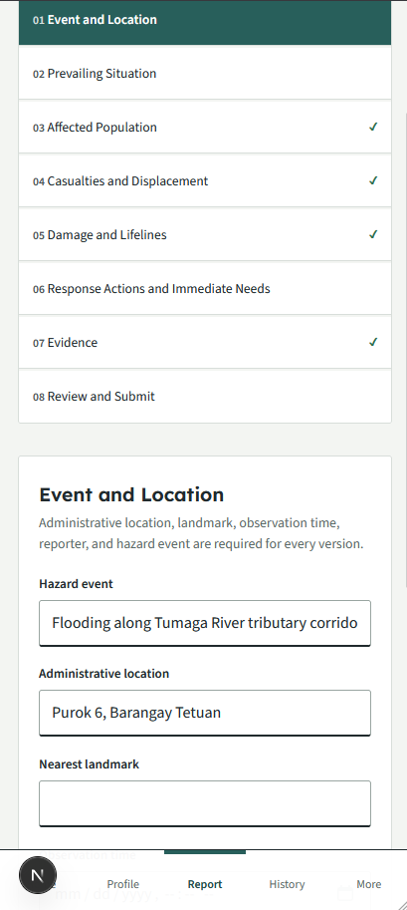
Purok Incident History
A historical catalog of the Purok's incident reports and monthly profiles, exposing submitted dates, review outcomes, and verification decisions. Missing information is never presented as zero impact records that have not been submitted are labeled accordingly.

Figure 47. Web Application Admin System Report Page
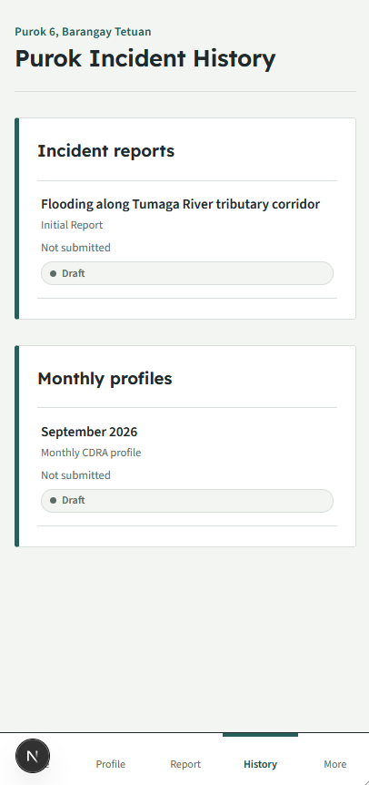

Barangay User Screen
Barangay User Dashboard
A desktop-first operational summary prioritizing Purok submission coverage, verification queues, consolidated verified totals, active incidents, and reporting gaps. Aggregates disclose their reporting period and verification status; the dashboard surfaces the Source Lineage Rail as the system's signature interaction, exposing how Purok totals travel through verification and consolidation.

Figure 48. Barangay User Dashboard
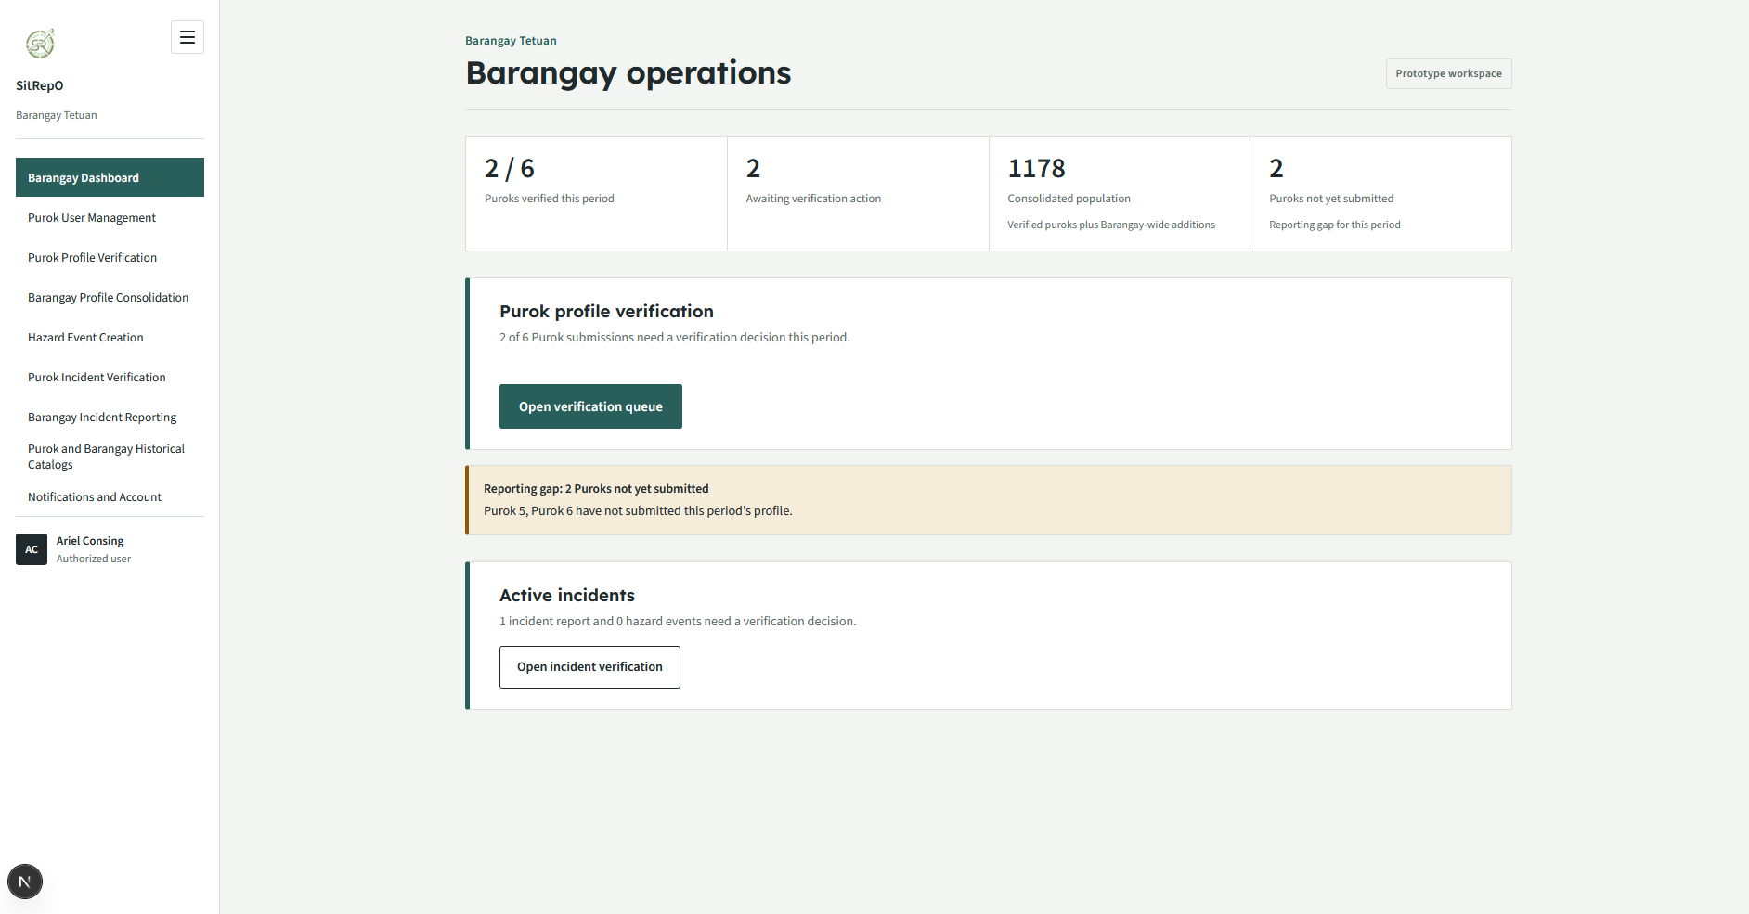
Purok User Management
The Barangay-level administration of Purok reporter accounts. Accounts are issued by the supervising administrative level as there is no self registration. The Barangay issues, resends, deactivates, and reactivates Purok accounts. The register models the role-assignment model (user-to-role-to-organizational-unit), allows multiple named users to belong to one Purok while a draft has one current owner, and preserves authorship and decision history across deactivation.

Figure 49. Purok User Management
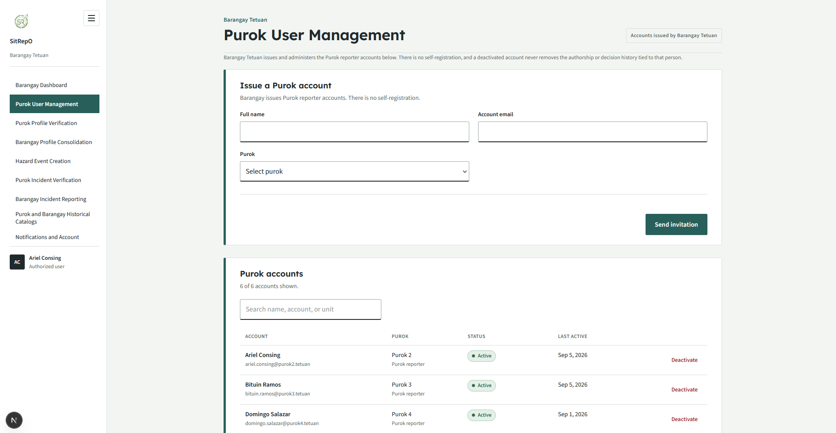
Purok Profile Verification
The queue for verifying Purok-submitted monthly profiles. It orders records by operational urgency and exposes each Purok's aggregation state (not-yet-submitted, submitted, under review, correction requested, verified, rejected) so that a reviewer never conflates a draft or a provisional figure with a verified total. A reviewer approves, rejects, or requests corrections, never silently edits a submitted record (Rule 9); corrections generate new linked versions

Figure 50. Purok Profile Verification
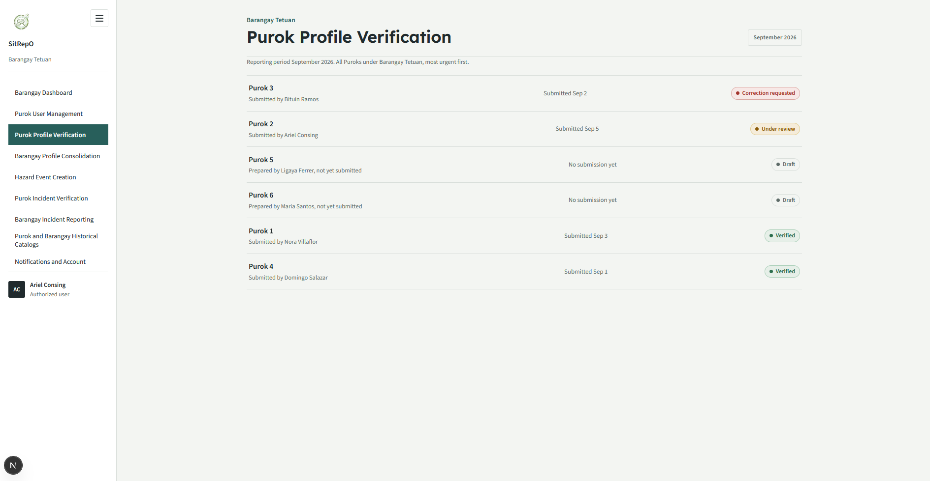
Purok Profile Detail
The per-Purok review surface, rendering the immutable submitted version, its comparable previous verified profile, validation flags, and the reviewer decision panel (Verify, Request Correction, Reject). It presents the source lineage from Purok source through verification to consolidation and mandates a documented reason for any return or rejection.

Figure 51. Purok Profile Verification
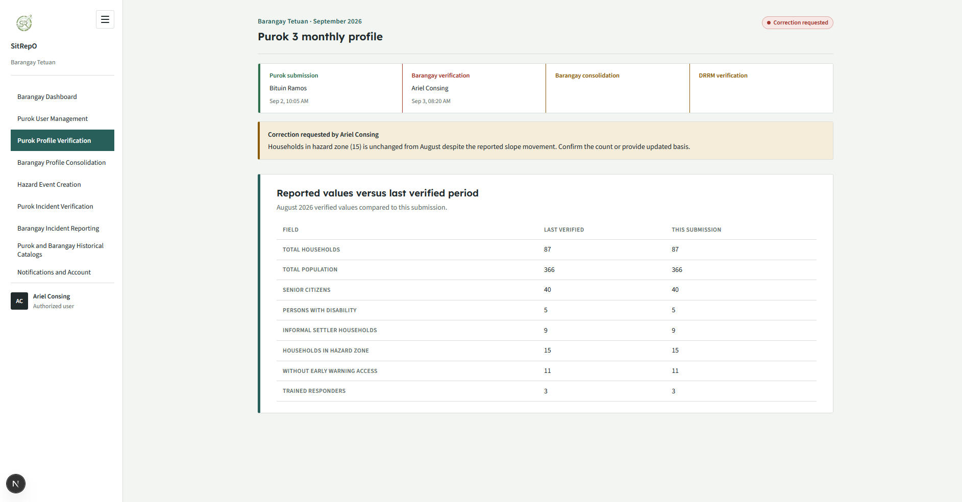
Barangay Profile
The aggregation surface that consolidates verified Purok profiles while separating Barangay-wide additions and discrepancies. It excludes not-yet-verified Purok totals from the verified aggregate, surfaced separately so a consolidated figure never silently understates coverage as complete, and distinguishes Barangay-wide items not assigned to any Purok. Additions are reported as Barangay-level rather than attributed to a Purok

Figure 52. Barangay Profile
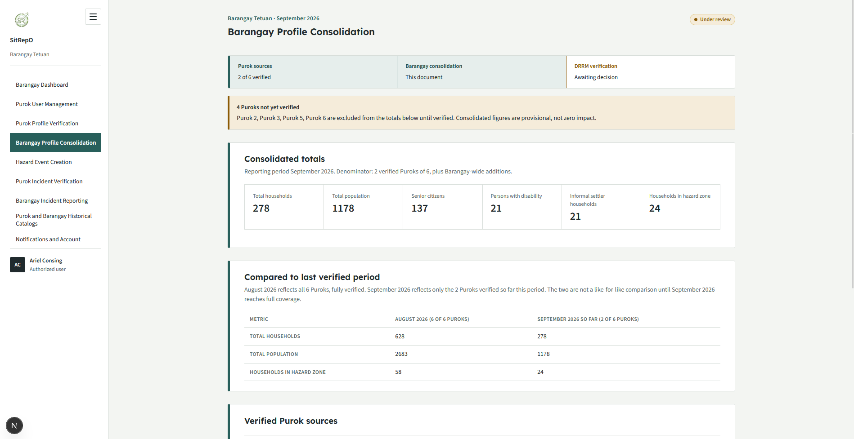
Purok Incident Verification
The review queue for Purok-submitted incident reports. It flags validation, possible duplicates, conflicts, and late reports as reviewer aids, and requires a documented reason for return, rejection, or partial verification. Decisions are stored against the specific version reviewed, so that every decision identifies the exact version reviewed.

Figure 53. Purok Incident Verification
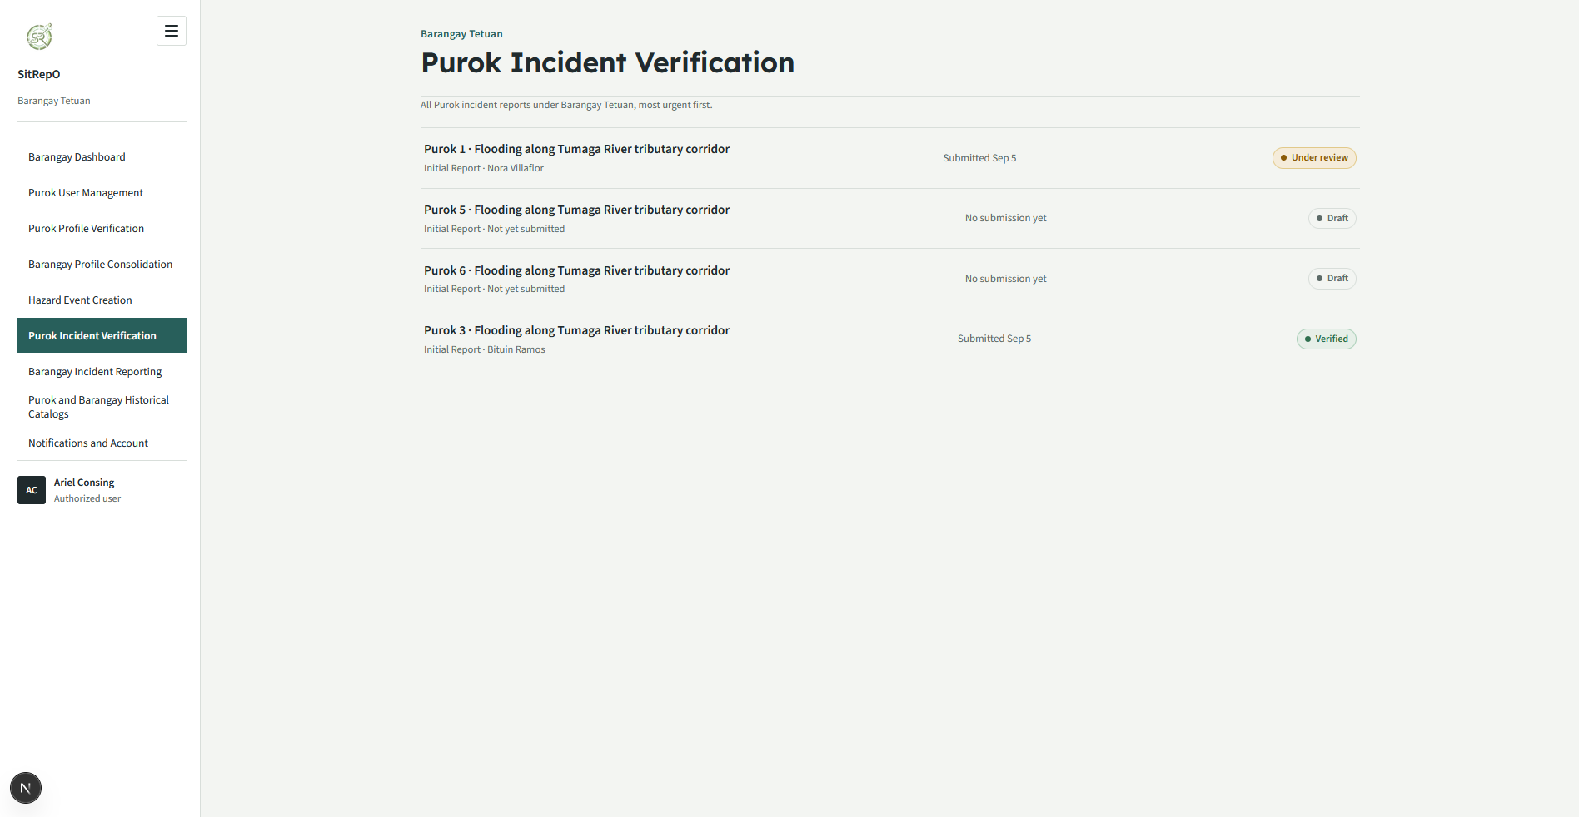
Purok Incident Verification Details
The drill-down review of a Purok incident version: the immutable submitted version, its evidence, the reviewer decision panel, and a correction loop that produces a newly linked version rather than an in-place edit. Modes of verification and unresolved discrepancies remain visible throughout.

Figure 54. Purok Incident Verification Details
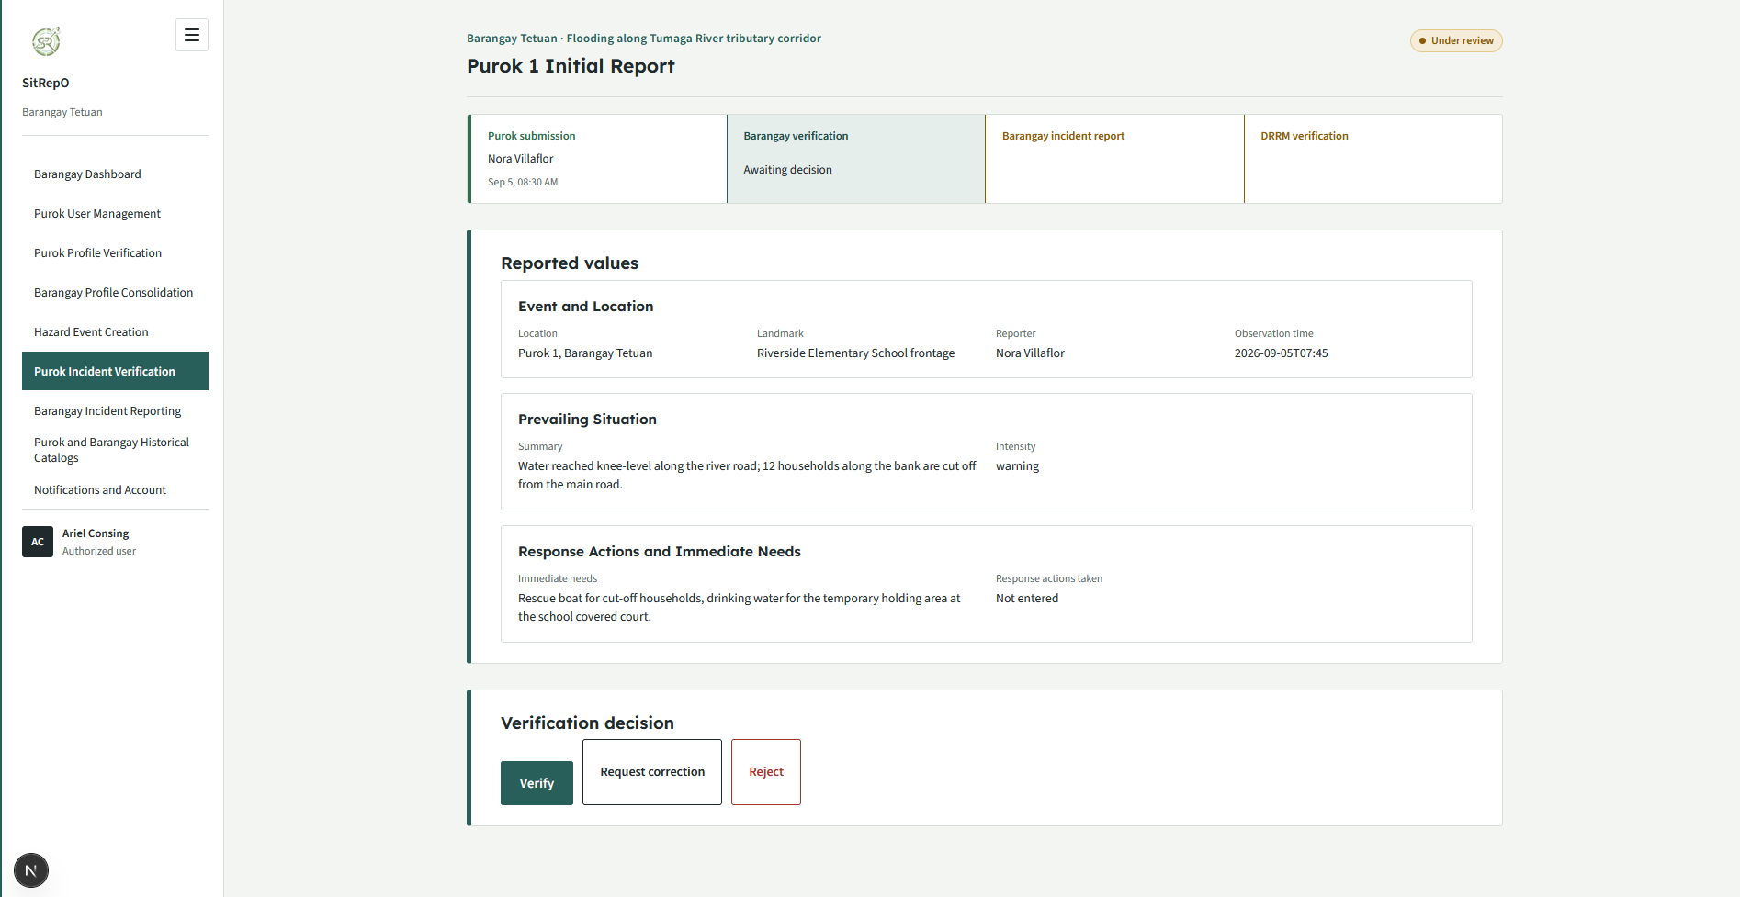
Barangay Incident Reporting
The consolidation of eligible verified Purok incident reports for a hazard event into a Barangay-level report, separately identifying other Barangay-level sources and discrepancies (Rule 11). The screen presents the eligible versus not-yet-eligible Purok reports and the narrative of Barangay-level additions so a consolidated incident total is never subtly inflated or conflated with Purok figures.

Figure 55. Barangay Incident Reporting
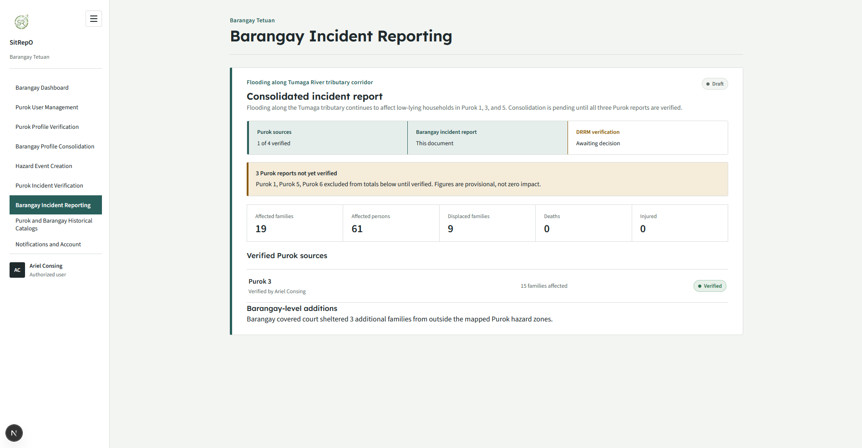
Purok and Barangay Historical Catalogs
A searchable, filterable catalog of Purok and Barangay records, timelines, and decisions, exposing missing-data states and comparison views. It supports the traceability requirement by making each record's verification state and submission history viewable without claiming completeness for records that are still draft or provisional.

Figure 56. Barangay Incident Reporting
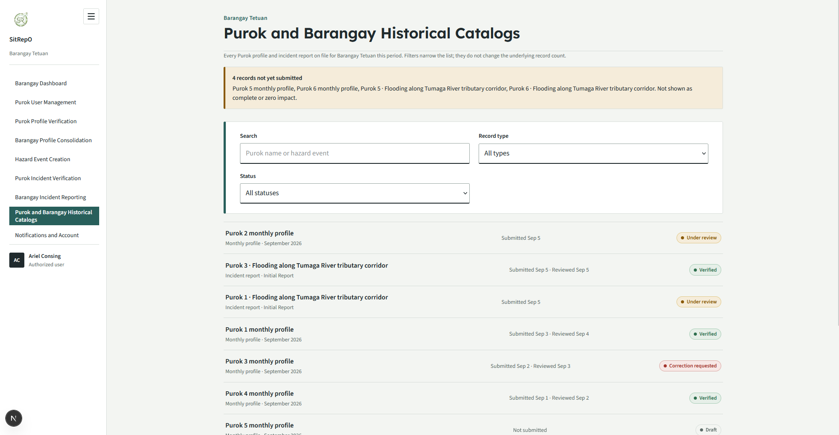
Notifications and Account
The combined in-app notification feed and account surface for a Barangay officer. It derives notifications from live store state: incoming Purok submissions awaiting verification, outstanding corrections, verified profiles, Purok-reported hazard events awaiting review, and consolidated drafts. It is accompanied by the account identity (issued by the city DRRM office) and the password control, and it reminds the officer that verification decisions are recorded against the submitted version and appear in the DRRM audit log.

Figure 57. Notifications and Account
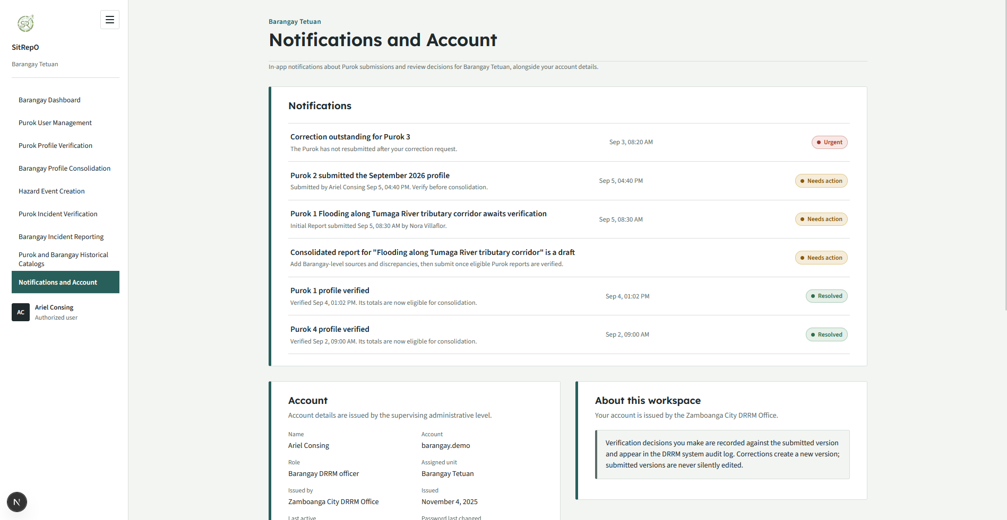
DRRM Administrator User Screen
DRRM User Dashboard
A citywide operational summary prioritizing verification queues across Barangays, verified incident effects, source coverage, SitRep readiness, discrepancies, and overdue submissions. It separates provisional from verified totals, exposes freshness, missingness, and drill-down, and reiterates the Dashboard Rule that historical trends are secondary to current operational work

Figure 58. DRRM User Dashboard
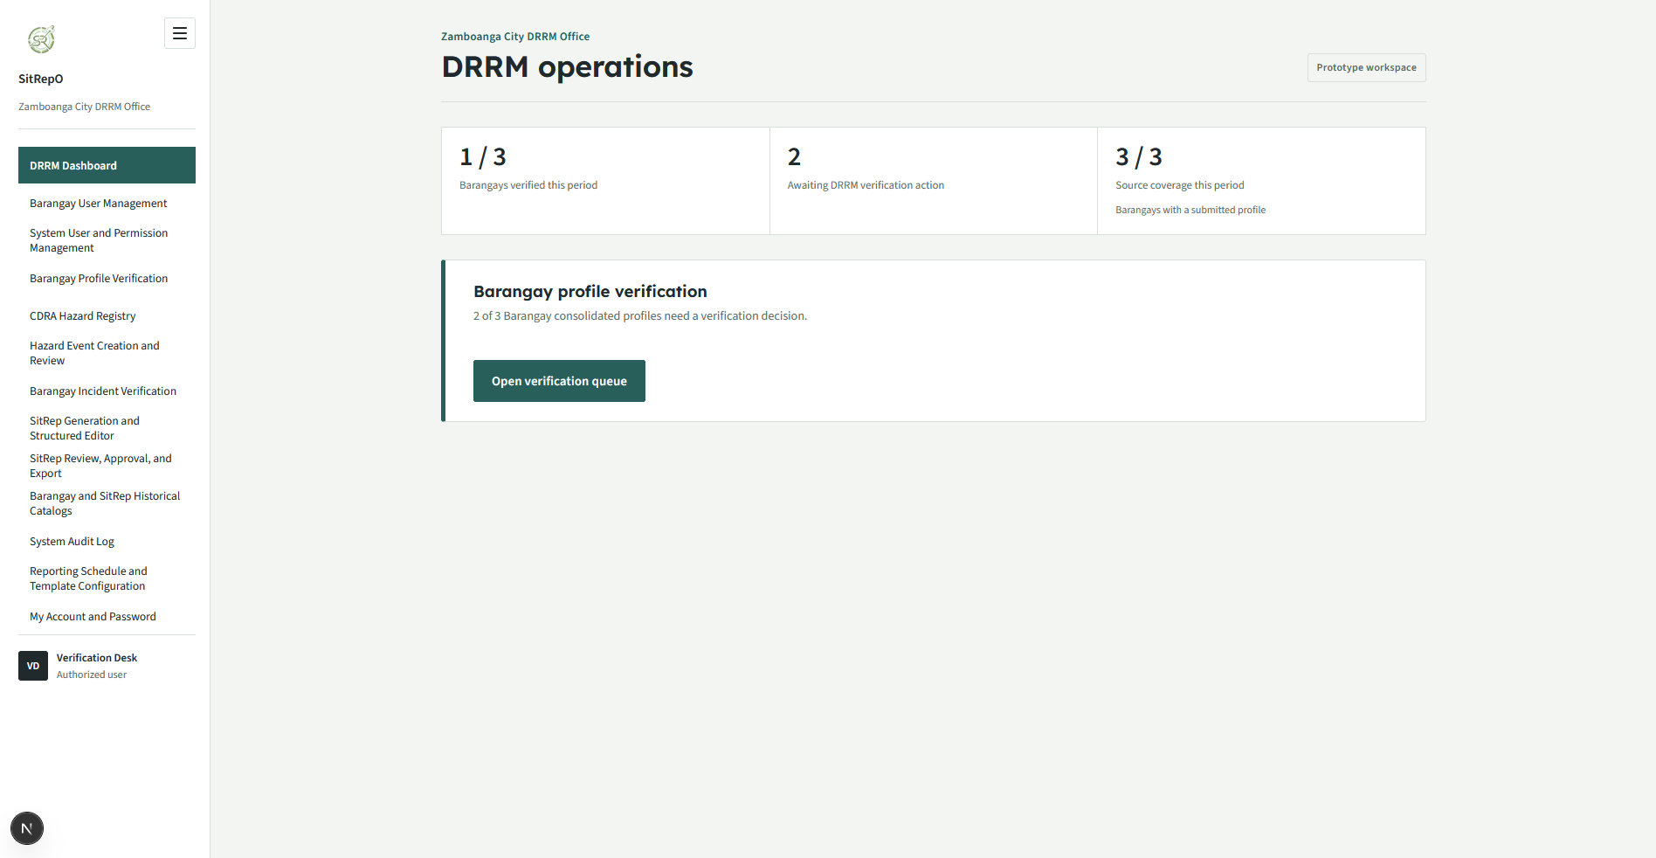
Barangay User Management
City-wide administration of Barangay DRRM officer accounts. Accounts are issued by the DRRM Office, and deactivation never deletes authorship or decision history. It implements the role-assignment model where a user is assigned a role and an organizational unit, and it permits only the supervising level to issue accounts.

Figure 59. Barangay User Management
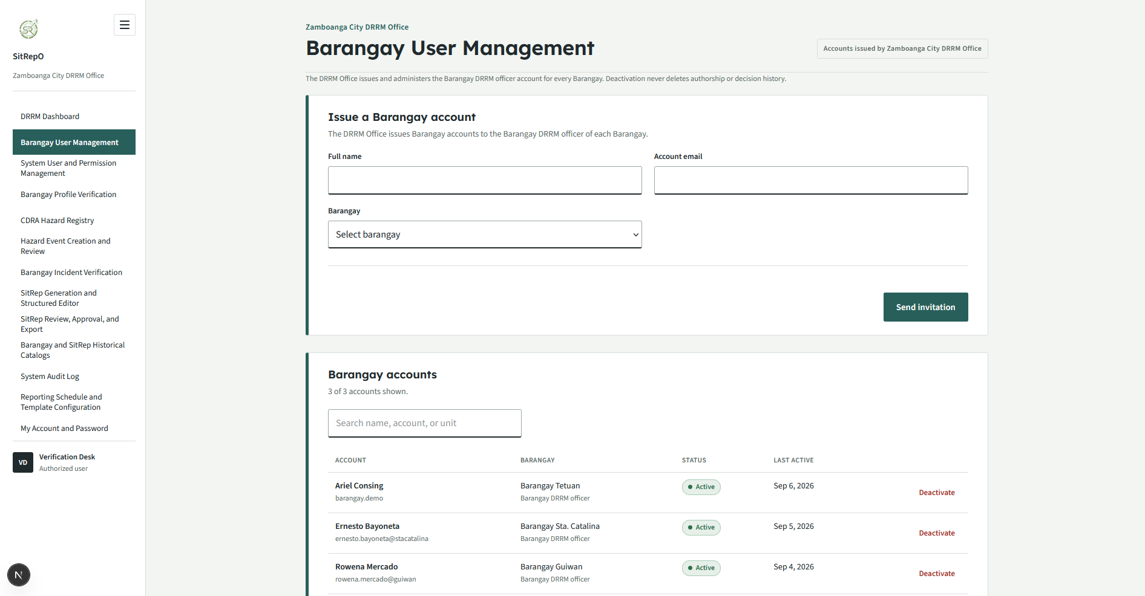
System User and Permission Management
Administration of DRRM system accounts and their permission sets. DRRM permissions distinguish Verifier, SitRep Preparer, and Approver, and one account may hold several permissions. The screen renders permissions as a selectable set and, critically, reads them as authorization rather than as a means of delegating editing authority. The signed-in account cannot edit its own permission set, preventing self-lockout, and the audit trail records every permission change.

Figure 60. Barangay User Management
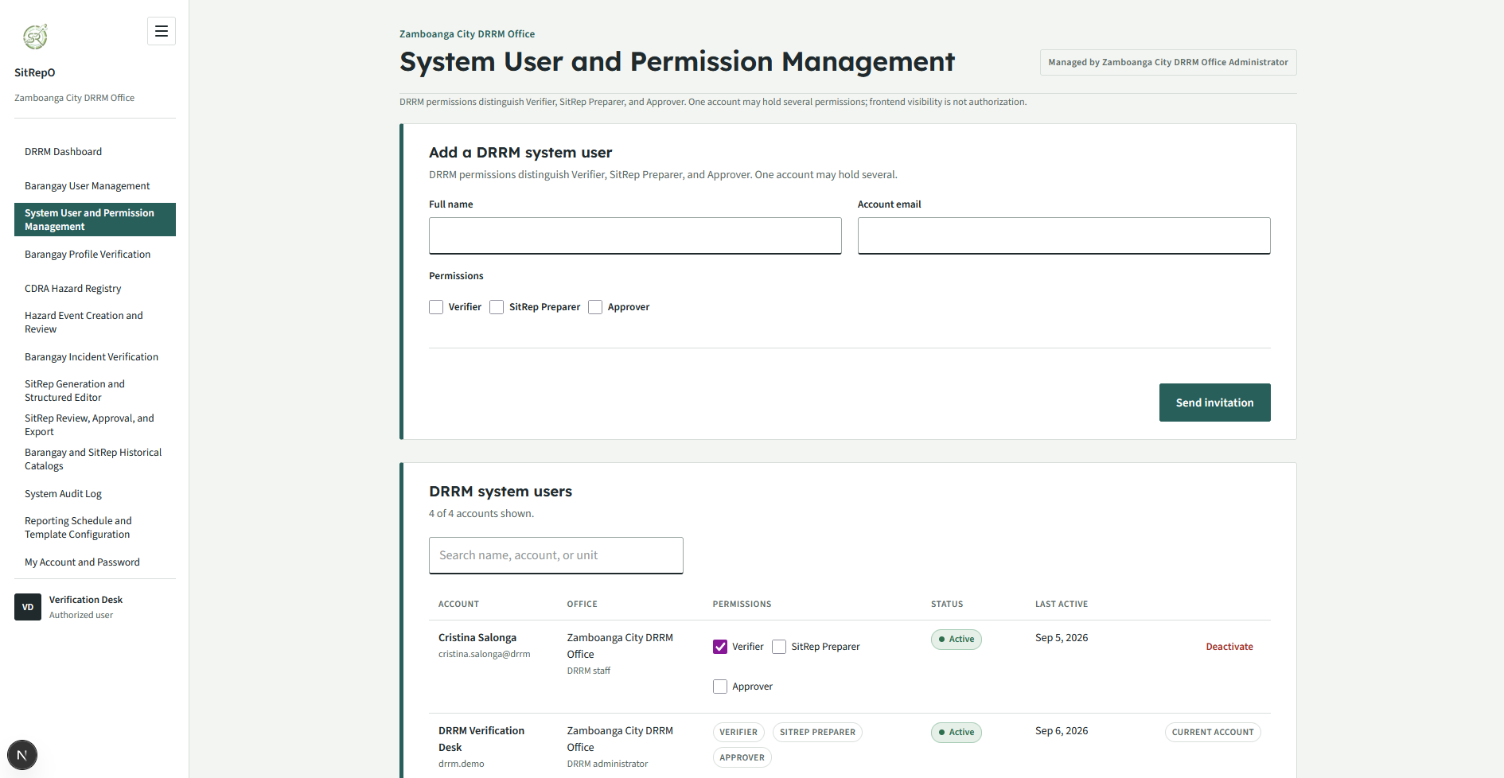
Barangay Profile Verification
The city-level verification queue for Barangay-submitted consolidated profiles. It enforces the rule that a submitted profile does not affect higher-level totals until verified and that reviewers never silently edit submitted records. Decisions are stored against the reviewed version.

Figure 61. Barangay Profile Verification
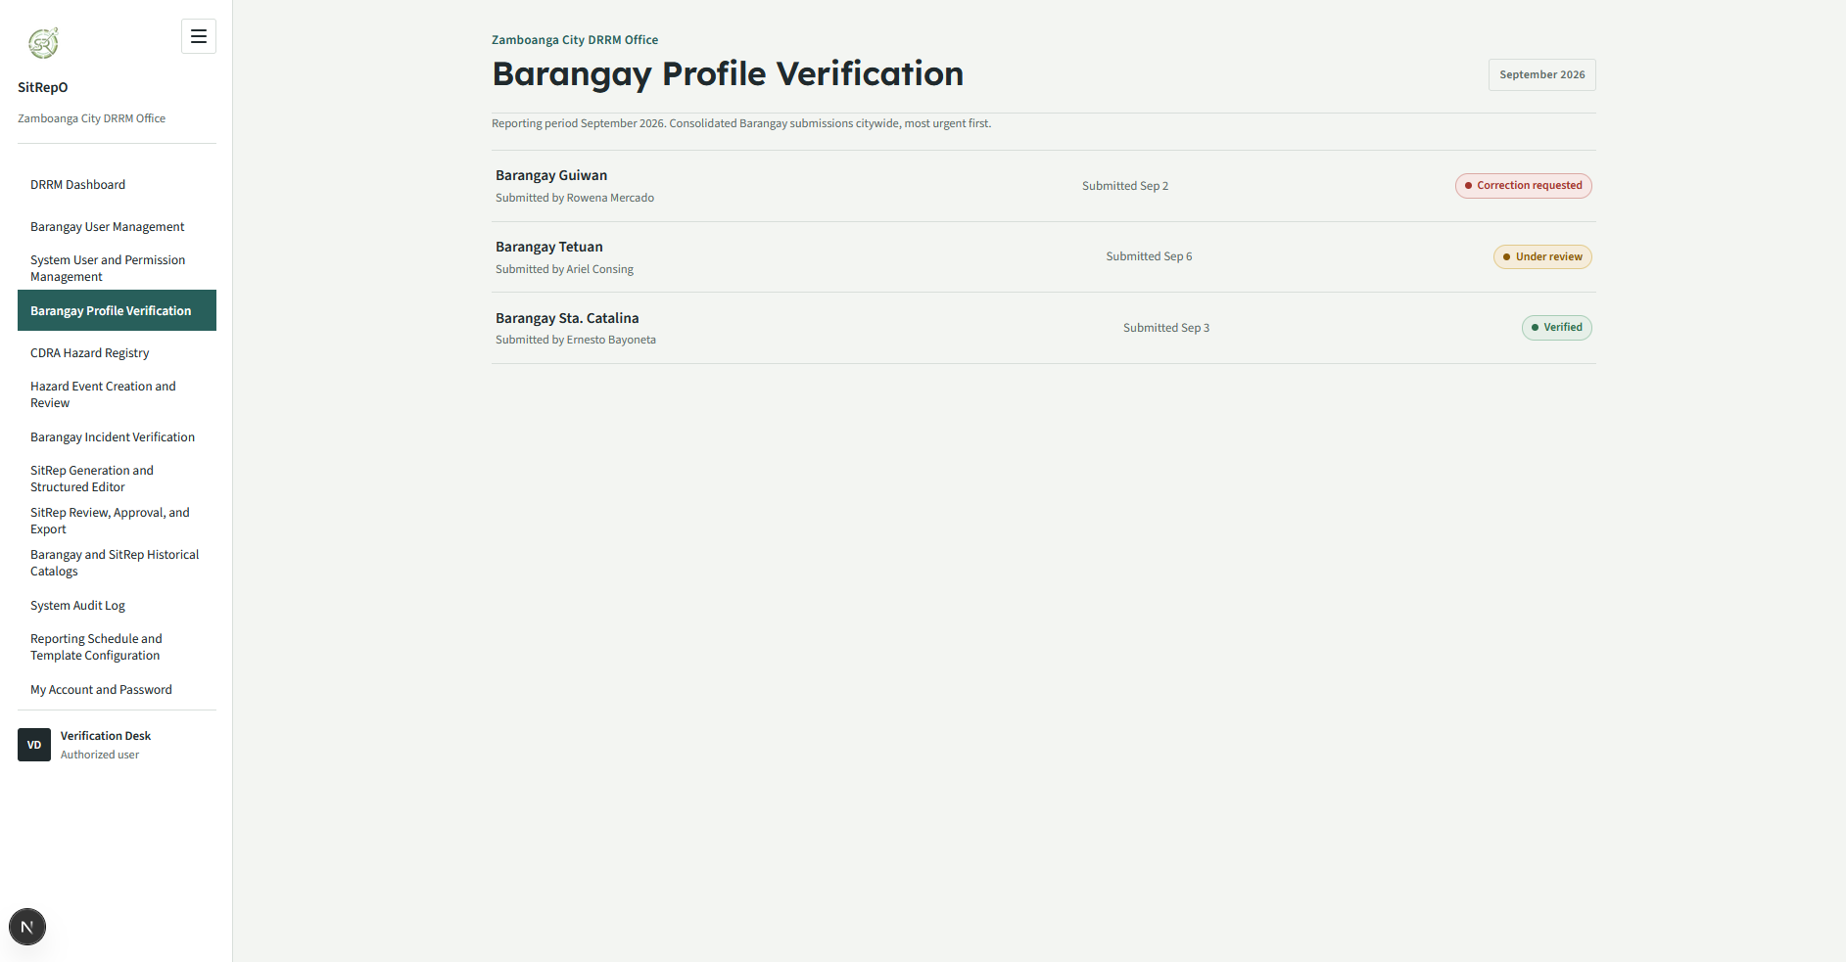
Barangay Profile Detail
The per-Barangay review surface showing the consolidated verified Purok totals, the separately identified Barangay-wide additions, and the reviewer decision panel. It exposes the source lineage from Purok through Barangay consolidation to city-level verification and requires a documented correction or rejection reason.

Figure 62. Barangay Profile Detail
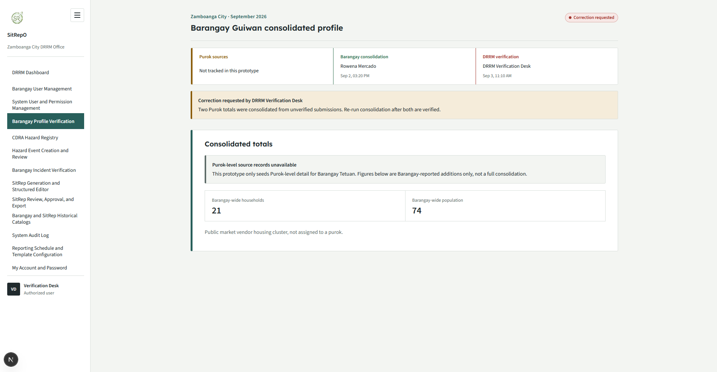
Hazard Registry
The reference list of approved hazard types that users at all three levels may select when creating a hazard event. Hazard types are DRRM-managed and configurable. Archiving a type hides it from new events without deleting existing history, the screen distinguishes Approved from Archived types and explains that the registry is maintained on the configuration screen, where the Source and Mandate Gate requires each type's authoritative basis, meaning, and applicability to be recorded.

Figure 63. Barangay Profile Detail
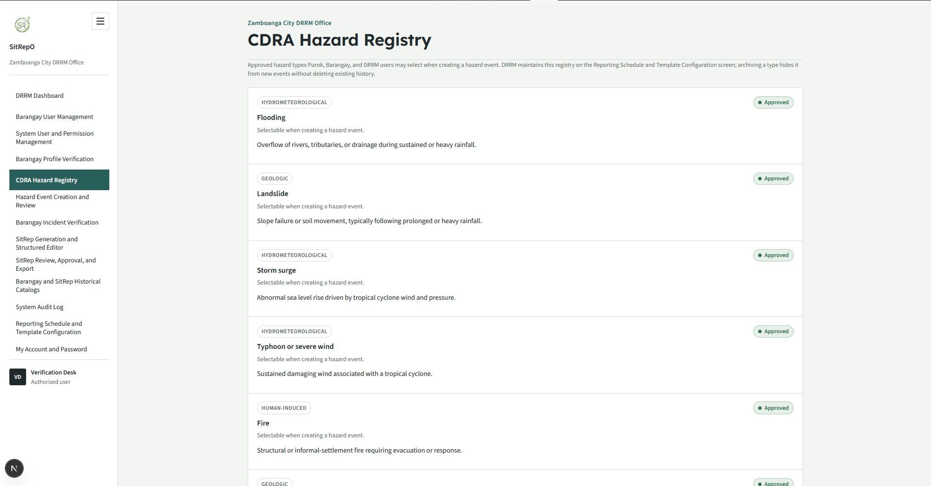
Barangay Incident Verification
The city-level review queue for Barangay-submitted incident reports, carrying validation, conflict, duplicate, and discrepancy flags, and requiring documented reasons for return, rejection, or reconciliation. Every decision identifies the exact version reviewed.

Figure 64. Barangay Incident Verification
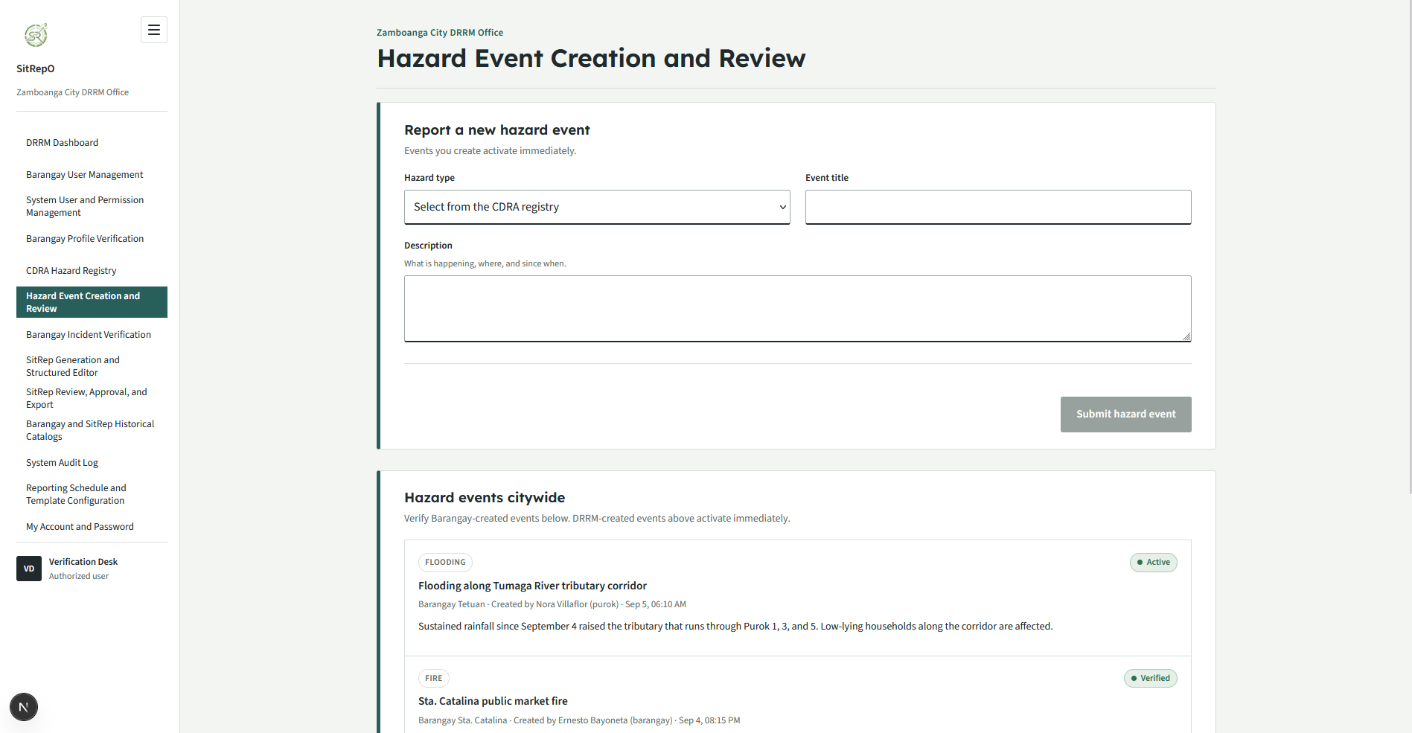
Barangay Incident Verification Detail
The drill-down review of a Barangay incident version, presenting the immutable version, evidence, discrepancies, and the reviewer decision panel. Corrections produce new linked versions; submitted versions remain immutable and traceable.

Figure 65. Barangay Incident Verification Detail
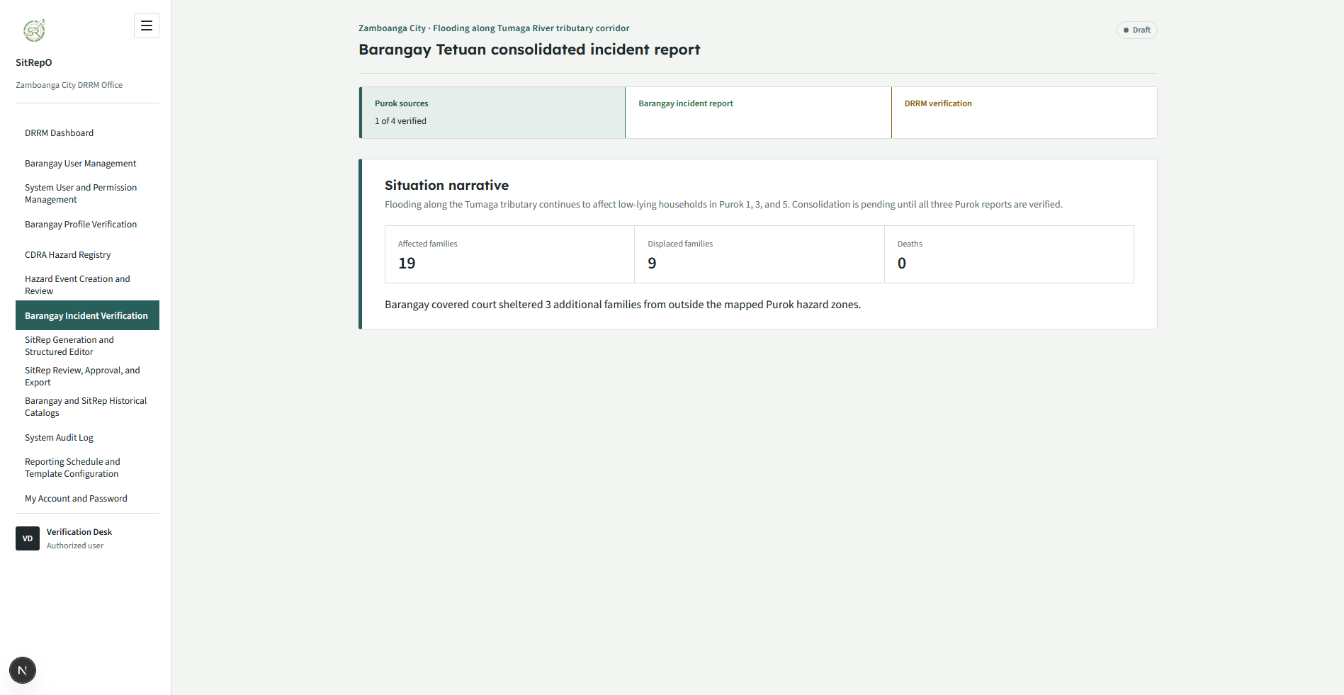
SitRep Generation and Structured Editor
The preparation of a Situation Report (SitRep) from eligible verified sources. The generation surface lets the DRRM preparer select a hazard event and shows how many Barangay incident reports are verified and eligible for inclusion; Situation, Area, and Casualty sections are pre-filled only from DRRM-verified Barangay reports, and events with no verified sources still generate but begin with authorable blank source-linked sections, never a fabricated zero.
The structured editor places editable sections beside a live document preview while preserving mandated document order, per-section validation, source links, unresolved discrepancies, template version, generated version, and approval state. It deliberately does not imitate an unrestricted word processor. Source-derived values remain linked and require a documented override or source correction before a materially divergent value may be submitted.

Figure 66. SitRep Generation and Structured Editor
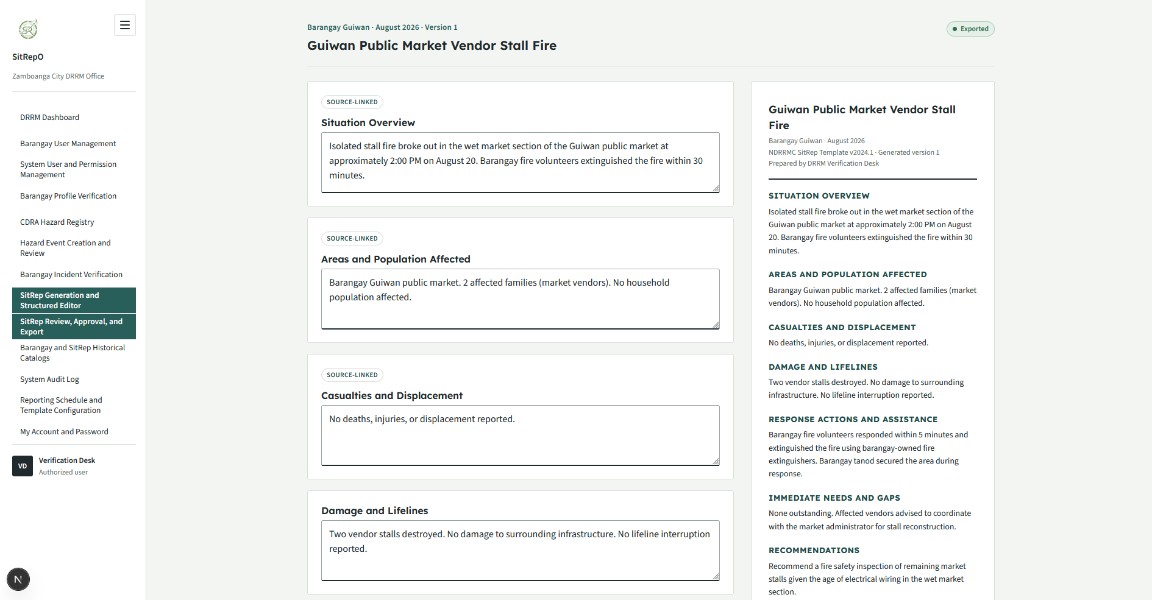
SitRep Review, Approval, and Export
The review, approval, and export surface. A reviewer may return a draft for revision with comments, and the approver re-authenticates by password before an approval is recorded against a specific SitRep version. Approved SitReps export cleanly with numbering, signatories, and source references; draft SitReps export with a watermark (for example, DRAFT FOR REVIEW), distinguishing a draft from a release-ready document. The decision, role, SitRep version, and timestamp are all recorded; this is authenticated workflow approval and is never claimed as a legally certified digital signature.

Figure 67. SitRep Generation and Structured Editor
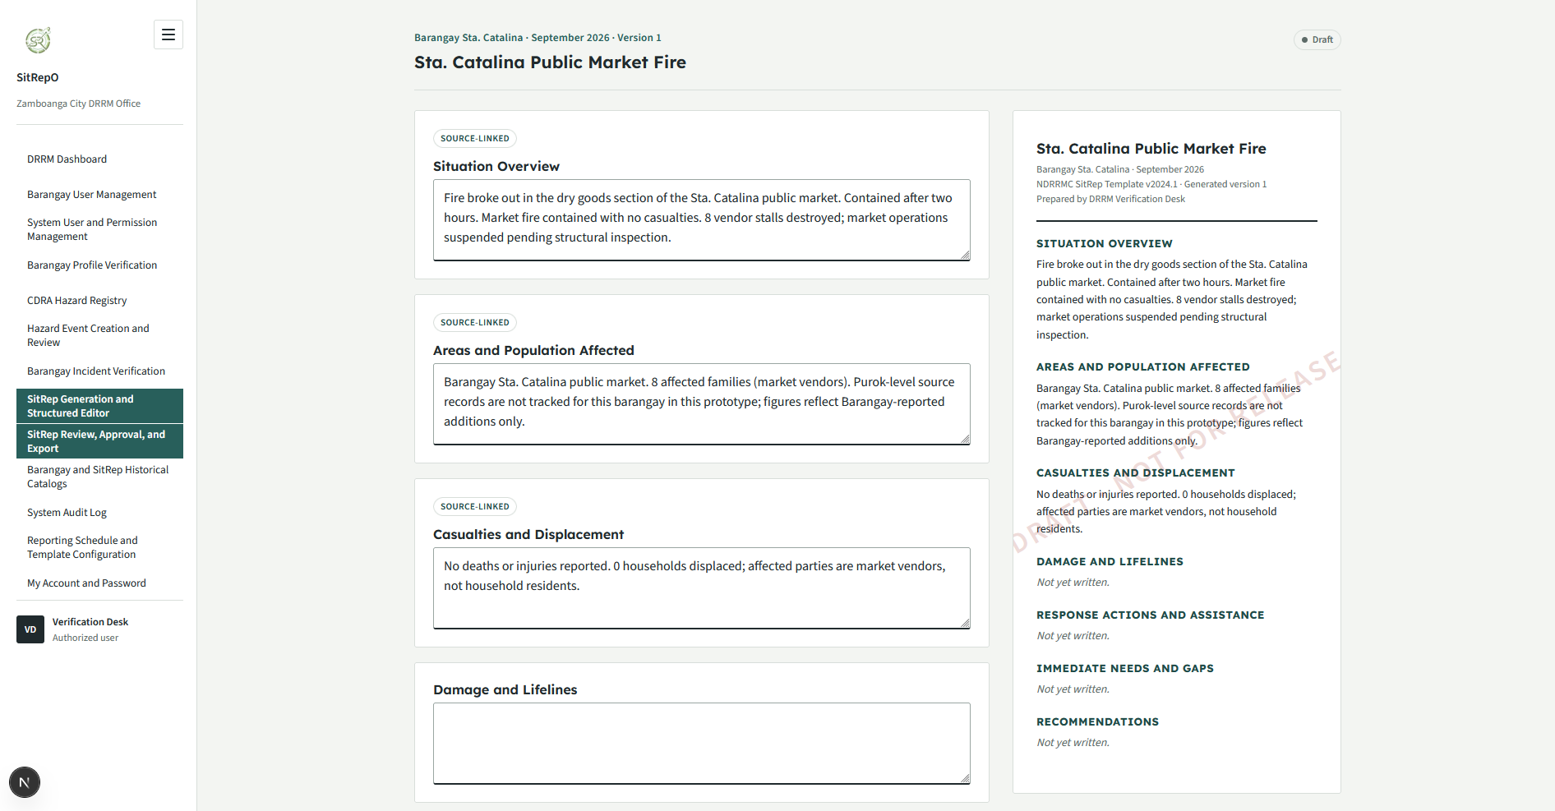
Barangay and SitRep Historical Catalogs
A searchable, filterable citywide catalog of Barangay consolidated profiles, incident reports, and hazard events, with status, submission, and review metadata. SitReps are cataloged separately under SitRep Generation and Review. The catalog exposes missing-data states rather than treating an unreported record as zero impact.

Figure 68. Barangay and SitRep Historical Catalogs
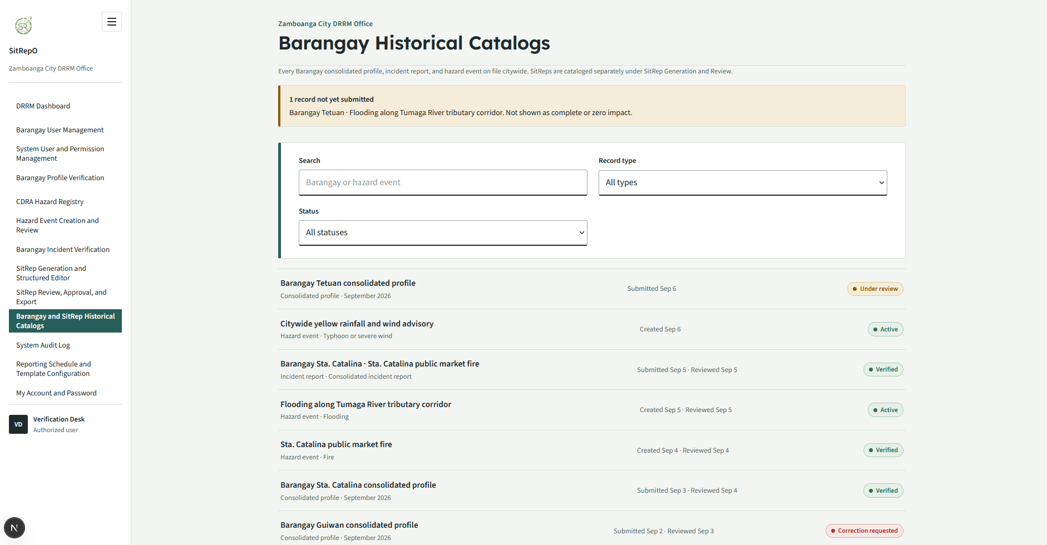
System Audit Log
The immutable city-level audit trail, restricted to authorized DRRM administrators. It records sign-ins, submissions, verification decisions, approvals, exports, account administration, and configuration changes, each with actor, action, category, target, and timestamp. The screen supports search and category filtering and is explicitly read-only; audit events in the real system are immutable and are never edited or deleted, preserving the traceability mandate that every decision identifies the exact version reviewed.

Figure 69. System Audit Log
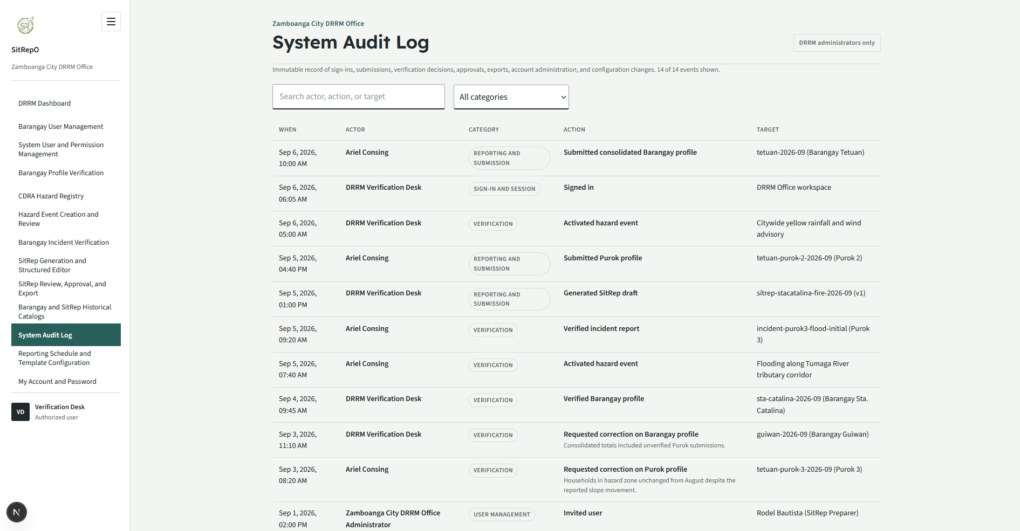
Hazard Creation
Create Hazard according to CDRA protocols across all user levels

Figure 70. Hazard Creation
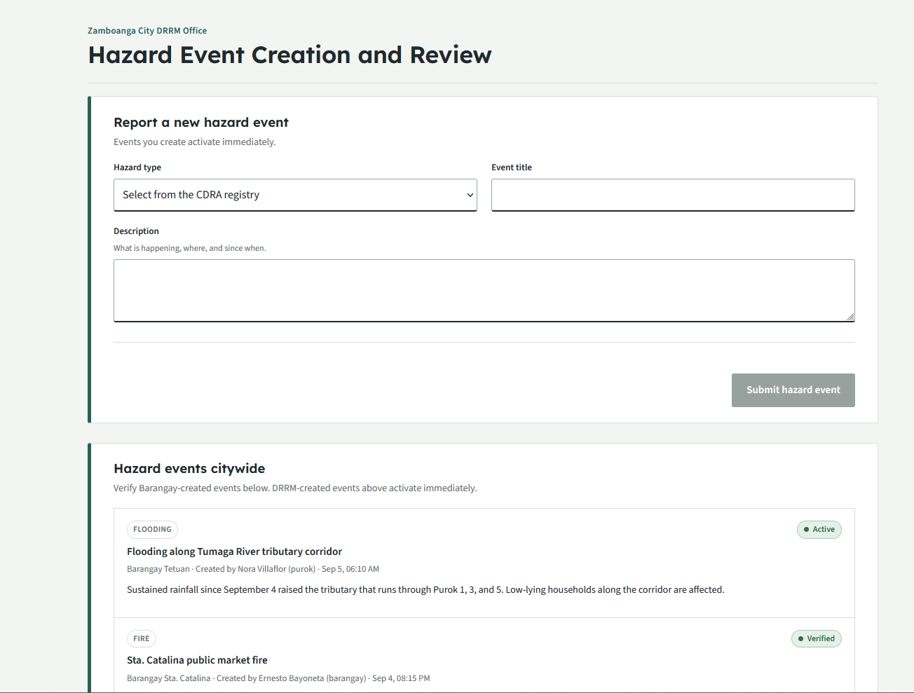

3.4.4 Integrity Controls
To ensure data accuracy, completeness, and reliability in the Integrated Disaster Incident Record Management and Automated Situation Report Generation System, several integrity checks and rules will be implemented integrated into the user interface, application logic, and database. These mechanisms aim to prevent invalid, incomplete, and inconsistent data entry, storage, and output, which will ensure the trustworthiness of the information throughout system operation.
- Input Integrity Controls
Input integrity controls will ensure all data entering into the system are valid, accurate, and complete before being processed and stored. The proposed system will use a multi-layered validation based from React’s built-in state management to manage data integrity across all modules like User Management and Initial Disaster Reporting. Required field validation will ensure that important inputs will not be left blank. Format and range checks will verify that entries like email addresses, dates, and numeric values follow proper formatting. In addition, duplication checks will be enforced to prevent repeated records, while confirmation prompts and error messages will guide the users in entering correct information. These validations will maintain data consistency and reliability across all CRUD operations in the system. These checks will happen in the front-end and back-end to ensure the system will not just accept data even though it is invalid, inconsistent (format), and incomplete.
Furthermore, in the Disaster Report Verification Module and Disaster Situation Reporting Module, stricter controls will be applied to minimize human errors. These modules will implement high-fidelity integrity checks to ensure critical data is precise and actionable by using APIs. This approach will ensure that the reports are valid, complete, authentic, and accurate.
- Database Integrity Controls
Database integrity will be maintained by using PostgreSQL, with PostgREST enforcing schema-level constraints, where data will be stored. Rules and features will be used to keep the data clean and reliable, like primary keys, foreign keys, and default values. Each record in the database will have a primary key to ensure it can be identified properly. In addition, foreign keys will connect related tables, which will help in maintaining appropriate operations in the system. Moreover, the system will also utilize default values for certain fields like setting a report’s status to “Unverified” until it is verified. Overall, these controls will help keep the database structured, reliable, and accurate, preventing issues like duplicates, missing and mismatched data, and missing records.
- Output Integrity Controls
Output integrity will ensure that all information generated and displayed by the system, and all data that goes out of the system (e.g., reports exported as PDF) will be accurate, complete, reliable, and valid. All system outputs, especially those from Disaster Situation Reporting Module, are retrieved directly from a live database using the appropriate database queries. Through this, any updates are immediately reflected in the system. Filtering, searching, and sorting features in the system will be validated to prevent incorrect data views or display of unauthorized and manipulated results. Access to the outputs, especially the initial and completed reports, will be strictly controlled and will only be given to those who have the authority to view the sensitive and confidential data.

3.4.5 Security Controls
Security controls and measures are critical to the system as it will be handling sensitive and confidential information. This will also help in protecting the privacy of the people (e.g., victims, responders, etc) in the report, protecting the system from unauthorized access, data breaches, manipulation of data, potential data loss, and other attacks from malicious actors that may harm the system's security and integrity. With this, the system will implement a multi-layered security mechanism to safeguard not just the users but also their credentials and the sensitive data. The following key security controls will be implemented to secure the system:
- User Authentication: User sign-in and credential management will be handled through OpenAuth, which manages secure session issuance and ensures passwords are never stored or transmitted in plaintext.
- Role-Based Access Control (RBAC): Using OpenAuth for identity verification and PostgreSQL role-based, row-level security policies enforced through PostgREST, the system will enforce the "least privilege" principle. Users will only access the specific data and modules necessary for their roles and operational tasks, preventing unauthorized exposure of sensitive data (e.g., victim identities).
- Database Encryption: On the server side, sensitive personally identifiable information (PII) such as victim names, address, and other sensitive details will be encrypted at the field level before being stored.
- Secure Data Transmission: The system will use a secure protocol (HTTPS) to ensure all communication between users and the server is encrypted.
- Sanitized Data Binding: Attacks like Cross-Site Scripting (XSS) will be prevented by using React’s behavior of escaping string variables to protect the system. A library like “DOMPurify” (for “dangerouslySetInnerHTML” property) will be utilized to prevent any malicious actors from injecting malicious scripts into the system.
- Parameterized Queries: Sanitized Data Binding: Attacks like Cross-Site Scripting (XSS) will be prevented by using React's behavior of escaping string variables to protect the system. A library like "DOMPurify" (for "dangerouslySetInnerHTML" property) will be utilized to prevent any malicious actors from injecting malicious scripts into the system.
- CSRF Protection: For the web system, especially the admin panel, Anti-Cross-Site Request Forgery (CSRF) tokens will be implemented to ensure that state-changing actions like deleting or verifying a report are intentional and authorized.
- Immutability of Logs: Every critical action in the system like verification, modification of report, or admin login will be recorded in a read-only audit log. This will provide accountability, transparency, and will help in security breach forensic analysis should such an incident occur.
- Automatic Session Termination: To prevent unauthorized access via unattended devices, the system will implement automatic session timeouts consistently across all devices and screen sizes accessing the web application.

3.5 Development
The system will be implemented as a single responsive web application. The frontend will be developed using React.js and Next.js, with HTML templates for page structure and Tailwind CSS for styling. The backend will run on Node.js together with PostgREST, which exposes the underlying PostgreSQL database as a RESTful API supporting real-time creation, retrieval, and updating of incident and situation report data. User authentication will be handled through OpenAuth. The system is planned for deployment on a Virtual Private Server (VPS) paired with a Content Delivery Network (CDN) to serve static assets and improve load times for users across different locations.
The developers will follow the Agile Software Development Life Cycle (SDLC) as it would work well with the proposed system and allows developers to simultaneously play roles during the analysis, design, development, and testing of the system. Agile will help the team to break down complex tasks into smaller, manageable tasks, which then would allow each member to effectively perform each of the tasks efficiently. Furthermore, Agile will help the team to adapt to the changes throughout the SDLC and stay consistent and organized.

3.6 Testing
This section presents the Alpha and Beta Testing phases, which aims to evaluate the functionality, reliability, usability, and overall readiness of the system. These phases will ensure correctness and the product’s quality before release.

3.6.1 Alpha Testing
Under Alpha Testing, the proponents will conduct unit, integration, system, and security testing. For unit testing, the developers will ensure that individual components, functions, and isolated modules of the source code operate correctly and yield the expected outputs before integration. To achieve high code coverage, structural precision, and efficiency during this Alpha Testing phase, automated testing tools will be systematically utilized during the unit and integration testing phases. Specifically, the development team will employ Jest to automate unit and component tests for the React.js/Next.js frontend, and Jest paired with Supertest to automate unit and API-level tests for the Node.js/PostgREST backend. Simultaneously, Cypress will be implemented as the primary automation tool for end-to-end testing of the web application, including its responsive behavior across desktop and mobile browser viewports.
Moreover, utilizing these automated testing frameworks can help the proponents in rapidly identifying and detecting syntax errors, logical errors, and edge-case exceptions within individual units of code. Subsequently, through these frameworks, integration testing will then be conducted to validate data communication and structural interfaces between the combined software modules. Also, system testing will be executed to evaluate the end-to-end functionality of the fully integrated system against the established technical specifications. Finally, since the system must be heavily secured as it will process confidential data, security testing will be performed to identify system vulnerabilities, safeguard data transmissions within the system, and mitigate potential security risks like unauthorized access prior to the external deployment of the system. Below are the sample criteria for the automated unit and integration testing.
Table 4 presents sample unit test cases covering the core modules of the system, from authentication and access control down to input sanitization and audit logging. Each test case pairs a specific testing criterion with its expected outcome and the automated tool responsible for validating it, ensuring that security-critical behaviors, such as OpenAuth-based authentication, PostgREST's parameterized queries, and RBAC enforcement, are verified at the individual component level before integration.
Table 4. Automated Unit Testing Sample Criteria
Component/Module | Unit Test Category | Testing Criteria | Expected Outcome | Automated Tool | Security Consideration (Inferred)
User Management Module | Authentication Logic | Validate login with unique credentials via OpenAuth | Successful login for valid credentials; no plaintext credentials stored or transmitted | Jest / Supertest (Unit) / Cypress (E2E) | Ensures protection against unauthorized access and credential theft
User Management Module | Access Control | Validate OpenAuth-issued session context and PostgREST row-level security enforcement of Role-Based Access Control (RBAC) | Users only access modules and data mapped to their specific roles | Jest / Supertest (Unit) / Cypress (E2E) | Enforces least privilege principle and prevents horizontal/vertical privilege escalation
React Web Components | Data Sanitization | Verify DOMPurify library usage for “dangerouslySetInnerHTML” | Malicious scripts are stripped from input before rendering | Cypress | Prevents Cross-Site Scripting (XSS) attacks by sanitizing string variables
Backend API / Database | Input Validation | Test PostgREST's auto-generated parameterized query layer for data persistence | User-provided data is treated as literal data, not executable code | Jest / Supertest | Mitigates SQL Injection attacks by preventing execution of database commands
SitRep Generation Module / Admin Panel | CSRF Protection | Check for Anti-CSRF token presence in state-changing actions | Reports are only modified or verified when authorized tokens are present | Cypress | Ensures state-changing actions (e.g., deleting/verifying) are intentional and authorized
User Session Management | Session Security | Validate automatic session timeout triggers via OpenAuth | Sessions terminate after a period of inactivity on mobile and web | Jest / Supertest (Unit) / Cypress (E2E) | Prevents unauthorized access via unattended devices
Audit Logging Logic | Accountability | Verify recording of critical actions to the audit log | Entries for verification, modification, and login are logged as read-only | Jest / Cypress | Ensures immutability of logs for forensic analysis and accountability
Initial Disaster Reporting Module | Functional Logic | Test data communication for report transmission from purok to barangay | Correct data transmission and notification delivery to the correct office | Jest / Supertest (Unit) / Cypress (E2E) | Protects the integrity of reporting flows to ensure data reaches authorized responders

Table 5 outlines how these individually tested components interact once combined, focusing on the data communication links between the frontend, backend, and database layers. This confirms that security controls implemented at the unit level, such as encrypted transmission, parameterized queries, and CSRF protection, continue to function correctly when modules operate together rather than in isolation.
Table 5. Automated Integration Testing Sample Criteria
Integration Component | Testing Objective | Data Communication Link | Validation Criteria | Security Control Check | Verification Method
User Management & Web Frontend | Validate authentication flows and session issuance | React.js/Next.js Web Interface to Node.js/OpenAuth Authentication Service | Successful login with unique credentials; verification of secure session issuance | User Authentication & Encryption | Jest/Supertest
Role-Based Access Control (RBAC) Module | Ensure least privilege principle is enforced across module interfaces | Ensure least privilege principle is enforced across module interfaces | Users only access data/modules necessary for their specific roles | RBAC Enforcement | Jest/Cypress
Disaster Reporting & Database Interface | Validate sanitized data storage for incident reports | Reporting Module to Database Storage | PII (names, addresses) is encrypted at field level; protection against XSS | Database Encryption & Sanitized Data Binding | Cypress
Web Admin Panel & Backend Service | Verify secure transmission and command integrity for administrative actions | React.js/Next.js Web Interface to Node.js/PostgREST Server API via HTTPS | Encrypted communication; prevention of SQL injection via PostgREST's parameterized query layer | HTTPS & Parameterized Queries | Cypress
Disaster Report Verification & SitRep Generation | Ensure state-changing actions are authorized and intentional | Verification Module to Generation Module | Verification of Anti-CSRF tokens for report deletion or verification actions | CSRF Protection | Cypress
System Activity & Log Management | Validate accountability and forensic readiness of critical actions | Action Modules to Read-Only Audit Log | Critical actions (modifications, logins) recorded in immutable logs | Immutability of Logs | Manual Audit Logs

Furthermore, the alpha testers will create test cases to ensure that each testing phase is well-documented and the alpha testers will be guided throughout the process. These test cases will include the manual test cases, which aims to allow for evaluation and testing using human intuition, that machines or automation might miss. Moreover, manual testing will allow the developers to discover unforeseen functional issues or complex edge-case exceptions that the scripts might not cover. As much as possible, the alpha testers will use Jira as a tool to document the errors encountered or functionalities that need fixes, which will aid in the process of resolving those errors, giving the developers a way to track changes, fixes, and the unfixed errors.

3.6.2 Beta Testing
Under Beta Testing, the proponents will invite target users to conduct acceptance and usability testing. Beta Testing will be conducted after the completion of Alpha Testing and will involve a selected end-users who will operate and utilize the system in a real-world environment. To ensure a systematic evaluation, this external testing phase is governed by clear entry and exit criteria. The entry criteria dictate that beta testing will only commence once all "Critical" and "Major" defects identified during automated Alpha testing (via Jest and Cypress) are completely resolved. Conversely, the exit criteria require that the system encounters zero unhandled application crashes or rendering failures across desktop and mobile browser sessions during independent user operations.
To measure user acceptance objectively, the proponents will deploy the standardized System Usability Scale (SUS) as the primary data collection instrument following the evaluation period. This will allow the team to mathematically and systematically compute a global usability score based on a 10-item Likert scale questionnaire, with a target success threshold set at a minimum average score of 68, which is the industry-standard benchmark for an acceptable system (Sauro, 2011). Additionally, open-ended questions will also be included to allow testers to openly express their perception of the application. Any non-blocking functional feedback gathered during this asynchronous testing phase will be logged, prioritized, and addressed in final code iterations to ensure the platform satisfies user expectations prior to deployment. The following is a sample of Likert-scale questionnaire based on SUS:

Question ID | Question Text | Evaluation Category | Scale Type | Response Options | Platform Applicability
SUS-01 | I think that I would like to use this system frequently. | Usability | 5-point Likert | 1 (Strongly Disagree) to 5 (Strongly Agree) | Web Application (desktop and mobile browsers)
SUS-02 | I found the system unnecessarily complex. | Usability | 5-point Likert | 1 (Strongly Disagree) to 5 (Strongly Agree) | Web Application (desktop and mobile browsers)
SUS-03 | I thought the system was easy to use. | Usability | 5-point Likert | 1 (Strongly Disagree) to 5 (Strongly Agree) | Web Application (desktop and mobile browsers)
SUS-04 | I think that I would need the support of a technical person to be able to use this system. | Learnability | 5-point Likert | 1 (Strongly Disagree) to 5 (Strongly Agree) | Web Application (desktop and mobile browsers)
SUS-05 | I found the various functions in this system were well integrated. | Usability | 5-point Likert | 1 (Strongly Disagree) to 5 (Strongly Agree) | Web Application (desktop and mobile browsers)
SUS-06 | I thought there was too much inconsistency in this system. | Usability | 5-point Likert | 1 (Strongly Disagree) to 5 (Strongly Agree) | Web Application (desktop and mobile browsers)
SUS-07 | I would imagine that most people would learn to use this system very quickly. | Learnability | 5-point Likert | 1 (Strongly Disagree) to 5 (Strongly Agree) | Web Application (desktop and mobile browsers)

3.7 Calendar of Activities
Figure 71 outlines the calendar of activities for implementing the proposed system, from the concept phase to the final defense and presentation. It starts with the writing of the concept paper, then moves to the proposal phase, which involves securing adviser approval, writing and submitting the proposal paper, and undergoing a proposal defense. When the proposal is accepted, the team proceeds to the development phase, where each unit of the system is built and tested simultaneously to ensure quality and detect errors early on. Lastly, the project ends with the finalization phase, covering the submission of the final paper, the final defense, and the completion of revisions to the capstone paper.

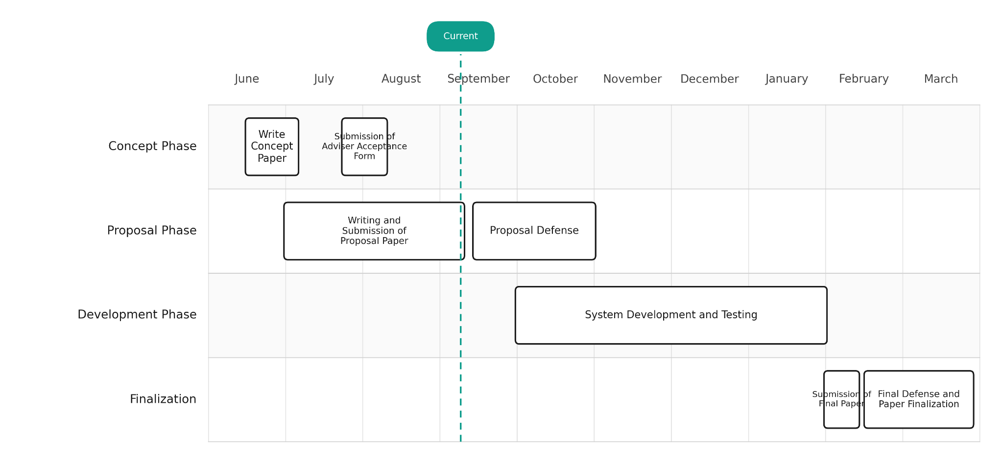
Figure 71. Gantt Chart for the Activities and Phases

REFERENCES
Abello, J. E. (2017). Meteorological disaster risk profile of the Philippines. Emergency and Disaster Reports, 4(2), 9–55. https://reunido.uniovi.es/index.php/edr/issue/view/1267/222
Aedo, I., Díaz, P., Carroll, J. M., Convertino, G., & Rosson, M. B. (2010). End-user oriented strategies to facilitate multi-organizational adoption of emergency management information systems. Information Processing & Management, 46(1), 11–21. https://doi.org/10.1016/j.ipm.2009.07.002
Agapito, J. V. C., Rosales, R. M. L., Pascual, A. C., Concepcion, C. R., & Lagmay, A. M. F. A. (2025). Counterfactual evidence on the impacts of operations research on Philippine disaster risk reduction efforts. Disaster Prevention and Management an International Journal, 35(6), 44–63. https://doi.org/10.1108/dpm-04-2025-0127
Alvarez, F., Gardner-Stephen, P., & Hollick, M. (2018). Maintaining both availability and integrity of communications: Challenges and guidelines for data security and privacy during disasters and crises. arXiv (Cornell University). https://doi.org/10.48550/arxiv.1808.04683
Aminoltaheri, N., Mejri, O., Menoni, S., & Matias, K. (2017). Crisis information to support spatial planning in post disaster recovery. International Journal of Disaster Risk Reduction, 22, 46–61. https://doi.org/10.1016/j.ijdrr.2017.02.007
Bangor, A., Kortum, P. T., & Miller, J. T. (2008). An empirical evaluation of the System Usability Scale. International Journal of Human–Computer Interaction, 24(6), 574–594. https://doi.org/10.1080/10447310802205776
Benigno, K. L. C., Pilar, E., & Sabado-Lao, Y. (2026). Grassroots governance and resilience: The role of barangay disaster communication amid political uncertainty. Jurnal Wacana Politik, 11(1). https://jurnal.unpad.ac.id/wacanapolitik/article/view/54312
Brooke, J. (1996). SUS: A quick and dirty usability scale. In P. W. Jordan, B. Thomas, B. A. Weerdmeester, & A. L. McClelland (Eds.), Usability evaluation in industry (pp. 189–194). Taylor & Francis. https://hci-studies.org/methods-and-measures/downloads/SUS_Brooke1996.pdf
Calanog, K. R. L., Rey, W. P., Adalin, S. a. S., & Jimenez, G. W. R. (2024). Mamamayan: a mobile community-based emergency reporting and notification system for the city of Makati in the Philippines. 5th International Conference on Software Engineering and Development, 35–41. https://doi.org/10.1145/3637792.3637799
Camoral, S. A., San Pedro, A. F. V., Camoral, S. A., Agustin, V. A., & Fernandez, R. B. (2026). Sagip Manileño: A mobile emergency response system with SMS-based offline alert capability. World Journal of Advanced Research and Reviews. https://wjarr.com/content/sagip-manileno-mobile-emergency-response-system-sms-based-offline-alert-capability
Chan, T. C., et al. (2009). Data quality for situational awareness during mass-casualty events. AMIA Annual Symposium Proceedings, 2009, 176–180. https://pmc.ncbi.nlm.nih.gov/articles/PMC2655881/
Congress of the Philippines. (2010). Republic Act No. 10121. Official Gazzette Philippines. https://www.officialgazette.gov.ph/2010/05/27/republic-act-no-10121/
De Gracia, M. V. R. (2025). A gap analysis of LGU social media communication strategies for disaster preparedness during crisis periods. ResearchGate. https://www.researchgate.net/publication/386000123_A_Gap_Analysis_of_LGU_Social_Media_Communication_Strategies_for_Disaster_Preparedness
De Los Santos, J. R. N., De Los Santos, M. G., Copino, R. C., & Loyaga, L. (2020, December 3). Bandilyo App: a disaster risk reduction monitoring and incident reporting system with geolocation and SMS technology. IEEE Conference Publication. https://ieeexplore.ieee.org/abstract/document/9400138
Department of the Interior and Local Government & Local Government Academy. (n.d.). Operation L!STO: Disaster preparedness manual for local chief executives and LDRRMOs. https://lga.gov.ph
Department of the Interior and Local Government Region IX. (2023). DILG IX convenes 2nd batch for Operation L!STO: Disaster preparedness manuals rollout. https://region9.dilg.gov.ph/dilg-ix-convenes-2nd-batch-for-operation-lsto-disaster-preparedness-manuals-rollout/
Dix, M., Wilkins, A., Pennaz, A., Smith, A., Vawter, J., Karlson, D., Tokar, S., & Brooks, E. (2021). Challenges and opportunities for Sendai framework disaster loss reporting in the United States. Progress in Disaster Science, 10, 100167. https://doi.org/10.1016/j.pdisas.2021.100167
Domingo, S. N. (2016). An assessment of the sectoral and institutional implementation of the National Disaster Risk Reduction and Management Plan (PIDS Discussion Paper Series No. 2016-49). Philippine Institute for Development Studies. https://serp-p.pids.gov.ph/publication/public/view?slug=an-assessment-of-the-sectoral-and-institutional-implementation-of-the-national-disaster-risk-reducti
Domingo, S. N., & Manejar, A. J. A. (2018). Disaster preparedness and local governance in the Philippines (PIDS Discussion Paper Series No. 2018-52). Philippine Institute for Development Studies. https://www.pids.gov.ph/publication/discussion-papers/disaster-preparedness-and-local-governance-in-the-philippines
Domingo, S. N., & Manejar, A. J. A. (2021). Policy, institutional, and expenditure review of bottom-up approach disaster risk reduction and management (PIDS Discussion Paper Series No. 2021-17). Philippine Institute for Development Studies. https://www.pids.gov.ph/publication/discussion-papers/policy-institutional-and-expenditure-review-of-bottom-up-approach-disaster-risk-reduction-and-management
Domingo, S. N., & Manejar, A. J. A. (2023). Climate change-disaster risk reduction and management loss and damage accounting in the Philippines (PIDS Discussion Paper Series No. 2023-47). Philippine Institute for Development Studies. https://pidswebs.pids.gov.ph/CDN/document/pidsdps2347.pdf
DOST-PHIVOLCS, OCD, & World Bank. (2022). PlanSmart ready to rebuild web application: Streamlining DRRM rehabilitation and recovery planning for local government units. Department of Science and Technology. https://www.dost.gov.ph
Fang, C., & Rahman, A. (2019). Appraisal of gaps and challenges in SENDAI Framework for Disaster Risk Reduction Priority 1 through the lens of Science, Technology and Innovation. Progress in Disaster Science, 1, 100006. https://doi.org/10.1016/j.pdisas.2019.100006
Goh, J. E. E., Goh, M. L. I., & Baccay, M. A. (2019). Community-based disaster risk reduction and management information system in the Philippines. 2019 International Conference on Computational Intelligence and Knowledge Economy (ICCIKE). https://www.semanticscholar.org/paper/Community-Based-Disaster-Risk-Reduction-and-in-the-Goh-Goh/90c7ef0ec03d6d538e1262d0b50304ab4f9d2a23
Goh, M. L. I., Manahan, V. A. M. M., Mangalus, C. J. U., Carreon, R. J. V., Ong, C. C. T., & Vicente, H. N. (2023). iAlerto: A web and mobile alert system for Pasig City Disaster Risk Reduction Management Office (PCDRRMO) with mobile GPS service integration. International Journal of Computing Sciences Research, 7. https://stepacademic.net/ijcsr/article/view/319
Ha, H., Li, T., Xie, N., Zeng, C., Zhou, W., Zheng, L., Jiang, Y., Yang, Y., Xue, W., Huang, Y., Chen, S., Navlakha, J., & Iyengar, S. S. (2017). Data-Driven Techniques in Disaster Information Management. ACM Computing Surveys, 50(1), 1–45. https://doi.org/10.1145/3017678
International Organization for Standardization. (2008). ISO/IEC 25012:2008 Software engineering—Software product quality requirements and evaluation (SQuaRE)—Data quality model. https://www.iso.org/standard/35736.html
International Organization for Standardization. (2023). ISO/IEC 25010:2023 Systems and software engineering—Systems and software quality requirements and evaluation (SQuaRE)—Product quality model. https://www.iso.org/standard/78176.html
Isaac, F., & Aceron, J. (2018). Filling a gap in governance: The case of Balangay as a useful application of digital technology. G-Watch & Making All Voices Count. https://www.g-watch.org/resources/research/filling-gap-governance-case-balangay-useful-application-digital-technology
Jayawardene, V., Huggins, T. J., Prasanna, R., & Fakhruddin, B. (2021). The role of data and information quality during disaster response decision-making. Progress in Disaster Science, 12, 100202. https://doi.org/10.1016/j.pdisas.2021.100202
Kedia, T., Ratcliff, J., O'Connor, M., & Oluic, S. (2022). Technologies enabling situational awareness during disaster response: A systematic review. Disaster Medicine and Public Health Preparedness, 16(1), 341–359. https://doi.org/10.1017/dmp.2020.196
Kurata, Y. B., Ong, A. K. S., Ang, R. Y. B., Angeles, J. K. F., Bornilla, B. D. C., & Fabia, J. L. P. (2023). Factors affecting flood disaster preparedness and mitigation in flood-prone areas in the Philippines: An integration of Protection Motivation Theory and Theory of Planned Behavior. Sustainability, 15(8), 6657. https://www.mdpi.com/2071-1050/15/8/6657
Lidres, K. A., Sadava, D. J. G., & Soberano, K. T. (2024). RescueLink: SOS alert system for disaster response and management. International Journal of Computer Science and Mobile Computing, 13(5), 130–135. https://www.ijcsmc.com/docs/papers/May2024/V13I5202419.pdf
Lopez, G. P., Jr., Mejica, M. N. A., & Madrigal, D. V. (2022). Disaster preparedness practices of low and middle-income households in the coastal communities in Negros Occidental, Philippines. Philippine Social Science Journal, 5(2), 40–50. https://www.researchgate.net/publication/361559868_Disaster_Preparedness_Practices_of_Low_and_Middle-Income_Households_in_the_Coastal_Communities_in_Negros_Occidental_Philippines
Montefalcon, M. D., Padilla, J. R., Ibanez, M., Sapinit, R., Reyes, L. L., Rodriguez, R. L., & Serrano, E. (2021). IRESPONDPH: a mobile and web-based application for post disaster needs assessment and response in the Philippines. 5th International Conference on E-Society, E-Education and E-Technology, 54–61. https://doi.org/10.1145/3485768.3485784
Mustafa, R., Han, J., Sarkar, N. I., & Petrova, K. (2025). Secure cross-layer mobile sensing framework for real-time disaster reporting and visualisation using a mobile application. Sensors, 25(21), 6766. https://doi.org/10.3390/s25216766
National Disaster Risk Reduction and Management Council. (2024). National Disaster Risk Reduction and Management Operations Center standard operating procedures and guidelines: 2024 edition. https://ndrrmc.gov.ph/attachments/article/4125/NDRRMOC_SOPG_2024_EDITION.pdf
National Disaster Risk Reduction and Management Council & Office of Civil Defense. (n.d.). NDRRMC Operations Center standard operating procedures (NDRRMOC SOP) and SitRep guidelines. https://ndrrmc.gov.ph
National Institute of Standards and Technology. (2024). The NIST Cybersecurity Framework (CSF) 2.0 (NIST CSWP 29). https://doi.org/10.6028/NIST.CSWP.29
National Privacy Commission. (2016). Implementing rules and regulations of Republic Act No. 10173, known as the Data Privacy Act of 2012. https://privacy.gov.ph/implementing-rules-regulations-data-privacy-act-2012/
National Privacy Commission. (2023). NPC Circular No. 2023-06: Security of personal data in the government and the private sector. https://privacy.gov.ph/wp-content/uploads/2024/05/2023-compendium-2.pdf
National Privacy Commission. (2025). NPC Advisory No. 2025-01: Clarification on data sharing agreements. https://privacy.gov.ph/wp-content/uploads/2025/07/SGD-2025-01-DSA-Clarification.pdf
Office of the City Disaster Risk Deduction Management | Zamboanga website. (n.d.). https://zamboangacity.gov.ph/office-of-the-city-disaster-risk-deduction-management/
OWASP Foundation. (n.d.). Multi-tenant security cheat sheet. https://cheatsheetseries.owasp.org/cheatsheets/Multi_Tenant_Security_Cheat_Sheet.html
Philippine Disaster Response Management Bureau. (2026). Advanced gathering for assistance preparedness for protection. Disaster Response Management. https://drm.dswd.gov.ph/others/
Republic Act No. 7277: An act providing for the rehabilitation, self-development and self-reliance of disabled persons and their integration into the mainstream of society (Magna Carta for Disabled Persons). (1992). LawPhil. https://lawphil.net/statutes/repacts/ra1992/ra_7277_1992.html
Republic Act No. 8792: Electronic Commerce Act of 2000. (2000). LawPhil. https://lawphil.net/statutes/repacts/ra2000/ra_8792_2000.html
Republic Act No. 9470: National Archives of the Philippines Act of 2007. (2007). LawPhil. https://lawphil.net/statutes/repacts/ra2007/ra_9470_2007.html
Republic Act No. 10173: Data Privacy Act of 2012. (2012). LawPhil. https://lawphil.net/statutes/repacts/ra2012/ra_10173_2012.html
Republic Act No. 12009: New Government Procurement Act. (2024). LawPhil. https://lawphil.net/statutes/repacts/ra2024/ra_12009_2024.html
Republic Act No. 12234: Konektadong Pinoy Act. (2025). LawPhil. https://lawphil.net/statutes/repacts/ra2025/ra_12234_2025.html
Republic Act No. 12254: E-Governance Act. (2025). LawPhil. https://lawphil.net/statutes/repacts/ra2025/ra_12254_2025.html
Rey, W. P. (2024). E-Ligtas in focus: A PACMAD-Based Usability Evaluation of Emergency Reporting in the Philippines. Proceedings of the 2024 the 6th World Symposium on Software Engineering (WSSE), 121–128. https://doi.org/10.1145/3698062.3698078
Seppanen, H., & Virrantaus, K. (2015). Shared situational awareness and information quality in disaster management. Safety Science, 77, 112–122. https://doi.org/10.1016/j.ssci.2015.03.018
Stauffacher, D. (2011, October 17). Strengthening crisis information management. United Nations. https://www.un.org/en/chronicle/article/strengthening-crisis-information-management
Toyado, D. (2020). Disaster preparedness of local government units communication systems in Catanduanes, Philippines. Journal of Communication Engineering and Its Innovations, 6, 33–38. https://doi.org/10.46610/JOCEI.2020.v06i02.004
United Nations Office for Disaster Risk Reduction. (n.d.). Disaster loss data and information systems. https://www.undrr.org/building-risk-knowledge/data
United Nations Office for Disaster Risk Reduction. (2015). Sendai Framework for Disaster Risk Reduction 2015–2030. https://www.undrr.org/publication/sendai-framework-disaster-risk-reduction-2015-2030
United Nations Office for the Coordination of Humanitarian Affairs. (2024, May 4). UNDAC Handbook, 8th Edition. OCHA. https://www.unocha.org/publications/report/world/undac-handbook-8th-edition
World Bank. (2021). GovTech procurement practice note. https://documents1.worldbank.org/curated/en/832711611728574814/pdf/GovTech-Procurement-Practice-Note.pdf
World Bank & United Nations Office for Disaster Risk Reduction. (n.d.). Philippines disaster risk management operations & LGU capability review. PreventionWeb. https://www.preventionweb.net
World Wide Web Consortium. (2023). Web Content Accessibility Guidelines (WCAG) 2.2. https://www.w3.org/TR/WCAG22/
Yuan, F., et al. (2023). Examining data imbalance in crowdsourced reports for improving flash flood situational awareness. International Journal of Disaster Risk Reduction, 96, 103825. https://doi.org/10.1016/j.ijdrr.2023.103825

