Data Mining Case Study of Football Shot Outcomes
Final Project Report
StatsBomb La Liga 2015/2016 shot events
Submission draft pending genuine required screenshots

Executive Summary
This project estimates whether a recorded football shot becomes a goal, then uses the frozen probabilities to describe shot quality and simulate conditional scorelines. I built the labelled dataset from StatsBomb Open Data for Spain's La Liga 2015/2016 season and preserved the source revision and file hashes. The final table contains 9,168 shots from 380 matches, with 1,014 goals and 8,154 non-goal outcomes. Three supervised classifiers were evaluated: 50-neighbour KNN, Gaussian Naive Bayes, and logistic regression. A match-grouped 80/20 holdout and ten-fold grouped cross-validation kept shots from the same match together.
The frozen candidate is sigmoid-calibrated logistic regression, selected using nested training-only out-of-fold log loss before the held-out test results were evaluated. On 1,834 shots from 76 held-out matches, it reached 89.9% accuracy, 74.5% precision, and 19.3% recall at a fixed 0.5 threshold. Accuracy is high partly because only 11.6% of the test shots were goals; the all-non-goal baseline still reaches 88.4% accuracy while finding no goals. The analysis therefore reports precision, recall, probability scores, and confusion counts alongside accuracy.
A seeded Monte Carlo procedure simulated the outcomes of the 1,834 observed test shots 100,000 times per match and checked the results against exact Poisson-binomial distributions. Two requested El Clasico matches are included as a separate development OOF case study. They are not independent test examples because their classifier variant was selected using development results. The report includes exported analysis figures, but the assignment's genuine application screenshots are not present; the final checklist identifies the evidence still to capture.

Project Question and Scope
The modelling question is: given the provider's recorded shot location and selected shot/context attributes, how well can a supervised classifier estimate the probability that the shot outcome is a goal? The observation is a shot event, not a player, possession, or match. The project uses one historical competition season, so the held-out evaluation measures performance on unseen matches from the same season rather than future seasons. The Monte Carlo analysis conditions on the observed shot attempts and does not model changes in tactics, rebounds, or later chances after a simulated outcome changes.
The supplied assignment asks for at least two data mining models and specifies separate training, ten-fold cross-validation, testing, performance metrics, and confusion matrices. KNN and Gaussian Naive Bayes satisfy the core classifier comparison. Logistic regression is included as a benchmark and the frozen simulation candidate. K-means is not used as a substitute classifier because the project has an observed binary target and the assignment requests classification evaluation; an unsupervised clustering study would answer a separate question.

1 Data Description

1 1 Dataset Description
The dataset contains shot events from every match in the StatsBomb Open Data La Liga 2015/2016 season. The original event files are JSON records for the full match, so the project extracts only events whose type is Shot. The source snapshot is pinned to repository commit 4b73468fc5b0f1950f9f66fada70ad3a4f9327cb, which prevents later repository changes from silently changing the input data [2]. The season has 380 matches and 1,295,354 recorded events across the downloaded match files; these are source-event counts, not modelling rows. Extraction produced 9,168 shot rows, including 1,014 goals and 8,154 recognized non-goal shot outcomes. Each row retains match and event identifiers for traceability and match-grouped validation.
StatsBomb coordinates use a 120 by 80 frame in the specification, with the attacked goal centre at (120, 40) and posts at (120, 36) and (120, 44) [3]. The feature names preserve this coordinate convention: distance is recorded in StatsBomb coordinate units, not metres, and angle is in radians. Source-supplied StatsBomb xG is retained as a reference value only. It is not treated as the target, a ground-truth probability, or an input to the classifiers.
Table 1. Example rows from the extracted shot dataset; identifiers are shortened for readability.
Match | Event | Team | Outcome | Distance | Angle | Goal
3825562 | 6cd6126a | Málaga | Blocked | 23.821 | 0.177 | 0
3825562 | fcec4921 | Málaga | Saved | 26.512 | 0.299 | 0
3825562 | 0ebdc15a | Sevilla | Saved | 25.639 | 0.283 | 0
3825562 | 8ff91fde | Sevilla | Off T | 15.765 | 0.262 | 0

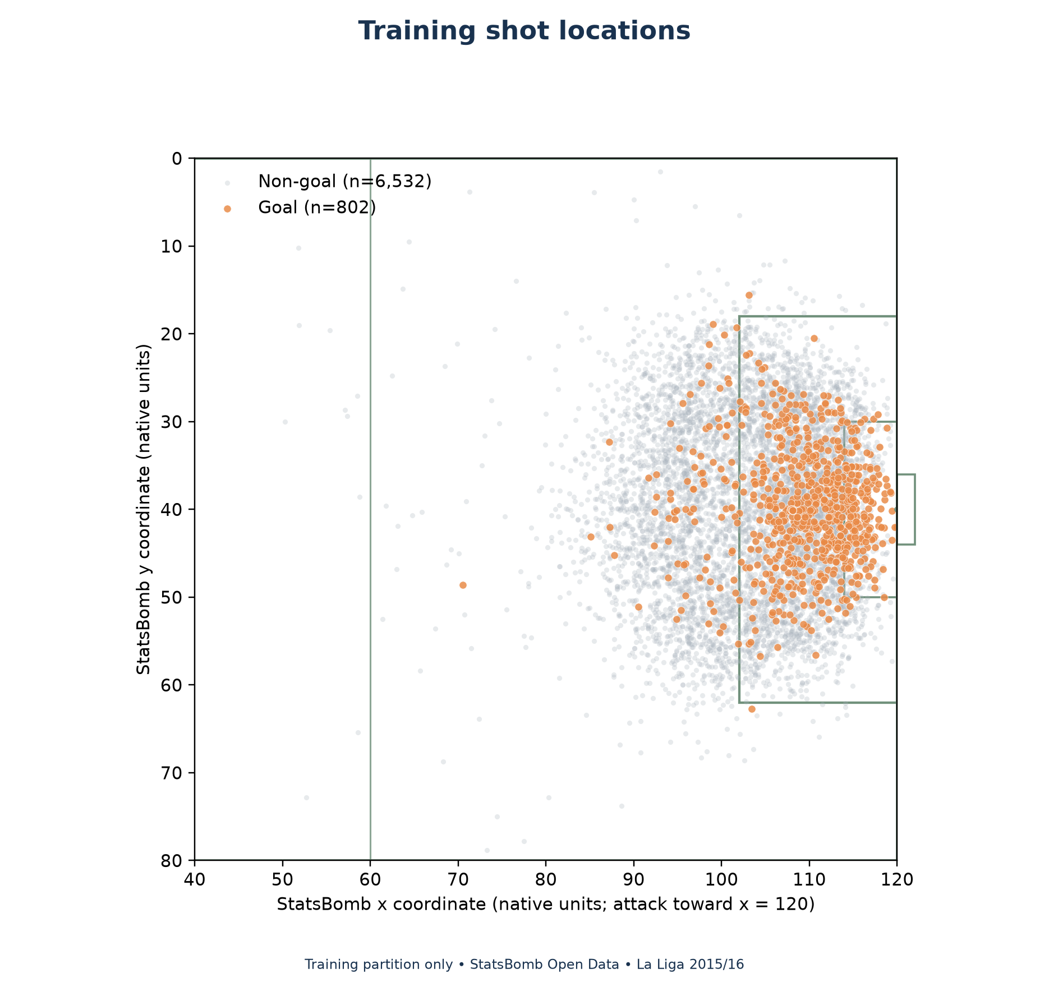
Figure 1. Training-partition shot locations in the StatsBomb coordinate frame. This exported analysis figure is not a UI screenshot.

1 2 Dataset Content
The extracted table has 35 columns and 9,168 shot instances. Each instance represents one shot event. The full season contains 380 matches, and each match is used as the grouping unit for data splitting and cross-validation. The target is is_goal, where 1 denotes a goal outcome and 0 denotes a recognized non-goal outcome. Shot outcomes in the source include Blocked, Off T, Saved, Wayward, Post, Saved Off Target, and Saved to Post as non-goals. The target is derived from the shot outcome; it is not supplied as a separate independent label.

1 3 Independent Attributes
The fixed feature contract contains nine independent attributes. The numeric inputs are distance_sb_units and angle_sb_radians. The categorical inputs are body_part, shot_type, technique, and play_pattern. The binary provider flags are under_pressure, first_time, and open_goal. The project uses these attributes because they describe shot geometry, execution, and the recorded context around the attempt.

1 4 Dependent Attribute
The sole dependent attribute is is_goal. Its positive class is 1 for a shot whose provider outcome is Goal, and its negative class is 0 for one of the seven recognized non-goal outcomes. A negative row is still a shot; it does not mean that a team failed to shoot. shot_outcome is retained to audit the target construction, while statsbomb_xg is an external reference field only. Neither is included among model predictors.

2 Data Preprocessing Methods
The pipeline first downloaded the source JSON files at the pinned repository revision and stored them with a manifest of source URLs, byte sizes, retrieval times, and SHA-256 hashes. Offline verification checks these hashes and the expected JSON structure without making network requests. A hash establishes byte integrity against the saved manifest; it does not prove that the provider's annotations are error-free. The acquisition report verified the indexed season contained all 380 expected matches and event files. The raw files remain separate from the processed table so extraction can be repeated and audited.
The extraction code scans match events and retains a row only when the event type is Shot. It requires each retained shot to have a unique event identifier and a valid match identifier. The goal label is 1 only when the shot outcome is Goal. The code maps Blocked, Off T, Saved, Wayward, Post, Saved Off Target, and Saved to Post to 0. It fails on missing or unknown outcomes instead of silently assigning a non-goal label. Regulation-time periods 1 and 2 are included; shootouts are outside this dataset definition. All 9,168 extracted shots had complete location, player, outcome, body-part, shot-type, technique, and xG fields in the source audit.
The two geometry features are computed from the raw shot coordinates using the StatsBomb frame. Distance is the Euclidean distance from the shot to (120, 40), and angle is the opening between lines from the shot to each goalpost. Locations are not converted to metres because no physical pitch dimensions were assumed. The original x and y coordinates remain as audit fields but are excluded from the initial predictor list. The pipeline does not flip coordinates for away teams, so the provider's attacking direction remains consistent.
The source records under_pressure, first_time, and open_goal sparsely. An absent flag is encoded as not flagged, not as proof that pressure or the other condition was objectively absent. Explicit malformed values fail validation. Required numeric or categorical inputs are not imputed; the builder rejects missing values rather than hiding them through row deletion. The source has paired Own Goal Against and Own Goal For event records, so the reconciliation counts the Against record once and uses For as corroboration. All 380 official match scores reconcile to goal-labelled shots plus the opponent's Own Goal Against events. The resulting feature contract excludes the goal label, shot outcome, StatsBomb xG, match and player identifiers, final score, and post-shot fields from predictors.
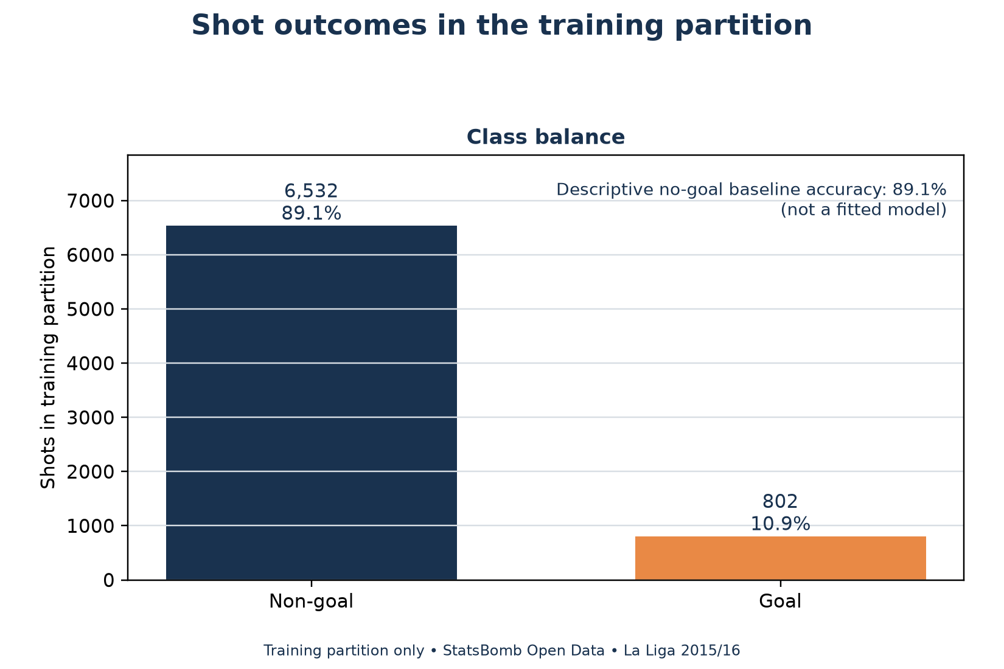
Figure 2. Goal and non-goal counts in the training partition, exported from the analysis pipeline.
During cross-validation, each fold receives a fresh preprocessing pipeline. StandardScaler learns means and scales for the two numeric fields from that fold's fitting rows only. OneHotEncoder learns categories for the four categorical fields from the same fitting rows and ignores a previously unseen validation category rather than failing. The three binary flags pass through as 0 or 1. This creates 28 transformed columns in the verified folds. The dense matrix supports Gaussian Naive Bayes, while the scaling keeps distance and angle from dominating KNN merely because their units have different numeric ranges.
The saved feature contract and processing reports make these choices inspectable. No global scaled matrix is created before cross-validation. The calibration stage also places preprocessing inside the estimator fitted in each inner fold. This matters because scaling or category discovery on validation rows would allow information from those rows to influence their own predictions. The supplied StatsBomb xG is useful for later comparison but remains outside model inputs so the classifiers do not simply reproduce the provider's probability field.
Documented screenshot evidence required by the assignment
The exported dataset excerpt, shot map, and saved validation reports document the analysis, but they are not screenshots of the working application. Capture genuine views from VS Code/Jupyter showing (1) the source or processed table, (2) the target and feature construction, and (3) the feature validation and own-goal reconciliation. Place the original captures in reports/screenshots; do not replace them with recreated images.

3 Data Splitting Methods
The project split data by match before model comparison so that shots from one match could not appear in both training and testing. The assignment's nominal 80/20 ratio is applied to the match groups and shot rows. A seeded match-count subset-sum procedure selected 304 of the 380 matches for training and 76 for the held-out test set. The procedure used only match identifiers and shot counts to obtain exactly 7,334 training shots and 1,834 test shots. It did not search labels or model scores to choose the holdout. The test set is exactly 20% of matches and approximately 20.00% of shot rows (1,834 of 9,168, or 20.0044%).
After allocation, the training partition contained 802 goals and 6,532 non-goals, for a 10.94% goal rate. The held-out partition contained 212 goals and 1,622 non-goals, for an 11.56% goal rate. These counts are reported after the allocation and did not drive its selection. A match-level membership file records which partition each match belongs to. Its hash is saved with the project reports so a later run can verify that no match has silently moved.
The ten-fold cross-validation map is created only from the 304 training matches. StratifiedGroupKFold uses ten folds, shuffling, and random seed 42. Stratification attempts to distribute goal and non-goal labels across folds, while grouping keeps every shot from a match together. Every training shot appears in one validation fold exactly once. The folds contain 29 to 31 validation matches and 726 to 743 validation shots. Every fold has both goal and non-goal examples in its training and validation portions.
The holdout is not used to learn numeric means, category vocabularies, model settings, calibration, or the decision threshold. For every outer fold, preprocessing and the classifier are fitted on nine folds and predictions are made on the tenth. Calibration adds five inner match-grouped folds inside each outer training portion, so the calibrator does not see the outer validation labels. The fixed choice of sigmoid calibration and the family selection rule use pooled training-only OOF log loss. The global candidate is frozen before held-out rows are evaluated.
The final held-out metrics therefore describe one frozen comparison on 76 unseen matches from the same league season. They do not represent a chronological forecast of a later season because the grouped folds are not time-ordered. Match grouping reduces leakage from shared match context, but shots from different matches can still share teams, players, and season conditions. The project uses one season, so testing another season or competition would be necessary before claiming performance generalizes broadly. The fixed threshold is 0.5, and no threshold was searched to improve recall or precision.
Table 2. Locked match and shot allocation
Partition | Matches | Shots | Goals | Non-goals | Goal rate
Training | 304 | 7,334 | 802 | 6,532 | 10.94%
Held-out test | 76 | 1,834 | 212 | 1,622 | 11.56%
Total | 380 | 9,168 | 1,014 | 8,154 | 11.06%

Table 3. Ten-fold match-grouped validation ranges
Validation matches per fold | Validation shots | Validation goals | Folds | Seed
29–31 | 726–743 | 78–85 | 10 | 42

The fold summary is computed on training data only. Pooled OOF metrics combine one validation prediction for each training shot; they are not the unweighted average of fold metrics. Fold standard deviations are reported separately in the saved CSV and are not confidence intervals.
Documented screenshot evidence required by the assignment
The split tables and membership manifest are exported analysis evidence, not application screenshots. Capture genuine screenshots showing (1) the 304/76 match allocation and 7,334/1,834 shot counts, (2) proof that no match ID overlaps across partitions, and (3) the ten-fold grouped validation summary. Store the original screenshots in reports/screenshots and keep the visible paths or notebook cells readable.

4 Data Modelling

4 1 Model Specifications
All classifiers use the same nine predictors and the same locked folds. The positive class is Goal, and hard predictions use the prespecified rule probability greater than or equal to 0.5. KNN uses 50 neighbours, uniform weights, brute-force search, and one worker. Gaussian Naive Bayes uses var_smoothing=1e-9. Logistic regression uses C=1, the lbfgs solver, and a 2,000-iteration limit. The prior baseline predicts the training subset's goal fraction and is included to show the effect of class imbalance.
Each model is a scikit-learn pipeline that fits its transformations within the relevant fold. KNN estimates a shot's probability from the proportion of goal outcomes among its 50 nearest training shots. Its distance calculation depends on the scaling and one-hot representation, so the neighbourhood model is a useful but representation-sensitive classifier. Gaussian Naive Bayes combines class-conditional likelihoods and assumes conditional independence between features. Its Gaussian treatment of one-hot and binary indicators is an approximation, so its probability quality must be measured rather than assumed. Logistic regression provides a linear benchmark over the encoded features and estimates probabilities through a logistic link.
Phase 8 compared raw and sigmoid-calibrated versions of the three classifiers using nested training-only OOF predictions. The family choice was the version with lower pooled OOF log loss; ties would retain the raw model. The chosen family variants were sigmoid KNN, sigmoid Gaussian Naive Bayes, and sigmoid logistic regression. Among those three, logistic regression had the lowest pooled development log loss and was frozen as the global candidate before test evaluation. The prior baseline remained a reference. No hyperparameter search, oversampling, class weighting, or threshold optimization was performed.
The model-specific results below focus on those three family-selected sigmoid variants. The following held-out comparison also shows the corresponding raw versions, so calibration's effects are visible without conflating raw and calibrated results.
Table 4. Raw and sigmoid-calibrated test comparison
Classifier | Raw accuracy | Selected accuracy | Raw log loss | Selected log loss
KNN | 0.899 | 0.899 | 0.373 | 0.291
GaussianNB | 0.880 | 0.884 | 1.218 | 0.332
Logistic regression | 0.899 | 0.899 | 0.277 | 0.277

The saved Phase 8 test metrics file also reports raw and selected precision, recall, Brier score, average precision, ROC-AUC, and confusion counts for all three families.
Table 5. Required classification metrics across evaluation scopes
Classifier | Scope | Accuracy | Precision | Recall | F1
KNN classifier | Training resubstitution | 0.8991 | 0.6476 | 0.1696 | 0.2688
KNN classifier | 10-fold pooled OOF | 0.8976 | 0.6244 | 0.1596 | 0.2542
KNN classifier | Held-out test | 0.8986 | 0.7407 | 0.1887 | 0.3008
Gaussian Naive Bayes | Training resubstitution | 0.8906 | 0.0000 | 0.0000 | 0.0000
Gaussian Naive Bayes | 10-fold pooled OOF | 0.8906 | 0.0000 | 0.0000 | 0.0000
Gaussian Naive Bayes | Held-out test | 0.8844 | 0.0000 | 0.0000 | 0.0000
Logistic regression | Training resubstitution | 0.9018 | 0.6783 | 0.1945 | 0.3023
Logistic regression | 10-fold pooled OOF | 0.9022 | 0.6889 | 0.1933 | 0.3019
Logistic regression | Held-out test | 0.8991 | 0.7455 | 0.1934 | 0.3071

The table separates same-row training diagnostics, pooled validation results, and final test results. The training resubstitution column evaluates fitted models on rows they saw during fitting, so it can be optimistic. The pooled ten-fold OOF column gives each training shot one prediction from a fold model that did not train on its match. Only the held-out test column is the final evaluation of the frozen choices.

4 2 Model One K Nearest Neighbours
Training results use all 7,334 training rows for fitting and then score those same rows. Ten-fold cross-validation uses the locked match-grouped outer folds and reports pooled OOF predictions. Test results use the 1,834 shots from 76 held-out matches after the candidate choices were frozen. This structure keeps in-sample fitting scores separate from validation and test evidence.
KNN classifier results by scope
Evaluation scope | Accuracy | Precision | Recall | F1
Training resubstitution | 0.899 | 0.648 | 0.170 | 0.269
10-fold pooled OOF | 0.898 | 0.624 | 0.160 | 0.254
Held-out test | 0.899 | 0.741 | 0.189 | 0.301

Probability scores by scope (log loss / Brier): training resubstitution: 0.2785 / 0.0802; 10-fold pooled OOF: 0.2907 / 0.0831; held-out test: 0.2906 / 0.0829.
The family-selected KNN includes sigmoid calibration. On the test partition, the thresholded classifier predicted 54 of 1,834 shots as goals. It found 40 of 212 actual goals and had 14 false positives. The calibrated test log loss was 0.291 and Brier score was 0.083. The corresponding uncalibrated KNN had test log loss 0.373, so the fixed development procedure selected calibration for its probability quality.
The selected variant's test confusion counts are TN 1,608, FP 14, FN 172, and TP 40. Its test ROC-AUC is 0.798 and average precision is 0.441. These probability and ranking measures complement accuracy, precision, and recall; none alone describes every operational cost of a missed goal or false alarm.

4 3 Model Two Gaussian Naive Bayes
Training results use all 7,334 training rows for fitting and then score those same rows. Ten-fold cross-validation uses the locked match-grouped outer folds and reports pooled OOF predictions. Test results use the 1,834 shots from 76 held-out matches after the candidate choices were frozen. This structure keeps in-sample fitting scores separate from validation and test evidence.
Gaussian Naive Bayes results by scope
Evaluation scope | Accuracy | Precision | Recall | F1
Training resubstitution | 0.891 | 0.000 | 0.000 | 0.000
10-fold pooled OOF | 0.891 | 0.000 | 0.000 | 0.000
Held-out test | 0.884 | 0.000 | 0.000 | 0.000

Probability scores by scope (log loss / Brier): training resubstitution: 0.3224 / 0.0910; 10-fold pooled OOF: 0.3235 / 0.0913; held-out test: 0.3318 / 0.0942.
The family-selected Gaussian Naive Bayes uses the same feature contract and a sigmoid-calibration layer. At the fixed 0.5 threshold it predicted no test shots as goals, producing 0 true positives and 212 false negatives. Its test accuracy was 88.4%, which is close to the all-non-goal baseline because non-goals make up most of the data. Its test log loss was 0.332 and its average precision was 0.364, showing that zero positive predictions at this threshold do not mean the probabilities contain no ranking information.
The selected variant's test confusion counts are TN 1,622, FP 0, FN 212, and TP 0. Its test ROC-AUC is 0.758 and average precision is 0.364. These probability and ranking measures complement accuracy, precision, and recall; none alone describes every operational cost of a missed goal or false alarm.

4 4 Model Three Logistic Regression
Training results use all 7,334 training rows for fitting and then score those same rows. Ten-fold cross-validation uses the locked match-grouped outer folds and reports pooled OOF predictions. Test results use the 1,834 shots from 76 held-out matches after the candidate choices were frozen. This structure keeps in-sample fitting scores separate from validation and test evidence.
Logistic regression results by scope
Evaluation scope | Accuracy | Precision | Recall | F1
Training resubstitution | 0.902 | 0.678 | 0.195 | 0.302
10-fold pooled OOF | 0.902 | 0.689 | 0.193 | 0.302
Held-out test | 0.899 | 0.745 | 0.193 | 0.307

Probability scores by scope (log loss / Brier): training resubstitution: 0.2718 / 0.0788; 10-fold pooled OOF: 0.2747 / 0.0796; held-out test: 0.2770 / 0.0805.
The family-selected logistic model is the frozen global candidate for the Phase 9 test-set simulation. It produced 41 true positives, 14 false positives, 171 false negatives, and 1,608 true negatives on the held-out test rows. Its test log loss was 0.277, Brier score was 0.081, average precision was 0.464, and ROC-AUC was 0.820. This was the lowest test log loss among the family-selected classifiers, but the test result did not cause the selection; the choice was already frozen from training-only OOF results.
The selected variant's test confusion counts are TN 1,608, FP 14, FN 171, and TP 41. Its test ROC-AUC is 0.820 and average precision is 0.464. These probability and ranking measures complement accuracy, precision, and recall; none alone describes every operational cost of a missed goal or false alarm.
Documented screenshot evidence required by the assignment
The model tables and exported metric figures are analysis outputs, not screenshots of a training or evaluation interface. Capture genuine screenshots from the VS Code notebooks showing training, ten-fold cross-validation, and held-out test results for KNN; the same three stages for Gaussian Naive Bayes; and the same three stages for logistic regression. Keep each model and evaluation scope visible in the capture. The checklist at the end gives the required filenames and evidence slots.

5 Evaluation
The goal class is positive. A true positive is a goal shot classified as a goal, and a true negative is a non-goal shot classified as a non-goal. A false positive is a non-goal shot predicted as a goal, while a false negative is a goal shot predicted as a non-goal. Confusion matrices below use these definitions and the fixed 0.5 threshold on the held-out test set. They are test results, not training or cross-validation confusion matrices.
Table 6. Held-out test confusion counts at probability threshold 0.5
Test classifier | TN | FP | FN | TP
knn_50 (sigmoid) | 1,608 | 14 | 172 | 40
gaussian_nb (sigmoid) | 1,622 | 0 | 212 | 0
logistic_regression (sigmoid) | 1,608 | 14 | 171 | 41
Prior baseline | 1,622 | 0 | 212 | 0

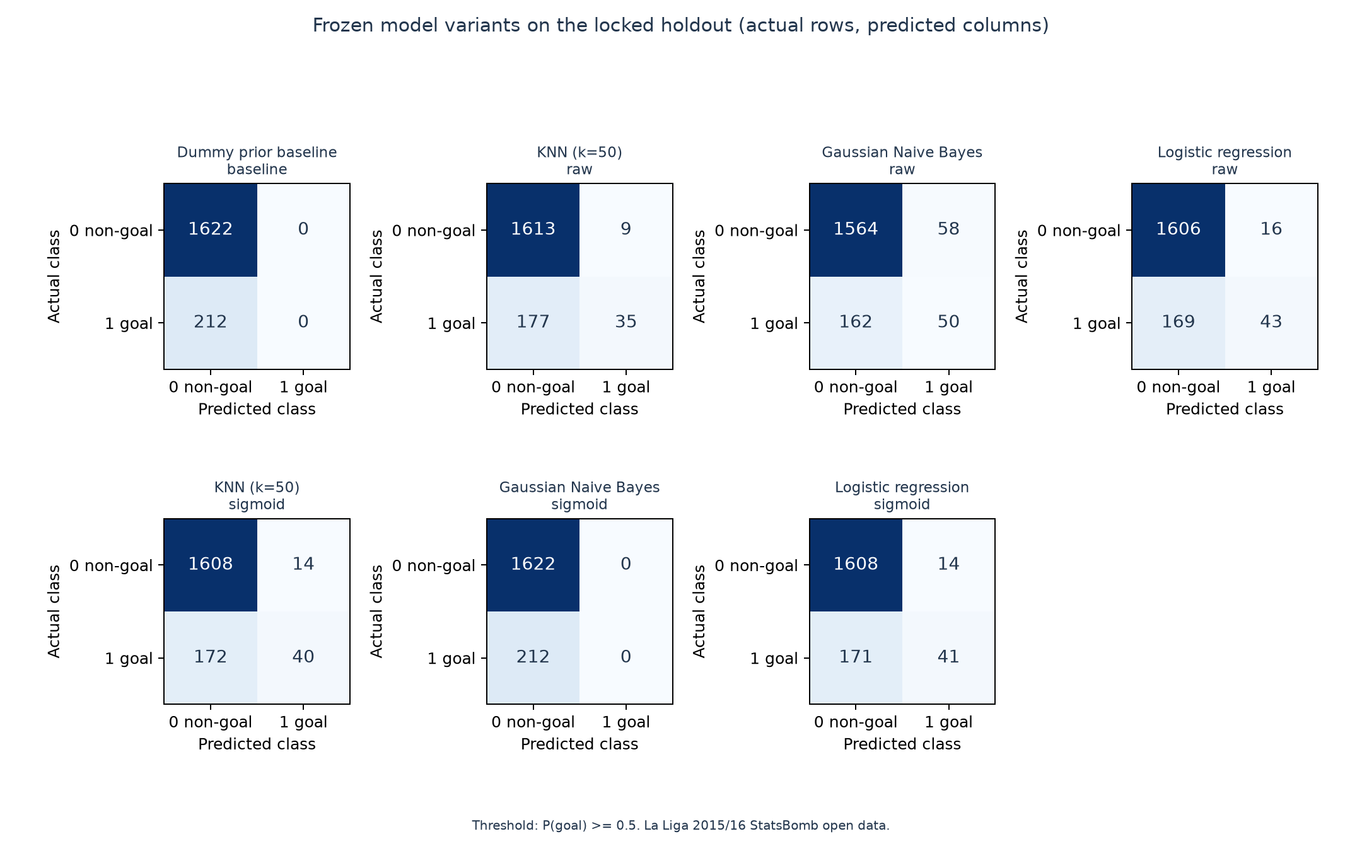
Figure 3. Exported test confusion matrices from the frozen Phase 8 evaluation. These are analytical charts, not screenshots of a software tab.
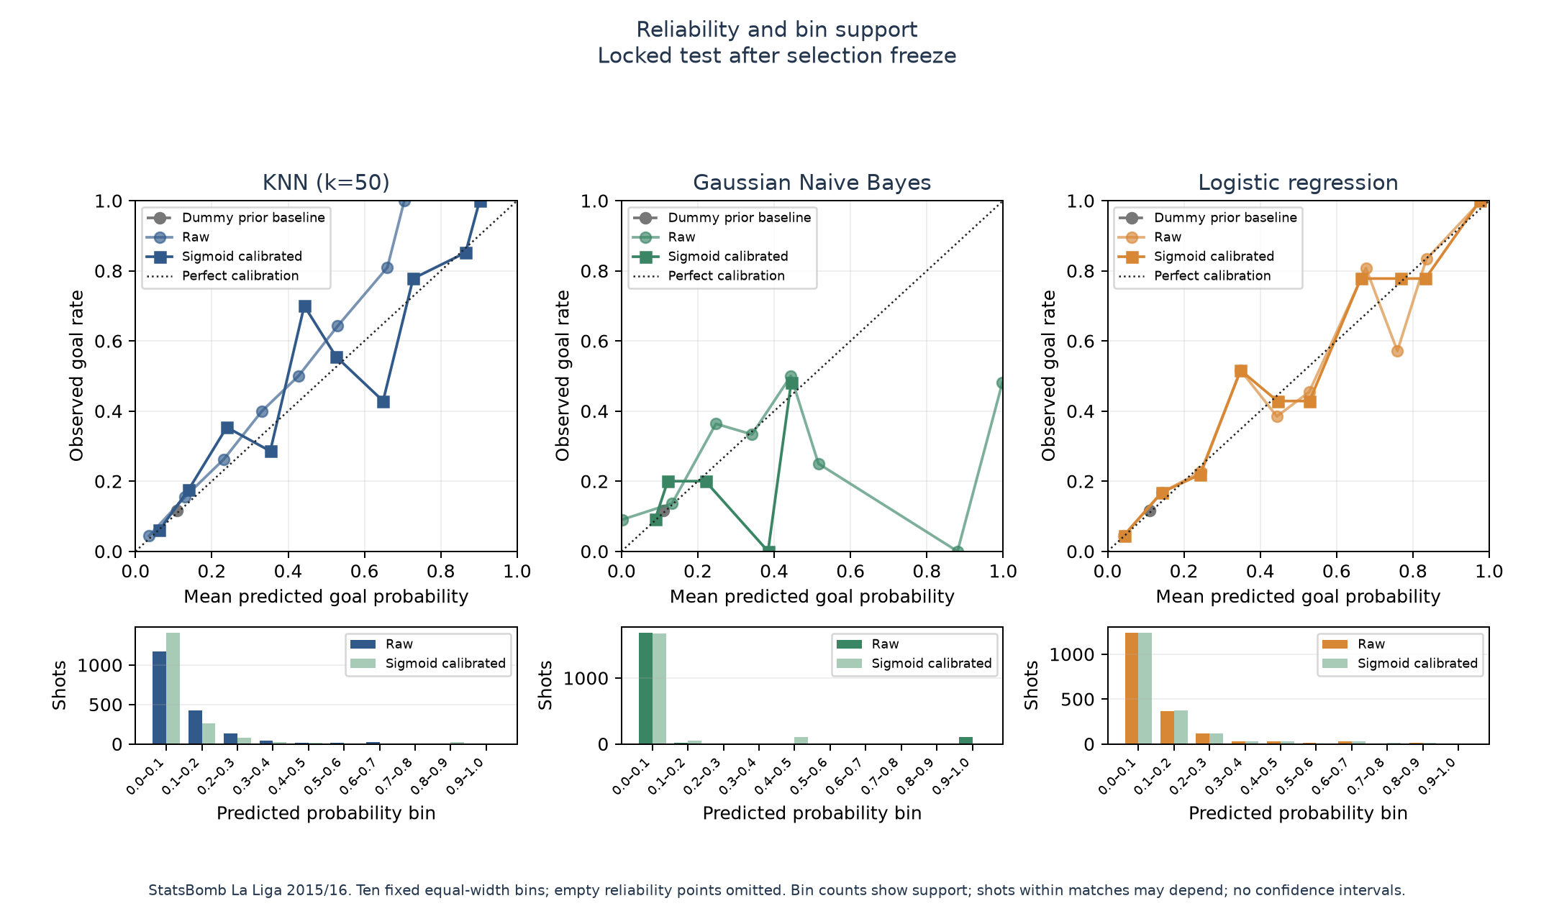
Figure 4. Test-set reliability curves for fixed raw and sigmoid variants. Calibration is evaluated on the held-out partition after selection.
The majority class is non-goal: 1,622 of 1,834 test shots, or 88.44%. The prior baseline therefore obtains 88.44% accuracy by predicting non-goal for every shot, but its precision and recall for goals are both zero. KNN and logistic regression improve test accuracy modestly over this reference, while calibrated Gaussian Naive Bayes ties the baseline. All selected models miss most goal shots at the fixed threshold. KNN and logistic regression identify about one in five actual goals, while Gaussian Naive Bayes identifies none at that threshold. The high precision of KNN and logistic regression means most positive predictions were goals, but those predictions cover only a small share of actual goals.
Log loss and Brier score assess predicted probabilities rather than only the binary decisions at 0.5. Among the selected variants, logistic regression has the lowest test log loss and Brier score, while KNN is close on Brier score. Average precision and ROC-AUC measure ranking across thresholds, so they can remain informative even when a fixed threshold yields no positive predictions. Test-set results are reported after model selection and should be read as one estimate for a single historical season. No confidence interval or claim of future-season accuracy is made.
Screenshot requirement for assignment evaluation
The assignment requests cropped screenshots of testing performance metrics and confusion matrices. The table and figures in this report are exported, reproducible results; they are not cropped UI screenshots. Capture one genuine test-metric view and one genuine confusion-matrix view for each of the three classifiers after the frozen evaluation. The exact screenshot slots are listed in the submission checklist. Do not substitute training or OOF matrices for the final test evidence.

6 Guide Questions

6 1 What Are the Accuracy Precision and Recall of Each Classification Model
On the held-out test set, the selected sigmoid KNN has 89.86% accuracy, 74.07% precision, and 18.87% recall. The selected sigmoid Gaussian Naive Bayes has 88.44% accuracy, 0% precision, and 0% recall because it predicted no test row as a goal at the fixed 0.5 threshold. The selected sigmoid logistic regression has 89.91% accuracy, 74.55% precision, and 19.34% recall. These three models are evaluated on the same 1,834 test shots, including 212 goal shots. The prior baseline reaches 88.44% accuracy but has zero goal precision and recall. Table 5 presents the corresponding training resubstitution and ten-fold pooled OOF values separately from these test metrics.

6 2 What Insights Can Be Derived from the Scores about Model Quality
The test goal prevalence is 11.56%, so an all-non-goal classifier reaches 88.44% accuracy without identifying any goals. The selected models' accuracy values near 90% must therefore be interpreted against that baseline. KNN and logistic regression achieve relatively high precision because only 54 and 55 test shots, respectively, cross the fixed positive threshold. Their recall remains below 20%, so they miss more than four out of five actual goal shots. Gaussian Naive Bayes has useful ranking scores but no positive predictions at this threshold, which exposes a gap between ranking, probability calibration, and a chosen decision rule. Logistic regression has the best test log loss and average precision among the selected variants, but its observed advantage is small and does not establish superiority on other seasons.

6 3 Which Metric Is More Significant in This Dataset
For the goal-detection question, recall is important because it directly measures how many actual goals the classifier identifies. Precision must be read with recall because a model can achieve high precision by making only a few positive predictions. Accuracy is less informative by itself because most observed shots are non-goals. Probability log loss is also important for the xG-oriented portfolio purpose because it rewards well-ranked, appropriately confident probabilities and penalizes confident mistakes. The best metric depends on whether the use case prioritizes identifying more goals, limiting false alarms, or assigning useful probabilities. This project keeps the threshold fixed and reports multiple metrics rather than claiming one universal winner.

6 4 What Factors Can Contribute to a Negative Label
A negative label means a recorded shot had a recognized non-goal outcome, such as a block, off-target attempt, save, or shot hitting the post. Shot distance and angle describe how the attempt relates geometrically to the goal. Body part and technique distinguish headers, footed attempts, volleys, and other shot forms that can differ in execution. The play pattern and provider flags add context about how the attempt arose and whether pressure, a first-time shot, or an open goal was explicitly flagged. In the training-only EDA, 100 of 214 shots from 0–6 StatsBomb distance units were goals (46.73%), compared with 46 of 1,980 shots from 24–36 units (2.32%). For shots in the narrowest angle bin, 308 of 5,308 were goals (5.80%). These descriptive rates show that geometry is associated with conversion in this sample, but they do not establish that changing distance or angle alone causes a different outcome. Defensive positioning, goalkeeper actions, shot placement, selection of which chances become shots, and finite sample variation may also influence the observed relationship.

7 Monte Carlo Simulation
The Phase 9 simulation uses the frozen sigmoid logistic-regression candidate on the 1,834 shots in the held-out 76-match test set. For each shot, a Bernoulli outcome is sampled using its saved predicted goal probability, and team goals are summed for each trial. The program runs 100,000 trials per match with seed 42 and separate deterministic random streams by match and side. It processes trials in chunks of 10,000 and checks simulated means and outcome frequencies against exact calculations. The exact reference is the Poisson-binomial distribution, obtained by convolving each shot's [1-p, p] probabilities; it is not a Poisson approximation from summed xG.
Across the held-out matches, the official scores total 134 home and 84 away goals. Goal-labelled shots account for 131 home and 81 away goals; the remaining six official goals are credited as own goals, three for each side. The primary Monte Carlo outputs simulate shot goals only. Own goals are retained in reconciliation tables but are not sampled or added to simulated scorelines. The trial checks show that all 76 match trial counts and outcome counts sum correctly and all simulated means fall within the predefined six-MCSE tolerance.
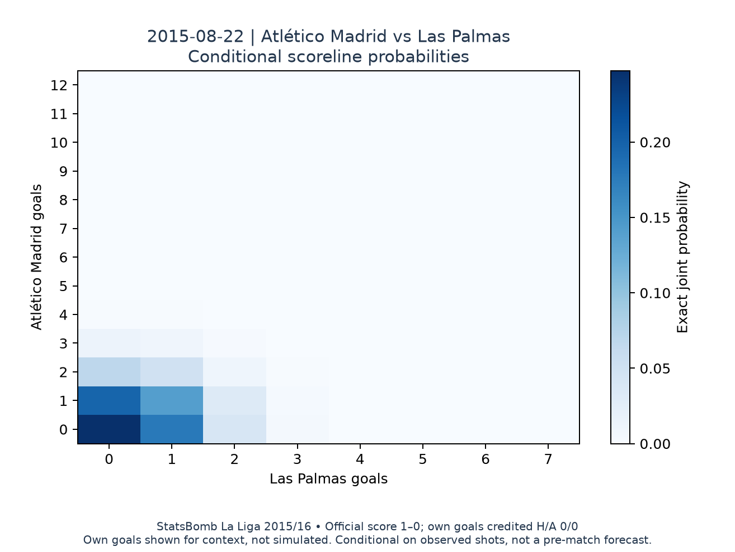
Figure 5. Complete conditional test-set scoreline distribution for the preselected earliest held-out example match.
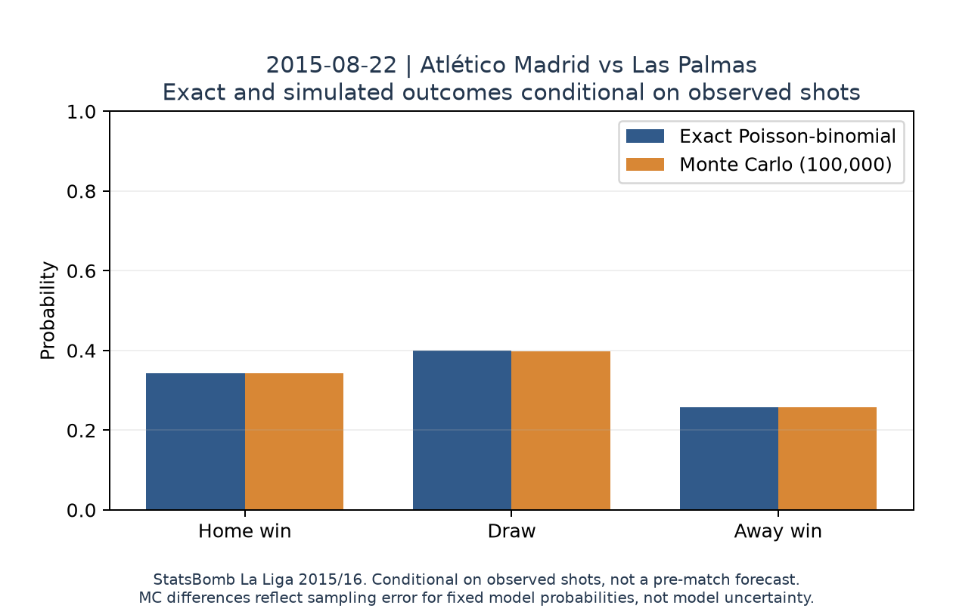
Figure 6. Exact and Monte Carlo home/draw/away probabilities for the same held-out example match.
The simulation is retrospective and conditional on the observed shot list. It cannot model the fact that an early goal or miss might change later attempts, player decisions, or match tactics. Monte Carlo standard errors describe finite random sampling conditional on the fixed model probabilities; they do not capture model uncertainty, annotation error, or variation across seasons. The 76 matches are not a complete league season, so the project does not simulate a final league table.

8 El Clasico Development OOF Case Study
Two fixtures were selected in advance for football interest: Real Madrid 0–4 Barcelona on 21 November 2015 and Barcelona 1–2 Real Madrid on 2 April 2016. Their probabilities come from saved Phase 8 outer-fold OOF predictions for the frozen sigmoid logistic-regression candidate. Each fixture was excluded from fitting and calibration in its outer validation fold, and the report verifies that both matches are in the training partition and outside the test partition. The model family itself was selected using development results, so these cases are not independent test evidence.
Table 7. Exact outcome probabilities for the two development case studies
Date | Official score | OOF fold | P home win | P draw | P away win
2015-11-21 | Real Madrid 0–4 Barcelona | 2 | 0.092 | 0.142 | 0.766
2016-04-02 | Barcelona 1–2 Real Madrid | 7 | 0.205 | 0.259 | 0.536

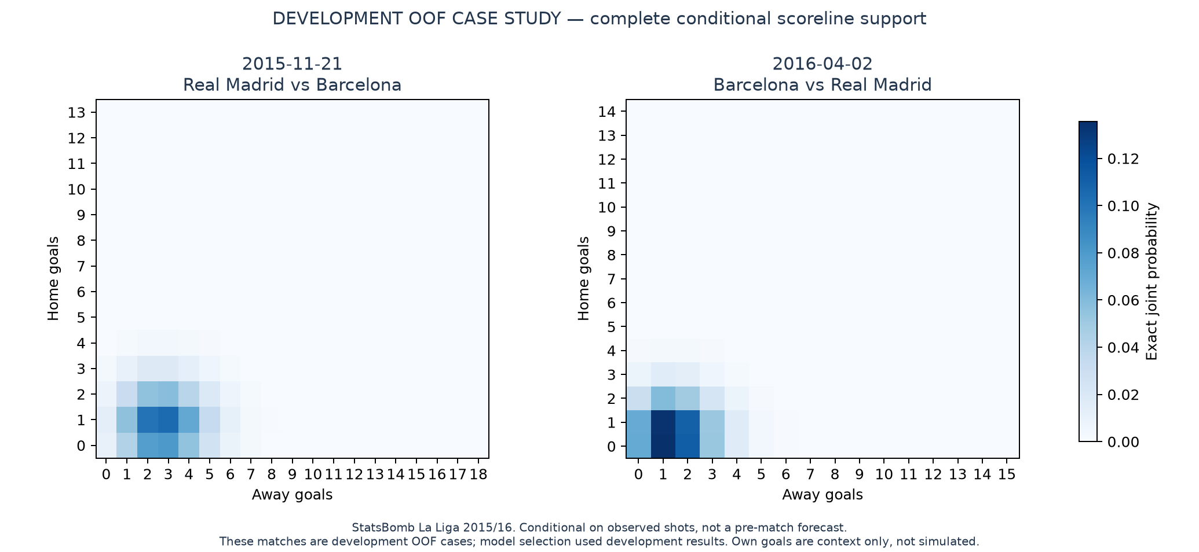
Figure 7. Exact complete scoreline supports for both El Clasico fixtures. Development OOF case study; conditional on observed shots, not an independent test or pre-match forecast.
For the November fixture, the exact conditional probabilities are 9.2% home win, 14.2% draw, and 76.6% away win. For the April fixture they are 20.5% home win, 25.9% draw, and 53.6% away win. These probabilities are conditional on the shots that occurred and exclude own goals from the simulation. They describe the model's shot-conversion uncertainty under its independent-shot assumption, not the probability assigned before kickoff. The cases are useful as an interpretable portfolio example, but the 76-match test set remains the final held-out evaluation.

9 Limitations and Interpretation
The observations come from one season and one competition. Match grouping prevents the same match from leaking across train and validation partitions, but it does not test transfer to a future season or another league. The goal class is imbalanced, and fixed-threshold recall is low for all selected classifiers. Gaussian Naive Bayes' distributional assumptions are only approximate for binary and one-hot features. The sparse provider flags mean not flagged, which is not necessarily the same as absent in the real match. The coordinate-derived distance and angle are in StatsBomb units because no pitch dimensions were assumed.
The target records whether an observed shot became a goal, not whether a possession or match produced a goal. The model does not include all potentially relevant factors such as defender positions, goalkeeper location, shot placement, or complete freeze-frame context. StatsBomb xG is excluded from the predictors and is not a ground truth label. Calibration may change on new seasons and does not guarantee that individual shot probabilities are correct. The Monte Carlo simulation assumes independent Bernoulli outcomes for the fixed set of shots and omits own goals from simulated scores. Its sampling tolerance does not cover uncertainty in the model probabilities or future football events.

References and Reproducibility
[1] CS.412 Data Mining Final Project. Course assignment supplied with this project. The report follows its requirements for two or more models, train/test evaluation, ten-fold cross-validation, metrics, confusion matrices, and four guide questions.
[2] StatsBomb. StatsBomb Open Data, pinned repository revision 4b73468fc5b0f1950f9f66fada70ad3a4f9327cb. https://github.com/hudl/open-data/tree/4b73468fc5b0f1950f9f66fada70ad3a4f9327cb. The repository requests source attribution and use of the StatsBomb logo when publishing analysis.
[3] StatsBomb. StatsBomb Open Data Specification v1.1, Appendix 2, page 34, at the pinned repository revision. https://raw.githubusercontent.com/hudl/open-data/4b73468fc5b0f1950f9f66fada70ad3a4f9327cb/doc/StatsBomb%20Open%20Data%20Specification%20v1.1.pdf.
[4] Scikit-learn and Python environment versions are recorded in requirements.txt and the phase protocol/report JSON files. Model settings, feature roles, fold membership, data hashes, and result metrics are preserved in the project scripts and docs/phase_03_data_acquisition.md through docs/phase_09_monte_carlo_simulation.md.
The raw source snapshot can be reproduced with python scripts/acquire_data.py and checked offline with python scripts/acquire_data.py --verify-only. The shot table, feature contract, split, folds, model protocols, saved OOF predictions, held-out results, and simulation tables are included under data/processed, docs, models, and reports. See the project README for the ordered commands and the Phase 10 checklist for remaining submission evidence.

Submission Screenshot Checklist
The provided screenshots folder was empty when this report was prepared. No application screenshots have been fabricated or represented by exported charts. The assignment requires genuine visual evidence, so this report remains a submission draft until these captures are added. Keep the original screenshots in reports/screenshots and insert them at the corresponding points in the final report.
Chapter | Required capture | What must be visible
Preprocessing | Source/processed shot table | Capture real dataset or notebook view with row and field labels visible.
Preprocessing | Target and feature construction | Capture the cell or workflow that creates is_goal and the nine predictors.
Preprocessing | Validation and reconciliation | Capture completed quality checks and the own-goal score reconciliation.
Splitting | 80/20 match allocation | Show 304 training and 76 test matches with their shot counts.
Splitting | Group separation | Show evidence that match IDs do not overlap between train and test.
Splitting | Ten-fold grouped CV | Show the ten-fold summary and match-grouped validation results.
Model training | KNN training results | Capture same-row training diagnostics and label them resubstitution.
Model training | KNN cross-validation | Capture pooled OOF or ten-fold results.
Model training | KNN test results | Capture final frozen held-out test results.
Model training | GaussianNB training results | Capture same-row training diagnostics and label them resubstitution.
Model training | GaussianNB cross-validation | Capture pooled OOF or ten-fold results.
Model training | GaussianNB test results | Capture final frozen held-out test results.
Model training | Logistic regression training | Capture same-row training diagnostics and label them resubstitution.
Model training | Logistic regression cross-validation | Capture pooled OOF or ten-fold results.
Model training | Logistic regression test results | Capture final frozen held-out test results.
Evaluation | KNN test metrics | Genuine cropped test metric view, not a training or OOF screenshot.
Evaluation | KNN test confusion matrix | Genuine cropped test confusion matrix at threshold 0.5.
Evaluation | GaussianNB test metrics | Genuine cropped test metric view, not a training or OOF screenshot.
Evaluation | GaussianNB test confusion matrix | Genuine cropped test confusion matrix at threshold 0.5.
Evaluation | Logistic regression test metrics | Genuine cropped test metric view, not a training or OOF screenshot.
Evaluation | Logistic regression test confusion matrix | Genuine cropped test confusion matrix at threshold 0.5.

Use clear filenames such as preprocessing_01_dataset.png, split_03_ten_fold_cv.png, knn_02_cross_validation.png, and evaluation_logistic_test_confusion.png. Screenshots should show the real notebook or application state without editing result values. Add the StatsBomb source credit and logo from the repository media pack if the analysis is published or distributed [2].

