 | Ateneo de Zamboanga University  College of Science, Information Technology and Engineering  Computer Science Department  CS.412 DATA MINING | 
FINAL PROJECT
NAME |  | YEAR & COURSE
DATASET TITLE | StatsBomb La Liga 2015/2016 Shot Outcomes | DATE
DATASET SOURCE | StatsBomb Open Data
SOFTWARE | Python with scikit-learn | DATA SIZE | 9,168 shots
CLASSIFICATION MODELS | KNN, Gaussian Naive Bayes, and Logistic Regression with sigmoid calibration

TABLE OF CONTENTS
1 |  | DATA DESCRIPTION | 3
 | 1.1 | DATASET DESCRIPTION | 3
 | 1.2 | DATASET CONTENT | 4
 | 1.3 | INDEPENDENT ATTRIBUTES | 4
 | 1.4 | DEPENDENT ATTRIBUTE | 4
2 |  | DATA PREPROCESSING METHODS | 5
3 |  | DATA SPLITTING METHODS | 8
4 |  | THE WORKSPACE WITH COMPLETE PROCESSES | 10
 | 4.1 | K NEAREST NEIGHBOURS | 10
 | 4.2 | GAUSSIAN NAIVE BAYES | 11
 | 4.3 | LOGISTIC REGRESSION | 13

5 |  | SAMPLE CLASSIFIED DATA | 16
6 |  | CONFUSION MATRIX | 20
7 |  | GUIDE QUESTIONS | 23
 | 7.1 | ACCURACY, PRECISION AND RECALL | 23
 | 7.2 | MODEL QUALITY | 23
 | 7.3 | SIGNIFICANT METRIC | 24
 | 7.4 | FACTORS FOR A NEGATIVE LABEL | 24
 |  | REFERENCES | 26
A |  | CALIBRATION EXTENSION | 27
B |  | MONTE CARLO SIMULATION | 28
C |  | EL CLASICO OOF CASE STUDY | 31

CHAPTER 1: DATA DESCRIPTION
1.1 Dataset Description
This project uses the StatsBomb Open Data snapshot for Spain's La Liga 2015/2016 season [2]. The source revision is pinned so later repository changes cannot silently alter the analysis. The downloaded season contains 380 matches and 1,295,354 event records, while the modelling table retains only shot events. A shot row is the unit of analysis, and match and event identifiers support traceability. The final table contains 9,168 shots, including 1,014 goals and 8,154 recognized non-goals. StatsBomb xG is retained as a reference field, not used as the target or as a model input.
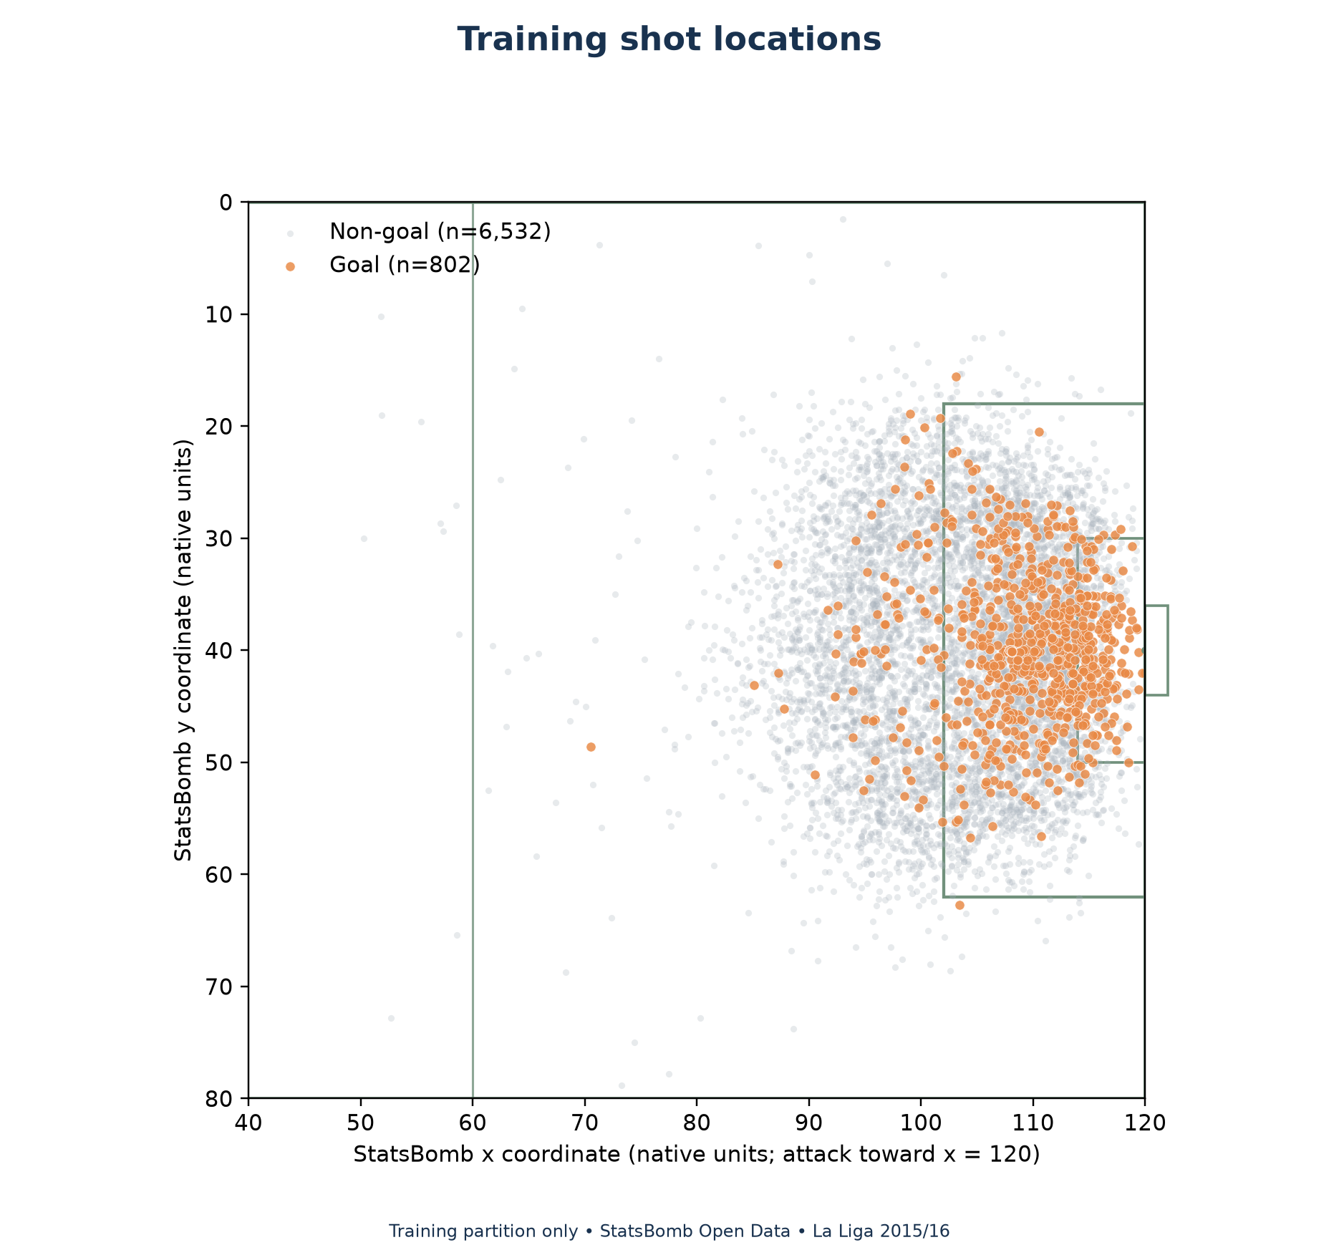
Figure 1. Training shot locations in StatsBomb coordinates; 7,334 shots comprising 802 goals and 6,532 non-goals.
Event ID | Match | Outcome | Distance | Angle | Goal
000d43e0-4… | 3825808 | Off T | 16.42 | 0.44 | 0
001d7c7d-1… | 3825850 | Off T | 22.42 | 0.26 | 0
0020d4fc-c… | 3825682 | Off T | 27.59 | 0.21 | 0
0021d8c9-2… | 3825605 | Off T | 30.91 | 0.25 | 0
002a524e-c… | 3825622 | Goal | 14.37 | 0.39 | 1

Table 1. Five deterministically ordered examples from the processed shot table. Distance is in StatsBomb units; angle is in radians.
1.2 Dataset Content
The processed table represents shot events and contains 35 columns. The season's matches are retained as groups for splitting and validation. The main dataset counts are:
- Instances: 9,168 shots from 380 matches.
- Attributes: 35 processed columns, including the target and audit fields.
- Class counts: 1,014 goals and 8,154 recognized non-goals.
1.3 Independent Attributes
The nine independent attributes are the fixed model inputs. Four are categorical, two are numeric, and three are binary provider flags.
- distance_sb_units: Euclidean distance from the shot to goal centre, in native StatsBomb units.
- angle_sb_radians: opening angle toward the goalposts, in radians.
- body_part: provider-recorded body part used for the attempt.
- shot_type: provider classification of the shot, including penalties.
- technique: recorded technique used for the shot.
- play_pattern: possession pattern associated with the shot.
- under_pressure: pressure flag; false means the provider did not flag it.
- first_time: first-time-shot flag; false means not flagged.
- open_goal: open-goal flag; false means not flagged.
1.4 Dependent Attribute
The sole dependent attribute is is_goal. Its value is 1 when the recorded shot outcome is Goal and 0 for a recognized non-goal outcome. It labels the result of a shot, not the result of a possession or match. The source shot outcome is retained to audit label construction. All nine predictors describe shot geometry, execution, or recorded context.

CHAPTER 2: DATA PREPROCESSING METHODS
The raw source snapshot was downloaded from immutable URLs under the pinned repository commit and preserved as original JSON files. A manifest records each source URL, size, retrieval time, and SHA-256 digest. Offline verification checks completeness and file integrity without contacting the network. This establishes that the local copy matches the saved manifest, but it does not guarantee that provider annotations are free of error. The acquisition report confirms 380 matches and their associated event files.
The extraction program scans match events and keeps a row only when the event type is Shot. It requires a non-empty unique event identifier and a valid match identifier for each retained row. It rejects malformed JSON, unknown outcomes, incomplete required fields, invalid coordinates, and non-finite values. A shot becomes a positive label only when its outcome is Goal. Seven known outcomes are mapped to the negative class, and unexpected outcomes cause an error rather than being silently assigned a label.
The initial dataset includes regulation periods 1 and 2; shootout events are outside the project definition. Shot distance is computed as the Euclidean distance to (120, 40), and shot angle is computed from vectors to the two goalposts. The geometry remains in native StatsBomb units and radians. The code does not rotate or flip coordinates according to home or away status. It records the attacking direction supplied by the provider and keeps the raw location fields for audit.
Under-pressure, first-time, and open-goal annotations are represented as binary provider flags. Where the provider omits a sparse flag, the project records not flagged as false and documents that distinction. It does not interpret an omitted annotation as certain absence in the real play. Required numeric and categorical inputs are complete in the audited source; the builder fails on unexpected missing values rather than imputing or dropping shots. The feature contract prevents target leakage by excluding is_goal, shot_outcome, StatsBomb xG, final scores, event identity, player identity, and post-shot fields.
Official scores are reconciled using each shot goal and the opponent's Own Goal Against record. Paired Own Goal For records corroborate the beneficiary but are not counted a second time. This reconciliation succeeds for all 380 matches. The 1,014 shot goals plus 29 own-goal credits reconcile to 1,043 official goals. Freeze-frame availability is not required for this project, and freeze-frame fields are not used as predictors. Off-camera flags are retained as audit information and excluded from the model contract.
Model preparation is fitted inside each cross-validation training fold. StandardScaler learns the two numeric means and scales using that fold's fitting shots only. OneHotEncoder learns category vocabularies from the same rows and ignores unseen validation categories without learning from them. The three binary fields pass through unchanged as 0 or 1. The verified transformation yields 28 columns in the development folds. This representation supports Gaussian Naive Bayes and allows KNN to compare inputs without raw coordinate ranges dominating distance calculations.
The sigmoid calibration procedure also keeps preprocessing inside each inner estimator. Thus, neither outer validation rows nor held-out test rows determine a scaler or category vocabulary used to score themselves. No global transformed matrix is fitted before cross-validation. No numeric imputation, resampling, class weighting, or synthetic examples are added. The saved feature contract and hash-checked reports make these preprocessing decisions inspectable and repeatable.
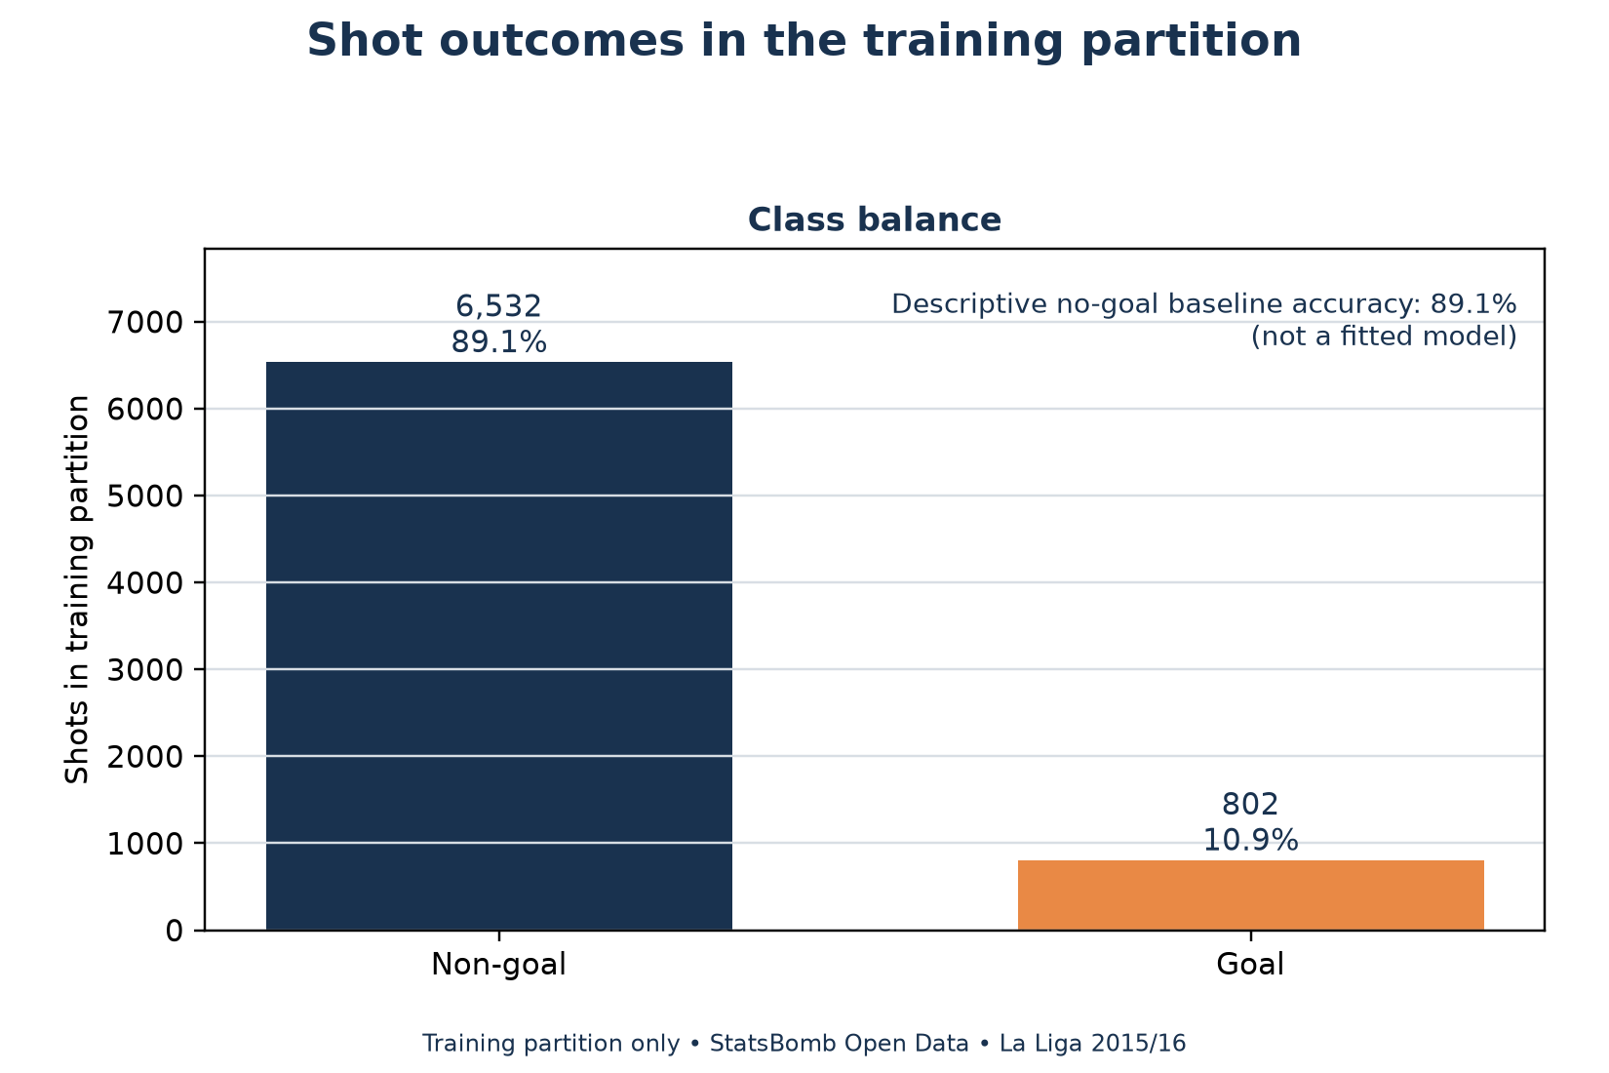
Figure 2. Training-partition class counts after shot extraction; exported analytical evidence.
Screenshot spaces are reserved for genuine VS Code and Jupyter captures. They remain empty until original application screenshots are added.
Processed source table and fields
Genuine screenshot pending
Insert the original application capture here.
Target and nine-predictor construction
Genuine screenshot pending
Insert the original application capture here.
Quality checks and score reconciliation
Genuine screenshot pending
Insert the original application capture here.

CHAPTER 3: DATA SPLITTING METHODS
The dataset was partitioned by match before model comparison so shots from one fixture could not appear in both training and testing. The nominal 80/20 split applies exactly to the 380 match groups: 304 matches are assigned to training and 76 to the holdout. A seeded subset-sum allocation uses match identifiers and shot counts to reach 7,334 training shots and 1,834 test shots. It does not inspect labels or model scores while selecting the match groups. The holdout contains 20.0044% of shot rows, which is approximately 20.00%, while the match allocation is exactly 20%.
Partition | Matches | Shots | Goals | Non-goals | Goal rate
Training | 304 | 7334 | 802 | 6532 | 10.94%
Held-out test | 76 | 1834 | 212 | 1622 | 11.56%

Table 4. Locked match-grouped holdout allocation.
The label counts shown in Table 4 are a consequence of the allocation, not a criterion used to choose it. A membership CSV and manifest lock each match to its partition and preserve hashes for later verification. The training and test match sets are disjoint. All preprocessing choices, model settings, calibration comparisons, and selection decisions are made using training data only. The test set remains untouched until the selected variants and protocol are frozen.
Ten-fold cross-validation is run only over the 304 training matches. StratifiedGroupKFold uses ten splits, shuffling, and random seed 42. Stratification helps distribute the positive and negative shot labels across folds, while grouping keeps every shot from a match together. Each training shot receives exactly one outer validation prediction. Each training match appears in one validation fold. Both classes occur in every fold's training and validation portions.
The validation folds contain 29 to 31 matches and 726 to 743 shots. Their goal counts range from 78 to 85. Per-fold metrics are retained, while pooled OOF metrics combine exactly one validation prediction for every training row. The pooled value is not the unweighted average of the fold values. Fold standard deviations describe variation among these ten partitions; they are not confidence intervals.
For each outer fold, the model pipeline fits its scaler, encoder, and classifier on nine folds and scores the tenth. Sigmoid calibration adds five grouped inner folds inside each outer training subset. The outer validation data do not enter those inner fits. The model family selection compares nested training-only OOF log loss, choosing the sigmoid version when it performs better and retaining raw if tied. The global candidate is then frozen before any held-out test prediction is examined.
The held-out test set estimates performance on unseen matches from this historical season. Because the split is not chronological and comes from one competition season, it does not establish future-season performance or transfer to another league. Match grouping reduces direct within-match leakage but does not eliminate shared team, player, or season effects. No threshold search was performed; classification metrics use the prespecified probability threshold of 0.5. Probability metrics are also reported because a shot-probability project cannot be evaluated by accuracy alone.
Fold | Validation matches | Validation shots | Goals | Goal rate
1 | 29 | 729 | 85 | 11.66%
2 | 30 | 727 | 79 | 10.87%
3 | 30 | 726 | 80 | 11.02%
4 | 31 | 739 | 79 | 10.69%
5 | 30 | 727 | 78 | 10.73%
6 | 31 | 740 | 79 | 10.68%
7 | 31 | 738 | 79 | 10.70%
8 | 31 | 733 | 78 | 10.64%
9 | 30 | 732 | 82 | 11.20%
10 | 31 | 743 | 83 | 11.17%

Table 5. Ten-fold training-only validation allocation.
80/20 match allocation and shot counts
Genuine screenshot pending
Insert the original application capture here.
Train/test match disjointness
Genuine screenshot pending
Insert the original application capture here.
Ten-fold grouped validation summary
Genuine screenshot pending
Insert the original application capture here.

CHAPTER 4: THE WORKSPACE WITH COMPLETE PROCESSES
Three supervised classifiers use the same nine-feature contract and locked partitions. Their selected report variants are the family choices frozen from nested training-only OOF log loss: sigmoid-calibrated KNN, Gaussian Naive Bayes, and logistic regression. The global candidate is logistic regression with sigmoid calibration. KNN and Gaussian Naive Bayes satisfy the course's requirement for at least two models; logistic regression is an additional linear benchmark. Every model's training, cross-validation, and testing results are shown as separate scopes.
4.1 K Nearest Neighbours
KNN uses 50 nearest training shots, uniform neighbour weights, brute-force search, and one worker. It estimates probability from the share of goal labels among its neighbours, followed by the selected sigmoid calibration. Its distance calculation depends on fold-local scaling and the one-hot representation.
a. Training Results
Accuracy | Precision | Recall | F1 | Log loss | Brier
0.8991 | 0.6476 | 0.1696 | 0.2688 | 0.2785 | 0.0802

a. Training Results: 7,334 shots; positive class Goal; threshold 0.5.
KNN training resubstitution screenshot
Genuine screenshot pending
Insert the original application capture here.

b. 80/20 Testing Results
Accuracy | Precision | Recall | F1 | Log loss | Brier
0.8986 | 0.7407 | 0.1887 | 0.3008 | 0.2906 | 0.0829

b. 80/20 Testing Results: 1,834 shots; positive class Goal; threshold 0.5.
KNN held-out test screenshot
Genuine screenshot pending
Insert the original application capture here.

c. Cross-Validation Results 10 Fold
Accuracy | Precision | Recall | F1 | Log loss | Brier
0.8976 | 0.6244 | 0.1596 | 0.2542 | 0.2907 | 0.0831

c. Cross-Validation Results 10 Fold: 7,334 shots; positive class Goal; threshold 0.5.
KNN ten-fold OOF screenshot
Genuine screenshot pending
Insert the original application capture here.

On the held-out test set, KNN classified 40 goal shots correctly and made 14 false-positive predictions; it missed 172 goal shots. Its goal precision was 74.1%, recall was 18.9%, and log loss was 0.291. These values describe the selected calibrated family variant at the fixed 0.5 threshold.
4.2 Gaussian Naive Bayes
Gaussian Naive Bayes combines class-conditional feature distributions under a conditional-independence assumption and uses var_smoothing equal to 1e-9. Its Gaussian likelihood for one-hot and binary variables is an approximation. The family-selected version includes sigmoid calibration chosen from training-only OOF log loss.
a. Training Results
Accuracy | Precision | Recall | F1 | Log loss | Brier
0.8906 | 0.0000 | 0.0000 | 0.0000 | 0.3224 | 0.0910

a. Training Results: 7,334 shots; positive class Goal; threshold 0.5.
Gaussian Naive Bayes training resubstitution screenshot
Genuine screenshot pending
Insert the original application capture here.

b. 80/20 Testing Results
Accuracy | Precision | Recall | F1 | Log loss | Brier
0.8844 | 0.0000 | 0.0000 | 0.0000 | 0.3318 | 0.0942

b. 80/20 Testing Results: 1,834 shots; positive class Goal; threshold 0.5.
Gaussian Naive Bayes held-out test screenshot
Genuine screenshot pending
Insert the original application capture here.

c. Cross-Validation Results 10 Fold
Accuracy | Precision | Recall | F1 | Log loss | Brier
0.8906 | 0.0000 | 0.0000 | 0.0000 | 0.3235 | 0.0913

c. Cross-Validation Results 10 Fold: 7,334 shots; positive class Goal; threshold 0.5.
Gaussian Naive Bayes ten-fold OOF screenshot
Genuine screenshot pending
Insert the original application capture here.

At the fixed threshold, this selected model made 0 positive test predictions that were true goals and 0 false positives. It made zero positive predictions in this test partition, so its precision and recall are both zero at that threshold. This does not imply that every probability is zero or that the model has no ranking information; its log loss, average precision, and ROC-AUC evaluate different properties.
4.3 Logistic Regression
Logistic regression uses C=1, the lbfgs solver, and a maximum of 2,000 iterations. It estimates a linear boundary over the scaled numeric and one-hot encoded predictors and produces probabilities through a logistic link. The sigmoid version had the lowest pooled development OOF log loss of the selected candidates and was frozen as the global simulation candidate before test evaluation.
a. Training Results
Accuracy | Precision | Recall | F1 | Log loss | Brier
0.9018 | 0.6783 | 0.1945 | 0.3023 | 0.2718 | 0.0788

a. Training Results: 7,334 shots; positive class Goal; threshold 0.5.
Logistic regression training resubstitution screenshot
Genuine screenshot pending
Insert the original application capture here.

b. 80/20 Testing Results
Accuracy | Precision | Recall | F1 | Log loss | Brier
0.8991 | 0.7455 | 0.1934 | 0.3071 | 0.2770 | 0.0805

b. 80/20 Testing Results: 1,834 shots; positive class Goal; threshold 0.5.
Logistic regression held-out test screenshot
Genuine screenshot pending
Insert the original application capture here.

c. Cross-Validation Results 10 Fold
Accuracy | Precision | Recall | F1 | Log loss | Brier
0.9022 | 0.6889 | 0.1933 | 0.3019 | 0.2747 | 0.0796

c. Cross-Validation Results 10 Fold: 7,334 shots; positive class Goal; threshold 0.5.
Logistic regression ten-fold OOF screenshot
Genuine screenshot pending
Insert the original application capture here.

On held-out shots, the selected logistic regression correctly identified 41 goals and generated 14 false positives. It missed 171 actual goals and had 1608 true negatives. Its fixed-threshold accuracy was 89.9%, while its test log loss was 0.277. The test result is reported after the model choice and does not itself establish broad generalization.
The prior baseline predicts the training partition's goal prevalence and provides a reference for imbalance. No hyperparameter grid search, oversampling, SMOTE, class weighting, or threshold optimization is applied. Raw-versus-calibrated comparisons are summarized separately in Appendix A. The use of calibration changes probability estimates; it does not add new information or make the binary decision threshold optimal for every use case.

CHAPTER 5: SAMPLE CLASSIFIED DATA
The tables show each model's predicted probability for the positive class Goal and its fixed-threshold classification. A predicted class is Goal when probability is at least 0.5 and non-goal otherwise. Training examples use inference from the frozen saved sigmoid models; their file hashes were verified, and full-training metrics reproduce the Phase 8 results. No estimator is refitted for this report. Development examples are saved outer-fold OOF predictions, while test examples are the frozen held-out predictions.
For each model and scope, eight event identifiers were selected by stable sorting rather than choosing examples for correctness. The displayed IDs are shortened only for page width; the saved evidence table contains full IDs, match IDs, labels, probabilities, and predicted classes. These examples explain classification output and are not a substitute for the complete-sample metrics.
5.1.a Training Results
Event ID | Actual goal | Predicted goal probability | Class at 0.5
000d43e0-4… | 0 | 0.0573 | 0
001d7c7d-1… | 0 | 0.0658 | 0
0020d4fc-c… | 0 | 0.0498 | 0
0021d8c9-2… | 0 | 0.0498 | 0
00348551-e… | 0 | 0.0498 | 0
003ccdf9-9… | 1 | 0.1653 | 0
00456818-0… | 0 | 0.1128 | 0
005040d3-b… | 0 | 0.0755 | 0

Training: K Nearest Neighbours; IDs sorted.
5.1.b Testing Results
Event ID | Actual goal | Predicted goal probability | Class at 0.5
002a524e-c… | 1 | 0.1653 | 0
005711bd-6… | 0 | 0.0433 | 0
0084e642-a… | 0 | 0.1866 | 0
008cefd4-2… | 0 | 0.0498 | 0
00993889-a… | 0 | 0.1459 | 0
009a79ee-b… | 0 | 0.0573 | 0
00c663ef-4… | 0 | 0.0658 | 0
010e810f-6… | 0 | 0.0433 | 0

Held-out test: K Nearest Neighbours; IDs sorted.
5.1.c Cross-Validation Results 10 Fold
Event ID | Actual goal | Predicted goal probability | Class at 0.5
000d43e0-4… | 0 | 0.0656 | 0
001d7c7d-1… | 0 | 0.0658 | 0
0020d4fc-c… | 0 | 0.0492 | 0
0021d8c9-2… | 0 | 0.0495 | 0
00348551-e… | 0 | 0.0579 | 0
003ccdf9-9… | 1 | 0.2154 | 0
00456818-0… | 0 | 0.0999 | 0
005040d3-b… | 0 | 0.0754 | 0

Ten-fold OOF: K Nearest Neighbours; IDs sorted.
5.2.a Training Results
Event ID | Actual goal | Predicted goal probability | Class at 0.5
000d43e0-4… | 0 | 0.0877 | 0
001d7c7d-1… | 0 | 0.0876 | 0
0020d4fc-c… | 0 | 0.0876 | 0
0021d8c9-2… | 0 | 0.0876 | 0
00348551-e… | 0 | 0.0877 | 0
003ccdf9-9… | 1 | 0.1569 | 0
00456818-0… | 0 | 0.0877 | 0
005040d3-b… | 0 | 0.0877 | 0

Training: Gaussian Naive Bayes; IDs sorted.
5.2.b Testing Results
Event ID | Actual goal | Predicted goal probability | Class at 0.5
002a524e-c… | 1 | 0.0877 | 0
005711bd-6… | 0 | 0.4455 | 0
0084e642-a… | 0 | 0.4455 | 0
008cefd4-2… | 0 | 0.0876 | 0
00993889-a… | 0 | 0.0879 | 0
009a79ee-b… | 0 | 0.0949 | 0
00c663ef-4… | 0 | 0.0876 | 0
010e810f-6… | 0 | 0.0876 | 0

Held-out test: Gaussian Naive Bayes; IDs sorted.
5.2.c Cross-Validation Results 10 Fold
Event ID | Actual goal | Predicted goal probability | Class at 0.5
000d43e0-4… | 0 | 0.0870 | 0
001d7c7d-1… | 0 | 0.0889 | 0
0020d4fc-c… | 0 | 0.0869 | 0
0021d8c9-2… | 0 | 0.0870 | 0
00348551-e… | 0 | 0.0793 | 0
003ccdf9-9… | 1 | 0.1497 | 0
00456818-0… | 0 | 0.0889 | 0
005040d3-b… | 0 | 0.0885 | 0

Ten-fold OOF: Gaussian Naive Bayes; IDs sorted.
5.3.a Training Results
Event ID | Actual goal | Predicted goal probability | Class at 0.5
000d43e0-4… | 0 | 0.0318 | 0
001d7c7d-1… | 0 | 0.0478 | 0
0020d4fc-c… | 0 | 0.0106 | 0
0021d8c9-2… | 0 | 0.0157 | 0
00348551-e… | 0 | 0.0313 | 0
003ccdf9-9… | 1 | 0.2938 | 0
00456818-0… | 0 | 0.1871 | 0
005040d3-b… | 0 | 0.0696 | 0

Training: Logistic Regression; IDs sorted.
5.3.b Testing Results
Event ID | Actual goal | Predicted goal probability | Class at 0.5
002a524e-c… | 1 | 0.1305 | 0
005711bd-6… | 0 | 0.0271 | 0
0084e642-a… | 0 | 0.1407 | 0
008cefd4-2… | 0 | 0.0290 | 0
00993889-a… | 0 | 0.2022 | 0
009a79ee-b… | 0 | 0.0893 | 0
00c663ef-4… | 0 | 0.0437 | 0
010e810f-6… | 0 | 0.0180 | 0

Held-out test: Logistic Regression; IDs sorted.
5.3.c Cross-Validation Results 10 Fold
Event ID | Actual goal | Predicted goal probability | Class at 0.5
000d43e0-4… | 0 | 0.0297 | 0
001d7c7d-1… | 0 | 0.0500 | 0
0020d4fc-c… | 0 | 0.0099 | 0
0021d8c9-2… | 0 | 0.0159 | 0
00348551-e… | 0 | 0.0312 | 0
003ccdf9-9… | 1 | 0.2999 | 0
00456818-0… | 0 | 0.1724 | 0
005040d3-b… | 0 | 0.0716 | 0

Ten-fold OOF: Logistic Regression; IDs sorted.

CHAPTER 6: CONFUSION MATRIX
The positive class is Goal. At probability threshold 0.5, a true positive is a goal shot predicted as a goal and a true negative is a non-goal shot predicted as a non-goal. A false positive is a non-goal predicted as a goal; a false negative is a goal predicted as a non-goal. The matrices in this chapter summarize the held-out test partition only, after the variants and evaluation protocol were frozen. They are not training or cross-validation matrices. When no positive predictions are made, precision is reported as 0 using the zero_division=0 convention.
Selected model | Accuracy | Goal precision | Goal recall | F1 | Log loss | TN/FP/FN/TP
K Nearest Neighbours | 89.86% | 74.07% | 18.87% | 30.08% | 0.291 | 1608/14/172/40
Gaussian Naive Bayes | 88.44% | 0.00% | 0.00% | 0.00% | 0.332 | 1622/0/212/0
Logistic Regression | 89.91% | 74.55% | 19.34% | 30.71% | 0.277 | 1608/14/171/41

Table 6. Held-out test performance at the fixed 0.5 threshold; confusion counts are TN/FP/FN/TP.
K Nearest Neighbours test confusion matrix
Actual \ Predicted | Non-goal | Goal
Non-goal | TN 1,608 | FP 14
Goal | FN 172 | TP 40

Table 6.1. Test confusion matrix for K Nearest Neighbours; positive class is Goal.
This test set has 1,834 shots, of which 212 are goals. K Nearest Neighbours produces 40 true positives, 1608 true negatives, 14 false positives, and 172 false negatives. Precision and recall in the preceding table use Goal as the positive class. The class threshold was fixed at 0.5 and was not optimized on the test set.
Gaussian Naive Bayes test confusion matrix
Actual \ Predicted | Non-goal | Goal
Non-goal | TN 1,622 | FP 0
Goal | FN 212 | TP 0

Table 6.2. Test confusion matrix for Gaussian Naive Bayes; positive class is Goal.
This test set has 1,834 shots, of which 212 are goals. Gaussian Naive Bayes produces 0 true positives, 1622 true negatives, 0 false positives, and 212 false negatives. Precision and recall in the preceding table use Goal as the positive class. The class threshold was fixed at 0.5 and was not optimized on the test set.
Logistic Regression test confusion matrix
Actual \ Predicted | Non-goal | Goal
Non-goal | TN 1,608 | FP 14
Goal | FN 171 | TP 41

Table 6.3. Test confusion matrix for Logistic Regression; positive class is Goal.
This test set has 1,834 shots, of which 212 are goals. Logistic Regression produces 41 true positives, 1608 true negatives, 14 false positives, and 171 false negatives. Precision and recall in the preceding table use Goal as the positive class. The class threshold was fixed at 0.5 and was not optimized on the test set.
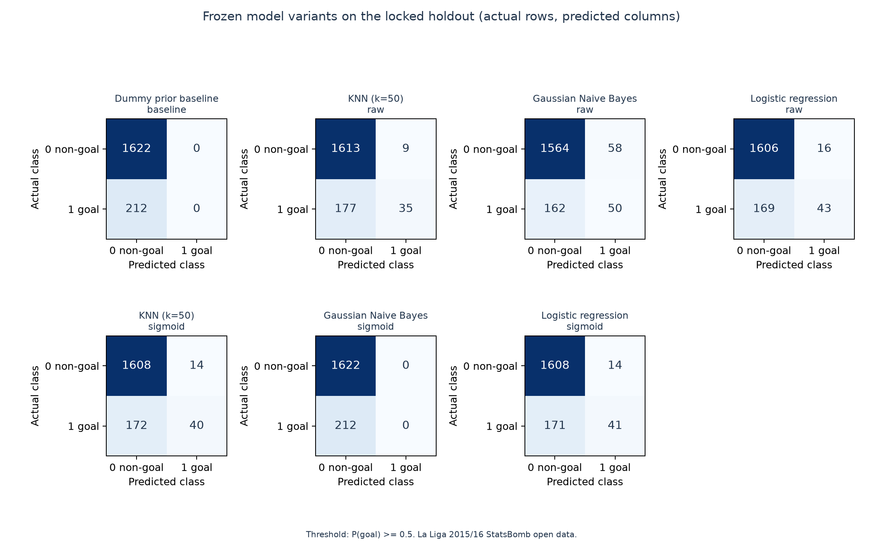
Figure 3. Exported held-out test confusion matrices for all selected sigmoid variants; analytical figures, not UI screenshots.
The all-non-goal baseline reaches 88.44% accuracy because non-goals form 88.44% of the test partition, yet it identifies no goals. KNN and logistic regression improve accuracy modestly while retaining low recall; calibrated Gaussian Naive Bayes ties the baseline and makes zero positive predictions at this threshold. Probability metrics such as log loss and Brier score, and ranking measures such as average precision and ROC-AUC, answer different questions from a thresholded confusion matrix. No one metric alone expresses the operational cost of missed goals and false alarms.
KNN held-out performance metrics
Genuine screenshot pending
Insert the original application capture here.
KNN held-out confusion matrix
Genuine screenshot pending
Insert the original application capture here.
Gaussian Naive Bayes held-out performance metrics
Genuine screenshot pending
Insert the original application capture here.
Gaussian Naive Bayes held-out confusion matrix
Genuine screenshot pending
Insert the original application capture here.
Logistic regression held-out performance metrics
Genuine screenshot pending
Insert the original application capture here.
Logistic regression held-out confusion matrix
Genuine screenshot pending
Insert the original application capture here.

CHAPTER 7: GUIDE QUESTIONS
7.1 What Is the Accuracy Precision and Recall of Each Classification Model
On the held-out test set, the selected sigmoid KNN has 89.86% accuracy, 74.07% goal precision, and 18.87% goal recall. The selected sigmoid Gaussian Naive Bayes has 88.44% accuracy, 0% goal precision, and 0% goal recall because it made zero positive predictions at the fixed threshold. The selected sigmoid logistic regression has 89.91% accuracy, 74.55% precision, and 19.34% recall. All three models are scored on the same 1,834 shots, including 212 goal shots. The prior baseline reaches 88.44% accuracy but finds no goals, so its goal precision and recall are both zero.
Model | Training |  |  | 80/20 Test |  |  | 10-fold OOF
Model | Accuracy | Goal  precision | Goal  recall | Accuracy | Goal  precision | Goal  recall | Accuracy | Goal  precision | Goal  recall
KNN sigmoid | 89.9 | 64.8 | 17.0 | 89.9 | 74.1 | 18.9 | 89.8 | 62.4 | 16.0
Gaussian NB | 89.1 | 0.0 | 0.0 | 88.4 | 0.0 | 0.0 | 89.1 | 0.0 | 0.0
Logistic Reg. | 90.2 | 67.8 | 19.5 | 89.9 | 74.5 | 19.3 | 90.2 | 68.9 | 19.3
Prior baseline | 89.1 | 0.0 | 0.0 | 88.4 | 0.0 | 0.0 | 89.1 | 0.0 | 0.0

Table 7.1. Accuracy, Goal precision, and Goal recall (%) for all three evaluation scopes.
Training resubstitution and ten-fold pooled OOF results are shown independently in Chapter 4 and in the saved result tables. The training values evaluate models on data used in fitting and can be optimistic. The OOF values are development estimates in which each shot is predicted by a model that excluded its match. The held-out test column is the final evaluation and was not used to choose the variants. Table 7.1 answers the assignment's requested comparison with the test scope clearly identified.
7.2 What Insights Can Be Derived From the Accuracy Precision and Recall Scores
The test goal prevalence is 11.56%, so an all-non-goal prediction already achieves 88.44% accuracy. The selected models' accuracy values near 90% therefore must be interpreted against that majority-class reference. KNN and logistic regression have relatively high precision, but they predict only 54 and 55 test shots as goals, respectively. Their recall remains below 20%, meaning that they miss more than four out of five actual goal shots. Gaussian Naive Bayes has non-zero ranking performance but does not cross the fixed threshold for any test shot, illustrating that probability ranking and thresholded class decisions are distinct.
Logistic regression has the lowest test log loss among the three selected variants, while average precision and ROC-AUC provide additional views of ranking. Those test statistics are descriptive for the frozen models on one historical season; they are not a guarantee of performance on another league or future season. A practical deployment would need a decision threshold linked to the cost of a missed goal versus a false alert, but this project did not tune such a threshold on test data. The OOF scores inform model development, whereas the test results provide the final held-out comparison.
7.3 In the Context of This Dataset Which Metric Is More Significant to Interpret With
Recall is significant when the objective is to identify as many eventual goals as possible, because it measures the share of actual goals that the classifier flags. Precision must be considered alongside recall because a model can achieve high precision by issuing very few positive predictions. Accuracy alone is less informative here because non-goal shots are the majority class. Log loss is also useful for this xG-oriented project because it evaluates probability quality and penalizes confident errors, while Brier score gives a squared-error measure on probabilities. The more relevant metric depends on whether a user values goal coverage, fewer false alarms, or reliable shot probabilities; the report therefore presents several metrics rather than claiming one universally best measure.
7.4 By Analyzing the Data What Factors Can Contribute in Getting a Label That the Data Considers Negative
A negative label means that a recorded shot had a recognized non-goal outcome, such as a block, an off-target attempt, a save, or a shot hitting the post. Distance and angle describe the shot's geometry relative to the goal. In the training-only analysis, 100 of 214 shots from 0 to 6 StatsBomb distance units were goals, a 46.73% goal rate, while 46 of 1,980 shots from 24 to 36 units were goals, a 2.32% rate. In the narrowest angle bin from 0 to pi/6 radians, 308 of 5,308 shots were goals, a 5.80% rate. These descriptive associations do not show that changing distance or angle alone causes an outcome, because defensive pressure, goalkeeper position, shot placement, and which attempts are taken also matter.
Body part and technique can influence execution, and the play pattern records how the attack developed. The under-pressure, first-time, and open-goal fields add context only when the provider flagged them; an unflagged value is not reliable proof that the condition did not occur. A shot can be negative for several interacting reasons, and the nine-feature model does not capture all defender and goalkeeper locations. These geometry rates come from the training partition only, preserving the held-out set for final model evaluation. The response describes associations in this dataset rather than causal effects or universal football rules.
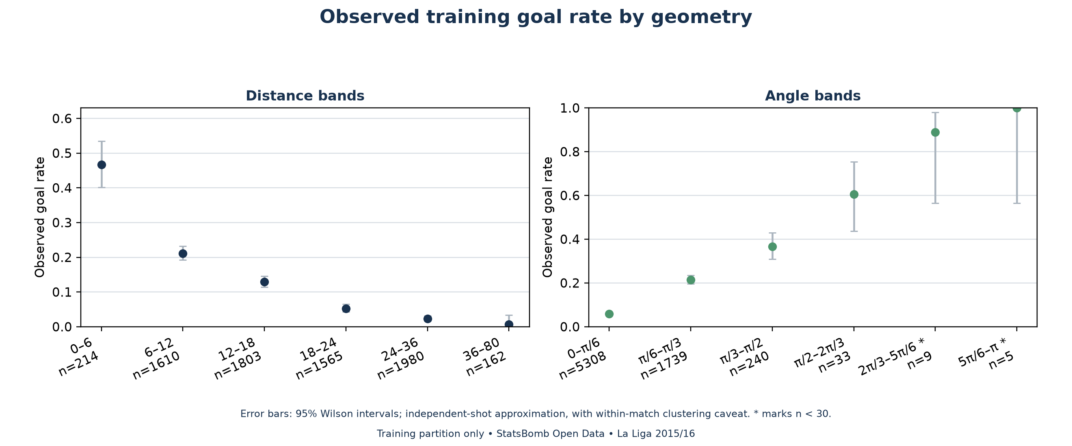
Figure 4. Training-only goal rates across distance and angle bins with sample counts; descriptive association, not causation.

REFERENCES
[1] CS.412 Data Mining Final Project. Course assignment supplied for this project. Requirements include at least two models, an 80/20 training and testing split, ten-fold cross-validation, performance metrics, test confusion matrices, and four guide questions.
[2] StatsBomb. StatsBomb Open Data, pinned repository revision 4b73468fc5b0f1950f9f66fada70ad3a4f9327cb. https://github.com/hudl/open-data/tree/4b73468fc5b0f1950f9f66fada70ad3a4f9327cb.
[3] StatsBomb. StatsBomb Open Data Specification v1.1, Appendix 2, page 34, at the pinned revision. https://raw.githubusercontent.com/hudl/open-data/4b73468fc5b0f1950f9f66fada70ad3a4f9327cb/doc/StatsBomb%20Open%20Data%20Specification%20v1.1.pdf.
[4] scikit-learn developers. scikit-learn user guide and API documentation for preprocessing, grouped model selection, classification metrics, and sigmoid calibration. The project records library versions in its frozen reports and protocols.
The project source files, pinned acquisition manifest, feature contract, split membership, cross-validation map, protocols, saved estimators, and result tables are preserved in the project directories. Reproduction commands are listed in the README and phase walkthroughs. The official StatsBomb source credit and logo should accompany any public distribution of the analysis.

APPENDIX A: CALIBRATION COMPARISON
The calibration extension compared raw and sigmoid-calibrated versions of KNN, Gaussian Naive Bayes, and logistic regression using nested training-only OOF log loss. The family selection chose sigmoid for all three model families. KNN's pooled training OOF log loss changed from 0.3674 raw to 0.2907 sigmoid. Gaussian Naive Bayes changed from 1.2973 to 0.3235, while logistic regression changed only slightly from 0.2747 to 0.2747 after rounding. Among the family choices, logistic regression had the lowest development OOF log loss and was selected as the global simulation candidate before test results were accessed.
Family | Raw test log loss | Sigmoid test log loss | Raw Brier | Sigmoid Brier
KNN | 0.3728 | 0.2906 | 0.0829 | 0.0829
Gaussian NB | 1.2176 | 0.3318 | 0.1165 | 0.0942
Logistic regression | 0.2768 | 0.2770 | 0.0805 | 0.0805

Table A.1. Frozen raw and sigmoid test scores, reported after the choices were fixed.
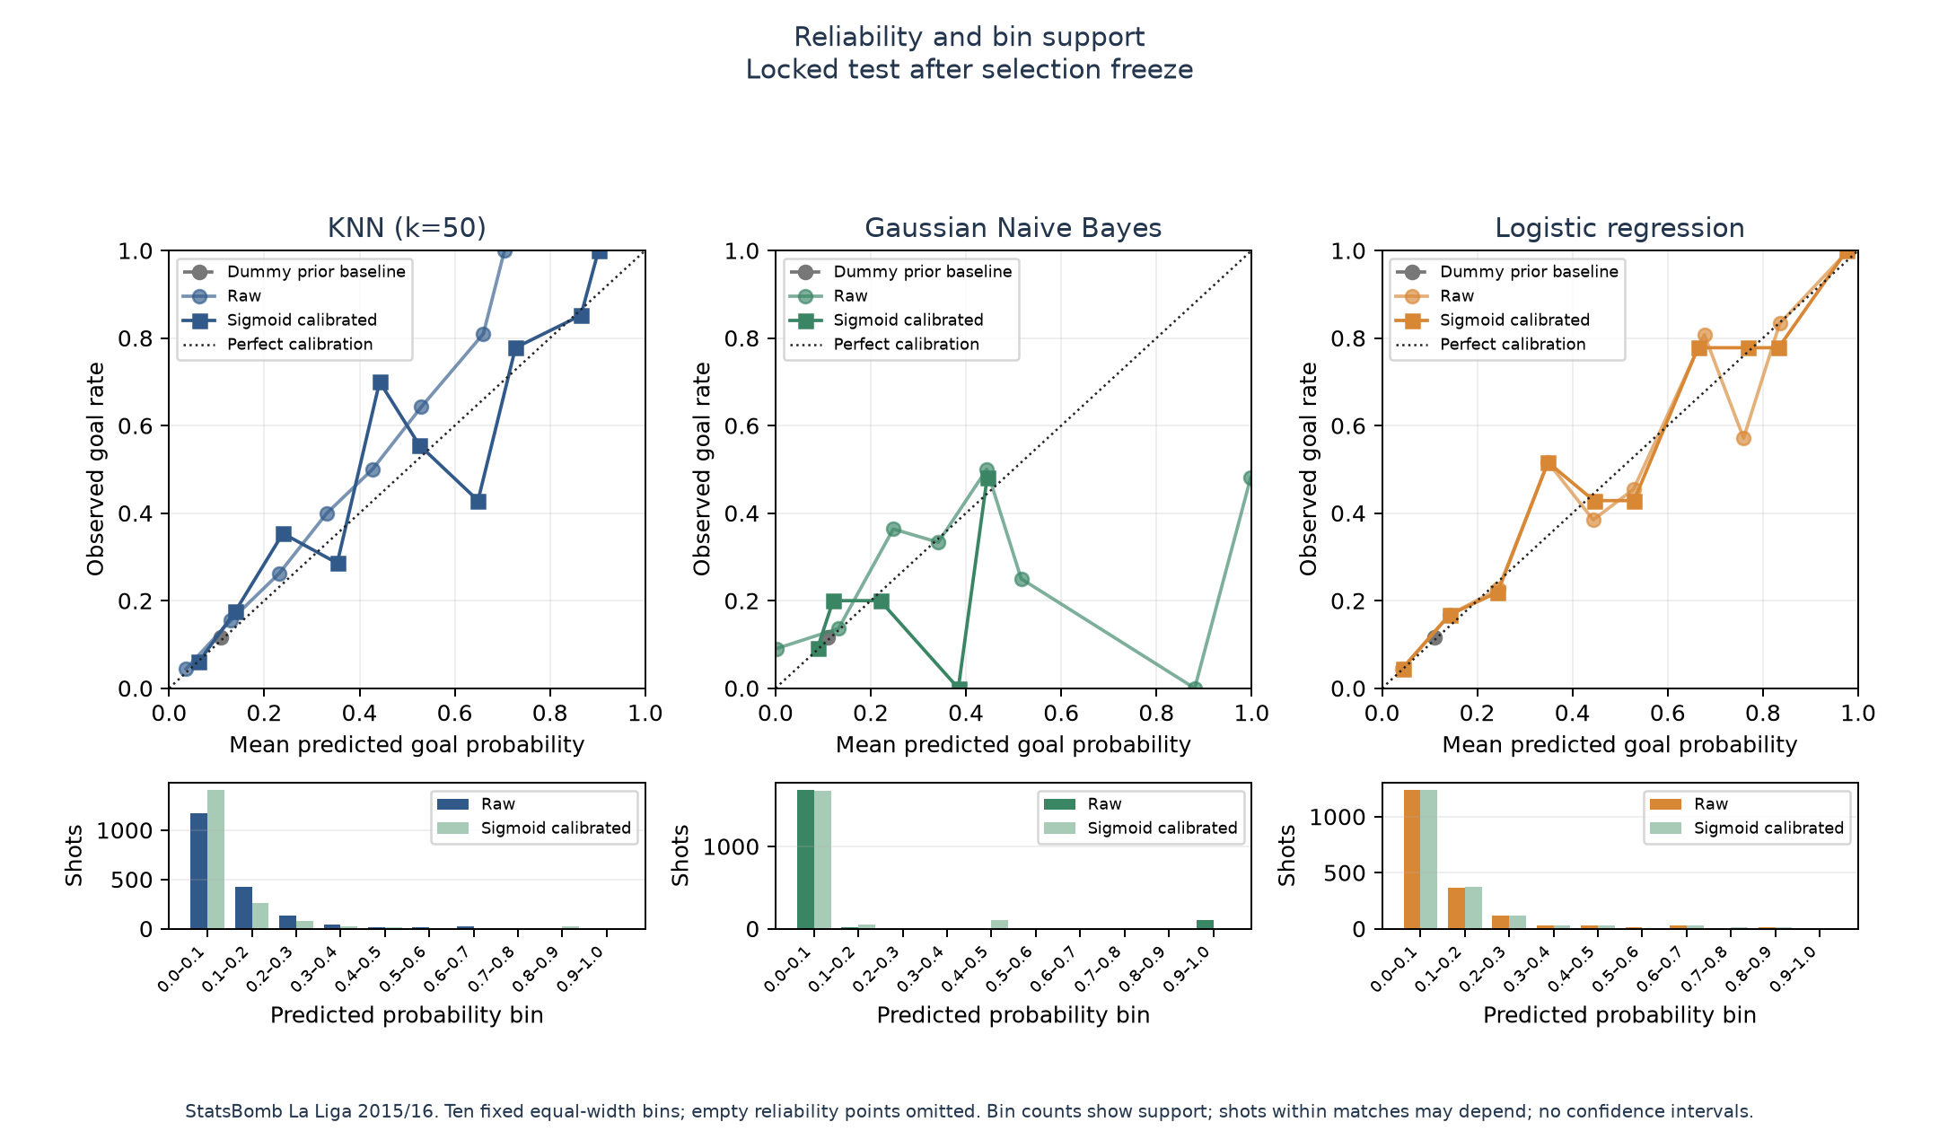
Figure A.1. Held-out reliability curves for the frozen raw and sigmoid variants.
Calibration does not guarantee correct probabilities for future data. The held-out reliability results are descriptive and were not used to revise the selection. Since the variant choices were made using training-only nested OOF results, raw and selected test columns should be interpreted as a frozen comparison rather than a new tuning exercise.

APPENDIX B: MONTE CARLO SIMULATION
The simulation applies the frozen global candidate, sigmoid logistic regression, to the observed shots in the 76 held-out matches. For each shot, it samples an independent Bernoulli outcome using the saved predicted probability and sums those outcomes by team. The implementation runs 100,000 trials per match with seed 42, separate random streams by match and side, and 10,000-trial chunks. For validation, it computes exact Poisson-binomial distributions by convolving the shot-level probabilities; this is not a Poisson approximation based on summed xG.
Across these held-out fixtures, official scores total 134 home and 84 away goals. Goal-labelled shots account for 131 home and 81 away goals; three additional goals for each side are reconciled as opponent own-goal credits. The primary simulation samples shot goals only and does not sample or add own goals. Simulated goal totals therefore describe the observed shot set under the model probabilities, not a reconstruction of every official score. Monte Carlo standard errors quantify finite simulation noise conditional on fixed probabilities and do not include model uncertainty.
The simulation is retrospective and conditional on shots that actually occurred. It does not let an early simulated goal change later tactics, attempts, or player decisions. The 76 fixtures are not a complete season, so the project does not simulate a league table. Results should not be described as a pre-match forecast or as the probability that a team would have won before kickoff.
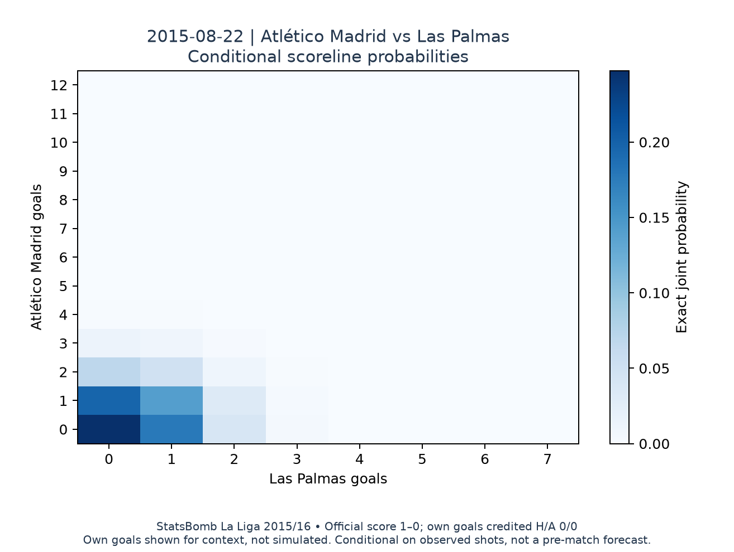
Figure B.1. Exact conditional joint scoreline probabilities for the preselected earliest test match; full support shown.
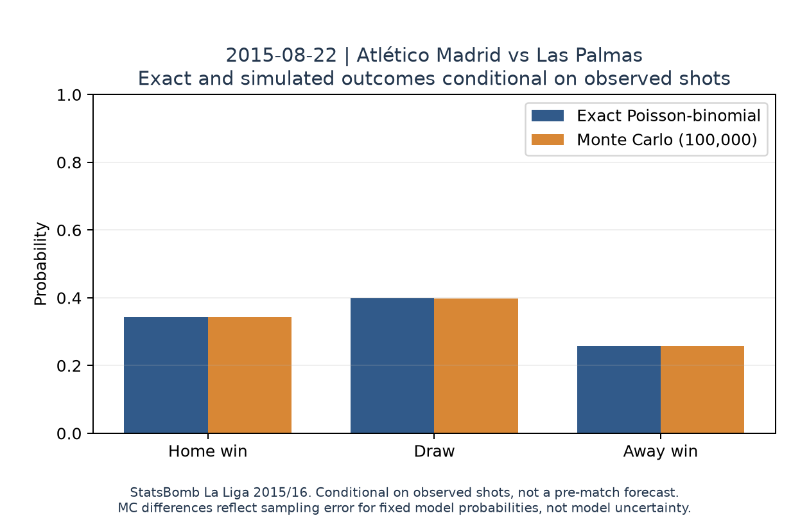
Figure B.2. Exact and Monte Carlo home, draw, and away probabilities for the same test fixture.
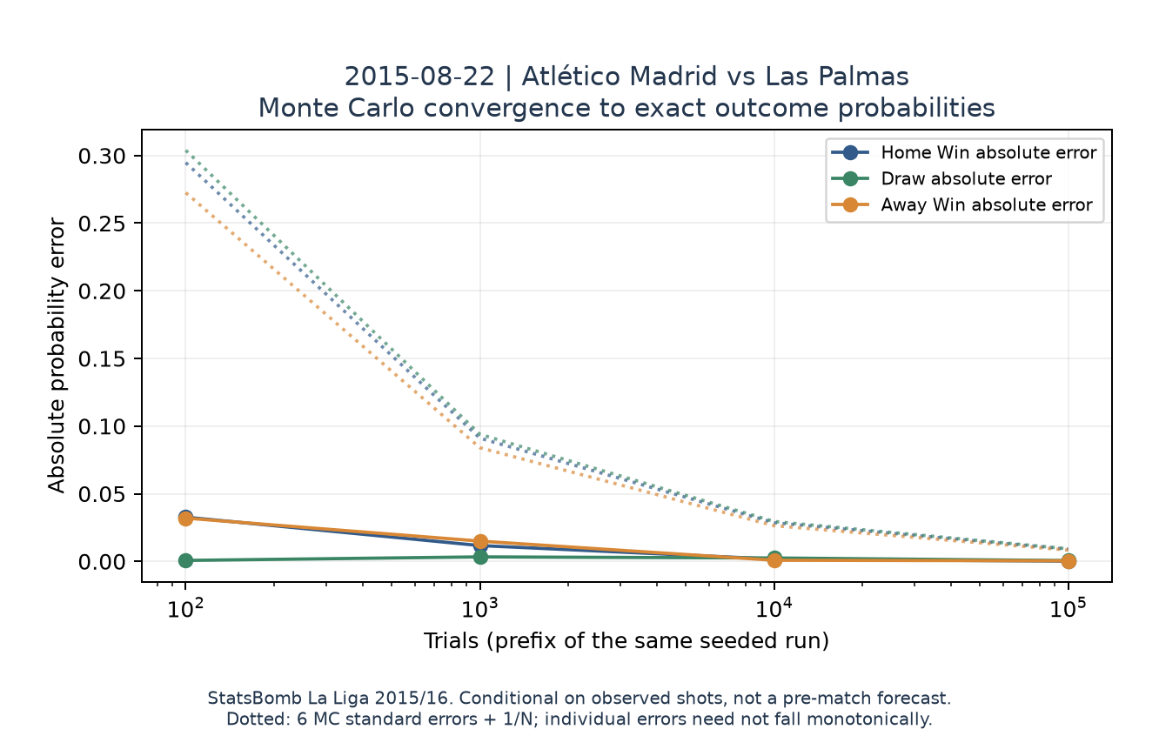
Figure B.3. Prefix convergence for one preselected match; sampling error is conditional on fixed model probabilities.
The archived Phase 9 summary contains 76 held-out matches and the fixed trial count of 100,000 per fixture. Exact and Monte Carlo outcome probabilities are compared match by match, and outcome counts sum to the trial total. These checks validate the simulation calculation under its independent-shot assumptions; they do not establish the football model's validity beyond this dataset.

APPENDIX C: EL CLASICO OOF CASE STUDY
The portfolio case study examines Real Madrid 0–4 Barcelona on 21 November 2015 and Barcelona 1–2 Real Madrid on 2 April 2016. Their probabilities come from saved outer-fold OOF predictions for the frozen sigmoid logistic-regression candidate. Each match was excluded from fitting and calibration in its own outer validation fold. Both fixtures belong to the training partition and are outside the held-out test partition. The chosen model family was selected using development results, so these examples are not independent test evidence.
Date | Official score | OOF fold | P home win | P draw | P away win
2015-11-21 | Real Madrid 0-4 Barcelona | 2 | 9.2% | 14.2% | 76.6%
2016-04-02 | Barcelona 1-2 Real Madrid | 7 | 20.5% | 25.9% | 53.6%

Table C.1. Exact outcomes for the two predeclared El Clasico development cases.
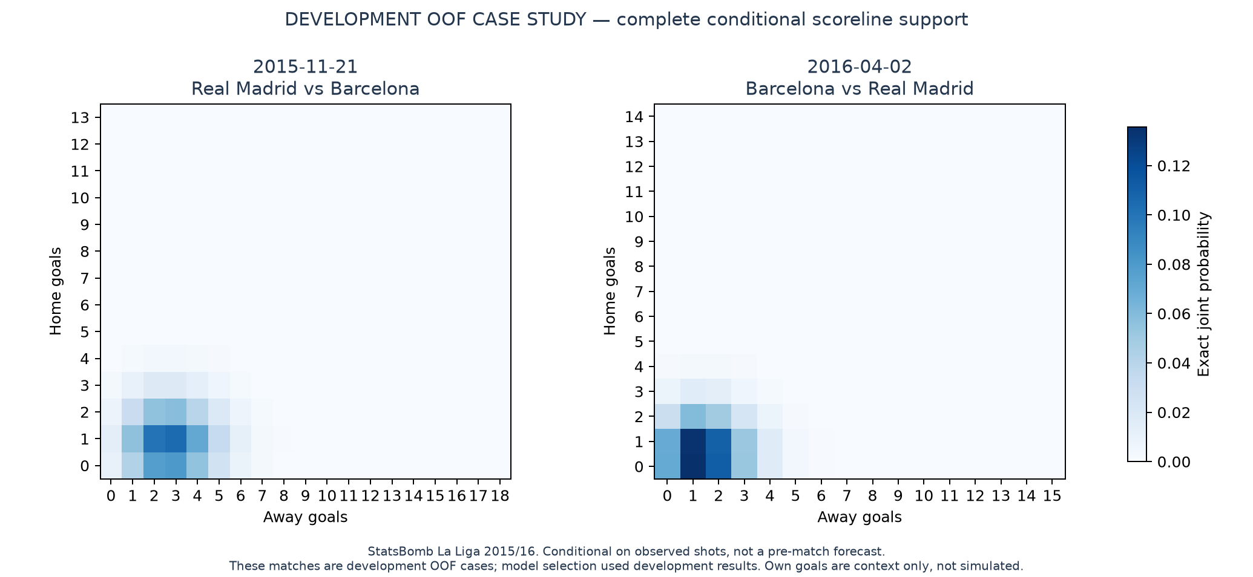
Figure C.1. Exact complete scoreline supports for the two development OOF cases; conditional on observed shots, not a forecast.
For the November fixture, the exact conditional probabilities are approximately 9.2% home win, 14.2% draw, and 76.6% away win. For the April fixture, the corresponding probabilities are approximately 20.5%, 25.9%, and 53.6%. These are conditional on the shots recorded during the match and exclude own goals from the scoreline simulation. The cases demonstrate a reusable analysis of familiar fixtures while preserving the held-out test set as the final independent evaluation within the chosen season.

