# A4: Conceptual Data Model - LearnIt (Q&A)

A Conceptual Domain Model contains the identification and description of the entities of the domain and the relationships between them in an UML class diagram. For each class, its attributes, associations (with respective multiplicity) and constraints are specified. There can also be additional business rules present in the UML, e.g. as notes. Below is the UML class diagram for the **LearnIt** system.

## Class Diagram

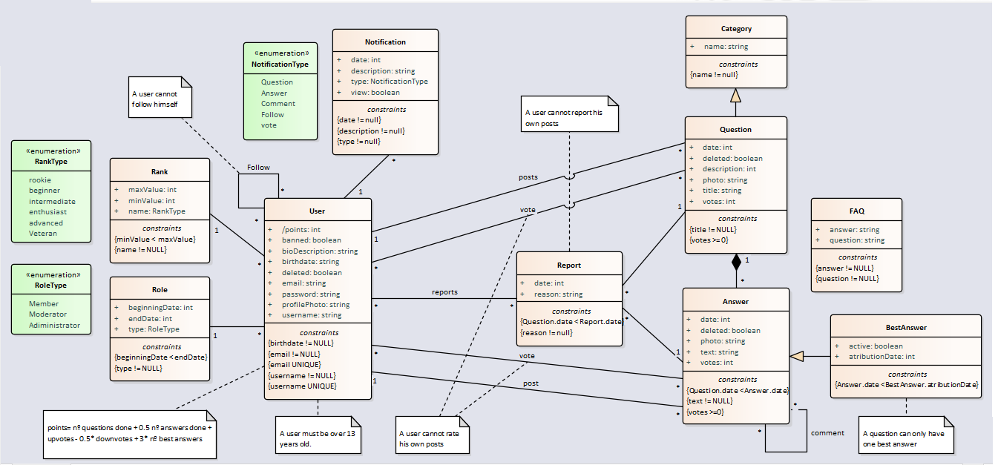

**Figure 1:** UML class diagram.

## Group1834:

* João Augusto dos Santos Lima, up201605314@fe.up.pt
* José Diogo da Cunha Moreira Trindade Martins, up201504761@fe.up.pt
* Juliana Maria Cruz Marques, up201605568@fe.up.pt
* Leonor Ribeiro e Sousa Mendes de Freitas, up201207603@fe.up.pt