A REVIEW OF PARTICLE AGGLOMERATION

Prepared for

US Department of Energy

April 2001

Prepared by | Elizabeth Allen, Paul Smith, Jim Henshaw | Customer Approval
Date | 4/25/01 | Date
Approved by | Mark Morgan
Date | 11/25/01

AEA TECHNOLOGY ENGINEERING SERVICES, INC  1301 Moran Road, Suite 202  Sterling, VA 20166  (703) 433 - 0720 |  | AEA TECHNOLOGY plc  A32, Winfrith  Dorchester, Dorset  DT2 8DH

A Review of Particle Agglomeration
Elizabeth Allen
Jim Henshaw
Paul Smith
April 2001

Title | A Review of Particle Agglomeration
Customer | US DOE
Customer reference
Confidentiality, copyright and reproduction | These data are submitted with limited rights under Government Contract Number DE-GI01-00EW56054. These data may be reproduced and used by the Government with the express limitation that they will not, without written permission of the Contractor, be used for purposes of manufacture nor disclosed outside the Government; except that the Government may disclose these data outside the government provided that the Government makes such disclosure subject to prohibition against further use and disclosure.
File reference | j:/pssd/projects2000-2001/agglomeration/
Report number | AEAT/R/PSEG/0398
Report status | Issue 1
AEA Technology plc
A32, Winfrith
Dorchester
Dorset
DT2 8DH

Telephone +44(0)1305-202107
Facsimile +44(0)1305-202508
AEA Technology is the trading name of AEA Technology plc
AEA Technology is certificated to BS EN ISO9001:(1994)

 | Name | Signature | Date
Author | Elizabeth Allen  Paul Smith
Reviewed by | Jim Henshaw
Approved by

Executive Summary
A review of particle agglomeration – prompted by the need to understand and control tank waste remediation processes – is presented. A wide range of literature of relevance to agglomeration of colloid particles has been reviewed.

The aerosol literature provides models for agglomeration of electrically neutral, spherical particles. The main processes involved are: Brownian motion, gravitational settling and turbulence. Established models are available for Brownian and gravitational agglomeration. A model is also available for turbulent agglomeration, which should provide reasonable, order-of-magnitude estimates of the effect in many circumstances, but is subject to greater uncertainty than the Brownian and gravitational models.

Few theoretical results are available for agglomeration of non-spherical particles and consequently more reliance must be placed on experimental results. Experimental shape factors (ratio of collisional efficiency of non-spherical particles to that of volume equivalent spheres) are available for chain-like agglomerates that form due to diffusion-limited aggregation. They cover a range of values from 1 to 16.

Calculations of Brownian and gravitational agglomeration of charged spheres are reported. Some experimental validation of models is available. The electrical charging of the particles is found to have a significant effect on the predicted agglomeration rates.

The theory of agglomerate break-up due to Means is presented. This predicts an upper limit on the size to which agglomerates can grow before being broken up by turbulent eddies or boundary layers. The theory needs to be generalised to non-spherical agglomerates and should be experimentally validated.

Methods for estimating the charging of colloid particles in aqueous solutions, as a function of pH and ionic strength, are discussed. Several examples of charge calculations are presented for simple chemical systems. The models contain parameters that can be adjusted to fit experimental data. More complicated reaction systems can occur for oxides in water and consequently it is important to understand the chemical system and identify the reactions which are significant to the charging of the colloid particles.

An overview of the DLVO theory of colloid stability is presented. This is based on the production of a potential energy which represents the competition between the attractive Van der Waals force and the repulsive electrostatic force between particles. The charging of colloid particles results in the formation of a layer of opposite charge in the fluid adjacent to the particle – the so-called diffuse electrical double layer – which partly screens the charge on the particle. At low ionic strengths the double layer extends beyond the range of the Van der Waals force. The resulting electrical repulsion between the particles prevents agglomeration, unless the particle is nearly electrically neutral (which depends on the pH). At high ionic strengths the double layer shrinks in size and the net force is always attractive. Hence, at high ionic strengths agglomeration always occurs.

Other effects that may effect agglomeration, or cause break up of agglomerates, such as temperature, mixing, passage through pumps, sound waves, are briefly discussed. However, quantitative information on these topics is limited.

Contents
1 Introduction 3
2 Issues and Importance of Agglomeration 3
3 Agglomeration Mechanisms 4
3.1 Brownian Agglomeration 5
3.2 Gravitational Agglomeration 7
3.2.1 Shape Factors for Gravitational Agglomeration 9
3.3 TURBULENT AGGLOMERATION 10
3.4 ELECTROSTATIC (DLVO THEORY) AGGLOMERATION 11
3.4.1 DLVO Theory – Background 11
3.4.2 DLVO Theory – Stability Modelling 13
3.4.3 DLVO Theory – Agglomeration Modelling 14
3.5 Example estimates of the effect of electrostatic charging on agglomeration rates 17
3.5.1 Brownian Agglomeration 17
3.5.2 Gravitational Agglomeration 18
3.5.3 Brownian, Inertial Impaction and Phoretic Agglomeration 19
3.6 Break-up of agglomerates 20
4 Charge on a Particle 23
4.1 colloid charging in aqueous systems 23
4.1.1 Gouy-Chapman Model with Mass Action Law 25
4.1.1.1 Mono-Protic Acid Group Surfaces 26
4.1.1.2 Surfaces with Two Independent Acid Groups 27
4.1.1.3 Amphoteric Surfaces 27
4.1.1.4 Surfaces with Two Kinds of Adsorbing Sites 29
4.1.2 The Inclusion of Stern layers 30
4.1.2.1 Zeroth Order Stern Model 30
4.1.2.2 The Stern Layer 31
4.1.2.3 Site Binding of Counter Ions 31
4.1.3 More Detailed Chemistry 32
4.2 Measuring colloid charge 32
5 Effects on Agglomeration 34
5.1 Effect of pH and Ionic Strength 34
5.2 Effect of OTHER PROCESSING CONDITIONS AND PARTICLE PROPERTIES 38
6 Conclusions 40
7 Acknowledgements 41
8 References 42

Appendix 1 Analysis of Experimental Conditions

Introduction
This report presents a review of particle agglomeration. The review was prompted by the need to understand and control tank waste remediation processes. The main issues giving rise to the review are reproduced in Section 2. Agglomeration mechanisms are discussed in Section 3. Electrical charging of particles is discussed in Section 4. Agglomeration arising from the competing attractive van der Waals forces and repulsive electrostatic forces (DLVO theory) is discussed, together with Brownian, gravitational and turbulent agglomeration mechanisms. The influence of pH, ionic strength and other processing conditions, such as heating and mixing, on agglomeration is addressed in Section 5. Conclusions are presented in Section 6.

In addition to the range of papers, dealing with particle agglomeration, already known to the authors, references suggested by Dr JR Jewett (Jewett, 2000) were obtained and reviewed, as were (subject to the time available) a selection of the most relevant papers arising from a search of the International Nuclear Information System (INIS) Database (IAEA, 1998).

Issues and Importance of Agglomeration
Particle agglomeration, and an understanding of agglomeration mechanisms, is important in a wide range of processes and applications. The current review was prompted by the need to understand and control particle agglomeration in tank waste remediation processes. The main issues involved are reproduced below.

Steps involved in tank waste remediation processes include (Rector and Bunker, 1995) sluicing to create waste suspensions, transporting the suspensions via pumping to central processing facilities, washing and leaching, and separating particles from supernatant liquids to form high and low level waste streams. High solid loadings are desirable for retrieval and transport to minimise waste volumes. However, this can result in the formation of viscous gels which cannot be pumped. High solid loadings are also desirable in settle-decant operations to minimise contaminants entrapped in interstitial liquids and to maximise use of the limited available processing volumes. Rapid sedimentation velocities are also desired to allow solid liquid separations within reasonable time frames. Laboratory experiments have, however, indicated negligible sedimentation velocities in certain circumstances. Furthermore, processes involve a wide range of compositions, particle types and solution chemistries. Despite these complexities, indications are that the observed behaviour can be predicted, understood, and perhaps ultimately controlled, via an understanding of the key concepts related to the formation of, and interactions between, colloidal aggregates.

As part of the Waste Feed Delivery Program (the transfer of nuclear waste from underground tanks at the Hanford Site to waste treatment and immobilisation plant) an engineering analysis (RPP-5346) was performed to determine the adequacy of the waste transfer system. The velocity of the waste required to suspend and transport the solid fraction of the waste – the “critical velocity” – was determined for each anticipated transfer. The pipeline pressure required to achieve the critical velocity was also determined. Uncertainties in the particle size distribution resulted in estimates for required pipeline pressures that greatly exceeded the design limits. The velocity and pipeline pressure required for transfer increase as the sizes of the particles in the waste increase. Results of work to address the particle size uncertainty are reported in Jewett et al, 2000b. The statistical analysis performed provided a bounding value for the median particle size suitable for use as a design basis for the waste transfer system. Unresolved issues remained, however, including uncertainties in the extent to which agglomerates would be present during transfer. Furthermore, the extent to which agglomerates will be diminished (e.g. by turbulence) and the time required for re-formation of the agglomerates are not known. The sizes of the agglomerates affect transportability of the slurry and depend greatly on the ionic strength of the solution. Reduction of such uncertainties might reduce the cost for design, construction and qualification of the waste feed delivery transfer system.

Agglomeration Mechanisms
Agglomeration is a mass-conserving, but number-reducing process that shifts the particle distribution towards larger sizes. This can have important consequences for particle (e.g. aerosol or colloid) transport as larger particles tend to settle more rapidly under gravity but diffuse more slowly. Agglomeration also reduces the particle surface area for condensation and/or chemical reaction. Accurate modelling of agglomeration is, therefore, essential for understanding and predicting particle transport.

In the absence of condensation onto particles, the evolution of the particle size distribution, n(r,t), is determined by the rate equation [Pertmer & Loyalka, 1979]:

(1)
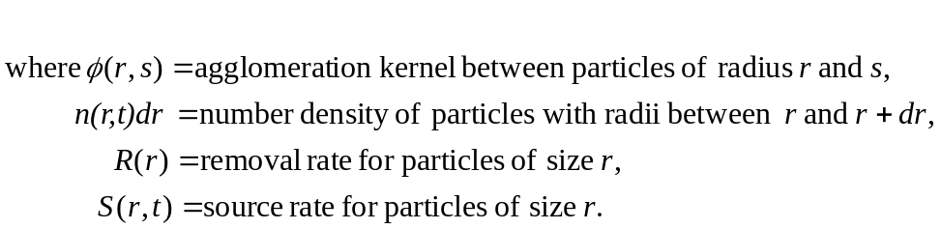

The first integral represents the creation of particles of radius r by agglomeration of particles of radius s (<r) with particles of radius r-s. The second integral gives the removal rate of particles of radius r by agglomeration with particles of any size. The third term on the right-hand-side represents the removal of particles by deposition mechanisms, such as gravitational settling, Brownian diffusion to walls etc. The final term is the source rate of particles of size r.

The agglomeration kernel, φ(r_{i}, r_{j}), expresses the rate at which particles of radius r_{i} agglomerate with particles of radius r_{j}. Agglomeration of a particle of radius r_{i} with a particle of radius r_{j} leads to an increase in the number of particles with a mean radius of (r_{i}³ + r_{j}³)^{1/3} and a decrease in the number of particles with radius r_{i} or r_{j}. An appropriate radius for the (non-spherical) particle formed by agglomeration is generally accounted for through the use of shape factors discussed below.

Experimental data on agglomeration are sparse and always involve more than one process, so that the validation of individual processes is not possible. The individual agglomeration kernels are often combined non-linearly, though there is no obvious consensus on this in the literature. For example, although an independent peer review of the fission product transport code, VICTORIA (Mubayi et al, 1997), considered that the basic elements of the agglomeration model (Brownian, gravitational and turbulent agglomeration) were sound, it was noted that the model did not provide an integrated assessment of competing rates. Such an assessment would involve changes to the basic code structure and approach. It was considered (Mubayi et al, 1997) that the current lack of integration was probably not a serious concern.

Brownian Agglomeration

Brownian motion – first studied by Robert Brown in the 19th century – refers to the continuous random movement (or diffusion) of particles suspended in a fluid. Brownian agglomeration occurs when, as a result of their random motion, particles collide and stick together. Brownian agglomeration is probably the best understood of the agglomeration mechanisms. It has been treated by several authors and extensive reviews have been made, e.g. Fuchs, 1964; Hidy and Brock, 1971-1973; Davies, 1966; Loyalka, 1976; and Twomey, 1977.

Brownian agglomeration was first calculated by Smoluchowski, 1916. He derived the following expression - from Brownian diffusion theory – for the Brownian agglomeration kernel, Φ_{B} (Perkins):

φ_{B}(r_{i}, r_{j}) = 4πk_{B}T_{g}β_{c}[(C_{n}(r_{i})/6πμr_{i}β_{a}) + (C_{n}(r_{i})/6πμr_{i}β_{a})](r_{i} + r_{j}) (2)

where:
k_{B} is the Boltzmann constant
T_{g} is the gas (or continuous phase) temperature
C_{n} is the Cunningham slip factor
β_{c} is a collision shape factor
μ is the dynamic viscosity
β_{a} is an aerodynamic shape factor

This model is used by the nuclear reactor safety assessment code, TRAPMELT2 (Parozzi and Masnaghetti, 1990).

The VICTORIA code (Heames et al, 1992) – which models the transport of fission products in the primary circuit of a light water nuclear reactor - also describes Brownian motion in the classic fashion, outlined above, but uses a more complicated multiplication factor for the Fuchs’s collision efficiency (Fuchs, 1989). As mentioned above, an independent peer review of the VICTORIA code (Mubayi et al, 1997), considered that the basic elements of the agglomeration model (Brownian, gravitational and turbulent agglomeration) were sound, but noted that the model did not provide an integrated assessment of competing rates.

The Brownian agglomeration model in the CONTAIN code (which predicts particle behaviour in the containment of a nuclear reactor) is based on the work of Fuchs and Sutugin, 1970. An Independent peer review of the CONTAIN code (Boyack et al, 1995) considered that, for single-component, spherical particles, the model is adequate. The model is not considered adequate, however, for mixed-component particles. The Brownian agglomeration kernel in this case is given by:

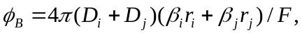 (3)

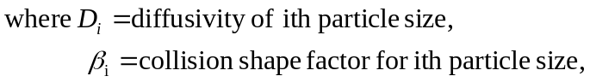

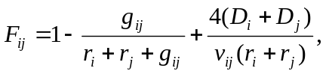 (4)

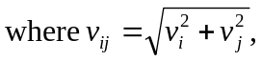 (5)
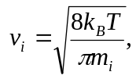 (6)

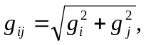 (7)

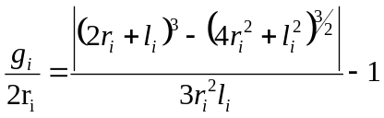 (8)

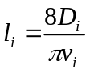 (9)

Note that if the collision shape factors are equal (β_{i} = β_{j}) and the correction factor is unity (F_{ij} = 1), the above equation reduces to the Smoluchowski kernel presented above. The collision shape factors used in CONTAIN are criticised by Loyalka for their ad-hoc nature [Boyak, 1995].

Brownian agglomeration is probably the best understood of the agglomeration mechanisms. Models such as that in Fuchs and Sutugin, 1970 are supported by independent numerical solutions of the Boltzmann equation (Loyalka, 1976).

Gravitational Agglomeration
Gravitational agglomeration occurs as a result of the size dependence of the terminal velocity of small particles. The slowly settling (generally smaller) particles are captured by the more rapidly settling (generally larger) particles. This mechanism is important for larger particles (super-micron). The gravitational agglomeration kernel φ_{G} is usually expressed as:

(10)

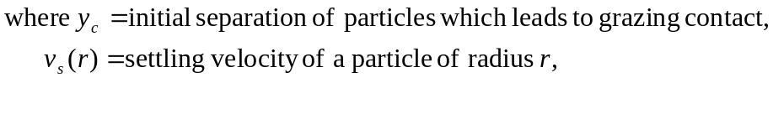

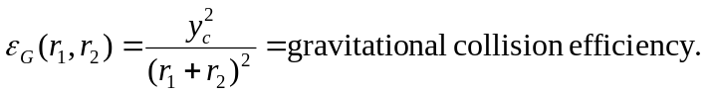 (11)
Thus the problem is reduced to the determination of the critical initial separation of the particles, which leads to grazing contact. Early attempts to estimate this parameter were based on Stokes flow around a sphere moving at its terminal velocity. It was assumed that the presence of the smaller particle had a negligible effect on the flow field around the larger particle. Based on these assumptions, Fuchs (1964) produced the following analytic expression for the gravitational collision efficiency:

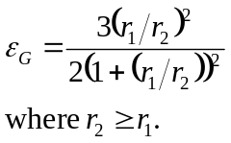 (12)

It was later noted by Pruppacher and Klett (1978) that the particle velocities should be added vectorially as they both fall through the fluid. In this case the estimated gravitational collisional efficiency is one third of that obtained by Fuchs. Comparison with more detailed calculations suggests [Klett and Davis, 1973] that the efficiency should be limited to a value of 0.05 when the colliding particles are of similar size, giving rise to the truncated Prupacher-Klett gravitational agglomeration kernel used in the AEROSIM code [Butland et. Al., 1984]:

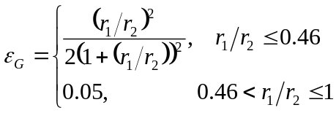 (13)

The problem with the above equations is that they predict that the collisional efficiency is a function of the relative size of the two settling particles, and does not depend on the absolute sizes of the two particles. This is contrary to the findings of more detailed investigations of gravitational collision, which suggest that the collisional efficiency is a function of the absolute sizes of the particles. Detailed numerical calculations of the motion of agglomerating particles have been undertaken by a number of workers in the field, in particular by Loyalka and co-workers. Pertmer and Loyalka, 1979 perform a numerical integration of the momentum equations:

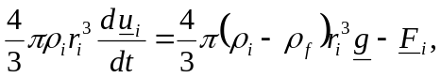 (14)

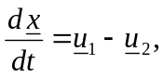 (15)
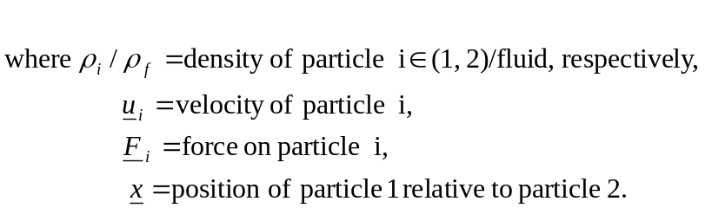

They use a number of different forms for the fluid drag force on the particles, including: Stokes, Oseen, Carrier-modified Oseen and the superposition method. The fluid acceleration is neglected (without justification) in all of the drag models used. The GCEFF (Gravitational Collision EFFiciency) code was produced, using the method of Gears to solve the stiff equation set. The authors claim that the use of the Gears method leads to more accurate solutions than obtained by previous numerical studies. Results of GCEFF calculations are found to be in reasonable agreement with similar studies in the atmospheric sciences. When the Carrier-modified Oseen drag is used, the results are found to be in agreement with reported measurements of the collection of E. Coli bacteria by water drops. The results of calculations are found to be sensitive to particle density, the absolute sizes of the particles and the choice of drag force. The use of the Carrier-modified Oseen drag is recommended, in view of the agreement obtained with measured data.

Pertmer and Loyalka, 1979, used cubic splines to interpolate between the results of the GCEFF calculations. However, the interpolated results were found to be unreliable. Buckley and Loyalka, 1990, used regression analysis to produce the following analytical fits to the gravitational collision efficiency, for different ranges of the larger particle radius, r₁:

r₁ (μm) | ε_{G} | Values of Constants
r₁ < 10 | 0.001
10 ≤ r₁ < 25 | C A^{m} | C = 0.154, m = 1.22
25 ≤ r₁ < 40 | α + βe^{γ/A} | α = -0.370, β = 1.24, γ = 0.110
40 ≤ r₁ ≤ 100 | α + βe^{γ/A} | α = -1.75, β = 2.80, γ = 0.020
r₁ > 100 | 1.0
A = r₂/r₁ = ratio of smaller particle radius to larger particle radius.

The above fit to the results of GCEFF calculations is generally accurate to within 20%.

Due to the difficulty in eliminating other effects, separate effects data are hard to come by. The data of Tu and Shaw, 1977, provide valuable validation of methods, as discussed above. There are some data available for the validation of gravitational agglomeration kernels (Terril et al, 1981), which may be regarded as reasonably well established. Haley et. al., 1991, performed experiments on the gravitational collision efficiency, but their results are inconclusive. They conclude that further experimental work is required on this topic.

Shape Factors for Gravitational Agglomeration

If the particles involved are non-spherical, it is to be expected that the gravitational collision efficiency will differ from the value appropriate to volume equivalent spheres. In such cases, the ratio of the actual gravitational collision efficiency to that of a pair of volume equivalent spheres is known as the gravitational collision shape factor.

Tuttle and Loyalka, 1981, have modified the GCEFF code to allow the particles to be an oblate spheroids. The resulting code is termed NGCEFF (Non-spherical Gravitational Collision EFFiciency). The superposition method must be used to estimate the drag for non-spherical particles. They report results for the gravitational collection of spheres by an oblate spheroid. For the collection of water droplets in air, by a collector which has a semi-major axis of 115.7 μm and axes ratio of 0.05, they find that the gravitational collision shape factor decreases smoothly from 4.259 to 4.061, as the radius of the droplets increases from 1.29 μm to 2.02 μm.

This work is extended in Tuttle and Loyalka, 1985 I-III. Particle rotation is neglected in the study. It is claimed that useful results are obtained for those situations in which the fluid flow field around the particles can be calculated and the mass ratio of the particles is less than 0.05. The methodology of Pitter and Prupacher, 1974, is followed. The results are presented in part III of Tuttle and Loyalka, which did not arrive in time to be included in the review. However, the results are reported to be similar to those of Pitter and Prupacher. They find that, for a 160 μm oblate spheroid collector, with axes ratio of 0.5, all spherical particles with initial trajectory offsets lying between y_{min} and y_{c} are intercepted by the collector. For spheres with radii between approximately 13μm and 20 μm, y_{min} is found to be greater than zero.

Tuttle and Loyalka, 1985 I, also note some experimental data on shape factors. Jordan and Gieseke, 1978, measured the gravitational collision shape factor for “fractal” agglomerates of sodium particles and obtained values around 3. Kops et. al, 1975, Van de Vate et. al., 1980 and Wegrzyn and Shaw, 1978 & 1979 measured the gravitational collision efficiency for chain-like agglomerates of metal oxide particles. They obtained values between 1 and 16.

TURBULENT AGGLOMERATION
Saffman and Turner, 1956, sub-divide turbulent agglomeration into 2 processes: turbulent shear agglomeration and turbulent inertial agglomeration.

Turbulent shear can cause particles following flow pathlines to collide with one another. This occurs because particles on different streamlines are travelling at different speeds. Turbulent shear agglomeration is a result of this effect. The model of Saffman and Turner is used in many aerosol codes, e.g. in the fission product transport code, VICTORIA (Bixler, 1998) the agglomeration rate, φ_{s}, of particles of radius r₁ with particles of radius r₂ is estimated from the following:

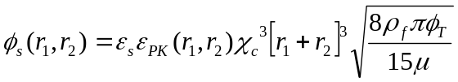 (16)

Where:
ε_{s} is the dimensionless particle to particle sticking efficiency
ε_{PK} is the dimensionless collision efficiency correction factor
χ_{C} is the dimensionless collisional shape factor
ρ_{f} is the fluid density
μ is the fluid dynamic viscosity
φ_{T} is the turbulent energy dissipation rate per unit mass which is given (Deliachasios and Probstein, 1974) by:

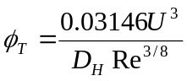 (17)

Where:
U is the fluid speed
D_{H} is the hydraulic diameter
Re is the Reynolds number

Turbulent inertial agglomeration results when particle trajectories depart from flow streamlines and such departures cause collisions. As for turbulent shear agglomeration, the model of Saffman and Turner for turbulent inertial agglomeration is used in many aerosol codes. The agglomeration kernel, φ_{I} of particles of radius r₁ with particles of radius r₂ is estimated from the following:

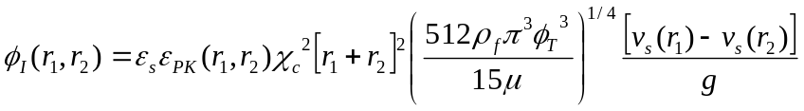 (18)

Where:
v_{s}(r) is the gravitational settling velocity of a particle of radius r.

Turbulence modelling is still beset with difficulties and consequently this is the least well understood of the agglomeration processes (Smith et al, 1999). The model of Saffman and Turner is unvalidated, but is expected to provide reasonable, order of magnitude estimates of the process over a wide range of conditions. This agglomeration process is important in turbulent flows with high energy density dissipation rates.

ELECTROSTATIC (DLVO THEORY) AGGLOMERATION

DLVO Theory – Background

In a colloidal system, consisting of a large number of small particles in a suspending fluid, particles will collide with one another in the course of their Brownian motion. In such a collision, the particles may be so attracted to one another that they stick together. The newly formed “doublet” will move more slowly than the individual particles, but may stick to other particles it encounters. The aggregate may continue to grow, becoming less mobile, until it settles. Individual particles can only remain in such systems if there is some mechanism to prevent them from sticking together when they collide with one another. The system is then said to be colloidally stable. One way of producing stability is to give the particles an electric charge (either positive or negative); if all particles have the same charge, they will repel one another on close approach. This is known as “electrostatic stabilisation”. A system is colloidally unstable if collisions lead to the formation of aggregates (coagulation or flocculation). Since, when a system changes from being stable to unstable, most of its properties e.g. settling, filtration and flow behaviour change, the control of colloid stability is of great interest.

Most colloidal particles are electrically charged e.g. most metal oxides have a surface layer of the metal hydroxide which is amphoteric and can become either positively or negatively charged, by taking up a proton or by proton abstraction, depending on the pH:

M-OH + H⁺ → MOH₂⁺ (19)
M-OH + OH⁻ → M-O⁻ + H₂O (20)

The particular pH at which the positive and negative charges are balanced, so there is no net charge on the colloid, is called the point of zero charge (pzc).

When solid particles are immersed in a fluid, there is a tendency for ions of one sign to be preferentially adsorbed onto the solid and for the oppositely charged ions to remain in the neighbouring fluid. The net charge, and hence the electrostatic potential on the particle surface, relative to the surrounding fluid, is strongly dependent on the balance between the positive and negative ions – the potential-determing ions – in the solution. For the oxide systems, and many other colloids, the H⁺ and OH⁻ ions are the potential-determining ions. In such systems, the surface charge and potential are determined largely by the balance between H⁺ and OH⁻ in solution i.e. by the pH.

To satisfy electroneutrality, each charged surface is charge-compensated by a cloud of (oppositely-charged) counterions. In the case, for example, of a positively charged colloid particle, negative counterions are attracted towards the particle by the electric field generated by the positively charged surface. The negative counterions are also subject to thermal motion which tends to spread them uniformally through the fluid. The resulting compromise leaves a few negative ions close to the surface with their concentration reducing with distance from the surface until it reaches that of the bulk solution. The distance over which this occurs depends on the electrolyte concentration e.g. ~ 1 nm at concentrations of ~1 M and ~100’s nm at concentrations of ~10⁻⁵ M. This charge arrangement is called the diffuse electrical double layer around the particle. Adding salt to a colloid suspension causes the double layer to shrink around the particles; this is known as double-layer compression.

The theory of colloid stability is based on the recognition of two forces in any stabilised sol: the electrostatic repulsion which opposes aggregation and a universal attractive van der Waals force which acts to bind particles (within close enough contact) together. The theory is known as the DLVO theory after the four scientists – Deryaguin, Landau, Verwey and Overbeek – who were responsible for its development.

In addition to influencing the stability of colloidal suspensions, interparticle potentials are important in determining the nature of agglomerates and the kinetics of agglomeration (LaFemina, 1995b). For diffusion-limited aggregation, there is no potential energy barrier to agglomeration; every time a primary particle or cluster encounters another cluster, it sticks and the resulting agglomerate tends to have an open structure and a low fractal dimension. When there is a significant barrier to aggregation (reaction-limited), particles tend to stick in only those regions of the agglomerate that represent the lowest potential energy sites and denser agglomerates form with higher fractal dimensions.

DLVO Theory – Stability Modelling

The van der Waals attraction arises from the fact that each atom in a particle exerts an attractive force on each atom in an adjacent particle. The attractive potential energy, V_{A}, for two spheres of equal radius, r, at small separations, s, is given (e.g. Rector and Bunker, 1995) by:

V_{A} = Ar/(12s) (21)

Where: A is the Hamaker constant

(Note that the van der Waals attraction for unequal spheres (Davis 1984) and for comparatively larger separations (Schenkel and Kitchner, 1960) are included in the treatment by Shahub and Williams, 1988 (see below)).

Such attractions will cause particles to stick to each other when they come within a few nm of each other. While van der Waals attractions can be strong at short distances (< 10 nm), the attraction becomes negligible for particles that are far apart.

The electrostatic term arises from charges at particle surfaces due to adsorption or desorption of species such as protons and hydroxide ions. For oxides, the charges can be positive or negative depending on the solution pH and the acid-base properties of the surface. To satisfy electroneutrality, each charged surface is charge-compensated by a cloud of ions extending into the solution (the electrical double layer). The counterion clouds interact, resulting in what is referred to as the double layer interaction (V_{R}). In dilute electrolyte solutions, the counterion clouds can extend far from the particle surface, making the double-layer interaction a long-range interaction. Since the van der Waals attraction is negligible at long range, the electrostatic repulsion dominates and a net potential energy barrier to agglomeration is created. However, as salts are added, the double layer moves closer to the particle surface (as more ions are present in solution to neutralise the surface charge) and the magnitude of the repulsive barrier decreases. At high salt concentrations, the net potential is purely attractive and there is no barrier to agglomeration. Van der Waals attraction dominates when surface charge is low (near isoelectric point) or when salt collapses the double layer. The length scale of the double layer interaction is characterised by the inverse Debye length, k, given (e.g. Rector and Bunker, 1995) by:

k² = 2e²cz²N_{A}/(εk_{B}T) (22)

Where:
e is the electronic charge
c is the electrolyte concentration
z is the electrolyte charge
N_{A} is Avogadro’s number
ε is the dielectric permittivity

The electrostatic potential energy for two spheres of equal radius, r, such that kr >> 1, is given (e.g. Rector and Bunker, 1995) by:

V_{R} = 2πεrϕ₀²ln[1 + exp(-ks)] (23)

where: ϕ₀ is the surface potential.

The DLVO pair potential (V_{T}) is the sum of the van der Waals attraction term and the electrostatic term, i.e.:

V_{T} = V_{A} + V_{R} (24)

For the case of a large surface potential (ϕ₀) and low electrolyte concentration (c), the repulsive electrostatic term dominates and there is a large potential barrier to agglomeration. As the electrolyte concentration is increased, the attractive (van der Waals) term becomes increasingly dominant. When enough salt is added, the potential is purely attractive, resulting in the rapid aggregation of colloidal particles.

As noted above, in addition to influencing the stability of colloidal suspensions, interparticle potentials are important in determining the nature of agglomerates and the kinetics of agglomeration.

DLVO Theory – Agglomeration Modelling

The classical view of agglomeration due to Brownian motion (Section 3.1) is that of rigid spheres moving under the action of random molecular impacts described by a diffusion coefficient determined by considering only an isolated particle in Stokes flow. The effect of the proximity of the spheres and the corresponding distortion of the Stokes flow has been accounted for by Spielman, 1970. Spielman modified the relative diffusion coefficient by taking into account the Stimson-Jeffery forces in calculating the friction coefficient. He also included the unretarded attractive van der Waals forces. Shahub and Williams, 1988, extend Spielman’s work by including an alternative expression for the van der Waals forces at comparatively large separations (retarded forces) and the appropriate electrostatic term for charged particles. Shahub and Williams, 1988, report a preliminary investigation of the effect of van der Waals, viscous and electrostatic forces on the collision efficiency for the Brownian coagulation of particles. For highly charged particles, the electrostatic effect dominates, whilst for particles with up to approximately 10 unit charges, the van der Waals, viscous and electrostatic forces interact in a complex fashion which significantly alters the conventional rate of coagulation predicted by classical theory.

Rector and Bunker’s, 1996, treatment of aggregation kinetics also includes consideration of the DLVO potential. They developed models to describe the rate of growth of particle aggregates as a function of time. The models are for systems where the rate of aggregate growth is roughly the same as the rate of sedimentation. The models can also be used to predict the equilibrium aggregate size distribution under different thermal and shear conditions. The modelling approach is reproduced below.

If the interparticle interactions have a sufficiently small repulsive barrier, particles or aggregates of i and j primary particles that collide form a larger aggregate containing k=i+j primary particles and having an effective radius a_{k} (see below). For Brownian flocculation, the growth process is controlled by the collision rate between two aggregates (Smoluchowski, 1917). For spherical particles the agglomeration rate is:

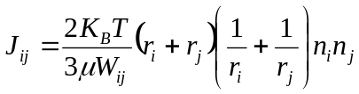, (25)

where:
n_{i} and n_{j} are the corresponding number densities of aggregates containing i and j primary particles, respectively,
W_{ij} is the stability ratio. It is a measure of the effectiveness of the electrical double layer in preventing the particles from coagulating. It is the inverse of the fraction of collisions between aggregates of sizes i and j that result in having the particles stick to each other to form an aggregate of size i+j.

The conservation equation for aggregates of size k can be written (Sonntag and Strenge, 1986) as:

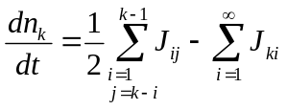 (26)

Where the net change in the number of aggregates of size k is the difference between the first term, which is the rate of increase resulting from collision of smaller aggregates, and the second term, which is the loss resulting from collision with other aggregates to form larger aggregates. A set of these equations for every aggregate size k can be integrated over time to give the aggregate distribution as a function of time.

The stability ratio, W_{ij}, measures the effectiveness of the potential barrier in preventing the particles from aggregating. For collisions between particles, this ratio is given by the following expression (Sonntag and Strenge, 1986):

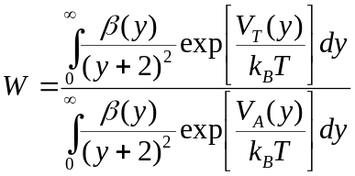 (27)

Where:
V_{T} is the DLVO potential energy
V_{A} is the van der Waals attractive term
β is a hydrodynamic factor, given by the approximation (Honig et al, 1971):

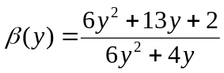, (28)

and y is the separation scaled by the particle radius.

The value for the stability ratio depends on the particle types involved and the pH and the electrolyte concentration of the solution.

For the case where there is no barrier to agglomeration (diffusion-limited aggregation), the average agglomeration radius, r_{a∞}, at long times is given by:

r_{a∞} = (4ck_{B}/3μm_{p})^{1/D} , (29)

where:
c is the initial particle concentration,
μ is the solution viscosity,
m_{p} is the mass of the primary particle,
D is the fractal dimension.

The aggregation rates derived above are based on an effective radius r_{k} for each aggregate size k. Both experiments and simulation (Rector and Bunker 1995b) have shown that most colloidal aggregates form fractal structures with a fractal dimension, D, in the range 1.6 – 2.5 (where D=3 represents constant packing as a function of radius). The aggregate size, k, is related to the effective radius by:

k ~ (r_{k}/a)^{D}, (30)

where: a is the primary particle radius.

Including the effect of packing, where φ_{m} is the maximum packing factor (0.74 for spherical particles), the expression for the effective aggregate radius becomes:

r_{k} = a(k/φ_{m})^{1/D}, (31)

Cluster sizes can also be limited by deaggregation, which may occur due to either fluid shear forces or Brownian motion. Literature studies clearly show that high shear rates result in smaller agglomerates, discussed later.

Deaggregation terms may be added to the aggregation kinetic model presented above. Defining b_{ij} as the rate at which size i+j aggregates break into size i and size j aggregates, the conservation equation for aggregates of size k, becomes:

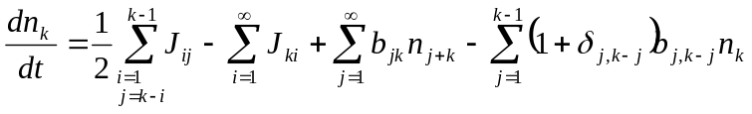, (32)

where, δ is the Kronecker delta.

By including terms for either shear- or Brownian-induced deaggregation, the equilibrium aggregate size distribution may be calculated by integrating these equations in time to a steady-state solution.

Example estimates of the effect of electrostatic charging on agglomeration rates

Brownian Agglomeration

The classical view of agglomeration due to Brownian motion (Section 3.1) is that of rigid spheres moving under the action of random molecular impacts described by a diffusion coefficient determined by considering only an isolated particle in Stokes flow. The effect of the proximity of the spheres and the corresponding distortion of the Stokes flow has been accounted for by Spielman, 1970. Spielman modified the relative diffusion coefficient by taking into account the Stimson-Jeffery forces in calculating the friction coefficient. He also included the unretarded attractive van der Waals forces. Shahub and Williams, 1988, extend Spielman’s work by including an alternative expression for the van der Waals forces at comparatively large separations (retarded forces) and the appropriate electrostatic term for charged particles. Shahub and Williams, 1988, report a preliminary investigation of the effect of van der Waals, viscous and electrostatic forces on the collision efficiency for the Brownian coagulation of particles. Shahub and Williams used the Boltzman charge distribution on the particles. For highly charged particles, the electrostatic effect dominates, whilst for particles with up to approximately 10 unit charges, the van der Waals, viscous and electrostatic forces interact in a complex fashion which significantly alters the conventional rate of coagulation predicted by classical theory.

When the ion asymmetry parameter differs from unity, see Section 4.1 (as is generally the case, or self-charging of radioactive particles occurs, the Boltzman charge distribution will not apply. The work of Shahub and Williams, 1988, has been generalised by Clement et al, 1992 a, b, 1995 to allow for non-Boltzman charge distributions. They developed a method of predicting the particle charge distribution (see Section 4.1) for this purpose. The results of extensive calculations (Clement et al, 1992 a, b, 1995) performed to obtain modifications to the Brownian coagulation rates induced by radioactive charging show that – compared with similar uncharged particles - large, complex changes occur to the coagulation rate. The results are summarised by Bowsher et al, 1994, as follows:

- Coagulation rates between small negatively charged particles and large positively charged particles are significantly enhanced;

- Intermediate sizes, with a positive mean charge, have enhanced coagulation rates with small sizes, reduced rates for intermediate sizes, but small reductions or possibly enhancement with large-sized particles. This is the effect of the negative tail of the distribution.

- Large-sized particles, which are entirely positively charged, have enhanced coagulation rates with small sizes, but a sharp reduction as the size and charge increases.

- Coagulation rates between a small-sized radioactive particle (negative charge) and a large-sized non-radioactive particle are enhanced over values obtained assuming no charging. The enhancement is sensitive to the value assumed for the ion asymmetry parameter, n⁺μ⁺/n⁻μ⁻ ( where n⁺ and n⁻ are positive and negative ion concentrations and μ⁺ and μ⁻ are the respective mobilities).

Gravitational Agglomeration

As noted above for Brownian agglomeration, Clement et al, 1992 a, b, report enhanced coagulation - over values obtained assuming no charging - between a small-sized radioactive particle (negative charge) and a large-sized non-radioactive particle. They suggest that enhancement factors similar to those for Brownian agglomeration are likely to operate in the case of gravitational or other types of agglomeration, but report that no simple formulae are available with which to perform calculations.

Changes to gravitational collision efficiencies have been calculated numerically for electrostatic effects on collisions between particles and cloud droplets of sizes down to 11 μm (Schlamp et al, 1976). Similar momentum equations are used to those presented in Pertmer and Loyalka, 1980, as discussed in Section 3.2. The particle drag is estimated using the superposition method (Langmuir, 1948). The electrostatic force model used is that developed by Davis, 1964, for conducting spheres. For low Re<0.02 the analytic flow field of Proudman and Pearson, 1957, was used. For Re≥0.02 the flow field was computed numerically.

For neutral systems, the collection efficiencies were found to be in reasonable agreement with the work of Lin & Lee, 1975, and Klett and Davis, 1973. Collector particle sizes of 11.4, 19.5, 31.4, 40.2, 50.7, 61.7 and 74.3 μm were studied. Three particle charges were used: 0, 0.2 esu cm⁻² and 2.0 esu cm⁻² (corresponding to the mean charge on particles in a thunder cloud). For 31.4 μm collector particles and larger, the charge on the particles made little difference to the collection efficiency. For the 19.5 μm particles the weaker charge had little effect, but the stronger charge was predicted to increase the collision efficiency by a factor of 6. For the 11.4 μm particles the weaker charge increased the collision efficiency by a factor of 3 and the stronger charge increased it by a further 1.5 orders of magnitude.

Brownian, Inertial Impaction and Phoretic Agglomeration

Grover et. al., 1977, developed a model for the collection of particles by falling water drops, due to: inertial impaction, thermophoresis, diffusiophoresis and electrostatic effects. The model is applicable to particles of 0.5 μm and larger. Trajectories for the particles were generated by numerical solution of the Navier-Stokes and heat and mass transfer equations. A complementary model for the collection of fine particles (smaller than 0.5 μm) by water drops was developed by Wang et. al., 1978. In this case agglomeration is due to Brownian, thermophoretic and diffusiophoretic processes. Due to the small size of the particles, their inertia was neglected. In addition the flow, temperature, concentration and electric fields were all assumed to be spherically symmetric. In particular, the electrostatic force between conducting spheres was used.

The two models were combined in Wang et al, 1978, to produce a model covering all particle sizes. The combined model was used to estimate the collection efficiency of particles ranging in size (radius) from 0.001 to 10 μm, by water droplets of 42, 72, 106, 173 and 310 μm radius. Particles were assumed to either be electrically neutral, or to have a charge of 2.0 esu cm⁻², corresponding to the mean particle charge in a thunder cloud. The particles and water droplets were assumed to have opposite charges, so that the electrostatic force is always attractive. The fluid was air at 10°C, 0.9 bar and relative humidities of 0.5, 0.75 and 0.95.

In the absence of electrical charging, the collection efficiency exhibits a minimum, typically centred somewhere between 0.2 and 2 μm radius, depending on the size of the collector, relative humidity etc. Around this size, the efficiency is low as the particles are too large for diffusion and phoretic processes to be very efficient and yet they are too small for inertial impaction to be very efficient. This size range, of low collection efficiency, is often referred to as the Greenfield gap. Outside the Greenfield gap, the electrical charging of the particles was found to have little effect. Within the Greenfield gap, the electrostatic attraction was found to increase the collection efficiency, typically by an order of magnitude. The presence of electrostatic charging was also found to change the position of the Greenfield gap, so that it was always centred about a radius of roughly 0.1 μm.

The model has been validated against the experiments of Wang and Pruppacher, 1977. The experiments were performed using particles of radius 0.25 μm, which is near where the two models are joined to produce the complete model. The individual models were compared against experimental data for collector drops of radius between 100 and 400 μm. Both models are found to mainly agree with the measured data, to within the experimental error.

It is considered (Mubayi et al, 1997) that the VICTORIA agglomeration models - Brownian, gravitational and turbulent - are adequate to cover the mechanisms believed to be important (for fission product transport in the primary system of a light water nuclear reactor). Despite being raised during the independent peer review of VICTORIA, electrostatic agglomeration – which has been largely discounted, in this context, over the years – was not considered to be of major significance. It is noted that, if electrostatic effects on agglomeration were to be included, a model to predict charge levels on particles would also be required. It is thought that this would be an uncertain process since such charging models have not been adequately verified by experiments, nor have agglomeration rates for charged particles been adequately studied. Determination of particle charge is addressed in the following section.

Break-up of agglomerates

The break-up of agglomerates due shear in turbulent eddies and boundary layers is discussed by Means, 1978. The discussion below follows Means 1978 closely, as his arguments are very economical.

In the turbulent core of a fluid flow the Kolmogorov microscale for the smallest eddies is given by:

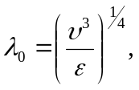 (33)
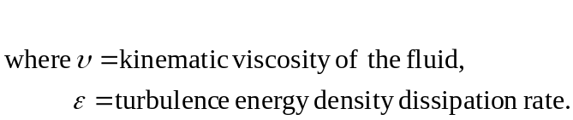

Means notes that particles up to 10 microscales in diameter experience laminar drag:

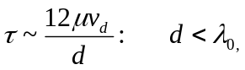 (34)
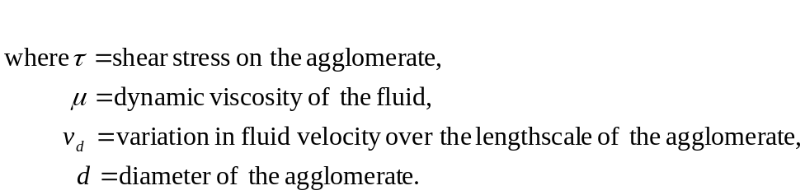

Larger particles are subject to turbulent drag with a drag coefficient of approximately unity:

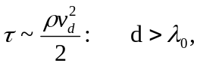 (35)

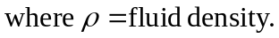

As the velocity variation on the lengthscale of the agglomerate is used in the above equations, Means assumes that this is the size of the force (per unit area) which is trying to break up the agglomerate.

If F_{A} is the average force of attraction between primary particles, Means postulates that the condition for stability of the agglomerate is:

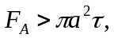 (36)

For particles in the turbulent core of the flow, the variation in velocity on the lengthscale of the agglomerate is given by:

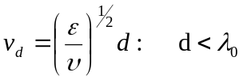 (37)

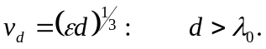 (38)

For particles which are smaller than the turbulence microscale the criterion for stability yields a critical value for the turbulence energy density dissipation rate, above which all agglomerates are unstable:

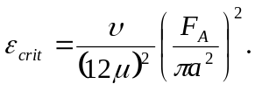 (39)

For agglomerates which are larger than the turbulence microscale, the stability criterion yields a maximum stable diameter:

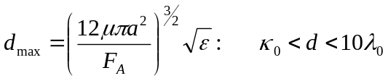 (40)
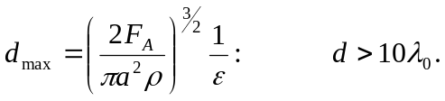 (41)

The velocities used in deriving the above results are associated with eddies having frequencies of v_{d}/d. Means defines the break-up rate θ by:

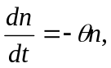 (42)

He then identifies the break-up rate with the eddy frequency:

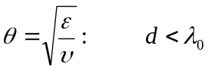 (43)

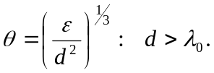 (44)

For agglomerates entering the boundary layer the the variation in velocity over the lengthscale of the agglomerate is:

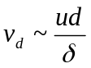 (45)

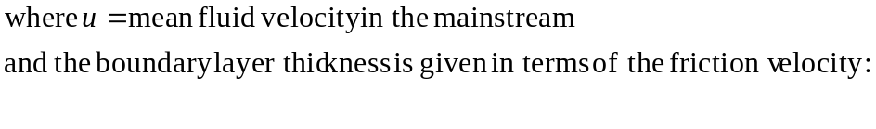
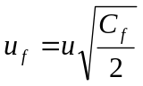 (46)
by:

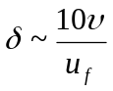 (47)

Means states that for particles up to the boundary layer thickness, the laminar drag law applies. Applying the stability criterion then yields a critical friction velocity, above which the agglomerates are unstable:

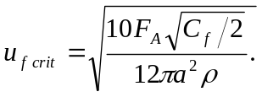 (48)

In this case the rate at which agglomerates are broken up is given by the rate at which the turbulence transports them to the boundary layer:

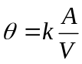 (49)
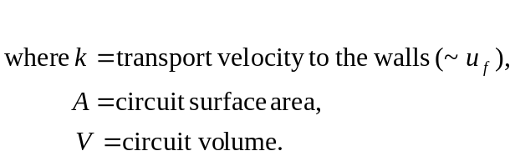

Means identifies the transport velocity with the friction velocity, as this is approximately equal to the average turbulent eddy velocity towards the wall.

The theory of particle break-up proposed by Means needs to be generalised to non-spherical agglomerates and requires experimental validation. The theory is very similar to that of Kobayashi, 1999, which has been validated experimentally. However, Means equations are applied in the Appendix to the experimental conditions that are being proposed in this program.

Charge on a Particle
Models for the prediction of electrostatic charging of colloid particles in aqueous solutions are described in Section 4.1. The material in this section is taken mainly from Hunter 1993 and Healy and White 1978. A method for measuring the average particle size and charge, from measurements of diffusivity and electrical mobility, due to Lim et al, 1979, is presented in Section 4.2.

colloid charging in aqueous systems
In a liquid system, solution molecules are in continuous contact with the surface of a particle and so the method of charging is different to that in a gas, whose molecules only have intermittent contact with the particles. As noted in Section 3, for oxide particles the electrostatic behaviour is usually dominated by hydrogen and hydroxide ions. These are known as the potential determining ions (pdi) of the system. As discussed in Section 3.4, a diffuse electrical double layer, of opposite charge to the particle, surrounds the particle. The Gouy-Chapman model provides useful quantitative description of the diffuse double layer and is described in Section 4.2.1 below. The model was modified by Stern, to allow for surface effects, as described in Section 4.2.2. More detailed chemistry is briefly addressed in Section 4.2.3.

The electrostatic potential, φ, is determined from the charge distribution, ρ, by the Poisson equation:

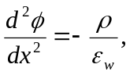 (50)

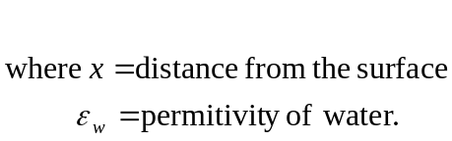

The number of ions of each type, n_{I}, has a Boltzmann distribution:

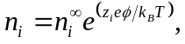 (51)
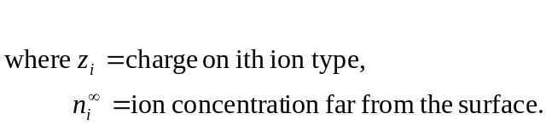
Hence, the electrostatic potential is determined by the Poisson-Boltzmann equation:

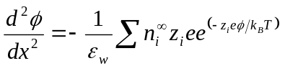. (52)

For symmetrical z:z valent electrolytes this simplifies to

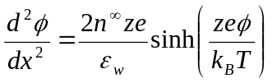 (53)

Integrating from a point in the bulk solution, where the potential and its gradient are zero, yields:

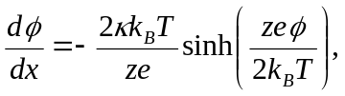 (54)

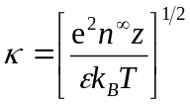 (55)

The total charge density in the diffuse double layer, per unit area of surface, σ_{d}, is given by:

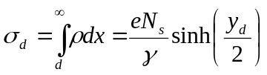 (56)

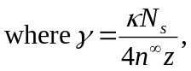 (57)

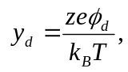 (58)

Gouy-Chapman Model with Mass Action Law

In the Gouy-Chapman model, the diffuse double layer is assumed to extend right up to the surface of the particle. In this case charge conservation requires that the charge per unit surface area on the surface of a particle, σ₀, be equal to the charge per unit surface area in the diffuse double layer:

σ₀ = σ_{d}. (59)

Also the electrostatic potential at the start of the diffuse double layer will be equal to the potential at the particle surface, φ₀:

φ_{d} = φ₀. (60)

Similarly, the y parameter can be defined at the surface:

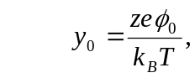 (61)
and the surface charge density is given as a function of it by the Gouy-Chapman expression:

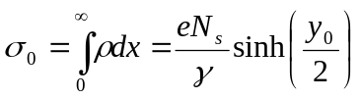. (62)

Healy and White use the mass action law for a particular set of surface reactions to derive a second relationship between σ₀ and y₀. When combined with the above equation, this allows the surface charge density, σ₀, to be determined. They consider reactions at four different types of surfaces: mono-protic acid group surfaces; surfaces with two independent acid groups; amphoteric surfaces; surfaces with two kinds of adsorbing sites. These are considered in turn below.

Mono-Protic Acid Group Surfaces

Consider a surface containing N_{s} simple –AH acid groups per unit area, which dissociate as:

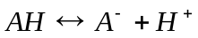 (63)

The mass action law for this reaction is:

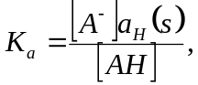 (64)
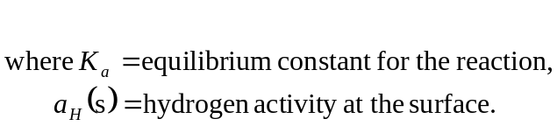

The hydrogen activity at the surface is related to that in the bulk fluid, a_{H} by:

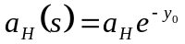. (65)

The pH of the bulk fluid is defined as:

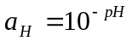. (66)

The surface charge density in this case is given by:

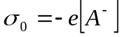 (67)

and the surface site density is:

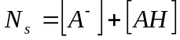. (68)

Combining the above equations leads to the relationship:

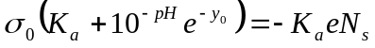. (69)

This can be solved, jointly with the Gouy Chapman expression to obtain:

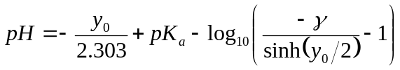 (70)

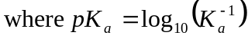. (71)

For a given pH and ionic strength, this equation can be solved for y₀, which can then be used to determine the surface charge density of the particle.

Surfaces with Two Independent Acid Groups

In addition to the –AH acid group considered above, let there be a second acid group, -BH, which dissociates as

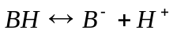, (72)

with equilibrium constant K_{a}’.

The total number of absorbing surface sites is assumed to be the sum of sites specific to AH and BH:

N_{s} = N_{A} + N_{B} = (q + 1)N_{B} (73)

where q = N_{A}/N_{B} .

A similar analysis to above leads to the relation:

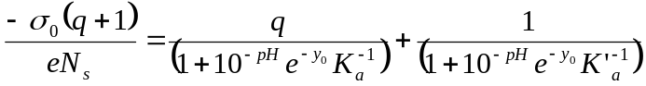 (74)

Amphoteric Surfaces

This is the first system considered which has positive and negative (and neutral) attachment sites, and therefore exhibits a point of zero charge. These kinds of surfaces are typified by, say, a diprotic acid group:

(75)

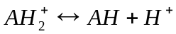, (76)

though the analysis is more general.

Let the two equilibrium constants be:

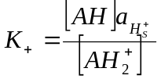 (77)
and
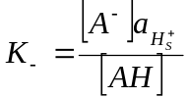. (78)

There are three species attached to the surface, AH, A⁻ and AH₂⁺, and so the surface charge density is given by:

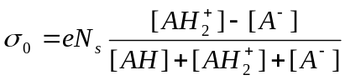 (79)

The pH at the point of zero charge, pH₀, is obtained by multiplying the mass action laws together and noting that [AH₂⁺] = [A⁻] at the point of zero charge, to get:

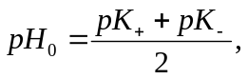 (80)
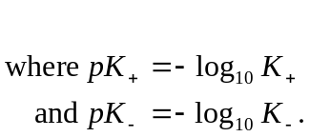

A similar analysis to Section 4.2.1 leads to the relation:

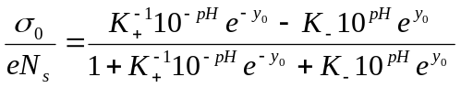 (81)

Combining with the Gouy-Chapman expression, for H⁺ and OH⁻ as potential determining ions yields:

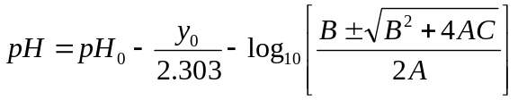 (82)

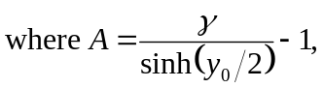 (83)
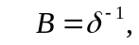 (84)
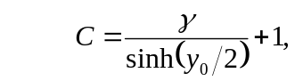 (85)

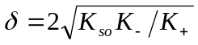, (86)

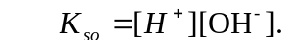 (87)

Surfaces with Two Kinds of Adsorbing Sites

Let the positive and negative charge carriers in the fluid be denoted by P⁺ and N⁻, respectively. In this model there are two, independent kinds of attachment sites, which are labelled S_{P} and S_{A}. The surface reactions are:

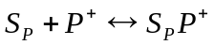 (88)
and
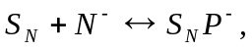 (89)
with equilibrium constants

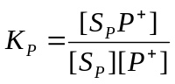 (90)

and

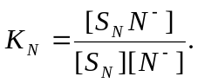 (91)

The solution ions are assumed to be connected by a solubility product relation:

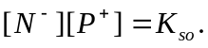 (92)

A similar analysis to the above yields the relation:

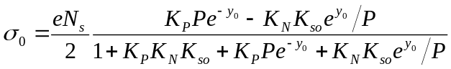 (93)

This is similar to the expression above for an amphoteric surface. However, an important difference is apparent. For oxides where δ << 1, the two-site model yields one half of the charge predicted by the amphoteric model.

Combining with the Gouy-Chapman expression yields the expression:

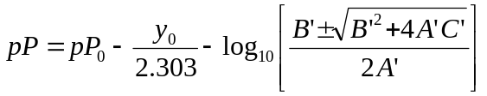 (94)

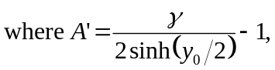 (95)

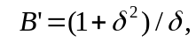 (96)

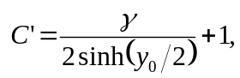 (97)

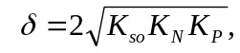 (98)

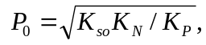 (99)

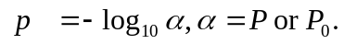 (100)

Again this is similar to the relation derived for an amphoteric surface, though important differences are apparent.

The Inclusion of Stern layers

In the Gouy-Chapman model it is assumed that the diffuse double layer extends up to the surface of the particle. In reality, there are phenomena which occur close to the surface, which are not taken into account in the Gouy-Chapman model. Thses phenomena are usually taken into account by inserting an inner (or compact) double layer (typically about 0.5 nm thick), between the surface and the diffuse double layer. The simplest model of the inner double layer is the zeroth order Stern model, used by Healey and White and by Hunter, and described in Section 4.2.2.1.

Zeroth Order Stern Model

In this model the inner layer is assumed to be free of electric charge. It results from the non-zero size of the ions, which leads to a layer adjacent to the surface which does not contain the centres of any charged particles. The effective radius of an ion depends on whether it is hydrated or not. At a metal-solution interface, cations tend to remain hydrated whereas anions do not. As this layer contains no charge, the electrostatic potential will vary linearly across the layer, of thickness d. Hence the potential at the start of the diffuse layer is related to that at the surface by:

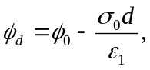 (101)

As the water molecules are strongly oriented in this region, they are not able to react to an applied electric field in the same way as normal water. Consequently, the permittivity in this layer is lower than for ordinary water, typically by a factor of between 4 and 13. This is a parameter that can be adjusted to optimise agreement with experimental data.

In view of the absence of any charge in the inner layer, conservation of charge implies:

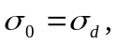 (102)

as for the Gouy-Chapman model.

The Stern Layer

A more detailed model of the inner layer is presented by Hunter. The model was initially introduced by Stern. It allows for charge accumulation in the inner layer. This may occur as unhydrated ions are smaller than their hydrated counterparts. Therefore, unhydrated ions that are attached to the surface will reside within the layer which is forbidden to the hydrated ions, due to their size. This is incorporated in the model by introducing an intermediate surface, a distance b (<d) from the surface, at which a charge density σ_{I} exists. Charge conservation now requires that:

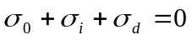. (103)

As there is no charge in the region 0<x<b or the region b<x<d, the electrostatic potential varies linearly over both regions. Hence,

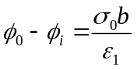 (104)
and
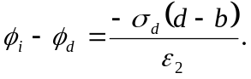 (105)

Finally, Hunter uses a simplified form of the Langmuir isotherm to derive an expression for the charge density on the intermediate layer:

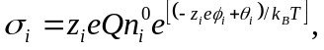 (106)
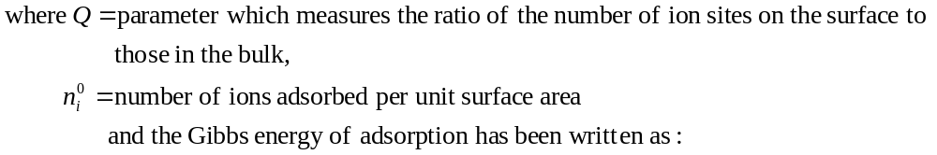
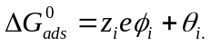 (107)
Again, this model has parameters which can be adjusted to optimise the fit to experimental data.

Site Binding of Counter Ions

In this model, which is discussed by Healy and White, the ions in the inner layer are coupled to specific surface sites. In this model the sites and their counter ions are treated as electric dipoles. Further details are given in Healy and White, 1978.

More Detailed Chemistry

In Section 4.2.1 relatively simple chemical systems were studied. More complicated chemistry may occur. For instance, Schindler and Stumm consider the oxide-water interface. In water, oxide surfaces are covered with surface hydroxyl groups. These may adsorb H⁺ and OH⁻ ions:

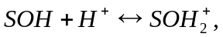 (108)
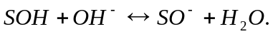 (109)

Metal ions may be adsorbed:

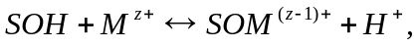 (110)

(111)

Further ligands may be aquired, to form a type A ternary surface complex:

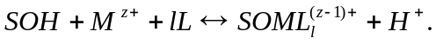 (112)

Ligand exchange may take place:

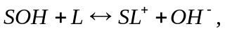 (113)

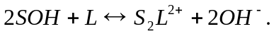 (114)

Type B ternary surface complexes may be formed:

(115)

Consequently it is important to understand the chemical system and identify the important reactions for charging of the colloid particles.

Measuring colloid charge
In the context of nuclear medicine, Lim et al, 1979, describe a “new” method to measure the distributions of size and charge in suspensions of radiocolloid particles. Following measurement of the electrophoretic mobility, ^{e}μ, and translational diffusion coefficient, D, the average charge on the particles, J, and the hydrodynamic radius, r, are calculated from established theory for spherical particles. First the particle radius is estimated from the measured diffusivity, using the relation:

D = k_{B}T/f = k_{B}T/6πμr (116)

where:
k_{B} is the Boltzmann constant,
T is the temperature,
f is the translational friction coefficient,
μ is the solvent viscosity.

The electrophoretic mobility, ^{e}μ, is related to the particle charge, J (in units of electron charge, e) by the Henry equation (Henry, 1931):

^{e}μ(J, r) = 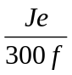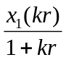 (117)
where:
x₁ is a tabulated function (Henry, 1931),
300 is a conversion factor,
k is the inverse thickness of the Debye-Huckel ion atmosphere.

The inverse Debye-Huckel thickness can be expressed in terms of the ionic strength as:

k = 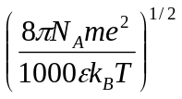, (118)
where:
N_{A} is Avogadro’s number,
ε is the solvent dielectric constant,
m is the ionic strength, which is defined to be:

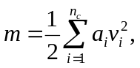 (119)

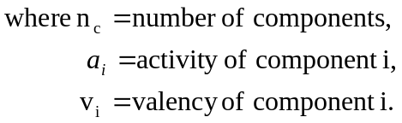

The x₁ function approaches 1 at low ionic strength (kr << 1) and 3/2 at high ionic strength or for very large particles (kr >> 1). It is the latter limit which applies in Lim’s application, allowing the electrophoretic mobility to be approximated as:

^{e}μ = Je/(300μk 4πr²) = σ/300μk (120)

where the surface charge density is defined as:
σ = Je/4πr². (121)
Note that the friction coefficient has been eliminated, using the equation for the diffusivity.

In the limit kr >> 1, ^{e}μ measures not particle charge but rather charge density (or, equivalently, zeta potential). The total particle charge is readily computed from σ, since r is known from the diffusion coefficient.

To predict the extent of agglomeration, the conditions leading to the formation of fixed charges on the particle surface need to be established. Surface charge (or zeta potential) has been measured as a function of pH using electrophoretic mobility measurements (Rector and Bunker, 1995). Results are summarised in Section 5.

Effects on Agglomeration

Effect of pH and Ionic Strength

As discussed in Section 3.4, a colloidal dispersion is said to be stable when significant agglomeration does not occur i.e. when the potential barrier is sufficiently high to prevent particles from contacting one another. Whether or not a dispersion is stable depends both on the surface electrostatic potential (which depends on the pH of the solution) and the ion concentration of the solution. By using expressions for the DLVO particle interaction potential, presented in Section 3.4, the conditions under which the dispersion is stable or unstable can be determined.

The net interaction potential between particles can be used to predict the pH and salt concentration regimes expected to promote agglomeration. For example, one can assume that agglomeration can occur when the repulsive barrier to agglomeration is less than or equal to the thermal energy in the system (K_{B}T). Rector and Bunker, 1995, show the pH and salt concentration for which the barrier height is equal to K_{B}T for pairs of boehmite particles. Their “stability curve” shows that near the isoelectric point at pH 8.5 (where the boehmite particles are neutral), agglomeration should occur, regardless of the salt concentration. As the salt concentration increases, the instability regime widens. For NaNO₃ concentrations exceeding 0.1 M, boehmite is predicted to be heavily agglomerated regardless of the pH. The typical form of a colloid stability map is shown in Figure 1.

ionic
strength
stable unstable stable

pH

Figure 1: Stability Map

A number of (mainly experimental) studies have been performed – in a variety of fields - to determine the effect of pH and ionic strength on agglomeration. A selection of these studies is reported below.

The effect of pH and salt content, on agglomeration, were studied under the Tank Waste Treatment Science Task of the Tank Waste Remediation Pretreatment Technology Development Project (LaFemina, 1995a). Experiments were performed for conditions representative of tank waste sludge. Insoluble components (oxides and hydroxides of aluminium, iron, zirconium and chromium, aluminosilicate minerals and salts, such as, calcium phosphate) were studied as individual components and in mixed-particle suspensions in high pH (11 – 14) and high salt content (0.01 to 5 M NaNO₃) solutions.

As described in Section 3.4, to predict the extent of agglomeration, the conditions leading to the formation of fixed charges on the particle surface need to be established. Surface charge (or zeta potential) has been measured as a function of pH using electrophoretic mobility measurements (both alternating and direct current). The zeta potential measurements (Rector and Bunker, 1995, LaFemina, 1995b) show that boehmite has an isolectric point (pH at which the surface is neutral) of between pH 8.5 and 9.0. Below pH 7, the surface has a substantial positive charge, while above pH 10, the surface has a substantial negative charge. Boehmite particles are dispersed, rather than agglomerated, for pH 3 – 5 in solutions having low salt content (< 0.01 M NaNO₃).

The effect of surface charge on agglomeration has been determined for boehmite suspensions by measuring the size distribution using light-scattering techniques (Rector and Bunker, 1995, LaFemina, 1995b). For pH ~ 3 (all particles positively charged) the particles are dispersed and the agglomerate size is almost identical to the primary particle size. At pH 7 (near the isoelectric point) the particles have little surface charge and the primary particles stick to each other to form large agglomerates. At pH 13 (all particles negatively charged) one might expect to see primary particles. However, the particles are somewhat agglomerated due to the high salt content of the solution.

Measurements of the sizes of particles suspended in liquids of differing ionic strength are reported by Jewett et al, 2000b. It is concluded that the size of agglomerates depends greatly on the ionic strength of the solution; “the higher the ionic strength of the liquid in which particles are suspended, the higher the likelihood that agglomeration will occur”. It is further concluded that “effective control of agglomeration probably can be attained only by adjustment of the ionic strength”.

Jewett et al, 2000b, report that metallic hydroxides and hydrated oxide particulates can be expected to agglomerate in solutions of moderate ionic strength (typical of those present in high level waste). As explained in Section 3.4, above, surface charge is required to keep the particles apart, but the presence of electrolytes in the solution causes these charges to be neutralised resulting in agglomeration. As discussed in Section 5.2, below, actions during waste transfer, such as mixing, may break up agglomerated particles but because the waste is not usually diluted extensively, the ionic strength will still be substantial and particles would tend to re-agglomerate when mixing ceases. This process is supported by theory and has been demonstrated for boehmite and ferric hydroxide particles (Rector and Bunker, 1995). Agglomerated particles may disperse into their component particles when placed into liquids of low ionic strength.

In the experimental studies reported by LeFemina, 1995b, high ionic strength solutions (which collapse the double layer) are expected to lead to agglomeration, irrespective of pH.

To assess colloid-facilitated radionuclide transport at the potential Yucca Mountain nuclear waste repository, aggregation experiments were performed to evaluate the stability of silica and clay colloids as a function of ionic strength in a carbonate rich synthetic groundwater (Wistrom and Triay, 1995). Kaolinite clay and amorphous silica particles, chosen because of their prevalence in the natural environment, were suspended in a 0.368 mM Na₂CO₃ + 10.60 mM NaHCO₃ solution having a pH of 7.8. Aggregation was induced by adding a NaCl electrolyte solution to the particulate suspension to a final concentration ranging from 100 to 800 mM. Aggregation of silica particles and clay particles was not detected for electrolyte concentrations below 300 mM and 100 mM, respectively. When the electrolyte concentration was increased to induce aggregation, aggregate growth was exponential and irreversible. The rate of aggregation increased with increasing electrolyte strength. After the initial rapid growth phase, as the electrolyte concentration continues to be increased, the rate of aggregation slows down abruptly. The first stage of exponential growth is characterised by reaction-limited aggregation and the second stage is characterised by diffusion limited aggregation. The authors report that rapid and slow regimes of aggregation have been observed in various particulate systems, such as polystyrene, gold and silica colloids (Cametti et al , 1989). Examination of stability ratios (calculated as the ratio between the Smoluchowski equation for doublet formation and the experimentally determined rate constant) indicated that clay particles were destabilised at a lower electrolyte concentration than silica particles. Also, the clay particles exhibited a gradual increase in stability, whereas the silica particles exhibited an abrupt transition from unstable to stable. Kaolinite clay has a negative charge on the clay face and a positive charge on the mineral edges. Wistrom and Triay note that, in low electrolyte solutions, collisions produce aggregates having an open and porous structure. At higher concentrations, the repulsive forces will be suppressed to allow aggregation into denser aggregates.

Satmark and Abinsson, 1992, measured the stability of colloids as a function of pH (ionic strength kept constant at 0.01 M with NaClO₄) and as a function of ionic strength (pH kept almost constant). Silicate colloids exhibited a sharp increase in size at ionic strengths over 0.1 M. At a pH of ~ 8, Al₂O₃ colloids were unstable, irrespective of the ionic strength. A sharp increase in the size of Al₂O₃ colloids occurred at pH ~ 6 – 7. The results were consistent with the point of zero charge for Al₂O₃ (pH ~ 8 – 9). Clay colloids appeared stable in the pH range 6 to 10; their sizes increased below pH 4. Samples of Finnsjo granite were stable in the pH range 6 – 9; their sizes increased sharply at lower pHs. At the lowest (0.005 M) ionic strength, 2 granite particle sizes (130 nm and 235 nm) were measured. At the highest ionic strength (0.5 M), particle diameters had increased to ~1000 nm.

The transport of colloidal gold through bentonite saturated with distilled water, and sand-bentonite saturated with synthetic sea water, was studied by Kurosawa et al, 1997. The experimental and theoretical work investigated the behaviour of colloids in environments relevant to the safety assessment of high level radioactive waste; the compacted bentonite surrounding the waste is considered to behave as a filter which traps colloids because of its microstructure. In addition to experimental observations, colloidal particle stabilities, as a function of electrolyte concentration, were estimated based on the repulsion potential from the double layer force and the attraction potential from the van der Waals force.

In the context of colloid generation in the interaction of high level nuclear waste glasses with groundwater, Feng et al, 1993, characterised the stability of colloidal suspensions with respect to salt concentration, pH, time, particle size and zeta potential. Experimental observations on the effect of salt concentration were explained in terms of the DLVO theory. In dilution experiments, lowering the salt concentration of a flocculated colloid solution, reduced the compression of the double layer. The expanded double layer decreased the van der Waals attraction and increased the repulsive force between the particles, resulting in resuspension of the flocculated colloids. This effect is important since, if a large amount of groundwater with a low salt content contacts the glass reaction site, precipitated colloids may become resuspended. A stability v. pH diagram for a pure silica colloidal system is used to help explain the experimentally observed trends of zeta potential, and particle size, as a function of pH. When the pH increases from 1 to 6, the negative charge on the colloid increases (due to deprotonation). Between pH 6 and 9, the negatively charged colloid may absorb some positively charged hydolyzed cations; this reduces the negative charge on the colloids. At pH 10.5, most hydrolysis products of metal cations are neutral or negatively charged, and the negative charge on the colloids increases again. As expected, the observed size of colloids was closely correlated with the pH and zeta potentials. At pH 1 (the point of zero charge) agglomeration is via van der Waals attraction and this produced the largest particle size. The smallest size was observed at pH 6; all the colloids are negatively charged and they collide less frequently and less effectively. At pH 9 the particles are less negatively charged and their size increases.

Maroto et al, 1980, present a model - based on the DLVO theory of colloid stability – to predict the influence of pH on the deposition of magnetite particles on oxidised zirconium surfaces. Zeta potentials, as a function of pH, were obtained from measurements of the electrophoretic mobilities of magnetite and zirconium dioxide in various aqueous electrolytic solutions. Potential energy profiles (c.f. V_{T}, V_{A}, V_{R} in Section 3.4, above) were calculated as a function of particle radii, temperature and pH.

Janusz, 1988, reports the experimental determination of the surface charge of zirconium dioxide in aqueous solutions of 0.1, 0.01 and 0.001 M NaCl.

An understanding of surface charge characteristics as a function of pH and ionic strength is important in optimising processing conditions for high technology ceramics applications. Chia, 1987, reports experimental characterisation of the surface charge of Y₂O₃, La₂O₃, CuO and BaCO₃. The effect of inorganic electrolyte, dissolved ions of other oxides, particle concentration and mixing time on the pH of the isoelectric point was investigated. Comparison of the measured isoelectric point with the point of zero charge determined by the pH of minimum solubility calculated using available thermodynamic data and/or predicted by Parks’ pzc equation (Parks, 1965, 1967) showed clear discrepancies in some cases.

Effect of OTHER PROCESSING CONDITIONS AND PARTICLE PROPERTIES
Studies concerned with the effect of processing conditions, e.g. heating and mixing, on agglomeration are presented below, together with issues related to particle properties, e.g. density.

Jewett et al, 2000b, recognise that the degree of turbulence may affect particle size distribution. Agglomerates might be dispersed by sonication, mechanical mixing or passage through pumps. The extent of these effects is, however, not well known. Similarly, the rate of re-agglomeration has not received much study. Specifically, in the waste transfer system of concern to Jewett et al, although particles present in a waste feed tank may be highly agglomerated, they will be subject to disruption by mixer pumps and a multistage turbine transfer pump before entering the transfer system piping. The extent to which agglomerates will be diminished and the time required for re-formation of the agglomerates are not known. Jewett et al, 2000b, report the application of hydrodynamic shear forces, such as ultrasound, to promote particle de-agglomeration, but recognise that rapid re-agglomeration may occur if interfacial surface tension between the solid particle phase and the liquid is too high or if electrical charges carried on the particles are discharged because of the high conductivity of the solvent.

According to Jewett et al, 2000b, the few laboratory studies on the effects of turbulence that have been performed indicate that the tendency towards agglomeration is strong; very severe mechanical treatment is required to break the agglomerates, and the agglomerates will reform when the mechanical treatment is halted. Jewett et al cite PNNL-11278 and PNNL-11636 in which a slight reduction in particle size and an apparent increase in particle size, respectively, are reported due to sonication.

Under the Tank Waste Treatment Science Task of the Tank Waste Remediation Pretreatment Technology Development Project, Pacific Northwest Laboratory report studies of how processing parameters, such as heating and stirring, influence agglomeration (LaFemina, 1995c). The sedimentation behaviour, observed during studies of gibbsite-boehmite (Al(OH)₃ – AlOOH) mixtures, is explained by assuming that heating and/or agitation has the net effect of disrupting the original agglomerate structures present in suspension. When an excess of (larger) gibbsite particles is present, most of the small particles generated by agglomeration-breakdown are scavenged by the larger particles to produce mixed agglomerates in which the large particles are coated by the smaller particles. The new agglomerate structure forms denser sediments because the small particles fill voids between the larger particles, and the small particles make the sediment more compressible. When an excess of (smaller) boehmite particles is present, the initial agglomerates are again broken down, but there are insufficient large particles to scavenge the small fragments and the small particles re-agglomerate to produce particles with a lower fractal dimension than that of the original material; the resulting sediment occupies more volume.

The behaviour of bi-modal suspensions of gibbsite and boehmite are further discussed and explained by Bruinsma et al, 1997. Here, a greater densification of sediments (and decreases in viscosity) are explained by the fact that the coating (adsorption) of (smaller) boehmite particles on the (larger) gibbsite particles provides short-range steric repulsion and reduces the attractive interactions between the larger particles. Essentially, boehmite acts as a dispersing agent by modifying the surface of the larger gibbsite particles. The fact that the addition of small particles can reduce, rather than increase, the viscosity of the suspension is contrary to what would be expected from models used to predict the viscosity of bi-modal suspensions, e.g, Farris, 1968 and Sengun and Probstein, 1989a, b.

Sludge Characterisation Studies, performed by the Pacific Northwest Laboratory, under the Tank Waste Treatment Science Task of the Tank Waste Remediation Pretreatment Technology Development Project (LaFemina, 1995b), showed that washing caused some large agglomerates to break up into fine fragments. Colloidal Studies for Solid-Liquid Separation, also reported in LaFemina, 1995b, mention that agglomeration can be inhibited by the presence of organics. Coagulation via particle addition, rather than conventional organic flocculating agents, might be preferable. Test results suggest that apatite is capable of scavenging fines from supernatant liquids. Even at high pH, the surface charge on apatite is low enough for the electrostatic repulsion between apatite and other oxide and hydroxide particles to be negligible. Such “heterocoagulation” may provide a mechanism for minimising the production of, or deliberately removing, fines during sludge processing.

Jewett et al, 2000b, recognise that agglomeration will affect settling rate and slurry transport. Stokes law shows that the terminal velocity of a spherical particle falling freely in a quiescent liquid is proportional to its cross sectional area and the difference between the density of the particle and the density of the liquid. Agglomerates, containing significant interstitial liquid, are expected to be less dense than solid particles. Consequently, agglomerates might be expected to settle more slowly than solid particles. However, the increased size of agglomerates containing, typically (Jewett et al, 2000b), hundreds or thousands of individual particles, usually outweighs the smaller density, and the agglomerate settles faster than the individual particle. (This is the theory behind many industrial flocculation/clarification processes). Jewett et al, 2000b, recognised that the particle density used in the Waste Feed Delivery Transfer System Analysis (RPP-5346) might be larger than it need be. Reduction of the particle density assumed in the slurry flow modelling would result in lower required velocities and pipeline pressures.

Conclusions
A wide range of literature of relevance to agglomeration of colloid particles has been reviewed. The aerosol literature provides models for agglomeration of electrically neutral, spherical particles. The main processes involved are: Brownian motion, gravitational settling and turbulence. Brownian agglomeration is important for small (sub-micron) particles and the modelling is well established. Gravitational agglomeration is important for larger particles (super-micron) and the theory is also reasonably well established. A model is available for turbulent agglomeration, which should provide reasonable, order-of-magnitude estimates of the effect in many circumstances, but is subject to greater uncertainty than the Brownian and gravitational models.

Few theoretical results are available for agglomeration of non-spherical particles and consequently more reliance must be placed on experimental results. Some theoretical results are available for gravitational agglomeration of oblate spheroids, based on numerical analysis, leading to shape factors (ratio of collisional efficiency of non-spherical particles to that of volume equivalent spheres) such as 4. Experimental shape factors are available for chain-like agglomerates that form due to diffusion-limited aggregation. They cover a range of values from 1 to 16. One author suggests that a value of 4 is reasonable for a range of such agglomerates.

Calculations of Brownian and gravitational agglomeration of charged spheres are reported. Some experimental validation of models is available. The electrical charging of the particles is found to have a significant effect on the predicted agglomeration rates.

The theory of agglomerate break-up due to Means is presented. This predicts an upper limit on the size to which agglomerates can grow before being broken up by turbulent eddies or boundary layers. The theory needs to be generalised to non-spherical agglomerates and should be experimentally validated.

Methods for estimating the charging of colloid particles in aqueous solutions, as a function of pH and ionic strength, are discussed. Several examples of charge calculations are presented for simple chemical systems. The models contain parameters that can be adjusted to fit experimental data. More complicated reaction systems can occur for oxides in water and consequently it is important to understand the chemical system and identify the reactions which are significant to the charging of the colloid particles.

An overview of the DLVO theory of colloid stability is presented. This is based on the production of a potential energy which represents the competition between the attractive Van der Waals force and the repulsive electrostatic force between particles. The charging of colloid particles results in the formation of a layer of opposite charge in the fluid adjacent to the particle – the so-called diffuse electrical double layer – which partly screens the charge on the particle. At low ionic strengths the double layer extends beyond the range of the Van der Waals force. The resulting electrical repulsion between the particles prevents agglomeration, unless the particle is nearly electrically neutral (which depends on the pH). At high ionic strengths the double layer shrinks in size and the net force is always attractive. Hence, at high ionic strengths agglomeration always occurs.

Other effects that may effect agglomeration, or cause break up of agglomerates, such as temperature, mixing, passage through pumps, sound waves, are briefly discussed. However, quantitative information on these topics is limited.

An important conclusion from this report is that at the ionic strengths present in the Hanford tank mixtures it is likely that the primary force controlling agglomerate stability will be Van der Waals interactions. How this force compares with the turbulent shear force will control the agglomerate size. The final size distribution of the agglomerate will then be a function of relative rates of agglomeration and de-agglomeration under the flow conditions of interest. The equations necessary to model this have been outlined, but no detailed modelling carried out. Such a validated model is required to predict the agglomerate behaviour at Hanford.

Acknowledgements
The authors would like to thank Jim Jewett for guiding the review, identifying many important references and for many useful comments.

References
Bixler NE, 1998, “”VICTORIA 2.0: A Mechanistic Model for Radionuclide Behaviour in a Nuclear Reactor Coolant System Under Severe Accident Conditions”, NUREG/CR-6131, December 1998.

Bowsher BR et al, “Electrophoretic Effects in Severe Accidents: the Role of PHEBUS-FP”, AEA-TSD-0016.

Boyack et al, 1995, “CONTAIN Independent Peer Review”, LA-12866, January 1995.

Bruinsma PA, 1997, “Rheological and Solid-Liquid Separation Properties of Bimodal Suspensions of Colloidal Gibbsite and Boehmite”, Journal of Colloid and Interface Science 192, 16-25.

Butland A T D, Dunbar I H, Fuller P F, Hall A N, Haller J P, Hill D J, Johns N A, Keeping P M, Lillington J N, Lyons A J, Moore K A, Morgan J, Porter W H L, Ramsdale S, Roberts G J, Smith P N, Starkie H, Turland B D, Williams D A Young R L D, "Report on Phase 1 of the PWR Severe Accident Containment Study", AEEW-R1842, 1984.

Cametti CP et al, 1989, “Aggregation Kinetics in Model Colloidal Systems: A Light Scattering Study”, J. Colloid and Interface Science, 131, 2, 409 – 422 (1989).

Chia YH, 1987, “Electrokinetic Behaviour of Oxide Components in Y(La)-Ba-Cu-O Systems”, “Conf 8711115 Intern. Conf. Ceramic Powder Processing Sciences, 1 – 4 Nov. 1987, pp 511-518.

Clement CF et al , 1992a, “The coagulation of Radioactive Aerosols”, Proc. European Aerosol Conference, Oxford, Sept. 1992, J. Aerosol Sci. 23, S145 - 148.

Clement CF et al, 1992b, “The Charging and Coagulation of Radioactive Aerosols”, GNSR (Den) TWP/N(91)17.

Clement CF and Harrison R G, 1992c, “The Charging of Radioactive Aerosols”, J. Aerosol Sci., 23, 481-504.

Clement et al, 1995, “Charge Distributions and Coagulation of Radioactive Aerosols”, J. Aerosol Sci. 26 1207 – 1225.

Clement C F, Smith P N and Williams D A, 1999, “Attachment of Molecular Fission Products to Particulate Material: A Review Produced for the IMC”, AEAT-5321, May 1999.

Davies CN, 1966, “Aerosol Science”, Academic, New York.

Davis M H, 1964, “Two Charged Spherical Conductors in a Uniform Electric Field: Forces and Field Strength”, Quart. J. Mech. Appl. Math., 17, 499-511.

Davis RH, 1984, J. Fluid Mech. 145 179.

Deliachasios MA and Probstein RF, 1974, “Coagulation in Turbulent Flow – Theory and Experiment”, Pub. No. 74 – 5, Department of Mechanical Engineering, MIT, Cambridge, MA, USA.

Farris RJ, 1968, Trans. Soc. Rheol. 12, 281.

Feng X et al, 1993, “Study on the Colloids Generated from Testing of High-Level Nuclear Waste Glasses”, Waste Management ’93, Tucson, AZ, USA, 28 Feb. – 4 Mar. 1993.

Fuchs NA, 1964, “The Mechanics of Aerosols”, Pergamon, New York.

Fuchs NA and Sutugin AGT, 1970, “Highly Dispersed Aerosols”, Ann Arbor Science, Ann Arbor.

Fuchs NA, 1989, “The Mechanics of Aerosols”, Dover, New York.

Grover S N, Prupacher H R and Hamielec A E, 1977, “A Numerical Determination of the Efficiency with which Spherical Aerosol Particles Collide with Spherical Water Drops due to Inertial Impaction, and Phoretic and Electric Forces”, J. Atmos. Sci., 34, 1655-1663.

Gunn R, 1954, “Diffusion Charging of Atmosphere Droplets by Ions, Resulting in Combination Coefficients”, J. Meteorol., 11, 329-347.

Haley C P, Loyalka S K, Warder R C, Tompson R V and Podzimek J, “Measurements of the Gravitational Collision Cross Section of Aerosols”, Thermal-Hydraulic Aspects of Reactor Safety – II, Trans American Nuclear Society, Vol. 61, p 300, 1991.

Healy T W and White L R, “Ionizable Surface Group Models of Aqueous Interfaces”, Advances in Colloid and Interface Science, 9, pp 303-345, 1978.

Heames TJ et al, 1992, “VICTORIA: A Mechanistic Model of Radionuclide Behaviour in the Reactor Coolant System under Severe Accident Conditions”, NUREG/CR-5545, Rev. 1, 1992.

Henry DC, 1931, Proc. R. Soc. A133, 106 – 129 (1931).

Hidy GM and Brock JR, 1971 – 1973, “Topics in Aerosol Research, Vols I, II, III”, Pergammon, New York.

Holland FA and Chapman FS, 1966, "Liquid mixing and processing in stirred tanks", Chap. 2, 4, Reinhold, New York.

Honig EP et al, 1971, J. Colloid Interface Sci., 36, 97.

Hunter R J, “Introduction to Modern Colloid Science”, OUP, 1993.

IAEA, 1998, “International Nuclear Information System (INIS) Database, 1976 – 1998”.

Janusz W, 1988, “Surface Charge and Adsorption of Na⁺ and Cl⁻ Ions at the Zirconium Dioxide/Water Interface”, Journal of Radioanalytical and Nuclear Chemistry, Articles, Vol. 125, No. 2 (1988) 393 – 401.

Jewett JR, 2000a, Private Communication with Dr J Henshaw, 1 November and 13 December 2000.

Jewett JR et al, 2000b, “Assessment of Available Particle Size Data to Support an Analysis of the Waste Feed Delivery Transfer System”, RPP-6247.

Jordan H and Gieseke J A, “Characterisation of Agglomerates of UO₂ Aerosol Particles”, BMI-2009, NUREG/CR-0489, 1978.

Klett J D and Davis M H, 1973 ,“Theoretical Collision Efficiencies of Cloud Droplets at Small Reynolds Numbers”, J. Atmos. Sci., 30, 107.

Kobayashi M, Yasuhisa A and Ooi S, 1999, "Breakup of Fractal Flocs in a Turbulent Flow", Langmuir, 15(13), 4351-4356.

Kops j, Dibbets G, Hermans L and Van de Vate J F, “The Aerodynamic Diameter of Branched Chain-Like Agglomerates”, J. Aerosol Sci., 6, 329, 1975.

Kurosawa S et al, 1997, “Experimental Study of Colloid Filtration by Compacted Bentonite”, Mat. Res. Soc. Symp. Proc. Vol. 465.

LaFemina JP, 1995a, “Tank Waste Treatment Science Task Quarterly Report for October – December 1994”, PNL10762, January 1995.

LaFemina JP, 1995b, “Tank Waste Treatment Science Task Quarterly Report for January – March 1995”, PNL10763, April 1995.

LaFemina JP, 1995c, “Tank Waste Treatment Science Task Quarterly Report for April – June 1995”, PNL1076x, July 1995.

Langmuir I, 1948, “The Production of Rain by a Chain Reactin in Cumulus Clouds at Temperatures above Freezing”, J. Meteor., 5, 175-192.

Lim et al, 1979, “Size and Charge Distributions of Radiocolloid Particles”, International Journal of Applied Radiation and Isotopes, Vol. 30, pp 531 – 536.

Lin C L and Lee S C, 1975, “Collision Efficiency of Water Drops in the Atmosphere”, J. Atmos. Sci., 32, 1412-1418.

Loyalka SA, 1976, “Brownian Coagulation of Aerosols”, J. Colloid and Interface Science, Vol. 57, No. 578, 1976.

Maroto AJG at al, 1980, “Colloidal Interactions on the Deposition of Magnetite Particles on the Fuel Elements Surface”, Water Chemistry II, BNES, 1980, Paper 30.

Means F A, “The Formation and Break-up of Corrosion Product Agglomerates in the Primary Coolant of Water Reactors”, CEGB Report RD/B/N4268, 1978.

Mubayi V et al, 1997, “VICTORIA Independent Peer Review”, Brookhaven National Laboratory Technical Report W-6436 4-17-97.

Parks GA, 1965, “The Isoelectric Points of Solid Oxides, Solid Hydroxides, and Aqueous Hydroxo Complex Systems”, Chemical Reviews, 65, 177-97 (1965)

Parks GA, 1967, “Aqueous Surface Chemistry of Oxides and Complex Oxide Minerals”, Advan. Chem. Ser., 67, 121-60 (1967).

Parozzi F and Masnaghetti A, 1990, “TRAP-MELT2/ENEL 88.1”, Report No. ENEL N6/88/02/MI.

Perkins RJ, “Aerosol Transport, Deposition and Resuspension in the LWR Circuit and Containment”, Contract No. 4120 90-10 ED ISP GB, Interim Report No. 2, Dept of Applied Mathematics and Theoretical Physics, University of Cambridge.

Perry RH and Chilton CH, 1973, "Chemical Engineers Handbook", 5th edition, pp 19-8, pub. McGraw-Hill.

PNNL-11278, 1996, “Washing and Caustic Leaching of Hanford tank Sludges: Results of FY 1996 Studies”, Rev. 1, Pacific Northwest National Laboratory, Richland, Washington.

PNNL-11636, 1997, “Washing and Caustic Leaching of Hanford Tank Sludge: Results of FY1997 Studies”, Pacific Northwest National Laboratory, Richland, Washington.

Proudman I and Pearson J R A, 1957, “Expansion at Small Reynolds Numbers for the Flow Past a Sphere and a Circular Cylinder”, J. Fluid Mech., 2, 237-262.

Pruppacher H R and Klett J D, “Microphysics of Clouds and Precipitation”, D Reidel, 1978.

Rector DR and Bunker BC, 1995, “Effect of Colloidal Aggregation on the Sedimentation and Rheological Properties of Tank Waste”, PNL-10761, September 1995.

Rector DR and Bunker BC, 1995b, “Sedimentation Models”, PNL-10754, September 1995.

RPP-5346, 2000, “Waste Feed Delivery Transfer System Analysis”, Rev. 0, CH2M HILL Hanford Group Inc., Richland , Washington.

Saffman PG and Turner JS, 1956, “Corrigendum to ‘On the Collision of Drops in Turbulent Clouds’”, J. of Fluid Mech. 1: 16 – 30.

Satmark B and Albinsson Y, 1992, “Sorption of Products on Colloids Made of Naturally Occurring Minerals and the Stability of these Colloids”, Radiochimica Acta, 58/59, 155 – 161 (1992).

Schenkel JH and Kitchener JA, 1960, Trans. Faraday Soc. 56 161.

Schindler P W amd Stumm W, “The Surface Chemistry of Oxides, Hydroxides and Oxide Minerals”, in Stumm, W (Ed) “Aquatic Surface Chemistry: Chemical Processes at the Particle-Water Interface”, Wiley, 1987.

Schlamp RJ et al, 1976, “A Numerical Investigation of the Effect of Electric Charges and Vertical External Fields on the Collision Efficiency of Cloud Drops”, J. Atmos. Sci. 33, 1747 – 1755.

Sengun MZ and Probstein RF, 1989a, Rheol. Acta. 28, 383.

Sengun MZ and Probstein RF, 1989b, Rheol. Acta. 28, 394.

Shahub AM and Williams MMR, 1988, “Brownian Collision Efficiency”, J. Phys. D: Appl. Phys. (1988) 231 – 236.

Smith PN et al, 1999, “”A Brief Overview of Aerosol/Dust Transport Phenomena”, AEAT 4941, February 1999.

Smoluchowski M von, 1916, “Drei Vortrage uber Diffusion, Brownshe Molekularbewegung und koagulation von kolloidteilchen”, Phys. Z. 17, 557.

Smoluchowski M von, 1917, Z Phys. Chem. 92, 129.

Sonntag H and Strenge K, 1986, “Coagulation Kinetics and Structure Formation”, Plenum Press.

Spielman LA, 1970, J. Colloid Interface Sci. 33 562.

Terril B et al, 1981, “Experimental Measurements of Gravitational Collision Efficiency”, Trans. American Nucl. Soc, Vol. 32, No. 40, 1981.

Tu K W and Shaw D T, “Experimental Determination of Interception Collection Efficiencies for Small Cloud Droplets”, J. Colloid Interface Sci., 62, 40, 1977.

Tuttle R F and Loyalka S K, “Gravitational Collision Efficiency of Non-spherical LMFBR Aerosols”, Trans. American Nucl. Soc, Vol. 32, No. 40, 1981.

Tuttle R F and Loyalka S K, “Gravitational Collision Efficiency of Nonspherical Aerosols I: Definitions of Shape Factors”, Nuclear Technology, Vol. 69, p 319, 1985.

Tuttle R F and Loyalka S K, “Gravitational Collision Efficiency of Nonspherical Aerosols II: Motion of an Oblate Spheroid in a viscous Fluid”, Nuclear Technology, Vol. 69, p 327, 1985.

Tuttle R F and Loyalka S K, “Gravitational Collision Efficiency of Nonspherical Aerosols III: Computer Program NGCEFF and Calculation of Shape Factors”, Nuclear Technology, Vol. 69, p 337, 1985.

Twomey SA, 1977, “Atmospheric Aerosols, Elsevier, New York.

Van de Vate J F, van Leeuwen W F, Plomp A and Smit H C D, “Morphology and Aerodynamics of Sodium Oxide Aerosol at Low Relative Humidities”, Proc. OECD/NEA-CSNI Specialist Mtg. Nuclear Aerosols In Reactor Safety, Gatlinburg Tennessee, April 15-17, 1980.

Wang PK, Grover S N and Prupacher H R, 1978, “On the Effect of Electric Charges on the Scavenging of Aerosol Particles by Clouds and Small Raindrops”, J. Atmos. Sci. 35, 1735 – 1743.

Wang P K and Pruppacher H R, 1977, “An Experimental Determination of the Efficiency with which Aerosol Particles are Collected by Wayer drops in Subsaturated Air”, J. Atmos. Sci., 34, 1664-1669.

Wegrzyn J and Shaw D T, “Experimental Investigation of Aerosol Behaviour in a Post-LMFBR Accident Reactor Containment Atmosphere”, NUREG/CR-0287, 1978.

Wegrzyn J and Shaw D T, “Experimental Investigation of Aerosol Behaviour in a Post-LMFBR Accident Reactor Containment Atmosphere”, NUREG/CR-0799, 1979.

Wistrom AO and Triay IR, 1995, “Colloid stability in a Potential Nuclear Waste Repository”, Annual International Conference on High Level Radioactive Waste Management, Las Vegas, NV, USA, 30 Apr. - 5 May 1995.

Appendix 1 Analysis of Experimental Conditions

It is intended to carry out experiments to study particle agglomeration,
de-agglomeration using the light scattering equipment used previously in this program. Before performing these experiments it is informative to apply some of the equations described in this report to the experimental conditions that will be used.

The equipment consists of a sample holder (capacity approximately 500cm³) from which the liquid (containing particulate) is pumped around a 0.8cm id pipe, approximately 2m long. The sample holder is stirred using a small two blade propeller, approximately 2.5cm in diameter and 1cm blade width. The blades of this propeller are angled at 45°. The pump consists of a chamber approximately 15cm³ capacity with a propeller, 2cm diameter, blade width 1cm and pitch 45°. During operation at the maximum flow velocity (65 cm s⁻¹) it is estimated that the sample chamber propeller is probably operating at 1 to 10 revolutions per second (rps), while the pump is operating at 10 to 50 rps.

In carrying out agglomeration-de-agglomeration experiments using this equipment the types of questions that need to be posed are:

- Which of the three components of the system, pipe, sample chamber, pump chamber, is associated with the largest degree of turbulence ?
- What is the Kolmogorov microscale of turbulence and how does this compare with the particle sizes ?
- How do the shear forces from the turbulence compare with the primary particle interaction forces ?
- What are the rates of agglomeration and de-agglomeration ?

A simple analysis can give some idea of the answers to some of these questions and this is what is presented here.

In order to answer the first two questions the energy density dissipation rate (J kg⁻¹ s⁻¹) due to the turbulent flow needs to be estimated for the three components of the equipment. Strictly speaking this should be measured or calculated using a computational fluid mechanics code. However, there are some simple correlation's for various forms of flow which can be used, and this is the approach adopted here.

For flow along a pipe the turbulent energy dissipation rate per unit mass is given by

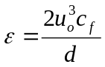 (A1)

where d is the pipe diameter, u_{o} is the friction velocity

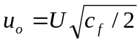 (A2)

and U is the fluid flow velocity. The coefficient of friction is given by

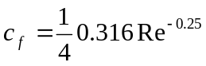 (A3)

and Re is the Reynolds number for the flow. Equation (A3) is valid for 10³ <Re<10⁵.

Using the density and viscosity of water (10³ kg m⁻³ and 10⁻³ kg m⁻¹ s⁻¹), for a pipe of 0.8cm id and a flow velocity of 65 cm s⁻¹ this gives a value for the energy dissipation rate (ε_{pipe}) of 2x10⁻⁴ J kg⁻¹ s⁻¹.

In the case of sample vessel and pump the turbulence is the result of the motion of the propeller. The power input to this propeller, equivalent to the power input to the water, is given by (Perry 1973)

P(J s⁻¹) = N_{p} ρ N³ D⁵ (A4)

Where ρ is the density of the fluid, N the revolutions per second and D the propeller diameter. The dimensionless power number N_{p} can be correlated to the propeller Reynolds number defined as

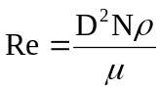 (A5)

where μ is the fluid viscosity. Correlation's of N_{p} versus Re are presented by Perry for different propeller designs. The following function is a fit to the Perry correlation giving the smallest value of N_{p} for a given Reynolds number

N_{p} = 0.74 Re^{0.51} exp(-0.58ln(Re)) + 40.4 Re^{-0.53} exp(-0.53ln(Re)) (A6)

The correlation giving the smallest N_{p} value was chosen because the correlation's presented by Perry are all for systems with baffles, which give higher values of N_{p} for a given Re than for the equivalent system without baffles, as is the case here. More extensive correlation's are available (Holland, 1966) but these have not been investigated. Equation (A4) implies that the turbulant energy dissipation rate is simply

ε(J kg⁻¹ s⁻¹) = N_{p} N³ D⁵/V (A7)

For the sample vessel rotating at 1rps to 10 rps equations (A6) and (A7) give ε_{sample} = 5.0x10⁻⁶ to 4x10⁻³ J kg⁻¹ s⁻¹ and for the pump at 10 to 100 rps, ε_{pump} = 1x10⁻³ to 1.0 J kg⁻¹ s⁻¹.

The Kolmogorov microscale of turbulence is given by equation (33) in the main text, reproduced here:

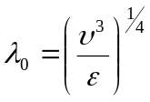 (A8)

where ν is the kinematic viscosity. This gives λ_{pipe} = 265μm, λ_{sample} = 660 to 125μm and λ_{pump} = 160 to 30μm.

In previous reported work (Rector 1995, LaFemina 1995) on Al, Fe oxy-hydroxy systems and the simulant C-106 the primary particle size (a) was estimated to be of the order of 1μm. If a 100μm diameter (d) floc/particle is therefore considered, then the variation of velocity across this particle, from equation (37) of the main text, is given by:

(A9)

and the shear stress on the agglomerate is (equation 34 main text):

(A10)

The force separating the primary particle from the agglomerate is given by (equation 36)

F_{d} = πa²τ (A11)

Equations (A9), (A10) and (A11) give the shear forces for the three components as
F_{pipe}= 5.4x10⁻¹³ , F_{sample}= 9x10⁻¹⁴ to 2x10⁻¹² and F_{pump}= 1.5x10⁻¹² to 4x10⁻¹¹ N.

The van der Waals attractive force holding the agglomerate together is given by (from equation (21)):

F_{vdw} = -Aa/12s² (A12)

where A is the Hamaker constant and s is the minimum distance between the particles. Hamaker constants can range from 10⁻¹⁸ to 10⁻²² J for the systems under investigation and similarly distance of closest approach may very from 10 to 100 Å. This gives a range of 8x10⁻¹⁴ to 8x10⁻⁸ N for the van der Waals force.

The rate of deagregation is given by equation (43) in the text :

(A13)

which therefore will vary from 0.1 to 30 s⁻¹ depending on the particular location in the system and propeller rotation rate. This should be compared with the maximum diffusion collision rate in the liquid of :

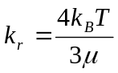 (A14)

giving a value for k_{r}(298K) of 5.5x10⁻¹⁸ m³ per particle per second. A mixture containing 2% solids, density 1g cm⁻³, primary particle size 1x10⁻⁶m would have a particle density of approximately 4x10¹⁶ particles m⁻³, giving an effective first order rate of the order of 0.2 s⁻¹.

Returning to the four questions posed at the start of this Appendix, the answer to the first question is simple, and what was expected, that the pump introduces the greatest turbulence into the system. At the highest propeller rate this may be as much as 10⁴ larger than in the pipe but is more likely to be of the order of 10 to 100 times more (based on energy density dissipation rates). The scale of turbulence in this system varies from 30 to 600 μm and so particles less than 30μm will always be below this scale. It is expected that in general this will be in the range 150 to 250 μm for normal operation and so 100μm particles will be smaller. For particles smaller than the turbulent length scale the shear forces of the fluid have been estimate and found to be in the range 10⁻¹³ to 10⁻¹¹N. This compares with the van der Waals attractive forces which are in the range 10⁻¹³ to 10⁻⁷ N. Depending on the Hamaker constants and point of closest approach the particles may or may not de-aggregate. The rate of de-aggregation is likely to be fast 0.1 to 30s⁻¹ which is comparable with the diffusion (Brownian) aggregation rate.

It is not intended as part of this work to carry out a detailed modelling analysis of either the experiments or the Tanks transfer system. The crude approach adopted here indicates which parameters are key to the agglomeration, de-agglomeration behaviour, namely : Hamaker constants, point of closest approach, primary particle size and the turbulent energy dissipation rate. Unfortunately there is quite a variation in the values of some of these parameters so it is difficults to say how the system will behave apriori to doing the experiments.

Generally the mass of a particle scales as r³, where r is the particle radius. For aggregated material this is generally not the case, the mass scaling as r^{D}, where D is the Fractal dimension < 3.
The Stimson-Jeffery force is the correction to the drag force on a particle due to the presence of a close neighbouring particle.

