Results Draft (Thesis Draft 2)

RQ1_a
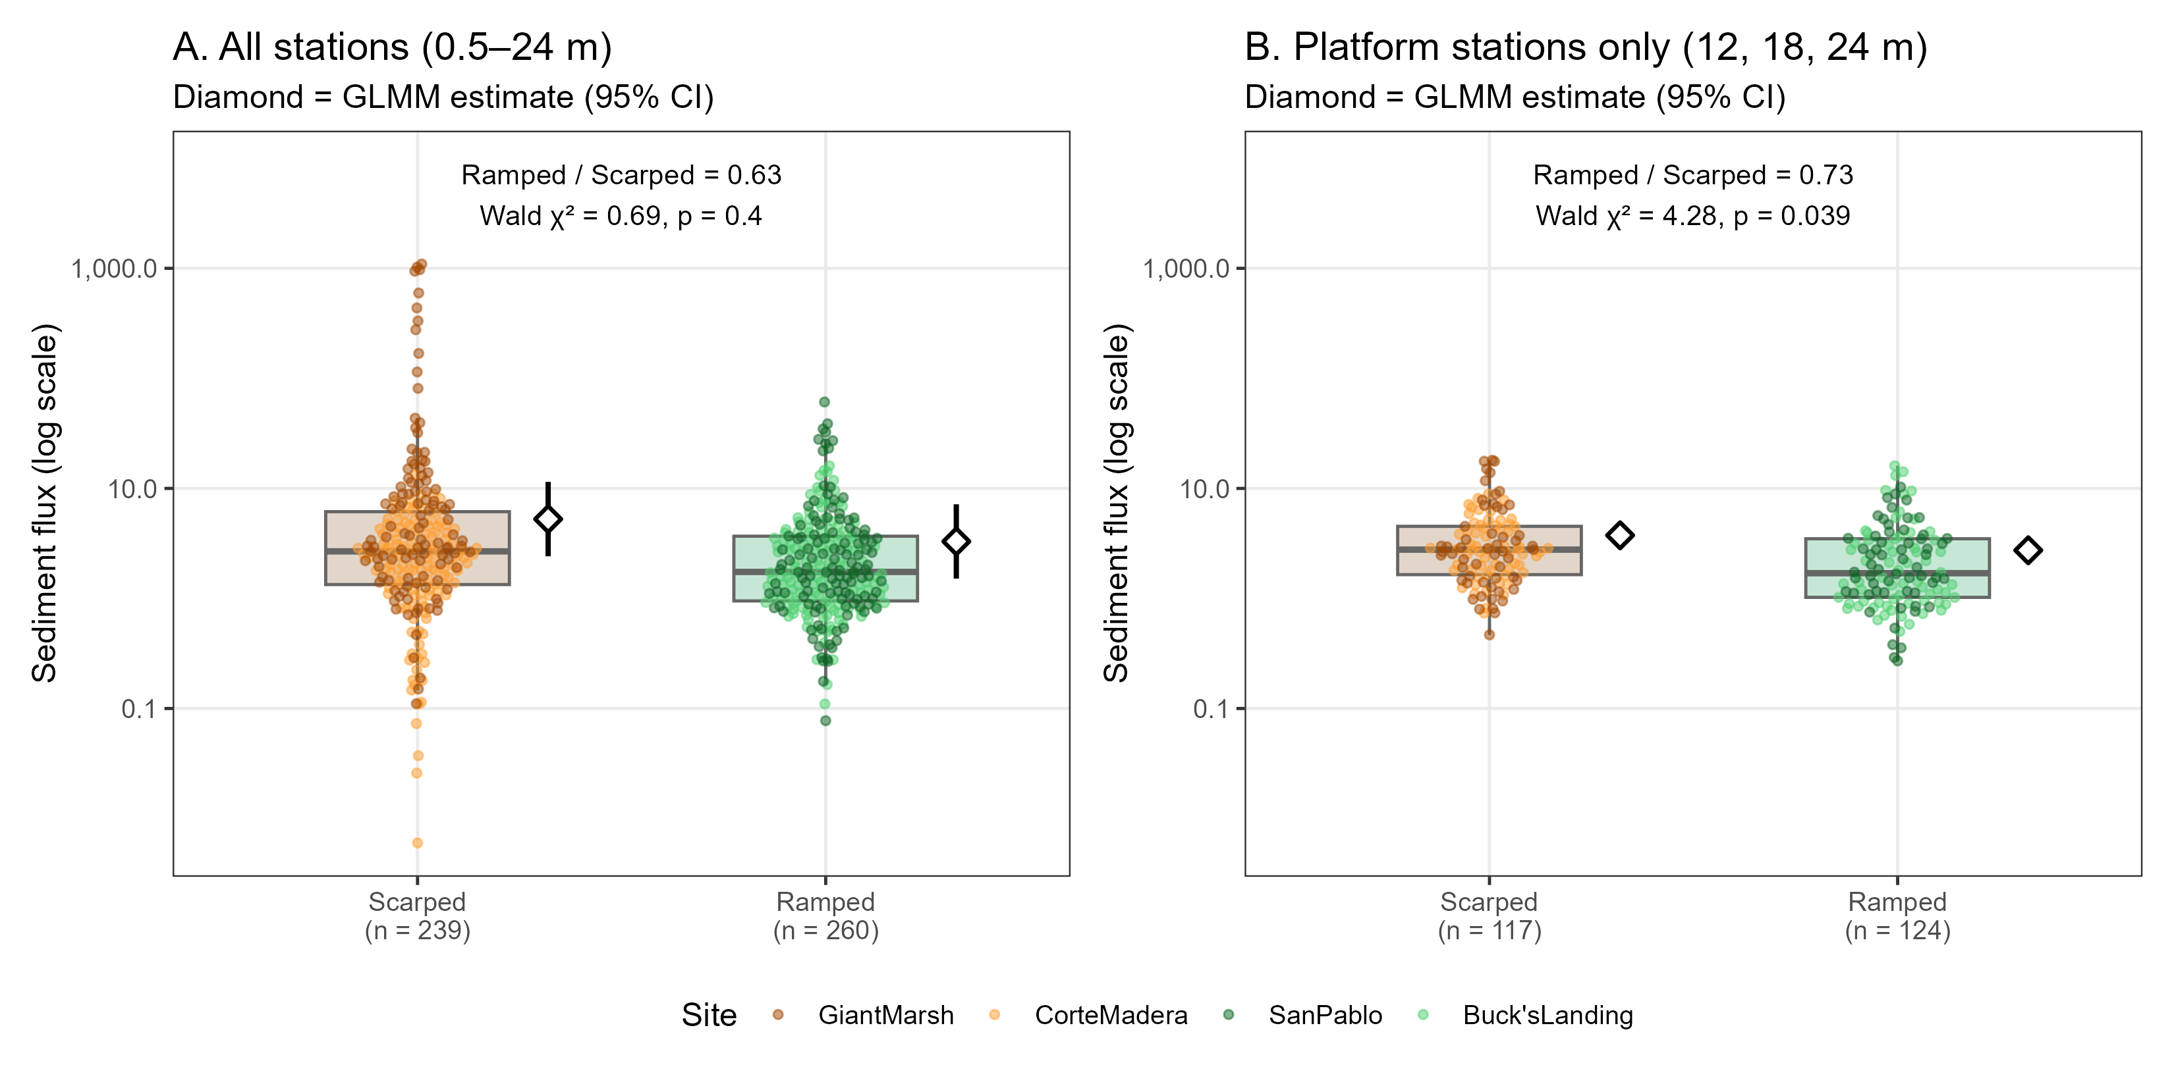

RQ2_a
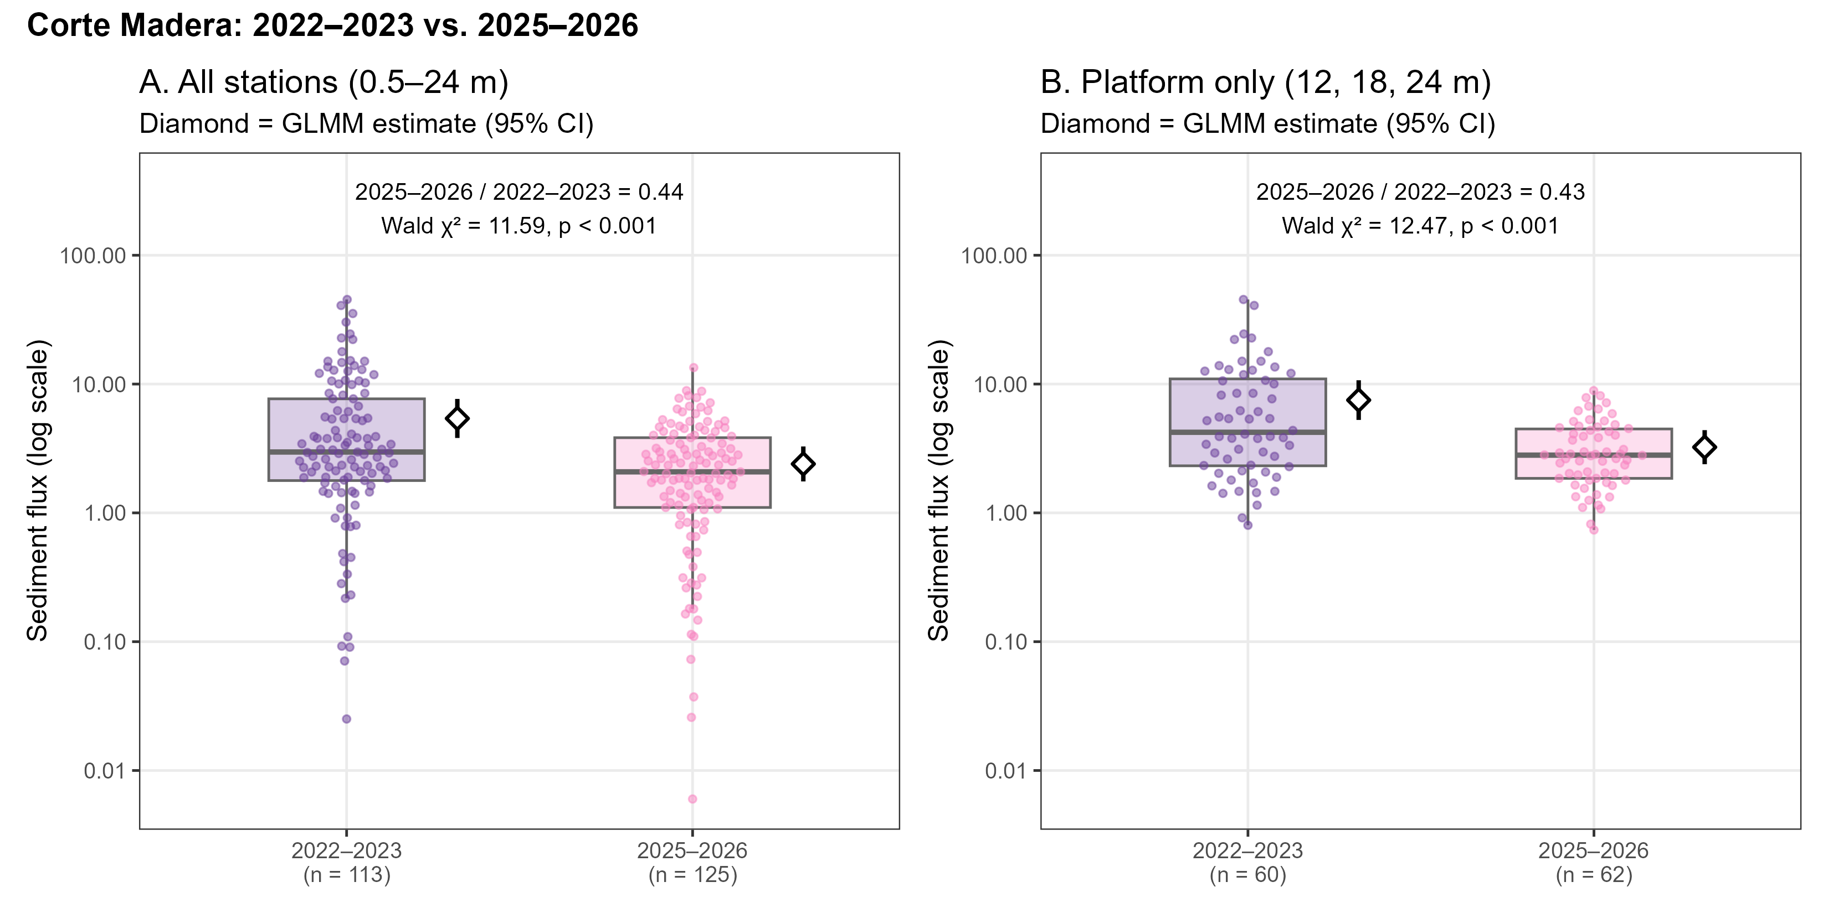

RQ3_a
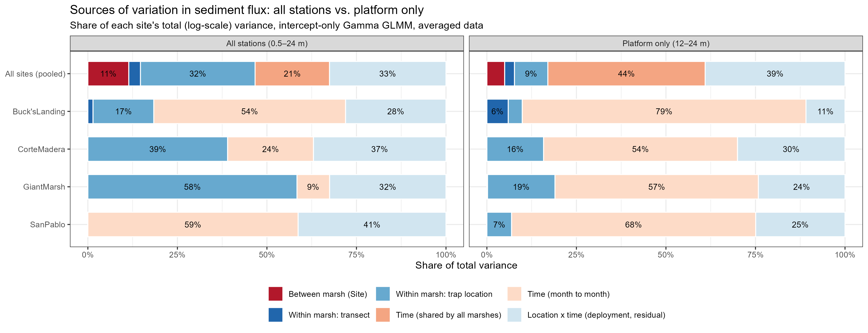

RQ3_b


