Assignment-01_web form

- Create an ASP.Net page that shows the use of Ad Rotator

Demo.aspx Code :

<asp:UpdatePanel ID="UpdatePanel1" runat="server">

<ContentTemplate>

<asp:AdRotator
ID="AdRotator1"
runat="server"
AdvertisementFile="~/XMLFile1.xml"
Width="500px"
Height="300px" />

<br /><br />

<br />

</ContentTemplate>

</asp:UpdatePanel>

Demo.aspx.cs Code :

protected void Timer1_Tick(object sender, EventArgs e)
{
// Refresh AdRotator every timer tick
AdRotator1.DataBind();
}

Output Screenshot :

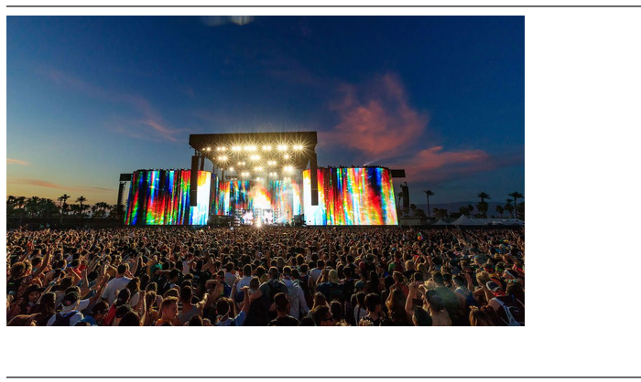

- Create an ASP.Net page that shows current day and also display selected date.

Demo.aspx Code :

<asp:Calendar ID="Calendar1" runat="server" BackColor="White" BorderColor="#3366CC" BorderWidth="1px" CellPadding="1" DayNameFormat="Shortest" Font-Names="Verdana" Font-Size="8pt" ForeColor="#003399" Height="200px" OnSelectionChanged="Calendar1_SelectionChanged" Width="220px">
<DayHeaderStyle BackColor="#99CCCC" ForeColor="#336666" Height="1px" />
<NextPrevStyle Font-Size="8pt" ForeColor="#CCCCFF" />
<OtherMonthDayStyle ForeColor="#999999" />

<SelectedDayStyle BackColor="#009999" Font-Bold="True" ForeColor="#CCFF99" />
<SelectorStyle BackColor="#99CCCC" ForeColor="#336666" />
<TitleStyle BackColor="#003399" BorderColor="#3366CC" BorderWidth="1px" Font-Bold="True" Font-Size="10pt" ForeColor="#CCCCFF" Height="25px" />
<TodayDayStyle BackColor="#99CCCC" ForeColor="White" />
<WeekendDayStyle BackColor="#CCCCFF" />
</asp:Calendar>

Demo.aspx.cs Code :

protected void Calendar1_SelectionChanged(object sender, EventArgs e)
{

Label1.Text = "Selected Date: " + Calendar1.SelectedDate.ToString("dd-MM-yyyy");
Label2.Text = "Day of the Week: " + Calendar1.SelectedDate.DayOfWeek.ToString();
}

Output Screenshot :

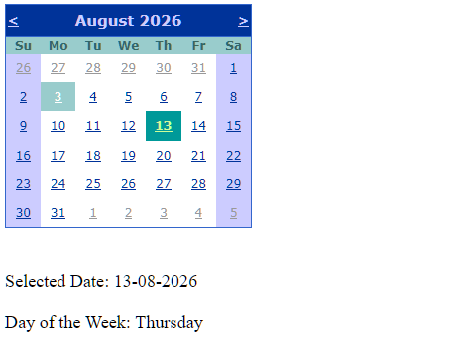

- Demonstrate the use of File Upload control.

Demo.aspx Code :

<asp:FileUpload ID="FileUpload1" runat="server" />

<br /><br />

<asp:Label ID="Label6" runat="server" Text="Label"></asp:Label>

<br /><br />

<asp:Button
ID="Button2"
runat="server"
Text="Upload"
OnClick="Button2_Click" />

Demo.aspx.cs Code :

protected void Button2_Click(object sender, EventArgs e)
{
//string file_name = System.IO.Path.GetFileName(FileUpload1.PostedFile.FileName);
//FileUpload1.SaveAs(Server.MapPath("~/img/" + file_name));
//Label6.Text = "File uploaded successfully!";

if(FileUpload1.HasFile)
{

string path = Server.MapPath("~/img/");
string filename = FileUpload1.FileName;
FileUpload1.SaveAs(path + filename);
Label6.Text = "File uploaded successfully!";

}
else
{
Label6.Text = "Please select a file to upload.";
}

Output Screenshot :

