**IT314 – SOFTWARE ENGINEERING**

**LAB – 6**

**202201192 – SMIT SHAH**



**Questions :**

1. **Develop Use Case Textual Description for "Process Sale" and "Handle Return" use cases.**

**Sol.**

***Process Sale :***

1. *Name* : Process Sale
2. *Actors* : Cashier, Customers
3. *Pre-conditions* :

* The cashier must be logged into the system.
* The system must be connected to the inventory as well as catalog systems

1. *Trigger* :

When the customers arrive to the cashier along with the items to purchase.

1. *Main Flow :*

* The cashier will initiate a new transaction in the system.
* The cashier then scans the barcode on every product.
* The system will retrieve the product’s information from inventory and deduct the purchased item from the inventory.
* Cashier may also apply any discount or valid coupon given by the customer.
* The system will calculate and display the final price due.
* Customer needs to select the payment method suitable.
* Cashier will then input all the necessary details and then the system processes the payment.
* When the payment is successful, the system generates a receipt and the sale is finalized.

1. *Post-conditions :*

* The inventory is updated once the payment is successful.
* A print of receipt is handed over to the customer.

1. *Alternative Flows* :

* If barcode is not recognized, the cashier should enter the details manually.
* If customer cannot pay full amount, the cashier cancels the transaction.
* If the payment methos fails, the cashier asks customer to try an alternative method.

**Handle Return :**

1. *Name* : Handle return
2. *Actors* : Customer, Cashier
3. *Pre-conditions :*

* The cashier must be logged in the system.
* The customer has a receipt of the items that needs to be returned.

1. *Trigger :*

The customer wants to return the purchased item.

1. *Main Flow :*

* The cashier will start a return transaction on the system as the customer provides the receipt.
* The cashier scans the barcode on returned items or enters the detail manually.
* The system verifies the items with the provided receipt.
* The inventory needs to be updated.
* The cashier asks customer for preferred return payment method and processes the refund in the system.
* When the refund is successful, the system prints the receipt and the transaction is completed.

1. *Post-conditions :*

* Update the inventory on successful refund.
* Give the customer a print of refund receipt.

1. *Alternative Flow :*

* The cashier informs the customer if in case the return period is over or item can’t be returned.
* If customer does not have the receipt the cashier handles the return manually according to store’s policy

1. **Identify Entity/Boundary Control Objects**

**Sol.**

1. *Entity objects :*

* Item :

Represents the product being purchased or returned.

* Sale Transaction :

Tracks the details of the transaction.

* Return Transaction :

Records the details of the returned items.

* Coupon :

Represents any discount during the sale.

* Receipt :

Represents the printed proof of sale.

1. *Boundary Objects :*

* POS interface :

The system interface with which the cashier interacts

* Barcode Scanner :

Device used to scan barcode.

* Payment terminal :

Hardware used in processing the payment methods.

* Printer :

Device that prints receipts.

1. *Control Objects :*

* Sale Controller :

Manages the sale process.

* Inventory Controller :

Ensuring the inventory is updated correctly.

* Coupon Controller :

Handles the validation and application of coupon discount during sale .

* Payment Controller :

Responsible for handling payment transactions.

* Return Controller :

Handles the return process by verifying returns.

1. **Develop Sequence Diagrams**

**Sol .**

**Process Sale :**

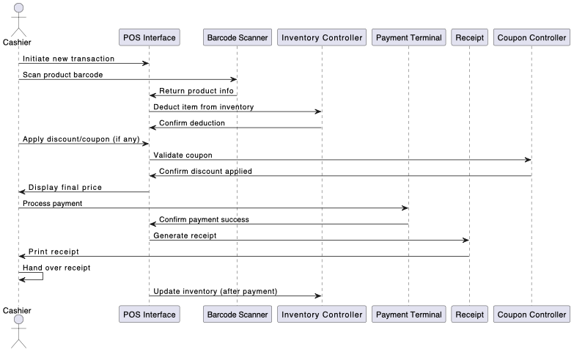

**Handle Returns :**

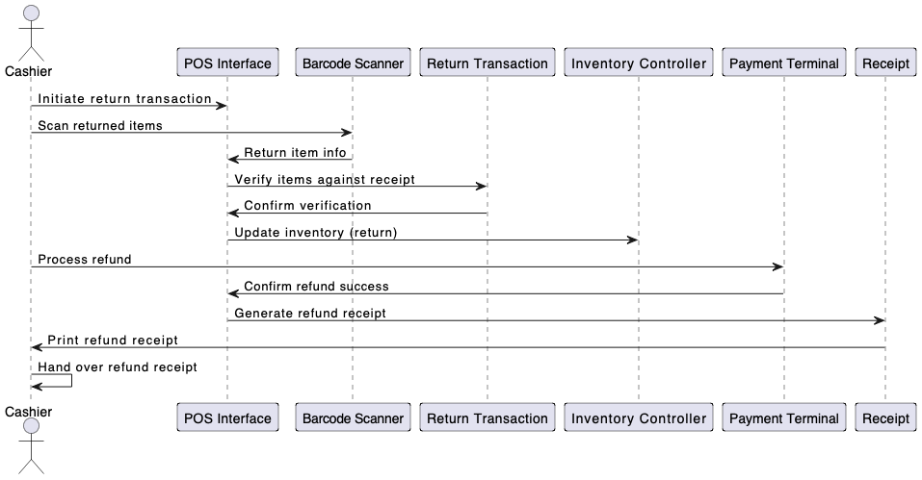

1. **Develop Analysis Domain Models**

**Sol.**

**Process Sale :**

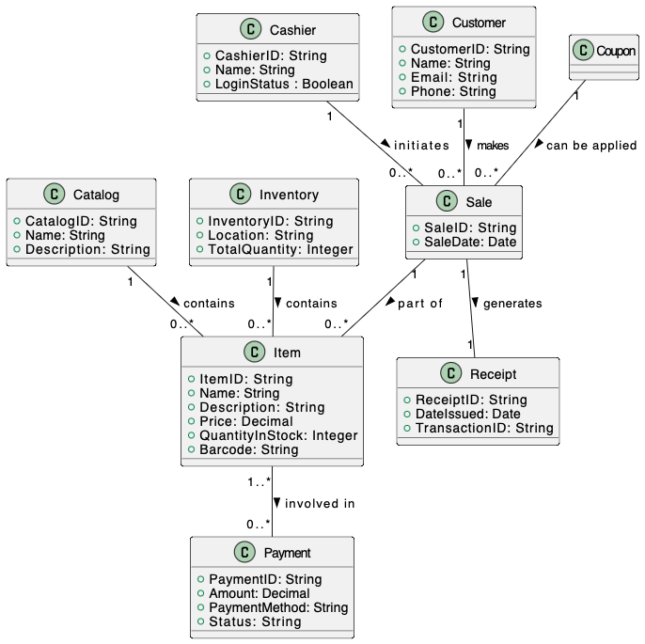

**Handle Returns :**

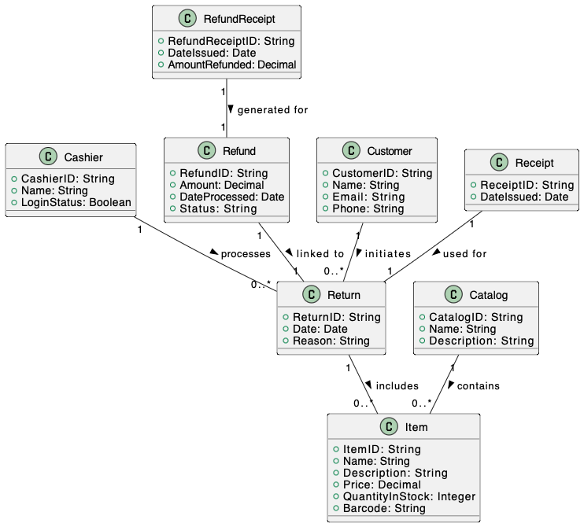

1. **Develop activity diagram for "Process Sale" and "Handle Return" use cases.**

