Experiment 1

# **Aim:** Installing Vagrant & creating basic Vagrant box using virtual box virtualization.

## **Step 1:** Download and install Oracle Virtual Box and Vagrant.

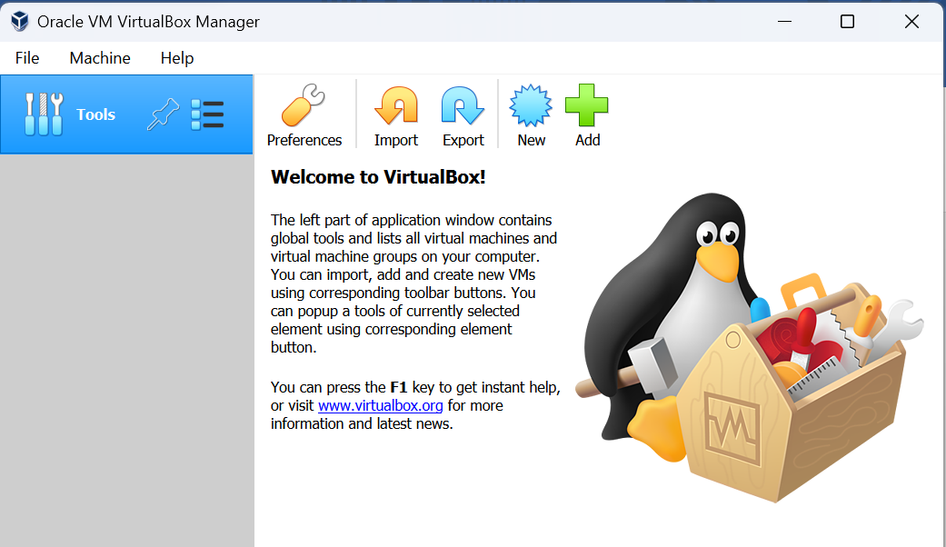

**Step 2:** Check the version of Vagrant.

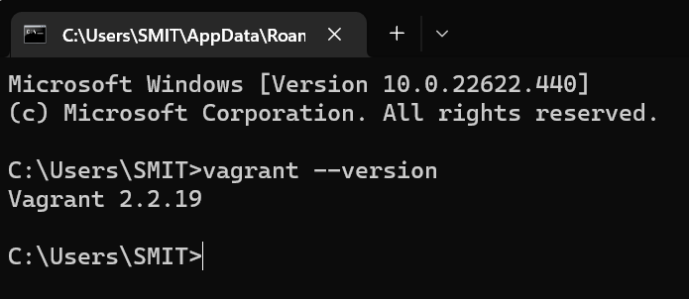

**Step 3:** Creating a new directory using CMD.

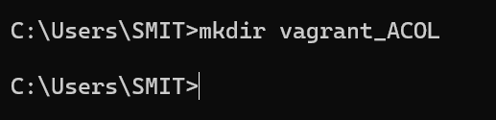

**Step 4:** Running vagrant init command

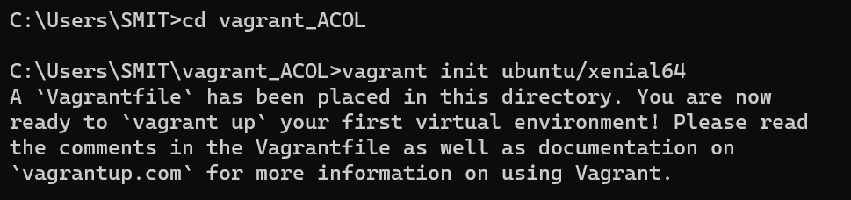

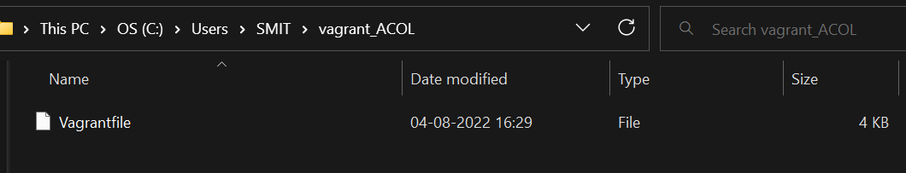

**Step 5:** Editing vagrant file and adding ubuntu/xenia64 in box tag.

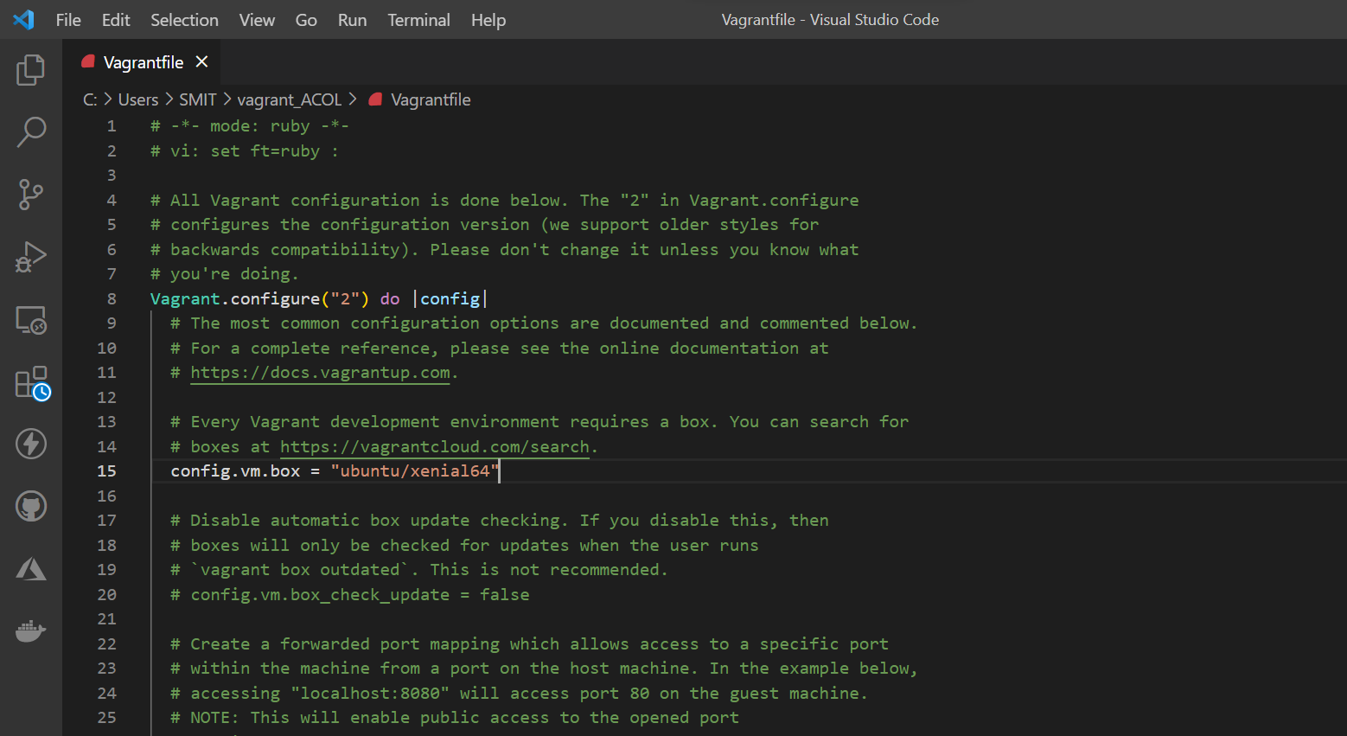

**Step 6:** Running vagrant up command.

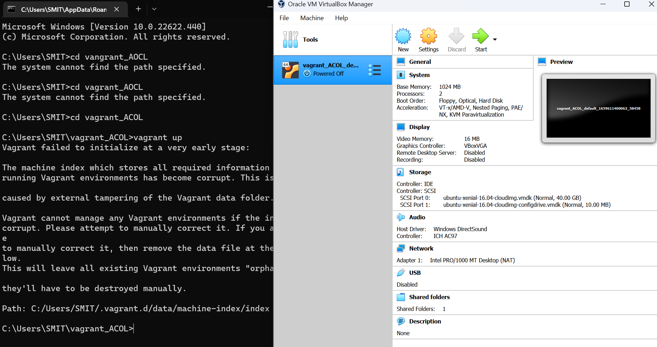

**Step 7:** Running vagrant halt command to stop VM.

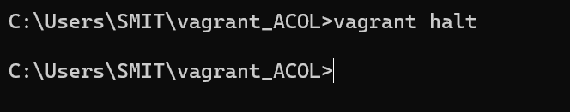

**Step 8:** Running vagrant destroy command to delete VM.

