**EXPERIMENT 2**

**AIM:** Working with Docker (Basic Commands)

1. **Search a Redis image on Docker Hub.**

Command : **docker search redis**

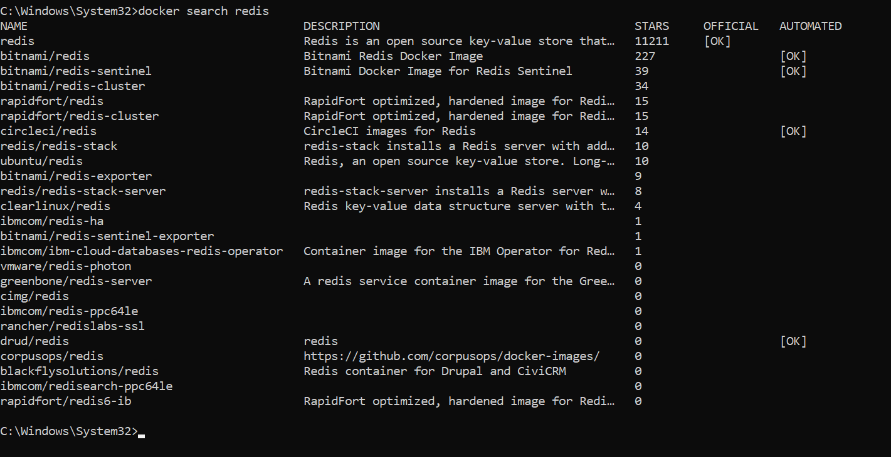

1. **Run Docker Container of Redis Image in background.**

Command: **docker run -d redis**

Command: **docker ps**

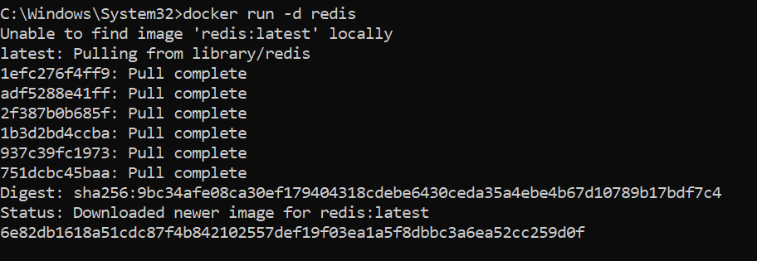



1. **Run Docker PS and Docker PS –a.**

Command: **docker ps**



Command: **docker ps -a**



1. **Run Docker Container and take its console.**

Command: **docker run redis -it /bin/bash**

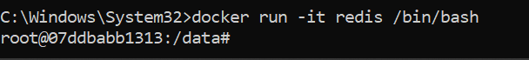

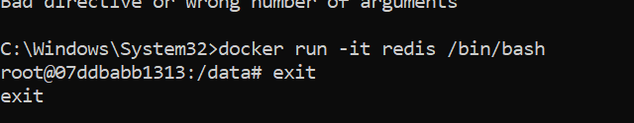

1. **Create a Docker Volume and connect it.**

Command: **docker inspect 6e82db1618a5**

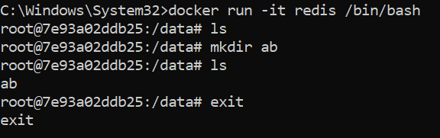

Command: **docker ps -a**

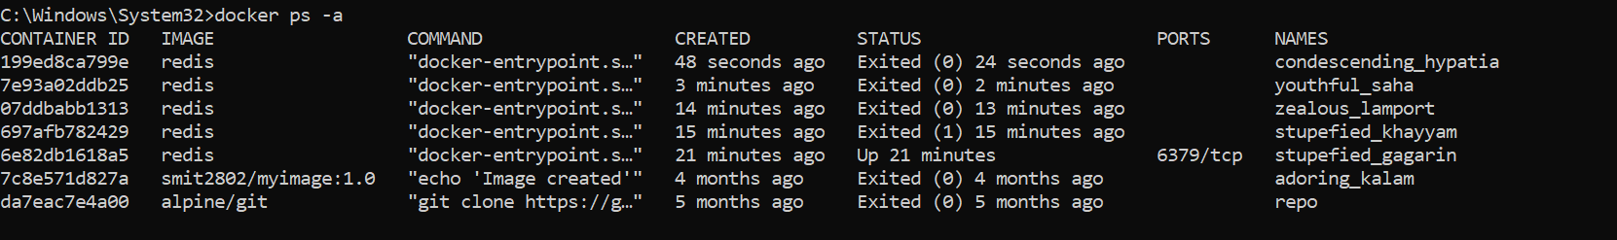

Command: **docker run -it -v myVol:/data redis /bin/bash**

