**Problem Statement**

Create a Volume Control using hand landmark detection and sign detection using Mediapipe framework and OpenCV. The project will use Google’s Hand Landmark model.

**Main packages to be used for the project**

Mediapipe

MediaPipe is a Framework for building machine learning pipelines for processing time-series data like video and audio. This is a platform Framework that works in Desktop, Mobile phones (ios and Android) and embedded devices and IoT devices. Unlike power-hungry machine learning Frameworks, MediaPipe requires only minimal resources. It is so small and efficient that embedded IoT devices also can run it.

MediaPipe is a deep learning and computer vision-based library for human skeletal posture detection. It employs machine learning (ML) to infer 21 3D landmarks of a hand from a single frame. MediaPipe offers ready-to-use but customizable Python solutions as a prebuilt package.

OpenCV

OpenCV-Python is a library of Python bindings designed to solve computer vision problems.

**Why hand movement recognition?**

The ability to perceive the shape and motion of hands is an important component in improving user experience across various technological domains and platforms. It can be the basis for sign language understanding and hand gesture control and can also enable the overlay of digital content and information on top of the physical world in augmented reality. While coming naturally to people, real-time hand perception is a challenging computer vision task, as hands often occlude themselves or each other (e.g. finger/palm occlusions and handshakes) and lack high contrast patterns.

**Hand Landmark Model of Google**

After the palm detection over the whole image, the subsequent hand landmark model performs precise keypoint localization of 21 3D hand-knuckle coordinates inside the detected hand regions via regression (direct coordinate prediction). The model learns a consistent internal hand pose representation and is resilient to partially visible hands and self-occlusions also.

To better cover the possible hand poses and provide additional supervision on the nature of hand geometry, google provides a high-quality synthetic hand model over various backgrounds and map it to the corresponding 3D coordinates.

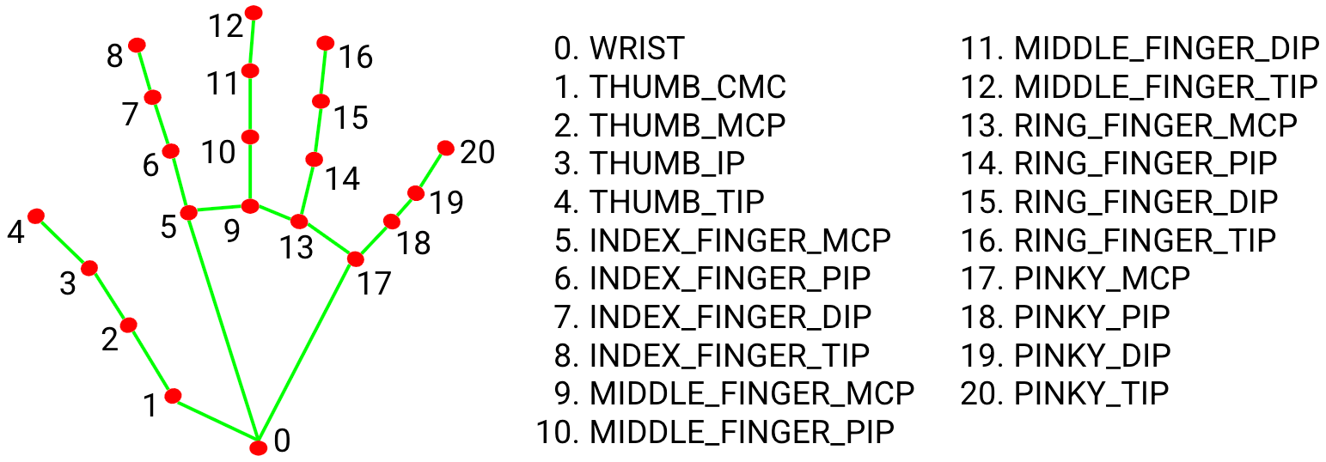

**FACE RECGNNITION**

To the already existing model of hand detection using mediapipe and open cv we have tried to create a face recognition tool which used open cv and mediapipe. We have taken care to detect a static case of the subject and have also incorporated a method to identify the webcam in the system. We have taken care of the cases to check if the webcam is active or not and then to execute the face recognition program.

**FUTURE PROSPECTS**

Extend the use of mediapipe to switch on lights and other electric devices through unique hand gestures. For the long term this project could find applications in facial recognition and differentiate between the real and lookalike faces. This could also be used for monitoring and security applications.

This could also help in digging deep to machine learning and artificial intelligence and help us find out the depth to which AI can understand and interpret our languages and gestures and whether we will be able to create an artificial brain in the future or not.

# **Links To References**

1. [OpenCV Python Tutorial - GeeksforGeeks](https://www.geeksforgeeks.org/opencv-python-tutorial/)
2. [Introduction to MediaPipe | LearnOpenCV](https://learnopencv.com/introduction-to-mediapipe/)
3. [Hand Gesture Classification Using Python | by Shanmukha Yenneti | Analytics Vidhya | Medium](https://medium.com/analytics-vidhya/hand-gesture-recognition-using-python-221623f4c4b4)
4. [Hand Gesture Recognition Using OpenCV Python | OpenCV Python Tutorial @Up Degree - YouTube](https://www.youtube.com/watch?v=QkO_3absfdw)
5. <https://www.youtube.com/watch?v=xHK>[-wv2JG18&t=632s](https://www.youtube.com/watch?v=xHK-wv2JG18&t=632s)