# Problem Statement

Create a Volume Control using hand landmark detection and sign detection using Mediapipe framework and OpenCV. The project will use Google’s Hand Landmark model.

# SUB-PARTS OF THE PROJECT

## *HAND DETECTION*

Using mediapipe framework hands are detected in the mediapipe solution for hands. We can use the data to create a finger counting system to see the number of fingers shown by the user. In this each finger can be straight or bent it doesn’t matter for the recogniser.

## *GESTURE RECOGNITION*

Using the data available from the mediapipe hand solution we have developed a gesture recognition tool on showing signs it will take a screenshot of the screen.

# *VOLUME CONTROL*

A volume control feature which increases and decreases volume using hand gestures is the third part of the project which uses mediapipe again.

# *Why hand movement recognition?*

The ability to perceive the shape and motion of hands is an important component in improving user experience across various technological domains and platforms. It can be the basis for sign language understanding and hand gesture control and can also enable the overlay of digital content and information on top of the physical world in augmented reality. While coming naturally to people, real-time hand perception is a challenging computer vision task, as hands often occlude themselves or each other (e.g. finger/palm occlusions and handshakes) and lack high contrast patterns.

# *Hand Landmark Model of Google*

After the palm detection over the whole image, the subsequent hand landmark model performs precise key point localization of 21 3D hand-knuckle coordinates inside the detected hand regions via regression (direct coordinate prediction). The model learns a consistent internal hand pose representation and is resilient to partially visible hands and self-occlusions also.

To better cover the possible hand poses and provide additional supervision on the nature of hand geometry, google provides a high-quality synthetic hand model over various backgrounds and map it to the corresponding 3D coordinates.

# SAMPLE RECOGNITION:

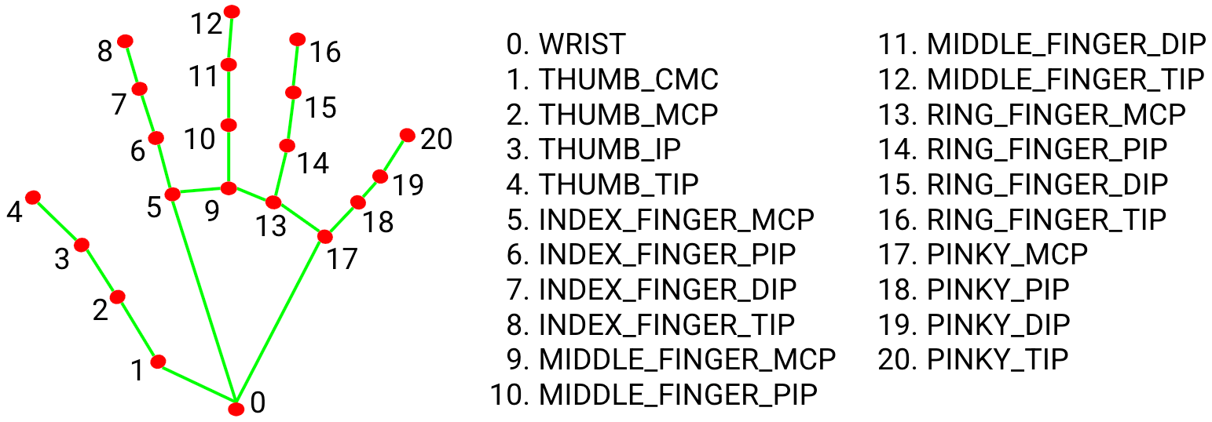

# Links To References

1. [OpenCV Python Tutorial - GeeksforGeeks](https://www.geeksforgeeks.org/opencv-python-tutorial/)
2. [Introduction to MediaPipe | LearnOpenCV](https://learnopencv.com/introduction-to-mediapipe/)
3. [Hand Gesture Classification Using Python | by Shanmukha Yenneti | Analytics Vidhya | Medium](https://medium.com/analytics-vidhya/hand-gesture-recognition-using-python-221623f4c4b4)
4. [Hand Gesture Recognition Using OpenCV Python | OpenCV Python Tutorial @Up Degree - YouTube](https://www.youtube.com/watch?v=QkO_3absfdw)
5. <https://www.youtube.com/watch?v=xHK>[-wv2JG18&t=632s](https://www.youtube.com/watch?v=xHK-wv2JG18&t=632s)

# CURRENT STATUS

We have completed the first part of the project . We have worked on hand recognition and halfway done with volume control and we expect to finish the whole project by the the end of the month.