Github

Git is a modern and widely used **distributed version control** system in the world. It is developed to manage projects with high speed and efficiency. The version control system allows

us to monitor and work together with our team members at the same workspace.

What is Git?

**Git** is an **open-source distributed version control system**. It is designed to handle minor to major projects with high speed and efficiency. It is developed to co-ordinate the work among the developers. The version control allows us to track and work together with our team members at the same workspace.Hello Java Program for Beginners

Git is foundation of many services like **GitHub** and **GitLab**, but we can use Git without using any other Git services. Git can be used **privately** and **publicly**.

Git was created by **Linus Torvalds** in **2005** to develop Linux Kernel. It is also used as an important distributed version-control tool for **the DevOps**.

Git is easy to learn, and has fast performance.

What is Github?

GitHub is a Git repository hosting service. GitHub also facilitates with many of its features, such as access control and collaboration. It provides a Web-based graphical interface.

GitHub is an American company. It hosts source code of your project in the form of different programming languages and keeps track of the various changes made by programmers.

It offers both **distributed version control and source code management (SCM)** functionality of Git. It also facilitates with some collaboration features such as bug tracking, feature requests, task management for every project.

It is an Internet hosting service for software development and version control using Git.

## Benefits of Git

A version control application allows us to **keep track** of all the changes that we make in the files of our project. Every time we make changes in files of an existing project, we can push those changes to a repository. Other developers are allowed to pull your changes from the repository and continue to work with the updates that you added to the project files.

Some **significant benefits** of using Git are as follows:

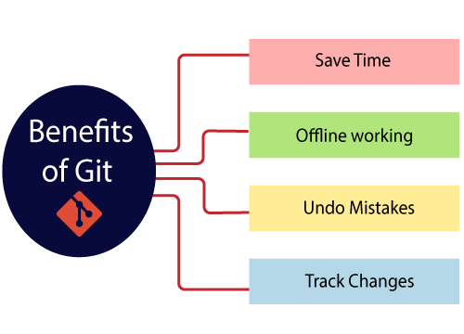

* **Saves Time**  
  Git is lightning fast technology. Each command takes only a few seconds to execute so we can save a lot of time as compared to login to a GitHub account and find out its features.
* **Offline Working**  
  One of the most important benefits of Git is that it supports **offline working**. If we are facing internet connectivity issues, it will not affect our work. In Git, we can do almost everything locally. Comparatively, other CVS like SVN is limited and prefer the connection with the central repository.
* **Undo Mistakes**  
  One additional benefit of Git is we can **Undo** mistakes. Sometimes the undo can be a savior option for us. Git provides the undo option for almost everything.
* **Track the Changes**  
  Git facilitates with some exciting features such as **Diff, Log,** and **Status**, which allows us to track changes so we can **check the status, compare** our files or branches.

Features of Github:

Some of its significant features are as follows.

* Collaboration
* Integrated issue and bug tracking
* Graphical representation of branches
* Git repositories hosting
* Project management
* Team management
* Code hosting
* Track and assign tasks
* Conversations
* Wikisc

Benefits of GitHub

GitHub can be separated as the Git and the Hub. GitHub service includes access controls as well as collaboration features like task management, repository hosting, and team management.

The key benefits of GitHub are as follows.

* It is easy to contribute to open source projects via GitHub.
* It helps to create an excellent document.
* You can attract recruiter by showing off your work. If you have a profile on GitHub, you will have a higher chance of being recruited.
* It allows your work to get out there in front of the public.
* You can track changes in your code across versions.

There are main two ways of upload project on github:

1. Using Gitbash
2. Via upload in Github Repository

How to upload and host project on github?

* 1. Create Account on Github
  2. Create repository on your account
  3. Choose add file
  4. In add file choose upload file
  5. Upload file of project

If project the is website you can host it on github pages.

* 1. open settings in your project repository
  2. left side click on pages
  3. Select branch as main and click on save
  4. After a few minutes a link pop up and says that your website is ready.