Smit Naik

April 2, 2020

Submission: “Deploy Static Website on AWS”

ENDPOINT URL: http://d1b12g3khyalvu.cloudfront.net/index.html

Website URL: http://uddevopslab-website.s3.amazonaws.com/index.html

In this project, you will deploy a static website to AWS using S3, CloudFront, and IAM.

The files included are:

index.html - The Index document for the website.

/img - The background image file for the website.

/vendor - Bootssrap CSS framework, Font, and JavaScript libraries needed for the website to function.

/css - CSS files for the website

Screen shots:

1. Created S3 bucket: “uddevopslab-website”

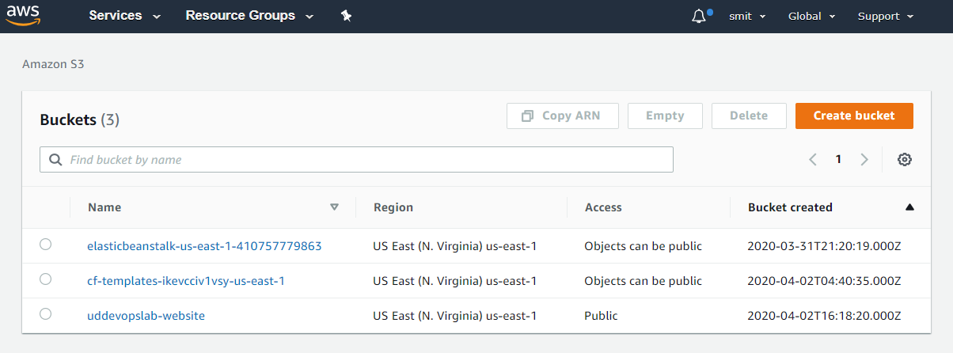

2. Set permissions: Unchecked “Block all public access”

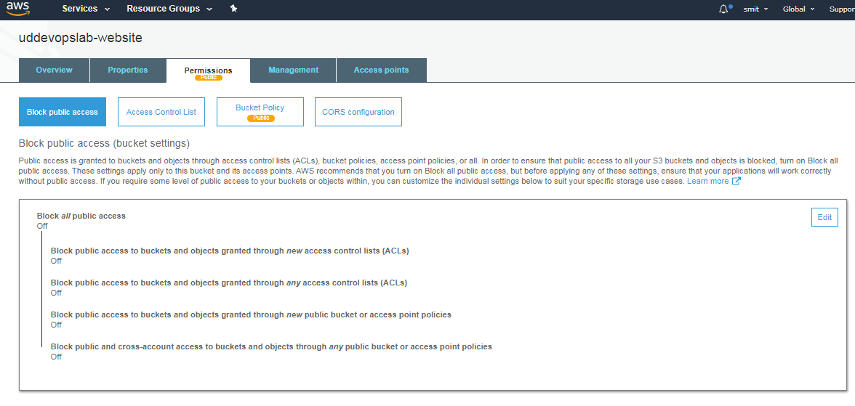

3. Uploaded Source code to S3 bucket.

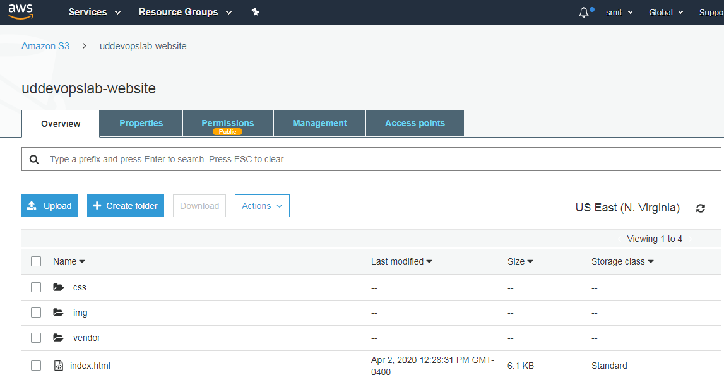

4.Securing S3 bucket via IAM.

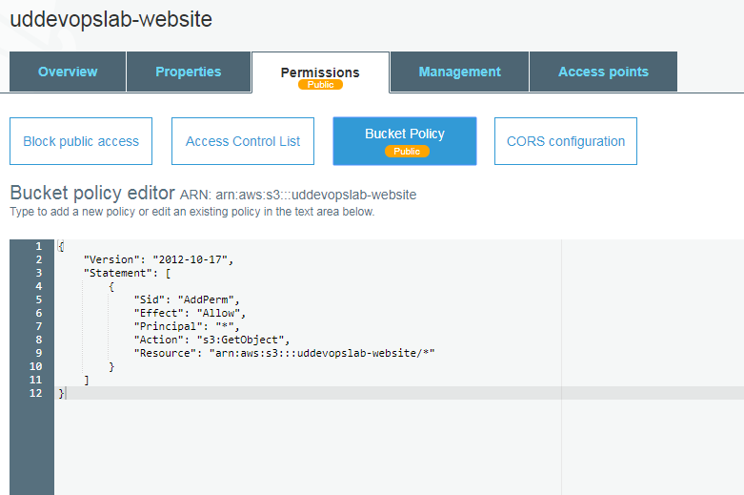

5. Configuring S3 bucket.

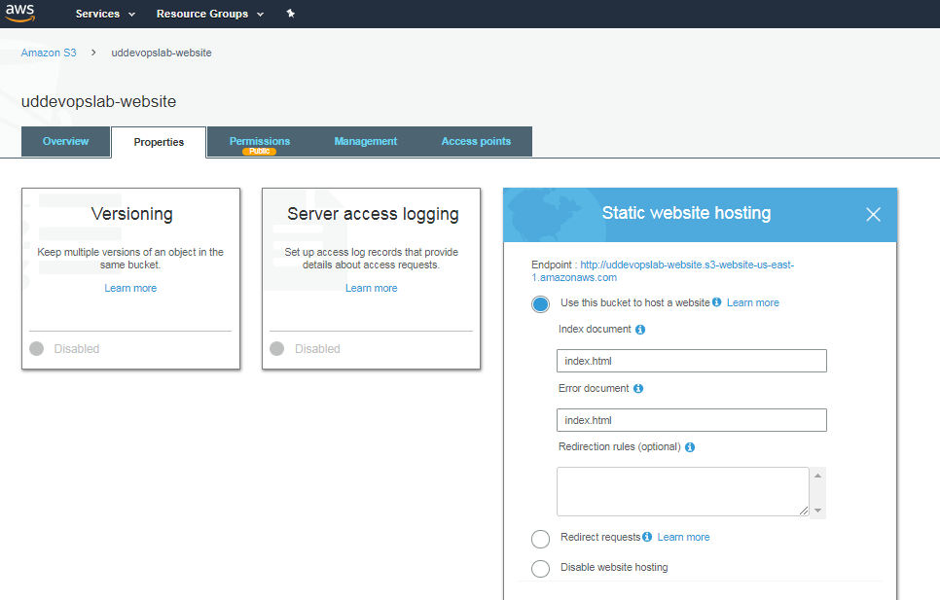

6. Distribute website via cloudfront:

