This document outlines Data Model, SQL queries necessary to load data into BigQuery tables, handle regular data updates, and create fact tables for mortality rates and net worth by age group.

**Data Model**

The data model comprises five main tables designed to store and analyse data related to causes of death, household income and wealth, and user information.

1. **dim_safe_user**
   * user_id (PK): Unique identifier for each user.
   * user_region: Geographic region of the user.
   * user_dob: Date of birth of the user.
   * age_group: Age group classification of the user.
2. **dim_household_income_and_wealth**
   * item_type (PK): Category of the item (e.g., financial assets, Non-financial assets).
   * item (PK): Specific item within the category.
   * age_15_24 to age_75_and_over: Values for different age groups.
3. **dim_cause_of_death_2015_2017**
   * cause_of_death (PK): Specific cause of death.
   * number_males: Number of males who died from this cause.
   * number_females: Number of females who died from this cause.
   * number_persons: Total number of persons who died from this cause.
   * rate_males, rate_females, rate_person: Mortality rates per 100,000 total persons**.**
   * age_group: Age group classification for the cause of death data.
4. **fact_age_group_mortality_rates**
   * age_group (PK): Age group classification.
   * rate_person_2015 to rate_person_2017: Mortality rates per 100,000 total_persons for each year.
   * cause_of_death (FK): Cause of death reference.
5. **fact_age_group_across_net_worth**
   * age_group_across_net_worth_id (PK): Unique identifier for each record.
   * user_id (FK): Reference to the user ID.
   * age_group (FK): Age group classification.
   * net_worth: Combined net worth of the age group.

Relationships

* dim_safe_user links to fact_age_group_across_net_worth through the user_id and age_group fields.
* dim_household_income_and_wealth contributes data to fact_age_group_across_net_worth for calculating net worth by age group.
* dim_cause_of_death_2015_2017 data is summarized in fact_age_group_mortality_rates which provides mortality rates by age group.
* fact_age_group_mortality_rates links to fact_age_group_across_net_worth through the age_group field.

Top of Form

Bottom of Form

**SQL**

The following tables are created to store the data:

1. Cause of Death Tables

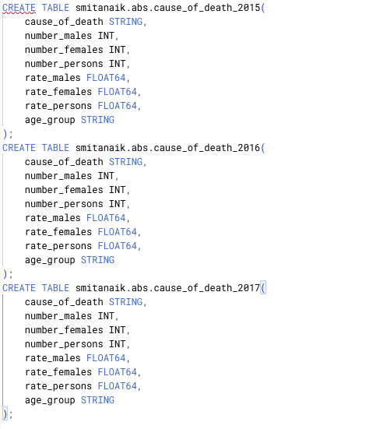

1. Houseold_income_and_wealth and safe_userTable

The MERGE statement ensures the tables are updated with new data and existing records are modified if necessary.

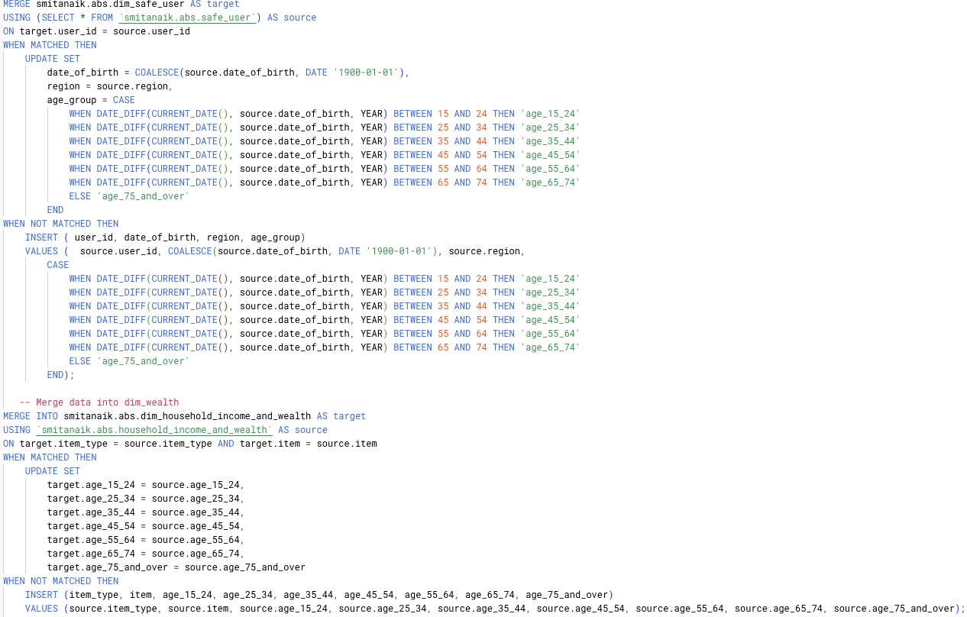

Fact Table for Mortality Rates by Age Group

This query aggregates the mortality rates by age group across the years 2015, 2016, and 2017.

Fact Table for net worth by Age Group

This query aggregates the net worth = (all assets – liabilities) for the age group for the users.  
  
