Business Requirement Document

MedJam's Integrated Signup and Engagement Experience for LoraLife Users

Contents

Executive summary 3

Problem Statement 3

Solution Overview 3

In Scope 4

Out of Scope 4

High level process flow diagram 5

Assumptions 5

Risks 6

Limitations 6

High level requirements 6

Detailed level requirements 6

Appendix 7

# Executive summary

MedJam’s business objective is to develop a savings card for the medication “LoraLife” which will allow those patients who will sign up on their website to avail benefits of saving money when fulfilling a prescription for LoraLife.

MedJam is partnered with “SavingsCo” and is integrating with them as a third-party vendor that manages LoraLife savings card on MedJam’s behalf. After a successful sign up by a customer, SavingsCo will pass a saving card number to MedJam which will then be forwarded to the participant in pdf format. A welcome email will also be sent to the customer and if customers are not redeeming the medication on their saving card, then follow up email will be sent to them.

# Problem Statement

The primary challenge is that the high cost of *LoraLife* medication creates significant financial barriers for patients, who are actively seeking consistent, accessible discounts. MedJam currently faces the following key issues:

1. **Lack of Real-Time Discount Application:** Without the technical infrastructure, MedJam is unable to provide an efficient, seamless way for customers to apply discounts at the point of prescription fulfillment across various pharmacies.
2. **Integration Gaps:** MedJam lacks the expertise and technical framework to integrate with pharmacy networks for streamlined discount management and real-time savings card validation.

# Solution Overview

To address the challenges outlined, MedJam will leverage its partnership with *SavingsCo*, a third-party vendor, to manage the entire savings card process. This integration will enable MedJam to offer a seamless, end-to-end customer experience, providing real-time discounts on *LoraLife* prescriptions at participating pharmacies.

MedJam will charge customers an annual subscription fee, creating a mutually beneficial arrangement for both companies while maximizing value for the customer by ensuring consistent savings on their medication.

Additionally, by partnering with *SavingsCo*, MedJam gains access to an established network of pharmacies already integrated with the vendor, expanding the reach and availability of the savings program, further enhancing the overall value proposition for customers.

# In Scope

1. MedJam will integrate with *SavingsCo* to manage the entire savings card process, including issuance, validation, and redemption.
2. Upon subscribing to MedJam's newsletter, customers will automatically receive a savings card number via PDF email.
3. Savings can only be applied at the point of prescription fulfillment in real time at participating pharmacies.
4. Customers can redeem discounts exclusively on a valid LoraLife prescription presented at approved pharmacies.

# Out of Scope

1. Customers will not be able to apply savings to past prescriptions of LoraLife.
2. The savings card is exclusively valid for LoraLife prescriptions and cannot be used for other medications.
3. A physical card will not be issued to customers; only a digital savings card will be provided via PDF email.

# High level process flow diagram

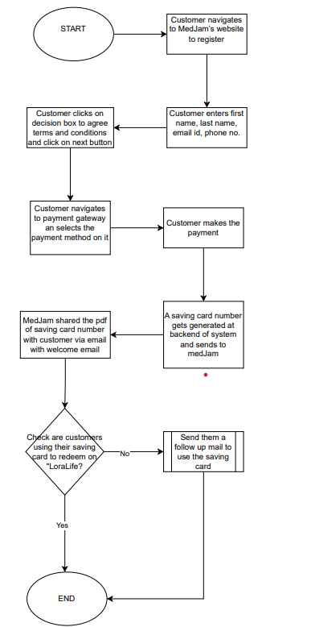

# Assumptions

1. MedJam will own the *LoraLife* savings card product, but the card’s management, including issuance and redemption, will be fully handled by *SavingsCo*.
2. Saving card will be functional to participating pharmacies.
3. *SavingsCo* will define and manage the business rules that govern the savings card’s functionality, ensuring compliance and effective discount application.
4. *SavingsCo will integrate with different payment gateways such as card payment, mobile payment, Bank transfer, wallet payments, etc.*
5. *SavingsCo* has an established algorithm to calculate and generate revenue by applying discounts, which will also drive the revenue-sharing model.
6. *SavingsCo* will utilize its proprietary algorithm to generate unique savings card numbers for each customer.
7. MedJam will have full access to a dashboard that provides insights into key metrics, including the number of cardholders, total benefits redeemed, and the market penetration achieved.
8. MedJam will focus its efforts on market segments where *LoraLife* medication is underutilized or where patients are not receiving the full benefits of the savings card program, to improve accessibility and engagement.

# Risks

1. **Low Customer Potential:** There is a limited customer base currently engaged in the savings card program, which impacts the overall effectiveness and reach of the initiative.
2. **Limited Decision-Making Involvement:** *SavingsCo* is not actively involving MedJam in key decision-making processes, potentially limiting MedJam’s control over the direction and optimization of the savings card program.
3. **Pharmacy Participation Challenges:** New pharmacies are hesitant to participate in the program due to concerns over low revenue generation and insufficient incentives to join the initiative.

# Limitations

1. The savings card is exclusively applicable to LoraLife and cannot be used for any other medications.
2. A physical copy of the savings card will not be issued; the discount can only be availed through the digital savings card.
3. Discounts will only be applicable when the digital savings card is presented in real time at participating pharmacies with an active prescription.
4. Customers cannot pay for the medication upfront and later seek reimbursement; the discount must be applied at the point of sale.

# High level requirements

1. To subscribe, customers must provide their information and click the "Submit" button to join the newsletter list.
2. After submission, customers will be redirected to a payment gateway to complete the yearly subscription payment.
3. Upon successful payment, a savings card number will be generated by *SavingsCo* and sent to MedJam for distribution to the registered customer through a pdf.
4. *SavingsCo* will track all cardholders and provide a dashboard that displays key metrics, such as the number of cardholders and their benefits, for stakeholder review.
5. MedJam admins will have secure login access to the application, enabling them to view the dashboard and track key data as needed.

# Detailed level requirements

1. To subscribe, customers must provide their information and click the "Submit" button to join the newsletter list.

* Customer first name
* Last name
* Email id
* Phone number
* Agree to terms and condition box
* Click on submit button

1. After submission, customers will be redirected to a payment gateway to complete the yearly subscription payment.

* Navigate to the payment gateway
* Select payment method
* Card payment: Enter card details such as name on card, card number, expiry date, CVV
* Digital Wallets: Open the wallet pay such as apple pay, google pay, Scan the QR code to make payment
* Mobile Payments: Use Stripe, venmo to make secure payments
* Notification is received via email of successful payment

1. Upon successful payment, a savings card number will be generated by SavingsCo and sent to MedJam for distribution to the registered customer through a pdf.

* Generate saving card number using the algorithm set
* Call an API to send the saving card number to MedJam server
* MedJam to send the card number to registered customer

1. SavingsCo will track all cardholders and provide a dashboard that displays key metrics, such as the number of cardholders and their benefits, for stakeholder review.

* Number of cardholders
* Cardholders information
* Total discount provided
* Total pharmacies participated
* Dashboard highlighting above points

1. MedJam admins will have secure login access to the application, enabling them to view the dashboard and track key data as needed.

* Admin’s login credentials
* Navigate through monthly, quarterly and yearly dashboard

# Appendix