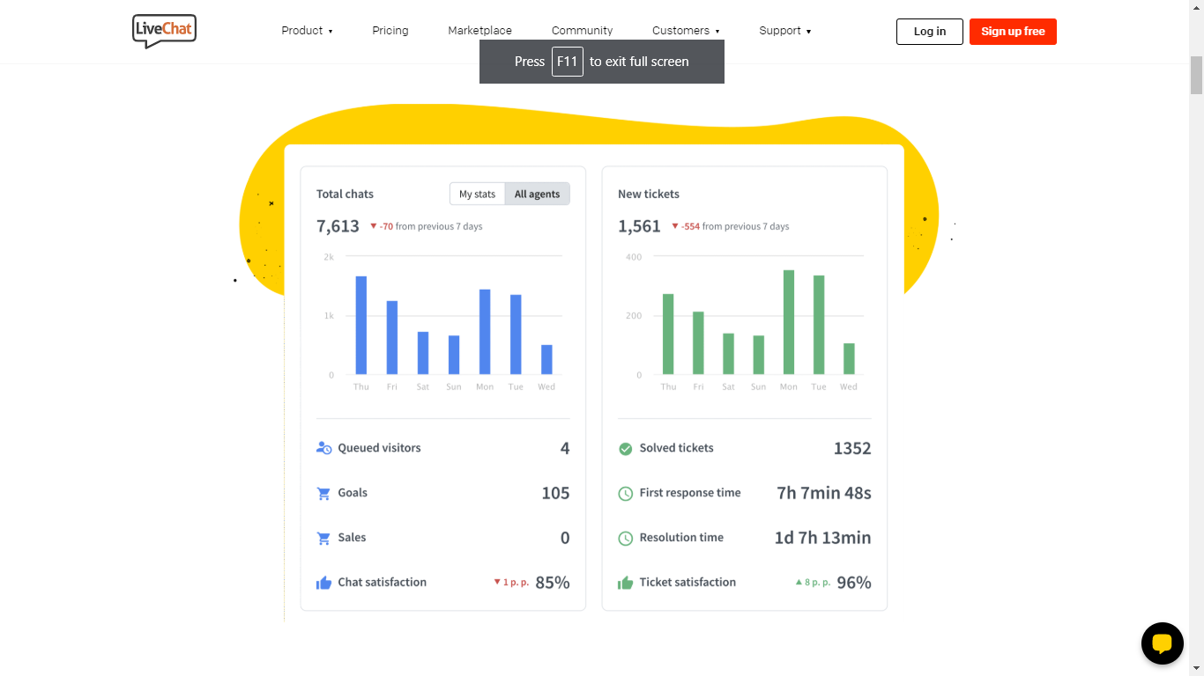

It has features :

Total Chats: The number of chats your team handles every day. The more conversations you have, the more opportunities to advise visitors and sell more

Missed chats: Make sure you are not leaving some customers empty-handed with the missed chats report. If you do, LiveChat gives you a way to get back to them and offer help.

Greetings conversion: Greetings are an easy way to encourage your customers to talk to you. See which greetings are the most efficient, and which need some tweaking.

Chat satisfaction: Keep your customers happy by tracking customer satisfaction with your team and individual agents.

Chat engagement : Check where your chats come from to see if your team can do more to engage visitors on your website.

Chat surveys: Chat surveys let you collect info about your customers that is important for your business. In chat reports, you see all that data in one place.

Chat availability: View how long during the week your team is available for customers.

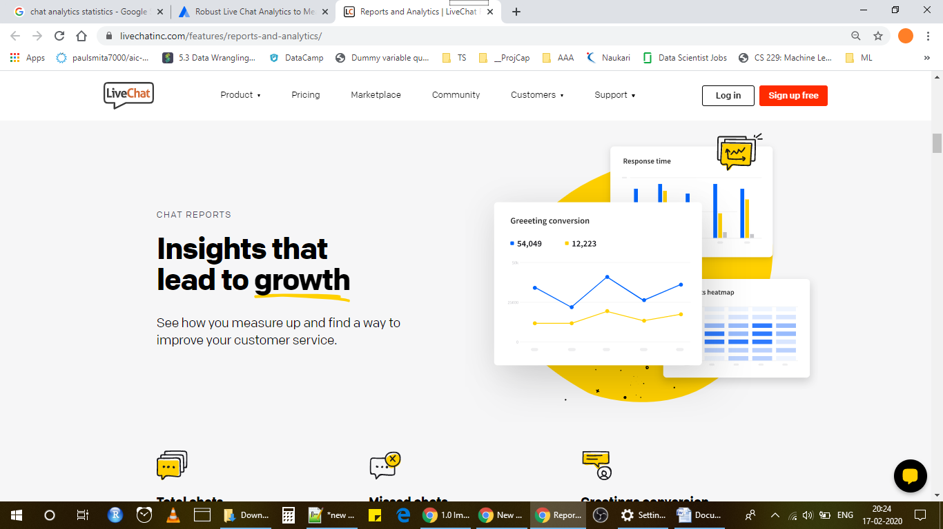

# Solve problems case by case:

Streamline your email support with the help of the ticket reports.

New tickets: The number of tickets your agents need to deal with on a daily basis. A great indicator of how many customers have issues with your product or app.

Solved tickets: Make sure that your team stays efficient, and solves a certain number of cases every day.

Ticket satisfaction: Tickets take longer to resolve and can be more frustrating for customers. Check if they are satisfied with your agents’ work.

Resolution time: Resolution time is a big factor in customer satisfaction. This report helps you keep this metric healthy.

First response time: Make sure your agents don’t make your customers wait for the first reply for too long.

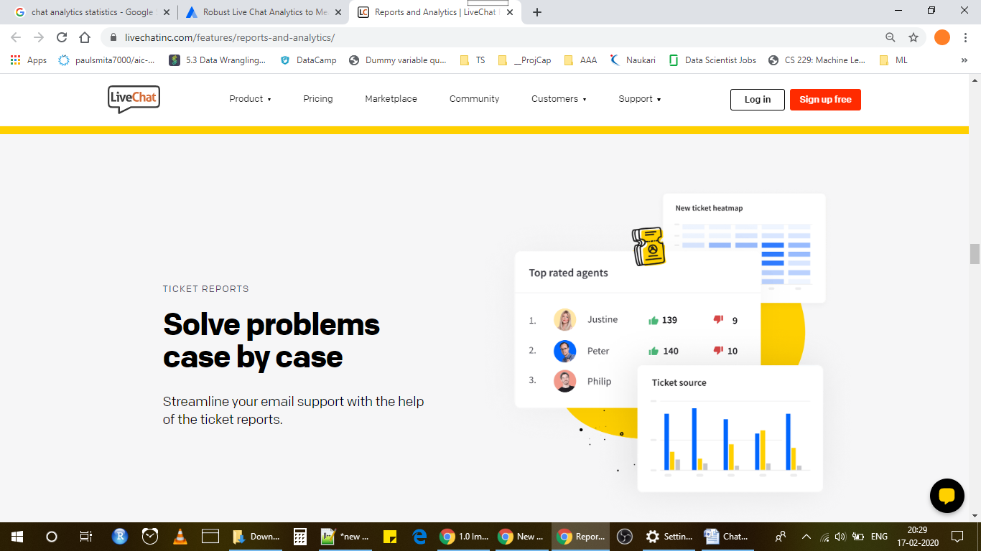

# Queued customers

Check how many potential customers leave the queue before they get a chance to talk to your team.

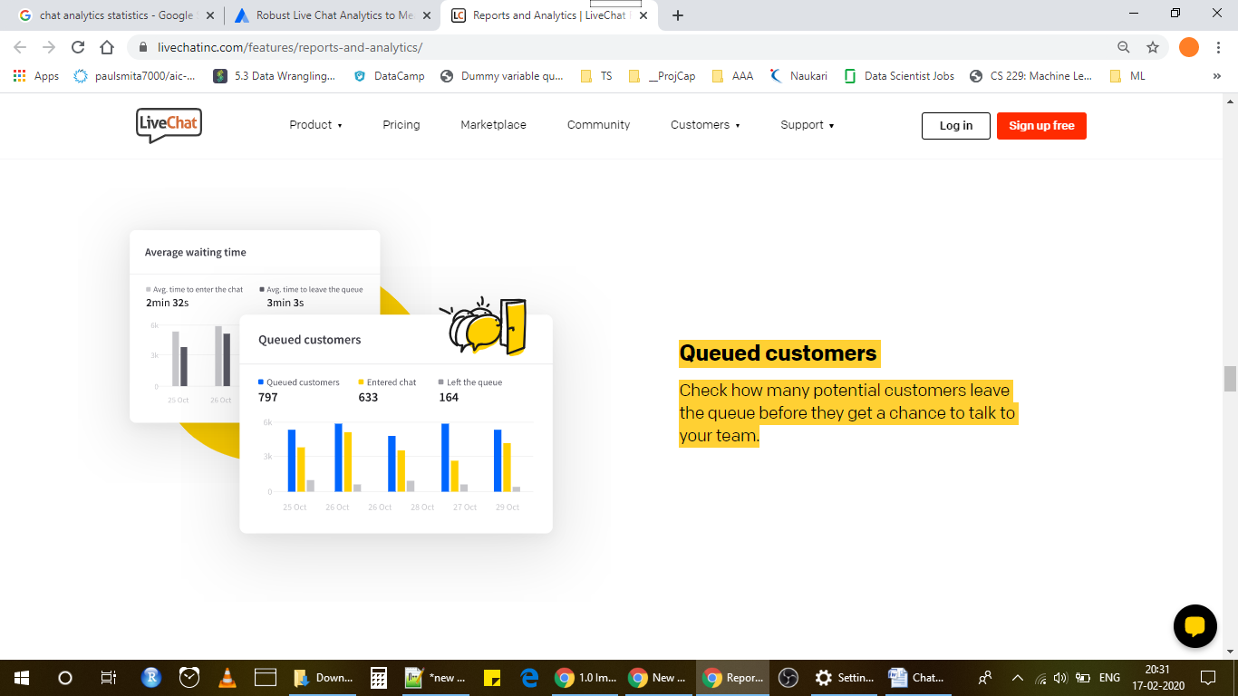

# Queue abandonment

Message customers who left the queue before getting connected to an agent.

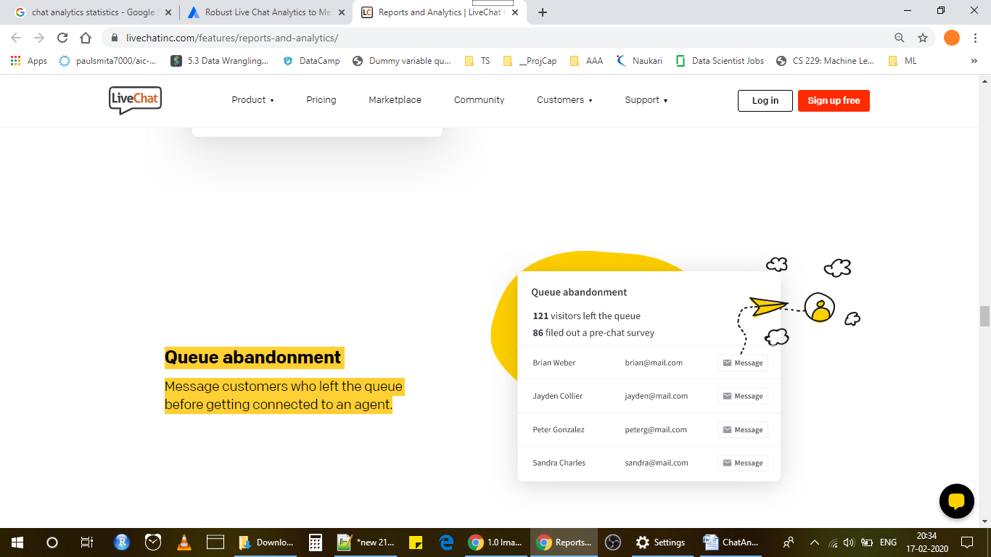

Achieved goals

This report shows how many of your chats end up with the desired action taken by the visitor. For example, a sale or a signup. You can track the statistics for each goal you create separately.

<https://www.zendesk.com/chat/live-chat-analytics/>  
  
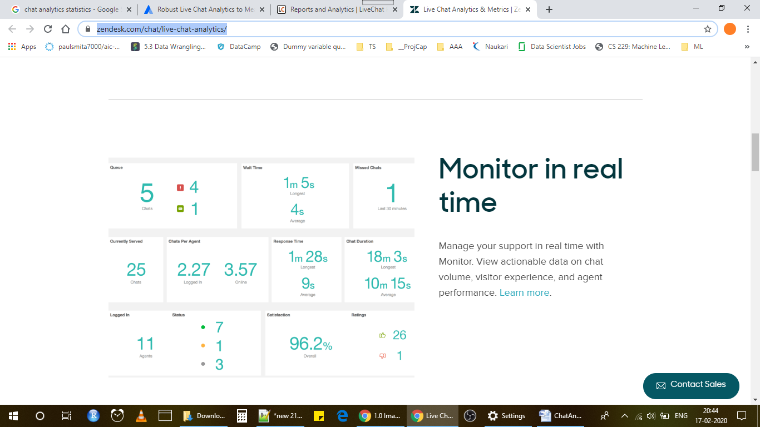

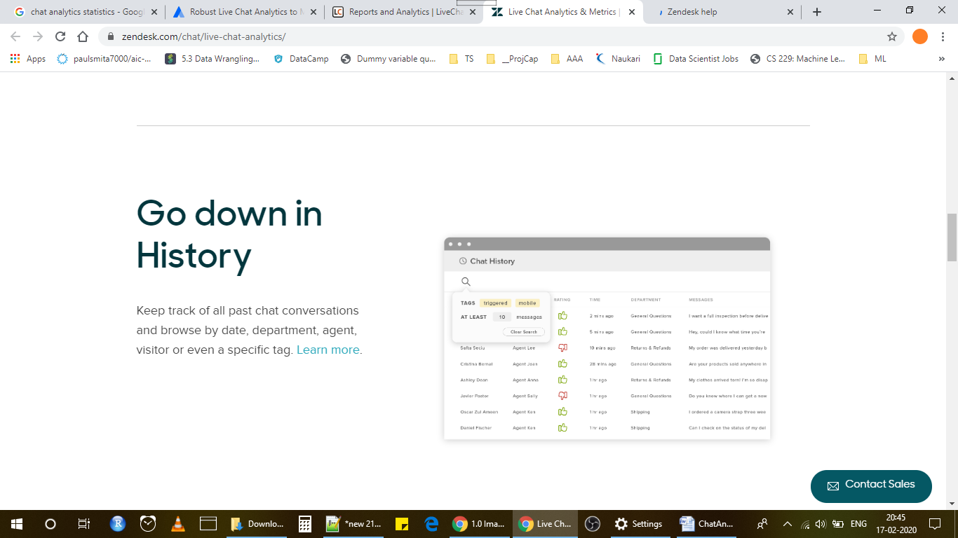

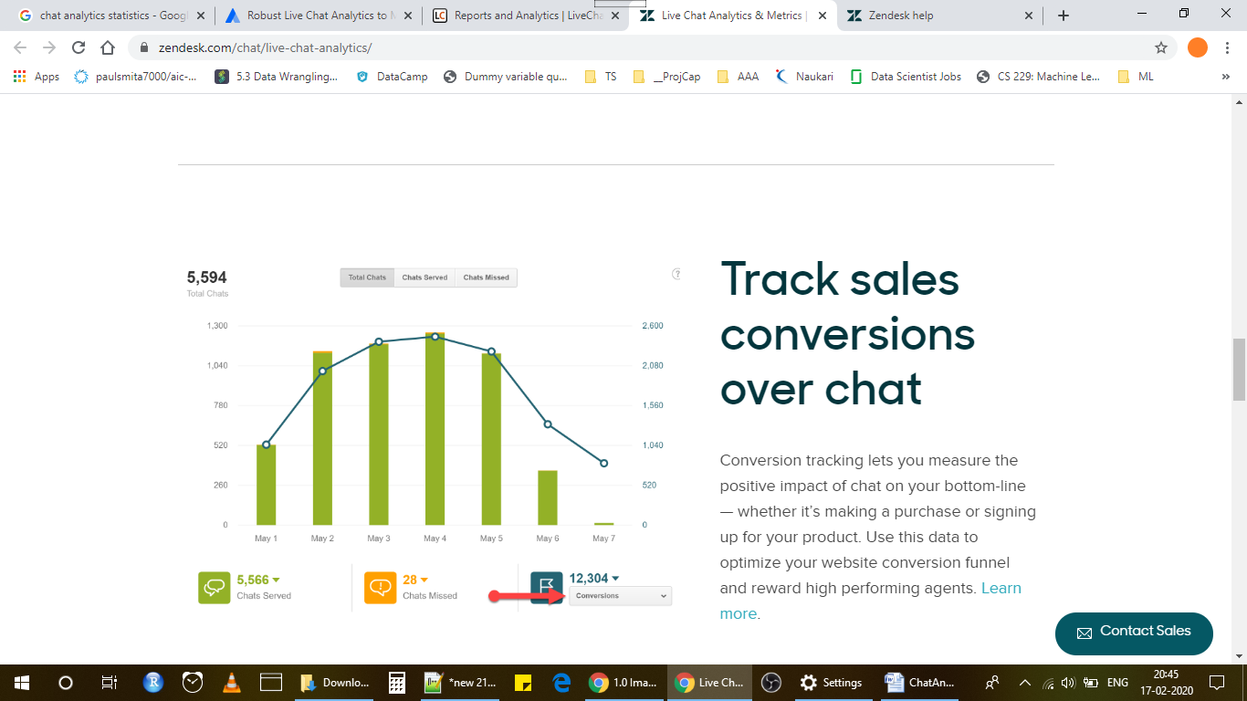

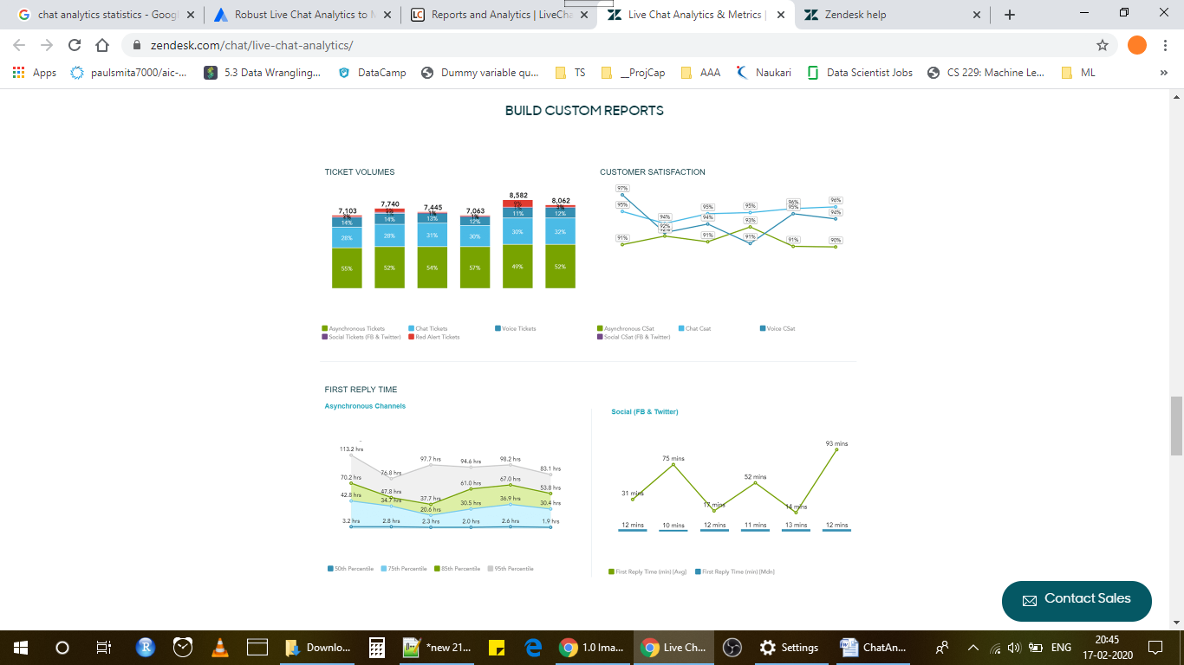

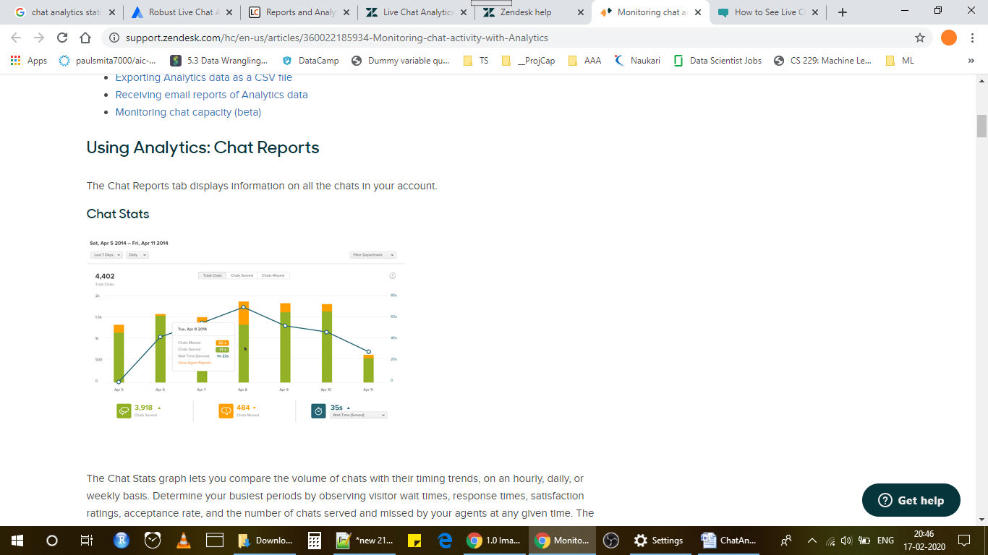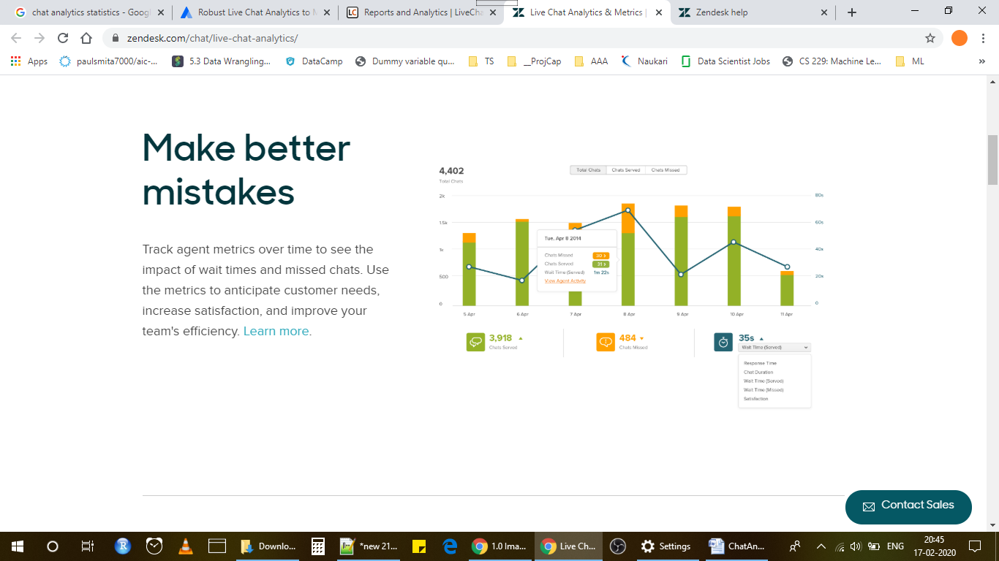

<https://support.zendesk.com/hc/en-us/articles/360022185934-Monitoring-chat-activity-with-Analytics>

