User Login Page:

No User Exist in DB

Trying to log in without Registering:

Login Failed With Below Message:

So Registered the user:

Register was successful:

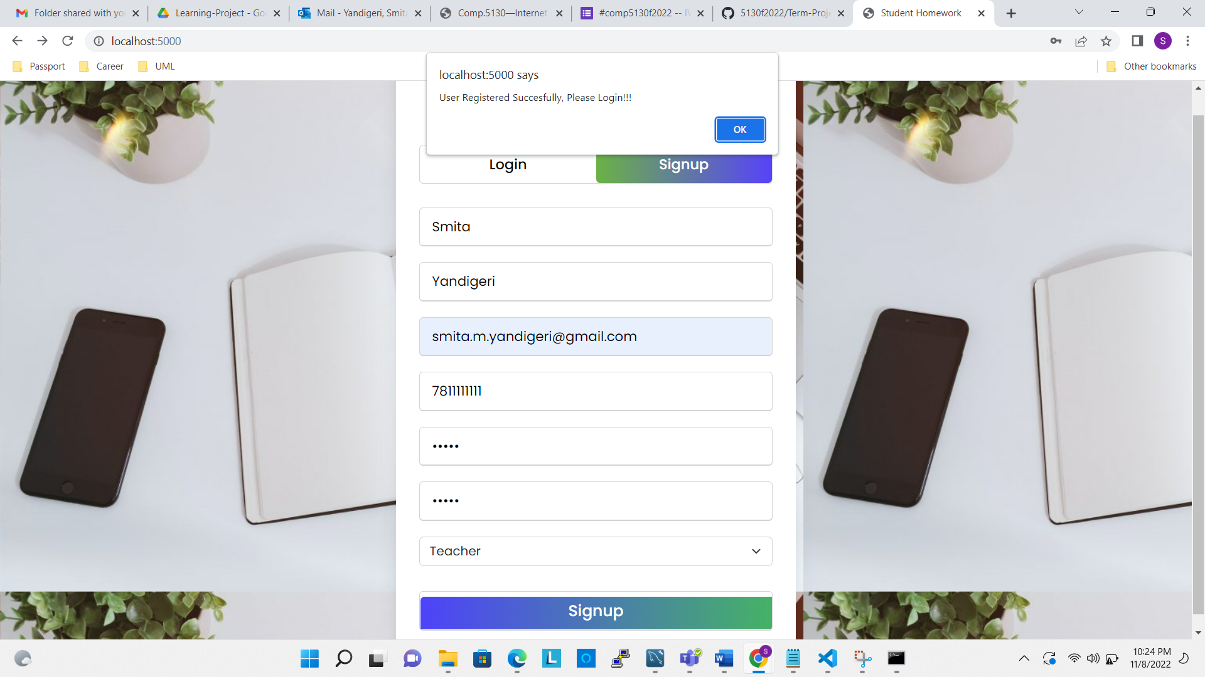

Registered Used saved to DB:

Trying To Register the Same User Failed with alert:

As user is registered as Teacher, after login, User will be rendered with Teacher Screen:

Let’s register another user as Student:

Registration Successful:

Now Lets login to Ganesh Account will render Student Page:

