**Database Archival:**

To efficiently manage table data by retaining only the most recent one-month data in the original table and archiving older records while preserving the original table structure and constraints.

**Phase-wise Implementation**

In the **first phase**, this approach was applied to **five tables**, targeting high-priority tables with significant data volumes. This phased approach ensures better control and validation of the archival process.  
Tables are:

1).BSAPILog  
2).Event  
3).Elamh_Error  
4).Stockinfoaudit  
5).Letter

**Approach :**

**What We Did and Why**

We moved older data from the main (source) table to an archive (destination) table. This helps:

1. **Improve Performance**: The source table becomes smaller, making queries faster.
2. **Maintain Compliance**: Older records are preserved in the archive table for reference.

**Steps in the Archival Process  
  
Step 1: Removing Constraints from the Original Table**

* Identify and drop all constraints (e.g., primary keys, foreign keys, indexes, and unique constraints) from the original table.
* This ensures a smooth migration of data and reconfiguration of constraints during the process.

**Step 2: Creating a Temporary Table (_new)**

* Create a new table with the same structure as the original table, appending _new to its name.
* Apply all constraints (e.g., keys, indexes, and rules) to the _new table to match the original table structure.

**Step 3: Migrating One-Month Data**

* Copy the most recent one-month data from the original table to the _new table.

**Step 4: Renaming Tables**.

* Rename the original table to indicate its archival purpose, e.g., append _archive to its name.
* Rename the _new table to the original table’s name to maintain continuity in application or query references.

**Step 5: Validation**

* The _new table contains the correct one-month data.
* The original table (renamed to _archive) retains all the older data.
* All constraints on the new table are intact and operational.

**Example Table Name Transformation**

* Original Table: BSAPILog
* Temporary New Table: BSAPILog _new
* Archive Table: BSAPILog _archive
* After the process:
  + BSAPILog _new is renamed to BSAPILog.
  + BSAPILog is renamed to BSAPILog _archive.

**The System Configuration is as below:**

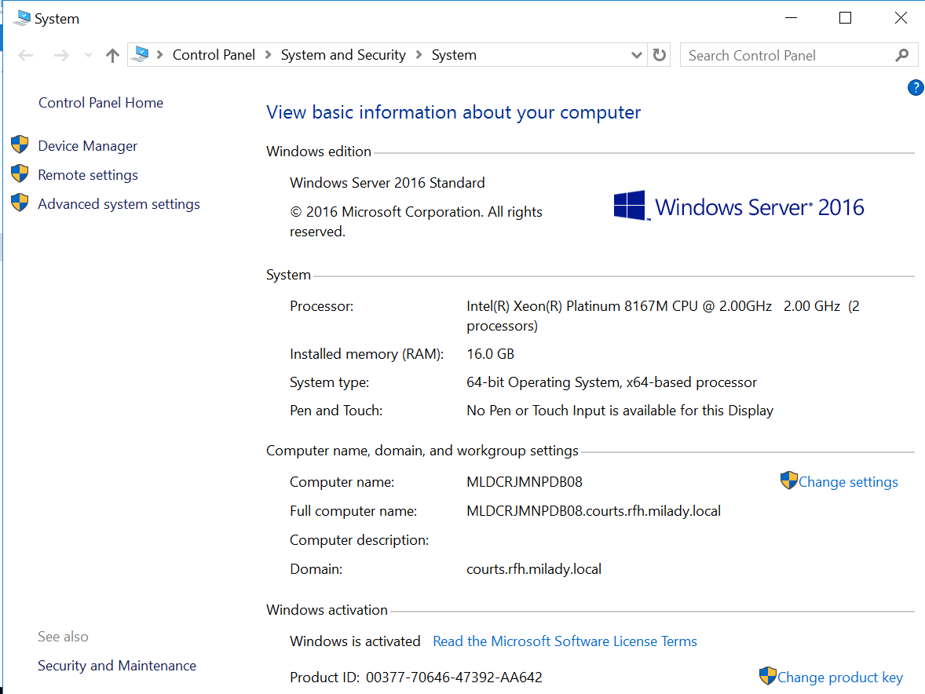

**Before and after Archival Process:**

|  |  |  |  |  |  |
| --- | --- | --- | --- | --- | --- |
| **Table Name** | **Record Count Before Archival** | **Record Count After Archival** | **Size Before Archival (MB)** | **Size After Archival (MB)** | **Time Taken** |
| bsapilog | 1,54,58,505 | 26,71,318 | 145068.17 | 24,774.91 | 28 min 45 sec |
| event | 9,77,44,092 | 6,45,837 | 40497.17 | 354.95 | 46 sec |
| letter | 13,91,75,744 | 1,38,14,693 | 17757.23 | 2,633.42 | 1 hr 33 min |
| elmah_error | 36,41,713 | 7,00,251 | 14952.95 | 2,814.38 | 4 min 31 sec |
| StockInfoAudit | 2,47,55,196 | 29,83,336 | 44907.01 | 597.13 | 1 min 9 sec |
| Total | 28,07,75,250 | 2,08,15,435 | 263182.53 | 31,174.79 |  |
|  |  |  | **257.06 GB**. | **30.44 GB**. |  |

**Details of Table Size Reduction**:

* **Before Archival**: 263,182.53 MB (**257.06 GB**)
* **After Archival**: 31,174.79 MB (**30.44 GB**)