## Pandit Deendayal Energy University, Gandhinagar

## School of Technology

**Department of Computer Science & Engineering**

**System Software & Compiler Design Lab (20CP302P)**



# Name: Sutariya Smit Dharmendrabhai

Enrolment No: **21BCP142**

Semester: **V**

Division: **3 (G5)**

Branch: **Computer Science Engineering**

**Practical: 2**

**Aim:**

a. Write a LEX program to count the number of tokens and display each token with its length in the given statements.

**Code:**

%option noyywrap

%{

int c1 = 0, c2 = 0, c3 = 0, c4 = 0;

%}

digit [0-9]

letter [a-zA-Z]

%%

auto|break|case|char|const|continue|default|do|double|else|enum|extern|float|for|goto|if|int|long|register|return|short|signed|sizeof|static|struct|switch|typedef|union|unsigned|void|volatile|while {printf("The length of keyword %s: %d \n",yytext, yyleng);c1++;}

{letter}({letter}|{digit})* {printf("The length of identifier %s is: %d \n", yytext,yyleng); c2++;}

{digit}+ {printf("The length of digit %s is: %d\n", yytext, yyleng); c3++;}

[ \t\n]

. {printf("The length of others %s is: %d\n", yytext, yyleng); c4++;}

%%

int main() {

yylex();

printf("keywords: %d, identifiers: %d, digits: %d, others: %d,\n Total number of tokens: %d", c1, c2, c3, c4, c1+c2+c3+c4);

return 0;

}

**Output:**

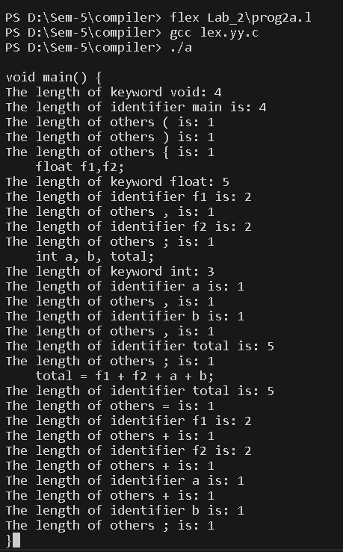

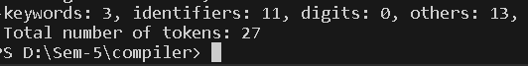

**Aim:**

b. Write a LEX program to identify keywords, identifiers, numbers and other characters and generate tokens for each.

**Code:**

%option noyywrap

%{

int c1 = 0, c2 = 0, c3 = 0, c4 = 0;

%}

digit [0-9]

letter [a-zA-Z]

%%

auto|break|case|char|const|continue|default|do|double|else|enum|extern|float|for|goto|if|int|long|register|return|short|signed|sizeof|static|struct|switch|typedef|union|unsigned|void|volatile|while {printf("%s: keyword\n", yytext);c1++;}

{letter}({letter}|{digit})* {printf("%s :identifiers\n", yytext); c2++;}

{digit}+ {printf("%s :digit\n", yytext); c3++;}

. {printf("%s :others\n", yytext); c4++;}

%%

int main() {

yylex();

printf("keywords: %d, identifiers: %d, digits: %d ,others: %d\n", c1, c2, c3, c4);

return 0;

}

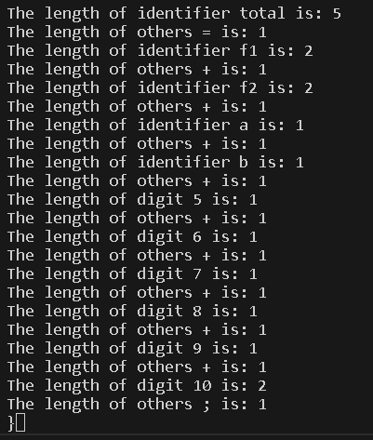**Output:**

