## Pandit Deendayal Energy University, Gandhinagar

## School of Technology

**Department of Computer Science & Engineering**

**System Software & Compiler Design Lab (20CP302P)**



# Name: Sutariya Smit Dharmendrabhai

Enrolment No: **21BCP142**

Semester: **V**

Division: **3 (G5)**

Branch: **Computer Science Engineering**

**Practical: 3**

**Aim:**

a. Write a LEX program to eliminate comment lines (single line and multiline) in a high-level program and copy the comments in comments.txt file and copy the resulting program into a separate file input.c.

**Code:**

%option noyywrap

%{

#include <stdio.h>

FILE* output_file;

FILE* comment_file;

%}

%%

\/\/(.*)|\/\*([^]|[^*]|\*[^/])*\*\/ {

comment_file = fopen("comments.txt", "a");

if (comment_file) {

fprintf(comment_file, "%s\n", yytext);

fclose(comment_file);

} else {

fprintf(stderr, "Error opening the file for writing.\n");

}

}

.|\n {

output_file = fopen("output.c", "a");

if (output_file) {

fprintf(output_file, "%s", yytext);

fclose(output_file);

} else {

fprintf(stderr, "Error opening the file for writing.\n");

}

}

%%

int main() {

yyin = fopen("input.c", "r");

yylex();

fclose(output_file);

return 0;

}

**Output:**

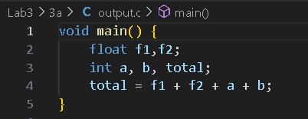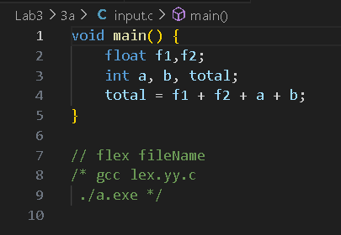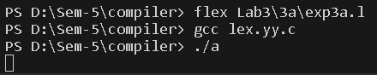

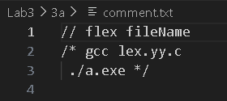

**Aim:**

b. Write a LEX program to count the number of characters, words and lines in the given input.

**Code:**

%option noyywrap

%{

#include <stdio.h>

int w,c,l;

%}

word [a-zA-Z]

%%

{word}{word}* {printf("%s\n ",yytext); w++; c+=yyleng;}

\n {l++;}

. {}

%%

int main() {

yyin = fopen("input.txt", "r");

yylex();

printf("\nWords: %d Chracters: %d Lines: %d",w,c,l+1);

fclose(yyin);

return 0;

}

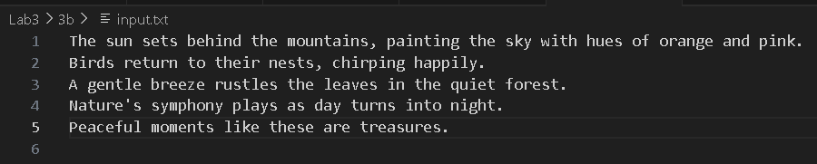

**Output:**

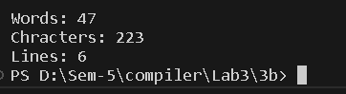

**Aim:**

c. Write a LEX program that read the numbers and add 3 to the numbers if the number is divisible by 7.

**Code:**

%option noyywrap

%{

#include<stdio.h>

FILE* number_file;

%}

digits [0-9]

%%

{digits}+ {

int num = atoi(yytext); // Convert matched text to an integer

if (num % 7 == 0) {

num += 3;

}

printf("%d", num);

number_file = fopen("number.txt", "a");

if (number_file) {

fprintf(number_file, "%d\n", num);

fclose(number_file);

} else {

fprintf(stderr, "Error opening the file.\n");

}

}

.|\n {

printf(" ");

}

%%

int main()

{

FILE* input = fopen("input.txt","r");

if(!input)

{

printf(stderr, "Error opening the input file");

}

yyin = input;

yylex();

fclose(input);

}



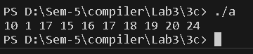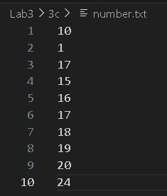**Output:**