## Pandit Deendayal Energy University, Gandhinagar

## School of Technology

**Department of Computer Science & Engineering**

**System Software & Compiler Design Lab (20CP302P)**



# Name: Sutariya Smit Dharmendrabhai

Enrolment No: **21BCP142**

Semester: **V**

Division: **3 (G5)**

Branch: **Computer Science Engineering**

**Practical: 7**

**Aim:**

a. Write a YACC program for desktop calculator with ambiguous grammar (evaluate arithmetic expression involving operators: +, -, *, / and ^).

**Code:**

**7a.l**

%{

#include "7a.tab.h"

extern int yylex();

extern void yyerror(const char* msg);

%}

%%

[0-9]+ { yylval = atoi(yytext); return NUMBER; }

"+" { return ADD; }

"-" { return SUBTRACT; }

"*" { return MULTIPLY; }

"/" { return DIVIDE; }

"^" { return POWER; }

"(" { return LPAREN; }

")" { return RPAREN; }

\n { return EOL; }

[ \t] ; // Skip whitespace

. { yyerror("Invalid character"); }

%%

int yywrap() {

return 1;

}

**7a.y**

%{

#include <stdio.h>

#include <stdlib.h>

#include <math.h>

int yylex();

void yyerror(const char* msg);

%}

%token NUMBER

%token ADD SUBTRACT MULTIPLY DIVIDE POWER LPAREN RPAREN EOL

%%

calculation:

expression EOL { printf("Result: %f\n", $1); }

| EOL { /* Ignore empty lines */ }

| calculation EOL { /* Allow multiple calculations */ }

;

expression:

NUMBER { $$ = $1; }

| expression ADD expression { $$ = $1 + $3; }

| expression SUBTRACT expression { $$ = $1 - $3; }

| expression MULTIPLY expression { $$ = $1 * $3; }

| expression DIVIDE expression {

if ($3 == 0) {

yyerror("Division by zero");

$$ = 0; // Handle division by zero

} else {

$$ = $1 / $3;

}

}

| expression POWER expression { $$ = pow($1, $3); }

| LPAREN expression RPAREN { $$ = $2; }

;

%%

void yyerror(const char* msg) {

fprintf(stderr, "Error: %s\n", msg);

}

int main() {

yyparse();

return 0;

}

**Output:**

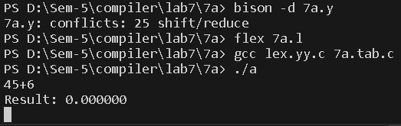

**Aim:**

b. Write a YACC program for desktop calculator with ambiguous grammar and additional information.

**Code:**

**7b.y**

%{

#include <stdio.h>

#include <math.h>

%}

%token NAME num

%left '+' '-'

%left '*' '/'

%right '^'

%nonassoc UMINUS

%%

s: NAME '=' Ex

| Ex { printf("= %d\n", $1); }

;

Ex: Ex '+' Ex {$$ = $1 + $3;}

| Ex '-' Ex {$$ = $1 - $3;}

| Ex '*' Ex {$$ = $1 * $3;}

| Ex '/' Ex {if($3 == 0)

yyerror("divide by zero");

else

$$ = $1 / $3;

}

| Ex '^' Ex {$$ = pow($1,$3);}

| '-' Ex %prec UMINUS {$$ = -$2;}

| '(' Ex ')' {$$ = $2;}

| num {$$ = $1;}

;

%%

int main() {

yyparse();

return 0;

}

**7b.l**

%{

#include "7b.tab.h"

%}

%%

[0-9]+ { yylval = atoi(yytext); return num; }

[ \t] ; /* Ignore whitespace */

\n return 0; /* Logical EOF */

. return yytext[0];

%%

int yywrap() {

return 1;

}

void yyerror(char *s) {

printf("error");

}

**Output:**

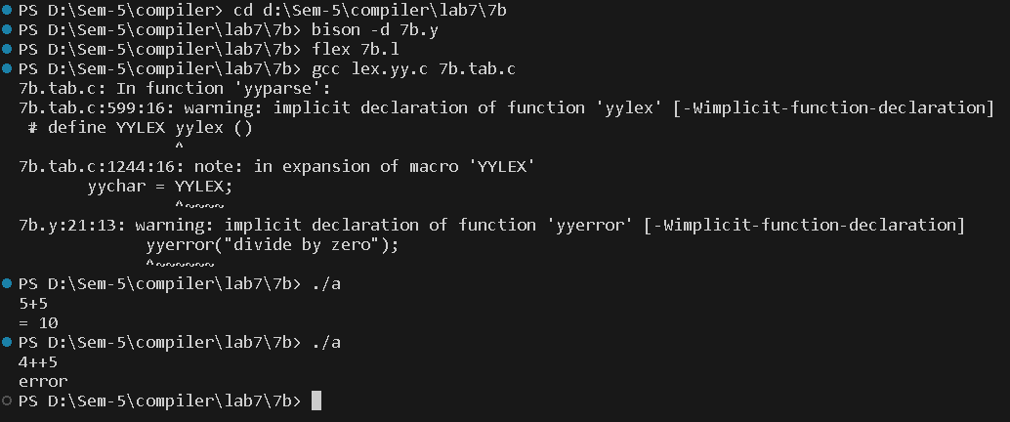

**Aim:**

c. Design, develop and implement a YACC program to demonstrate Shift Reduce Parsing technique for the grammar rules:

E→ E + T | T

T→ T * F | F

F → P ↑ F | P

P → (E) | id

And parse the sentence: id + id * id.

**Code:**

**7c.l**

%{

#include "7c.tab.h"

%}

%%

[0-9]+ { yylval = atoi(yytext); return NUMBER; }

[ \t] ; /* Ignore whitespace */

\n return 0; /* Logical EOF */

. return yytext[0];

%%

int yywrap() {

return 1;

}

void yyerror(char *s) {

printf("Syntax error\n");

}

**7c.y**

%{

#include <stdio.h>

#include <math.h>

%}

%token NUMBER

%right '^'

%%

statement: E { printf("Result: %d\n", $1); }

| statement E { printf("Result: %d\n", $2); }

;

E : E '+' T { $$ = $1 + $3; }

| E '-' T { $$ = $1 - $3; }

| T { $$ = $1; }

;

T : T '*' F { $$ = $1 * $3; }

| T '/' F { if ($3 == 0) yyerror("division by zero"); else $$ = $1 / $3; }

| F { $$ = $1; }

;

F : P '^' F { $$ = pow($1, $3); }

| P { $$ = $1; }

;

P : '(' E ')' { $$ = $2; }

| NUMBER { $$ = $1; }

;

%%

int main() {

yyparse();

return 0;

}

**Output:**

