Name: Smith Faldu
Roll No: 24bce298
Course: Full Stack Development
Aim: 1. JavaScript code embedded within the HTML file 2. Install Node.js: Download and install Node.js from nodejs.org. 3. create a “script.js” file to print “Hello world” on the server side 4. create an “app.js” file to create and store JSON Object in the File
Practical: 1
Code and Output:
Index.html
<!DOCTYPE html>
<html lang="en">
<head>
<title>JavaScript in HTML Example</title>
</head>
<body>

<script>
function greet(name){
alert("Hello, " + name + "!");
}
greet("Devendra Vashi");
</script>

</body>
</html>

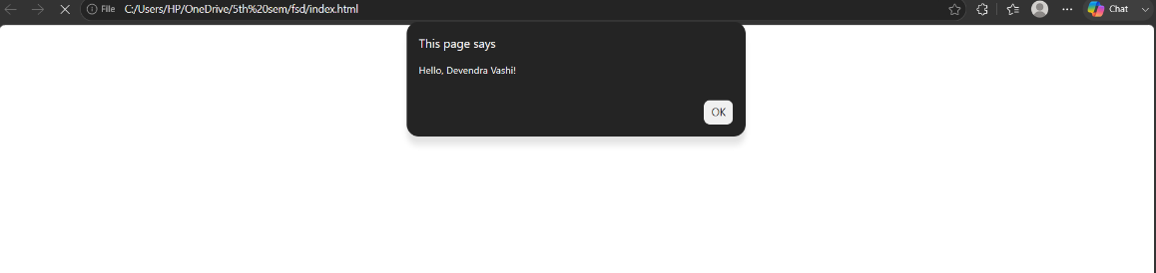
Script.js

console.log("Hello, World!");

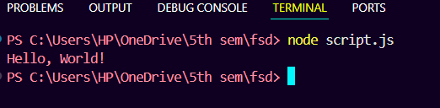
App.js
const fs=require('fs');

const jsonObject={
name:'John Doe',
age:25,
city:'Example City'
};

const jsonString=JSON.stringify(jsonObject,null,2);

const filePath='output.json';

fs.writeFile(filePath,jsonString,'utf-8',(err)=>{
if(err){
console.error('Error writing to file:',err);
}
else{
console.log('JSON object has been stored in',filePath);
}
});

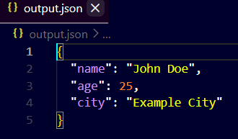
Conclusion: We learnt use how node.js,json and how it works

