Roll No:2BCE298
Name : Smith Faldu
Course: Microprocessor and Interfacing (3CS526CC23)
Practical:1 Aim-Introduction to SASM IDE -

a) Explore SASM editor, assembler settings, debugger panel —prepare a report on all debugger commands (step, breakpoint, register watch, memory dump):

1. SASM Editor
- The SASM editor is used to write, edit, save, and manage assembly language programs.
- It provides syntax highlighting, line numbers, and supports multiple assembly source files.
2. Assembler Settings
- Assembler settings allow the user to choose the assembler (NASM, GAS, FASM, MASM) and the target architecture (32-bit or 64-bit).
- They also let users configure build options and compiler/debugger preferences.
3. Debugger Panel
- The debugger panel helps execute the program step-by-step and inspect registers, memory, and program flow.
- It is useful for finding logical errors and understanding how each instruction affects the CPU.
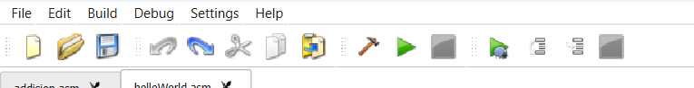

4. Step (Step Into)
- Executes one assembly instruction at a time.
- Allows users to observe changes in registers, memory, and the execution flow after each instruction.
5. Breakpoint
- A breakpoint pauses program execution at a selected line.
- It helps inspect the program state without executing the entire program.
6. Register Watch
- Displays the current values of CPU registers such as EAX, EBX, ECX, EDX, ESP, and EBP.
- It helps track how instructions modify register values during execution.
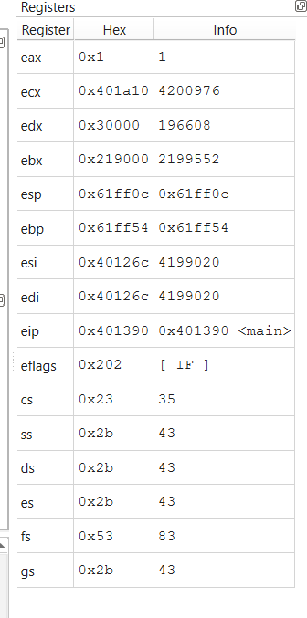
7. Memory Dump (Memory Window)
- Shows the contents of memory at a specified address or variable.
- It allows users to monitor changes in variables and data stored in memory while debugging.
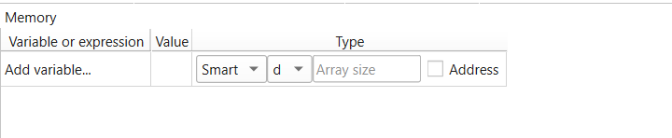

b) Write and run "Hello World"; add two numbers and trace execution step by step:

Code:
Print Hello World:
extern printf

section .data
msg db "Hello , World!",10,0

section .text
global main

main:
mov ebp, esp; for correct debugging
push msg
call printf
add esp , 4
xor eax,eax
ret
Output:
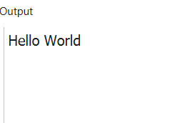

Addition of 2 numbers:
global main
extern printf
section .data
num1 dw 10h
num2 dw 30h
sum dw 0
fmt db "Sum = %d", 10,0

section .text

main:
mov ebp, esp; for correct debugging
mov ax, [num1]
add ax, [num2]
mov [sum], ax
movzx eax, word [sum]
push eax
push fmt
call printf
add esp, 8
mov eax, 0
ret

Output:
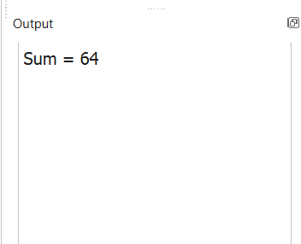

Subtraction of 2 numbers:
extern printf

section .data
num1 dw 10
num2 dw 20
sum dw 0
fmt db "Sum = %d",10,0

section .text
global main

main:
mov ax, [num1]
add ax, [num2]
mov [sum], ax

movzx eax, word [sum]
push eax
push fmt
call printf
add esp, 8

mov eax, 0
ret
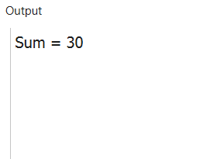
Multiplcation of 2 numbers:
extern printf

section .data
num1 dw 10
num2 dw 20
product dw 0
fmt db "Product = %d",10,0

section .text
global main

main:
mov ax, [num1]
mul word [num2]
mov [product], ax

movzx eax, word [product]
push eax
push fmt
call printf
add esp, 8

mov eax, 0
ret
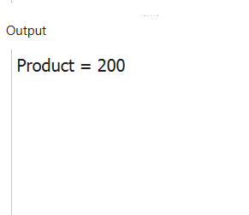
Division of 2 numbers
extern printf

section .data
num1 dw 20
num2 dw 5
quotient dw 0
fmt db "Quotient = %d",10,0

section .text
global main

main:
mov ax, [num1]
mov dx, 0
div word [num2]
mov [quotient], ax

movzx eax, word [quotient]
push eax
push fmt
call printf
add esp, 8

mov eax, 0
ret
