Name : Smith Faldu
RollNo : 24BCE298
CourseCode & Name :3CS201CC24 (Computer Networks)
Practical : 01
AIM : Understand following network commands with their utility: ping, ipconfig/ifconfig, iwconfig, netstat, traceroute/tracert, route, nslookup, hostname, dig, telnet, ssh, arp, nmap, getmac, pathping, ss and route add.

Ping Command :
1.Write the syntax of the ping command in Windows and Linux.
ping [options] <hostname/IP_address>
2.Ping the localhost and record the observations.
ping 127.0.0.1
ping localhost
3.Ping your default gateway and note the packet loss and RTT.
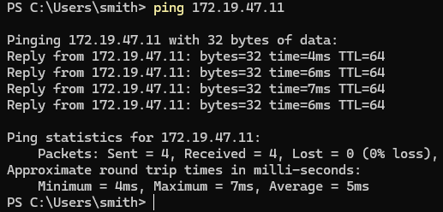
4.Ping the domain google.com. What does the command verify?
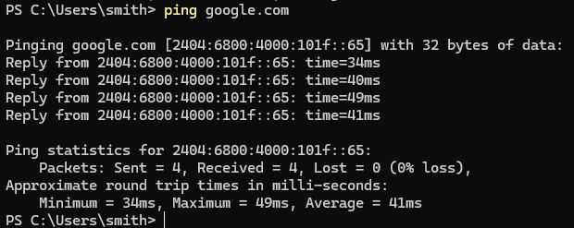
5.Explain the significance of TTL in ping results.
it is the time taken by the packet while traveling to the network
6.Execute continuous ping and stop it manually. Write the command used.
ping -t google.com
7.Compare ping results for a local IP address and a remote website.
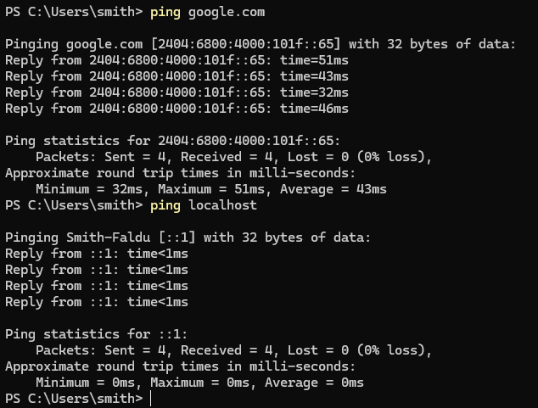
8.What happens when you ping an unreachable host?
Request timed out.
9.Use ping with packet size modification and record the output.
ping -l 1024 google.com
10.Differentiate between ICMP Echo Request andEcho Reply.
ICMP : sent by source device,it use if host is available or not
ECHO: send by destination device , response confirms the host is reachable

IPCONFIG Command:
1.Display the IP configuration of your system using ipconfig or ifconfig.
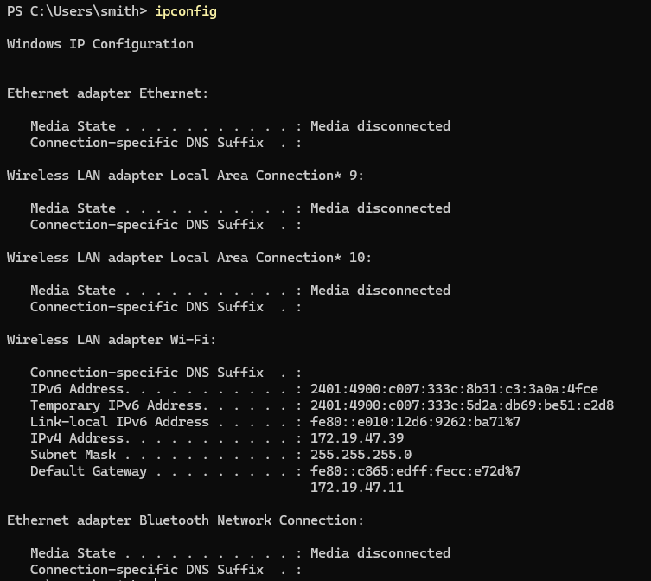
2.Identify: oIPv4 Address oSubnet Mask oDefault Gateway oMAC Address
Default Gateway : 172.19.47.11
Subnet Mask : fe80::c865:edff:fecc:e72d%7
IPv6 Address : 2401:4900:c007:333c:5d2a:db69:be51:c2d8
Physical Address : C8-5E-A9-A2-E8-CE
3.Explain the purpose of DHCP.
DHCP (Dynamic Host Configuration Protocol) automatically assigns network configuration to devices, including:
- IP Address
- Subnet Mask
- Default Gateway
- DNS Server

4.Use ipconfig /all and list additional information obtained.
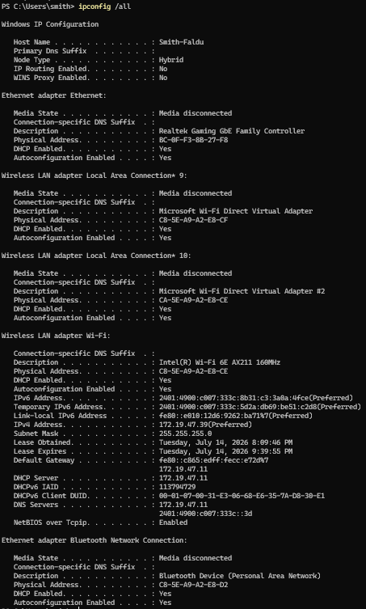
5.Release and renew the IP address using appropriate commands.
Release IP Address:
ipconfig /release
Renew IP Address:
ipconfig /renew
These commands work only if DHCP is enabled.

6.Differentiate between static and dynamic IP addressing.
Static IP | Dynamic IP
Assigned manually | Assigned automatically by DHCP
Does not change | Can change over time

7.What is the purpose of loopback address?
it is localhost it helps to communicate with localhost
8.Compare outputs of ifconfig and ipaddr.
9.Identify active and inactive interfaces.
Run ipconfig /all find which adepter’s media state is disconnected
10.Explain the significance of subnet mask in communication.
A subnet mask determines which part of an IP address represents the network and which part represents the host.

NETSTAT Command
1.Display all active connections using netstat.
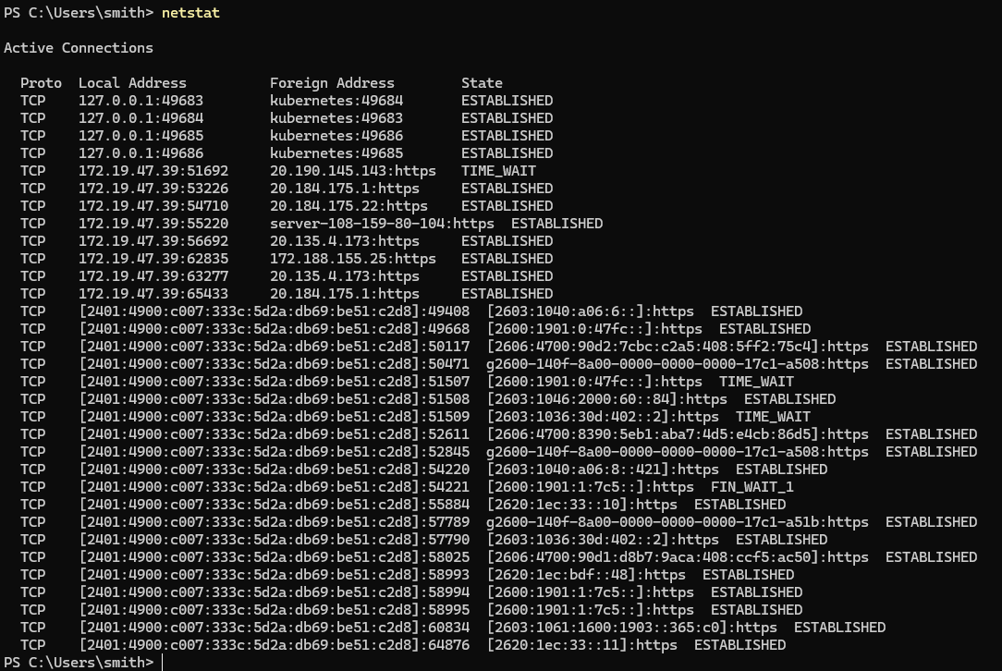
2.Identify listening ports on the system.
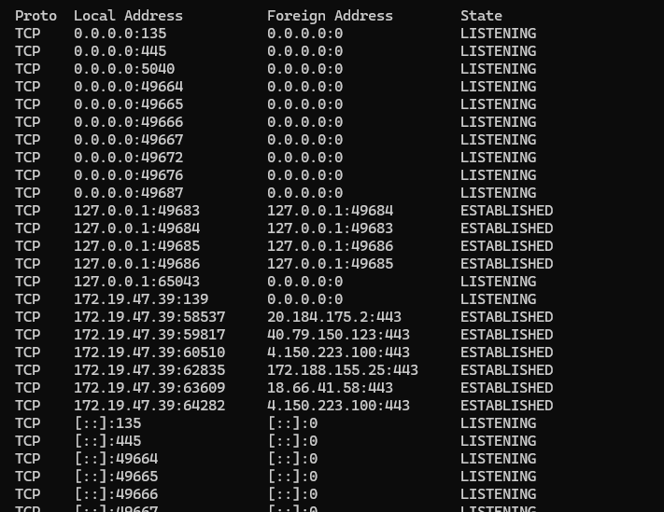
3.Explain the meaning of TCP states:
LISTENING
- The application is waiting for incoming connection requests.
ESTABLISHED
- A connection has been successfully created and data can be exchanged.
TIME_WAIT
- The connection has been closed, but the system waits for a short period to ensure delayed packets are discarded before reusing the port.
4.Find the process ID associated with a port.
Netstat -ano
TCP 0.0.0.0:135(PORT 135) 0.0.0.0:0 LISTENING 1904(PID)
5.Display routing table using netstat options.
Netstat -r
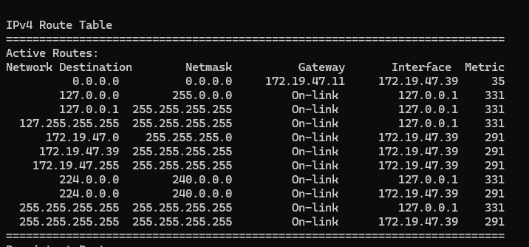
6.Compare TCP and UDP entries.
TCP | UDP
Connection-oriented | Connectionless
Reliable communication | Faster but unreliable
Shows connection state | No connection state
Uses acknowledgements | No acknowledgements

7.Identify foreign and local addresses.
Proto Local Address Foreign Address State PID
TCP 0.0.0.0:135 0.0.0.0:0 LISTENING 1904
TCP 0.0.0.0:445 0.0.0.0:0 LISTENING 4
TCP 0.0.0.0:5040 0.0.0.0:0 LISTENING 9428
8.Explain why some ports remain in TIME_WAIT state.
Ports remain in the TIME_WAIT state to:
- Ensure delayed packets from the old connection are discarded.
- Prevent confusion with new connections using the same port.
- Allow proper completion of the TCP connection termination process.

9.Display statistics of network protocols.
netstat -s
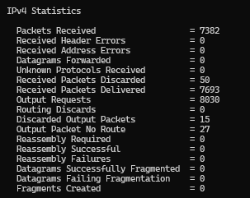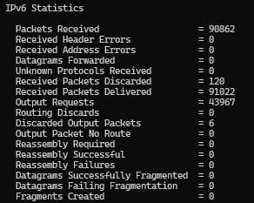

10.What security risks can be identified using netstat?
• Unauthorized or suspicious listening ports.
• Unexpected active network connections.

Trecert Command
1.Trace the route to google.com.
tracert google.com
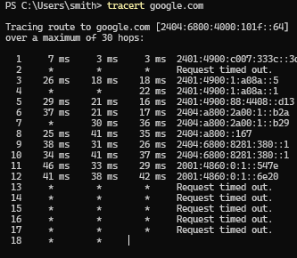
2.Record the number of hops observed.
20
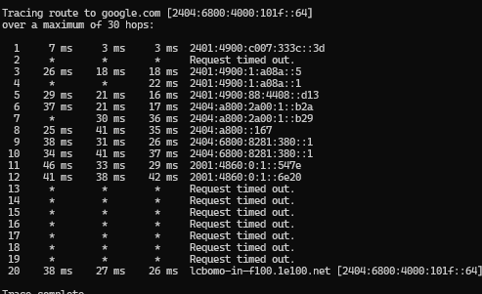
3.Explain the significance of each hop.
Each hop represents a router or gateway that forwards the packet toward its destination.
- Hop 1: Local router (default gateway).
- Intermediate Hops: ISP routers and backbone routers.
- Final Hop: Destination server (e.g., Google).

4.Why do some hops display * * *?.
Possible reasons include:
- The router blocks ICMP packets.
- The router is configured not to respond to traceroute requests.
- Packet loss due to network congestion.

5.Compare ping and traceroute commands.
Ping | Traceroute (Tracert)
Tests connectivity | Finds the complete network path

6.Explain the role of TTL in traceroute.
TTL (Time To Live) limits how many routers a packet can pass through.
7.Identify the ISP router from the output.
The ISP router is usually the second hop after the local gateway.
8.Trace a route to an unreachable destination.
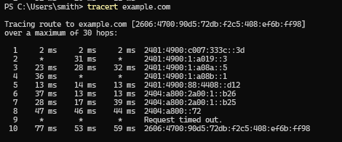
9.Measure delay variation between hops.
It increases as the distance increased
10.Explain practical applications of traceroute.
Traceroute is used to:
- Determine the path packets take across a network.
- Identify routing problems.
- Detect network congestion.
- Locate high-latency links.

Route Command
1.Display the routing table using route print or route.
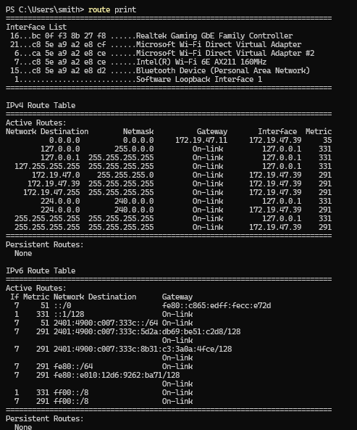
2.Identify the default route in the table.
The default route is used when no specific route matches the destination.
3.Explain:

Term | Explanation
Destination | The destination network or host IP address.
Gateway | The next-hop router used to reach the destination.
Genmask (Subnet Mask) | Defines the network portion of the destination address.
Metric | Cost or priority of a route. Lower values are preferred.

4.Add a temporary route using the route command.
C:\Windows\System32>route add 10.10.10.0 mask 255.255.255.0 192.168.1.1
OK!

5.Delete a route from the routing table.
C:\Windows\System32>route delete 10.10.10.0
OK!
6.Differentiate between static and dynamic routing.
Static Routing | Dynamic Routing
Configured manually | Learned automatically
Does not change automatically | Updates when network changes
Suitable for small networks | Suitable for large networks

7.Explain the significance of routing metrics.
A routing metric is a value used to determine the best path to a destination.
- Lower metric = preferred route.
- Used when multiple routes exist.
- Helps optimize packet forwarding.
- May be based on hop count, bandwidth, delay, or administrative cost.

8.Observe changes after adding a route.
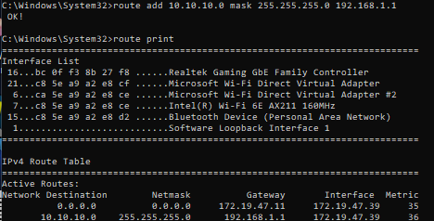
9.What is the role of gateway in routing?
A gateway is the next-hop router that forwards packets toward their destination.
10.Explain how routing tables help packet forwarding
A routing table stores information about available network routes.

NSLOOKUP Command

1.Find the IP address of google.com.
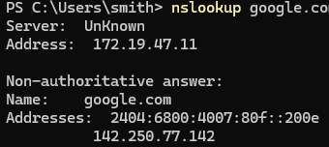
2.Query the mail server records of a domain. 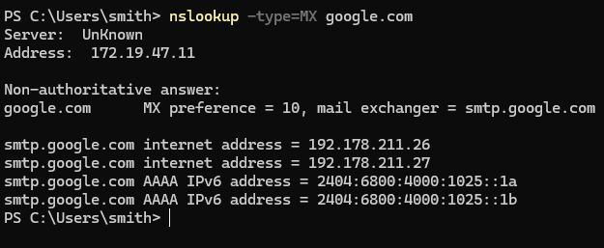
3.Explain forward and reverse DNS lookup.
Forward DNS Lookup | Reverse DNS Lookup
Converts a domain name to an IP address. | Converts an IP address to a domain name.

4.Find the authoritative DNS server of a domain.
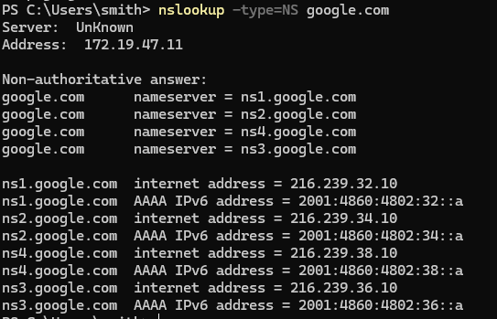
5.Compare nslookup and ping outputs.
nslookup | ping
Resolves domain names to IP addresses. | Tests network connectivity to a host.
Uses DNS protocol. | Uses ICMP Echo Request/Reply.

6.Query using a specific DNS server. 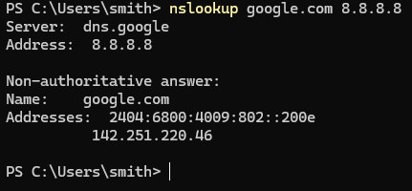

7.What happens when DNS resolution fails?
8.Explain the purpose of DNS caching.
DNS caching stores recently resolved domain names and their IP addresses.
9.Perform reverse lookup for a given IP address.
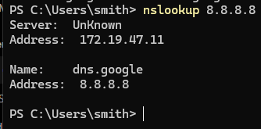
10.Identify different DNS record types.
Record Type | Purpose
A | Maps a domain name to an IPv4 address.
AAAA | Maps a domain name to an IPv6 address.
MX | Specifies the mail server for a domain.
NS | Identifies the authoritative name servers.
CNAME | Creates an alias for another domain name.
PTR | Used for reverse DNS lookup (IP to domain).
TXT | Stores text information, often for verification or email security (SPF, DKIM).
SOA | Contains administrative information about the DNS zone.

TELNET Command
1.Connect to a remote host using telnet.
telnet towel.blinkenlights.nl
2.Test connectivity to port 80 of a web server.
telnet google.com 80
3.Explain why telnet is considered insecure.
Telnet is insecure because data is sent in plain text.
4.Compare telnet and SSH.
SSH is encrypted; Telnet is not.
5.Observe server response after connection.
Successful connection shows server banner or blank screen.
6.What happens when a port is closed?
Closed port: Connection failed or timed out.
7.Use telnet to manually send HTTP requests.
Send: GET / HTTP/1.1 then Host: example.com.
8.Explain plaintext transmission in telnet.
Plaintext means anyone can read transmitted data.
9.Identify scenarios where telnet is still useful.
. Useful for testing TCP ports and legacy devices
10.Record observations for successful and failed connections.
Successful: connected. Failed: refused/timed out.

SSH command
Q1. Establish SSH connection to a remote host.
Answer: Establishes a secure remote connection.
Command:
ssh username@hostname
Q2. Explain the role of encryption in SSH.
Answer: Encrypts all communication.
Q3. Generate SSH keys and explain their purpose.
Answer: SSH keys enable secure password-less authentication.
Command:
ssh-keygen
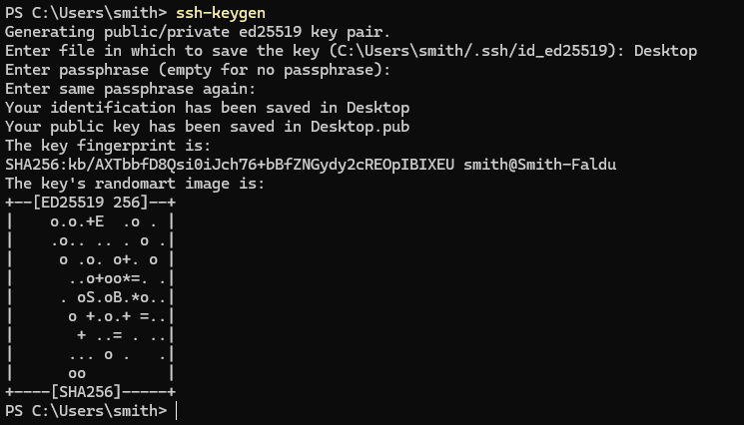
Q4. Compare password authentication and key authentication.
Answer: Key authentication is more secure than passwords.
Q5. Copy files securely using SCP.
Answer: SCP securely transfers files over SSH.
Command:
scp file.txt username@hostname:/path
Q6. Explain the role of port 22.
Answer: Port 22 is the default SSH port.
Q7. What happens when host key verification fails?
Answer: The connection is blocked until verified.
Q8. Compare SSH and Telnet.
Answer: SSH is encrypted; Telnet is not.
Q9. Identify common SSH applications.
Answer: Remote administration and secure file transfer.
Q10. Observe SSH session establishment steps.
Answer: Authenticate, encrypt, and establish the session.

ARP
Q1. Display the ARP cache using arp command.
Answer: Displays IP-to-MAC address mappings.
Command:
arp -a
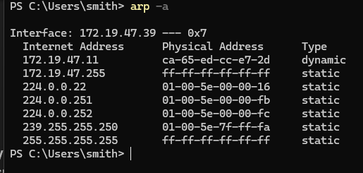
Q2. Identify IP and MAC address mappings.
Answer: Shows corresponding IP and physical addresses.
Q3. Explain the role of ARP in LAN communication.
Answer: ARP resolves IP addresses to MAC addresses.
Q4. Clear the ARP cache and observe changes.
Answer: Removes dynamic ARP entries.
Command:
arp -d *
Q5. Add a static ARP entry.
Answer: Creates a permanent ARP mapping.
Command:
arp -s 192.168.1.10 00-11-22-33-44-55
Q6. Differentiate static and dynamic ARP entries.
Answer: Static entries are manual; dynamic entries are automatic.
Q7. Explain ARP Request and ARP Reply.
Answer: Request asks for MAC; Reply returns the MAC.
Q8. What is Gratuitous ARP?
Answer: Updates ARP tables without a request.
Q9. Explain ARP spoofing attacks.
Answer: Fake ARP replies redirect network traffic.
Q10. Observe changes after pinging a new host.
Answer: A new ARP entry is added after communication.
Command:
ping 192.168.1.1
arp -a
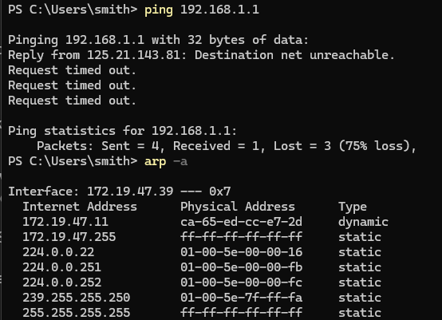

GETMAC
Q1. Display MAC addresses using getmac.
Answer: Lists the MAC addresses of all network adapters.
Command:
getmac
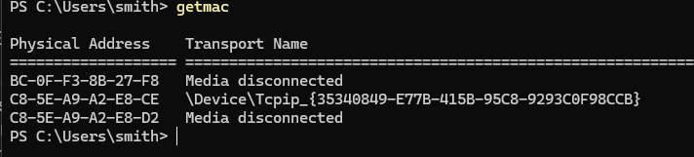
Q2. Compare physical and logical addressing.
Answer: MAC is a physical address; IP is a logical address.
Q3. Identify the transport name associated with adapters.
Answer: Displays the transport name for each adapter.
Command:
getmac /v
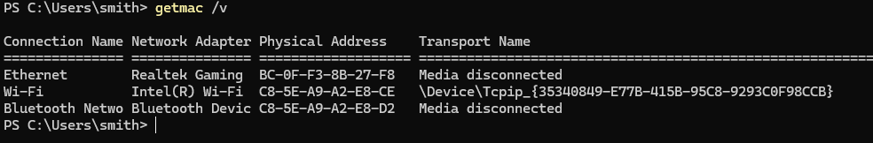
Q4. Explain the uniqueness of MAC addresses.
Answer: Each network adapter has a unique MAC address.
Q5. Compare MAC address and IP address.
Answer: MAC identifies hardware; IP identifies a device on a network.
Q6. Record MAC addresses of all interfaces.
Answer: Shows the MAC address of every installed adapter.
Command:
getmac /v
Q7. Explain vendor identification from MAC addresses.
Answer: The first 24 bits (OUI) identify the manufacturer.
Q8. Why are MAC addresses important in LAN communication?
Answer: They uniquely identify devices on the local network.
Q9. Compare outputs of getmac and ipconfig.
Answer: getmac shows MAC addresses; ipconfig shows IP configuration.
Q10. Explain MAC spoofing.
Answer: MAC spoofing changes the reported MAC address of a device.

