Name : Smith Faldu
Roll no : 24BCE298
Prac 2

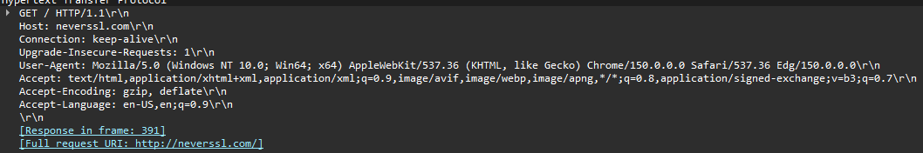
- Capture HTTP packets while opening a website in a browser and identify: o Request method o Response code o Content type o Host field

- Compare HTTP GET and POST requests using packet captures.

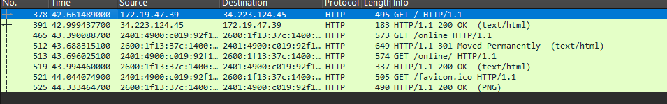
- Find the HTTP response time for loading a webpage.

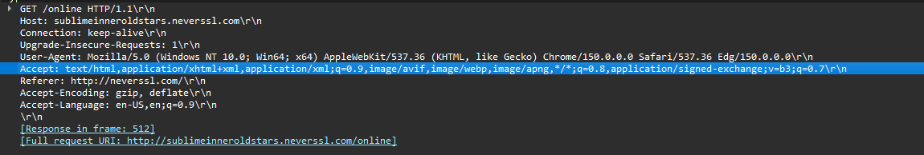
- Identify all objects transferred during a webpage load (HTML, CSS, images, JavaScript).

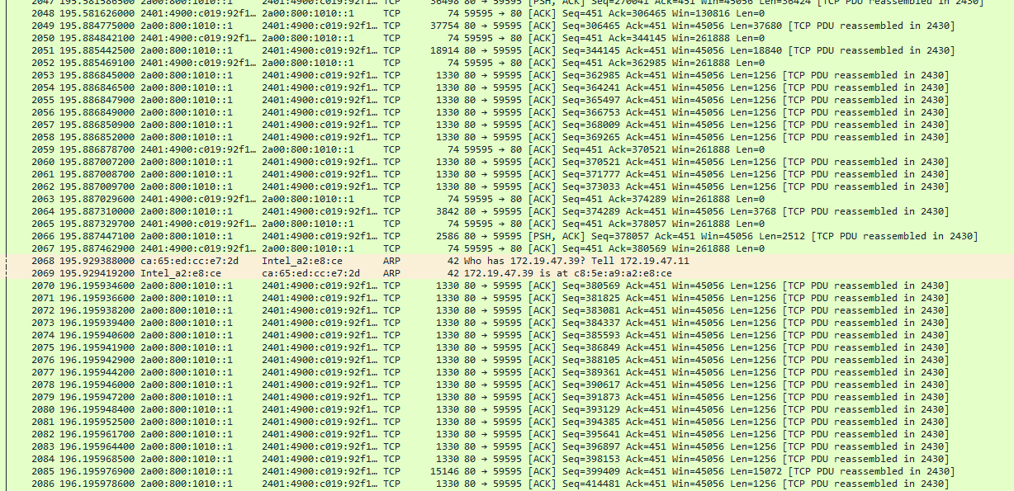
- Capture packets while downloading a file and determine: o File size o MIME type o Transfer duration

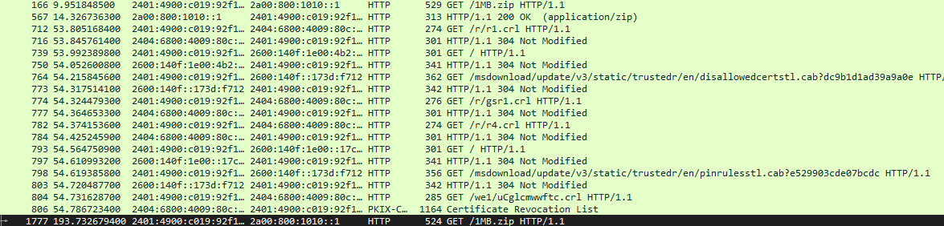
- Analyze HTTP status codes such as: o 200 OK o 301 Redirect o 404 Not Found o 500 Internal Server Error
- Use Wireshark filters to display only HTTP traffic.
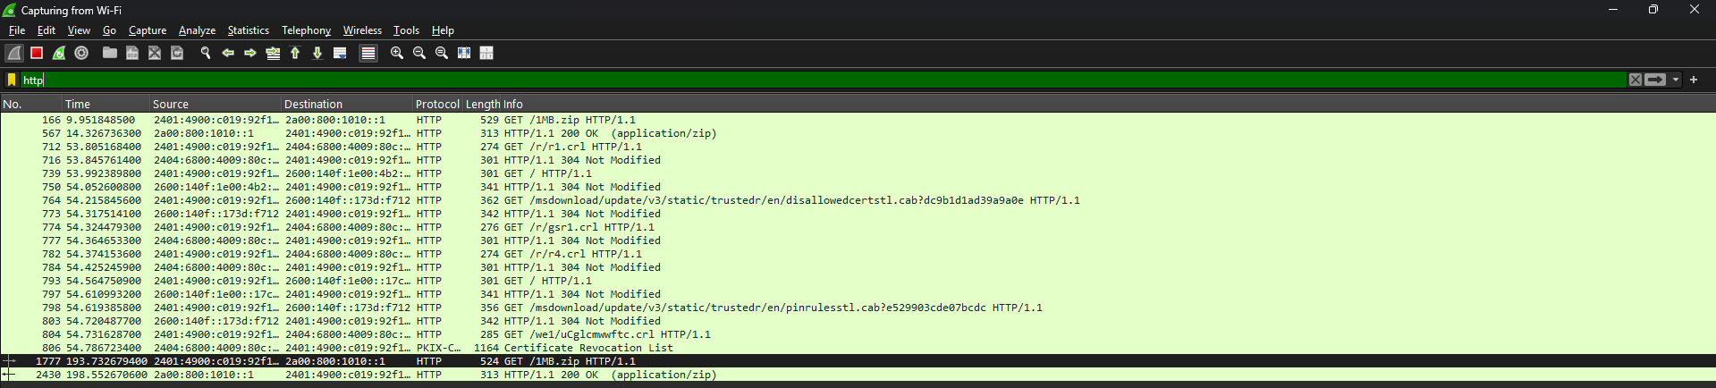
- Identify persistent and non-persistent HTTP connections from packet captures.
- Observe cookies exchanged between browser and server.

- Analyze HTTP headers and explain the purpose of:

  - User-Agent o Accept-Language : Identifies browser and operating system.
  - Cache-Control : Preferred language of user.
  - Content-Length : Controls browser caching.
  - 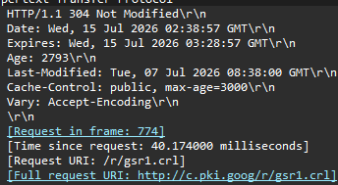

DNS Protocol Exercises
1. Capture DNS query and response packets when accessing a website.
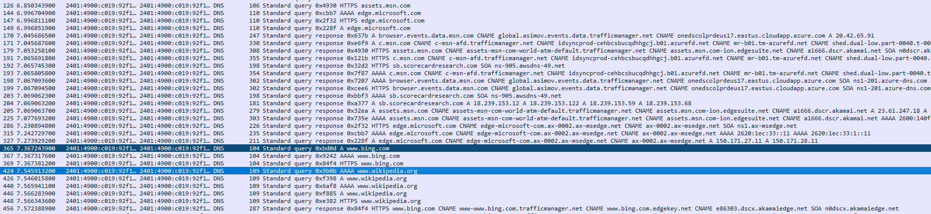
2. Identify: o Query type o Domain name o IP address returned
3. Compare recursive and iterative DNS query behavior.
Recursive Query
Client asks DNS server:
Give me the final IP address.
DNS server performs all lookups and returns the final answer.
In Wireshark you'll normally capture only:
Client → Local DNS Server

Local DNS Server → Client

Iterative Query
Occurs between DNS servers.
Example:
Root Server

↓

.com Server

↓

Google Authoritative Server
Each server refers the requester to another server.
Normally not visible unless capturing on a DNS server or specialized network.
Comparison
Recursive | Iterative
Client receives final answer | Server returns referral
Used between client and local DNS | Used between DNS servers
Faster for client | Multiple DNS servers involved

4. Find the Time-To-Live (TTL) value in DNS responses.
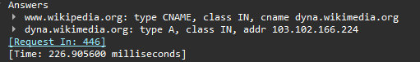
5. Analyze DNS traffic for multiple websites and compare response times.
Website | Response Time
Google | 6 ms
GitHub | 12 ms
Wikipedia | 8 ms

6. Use Wireshark filters to display only DNS traffic.
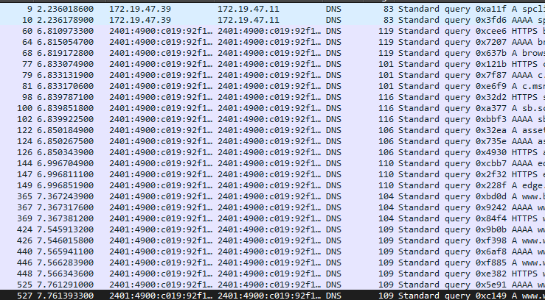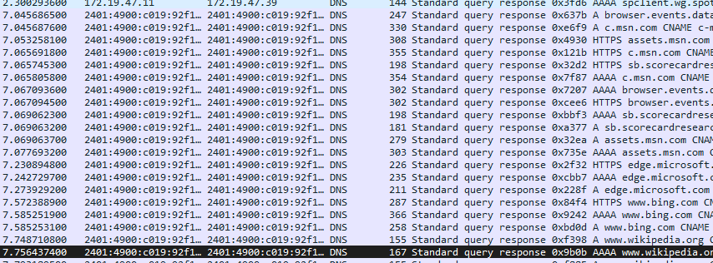
7. Identify the DNS server used by the system.
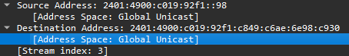
8. Capture reverse DNS lookup traffic and explain its purpose.

9. Observe DNS packet structure including:
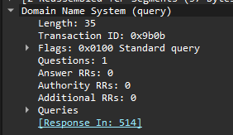
- Compare UDP-based and TCP-based DNS communication.
UDP DNS | TCP DNS
Faster | Slightly slower
No connection setup | Requires TCP handshake
Default for queries | Used for large responses and zone transfers
Less overhead | More reliable

