Experimental Protocol

**Observational Study and Core Experiment**

1. Site Selection - Each site selected for the observational study/experiment needs to be relatively homogeneous (i.e., not encompassing large gradients), dominated by herbaceous vegetation, and representative of a particular ecosystem (e.g., shortgrass steppe, tallgrass prairie). The site also needs to be large enough to accommodate a footprint of >1000 m . Natural disturbances, such as fire, do not need to be excluded from the site, but a record of the disturbance regime is required. It is preferable that the site is not grazed by cattle, given the size of the experimental plots.

**2. Observational Study**– The observational study will be composed of the pre-treatment sampling of all 30 experimental plots described below. Note: You can participate in the NutNet by participating in just the Observational Study if you do not have the time or support for the Experimental Study.

**3. Experimental Design -**The core experiment will be a completely randomized block (environmental gradient) design with three blocks, 10 treatments per block, and three replicates per treatment (N = 30 total experimental units; Fig. 1). Each experimental unit will be 5 x 5 m in size (Fig. 1), with the experimental units separated by at minimum 1-m walkways.  The corners of the plots should be marked permanently.

Experimental units are subdivided into 4 2.5 x 2.5 m subplots (designated A,B,C,D). These four subplot should be randomly assigned to be used for the core sampling, site-specific studies, or one of two possible future studies. Each of the four 2.5 x 2.5 m subplots is further subdivided into 4 1 x 1 m sub-subplots (1,2,3,4). Thus a specific location in the plot is designated by number, letter, number combination (e.g., 21A2, 13B4, etc). Figure 1 shows the layout of each experimental unit.

Note that the number of replicates per treatment (and blocks) can be increased or decreased on a site-specific basis *as long as there is a full set of all 10 treatments in at least one block and all eight nutrient treatments in all blocks.* For example, within-site replication can be reduced if necessary by only replicating exclosures in one block (two exclosures at a site) and maintaining three full blocks of the nutrient treatments.

To assess multiple resource limitation, three nutrient addition treatments (Nitrogen, Phosphorus, Potassium plus Other nutrients), each with two levels (Control, Added), will be crossed in a factorial design, for a total of 8 treatment combinations (Table 1). 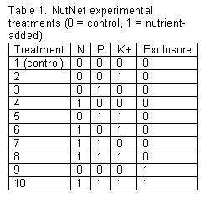For the nutrient addition treatments, we chose forms of N, P and K+ that are readily available and inexpensive. Each will be applied at a relatively high rate, 10 g m-2, which is comparable to previous studies.

In addition, there will be an herbivore caging treatment, in which the entire 5 x 5 m plot will be caged to exclude most herbivores. This treatment will be crossed with the Control and NPK+ treatments to assess top-down vs. bottom-up effects on community structure and function (Table 1).

 Each 25-m2 plot will be divided into four equal-sized 2.5 x 2.5 m subplots, with one dedicated to the core sampling (see below), one to additional site-specific studies, and the remaining two for future network-level research (Fig. 1). The experiment also may be expanded by adding additional treatments, such as a drought treatment using rainout shelters or insecticide/fungicide treatments.

For each site, our hope is that sampling will take no more than 1-2 days for the observational study/core experiment, with maintenance of experimental treatments costing ~$100 per year and initial set-up of herbivore exclosures representing a limited one-time expense (~$2000 plus labor).

**4. Core Sampling Methodology -**The core sampling 2.5 x 2.5 m subplot will be divided into four 1 x 1 m permanent subplots, surrounded by a 0.25 m buffer (Fig. 1).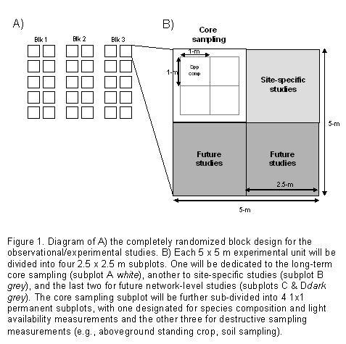One of these permanent 1-m2 subplots will be designated for plant species composition sampling and the other three for destructive sampling. Core sampling will include aboveground standing crop (sorted to at least three functional groups), percent cover of all plant species, and light availability measurements. All of these core measurements will be collected from all plots prior to initiation of the experiment and in each year of the experiment, using the same methodology for all sites. At minimum, soil samples will be collected from the plots for nutrient analyses prior to initiation of the experiment and at year 3 of the experiment.

We will provide a standard spreadsheet for the core sampling data. Copies of datasheets, electronic data and metadata will be sent to the Data Master at the end of each growing season.  These data will be collated and quality-controlled. All data will be available to all network members.

**a. Plant Species Composition**

Prior to initiation of the experiment, percent aerial cover will be estimated in one permanently marked 1-m2 subplot, one within the core-sampling subplot. Aerial cover will be estimated for each plant species separately using a modified Daubenmire method (Daubenmire 1959), in which cover is estimated to the nearest 1% percent for each species rooted within the plot (cardboard cutouts can be used to facilitate estimation). Percent cover also should be estimated for woody overstory, litter, bare soil, animal diggings/disturbance, and rocks if present. Note that total cover will typically exceed 100% because species cover is estimated independently for each species.

Within-season sampling frequency will need to be adjusted for individual ecosystems based on the phenology of the component species in order to capture the maximum cover of each species, which will be used in subsequent analyses. For example, in the tallgrass prairie, species composition will be measured in the spring (late-May) and again in the fall (late-Aug) to capture maximum relative cover of early-season C3 forb and grass species and late-season C4 forb and grass species, respectively.

**b. Light Availability**

Light availability will be measured using a light meter (e.g., 1-m length Decagon Ceptometer if possible) capable of integrated measures of photosynthetically active radiation (PAR, mol m-2 sec-1). Light availability will be measured at the same time and in the same 1-m2 subplot used for the species composition measurements. Light readings must be taken on a cloudless day as close to solar noon as possible (i.e., 11 am to 2 pm).  For each subplot, two light measurements at ground level (at opposite corners of the 1-m2 plot, diagonal to each other) and one above the canopy will be taken. Light availability will be calculated as the ratio of PAR below and above the canopy.  If you use a point sensor, record the mean of at least 10 readings in different locations (this is done automatically with the linear sensors).

**c. Aboveground Standing Crop**

Aboveground standing crop will be estimated destructively by clipping at ground level all aboveground biomass of individual plants rooted within a 0.2 m2 (two 10 x 100 cm) strips. Biomass will be clipped within the the 1-m2 subplots designated for destructive sampling within the core sampling subplot. Location of the quadrats should be noted or marked permanently to prevent resampling during the duration of the study. For shrubs and subshrubs rooted within the quadrat, leaves and current year’s woody growth should be collected.

Standing crop should be separated into the following categories: previous year’s dead, current year’s bryophytes, and current year’s vascular plant. If time permits, it would be highly valuable to separate biomass into the following six categories: 1. previous year’s dead, 2. current year’s bryophytes, 3. current year’s graminoid (grasses, sedges, rushes), 4. current year’s legumes, 5. current year’s non-leguminous forbs, 6. current year’s woody growth. All biomass should be dried at 60C for 48hrs prior to weighing to the nearest 0.01 g.

**d. Soil Sampling**

Prior to initiation of the experiment, soil cores will be collected during the growing season from all of the plots. For each plot, collect two to three soil cores (soil corer - 2.5 x 10 cm) from each of the 2.5 x 2.5 m subplots (in areas designated for destructive biomass sampling). Litter and vegetation should be removed from the soil surface before collecting each sample. Composite and homogenize these sub-samples into a single sample for each 5x5 m plot (total of 30 roughly 500 g samples).  All soil samples should be double bagged in paper and allowed to air dry. Label each bag (with permanent marker, Sharpie preferred) with the following information: date of collection, name of collector, name of sampling site, and block/plot/treatment identification.

To ship your pre-treatment soils to the University of Minnesota please precisely follow these instructions:

[Protocol for soil shipping](https://nutnet.org/soil-shipping)

These core measurements should provide the basic information needed to assess the effects of multiple resource limitation and top-down control on community structure and productivity. Additional sampling that should be considered includes: pitfall trapping for insects, plant tissue chemistry, soil chemistry (resin bags or other method), movable exclosures for ANPP measures, and small mammal trapping. Coordination among the sites with these measurements will be encouraged.

**5. Timeline** **–** Baseline plant and soils information were collect at the first cohort of nutnet sites  during the 2007 growing season, with herbivore exclosures would be established and addition of nutrients would initiated at the beginning of the 2008 growing season at each site. Core data collection will continue for at least three years, with hopes of continuing on for 10 or more years if possible. Sites starting in later years, should start with an year of baseline data collection prior to initiation of treatments.