LI-8100A Soil Gas Flux System

Written by: Morgan Appell

**Setup**

1. Collect the Licor-8100 briefcase, chamber, laptop, and laptop connection cord.
2. Connect one 12-volt lead acid battery inside the briefcase
3. Connect the chamber to the system as shown below.

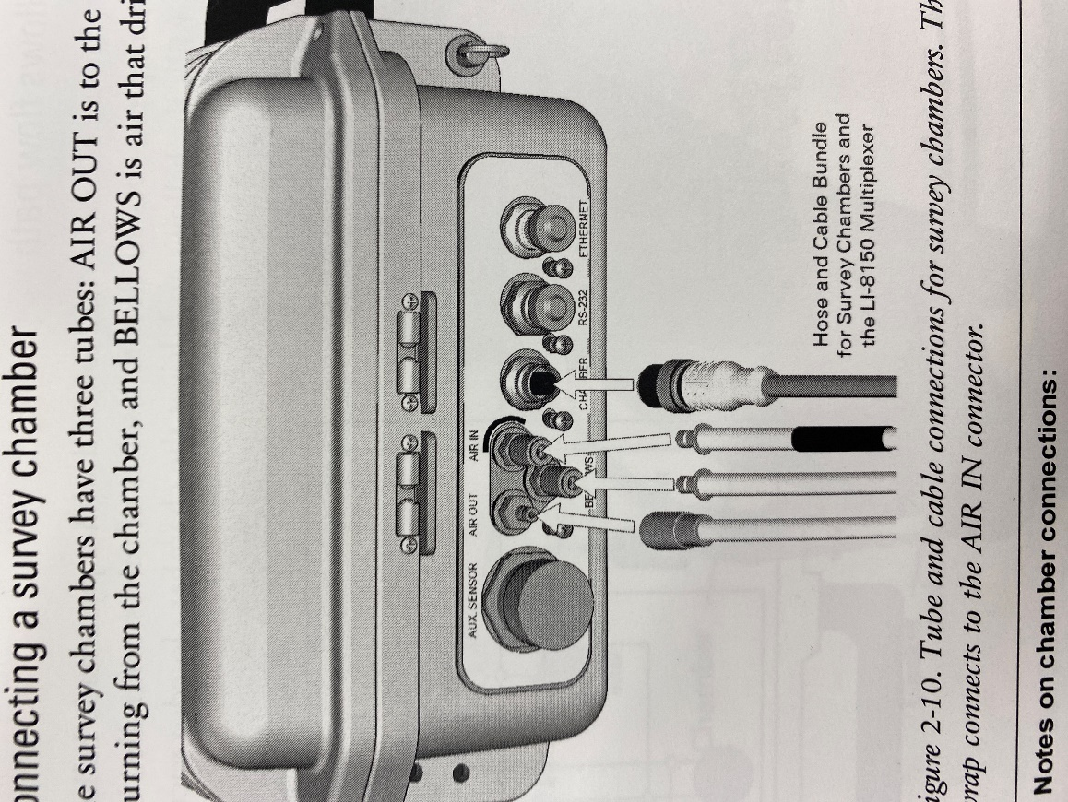

Figure 1: Chamber Connection

1. Connect the laptop connection cord into the RS-232 connection port. Note: Do not connected the USB side into the laptop yet
2. Place the chamber on the soil collar
3. Turn on the system
4. Open the LI-8100A software on the computer
5. Once the software is running, connect the USB side of the connection cord to the laptop. The top left USB connection port on the ThinkPad is Serial Port (COM) 3.
6. Select Communication -> Connect. This will open a dialog box.
7. Select Serial -> Select the port number -> Connect
8. Once the Licor is connected to the laptop, it should show on the bottom of the software screen: Connected to UNKNOWN on COM3.

Note: The external temperature and moisture probe connects to the Aux. Sensor connection port.

**Running a Chamber Measurement**

1. Make sure the system is on and IRGA ready. This may take a few minutes.
2. Select Setup -> Chamber Measurement. This will open a dialog box.
3. In the Chamber tab, select:

10cm Survey – (8100-102)

Soil Area (cm^2): 317.8

Chamber Offset (cm): 10cm (typical) *Distance between the soil surface and the top of the collar*

1. Select the Observation Tab, set desired measurement time lengths

Observation Length: Between 60-90 seconds (typically)

Pre-purge: 15 seconds

Dead Band: 0 s

Post-Purge: 0 s

Observation Count: 1

1. Select Start Measurement to begin a new observation file. A new dialog box should open.
2. Enter file requirements

Measurement File: Name, standard data file, split by the day

Destination: Onboard Internal Flash

Select Desired Start Time (typically immediate)

1. Select Start Measurement. The dialog boxes will disappear when the measurement starts.
2. The machine will pre-purge and then the chamber will lower to seal. You should hear a loud whirling noise while the system is running.

If you wish to see a graph of the measurement as it is recording:

1. select the Utilities -> Charting
2. Select your x and y axis
3. Select the Start button

**Downloading the data**

1. Select Utilities -> File Manager
2. Scroll through the Internal Storage to find your file name
3. Select File and click Transfer to PC
4. The file should appear on the computer home screen.

**Soil Flux Pro**

1. Open the file
2. Double Click on the file you wish to change
3. Move to the recompute tab and change data as necessary
4. Select Compute