**Smith Lab Split-Pot Construction**

Protocol by Kelly Carroll; March 28, 2024

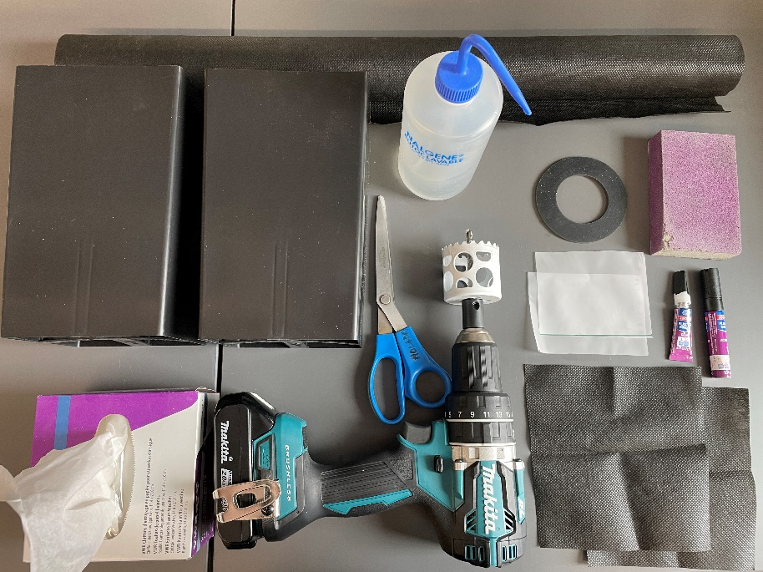**Tools/Non-Consumables Required:**

Scissors

Stapler (not shown)

Ruler (not shown)

Sharpie (not shown)

Power drill (high speed and torque preferred)

2” hole saw drill bit

Sandpaper (180 grit)

Spray/squirt-bottle with 70% EtOH

Box of Kimwipes

Bottle superglue (options below)

Loctite 498 ([McMaster-Carr ID 74985A71](https://www.mcmaster.com/74985A71)) (not shown)

Loctite Plastics Bonder ([Home Depot](https://www.homedepot.com/p/Loctite-Super-Glue-0-21-oz-Plastic-2-Part-Bonding-All-Plastic-All-Materials-Clear-Tubes-each-681925/100371829))

**Materials:**

2 5”x8” Anderson Band pots ([Stuewe & Sons, Inc.](https://stuewe.com/product/5-x-8-anderson-band/) AB58)

2 7” squares cut from: VIGORO 2’x40’ Medium Duty Garden Fabric ([Home Depot](https://www.homedepot.com/p/Vigoro-2-ft-x-40-ft-Medium-Duty-Perforated-Raised-Garden-Bed-Fabrics-RGB02B40PF/322251434))

1 129/32” ID Neoprene Pipe Gasket ([McMaster-Carr ID 97725K35](https://www.mcmaster.com/97725K35/))

1-2* 3” squares cut from: 1yd of 20 µm nylon mesh (Elko Filtering Co. PN 03-20/14, Possible Missions PN NC0569344)

1* 3” square cut from: 1sqft of 0.45 µm nylon mesh (Gilson Company Inc. PN NMD #325, Possible Missions PN NC0856945)

*Use 1sq 0.45 µm nylon mesh and 1sq 20 µm nylon mesh *if* building a mycorrhizal exclusion pot†.

†If building a mycorrhizal exclusion pot, *mark which side* you are placing the 0.45 µm mesh on to ensure it is standardized across all pots. I placed the mesh on the plant side of the pot.

**Protocol:**

Step 0.5: Cut all needed squares of landscaping fabric (7” square) and mesh (3” square).

1. Staple 7” square of landscaping fabric to the bottom of each pot. Best practice is 2 staples per side[1], holding the fabric taut (see Figure 1).

**1)**

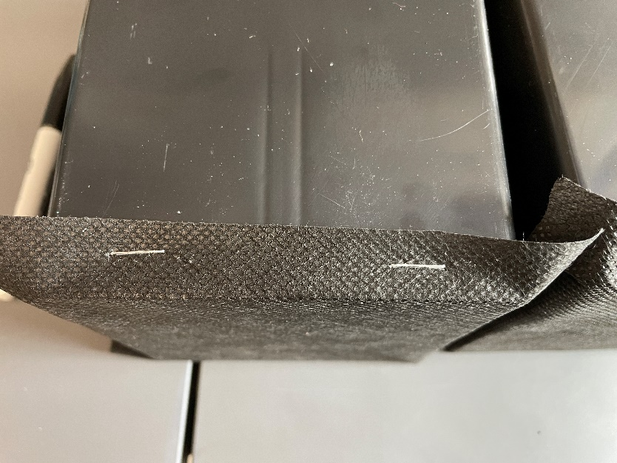

1. Mark location of future port on both pots. Best practice is to begin by using one gasket against the pot as a stencil to mark the extent and placement of the desired hole, using the ruler to center the hole[2] (see Figure 2a, b). You can, if wanted, mark the ruler with these dimensions as relative to the top of the pot (see Figure 2c).

**2c)**

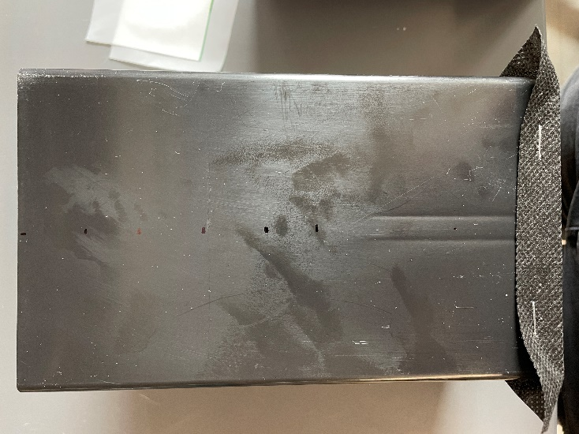

**2a)**

**2b)**

1. Lining the drill bit in the hole saw up with the center of the marked desired hole *and* the horizontal center of the pot, drill *forward* (clockwise) only until the hole saw bites into the plastic[3] (see Figure 3a). *Reverse the drill direction* and press downward, drilling/grinding through the plastic wall with the hole saw[4] (see Figure 3b).

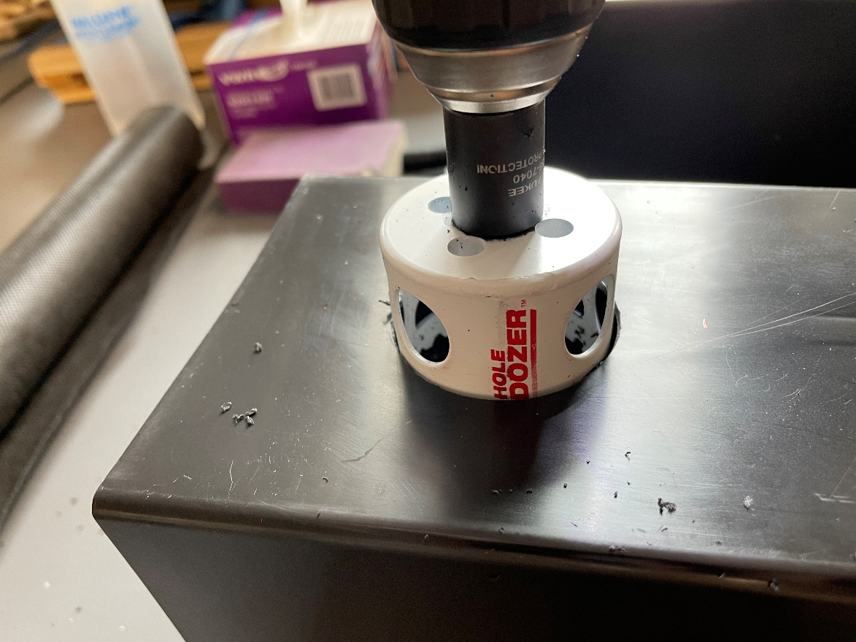

**3b)**

**3a)**

1. Clean edges of hole, removing sharp and/or rough edges, especially those facing outwards.
2. Use sandpaper to roughen outside of both pots around the hole to ensure binding of glue (see Figure 4).

**4)**

1. Use 70% EtOH and a KIMwipe to clean away plastic dust from the pots, as well as manufacturing debris from the neoprene gasket.

**If using Loctite 498:**

1. Line up 3” square of mesh with hole on one pot. Apply Loctite 498 to the neoprene gasket in an even circle around the entire gasket and press the gasket *over* the mesh to the pot (see Figure 5a, b) for at least 1min using even pressure.

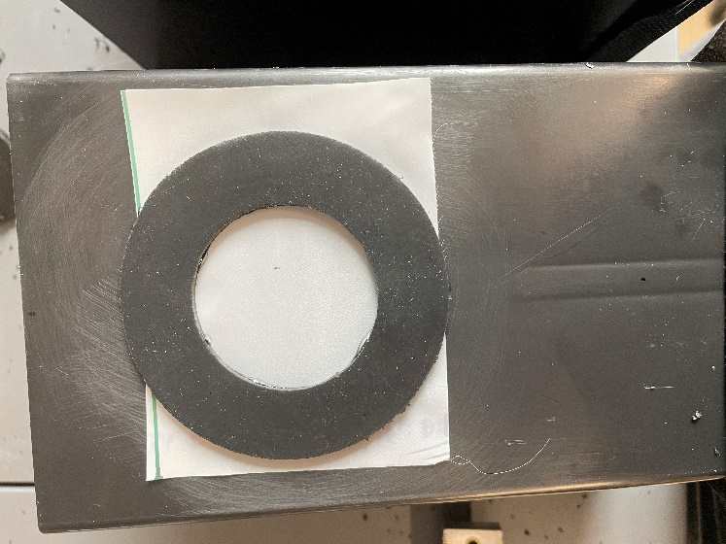

**5b)**

**5a)**

1. Apply Loctite 498 to gasket in an even circle (see Figure 6), *quickly* place mesh over the glue, and press the other pot to the gasket[5] for at least 1min using even pressure.

**6)**

**If using Loctite Plastics Bonder *in a well-ventilated space*:**

7. Use Step 1 of Plastics Bonder on the area surrounding the holes on both pots and on both sides of the gasket and allow the accelerator to dry (see Figure 7a, b); *do not* place the mesh on either pot before 1min has elapsed.

**7b)**

**7a)**

8. Place mesh over the hole, apply Step 2 of the Plastics Bonder to the neoprene seal, and *quickly* press the seal to the pot, holding for 1min using even pressure (see Figure 8).

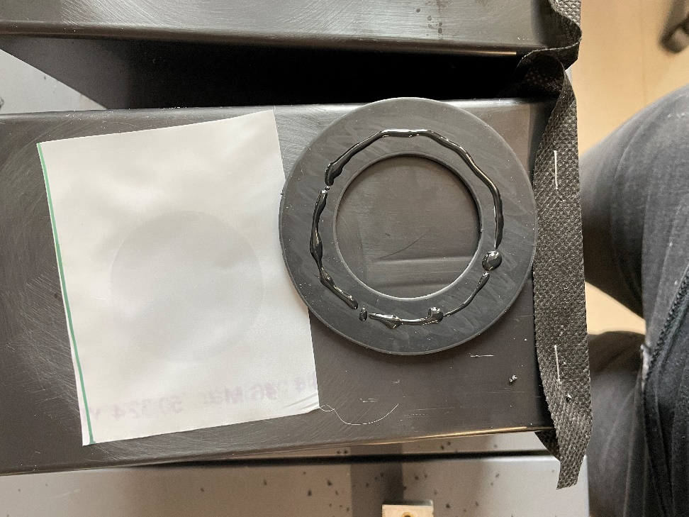

**8)**

1. Apply Step 2 of the Plastics Bonder to the gasket in an even circle, *quickly* place mesh over the glue (see Figure 9a, b) and press the other pot to the gasket[6] for at least 1min using even pressure.

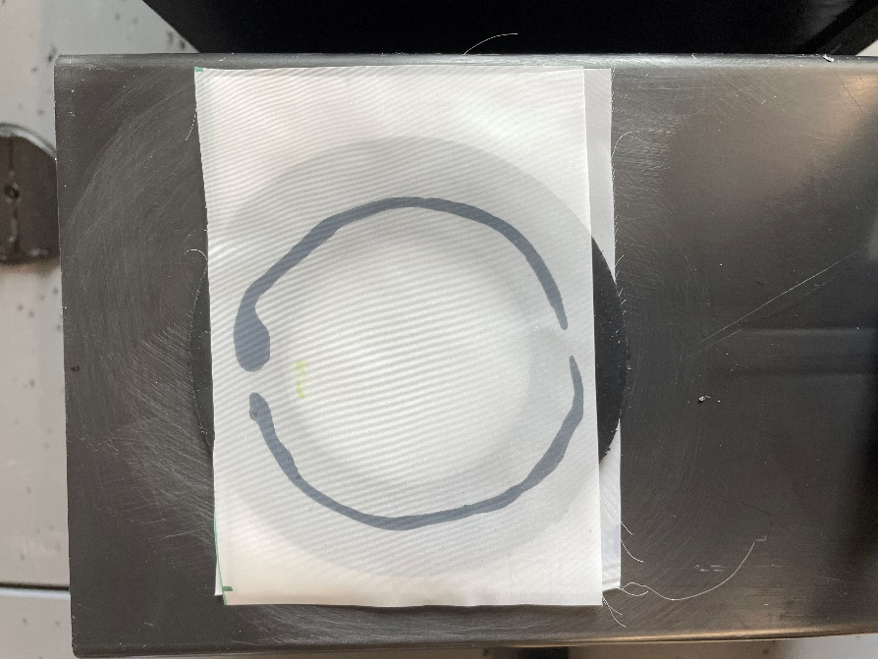

**9b)**

**9a)**

**Note: When handling pots after construction, do not pick up by only one side, *especially* once filled with soil. Pick up from the bottom or from the outside of each pot, pressing inwards to hold the seal together.**

**Final Product!**

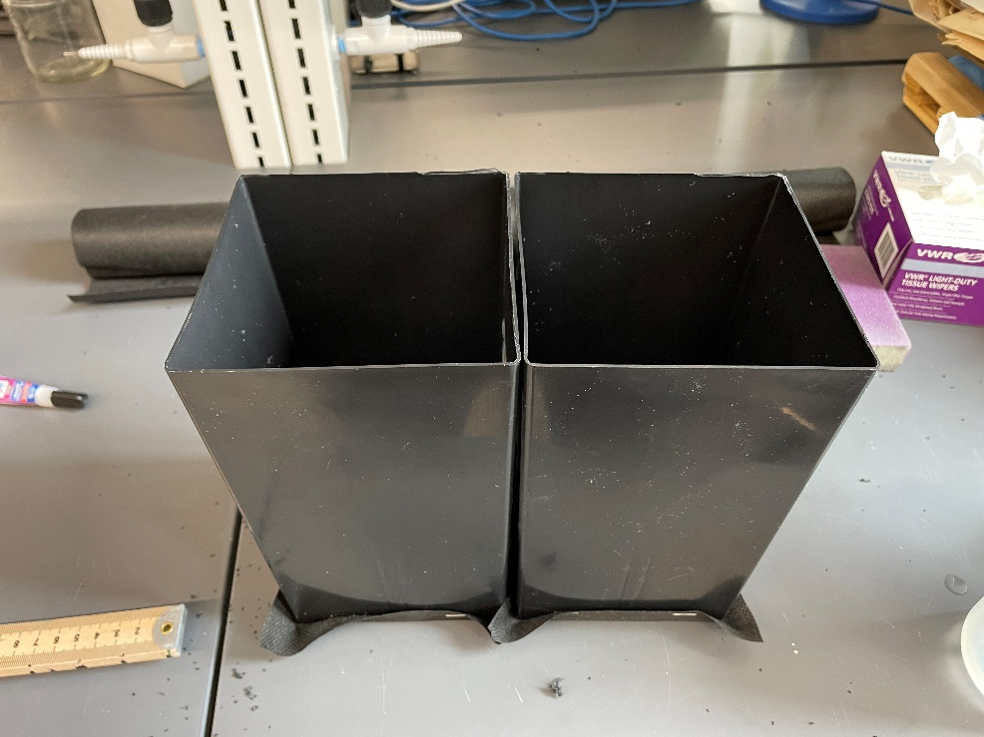

1. The stapler may not penetrate on the first try due to the give in the pots. Have many staples handy.
2. You want the hole centered so that the holes in both pots line up when glued together. *Do not rush* and skip this step.
3. You will know when it bites, and odds are that it will not drill through the plastic in the *forward* direction.
4. This sounds weird but is the only way to penetrate the plastic. Do not press too hard or you will deform the hole by bending the pot walls. You will throw small bits of plastic five feet in every direction. *Plan accordingly*.
5. Better to ensure level sitting of the whole pot, as opposed to perfect lining-up of the two gaskets. (The two gaskets’ diameter will be slightly smaller than the drilled hole, as they do not make 2” internal-diameter gaskets *or* 129/32” hole saws.)
6. Better to ensure level sitting of the whole pot, as opposed to perfect lining-up of the two gaskets. (The two gaskets’ diameter will be slightly smaller than the drilled hole, as they do not make 2” internal-diameter gaskets *or* 129/32” hole saws.)