DES算法实验报告

姓 名：
学 号：
课程名称：
指导教师：王景中

- DES算法简介
DES算法为密码体质中的对称密码体制，又被称为美国数据加密标准，是1972年美国IBM公司研制的对称密码体制加密算法。 明文按64位进行分组，密钥长64位，密钥事实上是56位参与DES运算（第8、16、24、32、40、48、56、64位是校验位， 使得每个密钥都有奇数个1）分组后的明文组和56位的密钥按位替代或交换的方法形成密文组的加密方法

- DES算法流程
- 加密
DES算法把64位的明文输入块变为64位的密文输出块，它所使用的密钥也是64位,其功能是把输入的64位数据块按位重新组合，并把输出分为L0 、R0两部分，每部分各长32位，其置换规则见下表：
58,50,12,34,26,18,10,2,60,52,44,36,28,20,12,4,
62,54,46,38,30,22,14,6,64,56,48,40,32,24,16,8,
57,49,41,33,25,17, 9,1,59,51,43,35,27,19,11,3,
61,53,45,37,29,21,13,5,63,55,47,39,31,23,15,7,
即将输入的第58位换到第一位，第50位换到第2位，……，依此类推，最后一位是原来的第7位。 L0、R0则是换位输出后的两部分，L0是输出的左32位，R0 是右32位，例：设置换前的输入值为D1D2D3……D64，则经过初始置换后的结果为：L0=D550……D8；R0=D57D49...D7。
经过26次迭代运算后，得到L16、R16，将此作为输入，进行逆置换，即得到密文输出。逆置换正好是初始置的逆运算，例如，第1位经过初始置换后，处于第40位，而通过逆置换，又将第40位换回到第1位，其逆置换规则如下表所示：
40,8,48,16,56,24,64,32,39,7,47,15,55,23,63,31,
38,6,46,14,54,22,62,30,37,5,45,13,53,21,61,29,
36,4,44,12,52,20,60,28,35,3,43,11,51,19,59,27,
34,2,42,10,50,18,58 26,33,1,41, 9,49,17,57,25,
放大换位表
32, 1, 2, 3, 4, 5, 4, 5, 6, 7, 8, 9, 8, 9, 10,11,
12,13,12,13,14,15,16,17,16,17,18,19,20,21,20,21,
22,23,24,25,24,25,26,27,28,29,28,29,30,31,32, 1,
单纯换位表
16,7,20,21,29,12,28,17, 1,15,23,26, 5,18,31,10,
2,8,24,14,32,27, 3, 9,19,13,30, 6,22,11, 4,25,
在f(Ri,Ki)算法描述图中，S1,S2...S8为选择函数，其功能是把6bit数据变为4bit数据。下面给出选择函数Si(i=1,2......8)的功能表：
选择函数Si
S1:
14,4,13,1,2,15,11,8,3,10,6,12,5,9,0,7,
0,15,7,4,14,2,13,1,10,6,12,11,9,5,3,8,
4,1,14,8,13,6,2,11,15,12,9,7,3,10,5,0,
15,12,8,2,4,9,1,7,5,11,3,14,10,0,6,13,
S2:
15,1,8,14,6,11,3,4,9,7,2,13,12,0,5,10,
3,13,4,7,15,2,8,14,12,0,1,10,6,9,11,5,
0,14,7,11,10,4,13,1,5,8,12,6,9,3,2,15,
13,8,10,1,3,15,4,2,11,6,7,12,0,5,14,9,
S3:
10,0,9,14,6,3,15,5,1,13,12,7,11,4,2,8,
13,7,0,9,3,4,6,10,2,8,5,14,12,11,15,1,
13,6,4,9,8,15,3,0,11,1,2,12,5,10,14,7,
1,10,13,0,6,9,8,7,4,15,14,3,11,5,2,12,
S4:
7,13,14,3,0,6,9,10,1,2,8,5,11,12,4,15,
13,8,11,5,6,15,0,3,4,7,2,12,1,10,14,9,
10,6,9,0,12,11,7,13,15,1,3,14,5,2,8,4,
3,15,0,6,10,1,13,8,9,4,5,11,12,7,2,14,
S5:
2,12,4,1,7,10,11,6,8,5,3,15,13,0,14,9,
14,11,2,12,4,7,13,1,5,0,15,10,3,9,8,6,
4,2,1,11,10,13,7,8,15,9,12,5,6,3,0,14,
11,8,12,7,1,14,2,13,6,15,0,9,10,4,5,3,
S6:
12,1,10,15,9,2,6,8,0,13,3,4,14,7,5,11,
10,15,4,2,7,12,9,5,6,1,13,14,0,11,3,8,
9,14,15,5,2,8,12,3,7,0,4,10,1,13,11,6,
4,3,2,12,9,5,15,10,11,14,1,7,6,0,8,13,
S7:
4,11,2,14,15,0,8,13,3,12,9,7,5,10,6,1,
13,0,11,7,4,9,1,10,14,3,5,12,2,15,8,6,
1,4,11,13,12,3,7,14,10,15,6,8,0,5,9,2,
6,11,13,8,1,4,10,7,9,5,0,15,14,2,3,12,
S8:
13,2,8,4,6,15,11,1,10,9,3,14,5,0,12,7,
1,15,13,8,10,3,7,4,12,5,6,11,0,14,9,2,
7,11,4,1,9,12,14,2,0,6,10,13,15,3,5,8,
2,1,14,7,4,10,8,13,15,12,9,0,3,5,6,11,
- 子密钥Ki(48bit)的生成算法
初始Key值为64位，但DES算法规定，其中第8、16、......64位是奇偶校验位，不参与DES运算。故Key 实际可用位数便只有56位。即：经过缩小选择换位表1的变换后，Key 的位数由64 位变成了56位，此56位分为C0、D0两部分，各28位，然后分别进行第1次循环左移，得到C1、D1，将C1（28位）、D1（28位）合并得到56位，再经过缩小选择换位2，从而便得到了密钥K0（48位）。依此类推，便可得到K1、K2、......、K15，不过需要注意的是，16次循环左移对应的左移位数要依据下述规则进行：
循环左移位数1,1,2,2,2,2,2,2,1,2,2,2,2,2,2,1
以上介绍了DES算法的加密过程。 DES算法的解密过程是一样的，区别仅仅在于第一次迭代时用子密钥K15，第二次K14、……，最后一次用K0，算法本身并没有任何变化。
- 解密
DES的解密过程和DES的加密过程完全类似，只不过将16圈的子密钥序列K1，K2……K16的顺序倒过来。即第一圈用第16个子密钥K16，第二圈用K15，其余类推。

- 流程图
- 加密流程图
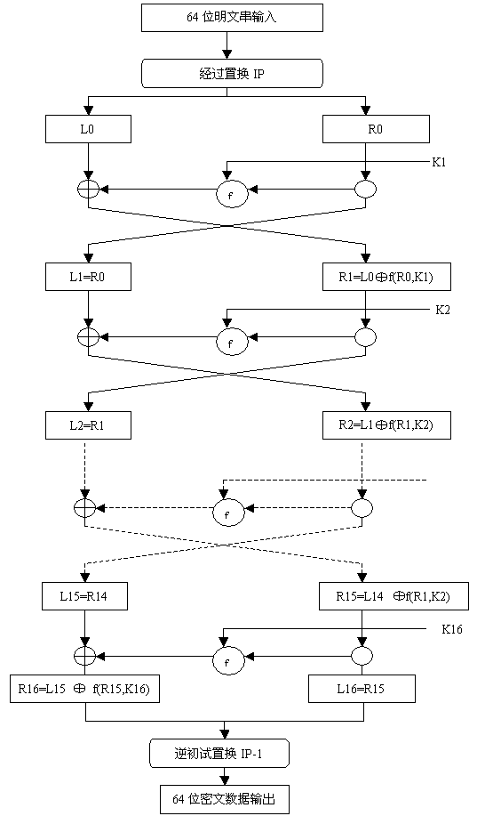
- 子密钥生成流程图
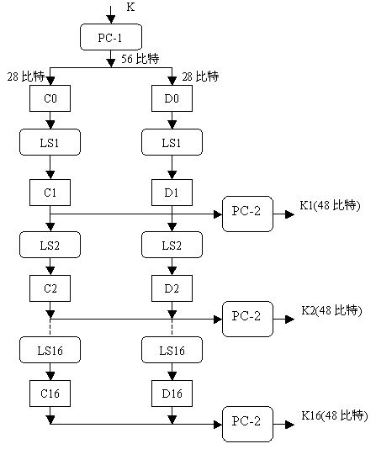
- 解密流程图

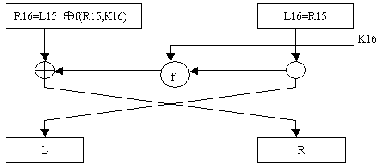

- 功能流程图

开始

输入密钥

输入明文

判断明文密钥是否为空、

加密
返回密文

判断密文是否符合规则

解密
返回明文

结束

- 变量定义
- IP 表
const static char IP_Table[] = {
58, 50, 42, 34, 26, 18, 10, 2,
60, 52, 44, 36, 28, 20, 12, 4,
62, 54, 46, 38, 30, 22, 14, 6,
64, 56, 48, 40, 32, 24, 16, 8,
57, 49, 41, 33, 25, 17, 9, 1,
59, 51, 43, 35, 27, 19, 11, 3,
61, 53, 45, 37, 29, 21, 13, 5,
63, 55, 47, 39, 31, 23, 15, 7
};
- E 表
const static char Exp_Table[] = {
32, 1, 2, 3, 4, 5,
4, 5, 6, 7, 8, 9,
8, 9, 10, 11, 12, 13,
12, 13, 14, 15, 16, 17,
16, 17, 18, 19, 20, 21,
20, 21, 22, 23, 24, 25,
24, 25, 26, 27, 28, 29,
28, 29, 30, 31, 32, 1
};
- S 盒
const static char S_Box[8][64] = {
/* S1 */
{
14, 4, 13, 1, 2, 15, 11, 8, 3, 10, 6, 12, 5, 9, 0, 7,
0, 15, 7, 4, 14, 2, 13, 1, 10, 6, 12, 11, 9, 5, 3, 8,
4, 1, 14, 8, 13, 6, 2, 11, 15, 12, 9, 7, 3, 10, 5, 0,
15, 12, 8, 2, 4, 9, 1, 7, 5, 11, 3, 14, 10, 0, 6, 13
},

/* S2 */
{
15, 1, 8, 14, 6, 11, 3, 4, 9, 7, 2, 13, 12, 0, 5, 10,
3, 13, 4, 7, 15, 2, 8, 14, 12, 0, 1, 10, 6, 9, 11, 5,
0, 14, 7, 11, 10, 4, 13, 1, 5, 8, 12, 6, 9, 3, 2, 15,
13, 8, 10, 1, 3, 15, 4, 2, 11, 6, 7, 12, 0, 5, 14, 9
},
…
};

- P 表
const static char P_Table[]= {
16, 7, 20, 21,
29, 12, 28, 17,
1, 15, 23, 26,
5, 18, 31, 10,
2, 8, 24, 14,
32, 27, 3, 9,
19, 13, 30, 6,
22, 11, 4, 25
};

- 实验说明
- 运行环境
- 操作系统：windows
- 开发工具：devcpp
- 实验任务
- 设计实现DES算法的计算机程序。
- 实验要求
- 编写实现DES加密/解密的完整程序，编程语言不限。程序中要明确划分加/解密模块、子密钥生成模块、数据置换模块、F函数模块、S变换模块等，定义相应的子函数。
- 清晰定义数据结构和数据变量。
- 友好的用户交互接口。
- 能实现给定数据的加密和解密。
- 程序运行效果图
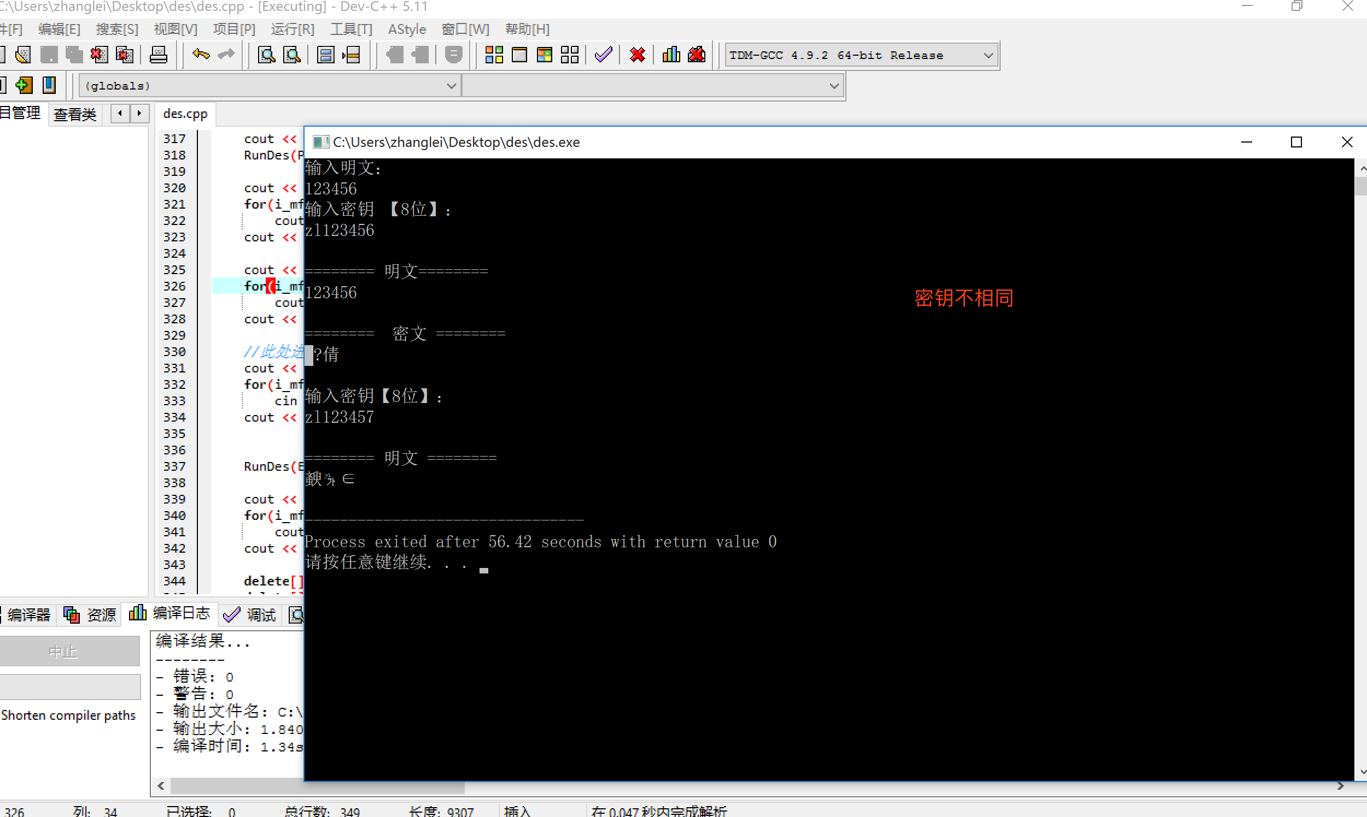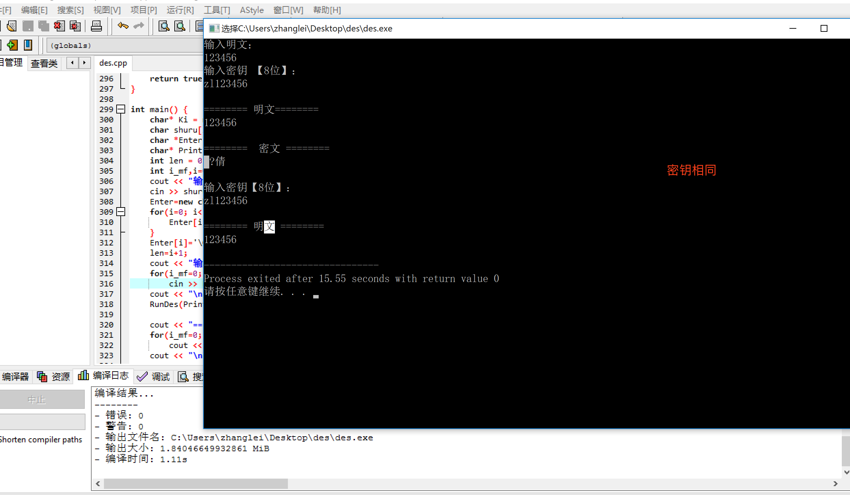

- 主要函数
#include <iostream>
#include<math.h>
#include<string.h>

using namespace std;

const static char IP_Table[] = { //IP_Table置换
58, 50, 42, 34, 26, 18, 10, 2,
60, 52, 44, 36, 28, 20, 12, 4,
62, 54, 46, 38, 30, 22, 14, 6,
64, 56, 48, 40, 32, 24, 16, 8,
57, 49, 41, 33, 25, 17, 9, 1,
59, 51, 43, 35, 27, 19, 11, 3,
61, 53, 45, 37, 29, 21, 13, 5,
63, 55, 47, 39, 31, 23, 15, 7
};
const static char Final_Table[] = { //最终置换
40, 8, 48, 16, 56, 24, 64, 32,
39, 7, 47, 15, 55, 23, 63, 31,
38, 6, 46, 14, 54, 22, 62, 30,
37, 5, 45, 13, 53, 21, 61, 29,
36, 4, 44, 12, 52, 20, 60, 28,
35, 3, 43, 11, 51, 19, 59, 27,
34, 2, 42, 10, 50, 18, 58, 26,
33, 1, 41, 9, 49, 17, 57, 25
};
const static char S_Box[8][64] = { //s_box
/* S1 */
{
14, 4, 13, 1, 2, 15, 11, 8, 3, 10, 6, 12, 5, 9, 0, 7,
0, 15, 7, 4, 14, 2, 13, 1, 10, 6, 12, 11, 9, 5, 3, 8,
4, 1, 14, 8, 13, 6, 2, 11, 15, 12, 9, 7, 3, 10, 5, 0,
15, 12, 8, 2, 4, 9, 1, 7, 5, 11, 3, 14, 10, 0, 6, 13
},

/* S2 */
{
15, 1, 8, 14, 6, 11, 3, 4, 9, 7, 2, 13, 12, 0, 5, 10,
3, 13, 4, 7, 15, 2, 8, 14, 12, 0, 1, 10, 6, 9, 11, 5,
0, 14, 7, 11, 10, 4, 13, 1, 5, 8, 12, 6, 9, 3, 2, 15,
13, 8, 10, 1, 3, 15, 4, 2, 11, 6, 7, 12, 0, 5, 14, 9
},

/* S3 */
{
10, 0, 9, 14, 6, 3, 15, 5, 1, 13, 12, 7, 11, 4, 2, 8,
13, 7, 0, 9, 3, 4, 6, 10, 2, 8, 5, 14, 12, 11, 15, 1,
13, 6, 4, 9, 8, 15, 3, 0, 11, 1, 2, 12, 5, 10, 14, 7,
1, 10, 13, 0, 6, 9, 8, 7, 4, 15, 14, 3, 11, 5, 2, 12
},

/* S4 */
{
7, 13, 14, 3, 0, 6, 9, 10, 1, 2, 8, 5, 11, 12, 4, 15,
13, 8, 11, 5, 6, 15, 0, 3, 4, 7, 2, 12, 1, 10, 14, 9,
10, 6, 9, 0, 12, 11, 7, 13, 15, 1, 3, 14, 5, 2, 8, 4,
3, 15, 0, 6, 10, 1, 13, 8, 9, 4, 5, 11, 12, 7, 2, 14
},

/* S5 */
{
2, 12, 4, 1, 7, 10, 11, 6, 8, 5, 3, 15, 13, 0, 14, 9,
14, 11, 2, 12, 4, 7, 13, 1, 5, 0, 15, 10, 3, 9, 8, 6,
4, 2, 1, 11, 10, 13, 7, 8, 15, 9, 12, 5, 6, 3, 0, 14,
11, 8, 12, 7, 1, 14, 2, 13, 6, 15, 0, 9, 10, 4, 5, 3
},

/* S6 */
{
12, 1, 10, 15, 9, 2, 6, 8, 0, 13, 3, 4, 14, 7, 5, 11,
10, 15, 4, 2, 7, 12, 9, 5, 6, 1, 13, 14, 0, 11, 3, 8,
9, 14, 15, 5, 2, 8, 12, 3, 7, 0, 4, 10, 1, 13, 11, 6,
4, 3, 2, 12, 9, 5, 15, 10, 11, 14, 1, 7, 6, 0, 8, 13
},

/* S7 */
{
4, 11, 2, 14, 15, 0, 8, 13, 3, 12, 9, 7, 5, 10, 6, 1,
13, 0, 11, 7, 4, 9, 1, 10, 14, 3, 5, 12, 2, 15, 8, 6,
1, 4, 11, 13, 12, 3, 7, 14, 10, 15, 6, 8, 0, 5, 9, 2,
6, 11, 13, 8, 1, 4, 10, 7, 9, 5, 0, 15, 14, 2, 3, 12
},

/* S8 */
{
13, 2, 8, 4, 6, 15, 11, 1, 10, 9, 3, 14, 5, 0, 12, 7,
1, 15, 13, 8, 10, 3, 7, 4, 12, 5, 6, 11, 0, 14, 9, 2,
7, 11, 4, 1, 9, 12, 14, 2, 0, 6, 10, 13, 15, 3, 5, 8,
2, 1, 14, 7, 4, 10, 8, 13, 15, 12, 9, 0, 3, 5, 6, 11
}
};
const static char Rar_Table[] = { //压缩置换
14, 17, 11, 24, 1, 5,
3, 28, 15, 6, 21, 10,
23, 19, 12, 4, 26, 8,
16, 7, 27, 20, 13, 2,
41, 52, 31, 37, 47, 55,
30, 40, 51, 45, 33, 48,
44, 49, 39, 56, 34, 53,
46, 42, 50, 36, 29, 32
};
const static char Exp_Table[] = { //扩展置换
32, 1, 2, 3, 4, 5,
4, 5, 6, 7, 8, 9,
8, 9, 10, 11, 12, 13,
12, 13, 14, 15, 16, 17,
16, 17, 18, 19, 20, 21,
20, 21, 22, 23, 24, 25,
24, 25, 26, 27, 28, 29,
28, 29, 30, 31, 32, 1
};
const static char P_Table[]= { //P置换
16, 7, 20, 21,
29, 12, 28, 17,
1, 15, 23, 26,
5, 18, 31, 10,
2, 8, 24, 14,
32, 27, 3, 9,
19, 13, 30, 6,
22, 11, 4, 25
};
const static char KeyRar_Table[]= {
57, 49, 41, 33, 25, 17, 9,
1, 58, 50, 42, 34, 26, 18,
10, 2, 59, 51, 43, 35, 27,
19, 11, 3, 60, 52, 44, 36,

63, 55, 47, 39, 31, 23, 15,
7, 62, 54, 46, 38, 30, 22,
14, 6, 61, 53, 45, 37, 29,
21, 13, 5, 28, 20, 12, 4
};

//设置全局变量，16轮密钥
bool key[16][48]= {{0}};

void ByteToBit(bool *Out,char *In,int bits) { //字节到位转换函数
int i;
for(i=0; i<bits; i++)
Out[i]=(In[i/8]>>(i%8))&1;
}
void BitToByte(char *Out,bool *In,int bits) { //位到字节转换函数
int i;
for(i=0; i<bits/8; i++)
Out[i]=0;
for(i=0; i<bits; i++)
Out[i/8]|=In[i]<<(i%8);
}
void Xor(bool *InA,const bool *InB,int length) { //按位异或
for(int i=0; i<length; i++)
InA[i]^=InB[i];
}
void keyfc(char *In) { //密钥生成函数
int i,j=0,mov,k,m;
bool* key0 = new bool[56];
bool* keyin = new bool[64];
bool temp;

ByteToBit(keyin,In,64); //字节到位的转换
for(i=0; i<56; i++) //密钥压缩为56位
key0[i]=keyin[KeyRar_Table[i]-1];
for(i=0; i<16; i++) { //16轮密钥产生
if(i==0||i==1||i==8||i==15)
mov=1;
else
mov=2;
for(k=0; k<mov; k++) { //分左右两块循环左移
for(m=0; m<8; m++) {
temp=key0[m*7];
for(j=m*7; j<m*7+7; j++)
key0[j]=key0[j+1];
key0[m*7+6]=temp;
}
temp=key0[0];
for(m=0; m<27; m++)
key0[m]=key0[m+1];
key0[27]=temp;
temp=key0[28];
for(m=28; m<55; m++)
key0[m]=key0[m+1];
key0[55]=temp;
}

for(j=0; j<48; j++) //压缩置换并储存
key[i][j]=key0[Rar_Table[j]-1];
}
delete[] key0;
delete[] keyin;
}

void DES(char Out[8],char In[8],bool Type) { //加密核心程序,Type=0时加密，反之解密
bool* MW = new bool[64];
bool* tmp = new bool[32];
bool* PMW = new bool[64];
bool* kzmw = new bool[48];
bool* keytem = new bool[48];
bool* ss = new bool[32];

int hang,lie,i;
ByteToBit(PMW,In,64);
for(int j=0; j<64; j++) {
MW[j]=PMW[IP_Table[j]-1]; //初始置换
}
bool *Li=&MW[0],*Ri=&MW[32];
for(i=0; i<48; i++) //右明文扩展置换
kzmw[i]=Ri[Exp_Table[i]-1];

if(Type==0) { //DES加密过程
for(int lun=0; lun<16; lun++) {
for(i=0; i<32; i++)
ss[i]=Ri[i];
for(i=0; i<48; i++) //右明文扩展置换
kzmw[i]=Ri[Exp_Table[i]-1];
for(i=0; i<48; i++)
keytem[i]=key[lun][i];
Xor(kzmw,keytem,48);
/*S盒置换*/
for(i=0; i<8; i++) {
hang=kzmw[i*6]*2+kzmw[i*6+5];
lie =kzmw[i*6+1]*8+kzmw[i*6+2]*4+kzmw[i*6+3]*2+kzmw[i*6+4];
tmp[i*4+3]=S_Box[i][(hang+1)*16+lie]%2;
tmp[i*4+2]=(S_Box[i][(hang+1)*16+lie]/2)%2;
tmp[i*4+1]=(S_Box[i][(hang+1)*16+lie]/4)%2;
tmp[i*4]=(S_Box[i][(hang+1)*16+lie]/8)%2;
}

for(i=0; i<32; i++) //P置换
Ri[i]=tmp[P_Table[i]-1];
Xor(Ri,Li,32); //异或
for(i=0; i<32; i++) { //交换左右明文
Li[i]=ss[i];
}
}
for(i=0; i<32; i++) {
tmp[i]=Li[i];
Li[i]=Ri[i];
Ri[i]=tmp[i];
}
for(i=0; i<64; i++)
PMW[i]=MW[Final_Table[i]-1];
BitToByte(Out,PMW,64); //位到字节的转换
} else { //DES解密过程

for(int lun=15; lun>=0; lun--) {
for(i=0; i<32; i++)
ss[i]=Ri[i];
for(i=0; i<48; i++) //右明文扩展置换
kzmw[i]=Ri[Exp_Table[i]-1];
for(i=0; i<48; i++)
keytem[i]=key[lun][i];
Xor(kzmw,keytem,48);
/*S盒置换*/
for(i=0; i<8; i++) {
hang=kzmw[i*6]*2+kzmw[i*6+5];
lie =kzmw[i*6+1]*8+kzmw[i*6+2]*4+kzmw[i*6+3]*2+kzmw[i*6+4];
tmp[i*4+3]=S_Box[i][(hang+1)*16+lie]%2;
tmp[i*4+2]=(S_Box[i][(hang+1)*16+lie]/2)%2;
tmp[i*4+1]=(S_Box[i][(hang+1)*16+lie]/4)%2;
tmp[i*4]=(S_Box[i][(hang+1)*16+lie]/8)%2;
}

for(i=0; i<32; i++) //P置换
Ri[i]=tmp[P_Table[i]-1];
Xor(Ri,Li,32); //异或
for(i=0; i<32; i++) { //交换左右明文
Li[i]=ss[i];
}

}
for(i=0; i<32; i++) {
tmp[i]=Li[i];
Li[i]=Ri[i];
Ri[i]=tmp[i];
}
for(i=0; i<64; i++)
PMW[i]=MW[Final_Table[i]-1];
BitToByte(Out,PMW,64); //位到字节的转换
}

delete[] MW;
delete[] tmp;
delete[] PMW;
delete[] kzmw;
delete[] keytem;
delete[] ss;
}

bool RunDes(char *Out, char *In, int datalength, char *Key, bool Type) { //加密运行函数，判断输入以及对输入文本8字节分割
if( !( Out && In && Key && (datalength=(datalength+7)&0xfffffff8) ) )
return false;
keyfc(Key);
for(int i=0,j=ceil(datalength/8); i<j; ++i,Out+=8,In+=8)
DES(Out, In, Type);
return true;
}

int main() {
char* Ki = new char[8];
char shuru[200];
char *Enter;
char* Print = new char[400];
int len = 0;
int i_mf,i=0;
cout << "输入明文：" <<"\n";
cin >> shuru;
Enter=new char[strlen(shuru)+1];
for(i=0; i<strlen(shuru); i++) {
Enter[i]=shuru[i];
}
Enter[i]='\0';
len=i+1;
cout << "输入密钥 【8位】：" <<"\n";
for(i_mf=0; i_mf<8; i_mf++)
cin >> Ki[i_mf];
cout << "\n";
RunDes(Print,Enter,len,Ki,0);//加密

cout << "======== 明文========" << "\n";
for(i_mf=0; i_mf<len; i_mf++)
cout << Enter[i_mf];
cout << "\n\n";

cout << "======== 密文 ========" << "\n";
for(i_mf=0; i_mf<len; i_mf++)
cout<<Print[i_mf];
cout << "\n\n";

// 测试
cout << "输入密钥【8位】：" <<"\n";
for(i_mf=0; i_mf<8; i_mf++)
cin >> Ki[i_mf];
cout << "\n";

RunDes(Enter,Print,len,Ki,1);//解密

cout << "======== 明文 ========" << "\n";
for(i_mf=0; i_mf<len; i_mf++)
cout << Enter[i_mf];
cout << endl;

delete[] Ki;
delete[] Print;

return 0;
}

- 小结
通过这次课程设计，我从中了解了DES算法的加密、解密过程，加深了对对称加密算法的理解, 在代码编写的过程中，强化的对思想转换为代码逻辑的能力，梳理了这段时间所学的安全知识，有了更好的提高。

