[1]

**Characterizing a photointerrupter**

Steven Tsienza , Prof : Veiko Vunder

Institute of Technology, Robotics and Computer Engineering

Lab session: 17.09.2022, Room: 140, Nooruse 1, University of Tartu

# 

# I. INTRODUCTION

In this task, a close observation was made on the phototransistor graph using a continuous servo motor with a rotating blade that creates an alternating shadow on it. A phototransistor is similar to a regular BJT except that the base current is produced and controlled by light instead of a voltage source. The phototransistor effectively converts light energy to an electrical signal. Depending on the light conditions, the conductivity of the phototransistor as well as the voltage across the diode changes. A DAQ device was used to register the voltage drop on the phototransistor.

The purpose of this study was to characterize the behavior of the photointerrupter device as a whole and investigate LabView in high- and low-speed acquisition.

**II. EQUIPMENT USED**

To perform this task, the following components are required:

1 - NI-DAQ 6211

2 - LabView 2021

3 - Arduino nano

4 - Continuous servo motor

5 - Breadboard and jumper wires

6 - Phototransistor

7 - 5,6k ohm resistor

**III. EXPERIMENTAL SETUP**

The components are connected as follows (Fig 1):

AI0

e) Servo

c) Phototransistor

d) Resistor

+5v

blade

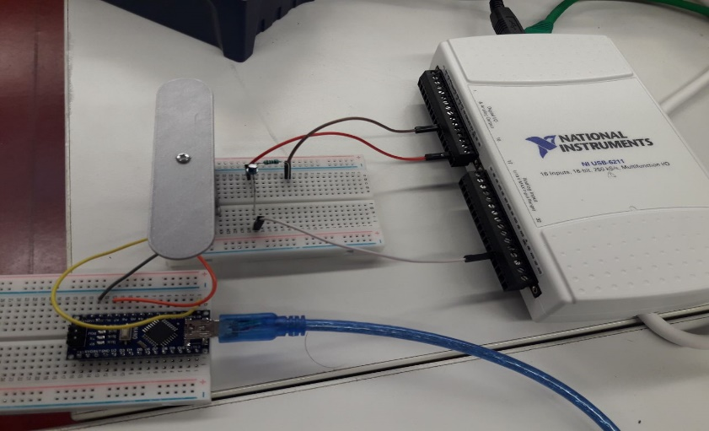

GND

a) DAQ

b) Arduino nano

**Figure 1:** Illustration of the implemented setup. **a)** Shows NI-DAQ 6211, device which is used to measure and analyze real-world signals [1]. LabView is used to communicate with the DAQ device and therefore the phototransistor is attached to it. **b)** the phototransistor is mounted with a resistor creating a voltage divider and connected to +5v, AI0 and GND of the DAQ device respectively. **b)** Arduino nano contains the program which makes the servo rotates. **e)** The servo connects to +5v, D9 and GND of Arduino nano.

**IV. MECHANISM**

The setup implemented above (Fig 1) works as follow:

In daylight (when the servo’s blade is not rotating), the ambient light level is high enough that the phototransistor is conducting. This essentially connects the output (AI0) to ground. As light falls (when the blade covers the phototransistor), the ambient light level will become no longer sufficient to cause the phototransistor to conduct. With no path to ground, the applied voltage now appears at the output of the circuit.

**V. EXPERIMENTS AND DISCUSSION**

* **Device Range** (-5v to 5v), the analog signal investigated varies between 0v to 5v.
* **Mode RSE** (Reference single-ended) inputs all reference to some common ground ground.
* The DAQ board used has a **16-bit resolution** to measure a signal with an input range of 0 – 5 V.

Resolution power = $\frac{5V}{2^{16}}= 0.076 mV$ or 76.3 microvolts.

The DAQ board will be able to detect a signal change as small as 76.3 microvolts.

1. **Experiment I**

High

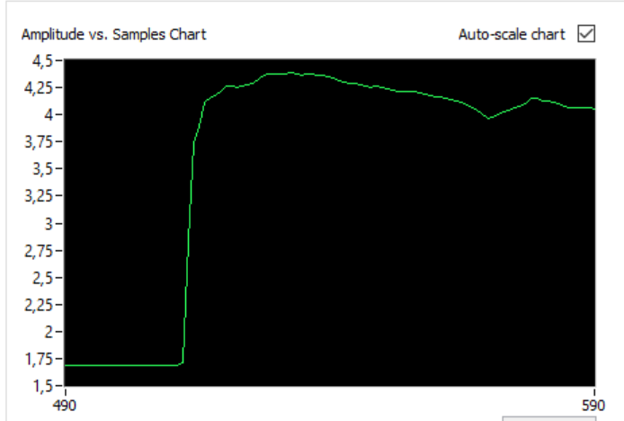

Time (ms)

Voltage (v)

Increase

Low

**Figure 2:** Checking the signal change with NI MAX testpanel.

This first experiment is to verify that the lightning detector circuit works. From the graph above, it is obvious that the graph changes depending on the light condition. In light condition, the phototransistor conducts thus the voltage remains “Low”. In Dark condition the voltage remains “High”. The voltage “increases” or “decreases” respectively depending on whether it’s light or dark.

1. **Experiment II**

Investigation of LabView sampling rate limitation.

High (peak)

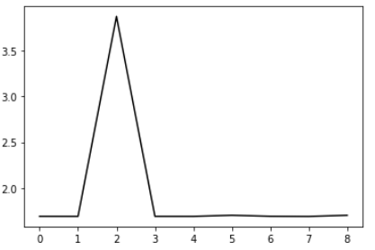

# 

Voltage (v)

# 

Decrease

Increase

Low

Time (s)

**Figure 3:** Illustration of voltage change due to lightning effect of the phototransistor. On-demand sampling rate, 1 Hz sampling rate and duration set to 10 s.

# The study was conducted for different measurement

**TABLE I:**

|  |  |  |  |  |
| --- | --- | --- | --- | --- |
| Time s | Sampling rates | Actual execution time | Actual sampling rate | Total number of sample |
| 10 | 1 Hz | 9.951 s | 1Hz | 10 |
| 10 | 10 Hz | 9.924 s | 10 Hz | 100 |
| 10 | 100 Hz | 26.543 s | 37.7 Hz | 1000 |
| 10 | 200 Hz | 54.2 s | 36.9 Hz | 2000 |

# Some measurements take pretty much time than the 10 s set at the beginning of the acquisition.

In Software-timed acquisition, the program determines when samples are acquired. Samples are read “on demand” one-at-a-time from the device. Acquiring samples at a regular time can be done using a “while loop”.

However, if the is running on a Desktop operating system like Windows the rate at which the loop executes and the interval from one samples to the next will not be fully accurate because Software-timing and Win operating system schedule program to execute is non-deterministic.

The highest reliable sampling rate in this measurement configuration is 35 Hz

In other to overcome this sampling rate limitation, a pre-buffered acquisition should be used. The DAQ collects this information to a buffer. All the data it collects goes to the buffer and is then displayed when the DAQ has finished collecting. Each data point enters the buffer in the form of an array. Each data point that we collect will be given a specific address within the array. When it comes time to display this data the first point in will be the first point out. Thus LabVIEW keeps track of the data it collects via the classic first-in/first-out or FIFO method [4].

High

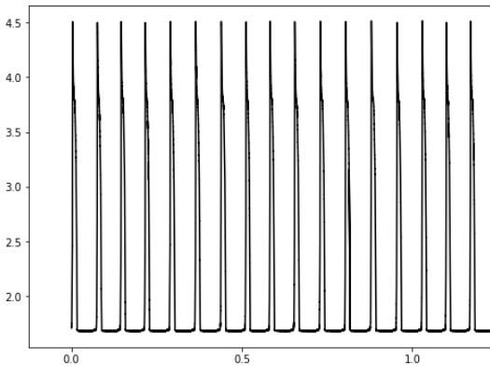

Voltage (v)

Low

Time (s)

**Figure 2:** Illustration of voltage change due to lightning effect of the phototransistor. High-speed acquisition. 250000 Hz sampling rate and duration set to 10 s.

**VI. Reference**

*[1] NI-DAQ 6211 user manual for more information:* *https://www.ni.com/pdf/manuals/375195d.pdf*

*[2] Phototransistor working principle: https://instrumentationtools.com/phototransistor-working-principle/*

*[3] Characterizing a photointerrupter: lab session. Data Acquisition and Signal Processing (LOTI.05.052)*

*[4] LABVIEW DATA ACQUISITION. Spring Semester 2010*

1.