[1]

**Characterizing a photointerrupter**

Steven Tsienza , Prof : Veiko Vunder

Institute of Technology, Robotics and Computer Engineering

Lab session: 17.09.2022, Room: 140, Nooruse 1, University of Tartu

# 

# I. INTRODUCTION

In this task, a close observation was made on the phototransistor graph using a continuous servo motor with a rotating blade that creates an alternating shadow on it. A phototransistor is similar to a regular BJT except that the base current is produced and controlled by light instead of a voltage source. The phototransistor effectively converts light energy to an electrical signal. Depending on the light conditions, the conductivity of the phototransistor as well as the voltage across the diode changes. A DAQ device was used to register the voltage drop on the phototransistor.

The purpose of this study was to characterize the behavior of the photointerrupter device as a whole and investigate LabView in high- and low-speed acquisition.

**II. EQUIPMENT USED**

To perform this task, the following components are required:

1 - NI-DAQ 6211

2 - LabView 2021

3 - Arduino nano

4 - Continuous servo motor

5 - Breadboard and jumper wires

6 - PT-IC-BC-3-PE-550 phototransistor

7 - 5,6k ohm resistor

**III. EXPERIMENTAL SETUP**

The components are connected as follows (Fig 1):

# C:\Users\ACER\Downloads\photo1667751036.jpegA)

# B)

AI0

e) Servo

c) Phototransistor

d) Resistor

+5v

blade

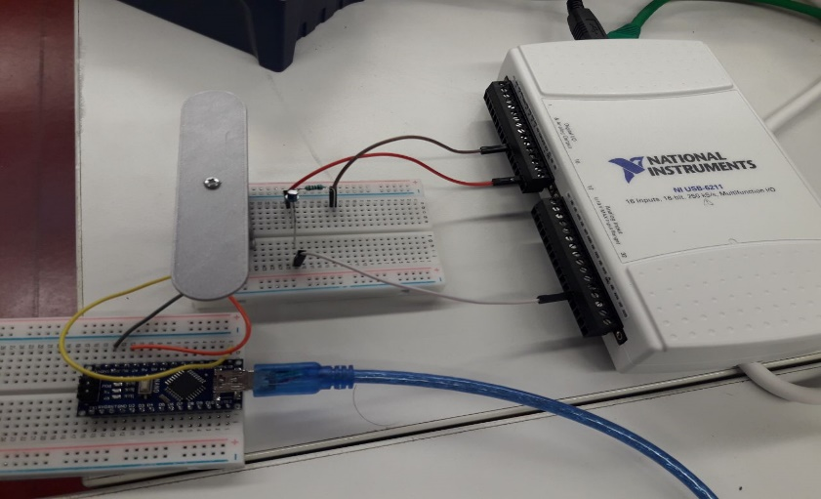

GND

a) DAQ

b) Arduino nano

**Figure 1. A)** Wiring diagram**. B)** Illustration of the implemented setup: **a)** Shows NI-DAQ 6211, device which is used to measure and analyze real-world signals [1]. LabView is used to communicate with the DAQ device and therefore the phototransistor is attached to it. **b)** the phototransistor is mounted with a resistor creating a voltage divider and connected to +5v, AI0 and GND of the DAQ device respectively. **b)** Arduino nano contains the program which makes the servo rotates. **e)** The servo connects to +5v, D9 and GND of Arduino nano.

**IV. MECHANISM**

The setup implemented above (Fig 1) works as follow:

In daylight (when the servo’s blade is not rotating), the ambient light level is high enough that the phototransistor is conducting. This essentially connects the output (AI0) to ground. As light falls (when the blade covers the phototransistor), the ambient light level will become no longer sufficient to cause the phototransistor to conduct. With no path to ground, the applied voltage now appears at the output of the circuit.

**V. EXPERIMENTS AND DISCUSSION**

* **Device Range** (-5 V to 5 V), the analog signal investigated varies between 1.75 V to 4.5 V.
* **Mode RSE** (Reference single-ended) inputs all reference to some common ground.
* The DAQ board used has a **16-bit resolution** to measure a signal with an input range of 10 V.

Voltage resolution = $\frac{10 V}{2^{16}}= 0.153 mV$ or 153 microvolts.

The DAQ board will be able to detect a signal change as small as 153 microvolts.

1. **Experiment I**

Dark

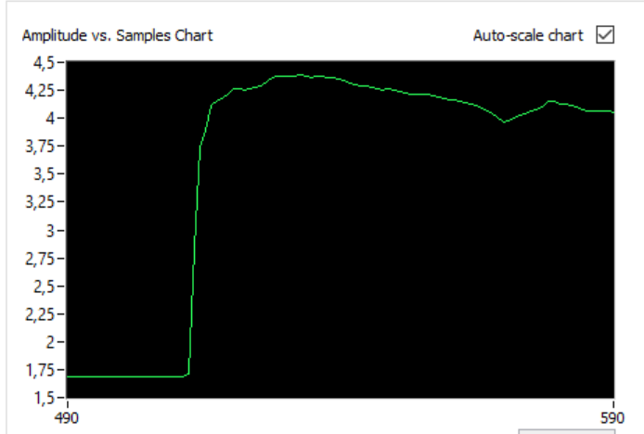

Bright

Increase

**Figure 2:** Checking the signal change with NI MAX testpanel.

This first experiment is to verify that the lightning detector circuit works. From the graph above, it is obvious that the graph changes depending on the light condition. **In light conditions, the phototransistor conducts thus the voltage remains “Low”. In Dark conditions the voltage remains “High”.** The voltage “increases” or “decreases” respectively depending on whether it’s **bright** or **dark**.

1. **Experiment II**

Investigation of LabView sampling rate limitation.

Dark (peak)

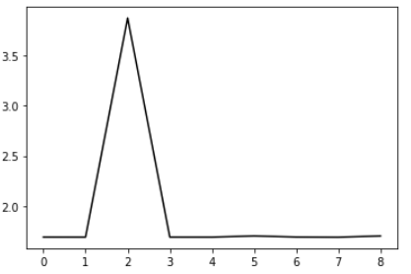

# 

Voltage (V)

# 

Bright

Decrease

Increase

Time (s)

**Figure 3:** Illustration of voltage change due to lightning effect of the phototransistor. On-demand sampling rate, 1 Hz sampling rate and duration set to 10 s.

**TABLE I:** Results of the voltage drop measurement using different sampling rates for 10 seconds in on-demand sampling.

|  |  |  |  |  |
| --- | --- | --- | --- | --- |
| Time s | Sampling rates | Actual execution time | Actual sampling rate | Total number of sample |
| 10 | 1 Hz | 9.951 s | 1Hz | 10 |
| 10 | 10 Hz | 9.924 s | 10 Hz | 100 |
| 10 | 100 Hz | 26.543 s | 37.7 Hz | 1000 |
| 10 | 200 Hz | 54.2 s | 36.9 Hz | 2000 |

# Some measurements take pretty much time than the 10 s set at the beginning of the acquisition.

It has been found that the more the sampling rate increases the more the actual execution time increases because the number of samples to acquire increases which result in more processing time. (See TABLE I)

The “Wait Until Next ms Multiple” Waits until the value of the millisecond timer becomes a multiple of the specified millisecond multiple. This function is used to synchronize activities. This function is called in the loop to control the loop execution rate. However, it is possible that the first loop period might be short. This function makes asynchronous system calls, but the nodes themselves function synchronously. Therefore, it does not complete execution until the specified time has elapsed.

In Software-timed acquisition, the program determines when samples are acquired. Samples are read “on demand” one-at-a-time from the device. Acquiring samples at a regular time can be done using a “while loop”.

However, if the is running on a Desktop operating system like Windows the rate at which the loop executes and the interval from one samples to the next will not be fully accurate because Software-timing and Win operating system schedule program to execute is non-deterministic.

In other to overcome this sampling rate limitation, a pre-buffered acquisition should be used. The DAQ collects this information to a buffer. All the data it collects goes to the buffer and is then displayed when the DAQ has finished collecting. Each data point enters the buffer in the form of an array. Each data point that we collect will be given a specific address within the array. When it comes time to display this data the first point in will be the first point out. Thus LabVIEW keeps track of the data it collects via the classic first-in/first-out or FIFO method [4]. Despite a high sampling rate, the execution time almost meets the 10 s as illustrates in TABLE II.

**TABLE II**: Result of voltage drop measurement with a high sampling rate for 10 seconds in high-speed acquisition

|  |  |  |  |
| --- | --- | --- | --- |
| Time s | Sampling rates | Actual execution time | Total number of sample |
| 10 | 250000 Hz | 11 | 2500000 |

Period

Dark

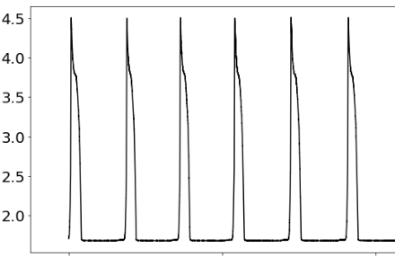

Voltage (V)

4

2

0

Time (s)

Bright

**Figure 2:** Illustration of voltage change due to lightning effect of the phototransistor. High-speed acquisition. 250000 Hz sampling rate and duration set to 10 s.

The appropriate sampling rate depends on the signal to be measured.

The optimal sampling rate to produce quality (frequency and amplitude) plots of the given photointerrupter for low- and high-speed measurement is find to be 35 Hz.

**VI. Reference**

*[1] Product Documentation - NI. (n.d.). Retrieved November 6, 2022, from* *https://www.ni.com/docs/en-US/bundle/usb-6211-specs/page/specs.html*

*[2] Editorial Staff. (2017, July 24). Phototransistor Working Principle. Inst Tools. Retrieved November 6, 2022, from https://instrumentationtools.com/phototransistor-working-principle/*

*[3] Characterizing a photointerrupter: lab session. Data Acquisition and Signal Processing (LOTI.05.052)*

*[4] LABVIEW DATA ACQUISITION. Spring Semester 2010. Retrieved November 6, 2022, from https://documents.pub/document/labview-data-acquisition-56b2ca29a3321.html?page=1*

*[5] Timing VIs in LabVIEW – WKU LabVIEW Academy. (n.d.). Retrieved November 6, 2022, from http://physics.wku.edu/phys318/notes/labview-foundations/timing/*

1.