[1]

**Triggered acquisition**

Tsienza Smith , Prof : Veiko Vunder

Institute of Technology, Robotics and Computer Engineering

Lab session: 02.11.2022, Room: 140, Nooruse 1, University of Tartu

***Abstract*—** **To measure the state of stress on the surface of a workpiece, a strain gauge can be glued on it. A strain gauge is an electrical dipole, whose resistance varies with its elongation in one direction. It can be a very thin, very long conducting wire.**

**The measurement cannot be made directly because the variations in conductivity of the gauge are too small to be measured directly with an ohmmeter. Direct measurement of signals makes it difficult to draw meaningful conclusions. Addition of noise makes the task more cumbersome. It is necessary to use a Wheatstone bridge circuit with an electronic amplifier.**

**Due to its sensitivity, the Wheatstone bridge circuit is a commonly used circuit for the measurement of small changes in electrical resistance, particularly for strain gauges. It comprises four resistive elements and can be excited by either a voltage or current source.**

**This task aims to perform triggered acquisition using the Wheatstone bridge.**

# 

# I. INTRODUCTION

In this work, we implement a circuit capable of amplifying the differential signal of a Wheatstone bridge simulating a load cell consisting of four resistors and a potentiometer and automatically correct its offset at start-up.

We use reference triggering to capture force changes on a digital balance when a lightweight object is bounced to the scale's plate and register the force readings of the digital balance together with the video frames describing the falling object's trajectory.

**II. EQUIPMENT USED**

To perform this task, the following components are used:

1 - NI-DAQ 6211

2 - Breadboard + jumper cables

3 - LabView 2021

4 - Camera

5 - A ball

6 - Customized PCB made of:

* 5v Battery pack with bi-polar power outlets
* INA128 instrumental amplifier with 100 Ω gain resistor (gain 501, no filter)
* LM293P comparator chip (for creating a digital trigger signal)

7- 22k ohm, 100 ohm resistors and 0.47 uF

**a)**  **b)**

# 

**c)**

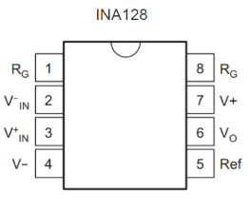 **d)**

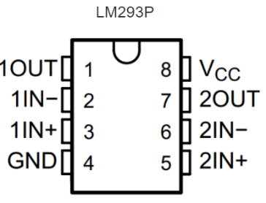

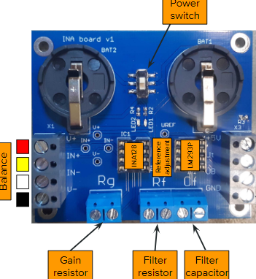

**e)**

**Figure 1:** Components illustration. **a)** Shows NI-DAQ 6211, device which is used to measure and analyze real-world signals [1]. **b)** scale with orange ball on it. (c) INA128, instrumentation amplifier [2]. **d)** LM293P [3]. **e)** PCB [5].

# 

# III. NI MYDAQ CONNECTION PROCEDURE

The components are connected as follows (Fig 2):

# https://lh3.googleusercontent.com/bK6S3qJG3ugHteHXHD9zDIQUE8E6Gx-jTPiWOMdtDNXSSoOQtBK0x-qsFnBLyhfmpvPKWyKTbtkJnsoECP1MbMlpjos7l6w68BXlS-IC2vYdPK2S1J9GeV_FCxYoxcgOFx4FEQcAy1M

Data Acquisition and Signal Processing (LOTI.05.052), Lab 8.

**Figure 2:** Wiring diagram of the implemented system. The circuit consists of a Wheatstone bridge supplied by a DC power source simulating a real force sensor. The output signal is amplified by INA128 and connected to DAQ device (pin AI0). To function, this component must be powered by + 3 V on V + and 0 V (ground) on V-. The output voltage is not referenced against ground, but against the 5 Vref pin called "reference". this pin is connected to a voltage equal to half of the reference voltage of the converter. LM293P is responsible for trigger generation.

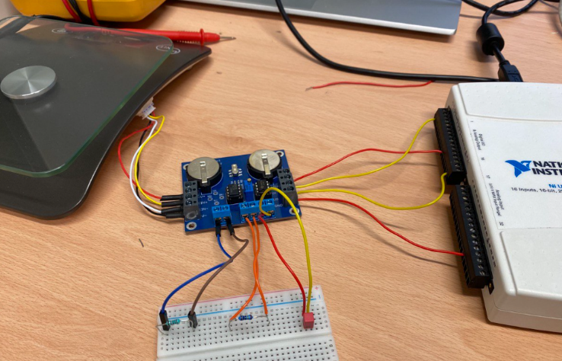

2

1

3

# Figure 3: Experimental setup. The setup depicts the hardware implementation of the proposed system with DAQ device (1), balance (2), PCB and breadboard circuitry (3). Programming and analysis is done LabView Software (DAQ device programming language).

# IV. BALL TRAJECTORY IN SYNC WITH THE FORCE ACTING IN THE BALANCE PLATE.

# A ball was released on the scale to trigger the acquisition. In this configuration, the hardware starts acquiring data before the trigger signal is received. With this type of acquisition, the user can view the signal before the trigger event. In such applications, the hardware initiates data acquisition with a software function and stores the data in a circular buffer in the PC memory. The buffer is large enough to ensure that the required number of pretrigger samples are stored. When the buffer is full, it simply wraps around and stores each subsequent sample over the oldest sample in memory. The primary responsibility of the trigger mechanism is to stop the acquisition so that the samples left in memory represent the “slice-in-time” the user wants.

As the ball hits the balance, we observe a deflection of the scale followed by a series of mechanical oscillations (Fig. 4.a). LabView software was used to visualize the output of the impact.

Impact

**a)**

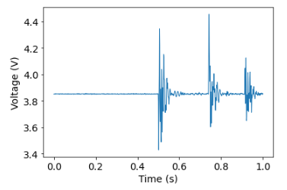

Resonance

Pre-sampling

Post-sampling

# b)

Pre-sampling

Falling trajectory

Post-sampling

# 

Impact

**Figure 4:** b) Ball trajectory in synchronization with a) the force acting on the balance.

Fig. 4.b. illustrates the falling trajectory of the ball. The laptop's built-in camera was positioned in such a way that it could detect the vision range of the ball falling on the scale. The camera frames are continuously stored to ring buffer with constant FPS. The buffer is simply the space assigned to store image in PC’s RAM (memory). Once a trigger event was detected on the PFI0 pin (DAQ device), the acquisition was stopped and the buffer was saved. The DAQ device was set to read 500 pretriggered samples, 1000 samples to read at 1ks/s. The camera mode is was set to 1280x720 MJPG.

We registered the force readings of the digital balance together with the video frames describing the falling object's trajectory **Fig. 4**.

One important thing to highlight is that when drawing in the image the coordinates referential works as shown in figure 5. The origin is at the top left corner of the image and we specify the x coordinate from left to right and the y coordinate from the top to the bottom. Also, the coordinates are specified in pixels [6].

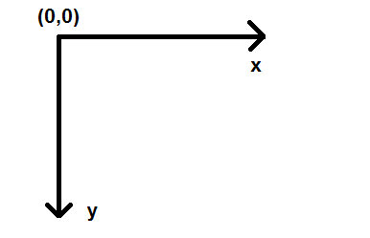

**Figure 5.** Referential when drawing in **OpenCV**

# 

# V. CONCLUSION

## During this manipulation we saw the main electronic and computer functions to be set up to use Wheatstone bridge sensor and strain gauge. The impact of the ball on a scale and triggered image acquisition were observed

**VI. Reference**

*[1] Product Documentation - NI. (n.d). Retrieved from November 20, 2022, from https://www.ni.com/docs/en-US/bundle/usb-6211-specs/page/specs.html*

*[2] INA128 datasheet (n.d). Retrieved from November 20, 2022, from https://www.ti.com/lit/ds/symlink/ina128.pdf?*

*[3] LM293P user manual:* *https://datasheet.octopart.com/LM293P-Texas-Instruments-datasheet-8209313.pdf*

*[4] J. Park, S. Mackay, practical data acquisition for instrumentation and control systems, 1st Ed - June 10, 2003*

*[5] Triggered Image acquisition: lab session. Data Acquisition and Signal Processing (LOTI.05.052)*

*[6] Python OpenCV: Drawing circles. (2019, March 14). Techtutorialsx. https://techtutorialsx.com/2018/07/08/python-opencv-drawing-circles/*

1.