# HO CHI MINH CITY UNIVERSITY TECHNOLOGY AND EDUCATION



**LECTURER**

**MAI ANH THO**

**Final Project**

**E-Commerce Website Using JSP, Servlet and MySQL**

**WEB PROGRAMMING**

**GROUP MEMBERS:**

**Ho Vu Minh Duc - 17110022 Nguyen Quang Minh - 17110051 Dang Thi Kim Ngan - 18110032 SEMESTER: 1 – YEAR: 2020-2021**

# HO CHI MINH CITY

# EVALUATION AND SCORE

# EVALUATION:

**.......................................................................................................................**

**.......................................................................................................................**

**.......................................................................................................................**

**.......................................................................................................................**

**.......................................................................................................................**

**.......................................................................................................................**

# ....................................................................................................................... SCORE:

|  |  |
| --- | --- |
| **WORD** | **NUMBER** |
|  |  |

# PREFACE

Web Programming is a quite interesting and difficult object but it also helps us know more about the technologies we use in daily application. Our project is to develop an E-Commerce Website using JSP and Servlet. It is pretty difficult for us but thank to your lecture we can complete it. We are grateful to you.

Thank you, Mrs.Tho

**Contents**

PREFACE 2

I. Project Overview 4

A. Definition 4

+ What is Servlet? 4

+ What is JSP? 4

+ What is MySQL? 4

+ What is MVC? 4

B. System Configuration 5

II. Task Distribution 7

III. Project’s Detail 7

IV. References 12

V. Resource 12

# Project Overview

# Definition

## + What is Servlet?

A servlet is a Java class which is used to extend the capabilities of servers that host applications accessed by means of a request-response model. Servlets are mainly used to extend the applications hosted by webs servers, however, they can respond to other types of requests too. For such applications, HTTP-specific servlet classes are defined by Java Servlet technology.

## + What is JSP?

A JSP is a text document which contains two types of text: static data and dynamic data. The static data can be expressed in any text-based format (like HTML, XML, SVG and WML), and the dynamic content can be expressed by JSP elements.

## + What is MySQL?

MySQL is an open source relational database management system (RDBMS) with a client-server model. It can runs on multi-platform such as Windows, Linux, macOS,… RDBMS is a software or service used to create and manage databases based on a relational model.

## + What is MVC?

The **Model-View-Controller (MVC)** framework is an architectural pattern that separates an application into three main logical components Model, View, and Controller. Hence the abbreviation MVC. Each architecture component is built to handle specific development aspect of an application. MVC separates the business logic and presentation layer from each other. It was traditionally used for desktop graphical user interfaces (GUIs). Nowadays, MVC architecture has become popular for designing web applications as well as mobile apps.

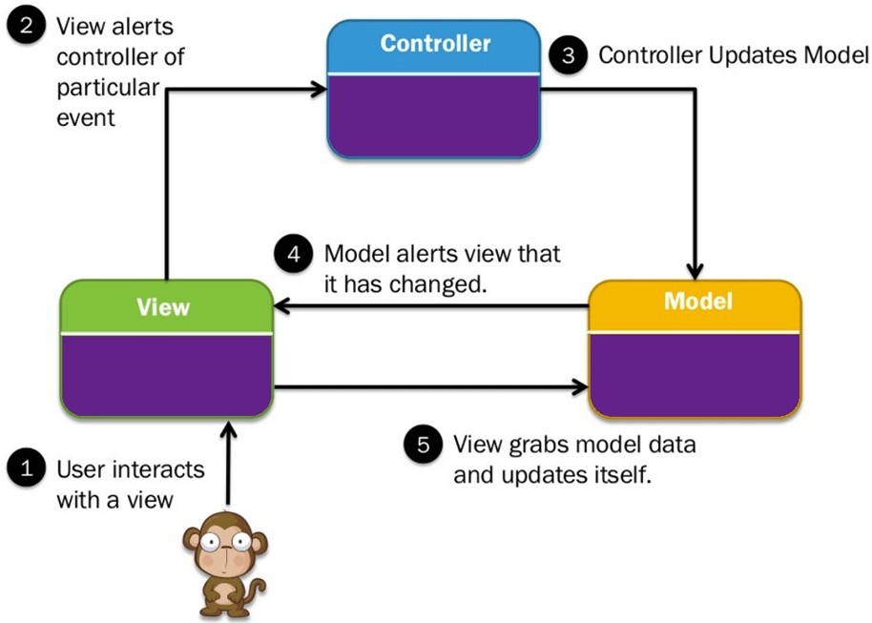

MVC Diagram

# System Configuration

We write the website in Eclipse IDE for Enterprise Java Developers version 2020-12 (4.18.0). The source code can run on every common OS such as Windows, macOS,…

## --- Deploy requirement: ---

+ **Eclipse IDE for Enterprise Java Developers version 2020-12 (4.18.0)**

Download link: http[s://www.e](http://www.eclipse.org/downloads/packages/)clip[se.org/downloads/packages/](http://www.eclipse.org/downloads/packages/)

# + Apache Tomcat server 9.0.41

Download link:

https://downloads.apache.org/tomcat/tomcat-9/v9.0.41/bin/apache-tomcat- 9.0.41.zip

# + MySQL community server 8.0.22

Download link: https://dev.mysql.com/downloads/mysql/

## * Import Database Instruction

In MySQL Workbench, create new schema name “gamestore” then go to folder GameStore-DB-Dump then run each SQL script

## Change DB connection string

Go to WebContent/META-INF/context.xml and look at line 31, 32 and change to username and password of your local DB

Example: url="jdbc:mysql://localhost:3306/gamestore" username="root" password="root"

## Deploy web to localhost server such as Apache Tomcat 9.0

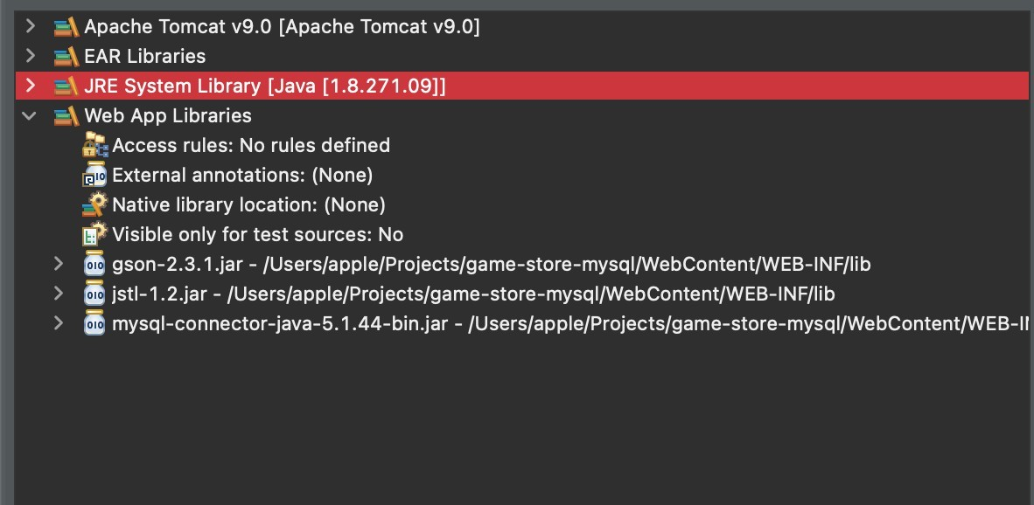

Check project’s java build path if it as same as this image After that export to .war file then copy the file to

./apache-tomcat-9.0.41/webapps*,* turn on the server in terminal and the project url is localhost:8080/GameSpeedStore

# Task Distribution

|  |  |
| --- | --- |
| **Members:** | **Task:** |
| Nguyen Quang Minh | Front-End |
| Dang Thi Kim Ngan | Front-End |
| Ho Vu Minh Duc | Back-End |

# Project’s Detail

Our project is an game and electronic store which user can purchase products and check order details

We deploy the web in Gstack free hosting service, which support java web host by Apache Tomcat with MySQL Database

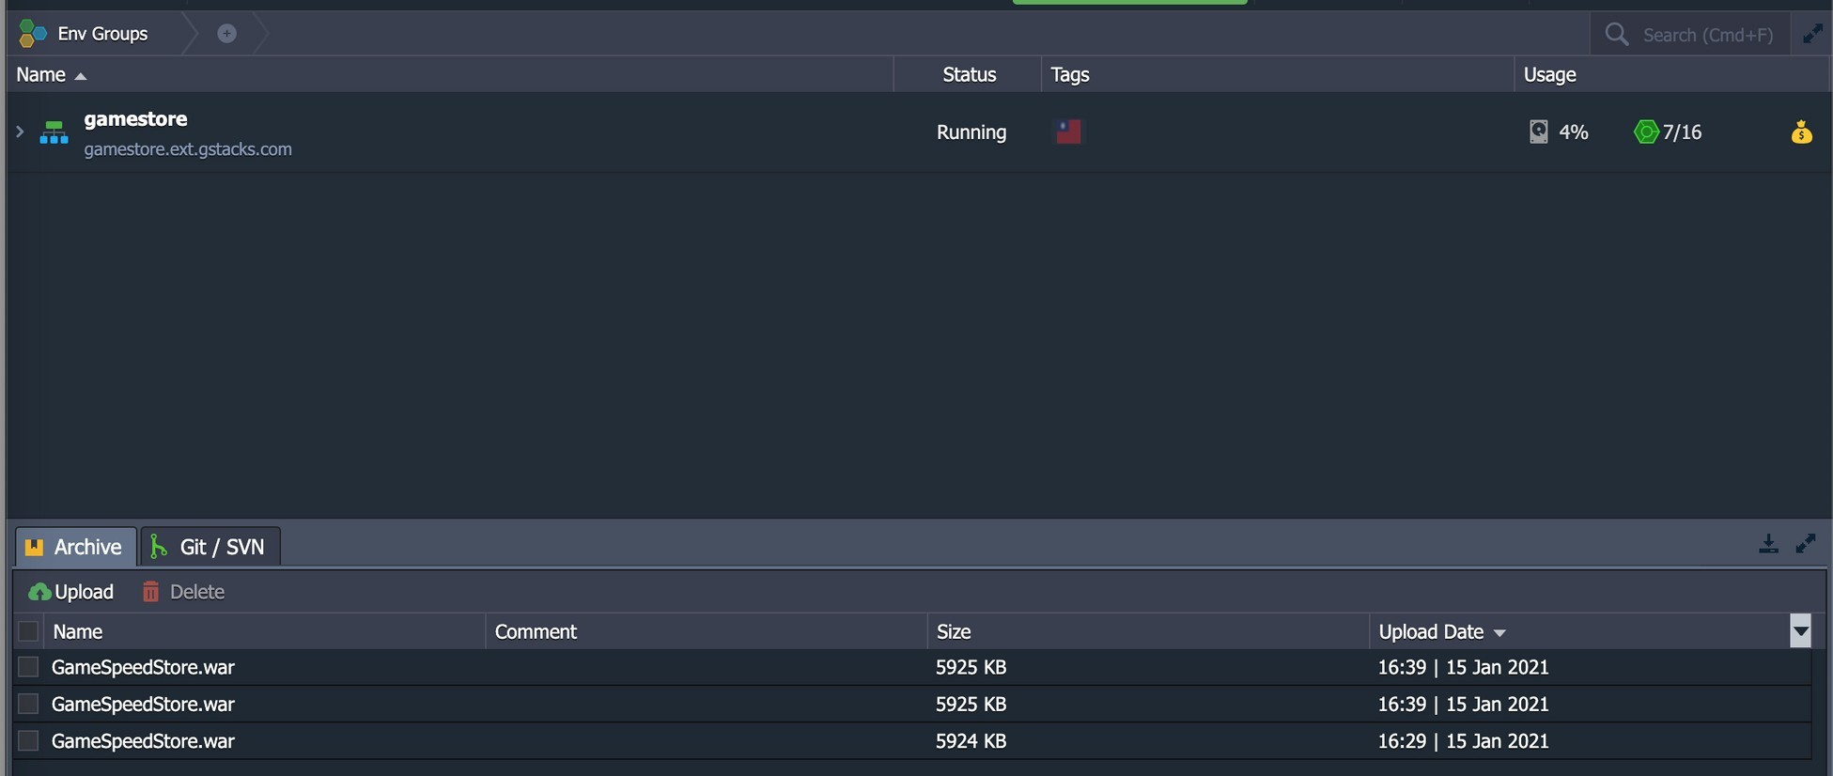

Project’s URL: <http://gamestore.ext.gstacks.com/> Screenshots below describe mostly our project’s details.

# Sign In Page

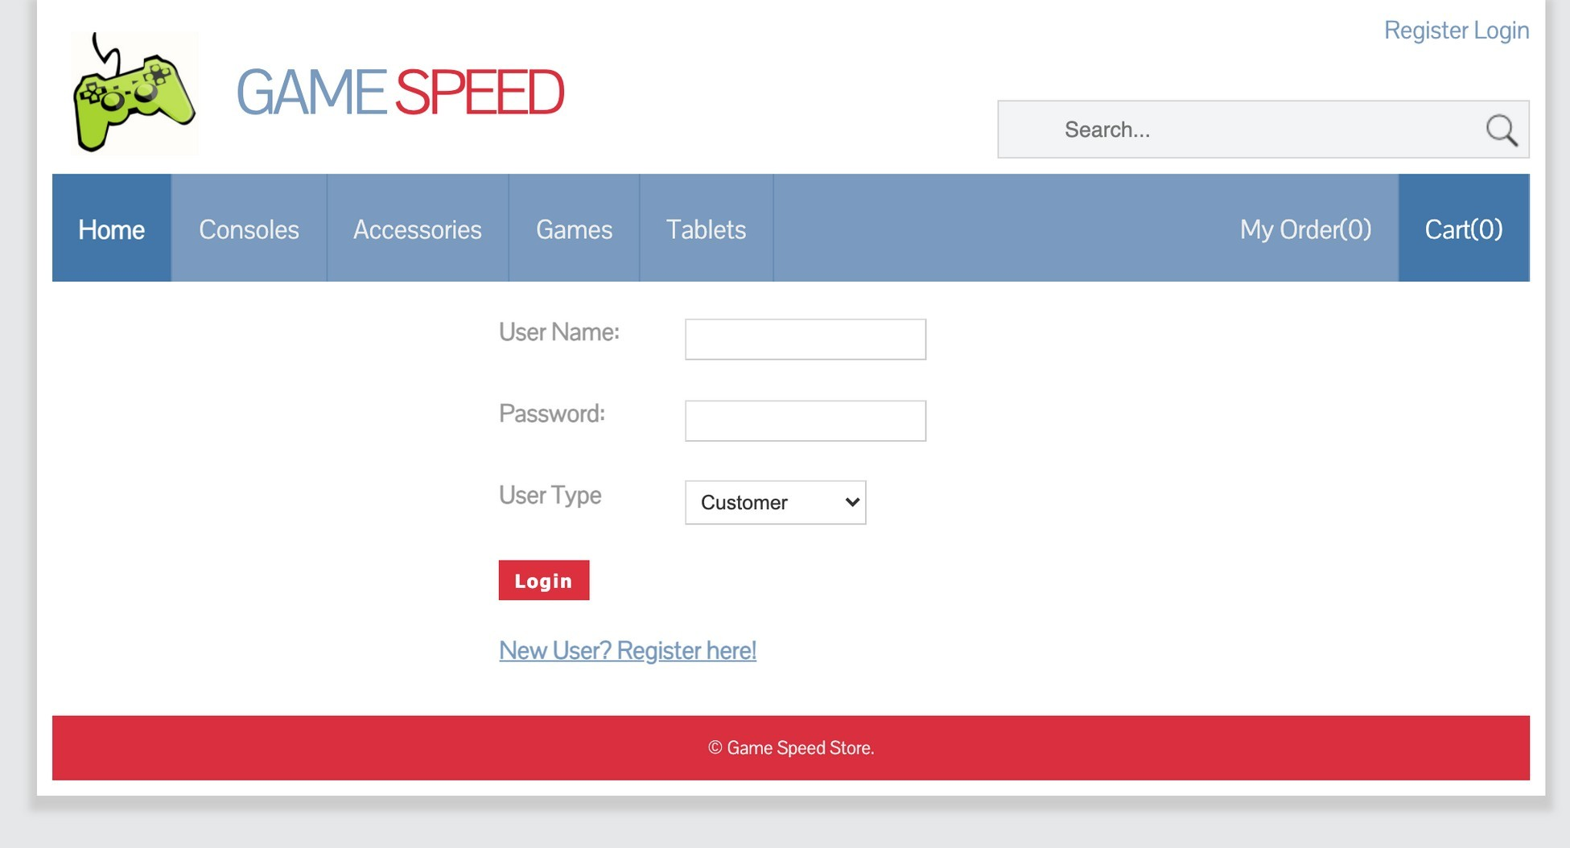

**Sign Up Page**

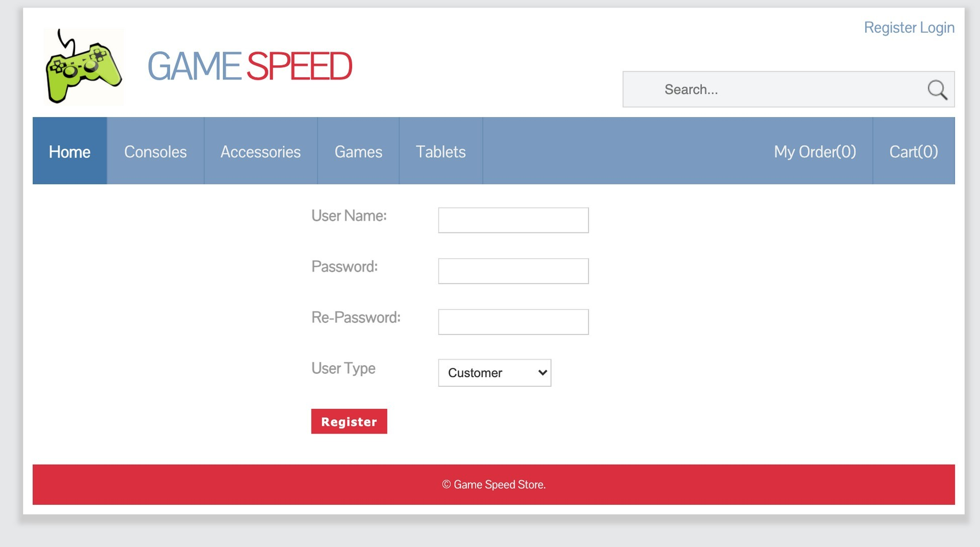

**Homepage**

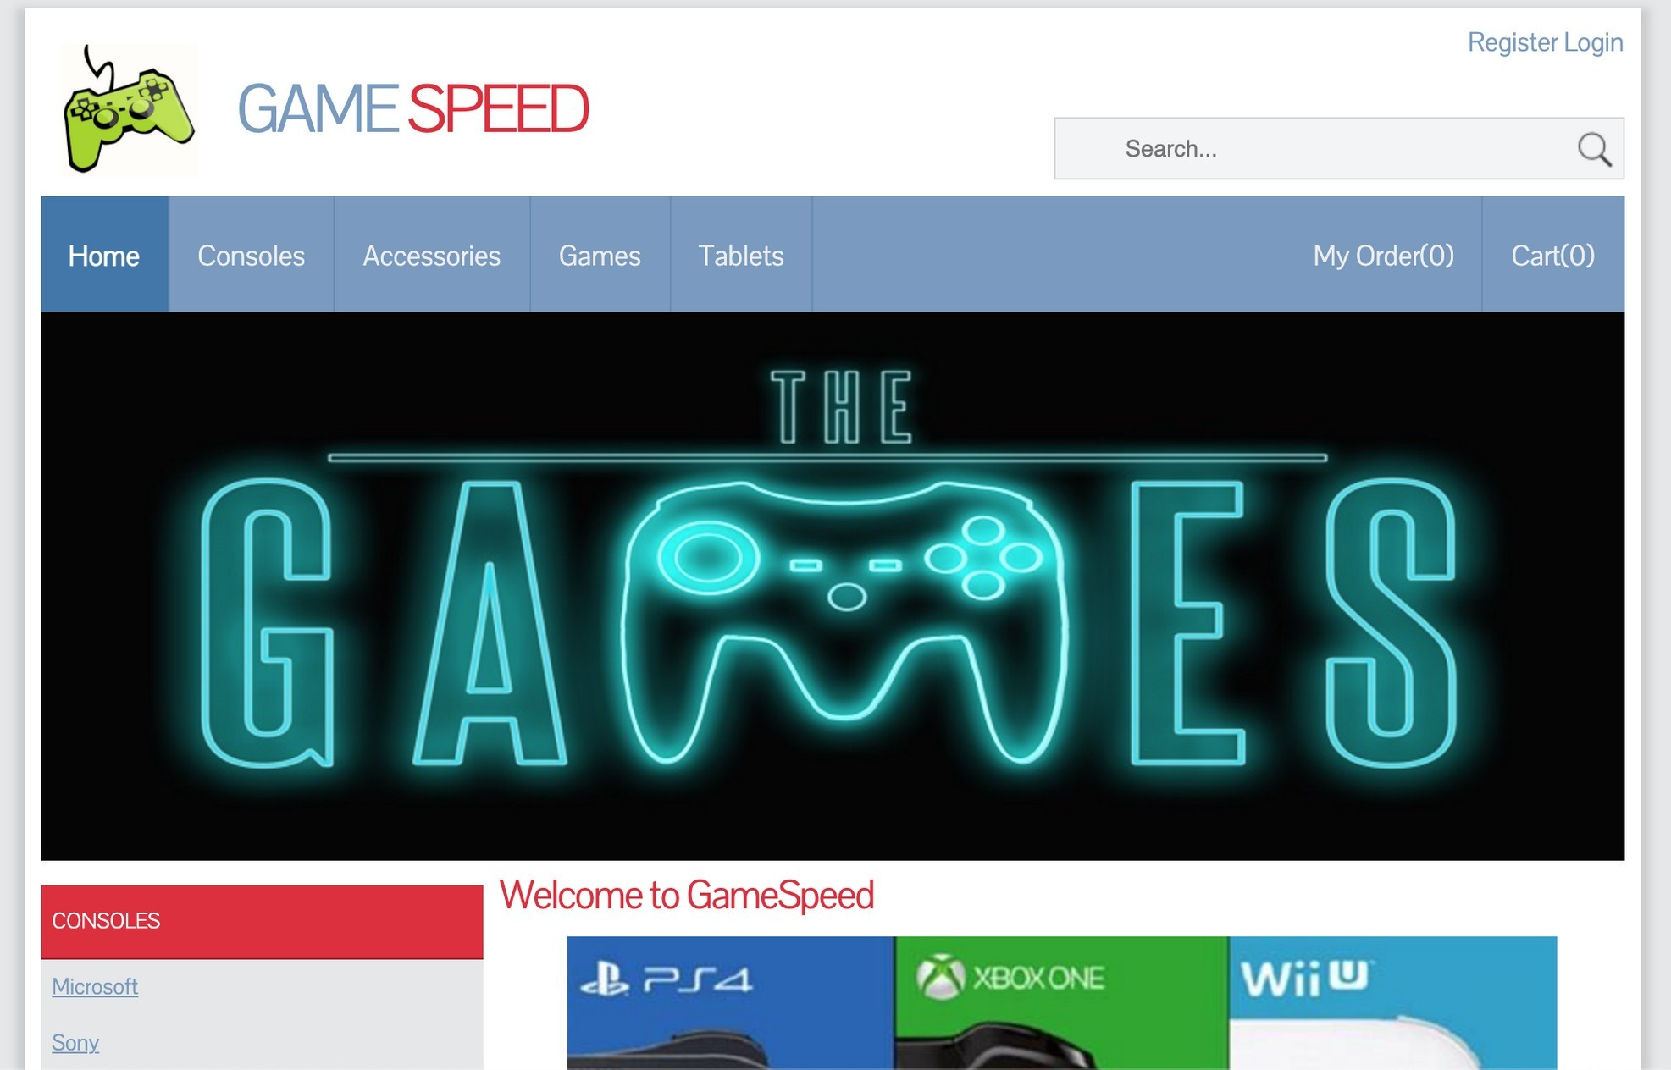

The homepage will be showed whenever we have an account or not, or logged in by distinguished account type.

The Homepage has the Register, Login/Logout, My Order and Cart button, with product categories navigation

**My Order Page**

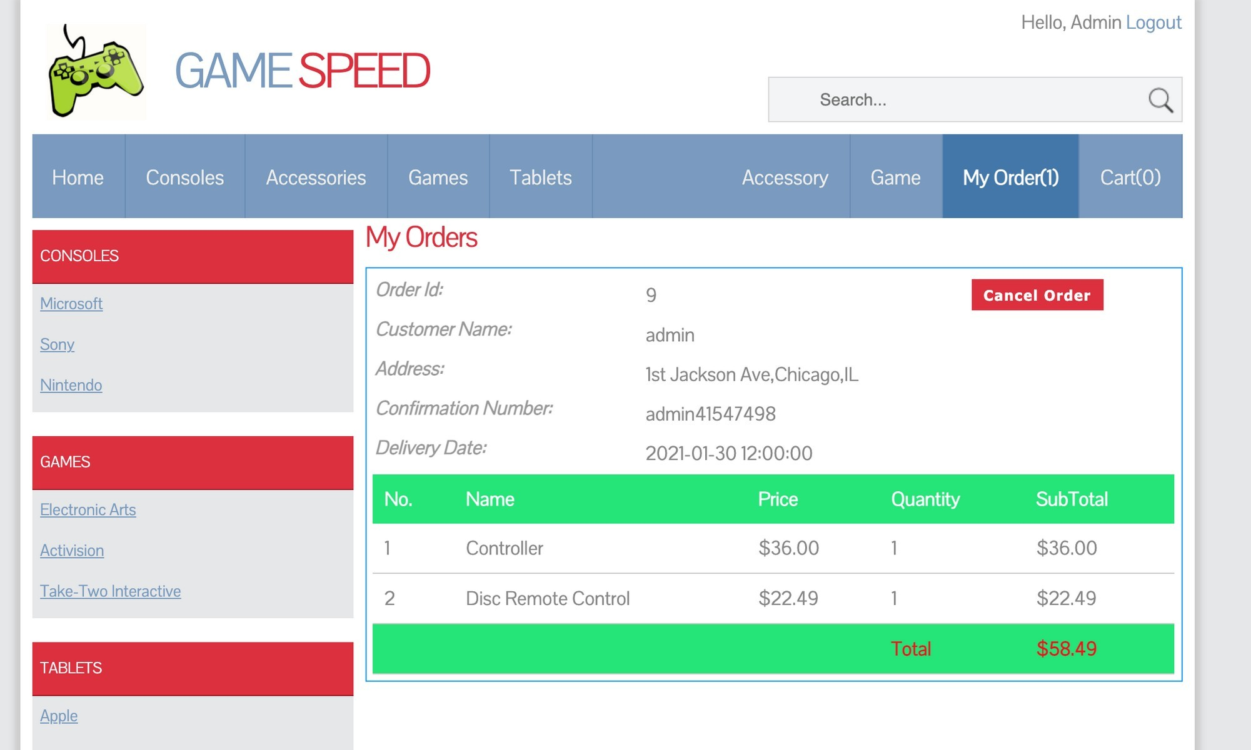

# In this search page, we can search the name of the product we want.

# Search page

# User management page

In user management, salesman user type can edit info and grant admin access to any user

# Order management page

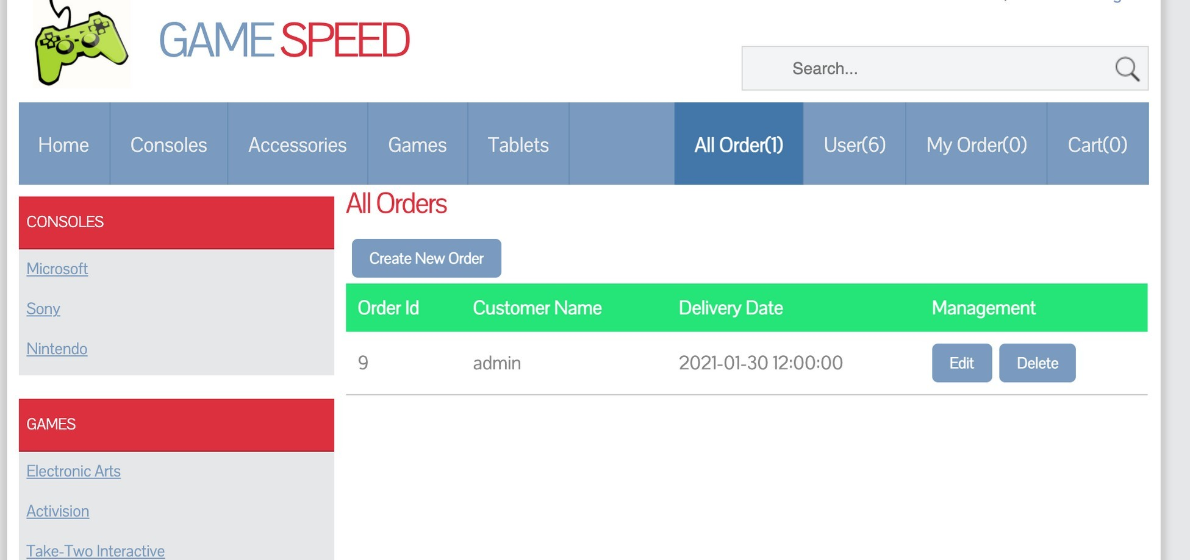

In order management page, salesman user type can check detail of orders and toggle delivered status to them

# References

Our lecturer’s materials on FHQ and video on Youtube, Google.

# Resource

Google Drive:

<https://drive.google.com/file/d/1Sjahy1NmZcZGXNCXCrjUXF-fcPCmV0ov/view?usp=sharing>