**K-MEANS CLUSTERING ILLUSTRATION ON MATLAB**

**1. Code for K-means Clustering (kmeans.m) which is running on Matlab**

%% Partition Data into Two Clusters

%%

% Randomly generate the sample data.

rng default; % For reproducibility

X = [randn(100,2)*0.75+ones(100,2);

randn(100,2)*0.5-ones(100,2)];

figure;

plot(X(:,1),X(:,2),'.');

title 'Randomly Generated Data';

%%

% There appears to be two clusters in the data.

%%

% Partition the data into two clusters, and choose the best arrangement out of

% five initializations. Display the final output.

opts = statset('Display','final');

[idx,C] = kmeans(X,2,'Distance','cityblock',...

'Replicates',5,'Options',opts);

%%

% By default, the software initializes the replicates separately using

% _k_-means++.

%%

% Plot the clusters and the cluster centroids.

figure;

plot(X(idx==1,1),X(idx==1,2),'r.','MarkerSize',12)

hold on

plot(X(idx==2,1),X(idx==2,2),'b.','MarkerSize',12)

plot(C(:,1),C(:,2),'kx',...

'MarkerSize',15,'LineWidth',3)

legend('Cluster 1','Cluster 2','Centroids',...

'Location','NW')

title 'Cluster Assignments and Centroids'

hold off

%%

% You can determine how well separated the clusters are by passing |idx| to

% <docid:stats_ug.f3984482>. for K-means Clustering

**2. Figures of illustration of data before and after running**

**Step 1. Create the data**

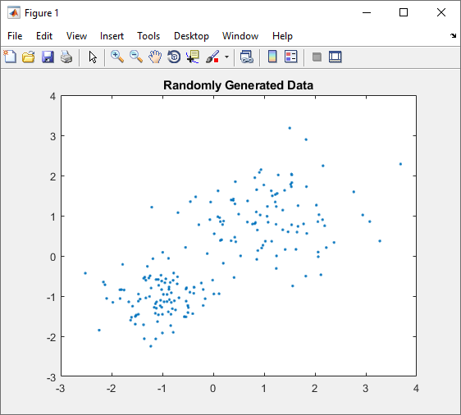

*Figure 1. Illustration of data before running (step1)*

**Step 2. Set up 2 clusters and run the algorithm**

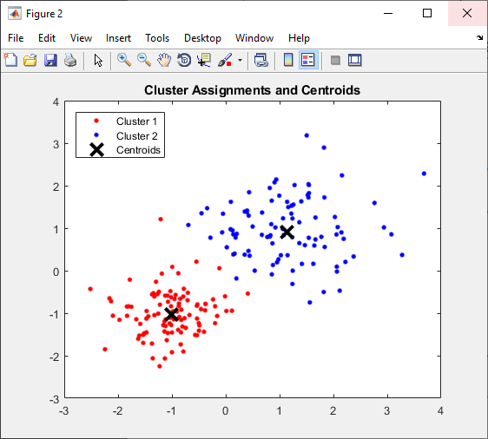

*Figure 2. Illustration of data after running*

Reference: <https://www.mathworks.com/help/stats/kmeans.html>