s

**DMA Mall chain network infrastructure design**

A mini project submitted for

**Enterprise Network Design (Semester VII)**

By

**Smith Dabreo (8382)**

**Shaleel Rodrigues (8423)**

**Valiant Rodrigues (8424)**

Under the guidance of

## Prof. Vaibhav Godbole



DEPARTMENT OF INFORMATION TECHNOLOGY

**Fr. Conceicao Rodrigues College of Engineering, Bandra (W), Mumbai**

## **400050**

University of Mumbai

October 15, 2020

## **Internal Approval Sheet**

### CERTIFICATE

This is to certify that the project entitled **"DMA Mall chain network infrastructure design"** is a bonafide work of **Smith Dabreo (8382),** **Shaleel Rodrigues (8423)** and **Valiant Rodrigues (8424)** submitted to the Information Technology Department.

(Name and sign)

Supervisor/Guide

(Name and sign)

Principal

# Approval Sheet

**Project Report Approval**

### This project report entitled DMA Mall chain network infrastructure design by Smith Dabreo (8382), Shaleel Rodrigues (8423), and Valiant Rodrigues (8424) by is approved.

Examiners

1.———————————– —

2.————————————–

Date:

Place:

## **Declaration**

We declare that this written submission represents our ideas in our own words and where others’ ideas or words have been included, we have adequately cited and referenced the original sources. We also declare that we have adhered to all principles of academic honesty and integrity and have not misrepresented or fabricated or falsified any idea/data/fact/source in my submission. We understand that any violation of the above will be cause for disciplinary action by the Institute and can also evoke penal action from the sources which have thus not been properly cited or from whom proper permission has not been taken when needed.

**Smith Dabreo (Roll No. 8382) (Sign)**

**Shaleel Rodrigues (Roll No. 8423) (Sign)**

**Valiant Rodrigues** **(Roll No. 8424) (Sign)**

Date: October 15, 2020

## **Acknowledgments**

We have great pleasure in presenting the report on **"** **DMA Mall chain network infrastructure design** **"**. We take this opportunity to express our sincere thanks towards the guide Prof. Vaibhav Godbole, C.R.C.E, Bandra (W), Mumbai, for providing the technical guidelines, and the suggestions regarding the line of this work. We enjoyed discussing the work progress with him for the project duration.

**Smith Dabreo (8382)**

**Shaleel Rodrigues (8423)**

**Valiant Rodrigues (8424)**

Date: October 15, 2020

# Table of Contents

List of Figures 7

List of Tables 7

Glossary ................................................................................................................................................ 8

1. Requirements of Enterprise Network ............................................................................................. 9
   1. Customer Service…...................................................................................................................... 9
   2. Retail Service Department........................................................................................................... 9
   3. Regional Demand Supply………………............................................................................................. 9
   4. Finance and Accounting............................................................................................................... 9
   5. Information Technology............................................................................................................... 9
2. Functional areas and construct high level modules ...................................................................... 10
3. Network devices required ............................................................................................................. 12
4. Floor wise Plan………………………………………...................................................................................... 17
   1. Customer Service....................................................................................................................... 17
   2. Retail Service Department ....................................................................................................... 18
   3. Regional Demand Supply.......................................................................................................... 19
   4. Finance and Accounting …........................................................................................................ 20

4.5 IT Division ................................................................................................................................ 21

1. Arrangement according to campus core, access layer, distribution layer ..................................... 22
2. Firewall Configuration ....................................................................................................................24
3. Enterprise Edge and ISP connectivity .............................................................................................25
4. Expenditure on buying equipment ................................................................................................ 26
5. Remote Site Connectivity ...............................................................................................................28
6. IP Addressing ................................................................................................................................ 29
7. Routing Protocol for the Organization ......................................................................................... 30
8. GNS3 Implementation………………………………………………………………………………………………………………..31
9. References .................................................................................................................................... 35

List of Figures

Figure 4.1 Logistics Department Network Design 17

Figure 4.2 Customer Service Network Design 18

Figure 4.3 Marketing Department Network Design 19

[Figure 4.4 Finance And Administration Network Design 20](https://d.docs.live.net/5b304c6c9239926b/SEM-7/END/END%20Project/END_MINIPROJ.docx#_Toc21516301)

Figure 4.5 IT Division Network Design 21

Figure 5.1 Campus Core, Access Layer, and Distribution Layer Representation 22

Figure 6.1 Firewall Configuration 24

Figure 7.1 Enterprise Edge 25

# List of Tables

Table 8.2 Price Estimate 26

Table 10.1 IP Addressing 29

# Glossary

**DMZ** De-Militarized Zone pg. 10

**NCS** Network Convergence System pg. 12, 30, 26

**PoE** Power over Ethernet pg. 13

**WAP** Wireless Access Point pg. 13, 26

**SIP** Session Initiation Protocol pg. 15, 26 **SMTP** Simple Mail Transfer Protocol pg. 15 **XML** Extensible Mark-up Language pg. 15

**API** Application Programming Interface pg. 15 **PCI** Peripheral Component Interconnect pg. 15 **VPN** Virtual Private Network pg. 27

# Requirements Of Enterprise Network

# Customer Requirements

* Quick response to inquiries
* An integrated value proposition to all stakeholders - consumers, retail brands, investors, and developers.
* A holistic approach to plan, build and operate shopping centers ensuring that each of these retail properties matures as investment-grade assets
* The network provides the Voice over Internet Protocol (VoIP), network printer, and multimedia services.
* Users in branch malls can access the main network through the Intranet.
* Users outside the malls can access the main network through the Internet.
  1. **Customer service**

There are many choices today for delivering high-quality customer service. This can be managed by activities in-house or outsource to a third party. Basic customer service for sales and post-sales activities can be handled using email and, for more extensive needs, phone support. A customer-management system will make those activities easier and is a major requirement for the undertaken project.

* 1. **Retail Service Department**

Retail Service deals with different retail sectors and departments involved with the mall management. This sector provides services to different mall departments like Electronics, Food and Grocery, Entertainment, Clothing and Apparel, and many more.

* 1. **Regional Demand Supply**

Regional demand-supply assesses the supply and demand balance on a regional basis. Its analysis and relies on estimates of renewable product supplies compared to the demand for renewable products and the good generation needed to meet existing demand by consumers.

* 1. **Finance and Accounting**

The finance and accounting have an important role to play wherein they handle: Booking Management, Auditing, Bookkeeping, Financial Reporting, and Control Tax and Compliance, Risk Management, Treasury and Working Capital Management

* 1. **Information technology**

In mall chaining, it is always better to have control over the servers and have an internal Information Technology staff maintain it. The needs of a company such as development, integrations, migrations, patches, updates can be delivered efficiently in presence of the IT division. Besides maintaining network configurations it is necessary to have properly trained staff.

# Functional Areas and Construct High-Level Modules

### Demilitarized Zone (DMZ)

The DMZ separates the corporate network from the Internet. The DMZ is a tightly secured area into which you place servers providing Internet services and facilities (for example, web servers). These machines are hardened to withstand the attacks they might face. To limit exposure in case of a security breach from such attacks, these servers typically contain no information about the internal network. For example, the name server facilities only include the server and the routers to the Internet. The DMZ remains segmented from the internal networks. Web servers, FTP servers, mail servers, and external DNS should be located on a DMZ segment.

 **Intranet**

The DMZ provides a network segment for hosts that offer services to the Internet. This design protects your internal hosts, as they do not reside in the same segment as hosts that could be compromised by an external attack. Separation of services in this manner also permits tighter controls to be placed on the router filtering. The firewall rules providing the segmentation should be configured similarly to the rules used for the DMZ’s firewall.

### Internal Network

Machines on internal networks should not communicate directly with machines on the Internet. Preferably, these machines avoid direct communication with machines in the DMZ. Ultimately, the services they require should reside on hosts in the intranet. A host on the intranet can in turn communicate with a host in the DMZ to complete a service (such as outbound email or DNS). This indirect communication is acceptable.

 **Proxies**

The proxy communicates directly with machines on the Internet, it should reside in the DMZ. However, this conflicts with the desire to prevent internal machines from directly communicating with DMZ machines. To keep this communication indirect, use a double proxy system. A second proxy residing in the intranet passes connection requests of the internal machines to the proxy in the DMZ, which in turn makes the actual connection out on the Internet.

### Firewall Configuration

Based on the network’s topology, the only packets containing a source IP address from internal machines should come from within the network itself, not from the Internet. By preventing IP spoofing, this possibility is eliminated, and the potential for bypassing IP address-based authorization and the other firewall filtering rules is reduced. Use the same IP-spoofing protection on any internal firewall as well.

### Mobile Users

When you have remote or mobile users, pay attention should be made in a way to will provide them access to the facilities. The mobile deployment should be made secure and omnipresent to avoid a loss to the company.

# Network Devices Required

### Cisco Network Convergence System 5500 series routers:

The Network Convergence System (NCS) 5500 Series offers an industry-leading density of routed 100 GE ports for high-scale WAN aggregation. It is designed to efficiently scale between data centers and large enterprise, web, and service provider WAN and aggregation networks.

### Features:

* 1. **High performance and high capacity:** Up to 288 100-Gbps ports at up to 28 Tbps in one-third of a rack.
  2. **Redundancy:** Redundant processors, fabric, and power
  3. **Low power consumption:** The NCS series uses only 0.3 watts per 1 Gbps.
  4. **WAN aggregation solution:** The series runs the latest version of Cisco IOS XR Software and supports segment routing, advanced forwarding feature sets, and programmable network management.

### Cisco Catalyst 9300 Series Switches:

The Catalyst 9300 Series is the next generation of the industry's most widely deployed stackable switching platform, and it was recently recognized as CRN's 2017 Overall Network Product of the Year. But for security, IoT, and the cloud, those network switches form the foundation for Cisco's Software-Defined Access, our leading enterprise architecture.

### Features:

* Highest wireless scale for Wi-Fi 6 and 802.11ac Wave 2 access points supported on a single switch with select models
* Cisco UADP 2.0 Application-Specific Integrated Circuit (ASIC) with programmable pipeline and micro engine capabilities, along with the template-based, configurable allocation of Layer 2 and Layer 3 forwarding, Access Control Lists (ACLs), and Quality of Service (QoS) entries
* x86 CPU complex with 8-GB memory, and 16 GB of flash and external USB 3.0 SSD pluggable storage slot (delivering 120GB of storage with an option SSD drive) to host containers
* USB 2.0 slot to load system images and set configurations
* Up to 480 Gbps of local stackable switching bandwidth
* Flexible and dense uplink offerings with 1G, Multigigabit, 10G, 25G, and 40G in

the form of fixed or modular uplinks

* + Easy transition from 10G to 25G with dual-rate optics
  + Flexible downlink options with 1G Copper and Fibre as well as Multigigabit links
  + Leading PoE capabilities with up to 384 ports of PoE per stack, 60W Cisco UPOE, and PoE+
  + Intelligent Power Management with Cisco Stack Power technology, providing power stacking among members for power redundancy
  + Line-rate, hardware-based Flexible NetFlow (FNF), delivering flow collection of up to 64,000 flows
  + IPv6 support in hardware, providing wire-rate forwarding for IPv6 networks
  + Dual-stack support for IPv4/IPv6 and dynamic hardware forwarding table allocations, for ease of IPv4-to-IPv6 migration
  + IEEE 802.1ba AV Bridging (AVB) built in to provide a better audio and video experience through improved time synchronization and QoS
  + Precision Time Protocol (PTP; IEEE 1588v2) provides accurate clock synchronization with sub-microsecond accuracy making it suitable for distribution and synchronization of time and frequency over a network
  + Cisco IOS XE, a modern operating system for the enterprise with support for model-driven programmability including NETCONF, RESTCONF, YANG, on-box Python scripting, streaming telemetry, container-based application hosting, and patching for critical bug fixes. The OS also has built-in defenses to protect against runtime attacks.

### Cisco Aironet 3800 WAP:

For organizations paving the way for the new 802.11ac Wave 2 standard, the Cisco Aironet 3800 Series is the perfect solution. The access points go beyond getting ready for the new standard, providing the ultimate in flexibility and versatility.

For large enterprise organizations that rely on Wi-Fi to engage with customers, the 3800 Series is a hands-off product that’s intelligent enough to make decisions based on end-device activities and usage. This automation allows you to devote time to other pressing matters, secure in the knowledge that your Wi-Fi network is performing to its utmost potential.

* 802.11ac Wave 2 support
* Multiuser Multiple-Input Multiple-Output (MU-MIMO) technology
* Multigigabit Ethernet Support
* Flexible Radio Assignment

### NAS (Network Attached Storage):

**Dell Storage NX430**

The NX430 is Dell's entry-level appliance in its NX Storage family. Designed for use with Windows Storage Server 2016, it comes with the operating system pre-installed for easy deployment. It's built on Dell's PowerEdge server platform featuring Intel Xeon processors.

Form factor: 1U rack-mount Media: SAS or SATA HDD Maximum Capacity: 40 TB Key Features:

* Intel® Xeon® processor E3-1220 v5
* Up to four hot-swap 3.5” NL-SAS or SATA drives for data and OS
* Built on Dell R330 PowerEdge Server
* Continuous Availability and failover clustering
* RAID 5
* Data deduplication
* Thin provisioning
* DFS-R synchronization capabilities

### Cisco Route Switch Processor 4

The Route Switch Processor 4 (RSP4) is the main system processor for the Cisco 7500 Series Router. The RSP4 combines all of the routing and high-speed switching functions for the Cisco 7500 series router. In addition to running the system software, the RSP4 contains and executes the following management functions that control the system:

* Sending and receiving routing protocol updates
* Managing tables and caches
* Monitoring interface and environmental status
* Providing Simple Network Management Protocol (SNMP) management and the interface between the console and Telnet

The high-speed switching section of the RSP4 communicates with and controls the interface processors on the Cisco 7500's internal high-speed buses. This switching section determines the destination of a packet and switches it based on that decision.

### The Cisco UCS® C220 M5 Rack Server

**T**he Cisco UCS C220 M5 Rack Server is among the most versatile general-purpose enterprise infrastructure and application servers in the industry. It is a high-density 2-socket rack server that delivers industry-leading performance and efficiency for a wide range of workloads, including virtualization, collaboration, and bare-metal applications.

The C220 M5 delivers outstanding levels of expandability and performance in a compact package, with:

* Latest (second generation) Intel Xeon Scalable CPUs with up to 28 cores per socket
* Supports first-generation Intel Xeon Scalable CPUs with up to 28 cores per socket
* Up to 24 DDR4 DIMMs for improved performance
* Support for the Intel Optane DC Persistent Memory (128G, 256G, 512G)
* Up to 10 Small-Form-Factor (SFF) 2.5-inch drives or 4 Large-Form-Factor (LFF) 3.5-inch drives (77 TB storage capacity with all NVMe PCIe SSDs)
* Support for 12-Gbps SAS modular RAID controller in a dedicated slot, leaving the remaining PCIe Generation 3.0 slots available for other expansion cards
* Modular LAN-On-Motherboard (mLOM) slot that can be used to install a Cisco UCS Virtual Interface Card (VIC) without consuming a PCIe slot
* Dual embedded Intel x550 10GBASE-T LAN-On-Motherboard (LOM) ports

The Cisco Integrated Management Controller (IMC) delivers comprehensive out-of-band server management with support for many industry standards, including:

* Redfish Version 1.01 (v1.01)
* Intelligent Platform Management Interface (IPMI) v2.0
* Simple Network Management Protocol (SNMP) v2 and v3
* Syslog
* Simple Mail Transfer Protocol (SMTP)
* Key Management Interoperability Protocol (KMIP)
* HTML5 GUI
* HTML5 virtual Keyboard, Video, and Mouse (vKVM)
* Command-Line Interface (CLI)
* XML API

### Cisco Unified SIP Phone 3900 Series:

The Cisco® Unified SIP Phone 3905 is a cost-effective, entry-level IP phone that addresses the need for basic voice communications with common Cisco Unified Communications features in an attractive design that is also budget-friendly. The phone can fill the communication needs of cubicle, retail, classroom, manufacturing floor, and hallway, as well as various wall-mounted deployments.

### Call Features:

* Adjustable volume levels
* Auto barge
* Call forward
* Call pickup
* Call waiting
* Call transfer
* Conference
* Forced Authorization Codes (FAC)
* Group call pickup
* Message-waiting indicator
* Music on hold
* Private-line automatic ringdown (PLAR)
* Redial
* Shared line

# Floor Wise Plan (TweetBook)

## Customer Service

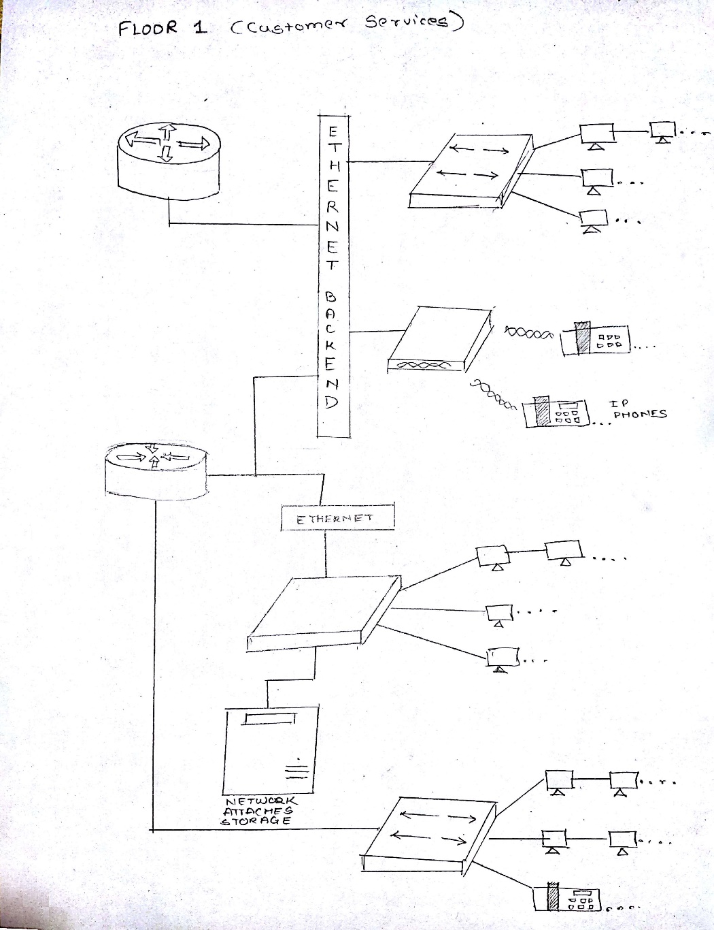

*Figure 4. 2 Customer Service Network Design*

‘The customer service department has to persistently solve the queries of the users/consumers of the company. As this department should be active 24/7 it is subdivided into two regions which are held up by one router each. This redundancy assures that if one router fails the other router branch will be still active. One important component in customer service architecture is IP telephony in this case. The calls of customers will be redirected to various customer service representatives. Also each customer service rep. will have a computer attached to the internet to work on. The IP telephony can be carried out with wired or wirelessly. The department also has its’s own NAS to store customer complaint data.

## Retail Services Department

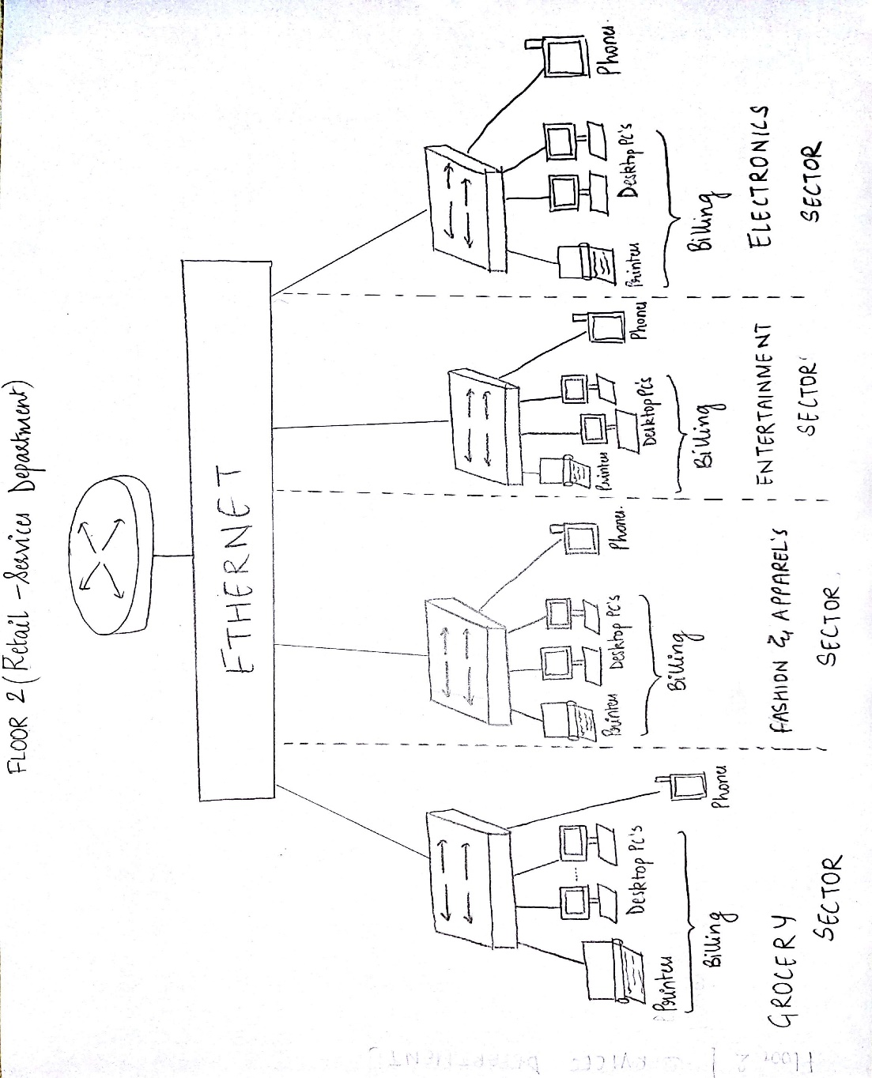

*Figure 4.3 Retail-Services Department Network Design*

The Retail Services which is located on 2nd floor will have access to internet via a router and 4 switches. The Ethernet connection will be provided to the laptops and desktop PCs of the different department. The Wi-Fi enabled devices such and mobile phones and laptops will also be provided with wireless access point. The Logistics division employees can print the billing documents via printers connected on network, which implies ease of us. To make creative marketing campaigns they will have access to adequate desktops with internet connectivity. The wireless access point will guarantee access to Wi-Fi enabled devices so that the marketing team can work anywhere on their floor as per their convenience.

## Regional Demand Supply

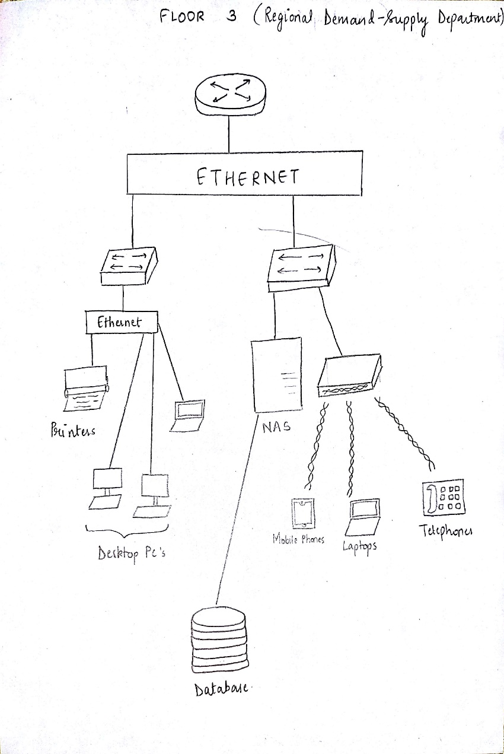

*Figure 4.1 Demand Supply Department Network Design*

The regional demand supply which is located on 3rd floor will have access to internet via a router and 2 switches. The Ethernet connection will be provided to the laptops and desktop PCs of the department and will have their own NAS for storage purposes. The Wi-Fi enabled devices such and mobile phones and laptops will also be provided with wireless access point. The Logistics division employees can print the documents via printers connected on network, which implies ease of use.

## Finance and Accounting

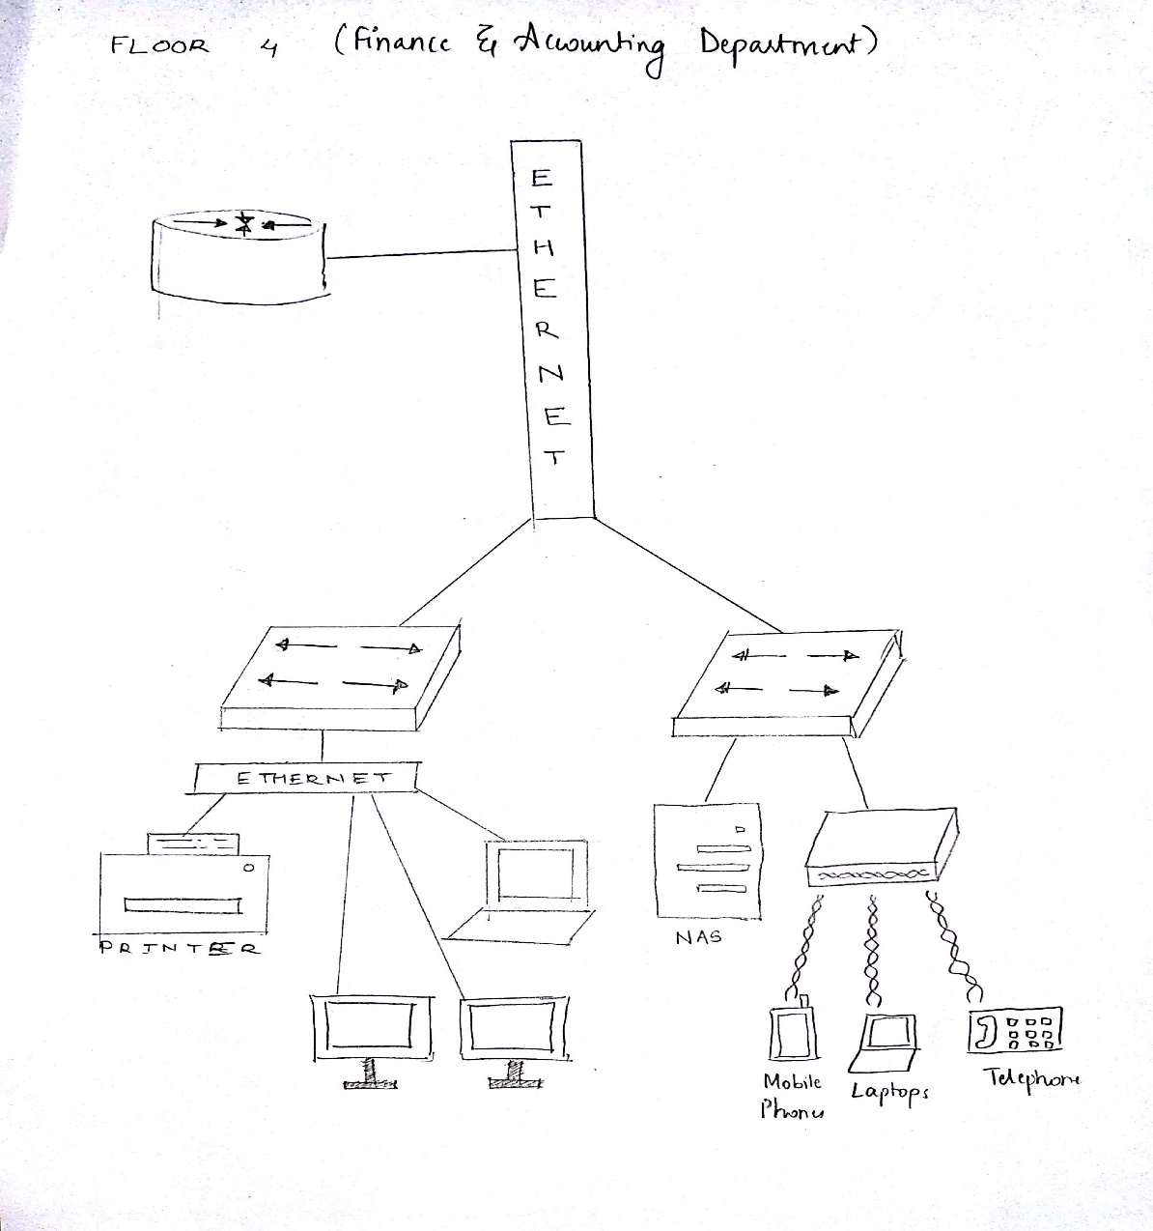

*Figure 4.4 Finance And Administration Network Design*

The company’s analysis about financial data is dealt by finance and administrator division of the company. It is very important to analyses the finance data can be analyzed at the workstations allotted with the addition of third switch. The analyzed data can be stored in the department’s network attached server. There are total 2 switches in this configuration where in different subdivisions of finance and administrations. The cat5 cable will guarantee the speed of connection will be fast.

## IT Division

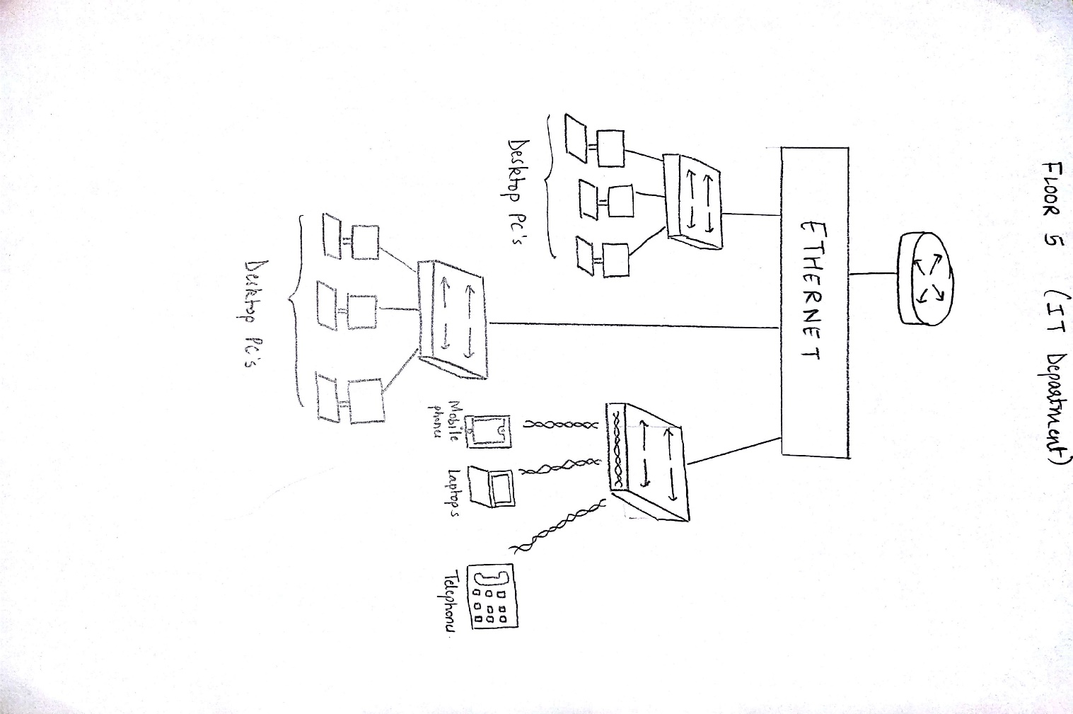

*Figure 4.5 IT Division Network Design*

The IT branch will cater to all the technological needs of other divisions may it be configurations, making online platform, upscaling/downscaling the server configurations to make best use of available hardware, and to develop internal software for smooth functioning of company. This will call for multi-branched division, so for architecture of this division multiple switches are arranged to cater the needs. One wireless access point for mobile devices. The divisions can be isolated or merged as per company’s needs. The concept of parallel software development can be enhanced using this type of architecture.

# Arrangement according to campus core, access layer, distribution layer

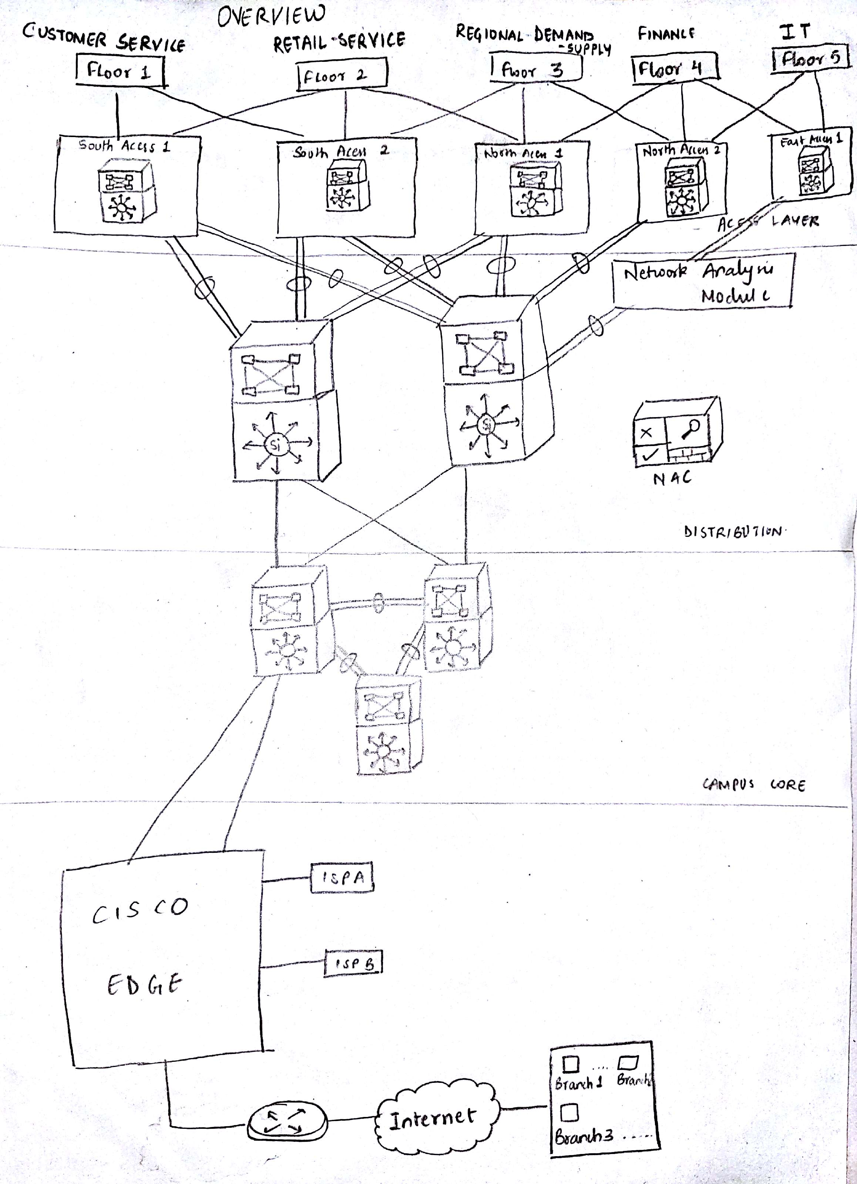

*Figure 5.1 Campus Core, Access Layer, and Distribution Layer Representation*

The access layer has been discussed in previous floor plans, but rising from floor-wise connections it is time for discussing about distribution layer. As seen in the architecture diagram above the access layer is connected in mesh topology with the Cisco Route Switch Processors in distribution layer to assure redundancy and fine control on system. The distribution layer processors and in-turn connected with campus core where again such high speed and high capability Cisco Route Switch Processors are available to handle the heavy traffic and perform efficient switching. These campus core processors are connected to:

1. Servers (Mainly DNS Server, Mail Server, Web Server
2. Via a switch to Agent and Cisco Unified CCE and
3. Via a switch to NAS and databases of the company

# Firewall Configuration

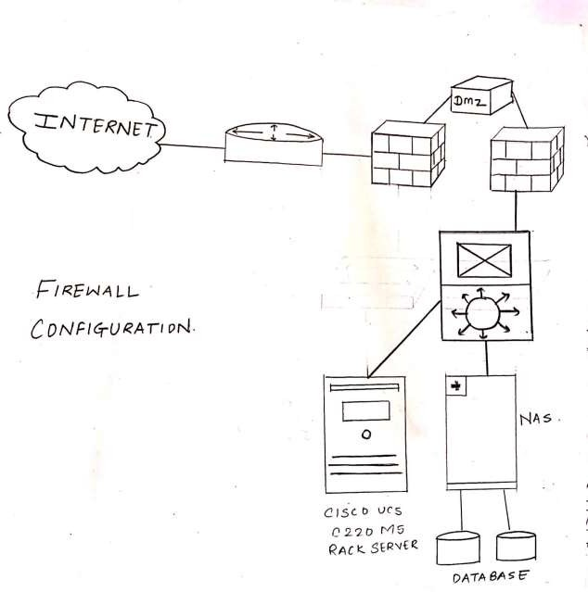

*Figure 6.1 Firewall Configuration*

The firewall configuration is set to majorly two servers:

1. Cisco UCS c220 M5 Rack server:
   1. This server supports Mail Server and Web Server configuration and therefore needs a firewall to check incoming and outgoing traffic.
2. NAS with Databases of company:
   1. This database server will be used to store data internally in company and for the software product of company plus the user data.

# Enterprise Edge and ISP connectivity

*Figure 7.1 Enterprise Edge*

The enterprise edge will be connected to two ISPs namely A and B to ensure redundancy and also as a backup. The ISP connections leased will have speeds

### Verizon 960 Mbps

1. **COX 1000 Mbps**

# Expenditure on Buying Equipment

1. *Table 8.1 Price Estimate*

|  |  |  |  |  |
| --- | --- | --- | --- | --- |
| **Name of Equipment** | **Units Needed** | **Price per unit**  **₹** | **Total**  **₹** | **Outlet** |
| **Cisco Network Convergence System 5501 series Router** | **12** | **1,00,000** | **12,00,000** | *https://www.indiamart.com/proddetail/cisco-ncs-5500-series-router-19446672655.html* |
| **Cisco Catalyst 9300 Series Switch** | **19** | **1,47,924** | **28,10,556** | *Amazon.com* |
| **Cisco Aironet 3800 WAP** | **4** | **44,969** | **1,79,876** | *https://www.router-switch.com/cisco-3800-access-points-price.html* |
| **Dell Storage NX430 NAS** | **4** | **2,10,792** | **8,43,168** | *https://www.enterprisestorageforum.com/products/dell-storage-nx430-product-overview-and-insight.html* |
| **The Cisco UCS® C220 M5 Rack Server** | **1** | **3,07,018** | **3,07,018** | *https://www.google.com/search?q=The+Cisco+UCS%C2%AE+C220+M5+Rack+Server&oq=The+Cisco+UCS%C2%AE+C220+M5+Rack+server* |
| **Cisco Unified SIP Phone 3900 Series** | **50(rough)**  **6 in diagrams** | **4,609** | **12,30,450** | *https://www.amazon.in/Cisco-CP-3905-SIP-Phone/dp/B005A9PW1I* |
| **Verizon fios Gigabit Connection 940Mbps** | **1** | **5,917 p.m.** | **5,917** | *https://fios.verizon.com/fios-speeds.html* |
| **COX Xfinity Internet 1000Mbps** | **1** | **8,280 p.m.** | **8,280** | *https://www.cox.com/residential/internet.html* |
| **CAT5 (500 m)** | **1** | **35 per meter** | **17,500** | *https://dir.indiamart.com/impcat/cat-5-cable.html* |
| **Dell Inspiron 3800 Desktop PC’s** | **31** | **32,000** | **9,92,00** | [*https://www.dell.com/en-in/shop/deals/desktop-deals*](https://www.dell.com/en-in/shop/deals/desktop-deals) |
| **HP Deskjet 4729 Printer’s** | **6** | **8,999** | **53,994** | *https://www.amazon.in/HP-DeskJet-4729-Advantage-Wireless* |
|  |  | **Grand Total** | **67,55,959** |  |

# Remote Site Connectivity

The UDP packets like voice, videos etc. need low latency and easy provisioning, with low cost and the normal wan technologies like Frame relay, ATM cannot provide this so we use VPN technology. Multiprotocol Label Switching is mostly used by ISP’s for their backbone

And also, by some large enterprise.

* It uses label path for forwarding packets
* It uses label of 32 bit which is inserted between Layer 2 and Layer 3.
* MPLS often called as shim header. L2 mpls vpn and L3 mpls vpn:

Tunnel based virtual networks:

A tunnel is a virtual network made up of N number of routers but looks as if the tunnel is made up of two routers connected with interfaces.

Types:

1. GRE
2. Multipoint GRE
3. DMVPN
4. IPsec

We will use DMVPN and details are as follows:

It is a secure network that exchanges data between sites without needing to pass traffic through an organization's headquarter virtual private network (VPN) server or router.

DMVPN deployments include mechanisms such as GRE tunnelling and IPsec encryption with Next Hop Resolution Protocol (NHRP) routing that are designed to reduce administrative burden and provide reliable dynamic connectivity between sites. It is in every company’s advantage to make use of DMVPN where possible, to help reduce WAN costs and increase bandwidth and reliability.

Direct spoke-to-spoke deployments provide a number of advantages when compared to traditional VPN deployments:

* Traffic between remote sites does not need to traverse the hub (headquarter VPN router).
* A DMVPN deployment eliminates additional bandwidth requirements at the hub.
* DMVPNs eliminate additional network delays.
* DMVPNs conserve WAN bandwidth.
* They lower costs for VPN circuits.
* They increase resiliency and redundancy.

# IP Addressing

Malls mainly are mid-sized to large sized companies and will therefore have ample amount of hosts. The IP addressing used for networks of these malls will be IP version 4 addresses, which uniquely identify a device on IP network.

The IP Address Class chosen for the project undertaken will be Class ‘A’ IP addressing. This is because class A has IP addresses which will be enough for the mall employee strength.

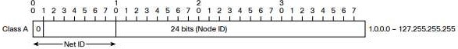

For the internal network infrastructure we will use private network ranges ranging from 10.0.0.0 --- 10.255.255.255 (10.0.0.0/8)

This allows the greatest flexibility with the equivalent of 255 Class A address spaces to be used as needed. The public address space can be difficult to get and can be expensive so the IP addresses will be carefully mapped to private IP addresses in the company.

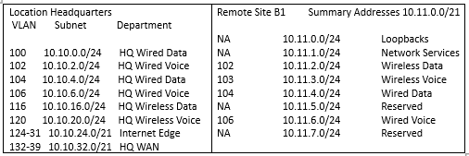

Table 10.1 IP Addressing

# Routing Protocol for the Organization

[**Border Gateway Protocol (BGP)**](https://practice.geeksforgeeks.org/problems/bgpborder-gateway-protocol)

It is used to Exchange routing information for the internet and is the protocol used between ISP which are different ASes.

The protocol can connect together any internetwork of autonomous system using an arbi- trary topology. The only requirement is that each AS have at least one router that is able to run BGP and that is router connect to at least one other AS’s BGP router. BGP’s main function is to exchange network reach-ability information with other BGP systems. Border Gateway Protocol constructs an autonomous systems’ graph based on the information ex- changed between BGP routers.

### Characteristics of Border Gateway Protocol (BGP):

* **Inter-Autonomous System Configuration:** The main role of BGP is to provide com- munication between two autonomous systems.
* BGP supports Next-Hop Paradigm.
* Coordination among multiple BGP speakers within the AS (Autonomous System).
* **Path Information:** BGP advertisement also include path information, along with the reachable destination and next destination pair.
* **Policy Support:** BGP can implement policies that can be configured by the adminis- trator. For ex: - a router running BGP can be configured to distinguish between the routes that are known within the AS and that which are known from outside the AS.
* Runs Over TCP.
* BGP conserve network Bandwidth.
* BGP supports CIDR.
* BGP also supports Security.

**Secure Electronic Transaction (SET) Protocol**

* + SET protocol was initially designed by Visa and MasterCard in 1997 and has evolved since then. SET protocol meets the four security requirements for EC as SSL(Secure Socket Layer) does: authentication, encryption, integrity, and non repu diation. In ad- dition, SET defines the message format, certificate format, and procedure of message exchange as depicted in.
  + The role of payment gateway is to connect the Internet and proprietary networks of banks. Each participating entity needs its own certificate. To keep the consumer’s certificate in his or her personal computer or IC card, software called the electronic wallet, or *digital wallet,* is necessary. To connect the dig-ital wallet with various mer- chants, interoperability is a very important characteristic to meet.

# GNS3 Implementation

# IT Division Floor Wise Plan

# 

**BGP Protocol Implelentation:**

File Link: https://drive.google.com/drive/folders/1FeAb4f5zHRUIrx7IqIspN5-MLj7NXdEN?usp=sharing

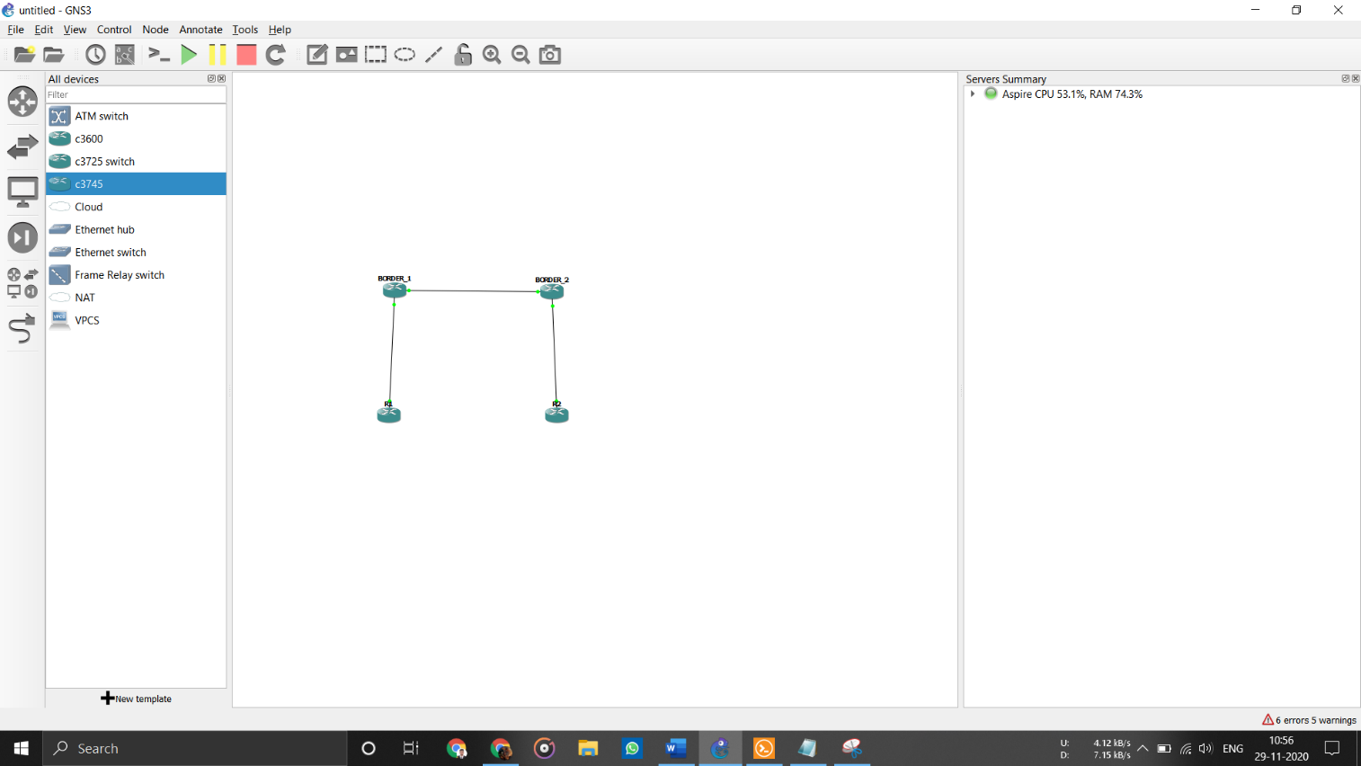

Success Rate 100%

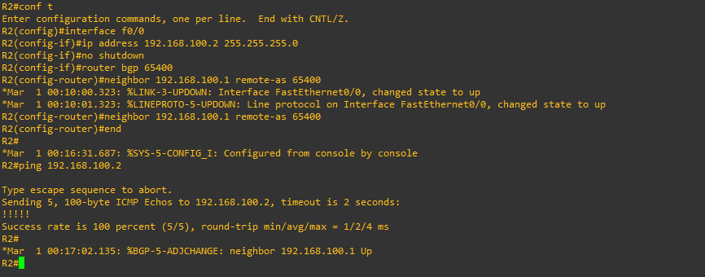

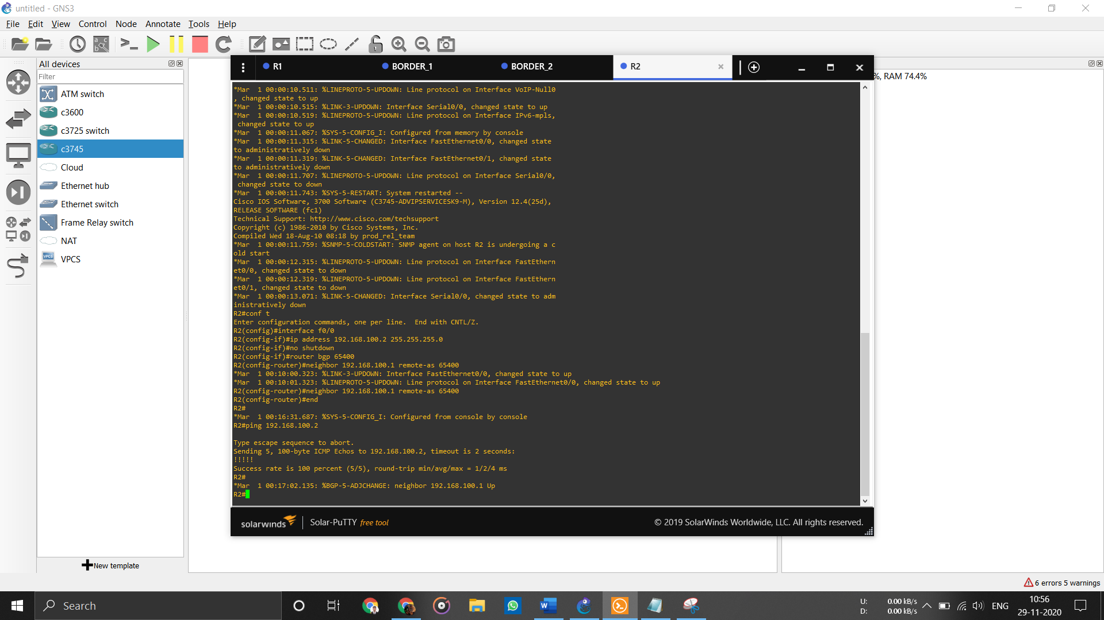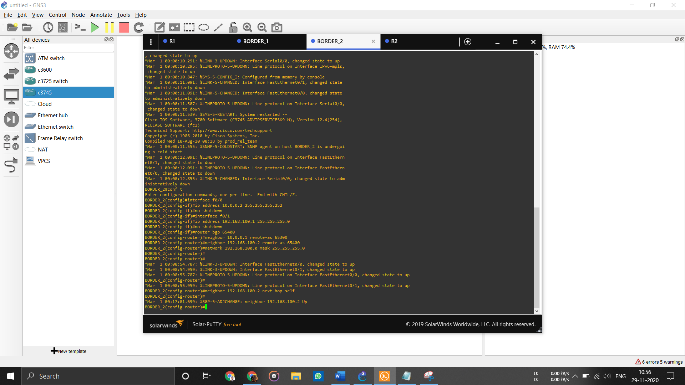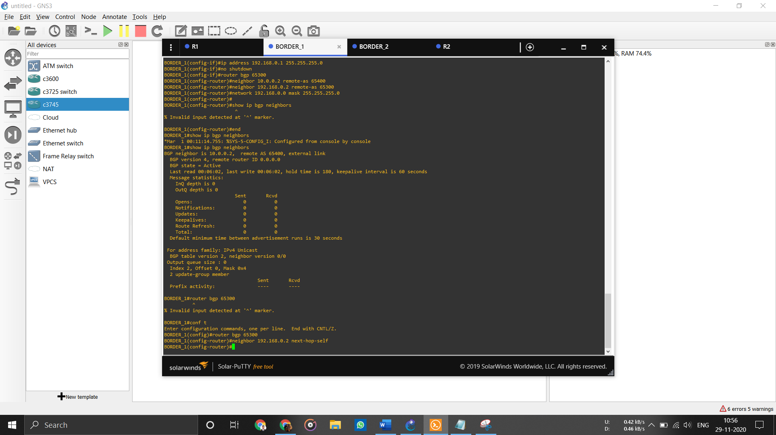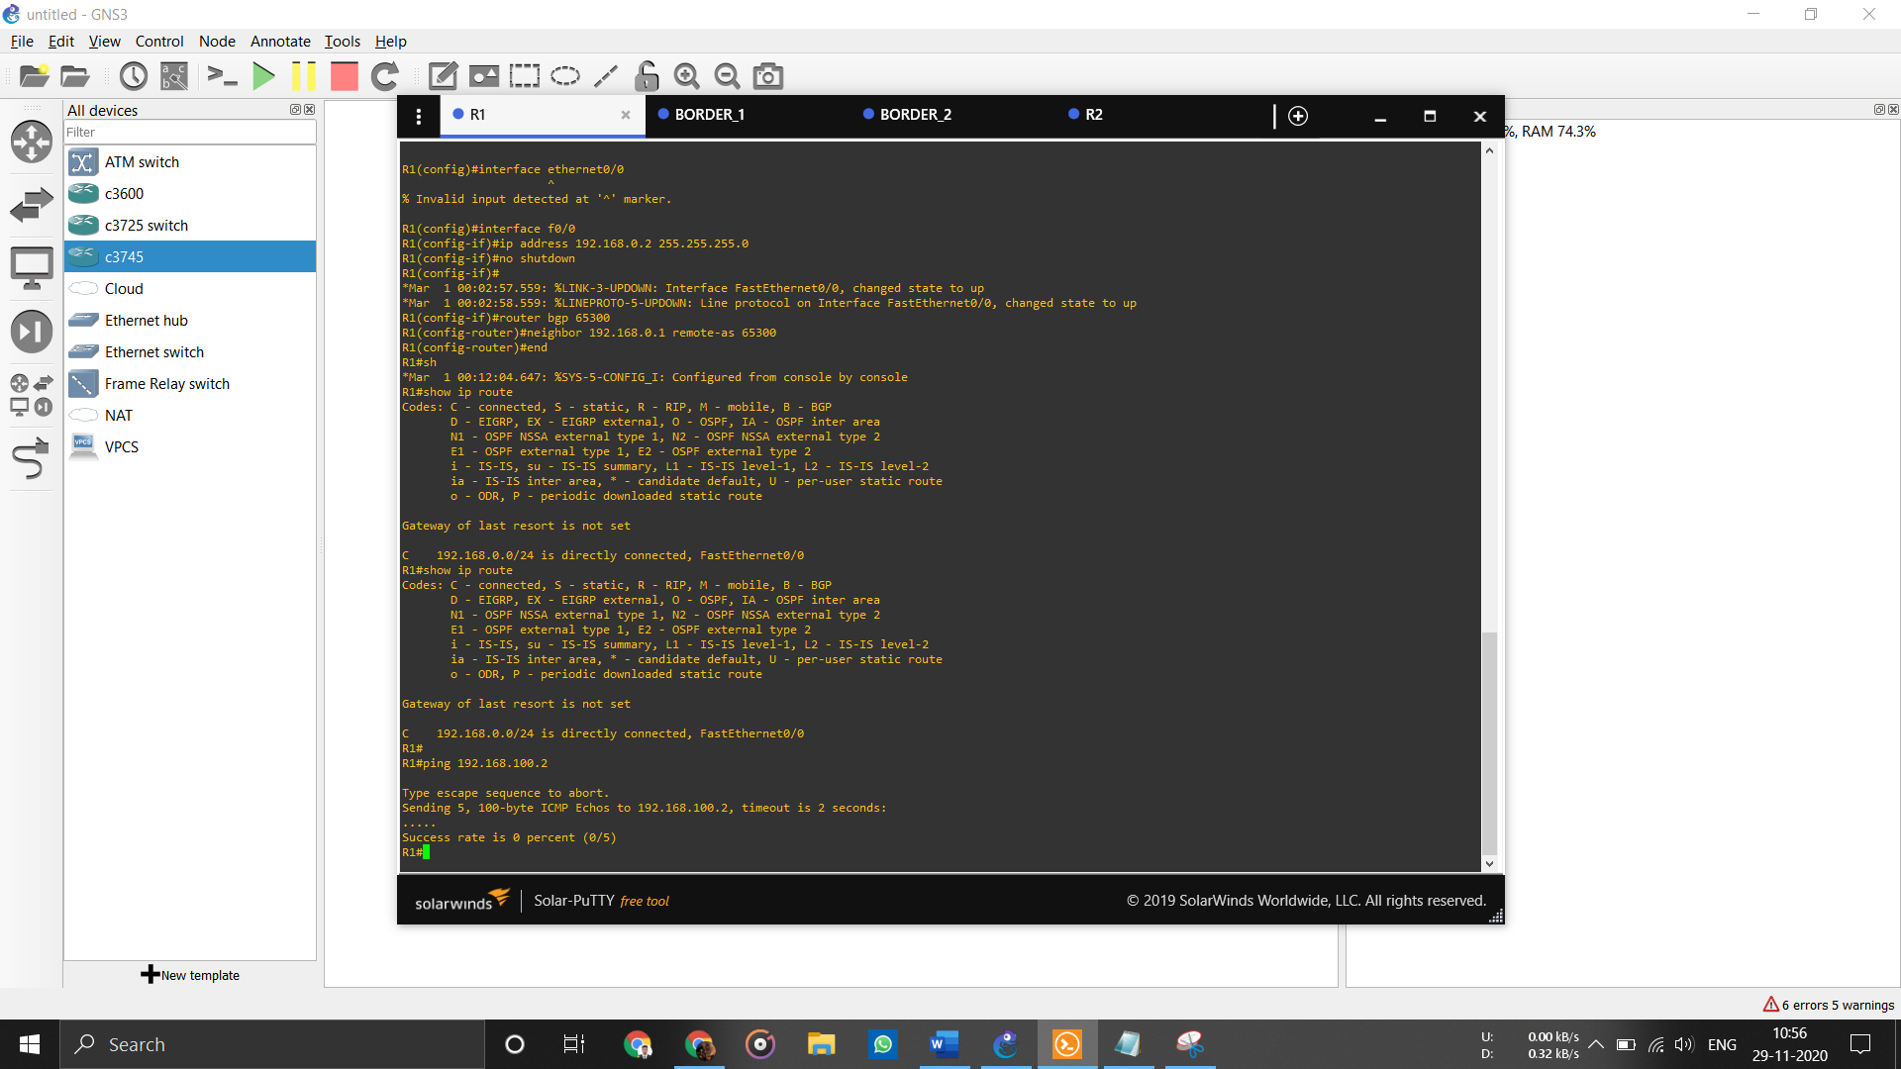

# References

1. <https://www.cisco.com/c/en/us/products/switches/index.html>
2. <https://www.cisco.com/c/en/us/products/routers/index.html>
3. <https://www.cisco.com/c/en/us/products/routers/network-convergence-system-5500-series/index.html>
4. <https://www.indiamart.com/proddetail/cisco-ncs-5500-series-router-19446672655.html>
5. <https://www.router-switch.com/cisco-catalyst-9300-switches-price.html>
6. <https://www.eagle.in/shop/cisco-ucs-c220-m5-1u-rack-server/>
7. <https://www.uml-diagrams.org/network-architecture-diagrams.html>
8. [https://www.cisco.com/c/en/us/products/collateral/collaboration-](https://www.cisco.com/c/en/us/products/collateral/collaboration-endpoints/unified-sip-phone-3905/data_sheet_c78-651588.html)
9. [endpoints/unified-sip-phone-3905/data_sheet_c78-651588.html](https://www.cisco.com/c/en/us/products/collateral/collaboration-endpoints/unified-sip-phone-3905/data_sheet_c78-651588.html)